Supplementary Files:
Supplementary figure 1: cumulative percentage of deviance explained by each variable (blue-foi; green – cases the previous week; pink – the interaction between foi and previous week’s cases).
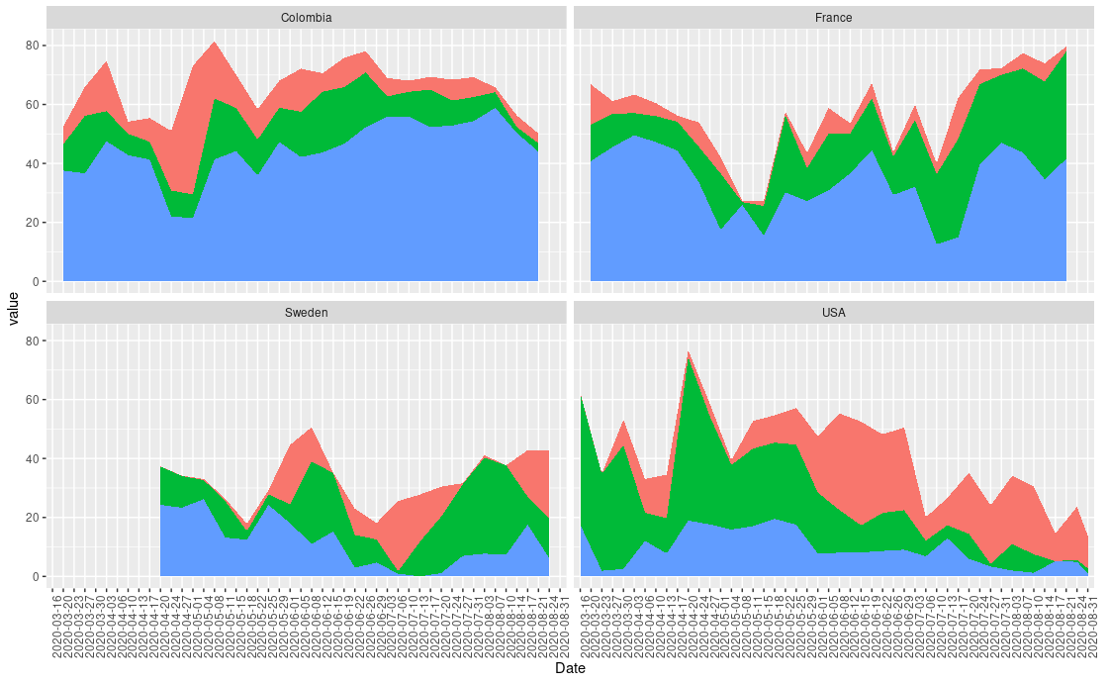

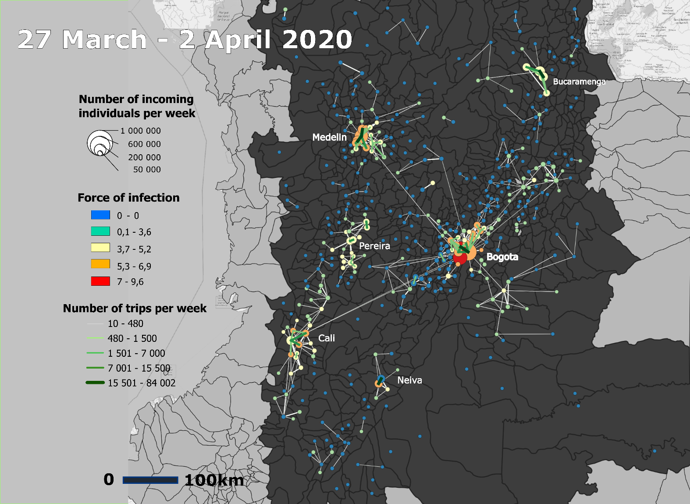
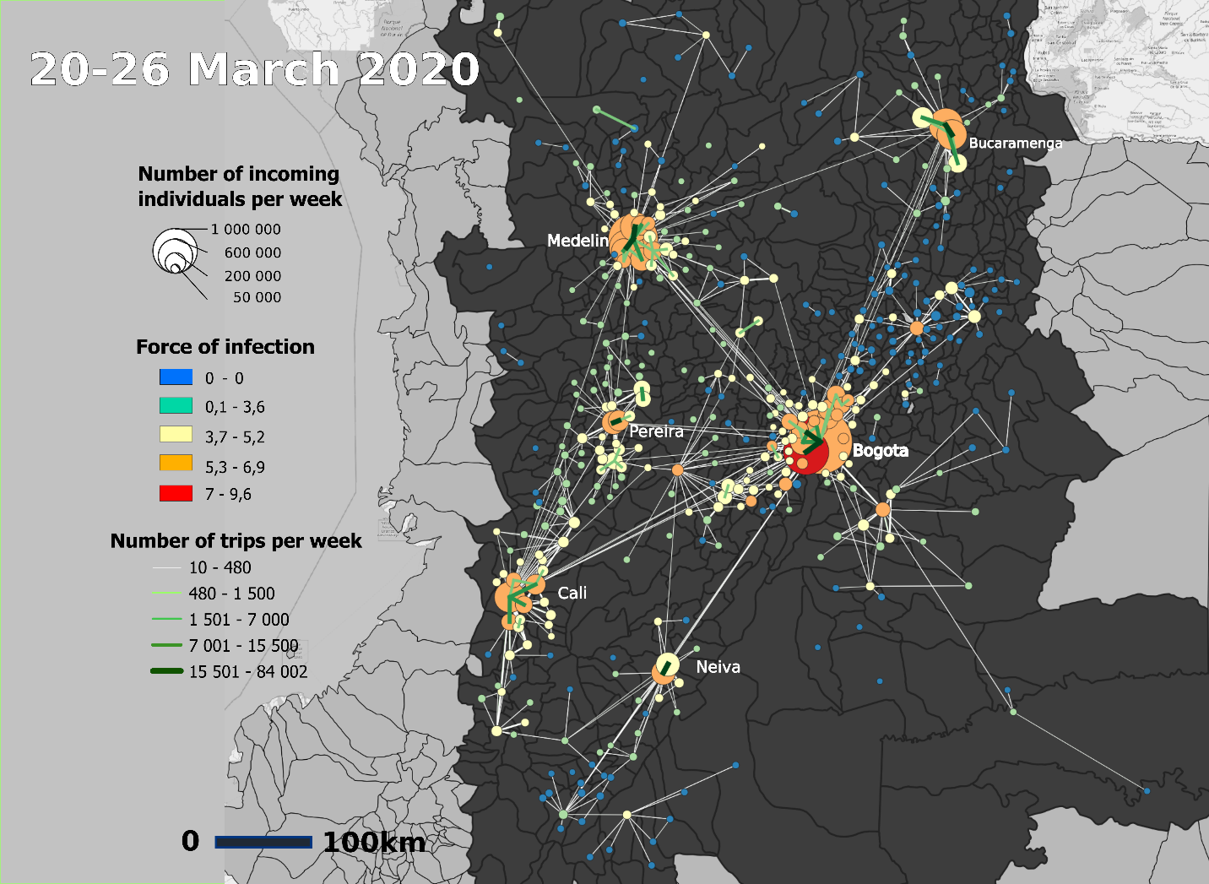
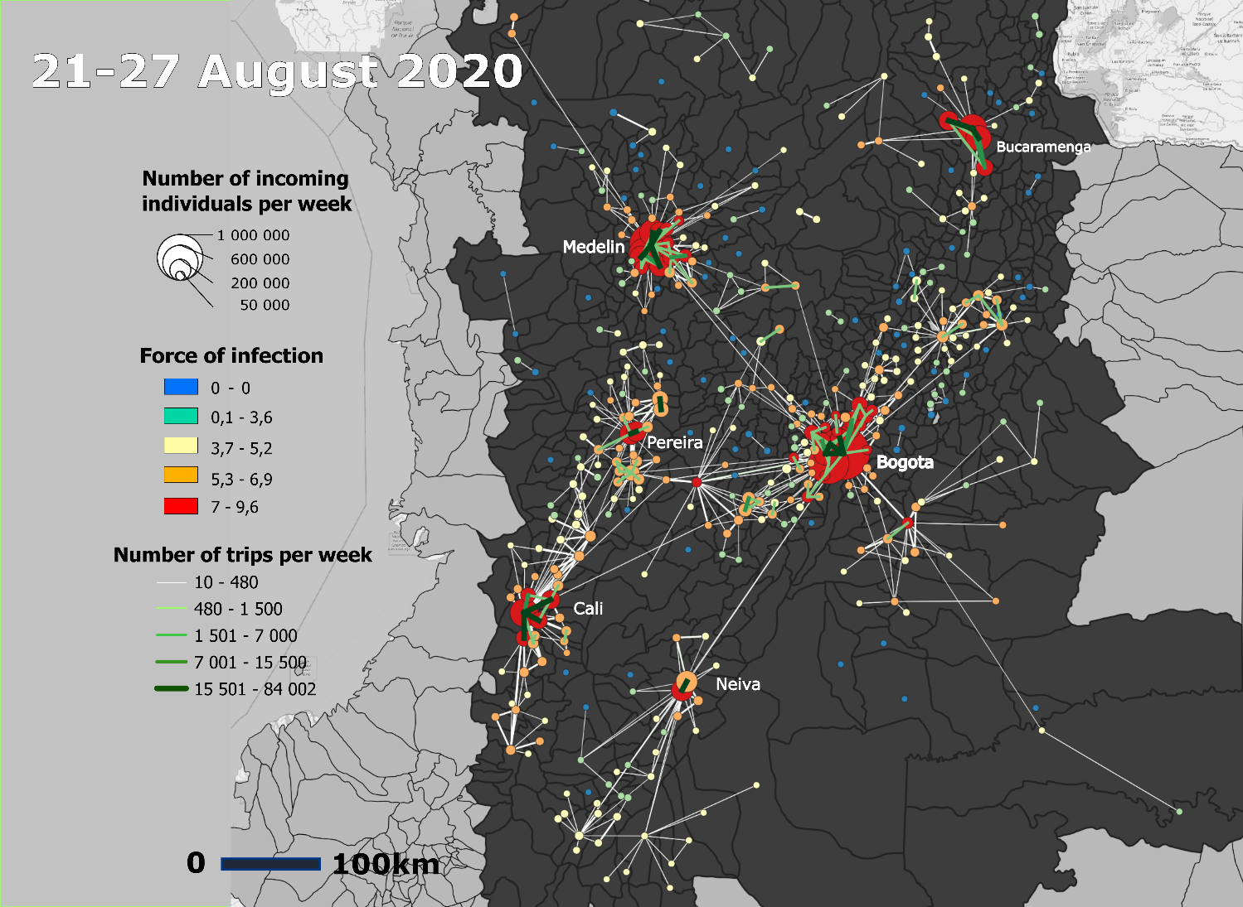
Collection of maps 1 : Mobility flux, number of incoming mobility and FOI Before the lockdown, during the lockdown and in August in Colombia
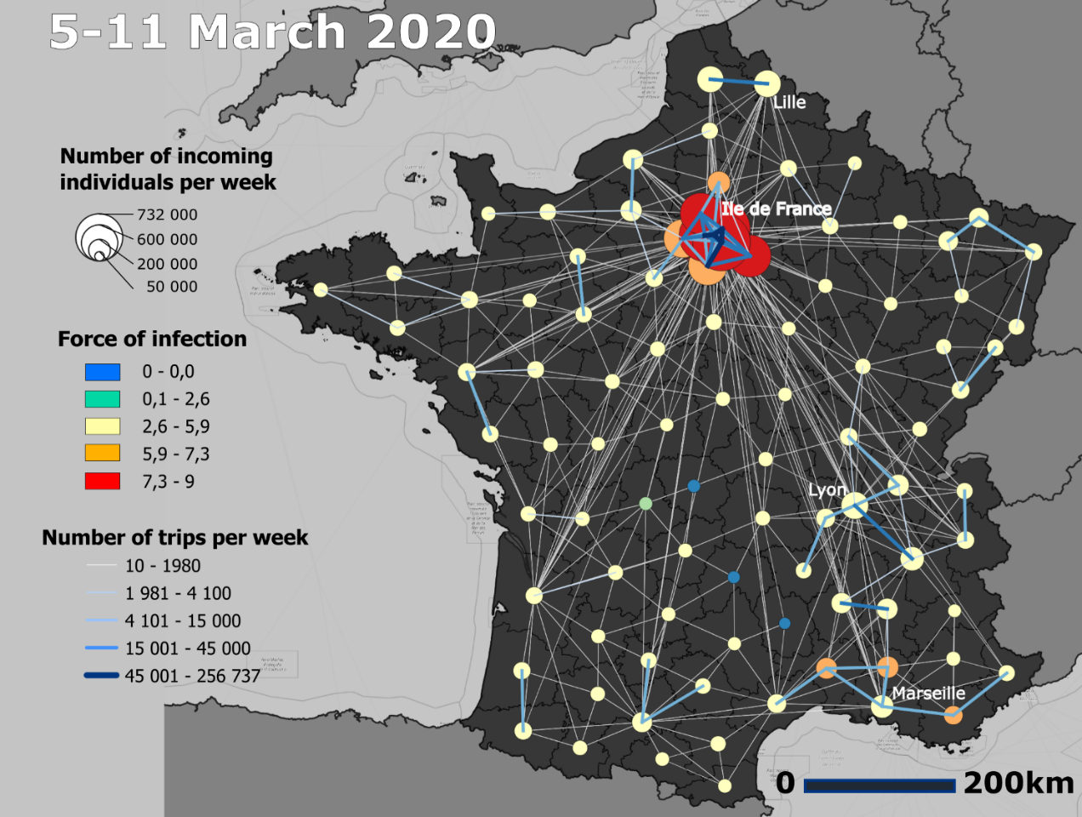
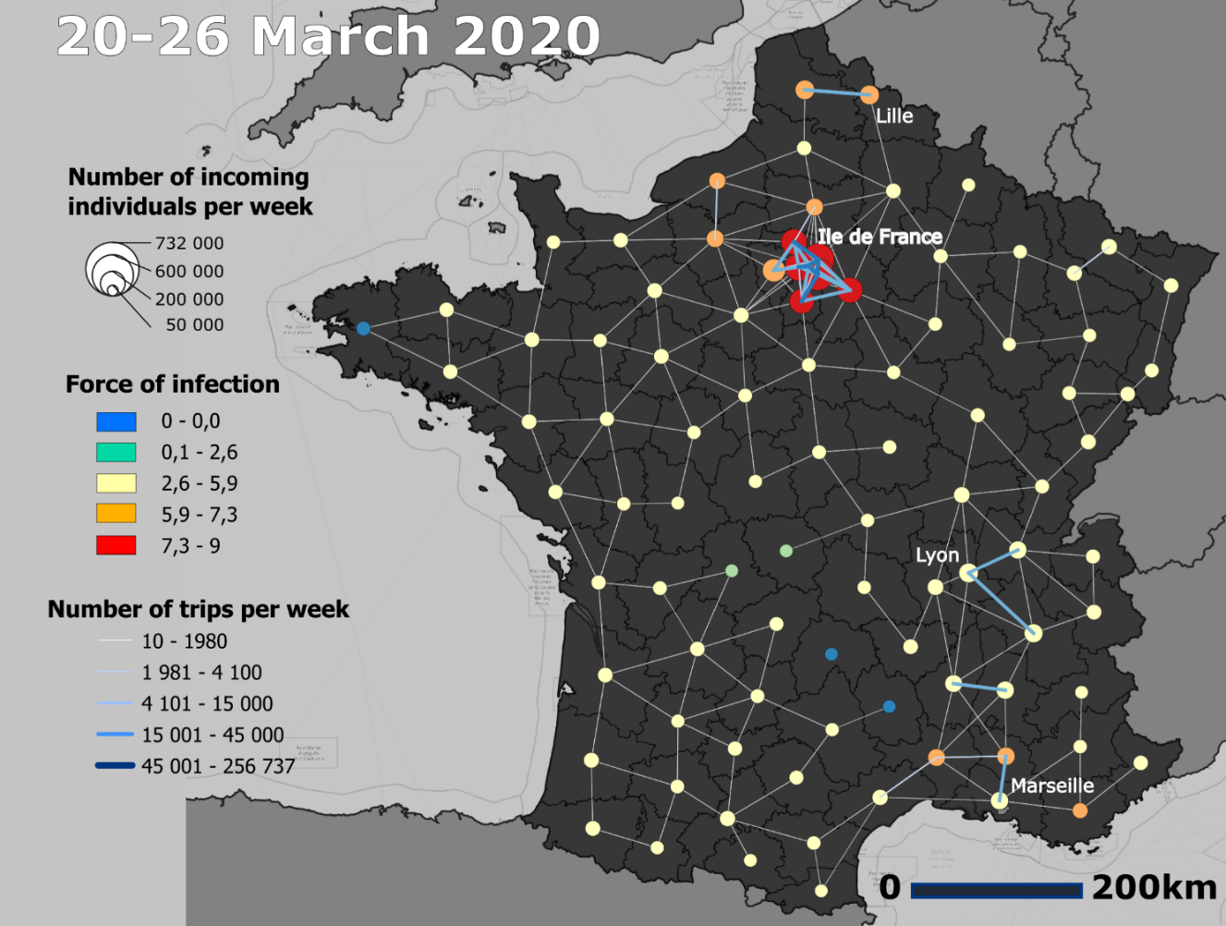
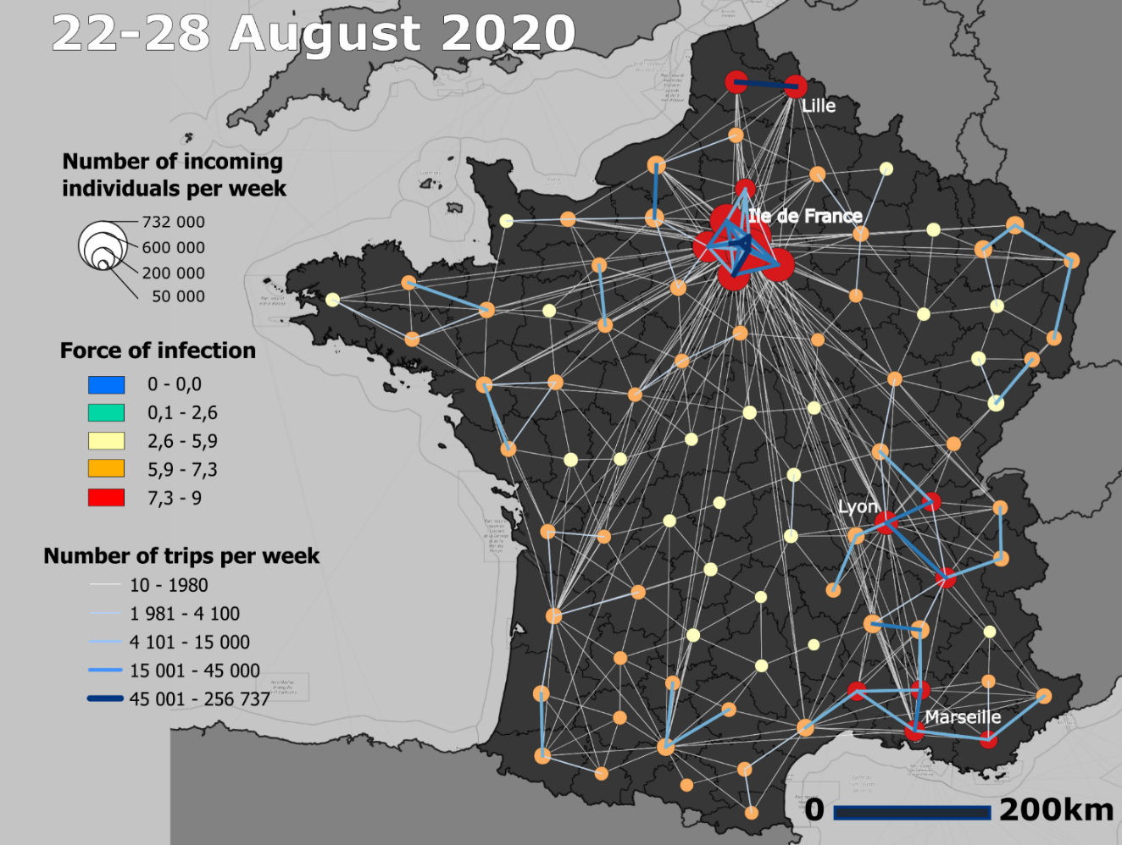
Collection of maps 2 : Mobility flux, number of incoming mobility and FOI Before the lockdown, during the lockdown and in August in France
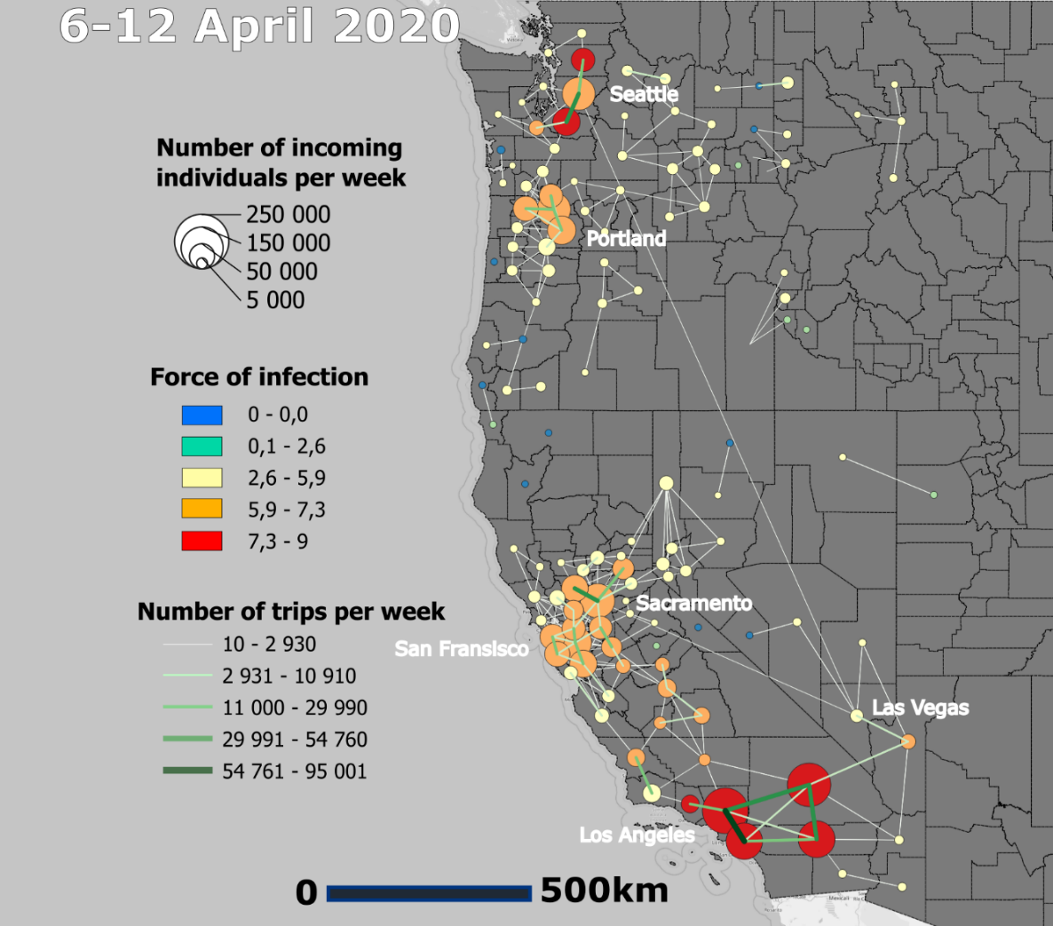
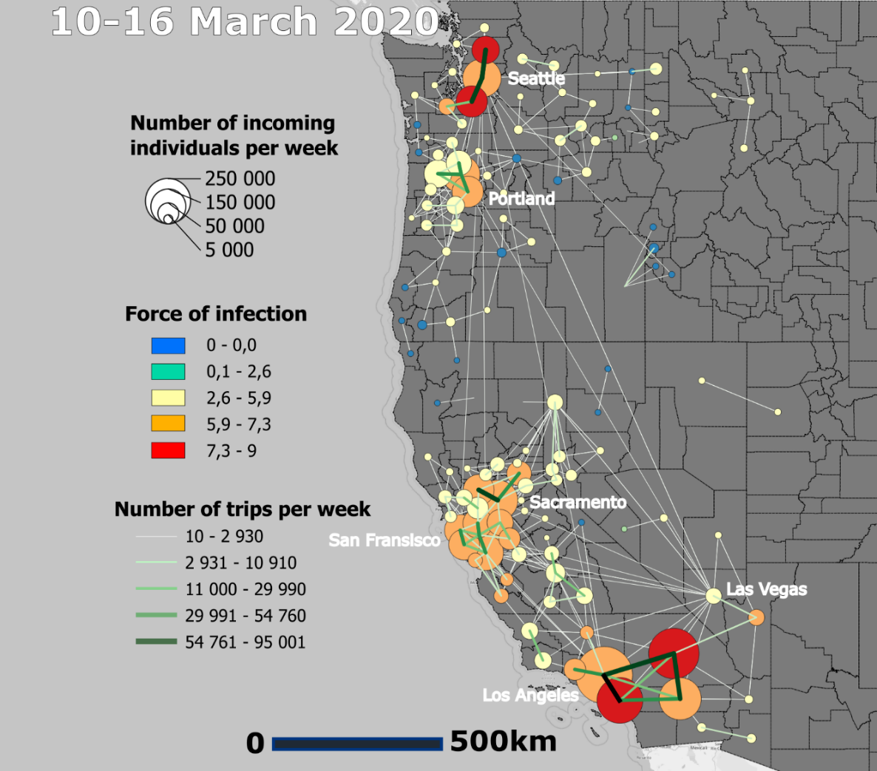
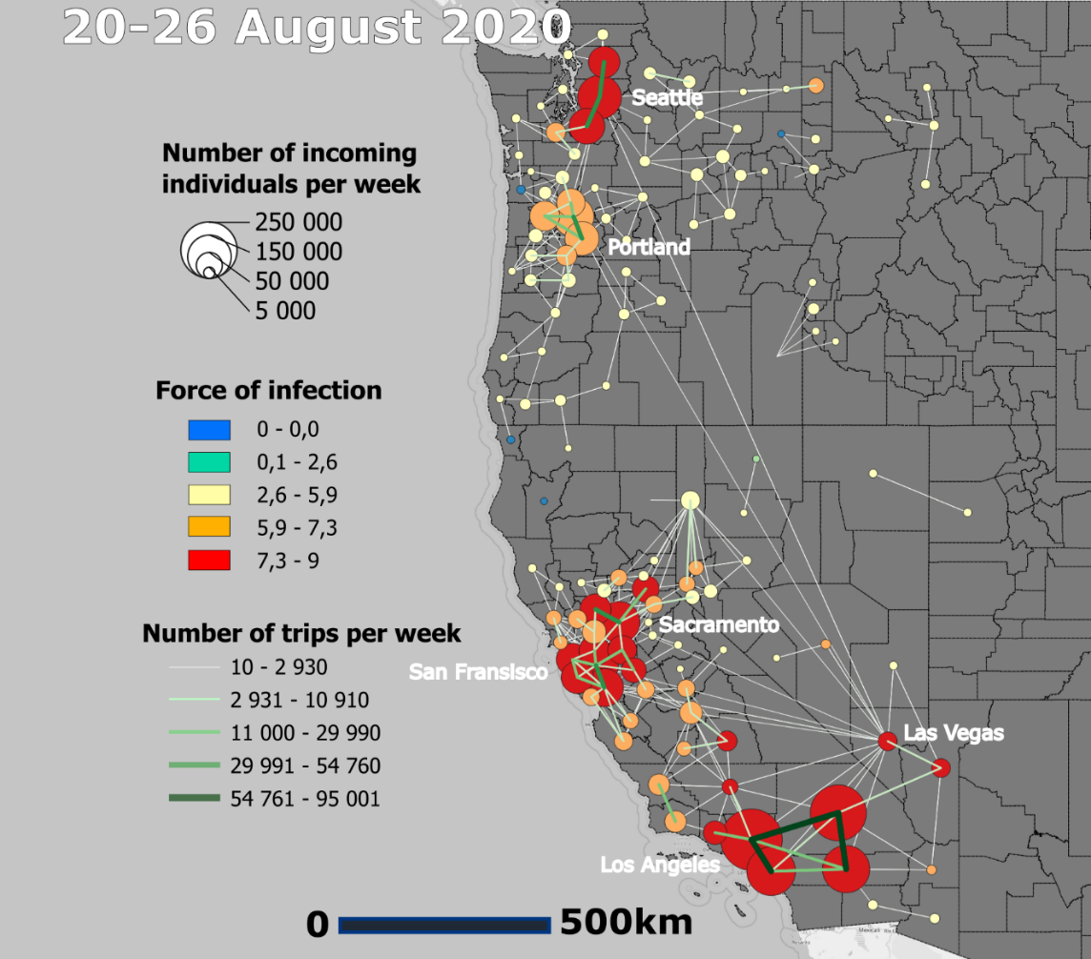
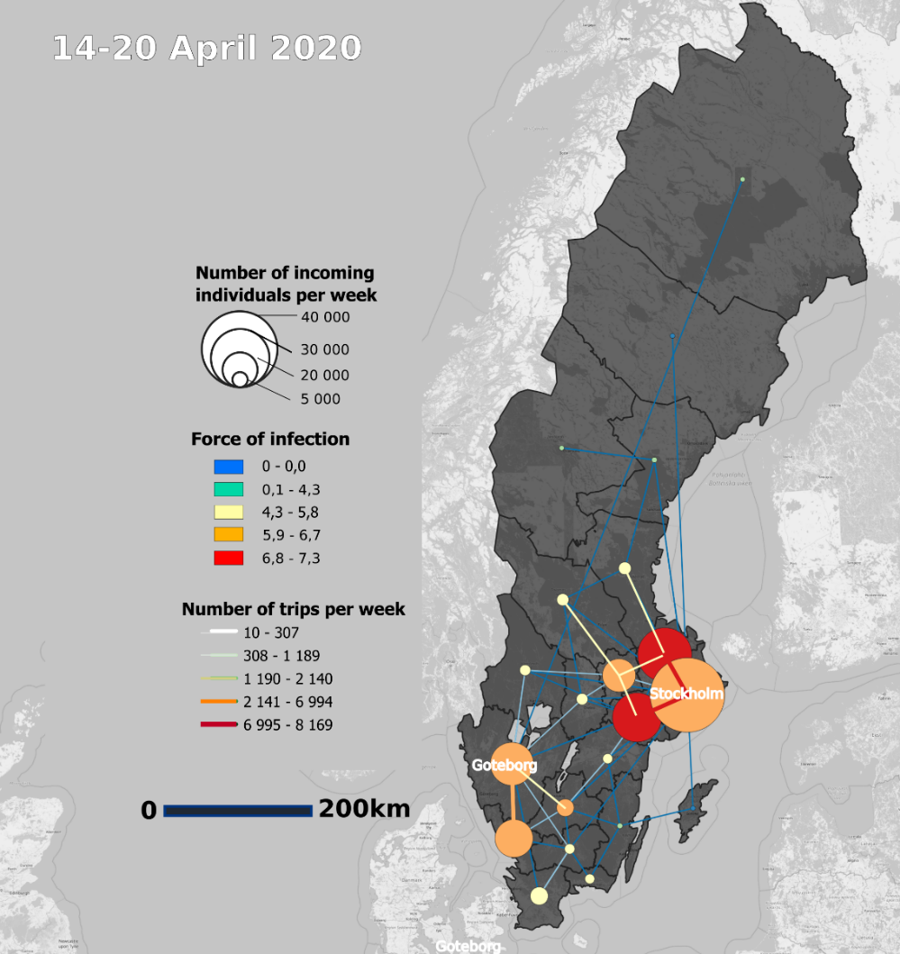
Collection of maps 3 :Mobility flux, number of incoming mobility and FOI Before the lockdown, during the lockdown and in August in the west coast of USA
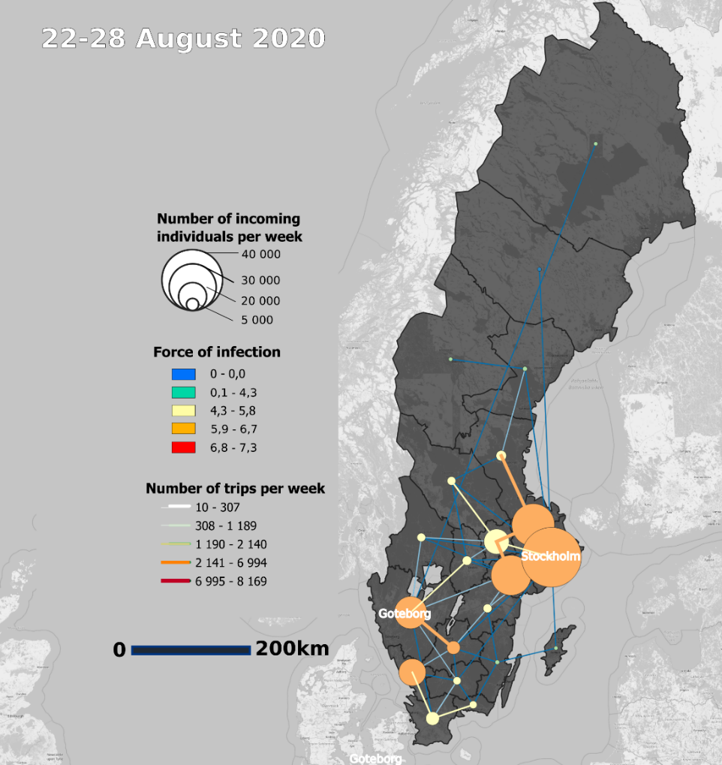
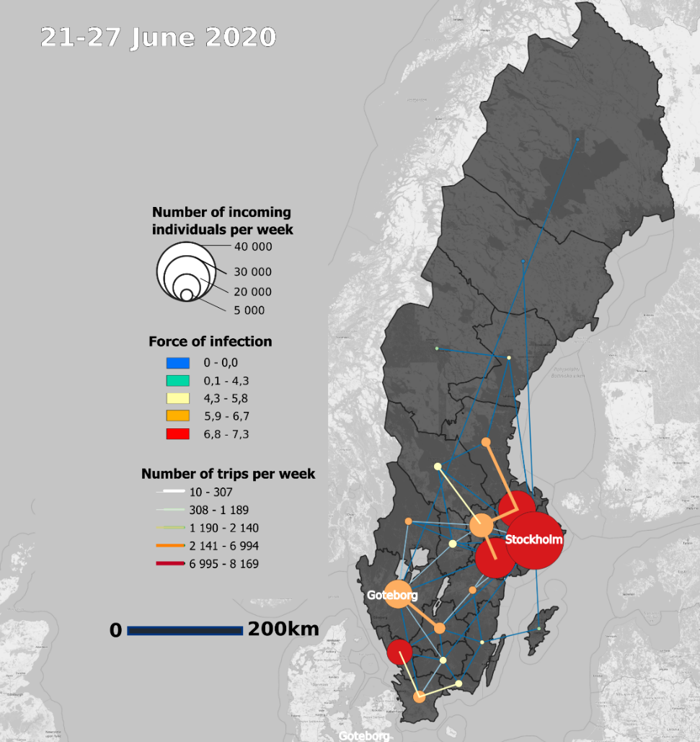
Collection of maps 4: Mobility flux, number of incoming mobility and FOI In April, June and in August in Sweden
Collection of maps 4 :Mobility flux, number of incoming mobility and FOI In April, June and in August in Sweden

