Supplementary Information
Motivation for COVID-19 vaccination in adolescents in an urban area in Germany

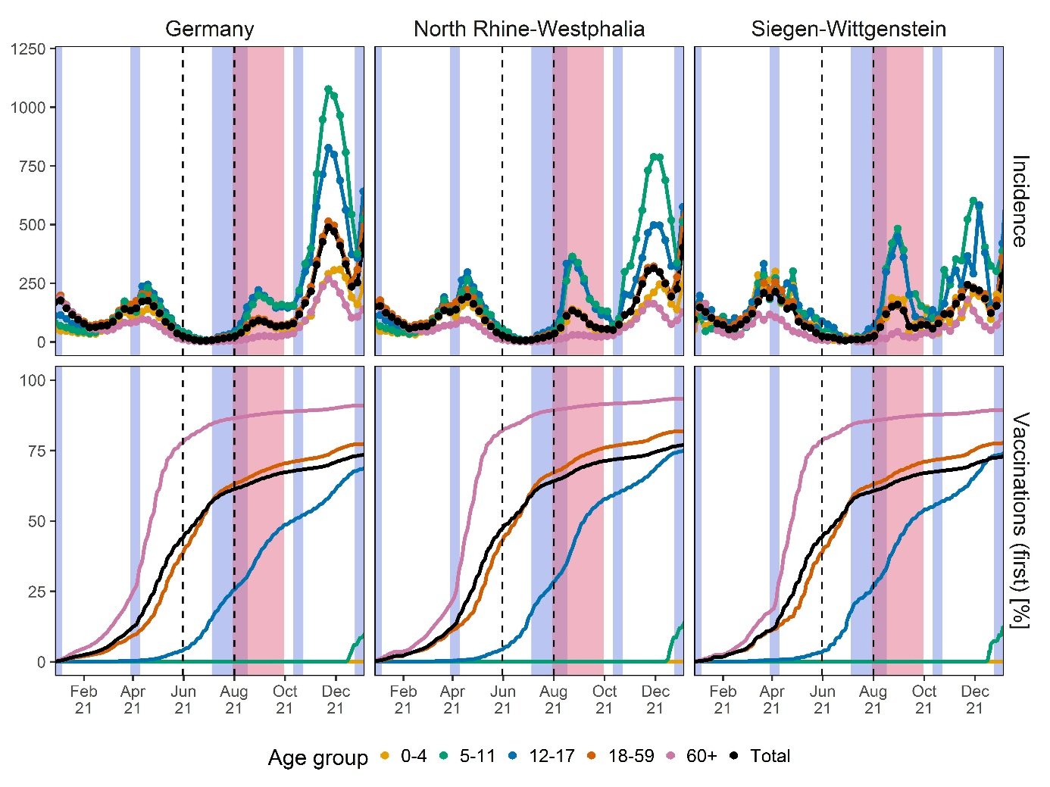
Figure S1: SARS-CoV-2 7-day incidence per 100,000 inhabitants and the fraction of vaccinated individuals (first vaccine dose) in Germany, federal state North Rhine-Westphalia and study region Siegen-Wittgenstein stratified by age group. School holidays are marked by blue shades, the study time frame is marked by red shades.

Table S1: Reasons for accepting a COVID-19 vaccination as answered by the adolescents.
 |  |  | First generation migration background
Reason for vaccination |  | all | without | with
Reason for vaccination | Total (n) | 1378 | 1148 | 230
Protection of own family | missing | 53 (3.8%) | 45 (3.9%) | 8 (3.5%)
Protection of own family | totally agree | 797 (57.8%) | 670 (58.4%) | 127 (55.2%)
Protection of own family | rather agree | 181 (13.1%) | 143 (12.5%) | 38 (16.5%)
Protection of own family | partly | 209 (15.2%) | 178 (15.5%) | 31 (13.5%)
Protection of own family | rather disagree | 61 (4.4%) | 46 (4.0%) | 15 (6.5%)
Protection of own family | totally disagree | 77 (5.6%) | 66 (5.7%) | 11 (4.8%)
Self-protection | missing | 34 (2.5%) | 28 (2.4%) | 6 (2.6%)
Self-protection | totally agree | 969 (70.3%) | 818 (71.3%) | 151 (65.7%)
Self-protection | rather agree | 165 (12.0%) | 134 (11.7%) | 31 (13.5%)
Self-protection | partly | 128 (9.3%) | 101 (8.8%) | 27 (11.7%)
Self-protection | rather disagree | 40 (2.9%) | 32 (2.8%) | 8 (3.5%)
Self-protection | totally disagree | 42 (3.0%) | 35 (3.0%) | 7 (3.0%)
Travelling | missing | 80 (5.8%) | 70 (6.1%) | 10 (4.3%)
Travelling | totally agree | 495 (35.9%) | 406 (35.4%) | 89 (38.7%)
Travelling | rather agree | 134 (9.7%) | 104 (9.1%) | 30 (13.0%)
Travelling | partly | 248 (18.0%) | 207 (18.0%) | 41 (17.8%)
Travelling | rather disagree | 205 (14.9%) | 178 (15.5%) | 27 (11.7%)
Travelling | totally disagree | 216 (15.7%) | 183 (15.9%) | 33 (14.3%)
Leisure activities | missing | 38 (2.8%) | 29 (2.5%) | 9 (3.9%)
Leisure activities | totally agree | 873 (63.4%) | 720 (62.7%) | 153 (66.5%)
Leisure activities | rather agree | 186 (13.5%) | 162 (14.1%) | 24 (10.4%)
Leisure activities | partly | 144 (10.4%) | 127 (11.1%) | 17 (7.4%)
Leisure activities | rather disagree | 69 (5.0%) | 58 (5.1%) | 11 (4.8%)
Leisure activities | totally disagree | 68 (4.9%) | 52 (4.5%) | 16 (7.0%)

Table S2: Reasons for accepting a COVID-19 vaccination of the adolescents as answered by the parents stratified by migration background.
 |  |  | First-generation migration background
Reason for vaccination |  | all | without | with | unknown
Reason for vaccination | Total (n) | 820 | 654 | 57 | 109
Protection of the adolescent | missing | 9 (1.1%) | 6 (0.9%) | 1 (1.8%) | 2 (1.8%)
Protection of the adolescent | totally agree | 704 (85.9%) | 561 (85.8%) | 49 (86.0%) | 94 (86.2%)
Protection of the adolescent | rather agree | 49 (6.0%) | 39 (6.0%) | 3 (5.3%) | 7 (6.4%)
Protection of the adolescent | partly | 40 (4.9%) | 36 (5.5%) | 2 (3.5%) | 2 (1.8%)
Protection of the adolescent | rather disagree | 9 (1.1%) | 6 (0.9%) | 2 (3.5%) | 1 (0.9%)
Protection of the adolescent | totally disagree | 9 (1.1%) | 6 (0.9%) | 0 (0.0%) | 3 (2.8%)
Protection of the family | missing | 18 (2.2%) | 15 (2.3%) | 1 (1.8%) | 2 (1.8%)
Protection of the family | totally agree | 554 (67.6%) | 437 (66.8%) | 38 (66.7%) | 79 (72.5%)
Protection of the family | rather agree | 68 (8.3%) | 56 (8.6%) | 6 (10.5%) | 6 (5.5%)
Protection of the family | partly | 109 (13.3%) | 90 (13.8%) | 5 (8.8%) | 14 (12.8%)
Protection of the family | rather disagree | 39 (4.8%) | 31 (4.7%) | 3 (5.3%) | 5 (4.6%)
Protection of the family | totally disagree | 32 (3.9%) | 25 (3.8%) | 4 (7.0%) | 3 (2.8%)
Protection of the parents | missing | 22 (2.7%) | 18 (2.8%) | 1 (1.8%) | 3 (2.8%)
Protection of the parents | totally agree | 372 (45.4%) | 287 (43.9%) | 33 (57.9%) | 52 (47.7%)
Protection of the parents | rather agree | 60 (7.3%) | 51 (7.8%) | 4 (7.0%) | 5 (4.6%)
Protection of the parents | partly | 109 (13.3%) | 88 (13.5%) | 6 (10.5%) | 15 (13.8%)
Protection of the parents | rather disagree | 117 (14.3%) | 96 (14.7%) | 3 (5.3%) | 18 (16.5%)
Protection of the parents | totally disagree | 140 (17.1%) | 114 (17.4%) | 10 (17.5%) | 16 (14.7%)
Travelling | missing | 23 (2.8%) | 20 (3.1%) | 1 (1.8%) | 2 (1.8%)
Travelling | totally agree | 361 (44.0%) | 274 (41.9%) | 35 (61.4%) | 52 (47.7%)
Travelling | rather agree | 85 (10.4%) | 69 (10.6%) | 6 (10.5%) | 10 (9.2%)
Travelling | partly | 124 (15.1%) | 107 (16.4%) | 3 (5.3%) | 14 (12.8%)
Travelling | rather disagree | 105 (12.8%) | 90 (13.8%) | 5 (8.8%) | 10 (9.2%)
Travelling | totally disagree | 122 (14.9%) | 94 (14.4%) | 7 (12.3%) | 21 (19.3%)
Leisure activities | missing | 8 (1.0%) | 6 (0.9%) | 0 (0.0%) | 2 (1.8%)
Leisure activities | totally agree | 615 (75.0%) | 488 (74.6%) | 46 (80.7%) | 81 (74.3%)
Leisure activities | rather agree | 96 (11.7%) | 78 (11.9%) | 7 (12.3%) | 11 (10.1%)
Leisure activities | partly | 65 (7.9%) | 53 (8.1%) | 2 (3.5%) | 10 (9.2%)
Leisure activities | rather disagree | 20 (2.4%) | 17 (2.6%) | 1 (1.8%) | 2 (1.8%)
Leisure activities | totally disagree | 16 (2.0%) | 12 (1.8%) | 1 (1.8%) | 3 (2.8%)
Schooling of the child | missing | 8 (1.0%) | 6 (0.9%) | 0 (0.0%) | 2 (1.8%)
Schooling of the child | totally agree | 699 (85.2%) | 560 (85.6%) | 44 (77.2%) | 95 (87.2%)
Schooling of the child | rather agree | 59 (7.2%) | 45 (6.9%) | 8 (14.0%) | 6 (5.5%)
Schooling of the child | partly | 31 (3.8%) | 24 (3.7%) | 4 (7.0%) | 3 (2.8%)
Schooling of the child | rather disagree | 10 (1.2%) | 9 (1.4%) | 0 (0.0%) | 1 (0.9%)
Schooling of the child | totally disagree | 13 (1.6%) | 10 (1.5%) | 1 (1.8%) | 2 (1.8%)

