Supplementary materials

Psychromarinibacter sediminicola sp. nov., a novel salt-tolerant, metabolically diverse bacterium isolated from a solar saltern sediment, and comparison between members of family Roseobacteraceae

Yu-Hui Wang¹, Jun-Cheng Liu¹, Yi-Heng Du^{1,5}, Jin-Hao Xu¹, Zong-Jun Du^{2,4*} and Meng-Qi Ye^{2,3,4*}

¹SDU-ANU Joint Science College, Shandong University, Weihai, Shandong, 264209, PR China
²Marine College, Shandong University, Weihai, Shandong, 264209, PR China
³Shenzhen Research Institute of Shandong University, Shenzhen, Guangdong, 518057, PR China
⁴Weihai Research Institute of Industrial Technology of Shandong University, Weihai, Shandong, 264209, PR China
⁵Research School of Biology, Australian National University, Canberra, ACT, Australia.

*Correspondence:
Meng-Qi Ye: yemengqi@126.com
Zong-Jun Du: duzongjun@sdu.edu.cn

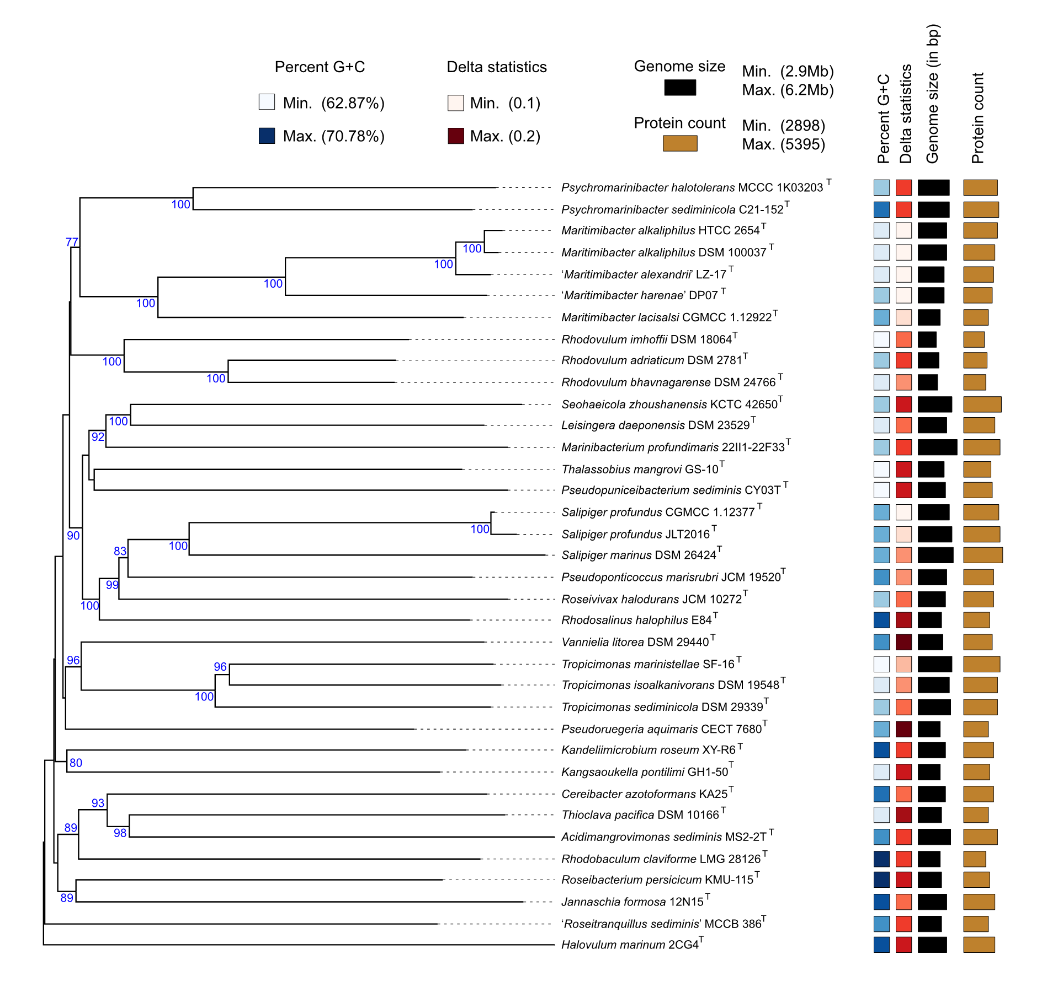

Supplementary Fig. S1. The phylogenetic tree based on proteomes. Overview of the phylogenomic tree inferred with FastME from GBDP distances calculated from whole proteomes. The numbers above branches are GBDP pseudo-bootstrap support values > 60 % from 100 replications.

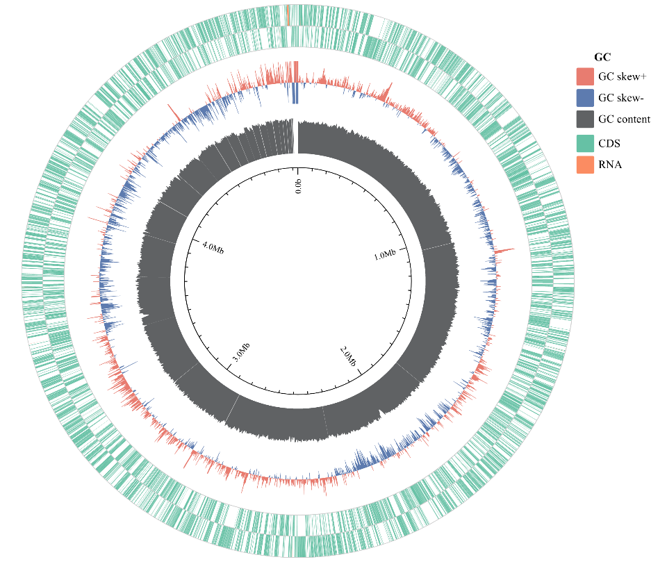
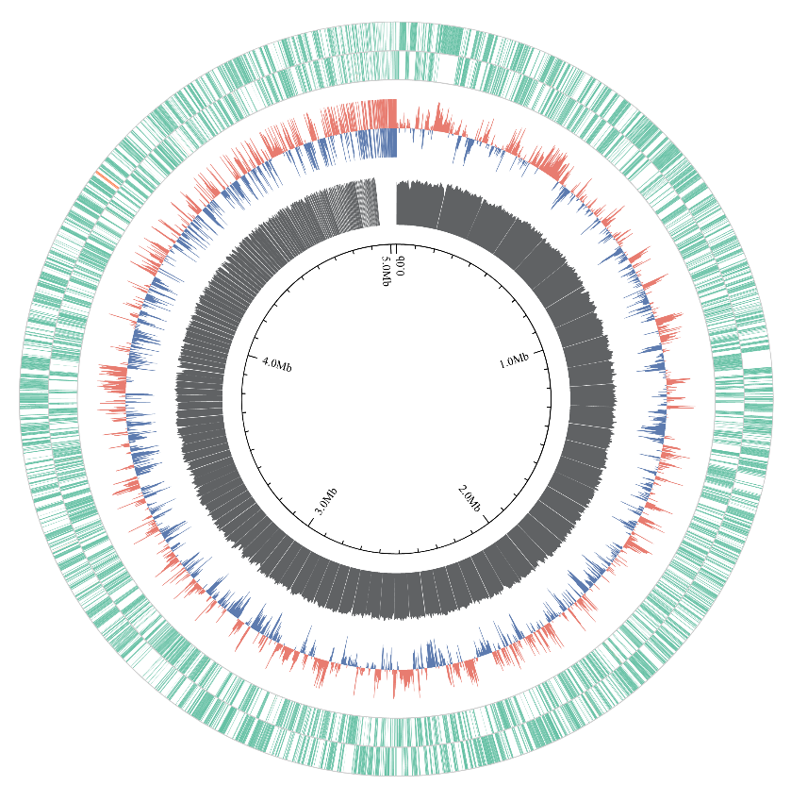
P. halotolerans MCCC 1K03203^{T}
Strain C21-152^{T}

Supplementary Fig. S2. The genome draft distribution of the two species sequenced in this study. GC content, GC skew, and genomic category of each fragment were included, with sampling points at 2,000 bp intervals.

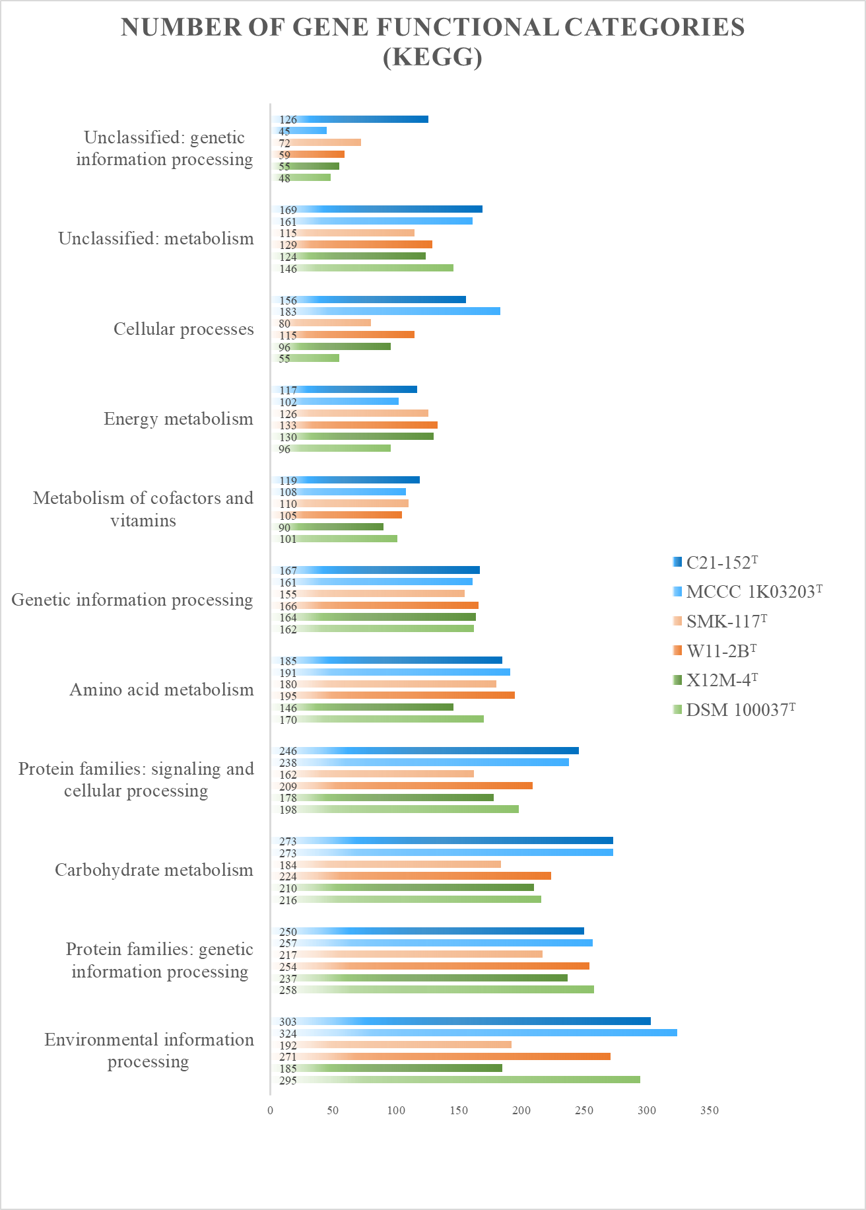

Supplementary Fig. S3. Numbers of gene functional categories of six strains, C21-152^{T}, P. halotolerans MCCC 1K03203^{T}, M. alkaliphilus DSM 100037^{T}, M. lacisalsi X12M-4^{T}, L. saemankumensis SMK-117^{T}, and L. pacificus W11-2B^{T}, performed by KEGG.

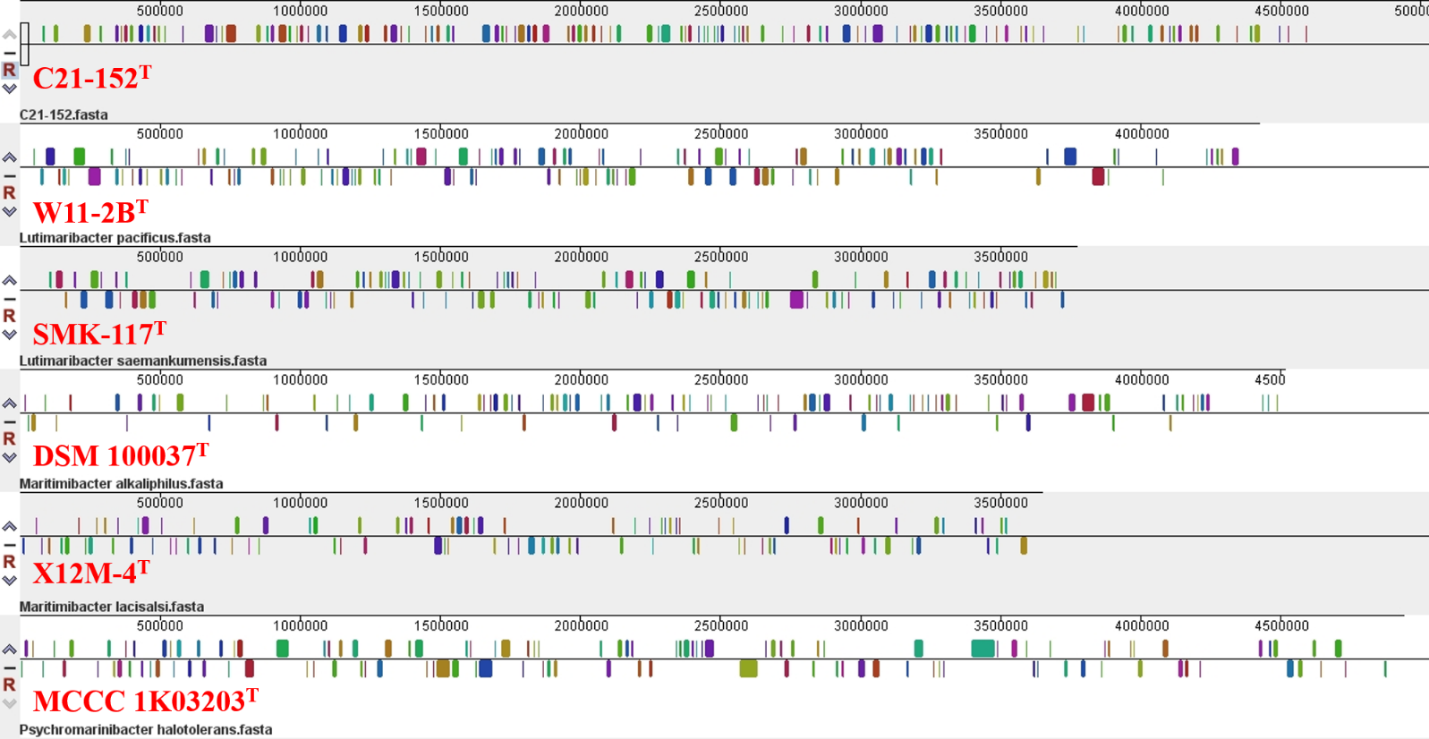
Supplementary Fig. S4. Mauve alignment of strain C21-152^{T} and the closely related species P. halotolerans MCCC 1K03203^{T}, M. alkaliphilus DSM 100037^{T}, M. lacisalsi X12M-4^{T}, L. saemankumensis SMK-117^{T}, and L. pacificus W11-2B^{T}, which shows matched colored regions.

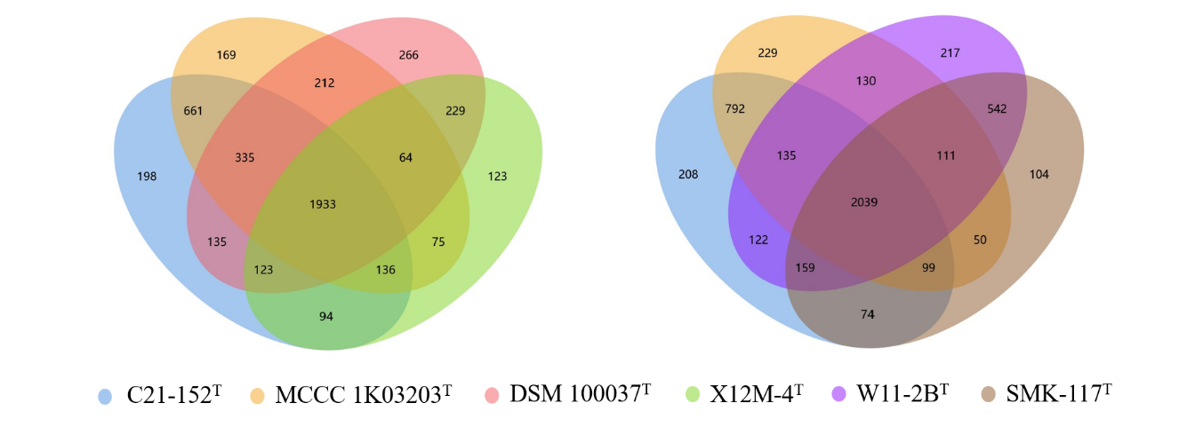

Supplementary Fig. S5. Core genes and specific genes statistics: venn plots comparing species of genus Psychromarinibacter with species of genus Maritimibacter and species of genus Lutimaribacter, respectively.

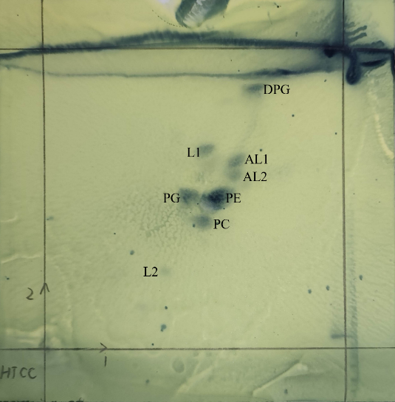
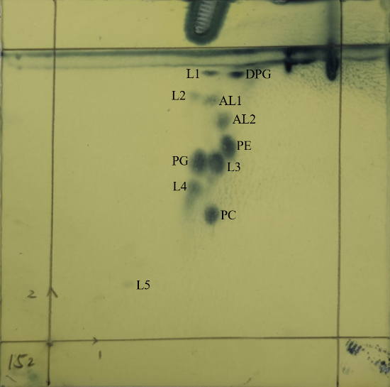

M. alkaliphilus DSM 100037^{T}
Strain C21-152^{T}
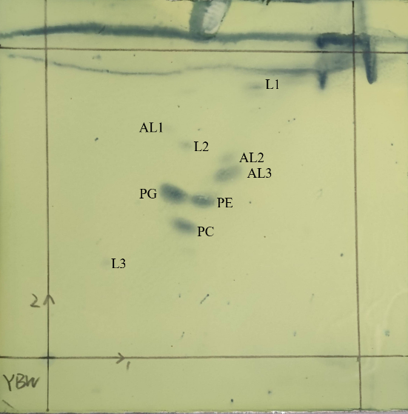

P. halotolerans MCCC 1K03203^{T}

Supplementary Fig. S6. Two-dimensional TLC of polar lipids of all strains. Spots were revealed by spraying the plate with 10 % ethanolic molybdophosphoric acid. PE, phosphatidylethanolamine; PG, phosphatidylglycerol; PC, phosphatidylcholine; DPG, diphosphatidylglycerol; L1-L4, lipid; AL1-AL3, aminolipid.

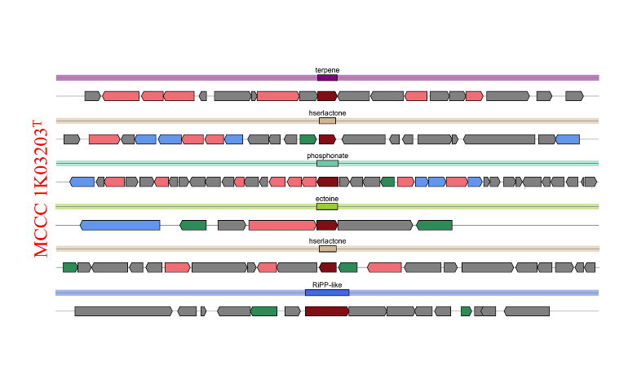
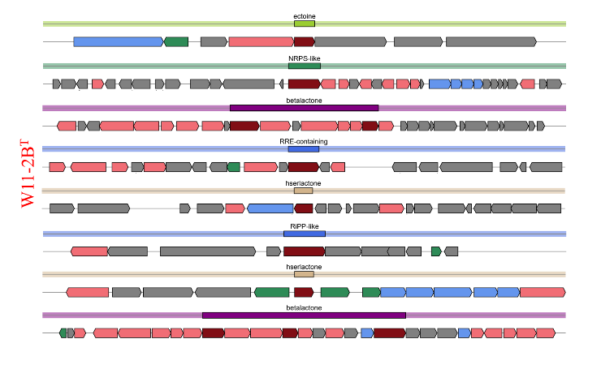
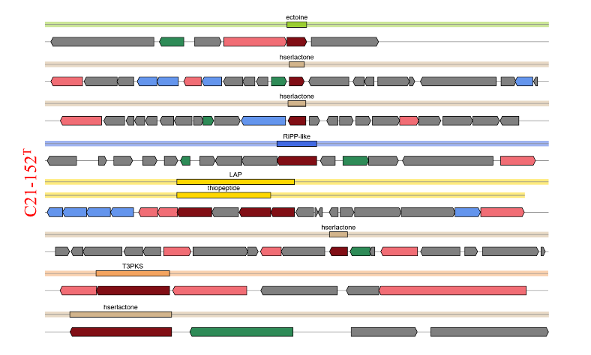
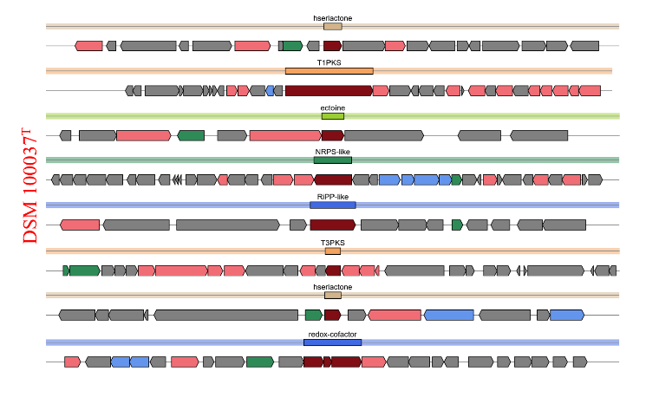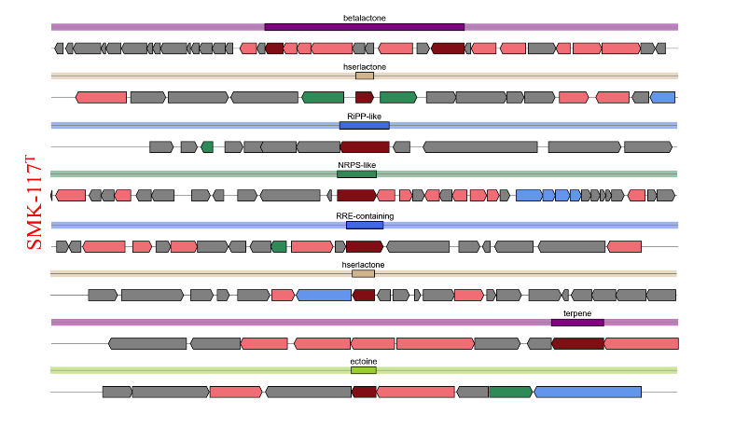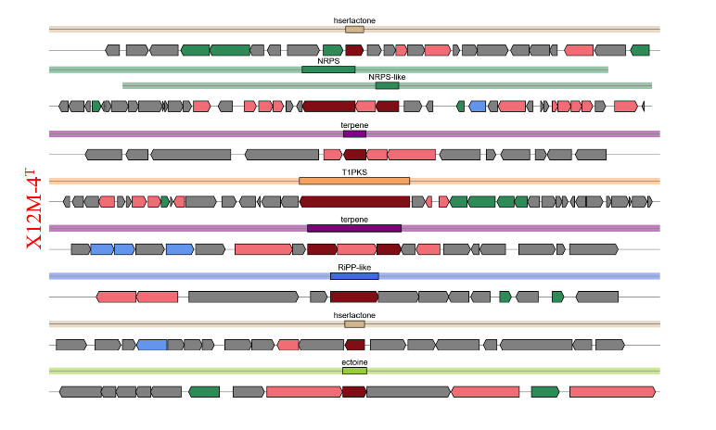

Supplementary Fig. S7. Organization of biosynthetic gene clusters (BGCs) of genome strain C21-152^{T}, P. halotolerans MCCC 1K03203^{T}, M. alkaliphilus DSM 100037^{T}, M. lacisalsi X12M-4^{T}, L. saemankumensis SMK-117^{T}, and L. pacificus W11-2B^{T}.

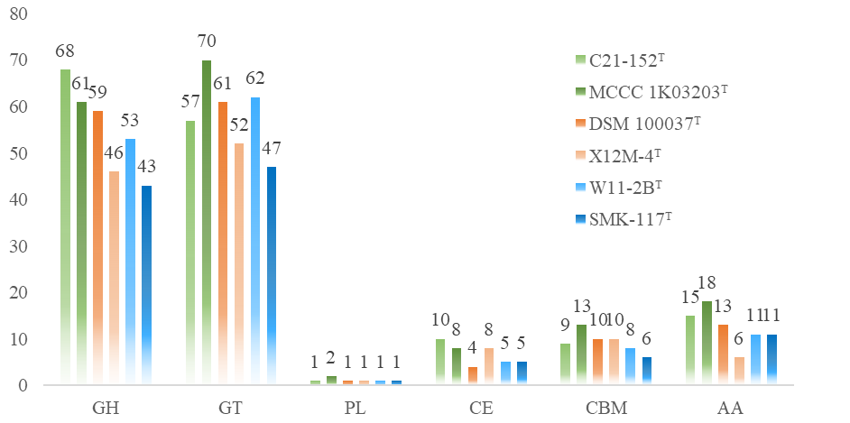

Supplementary Fig. S8. Histogram of predicted carbohydrate-active enzymes (CAZymes) in strain C21-152^{T}, P. halotolerans MCCC 1K03203^{T}, M. alkaliphilus DSM 100037^{T}, M. lacisalsi X12M-4^{T}, L. saemankumensis SMK-117^{T}, and L. pacificus W11-2B^{T}. Numbers of each enzyme detected in the genome were shown in the map.

A
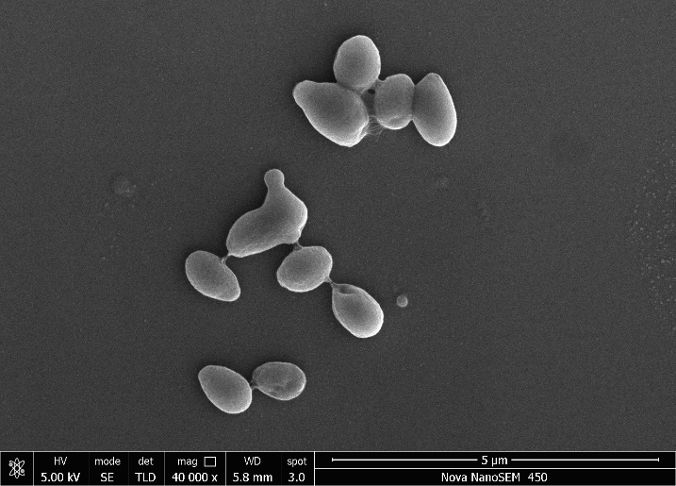
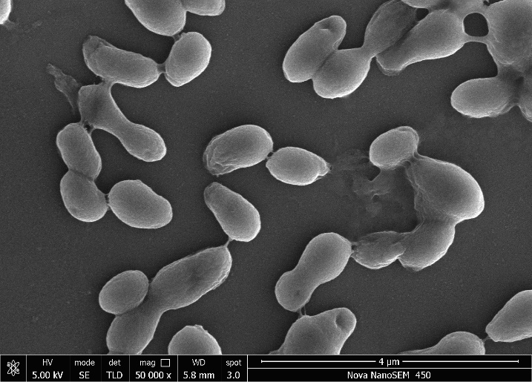
B
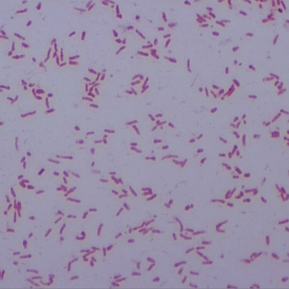
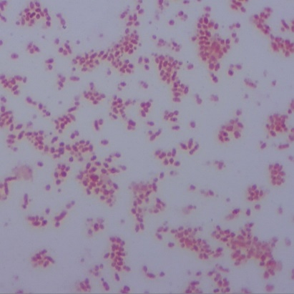
6%
4%

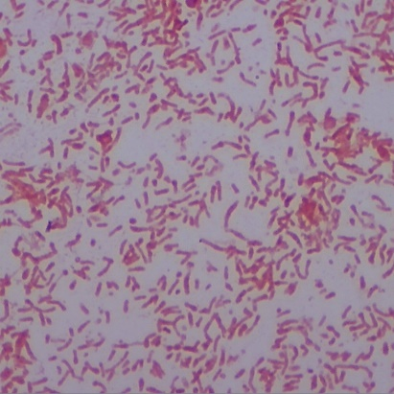
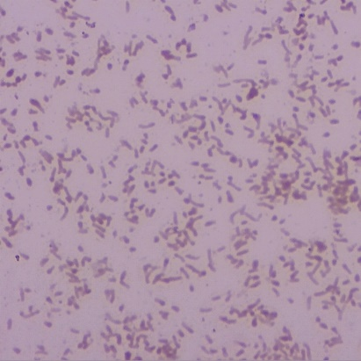
8%
10%

Supplementary Fig. S9. Transmission electron microscopy of cells of strain C21-152^{T}. Bars, 4 µm and 5 µm (A). Light microscopy of cells of strain C21-152^{T} at different salinities (w/v) (B). Stained with iodine solution at a magnification of 1000X. Cells were grown on modified MA at 37℃ for 72 h.

Supplementary Table S1. Complete list of phenotypic response to API ZYM, API 20E and API 50CH identification systems (bioMérieux) and Biolog GEN III MicroPlates.

Strain |  | 1 | 2 | 3
API ZYM
2 | alkaline phosphatase | + | + | +
3 | esterase (C4) | + | + | +
4 | esterase lipase (C8) | + | + | +
5 | lipase (C14) | - | - | -
6 | leucine arylamidase | + | + | +
7 | valine arylamidase | w | w | w
8 | cystine arylamidase | - | - | -
9 | trypsin | - | - | -
10 | α-chymotrypsin | - | - | -
11 | acid phosphatase | - | w | -
12 | naphthol-AS-Biphosphohydrolase | + | + | +
13 | α-galactosidase | - | - | -
14 | β-galactosidase | - | - | -
15 | β-glucuronidase | - | - | -
16 | α-glucosidase | - | + | -
17 | β-glucosidase | - | - | -
18 | N-acetyl-β-glucosaminidase | - | - | -
19 | α-mannosidase | - | - | -
20 | α-fucosidase | - | - | -
API 20E
ONPG | β-Galactosidase | - | - | -
ADH | Arginine dihydrolase | - | - | -
LDC | Lysine decarboxylase | - | - | -
ODC | Ornithine decarboxylation | - | - | -
CIT | Citrate utilization | + | + | +
H2S | H₂S production | - | - | -
URE | urease | + | + | -
TDA | Tryptophan deaminase | + | + | -
IND | Indole production | - | - | -
VP | Voges-Proskauer reaction | + | - | -
GEL | Gelatin | + | + | +
GLU | glucose | - | - | -
MAN | mannitol | - | - | -
INO | inositol | - | - | -
SOR | sorbitol | - | - | -
RHA | rhamnol | - | - | -
SAC | sucrose | - | - | -
MEL | melibiose | - | - | -
AMY | amygdalin | - | - | -
ARA | arabinose | - | - | -
API 50CH
1 | glycerol | - | - | w
2 | erythritol | - | - | w
3 | d-arabinose | - | - | -
4 | l-arabinose | - | - | -
5 | d-ribose | w | w | w
6 | d-xylose | - | - | -
7 | l-xylose | - | - | -
8 | d-adonitol | - | - | w
9 | methyl-β- D-xylopyranoside | - | - | -
10 | d-galactose | - | - | -
11 | d-glucose | + | - | -
12 | d-fructose | - | - | -
13 | d-mannose | - | - | -
14 | l-sorbose | w | - | w
15 | l-rhamnose | - | - | w
16 | dulcito | - | - | -
17 | inositol | - | - | w
18 | d-mannito | - | - | -
19 | d-sorbitol | - | - | -
20 | methyl-αd-mannopyranoside | - | - | -
21 | methyl-αd-glucopyranoside | - | - | -
22 | N-acetylglucosamine | - | - | -
23 | amygdaline | - | - | -
24 | arbulin | - | - | w
25 | esculin | + | + | +
26 | salicin | - | - | +
27 | d-cellobiose | - | - | +
28 | d-maltose | - | w | +
29 | d-lactose | - | w | -
30 | d-melibiose | - | - | -
31 | d-saccharose | - | + | +
32 | d-trehalose | - | - | +
33 | inulin | - | - | -
34 | d-melezitose | - | - | -
35 | d-raffinose | - | - | -
36 | starch | - | + | +
37 | glycogen | + | - | +
38 | xylitol | - | w | w
39 | gentiobiose | + | + | w
40 | d-turanose | w | + | -
41 | d-lyxose | w | - | -
42 | d-tagatose | + | w | w
43 | d-fucose | - | - | w
44 | l-fucose | - | - | w
45 | d-arabitol | - | - | w
46 | l-arabitol | - | - | w
47 | potassium gluconate | - | - | -
48 | potassium 2-ketogluconate | - | - | -
49 | potassium 5-ketogluconate | + | w | w
API Biolog GEN III MicroPlate
1A | negative-control | - | - | -
2A | dextrin | + | + | w
3A | d-maltose | w | - | -
4A | d-trehalose | + | + | -
5A | d-cellobiose | + | + | -
6A | gentiobioswe | w | - | w
7A | sucrose | - | + | -
8A | d-turanose | + | - | w
9A | stachyose | - | + | -
10A | positive control | + | + | +
11A | pH 6 | + | - | +
12A | pH 5 | + | - | +
1B | d-raffinose | - | + | -
2B | d-lactose | - | - | -
3B | d-melibiose | - | + | -
4B | β-methyl-d-glucoside | - | w | -
5B | d-salicin | - | w | -
6B | N-acetyl-d-glucosamine | - | + | -
7B | N-acetyl-β-d-mannosamine | - | + | -
8B | N-acetyl-d-galactosamine | - | - | -
9B | N-acetyl neuraminic acid | - | + | -
10B | 1% NaCl | + | + | +
11B | 4% NaCl | + | + | +
12B | 8% NaCl | + | - | +
1C | α-d-glucose | w | w | -
2C | d-mannose | - | - | -
3C | d-fructose | w | + | -
4C | d-galactose | - | - | -
5C | 3-methyl glucose | - | - | -
6C | d-fucose | w | - | -
7C | l-fucose | w | - | -
8C | l-rhamnose | w | w | -
9C | inosine | - | - | -
10C | 1% sodium lactate | + | - | w
11C | fusidic acid | + | - | +
12C | d-serine | + | - | +
1D | d-sorbitol | - | - | -
2D | d-mannitol | - | - | -
3D | d-arabitol | - | - | -
4D | myo-inositol | - | w | -
5D | glycerol | - | - | -
6D | d-glucose-6-PO₄ | - | - | -
7D | d-fructose-6-PO₄ | w | - | w
8D | d-aspartic acid | - | - | -
9D | d-serine | - | - | -
10D | troleandomycin | + | - | +
11D | rifamycin SV | + | - | +
12D | minocycline | + | - | +
1E | gelatin | - | - | -
2E | glycyl- l-proline | - | - | -
3E | l-alanine | - | - | -
4E | l-arginine | - | - | -
5E | l-aspartic acid | - | - | -
6E | l-glutamic acid | - | w | -
7E | l-histidine | - | - | -
8E | l-pyroglutamic acid | - | + | -
9E | l-serine | - | - | -
10E | lincomycin | + | - | +
11E | guanidine HCl | + | - | +
12E | niaproof 4 | + | - | +
1F | pectin | - | + | -
2F | d-galacturonic acid | w | + | w
3F | l-galactonic acid lactone | w | - | w
4F | d-gluconic acid | - | - | -
5F | d-glucuronic acid | + | - | +
6F | glucuronamide | + | w | +
7F | mucic acid | - | - | -
8F | quinic acid | - | w | -
9F | d-saccharic acid | - | - | -
10F | vancomycin | + | - | +
11F | tetrazolium violet | - | w | -
12F | tetrazolium blue | - | - | -
1G | ρ-hydroxy-phenylacectic acid | - | - | -
2G | methyl pyruvate | - | - | -
3G | d-lactic acid methyl ester | - | + | -
4G | l-lactic acid | - | + | -
5G | citric acid | - | - | -
6G | α-keto-glutaric acid | w | - | -
7G | d-malic acid | - | - | -
8G | l-malic acid | - | - | -
9G | bromo-succinic acid | - | - | -
10G | nalidixic acid | + | - | +
11G | lithium chloride | + | - | +
12G | potassium tellurite | + | + | +
1H | tween-40 | - | - | +
2H | γ-amino-butyric acid | - | - | -
3H | α-hydroxy-butyric acid | - | + | -
4H | β-hydroxy-d, l-butyric acid | w | + | -
5H | α-keto-butyric acid | - | - | -
6H | acetoacetic acid | w | w | w
7H | propionic acid | - | - | -
8H | acetic acid | w | + | -
9H | formic acid | - | - | -
10H | aztreonam | + | + | +
11H | sodium butyrate | + | - | +
12H | sodium bromate | + | - | +

Strain: 1, C21-152^{T}; 2, P. halotolerans MCCC 1K03203^{T}; 3, M. alkaliphilus DSM 100037^{T}. All data were obtained in this study. +, positive; w, weak positive; -, negative.

Supplementary Table S2. Number of genes associated with general eggNOG functional categories in the genome of strain C21-152^{T}.

Code | Count | Description
A | 0 | RNA processing and modification
C | 206 | Energy production and conversion
D | 29 | Cell cycle control, cell division, chromosome partitioning
E | 324 | Amino acid transport and metabolism
F | 58 | Nucleotide transport and metabolism
G | 197 | Carbohydrate transport and metabolism
H | 118 | Coenzyme transport and metabolism
I | 149 | Lipid transport and metabolism
J | 119 | Translation, ribosomal structure and biogenesis
K | 193 | Transcription
L | 108 | Replication, recombination and repair
M | 141 | Cell wall/membrane/envelope biogenesis
N | 14 | Cell motility
O | 95 | Posttranslational modification, protein turnover, chaperones
P | 192 | Inorganic ion transport and metabolism
Q | 115 | Secondary metabolites biosynthesis, transport and catabolism
S | 556 | Function unknown
T | 81 | Signal transduction mechanisms
U | 65 | Intracellular trafficking, secretion, and vesicular transport
V | 21 | Defense mechanisms

Supplementary Table S3. Functions of some genes related to salt tolerance.

Gene | Function
mnhA | multicomponent Na+:H+antiporter subunit A
mnhB | multicomponent Na+:H+antiporter subunit B
mnhC | multicomponent Na+:H+antiporter subunit C
mnhE | multicomponent Na+:H+antiporter subunit E
mnhF | multicomponent Na+:H+antiporter subunit F
mnhG | multicomponent Na+:H+antiporter subunit G
trkA | trkA type sodium hydrogen exchanger
trkH | trkH type K uptake
betA | choline dehydrogenase
betB | NAD/NADP-dependent betaine aldehyde dehydrogenase
proB | glutamate 5-kinase
proA | gamma-glutamyl phosphate reductase
proC | pyrroline-5-carboxylate reductase
proV | glycine betaine/proline transport system ATP binding protein
proW | glycine betaine/proline betaine transport system permease protein
proX | glycine betaine/proline betaine binding periplasmic protein
SDMT | sarcosine/dimethylglycine N-methyltransferase
glpV | glycerol transport system substrate binding protein
glpP | glycerol-3-phosphate responsive antiterminator
glpQ | glycerophosphoryl diester phosphodiesterase
glpS | glycerol transport system ATP binding protein
glpT | glycerol-3-phosphate transporter
ugpA | sn-glycerol-3-phosphate ABC transporter
ugpC | sn-glycerol-3-phosphate import ATP binding protein
ugpE | sn-glycerol 3-phosphate transport system permease protein
ostA | trehalose-6-phosphate synthase
ostB | trehalose-6-phosphate phosphatase
malK | trehalose/maltose import ATP binding protein

