Appendices
Table S1: Inclusion and Exclusion criteria
Inclusion and Exclusion criteria：
Inclusion criteria：
a) The population who have been detected serum selenium content, thyroid peroxidase antibody (TPO-Ab), thyrotropin (TSH), thyroxine (T₄) and triiodothyronine (T₃) at baseline survey.
b) Population with complete information on covariates such as educational level, marriage, occupation, smoking status, alcohol consumption, eating habits and so on.
c) Those who have self-reported or diagnosed with thyroid-related disease or been in the subclinical stage at baseline.
d)Those who participate in the follow-up survey voluntarily and have signed the informed consent.
e)The participants who can cooperate in completing the questionnaire, physical and blood examinations.
f) Those who have not moved out of the local area in the past 6 years or out for less than 1 year.
Exclusion criteria:
a) Patients with autoimmune diseases (such as Systemic Lupus Erythematosus, type 1 diabetes, etc.), women with abnormal thyroid function during pregnancy, those with renal insufficiency, liver insufficiency, severe systemic diseases or chronic wasting diseases.
b)Those who have taken I-containing drugs or contrast agents within the past 6 months;
c)Women under the age of 18 or pregnant.
The research protocol was approved by the Medical Ethics Committee of Xi’an Jiaotong University. The ethical approval file number was 2019-874. All participants provided written informed consent before participating in the study.
Table S2: Comparison of the change of thyroid function in different investigating time by county
County | Index |  | Baseline |  | Follow-up |  | Δ% | Z | P
County |  |  | N | % | N | % | Δ% | Z | P
Se-adequate | TPO-Ab | Normal | 371 | 67.6 | 401 | 73.2 | 5.5 | -3.444 | 0.001
Se-adequate | TPO-Ab | High | 178 | 32.4 | 147 | 26.8
Se-adequate | TSH | Low | 28 | 5.1 | 12 | 2.2 |  | -3.800 | <0.001
Se-adequate | TSH | Normal | 347 | 63.2 | 330 | 60.2 | -3.2
Se-adequate | TSH | High | 174 | 31.7 | 206 | 37.6
Se-adequate | T₃ | Low | 116 | 21.1 | 25 | 4.6 |  | -8.223 | <0.001
Se-adequate | T₃ | Normal | 419 | 76.3 | 494 | 90.1 | 13.8
Se-adequate | T₃ | High | 14 | 2.6 | 29 | 5.3
Se-adequate | T₄ | Low | 40 | 7.3 | 14 | 2.6 |  | -2.650 | 0.008
Se-adequate | T₄ | Normal | 479 | 87.2 | 506 | 92.3 | 5.1
Se-adequate | T₄ | High | 30 | 5.5 | 28 | 5.1
Se-deficient | TPO-Ab | Normal | 440 | 68.6 | 479 | 75.3 | 6.7 | -3.697 | <0.001
Se-deficient | TPO-Ab | High | 201 | 31.4 | 157 | 24.7
Se-deficient | TSH | Low | 13 | 2.0 | 9 | 1.4 |  | -7.019 | <0.001
Se-deficient | TSH | Normal | 232 | 36.2 | 365 | 57.3 | 21.1
Se-deficient | TSH | High | 396 | 61.8 | 263 | 41.3
Se-deficient | T₃ | Low | 115 | 17.9 | 48 | 7.5 |  | -3.660 | <0.001
Se-deficient | T₃ | Normal | 487 | 76.0 | 574 | 90.1 | 14.1
Se-deficient | T₃ | High | 39 | 6.1 | 15 | 2.4
Se-deficient | T₄ | Low | 55 | 8.6 | 12 | 1.9 |  | -3.093 | 0.002
Se-deficient | T₄ | Normal | 538 | 83.9 | 582 | 91.4 | 7.5
Se-deficient | T₄ | High | 48 | 7.5 | 43 | 6.8

Table S3: Diagnostic criteria for thyroid diseases
Thyroid condition | Diagnostic Criteria
Subclinical hypothyroidism | TSH > 5.0μIU/mL and 13.5μg/dL ≥ T₄ ≥ 4.2μg/dL
Overt hypothyroidism | TSH > 5.0μIU/mL and T₄ < 4.2μg/dL, or history of overt hypothyroidism
Subclinical hyperthyroidism | TSH < 0.25μIU/mL, 13.5μg/dL ≥ T₄ ≥ 4.2μg/dL
Hashimoto thyroiditis (HT) | 1. TPOAb positive.  2. Normal thyroid function, clinical or subclinical hypothyroidism.  3. Diffuse enlargement of the thyroid gland by ultrasound.  4. Echogenicity within the thyroid gland by ultrasound.
Graves’ disease (GD) | 1. Obvious signs and symptoms of hyperthyroidism.  2. Diffuse enlargement of the thyroid gland detected by ultrasound or palpation.  3. Decreased TSH and elevated T4.  4. Ocular proptosis and other infiltrative eye signs.  5. Anterior tibial fluid edema.  6. TPOAb positive, or TRAbª > 2IU/L.  (1-3 are diagnostic prerequisites, 4~6 are auxiliary conditions.)
Single TPO-Ab positive | Only TPOAb positive.
ª TRAb: thyrotropin (TSH) receptor antibodies.

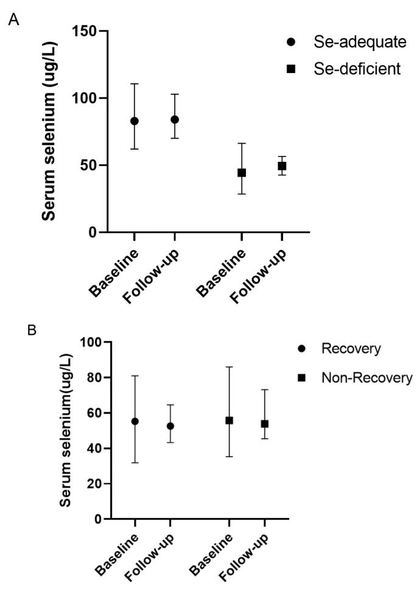
Figure S1: Alterations in serum Se during the six years observation period in the two areas with different Se status or recovery status. A) Change of serum selenium in whole subjects (Se-adequate: Z=-1.512, P=0.131; Se-deficient: Z=-1.636, P=0.102). B) Change of serum Se in (sub-)clinical hypothyroidism (Recovery: Z=-0.748, P=0.455; Non-Recovery: Z=-1.025, P=0.305).

