Novel Thiadiazoline Spiro Quinoline Analogues Induced Cell death in MCF-7 cells via
G2/M Phase Cell Cycle Arrest
Selvaraj Shyamsivappan^{a,}*, Raju Vivek^{b}, Thangaraj Sureshª, Adhigaman Kaviyarasuª, Sundarasamy Amsaveniª, Shunmuganarayanan Athimoolam^{c}, Palathurai Subramaniam Mohan^{a,}*
ªSchool of Chemical Sciences, Bharathiar University, Coimbatore, Tamil Nadu, India.
^{b}Cancer Research Program (CRP), Bio-Nano Therapeutics Research Laboratory, School of Life Sciences, Department of Zoology, Bharathiar University, Coimbatore, Tamil Nadu, India.
^{c}Department of Physics, Anna University, Nagercoil, Tamil Nadu, India

Crystal Data
Table S1. Crystallographic details of the compound 4a, 4c, and 4d
 | 4a | 4c | 4d
Empirical formula | C₁₄H₁₅N₅O₄S | C₁₆H₁₉N₅O₄S | C₂₀H₁₉N₅O₄S
Formula weight | 349.37 | 377.42 | 425.46
Temperature | 293(2) K | 293 (2) K | 293 (2) K
Wavelength | 0.71073 Å | 0.71073 Å | 0.71073 Å
Crystal system | Tetragonal | Monoclinic | Triclinic
Space group | I 41/a | C 2/c | P -1
Unit cell dimensions | a = 18.03(3) Å | a = 26.46(4) Å; α = 90°. | a = 8.80(2) Å α= 65.16(5)°.
 | b = 18.028 Å | b = 6.552(10) Å; β = 94.62(2)°. | b = 11.28(3) Å β= 87.05(7)°.
 | c = 20.39(4) Å | c = 20.28(3) Å; γ = 90°. | c = 11.33(3) Å γ = 84.17(7)°.
Volume | 6627(26) Å³ | 3504(9) Å³ | 1015(5) Å³
Z | 16 | 8 | 2
Density (calculated) | 1.401 Mg/m³ | 1.431 Mg/m³ | 1.392 Mg/m³
Absorption coefficient | 0.225 mm⁻¹ | 0.218 mm⁻¹ | 0.197 mm⁻¹
F(000) | 2912 | 1584 | 444
Theta range for data collection | 2.259 to 24.998° | 2.439 to 25.000° | 2.147 to 24.999°
Index ranges | -21≤ h ≤ 20, -21≤ k ≤ 18, -24≤ l≤24 | -31 ≤ h ≤ 31, -7 ≤ k ≤ 7, -24 ≤ l ≤ 24 | -10 ≤ h ≤ 10, -13 ≤ k ≤ 13, -13 ≤ l ≤ 13
Reflection collected | 28469 | 14309 | 19566
Independent reflections | 2922 [R(int) = 0.0503] | 3080 [R(int) = 0.0550] | 3591 [R(int) = 0.0811]
Completeness to theta=25.242° | 97.20 % | 97.00 % | 97.50 %
Refinement method | Full-matrix least-squares on F² | Full-matrix least-squares on F² | Full-matrix least-squares on F²
Data/ restraints/ parameters | 2922/ 0/ 219 | 3080/ 4/ 257 | 3591/ 0/ 277
Goodness of fit on F2 | 1.078 | 1.035 | 1.11
Final R indices [1.2sigma (I)] | R1 = 0.0440, wR2 = 0.1151 | R1=0.0529, wR2 = 0.1307 | R1 = 0.0643, wR2 = 0.1540
R indices (all data) | R1= 0.0539, wR2= 0.1224 | R1= 0.0821, wR2= 0.1463 | R1= 0.0996, wR2= 0.1712
Extinction coefficient | n/a | n/a | n/a
Largest diff. peak and hole | 0.409 and -0.368 e.Å⁻³ | 0.337 and 0.611 e.Å⁻³ | 0.796 and -0.302 e.Å⁻³
CCDC No. | 19800335 | 1946891 | 1980306

Table S2. Crystallographic details of the compound 4f and 4i
 | 4f | 4i
Empirical formula | C₁₆H₁₉N₅O₄S | C₁₄H₂₄ClN₅O₄S
Formula weight | 377.42 | 1531.21
Temperature | 293(2) K | 292 (2) K
Wavelength | 0.71073 Å | 0.71073 Å
Crystal system | Monoclinic | Triclinic
Space group | C2/c | P-1
Unit cell dimensions | a = 26.56(4) Å | a = 12.294(7) Å= 104.620(9)°.
 | b= 7.133(12) Å = 95.72(2)°. | b = 16.369 (7) Å= 105.192(12)°.
 | c= 19.18(3) Å | c = 18.699(10) Å = 100.914(9)°.
Volume | 3615(10)Å³ | 3380(3)Å³
Z | 8 | 8
Density (calculated) | 1.387 Mg/m³ | 1.505 Mg/m³
Absorption coefficient | 0.212 mm⁻¹ | 0.380 mm⁻¹
F(000) | 1584 | 1576
Theta range for data collection | 2.505 to 24.997°. | 2.171 to 25.000°.
Index ranges | -31 ≤ h ≤ 31, -8 ≤ k≤ 8, -22 ≤ l≤ 22 | -14 ≤ h ≤ 14, -19 ≤ k ≤ 18, -22 ≤ l ≤ 22
Reflection collected | 16162 | 65269
Independent reflections | 3190 [R(int) = 0.0823] | 11902 [R(int) = 0.0644]
Completeness to theta=25.242° | 97.10% | 97.20%
Refinement method | Full-matrix least-squares on F² | Full-matrix least-squares on F²
Data/ restraints/ parameters | 3190 / 0 / 239 | 11902 / 0 / 909
Goodness of fit on F2 | 1.042 | 1.037
Final R indices [1.2sigma (I)] | R1 = 0.0581, wR2 = 0.1298 | R1 = 0.0552, wR2 = 0.1387
R indices (all data) | R1 = 0.1023, wR2 = 0.1482 | R1 = 0.0831, wR2 = 0.1550
Extinction coefficient | n/a | n/a
Largest diff. peak and hole | 0.334 and -0.254 e.Å-³ | 1.112 and -0.402 e.Å⁻³
CCDC No. | 1980370 | 1980267

Table S3. Crystallographic details of the compound 4h and 4k
 | 4h | 4k
Empirical formula | C₂₁H₂₁N₅O₄S | C₁₆H₁₈ClN₅O₄S
Formula weight | 439.49 | 410.85
Temperature | 293(2) K | 293(2) K
Wavelength | 0.71073 Å | 0.71073 Å
Crystal system | Monoclinic | Monoclinic
Space group | P 21/n | C 2/c
Unit cell dimensions | a = 9.726(17) Å | a = 26.56(3) Å
 | b = 11.07(2) Å;  = 99.75(3)° | b = 6.708(6) Å  = 93.285(17)°.
 | c = 20.74(3) Å | c = 20.85(2) Å
Volume | 2200(7) Å³ | 3709(6) Å³
Z | 4 | 8
Density (calculated) | 1.327 Mg/m³ | 1.472 Mg/m³
Absorption coefficient | 0.184 mm⁻¹ | 0.352 mm⁻¹
F(000) | 920 | 1704
Theta range for data collection | 2.092 to 24.999°. | 2.418 to 25.000°.
Index ranges | -10 ≤ h ≤ 11, -13 ≤ k ≤ 13, -24 ≤ l ≤ 24 | -31 ≤ h ≤ 31, -7 ≤ k ≤ 7, -24 ≤ l ≤ 21
Reflection collected | 16122 | 12115
Independent reflections | 3880 [R(int) = 0.0357] | 3255 [R(int) = 0.0412]
Completeness to theta=25.242° | 97.40% | 97.10%
Refinement method | Full-matrix least-squares on F2 | Full-matrix least-squares on F2
Data/ restraints/ parameters | 3880 / 0 / 283 | 3255 / 0 / 250
Goodness of fit on F2 | 1.067 | 1.055
Final R indices [1.2sigma (I)] | R₁ = 0.0436, wR₂ = 0.1073 | R₁ = 0.0578, wR₂ = 0.1422
R indices (all data) | R₁ = 0.0559, wR₂ = 0.1136 | R₁ = 0.0791, wR₂ = 0.1553
Extinction coefficient | n/a | n/a
Largest diff. peak and hole | 0.254 and -0.175 e.Å⁻³ | 0.588 and -0.471 e.Å⁻³
CCDC No. | 1980270 | 1980268

Spectral Data
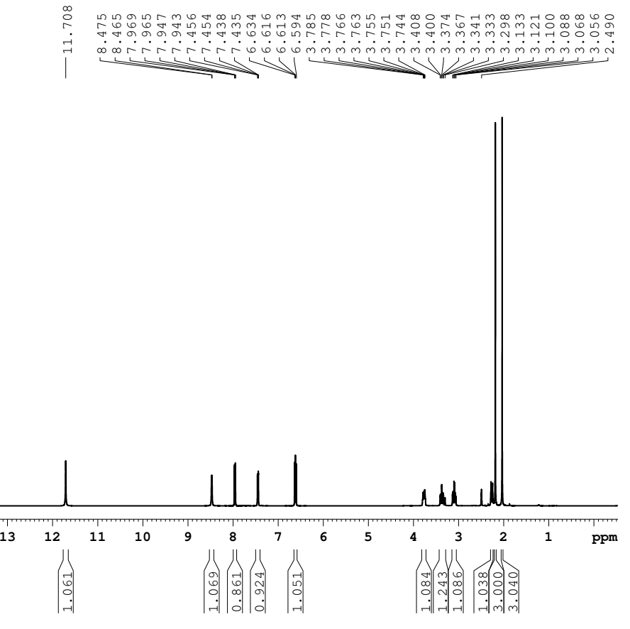
Figure S1. ¹H NMR spectrum of compound 4a
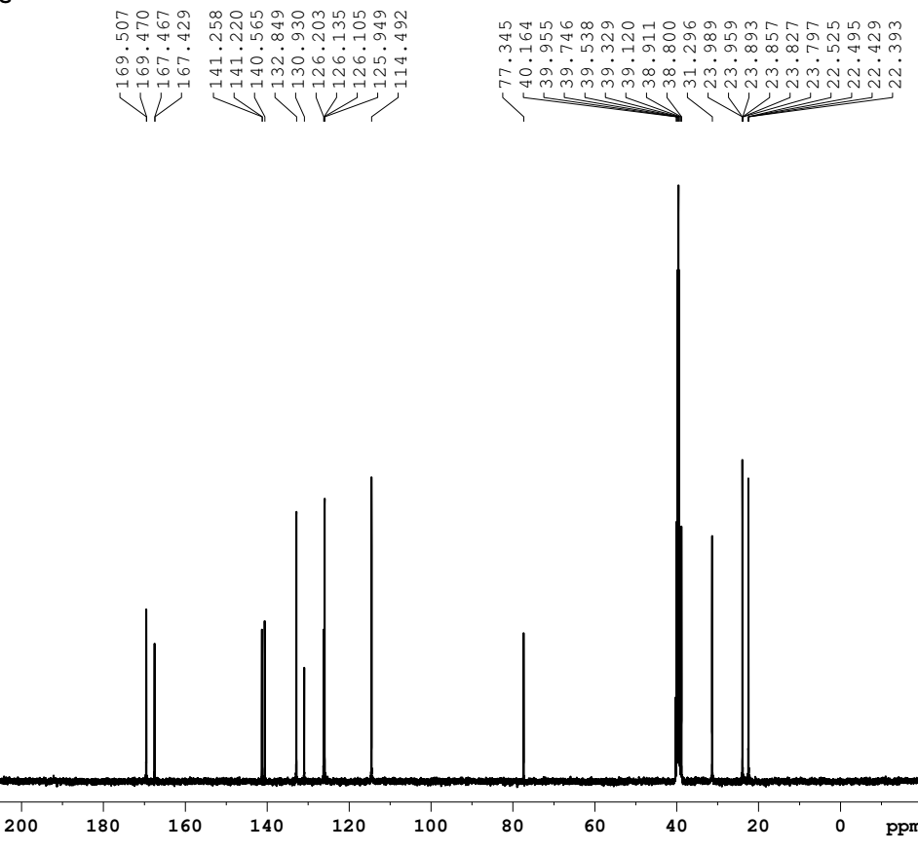
Figure S2. ¹³C spectrum of compound 4a
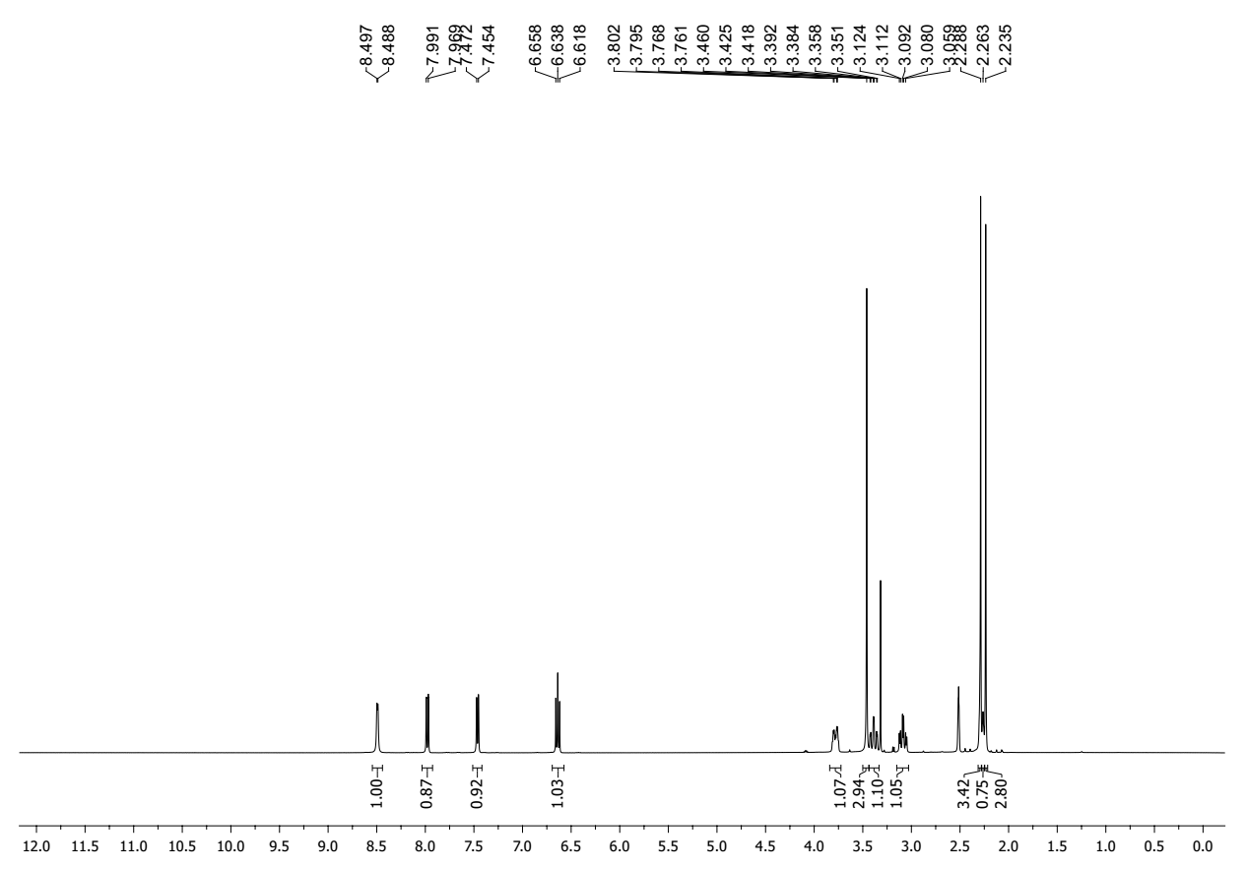
Figure S3. ¹H NMR spectrum of compound 4b
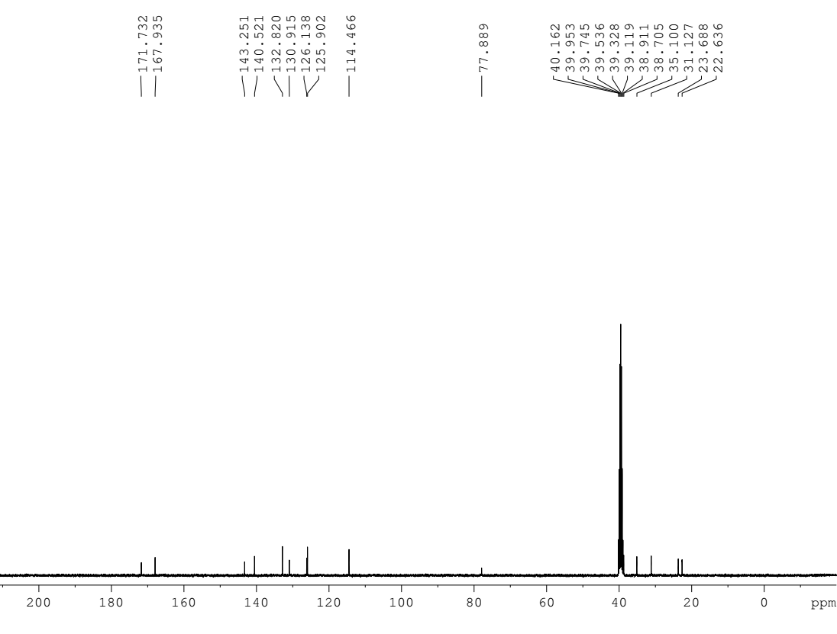
Figure S4. ¹³C spectrum of compound 4b
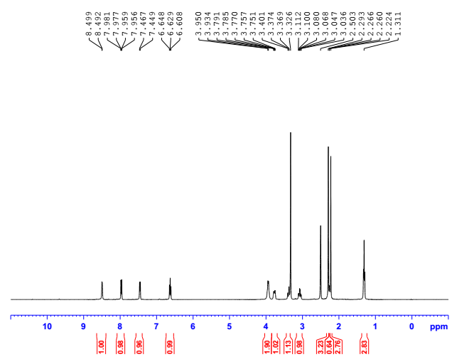
Figure S5. ¹H NMR spectrum of compound 4c
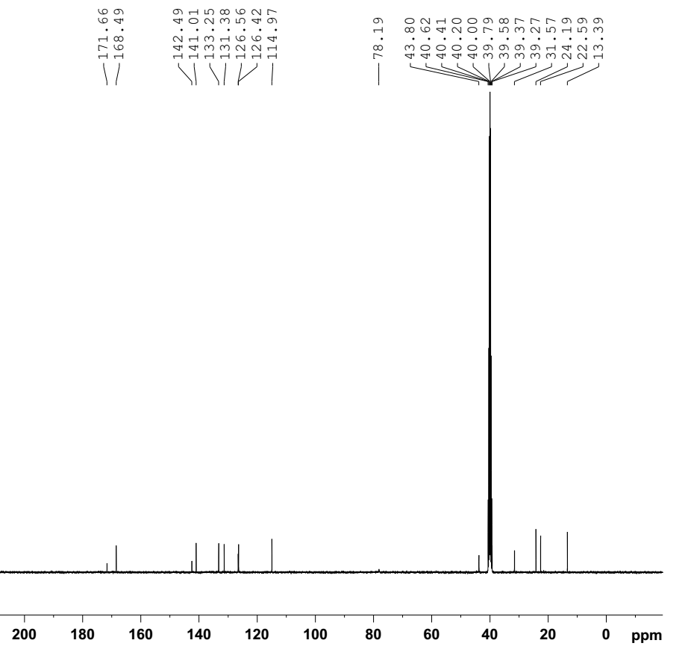
Figure S6. ¹³C NMR spectrum of compound 4c
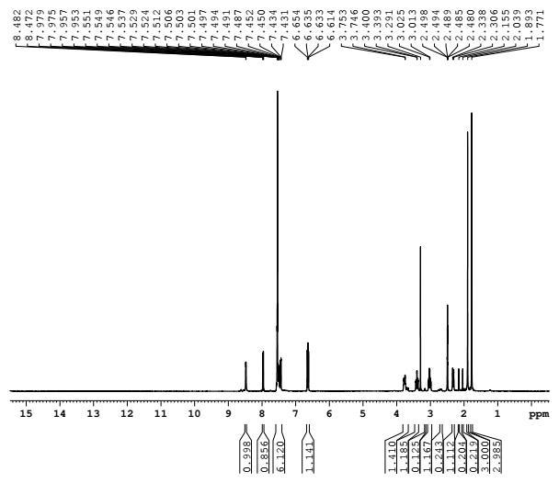
Figure S7. ¹H NMR spectrum of compound 4d
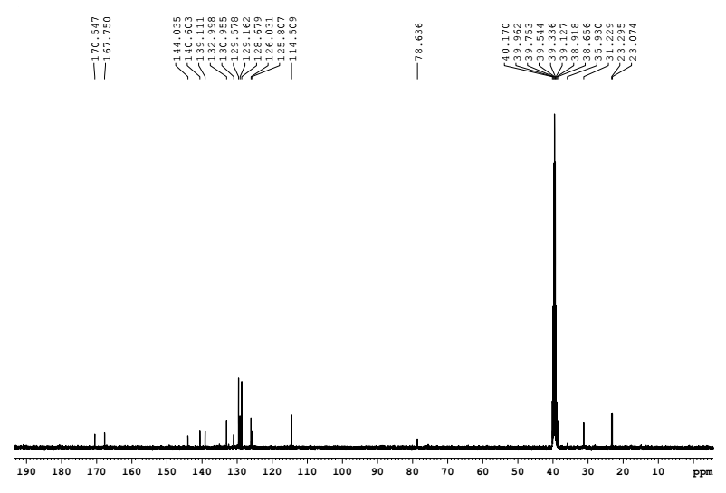
Figure S8. ¹³C NMR spectrum of compound 4d
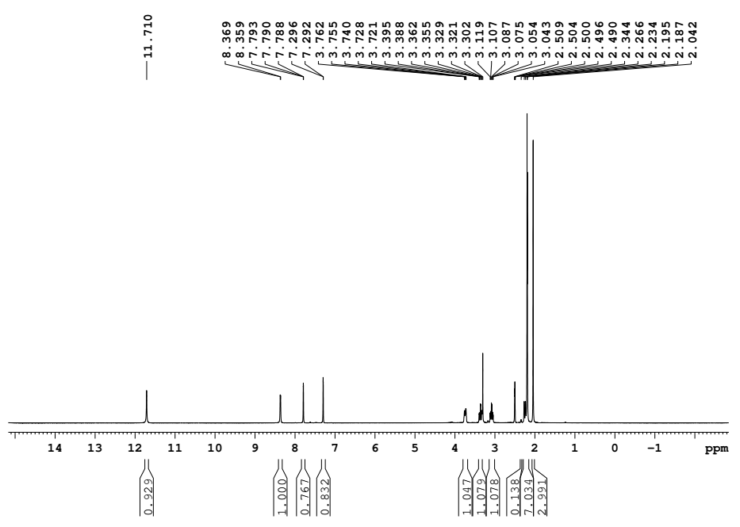
Figure S9. ¹H NMR spectrum of compound 4e
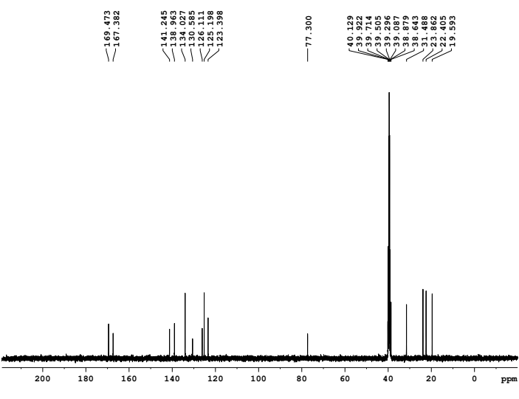
Figure S10. ¹³C NMR spectrum of compound 4e
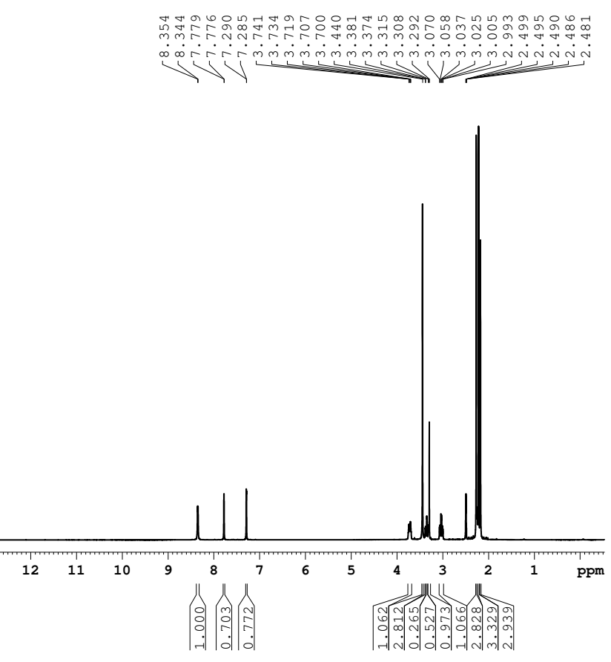
Figure S11. ¹H NMR spectrum of compound 4f
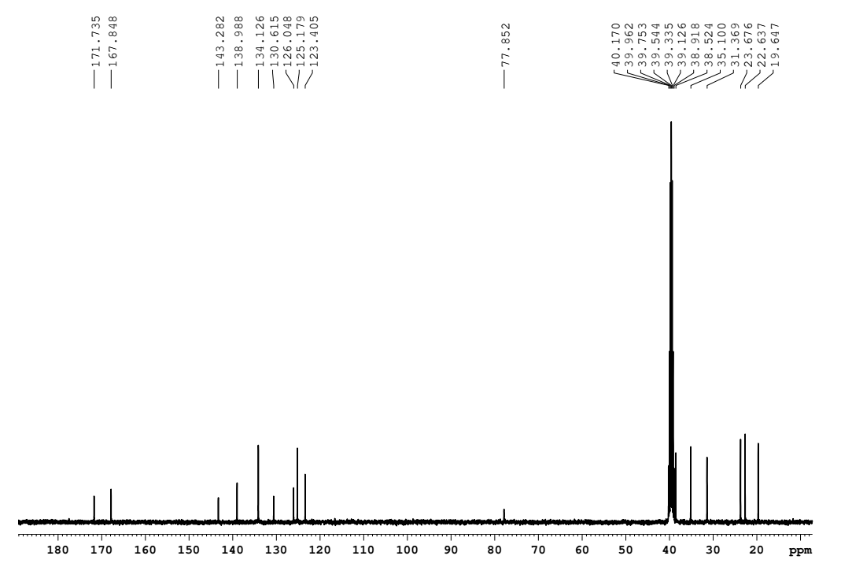
Figure S11. ¹³C NMR spectrum of compound 4f
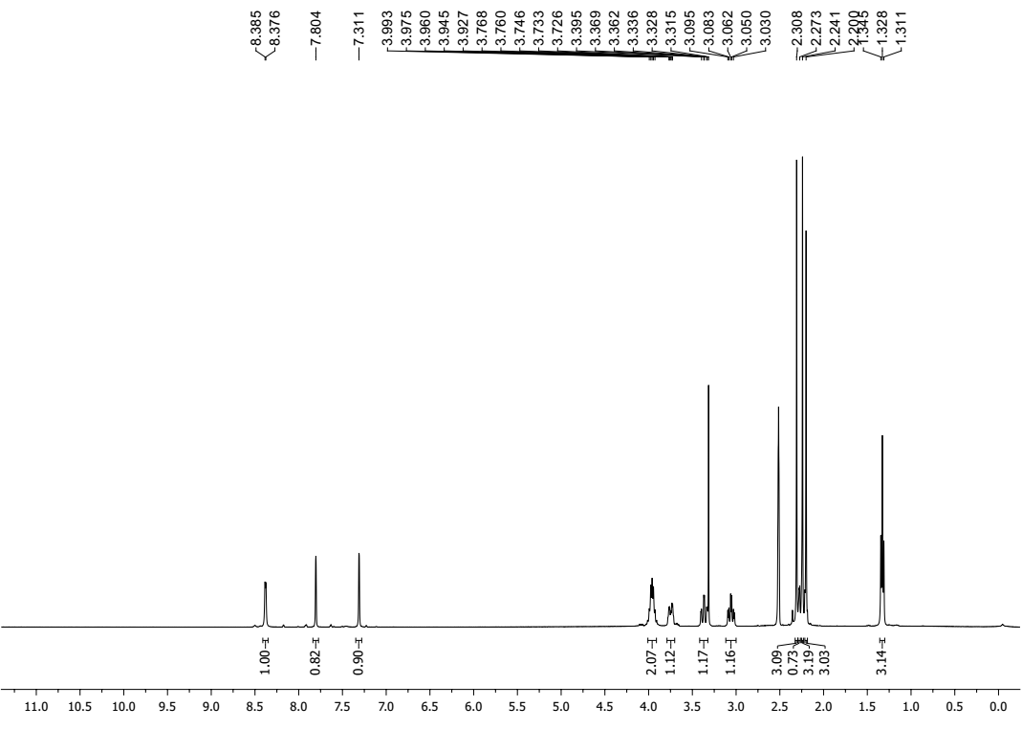
Figure S13. ¹H NMR spectrum of compound 4g
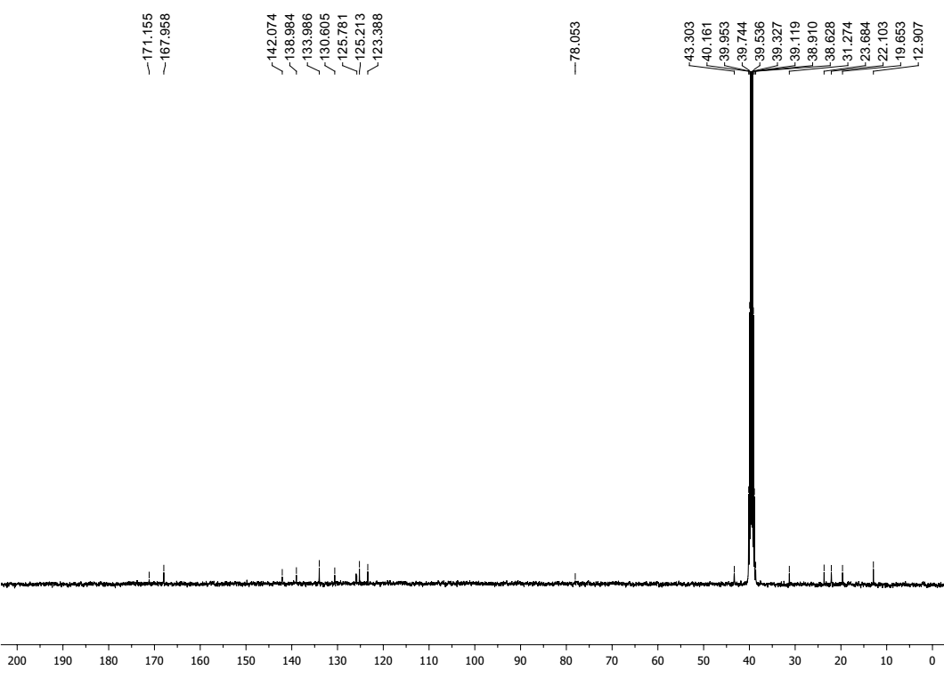
Figure S14. ¹³C NMR spectrum of compound 4g
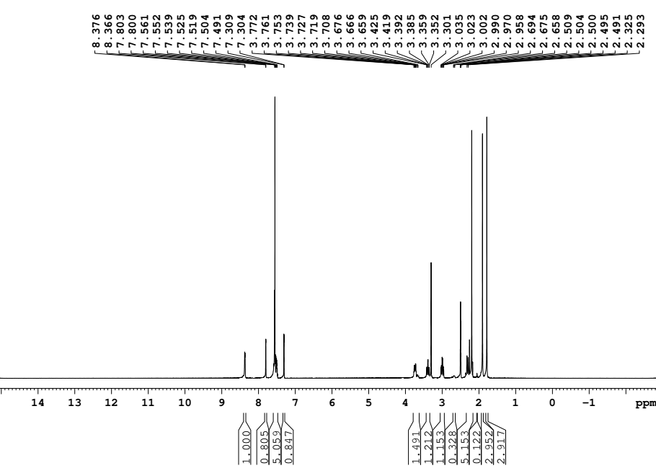
Figure S15. ¹H NMR spectrum of compound 4h
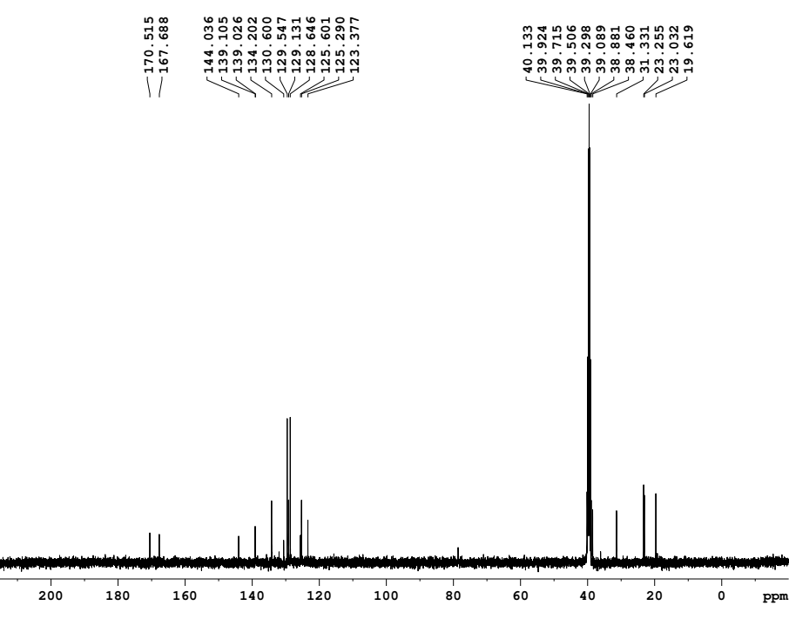
Figure S16. ¹³C NMR spectrum of compound 4h
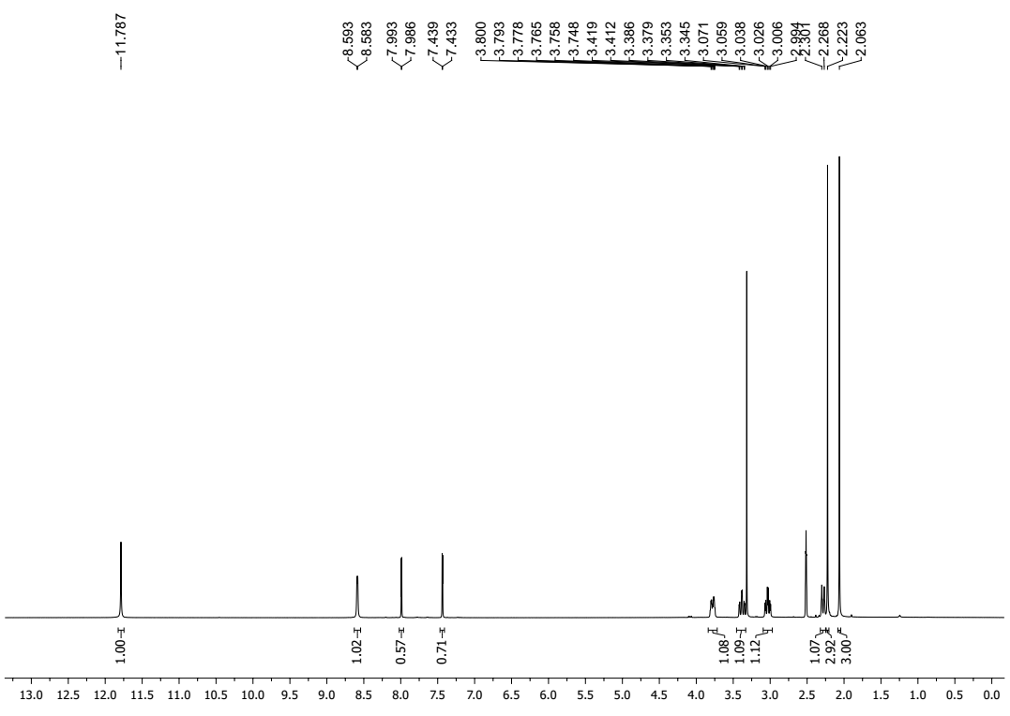
Figure S17. ¹H NMR spectrum of compound 4i
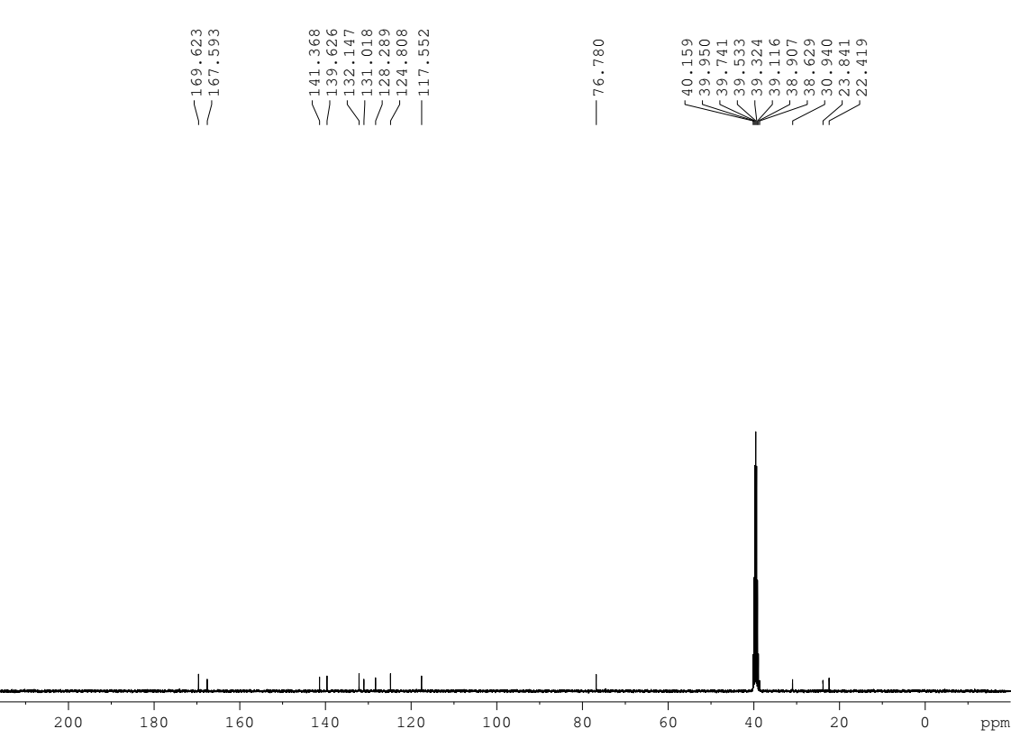
Figure S18. ¹³C NMR spectrum of compound 4i
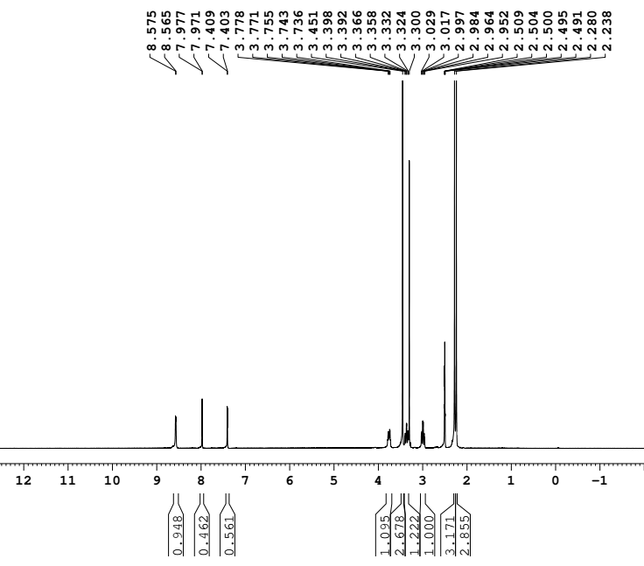
Figure S19. ¹H NMR spectrum of compound 4j
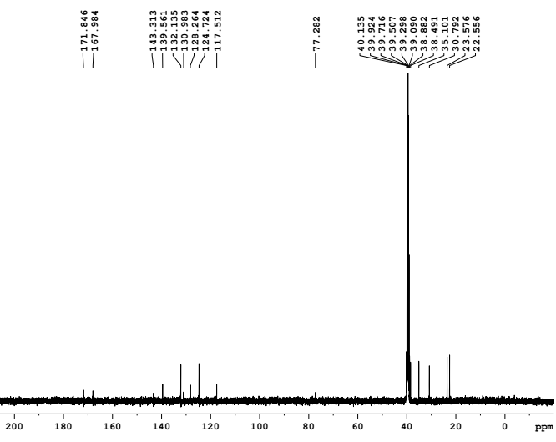
Figure S20. ¹³C NMR spectrum of compound 4j
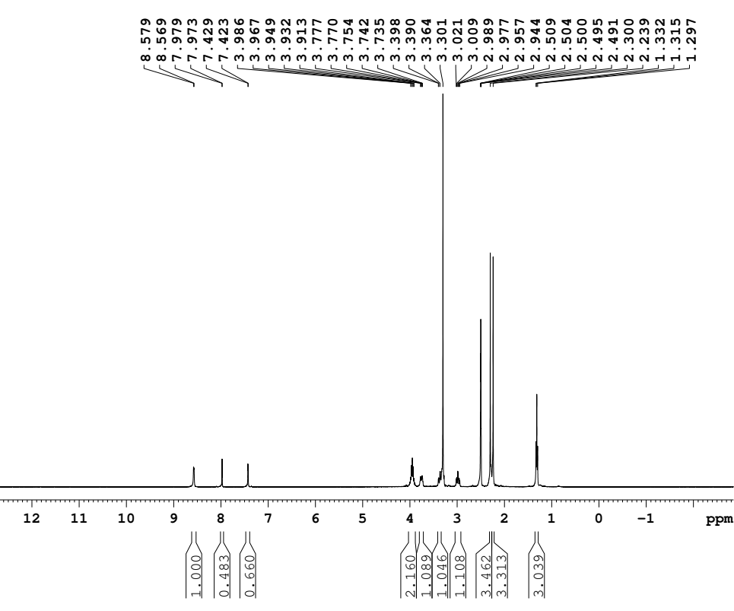
Figure S21. ¹H NMR spectrum of compound 4k
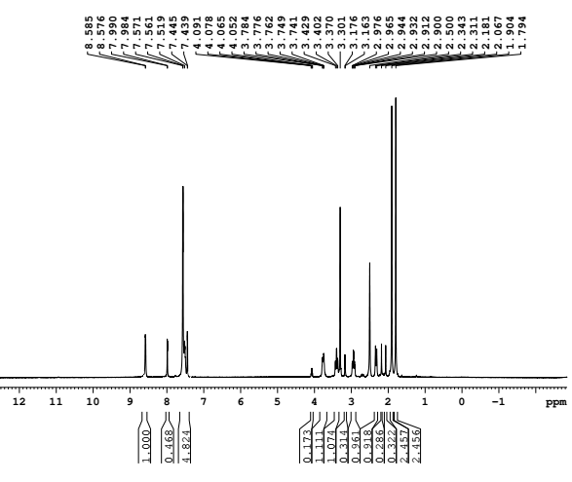
Figure S22. ¹H NMR spectrum of compound 4l
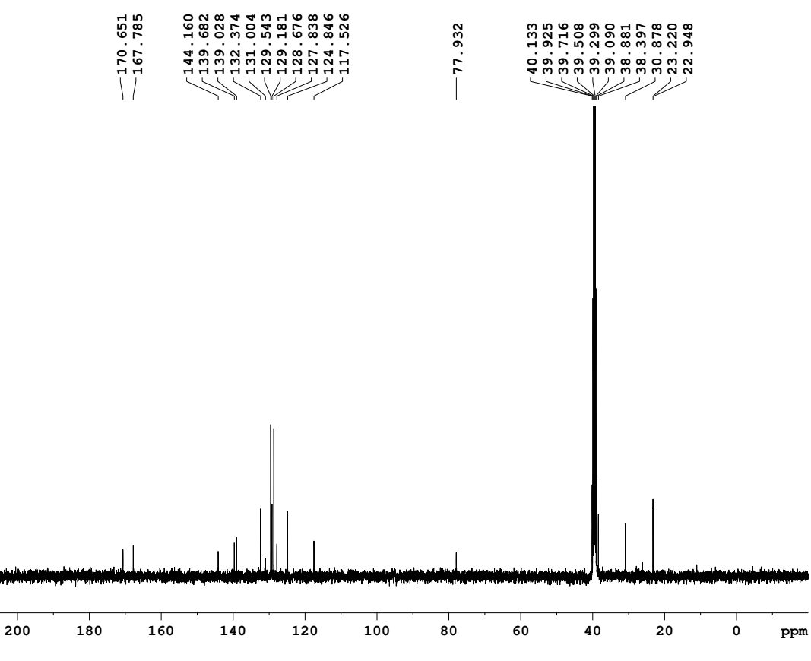
Figure S23. ¹³C NMR spectrum of compound 4l

