Supporting Information
A Ratiometric Fluorescent Probe Based on Copper Complex of Mercaptopyrimidine with Bifunctional Detection
Xinxuan Zouª, Lanzhi Meiª, Manbo Zhang ª,* Shian Xieª, Yan Xuª, Yongqin Wei^{b}, Hongmei Yu^{c}, William Nguyen^{d} , and Wei Chen^{d,}*
ª Key Laboratory of Chemical Biology & Traditional Chinese Medicine Research (Ministry of Education), College of Chemistry and Chemical Engineering, Hunan Normal University, Changsha, 410081, China
^{b} State Key Laboratory of Structural Chemistry, Fujian Institute of Research on the Structure of Matter, Chinese Academy of Sciences, Fuzhou, Fujian 350002, China
^{c} School of Chemical Engineering, University of Science and Technology Liaoning, Anshan 114051, People’s Republic of China
^{d} Department of Physics, The University of Texas at Arlington, Arlington, TX, 76019-0059, USA
* Correspondence: zmb@hunnu.edu.cn; weichen@uta.edu

- The fabrication of CuDpy-CDs probe
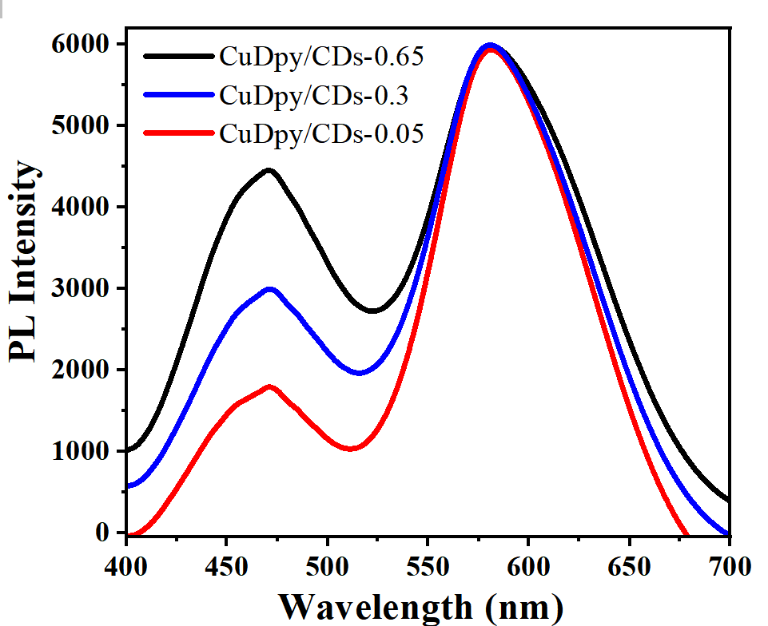
Fig. S1. Emission spectra of CuDpy-CDs ratiometric fluorescent probe.

- The determination of copper content of CuDpy by calcination and titration methods
Based on the principle that the copper content in the copper complexes was calculated by weighing the mass of the copper complexes before calcination and the mass of the CuO after calcination, and the experimental results are shown in Table S1. Moreover, the CuO obtained by calcination of 10 mg of CuDpy was fully dissolved with 3 mol·L⁻¹ H₂SO₄ according to the principle of the determination of Cu²⁺ concentration by DDTC method, and then transferred to a 100 ml volumetric flask, and then diluted 10 times to determine the absorbance, and finally the copper content was obtained according to the copper standard curve, and the experimental results are shown in Table S2.
Fig. S2. Standard curve for the determination of Cu²⁺ concentration in solution by ultraviolet spectrophotometry.

Fig. S3. Determination of the concentration of leached copper ions in CuDpy solution by DDTC method.

Table S1. Calcination results of copper content in CuDpy.
Number of groups | m₁  (g) | m₂  (g) | m(CuO)  (g) | Copper content  (Actual %) | Copper content (average %) |  | Copper content (theoretical %)
Group 1 | 9.1641 | 9.1545 | 0.0041 | 23.94 |  | 22.11 | 22.92
Group 2 | 9.3256 | 9.3095 | 0.0057 | 20.82 |  | 22.11 | 22.92
Group 3 | 9.2871 | 9.2806 | 0.0024 | 21.57 |  | 22.11 | 22.92

Table S2. Titration results of DDTC method.
Number of groups | Absorbance | Copper content  (Actual %) | Copper content (average %) |  | Copper content (theoretical %)
Group 1 | 0.021  0.021  0.022 | 22.41 |  | 22.96 | 22.92
Group 2 | 0.021  0.021  0.022 | 22.41 |  | 22.96 | 22.92
Group 3 | 0.021  0.021  0.022 | 24.07 |  | 22.96 | 22.92

- The detection procedure of CuDpy for S²⁻ and Ag⁺

3.1 The detection of S²⁻ and Ag⁺
The sensing of S²⁻ was performed in a buffer solution of pH = 7.4. The typical procedure: 0.2 mg·mL⁻¹ CuDpy-CDs solution, buffer solution of pH = 7.4, and different concentrations of S²⁻ solution were mixed. The final detection solution is composed of 10 mM buffer solution and 0.1 mg·mL⁻¹ CuDpy-CDs solution, and the volumes of the final detection solutions were 2000 μL. The emission spectra were recorded at 370 nm excitation for each solution after 25 mins of incubation with ultrasound at 30 ± 2 °C. (The sensing of Ag⁺ was the same as above.)

3.2.2 The detection of the real water
In order to explore the feasibility of the Ag⁺ and S²⁻ detection for water samples based on CuDpy-CDs, laboratory tap water and Xiangjiang River water were chosen as real samples for testing. Since neither Ag⁺ nor S²⁻ was detected in the real samples, we conducted a standard addition test experiment.
The laboratory tap water was not treated. The Xiangjiang River water was boiled with activated carbon for 20 mins and filtered through medium-speed filter paper. The filtrate is taken for the standard addition test experiment of Ag⁺ and S²⁻. The detection procedure of the real sample was the same as the previous detection procedure for Ag⁺ and S²⁻, except that the deionized water used in the solution was replaced by the really water sample. (CuDpy used the same detection procedure as CuDpy-CDs for S²⁻, Ag⁺ and real water samples.)

- The sensing application of the CuDpy

4.1 Sensing of S²⁻
The fluorescence response of CuDpy to different concentrations of S²⁻ was investigated in a buffer solution of pH = 7.4. As shown in Fig. S4, the trend of the fluorescence intensity of CuDpy was basically constant when the concentration of S²⁻ was gradually increased. As the S²⁻ concentration increases until the complete quench at 40 μM, and the quench saturation phenomenon appeared when the concentration of S²⁻ was too high. When the S²⁻ concentration was between 5 and 40 μM, the fluorescence quench of CuDpy showed a good linear relationship with the S²⁻ concentration, and the linear equation was:
F₀-F/F₀ = 0.02212[S²⁻] + 0.02982 (R² = 0.9946)
Where F₀ and F represent the fluorescence intensity when no S²⁻ was added and the fluorescence intensity when different concentrations of S²⁻ were added, respectively.
The detection limit of S²⁻ was obtained by the following equation [1, 2]:
LOD = 3σ/ k
Where σ is the standard deviation of the blank sample and k is the slope of the linear relationship between the fluorescence intensity of the probe and the Ag⁺ concentration. Here in this paper, σ = 8.37 (obtained by measuring the emission fluorescence intensity of 10 CuDpy solutions) and k = Slope = 1.16 × 10⁷ M⁻¹, the limit of detection for S²⁻ was calculated to be 0.27 μM, which is much lower than the maximum standard level of S²⁻ in residential drinking water (15 μM) set by the World Health Organization (WHO) [3]. The above results fully demonstrate the potential application of the method in the rapid determination of trace amounts of S²⁻ in drinking water and environmental systems.
Fig. S4. (a) The emission spectra of CuDpy under different S²⁻ concentrations (The concentration from top to bottom are 0, 1, 2, 3, 4, 5, 6, 8, 10, 15, 20, 25, 30,35, 40, 45, 50 and 55 μM); (b) The relationship between fluorescence intensity of CuDpy and S²⁻ concentration.

4.2 Sensing probe for Ag⁺
We examined the fluorescence response of CuDpy to different concentrations of Ag⁺. As shown in Fig. S5a, with the increase of Ag⁺ concentration, the trend of fluorescence intensity of CuDpy first remained basically constant, and then gradually decreased until completely quenched at 500 μM, and the color of the solution gradually changed from yellow to gray-black (Fig. S5b). Therefore, it is possible to roughly quantify the Ag⁺ concentration by bare eyes, which is of some practicality. Meanwhile, the degree of fluorescence quench of CuDpy showed a good linear relationship with the Ag⁺ concentration when the Ag⁺ concentration was in the range of 50-500 μM, and the linear equation was:
F₀-F/F₀ = 2.16×10⁻³[Ag⁺]- 0.07 (R² = 0.9943)
Where F₀ and F represent the fluorescence intensity when no Ag⁺ was added and the fluorescence intensity when different concentrations of Ag⁺ were added, respectively.
The detection limit of Ag⁺ was calculated by LOD = 3σ/ k as 2.16 μM. The above results indicate that CuDpy can be used as a fluorescent probe to detect the Ag⁺ concentration in waste water.
Fig. S5. (a) The emission spectra of CuDpy under different Ag⁺ concentrations (The concentration from top to bottom are 0, 10, 20, 30, 40, 50, 100, 150, 200, 250, 300, 350, 400, 500, 600, 650, 700 and 800 μM); (b) The relationship between fluorescence intensity of CuDpy and Ag⁺ concentration. (Inset shows the fluorescence quenching photographs of CuDpy with different Ag⁺ concentration)

4.3 Sensing of Ag⁺ and S²⁻ in real water samples
To determine the accuracy of the established fluorescent probe in the detection of real water samples. In this study, laboratory tap water and Xiangjiang River water were used as the real samples and tested for S²⁻ and Ag⁺ under the same test conditions. The results are shown in Table S3 and Table S4. The results showed that the recoveries of S²⁻ remained between 84.09 and 113.57%, and the recoveries of Ag⁺ ranging from 83.98 to 111.93%, which indicated that the fluorescent probes established in this study could be initially used for S²⁻ and Ag⁺ detection in real samples.

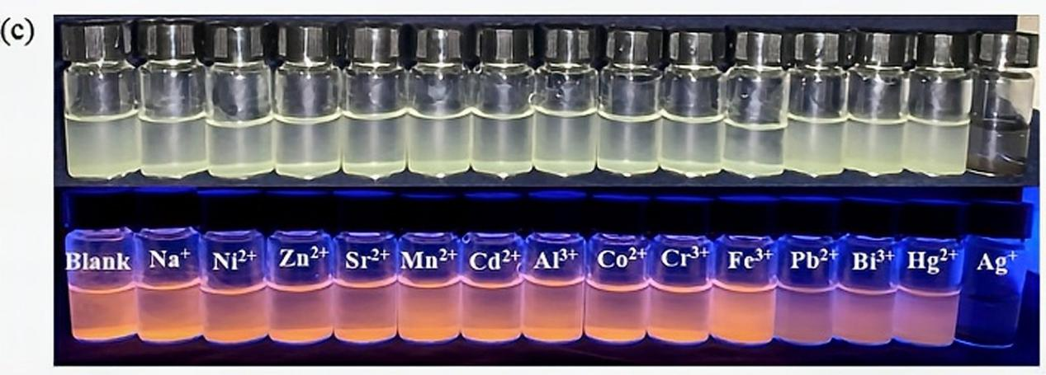
Fig. S6. Selective identification of Ag⁺ by CuDpy.

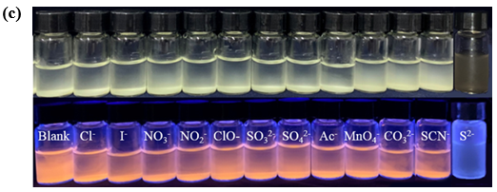
Fig. S7. Selective identification of S²⁻ by CuDpy.

Fig. S8. Figure of CuDpy's fluorescence intensity over response time: (a) Ag⁺ and (b) S²⁻.

Table S3. Detection of S²⁻ in tap water and Xiangjiang River water samples
the amount of S²⁻ added(μM) | Tap water samples |  | Xiangjiang River water sample
the amount of S²⁻ added(μM) | detected amount ª±SD^{b} | recovery rate(%) | detected amount ª±SD^{b} | recovery rate(%)
15 | 13.91±0.14 | 92.70 | 12.61±0.16 | 84.09
20 | 17.75±0.43 | 88.74 | 21.76±0.20 | 108.81
30 | 34.07±0.28 | 113.57 | 27.71±0.14 | 92.36
ª mean value of the three measurements; SD^{b}, standard deviation

Table S4. Detection of Ag⁺ in tap water and Xiangjiang River water samples
the amount of Ag⁺ added  (μM) | Tap water sample |  | Xiangjiang River water sample
the amount of Ag⁺ added  (μM) | detected amount ª±SD^{b} | recovery rate(%) | detected amount ª±SD^{b} | recovery rate(%)
100 | 85.66±0.16 | 85.66 | 83.98±0.18 | 83.98
200 | 187.14±0.22 | 93.57 | 188.10±0.32 | 94.05
300 | 270.42±0.32 | 90.14 | 335.79±0.14 | 111.93
ª mean value of three measurements; SD^{b}, standard deviation

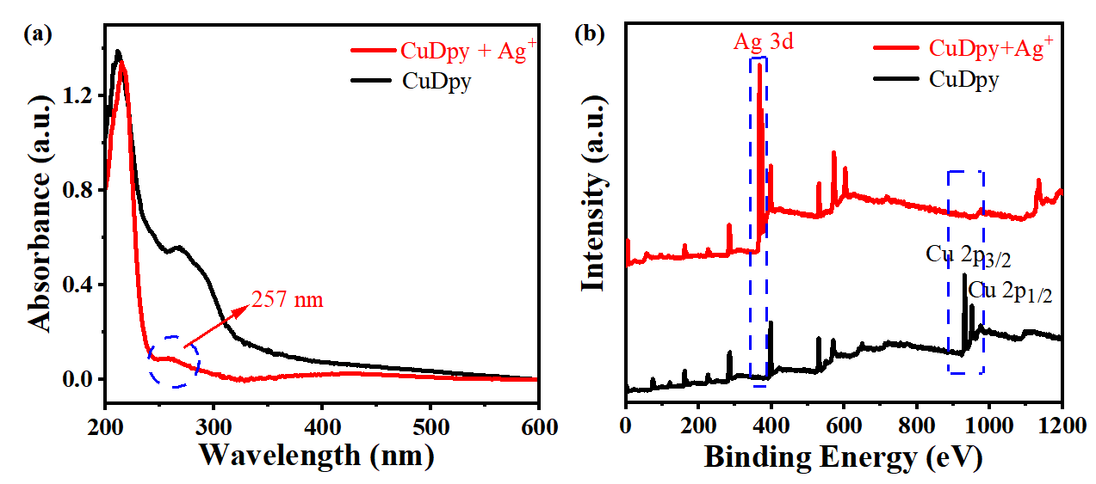
Fig. S9. UV-Vis (a) and XPS (b) spectra after adding Ag⁺ to CuDpy.

Fig. S10. IR spectrum of CDs.
Fig. S10. XRD pattern of CDs.
Fig. S11. XPS of CDs: (a) full spectrum; (b-d) high-resolution C1s, N1s and O 1s XPS spectrum.

Fig. S12. (a) UV-Vis spectrum and fluorescence emission spectrum of the CDs (Inset shows the fluorescence photographs of CDs); (b) Fluorescence emission spectra of CDs in different solvents.

Fig. S13. The effect of (a) pH; (b) different concentrations of NaCl solution; (c) Irradiation time of Xenon Lamp on the fluorescence of CDs.

Table S5. Elemental analysis of CDs.
 | Test molecule | C (%) | H (%) | O (%) | N (%)
CDs | C_{4.1}H_{6.601}O_{1.83}N_{0.926} | 49.03 | 6.601 | 29.246 | 12.98

References
[1] Zhou, R. S., Zhang, W., Xin, L. D., Wen, H. F., Zhang, X. Y., Su, L. J., Song, J. F., A novel binary Cu2I2 and Cu6S6 cluster-based red emission compound and sensing of Cr(VI) in water, Inorg Chem Commun. (2018) 154-158.
[2] Liu, G. N., Zhao, R. Y., Xu, R. D., Zhang, X., Tang, X. N., Dan, Q. J., Wei, Y. W., Tu, Y. Y., Bo, Q. B., Li, C. C., A Novel Tetranuclear Copper(I) Iodide Metal-Organic Cluster Cu4I4(Ligand)(5) with Highly Selective Luminescence Detection of Antibiotic, Crystal Growth & Design. 9 (2018) 5441-5448.
[3] Mercante, J. W., and Winchell, J. M., Current and Emerging Legionella Diagnostics for Laboratory and Outbreak Investigations, Clinical Microbiology Reviews. 1 (2015) 95-133.

