Excellent optical, flexible, and mechanical properties of cellulose liquid crystal films induced by carbon quantum dots
Xinyu Zhaoª, Huimin Fengª, Wenjia Kangª, Boying Yangª, Yueer Maª, Xinping Liª, Hui Chang^{b}, Shuhua Tong^{c}, Chuanyin Xiongª, Zhao Zhang^{a,＊}
ª College of Bioresources Chemical and Materials Engineering, Shaanxi University of Science and Technology, Xi'an, 710021, Shaanxi, PR China
^{b} College of Mechanical and Electrical Engineering, Shaanxi University of Science and Technology, Xi'an, 710021, PR China
^{c} Zhejiang Jinchang Special Paper Co., Ltd. Zhejiang, Quzhou, 324404
＊E-mail: zhangzhaoqg@sust.edu.cn

Characterization
Fourier transform-infrared (FT-IR) spectra were recorded using a Bruker Vertex 70 IR spectrometer (Bruker Corp., Billerica, MA, USA) in the spectral range from 4000 to 400 cm⁻¹ using pressed potassium bromide discs. The material was coated with gold to a thickness of ~8 nm and then the fracture surfaces of samples examined by a scanning electron microscope (SEM; S-4800, Hitachi Instruments, Inc., Tokyo, Japan) at an accelerating voltage of 3.0 kV. X-ray diffractograms (XRD) were obtained with a Nihon Reiji Smart diffractometer (Rigaku Corp., Tokyo, Japan), using Cu-K_{α} radiation and the 2ϴ from 5 to 60º. Structure was recorded by Raman spectroscopy (AVANCE NEO 600 MHz, Bruker Corp.). UV-Vis and fluorescent spectra were recorded using an UV-VIS-NIR spectrometer (Carry 5000 UV, Agilent Technologies, Inc., Santa Clara, CA, USA), a fluorescence spectrometer (FS 5, Edinburgh, UK), respectively. The liquid crystallinity and structure were recorded using a Primotech polarizing light microscope (POM; Carl Zeiss AG, Oberkochen, Germany). Thermal stability curves were recorded using a STA449F-1053-M (Netzsch Instruments North America, Burlington, MA, USA) simultaneous thermal analyzer (TG), Germany, using a 2 × 2 cm size paper fixed on a slide. The laser confocal lens selected to the most suitable excitation wavelength at 400 nm for analysis. The paper was cut into 1 cm width strips and fixed between two ends of a clamp, with the parameters set for mechanical property testing.

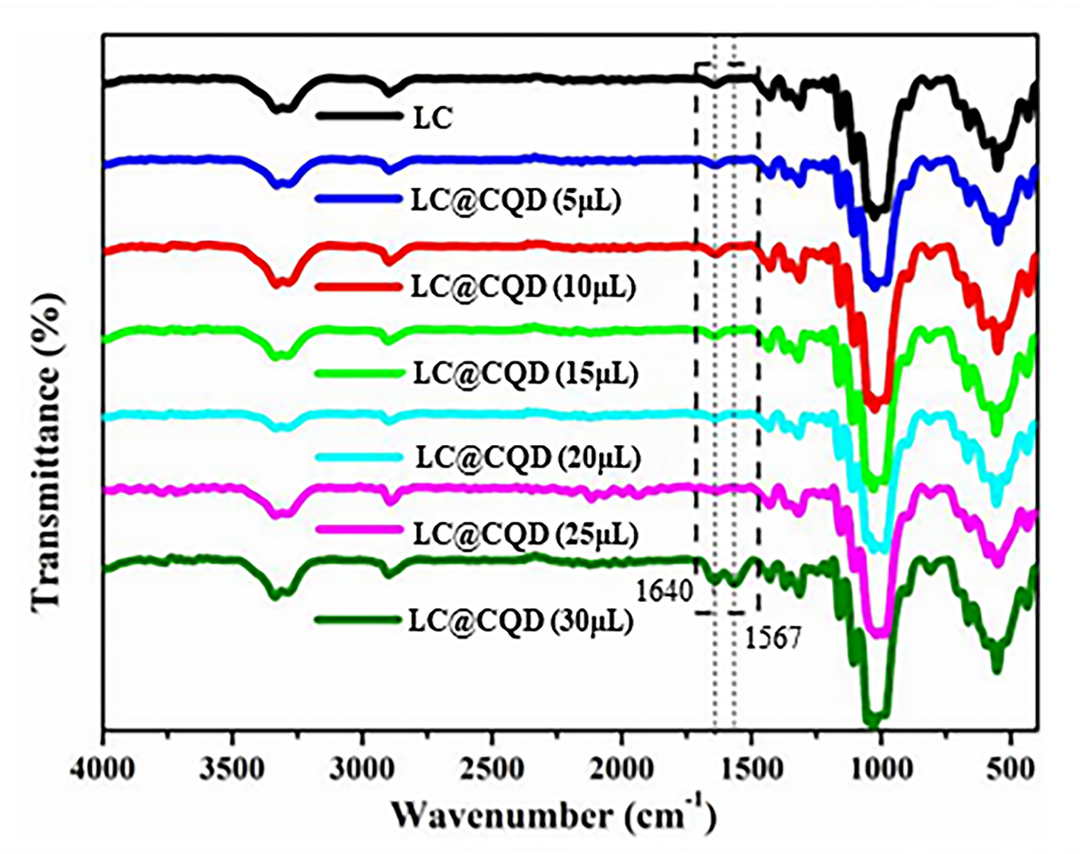
Fig.S1 FT-IR spectrum of LC@CQD films

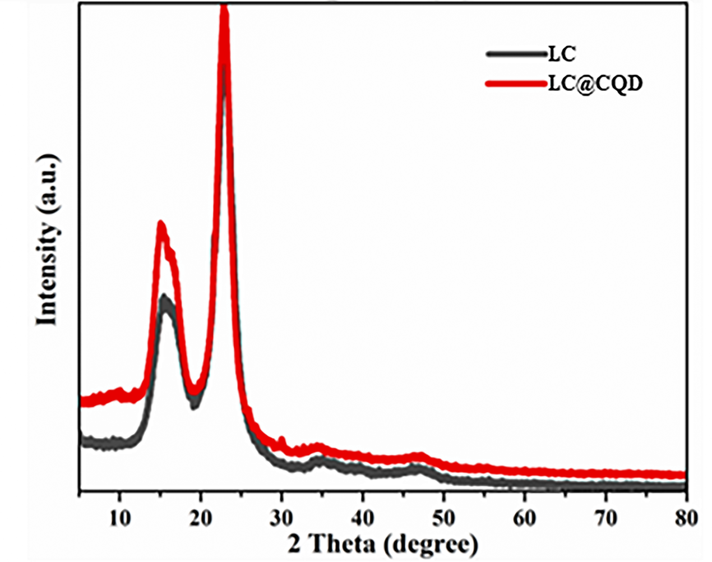
Fig.S2 XRD spectrum of LC and LC@CQD film

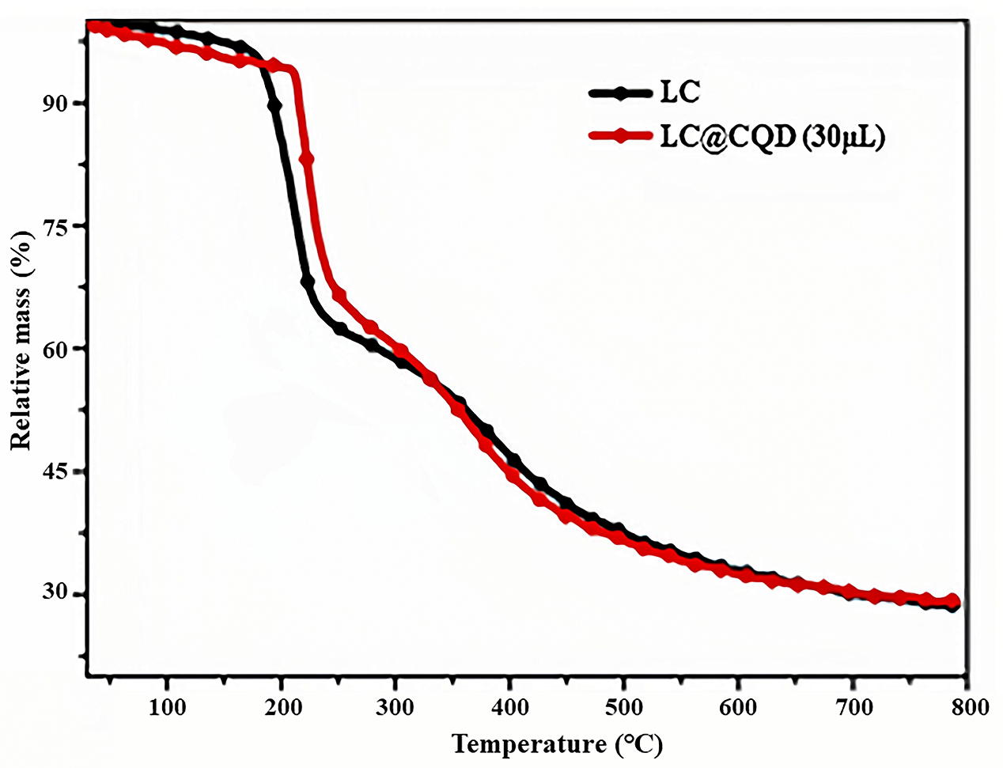
Fig.S3 TG spectrums of LC and LC@CQD films

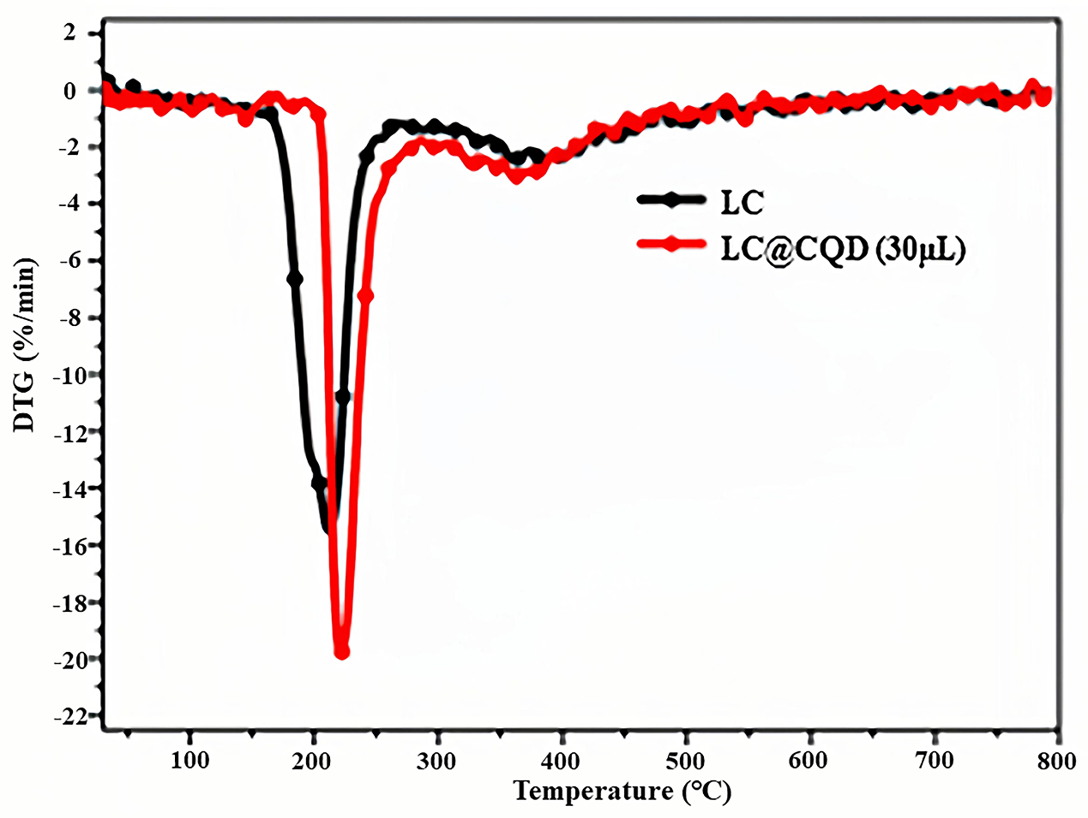
Fig.S4 DTG spectrums of LC and LC@CQD films

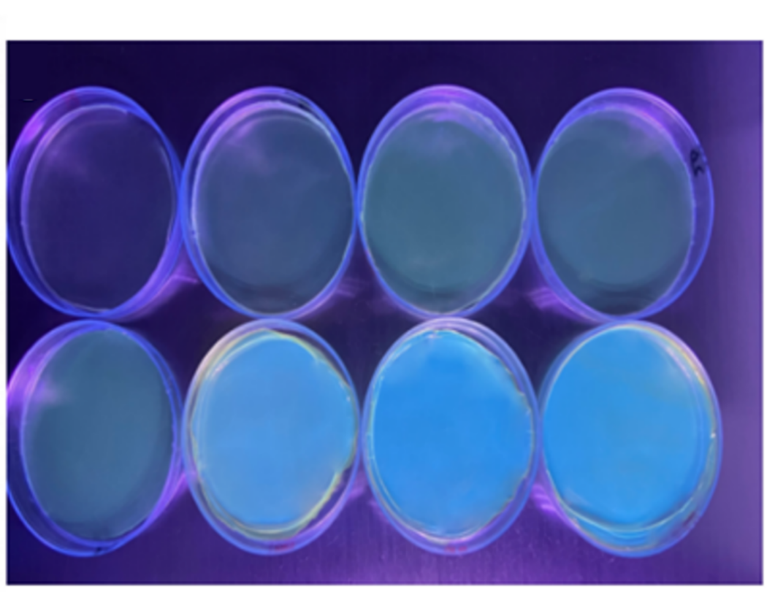
Fig.S5 Physical picture of the LC-CQD films under a UV lamp at 365 nm (from left to right, CQD concentration is 0, 5, 10, 15, 20, 25, 30, 100 μL, respectively)

