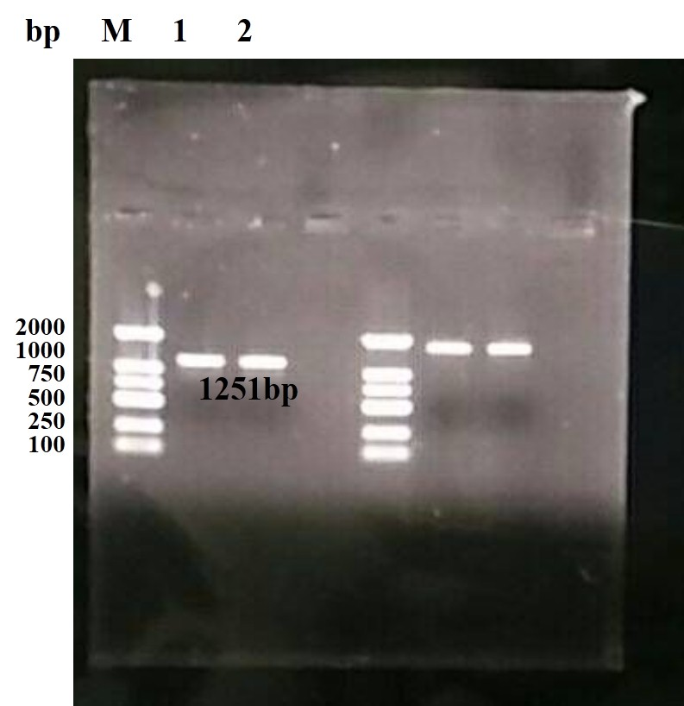
Fig. 1 Agarose gel electrophoresis of EtCRK2 gene ORF. M, DL2000 DNA Marker; 1and 2, PCR amplification products via pET-28a (+) vector universal primers.

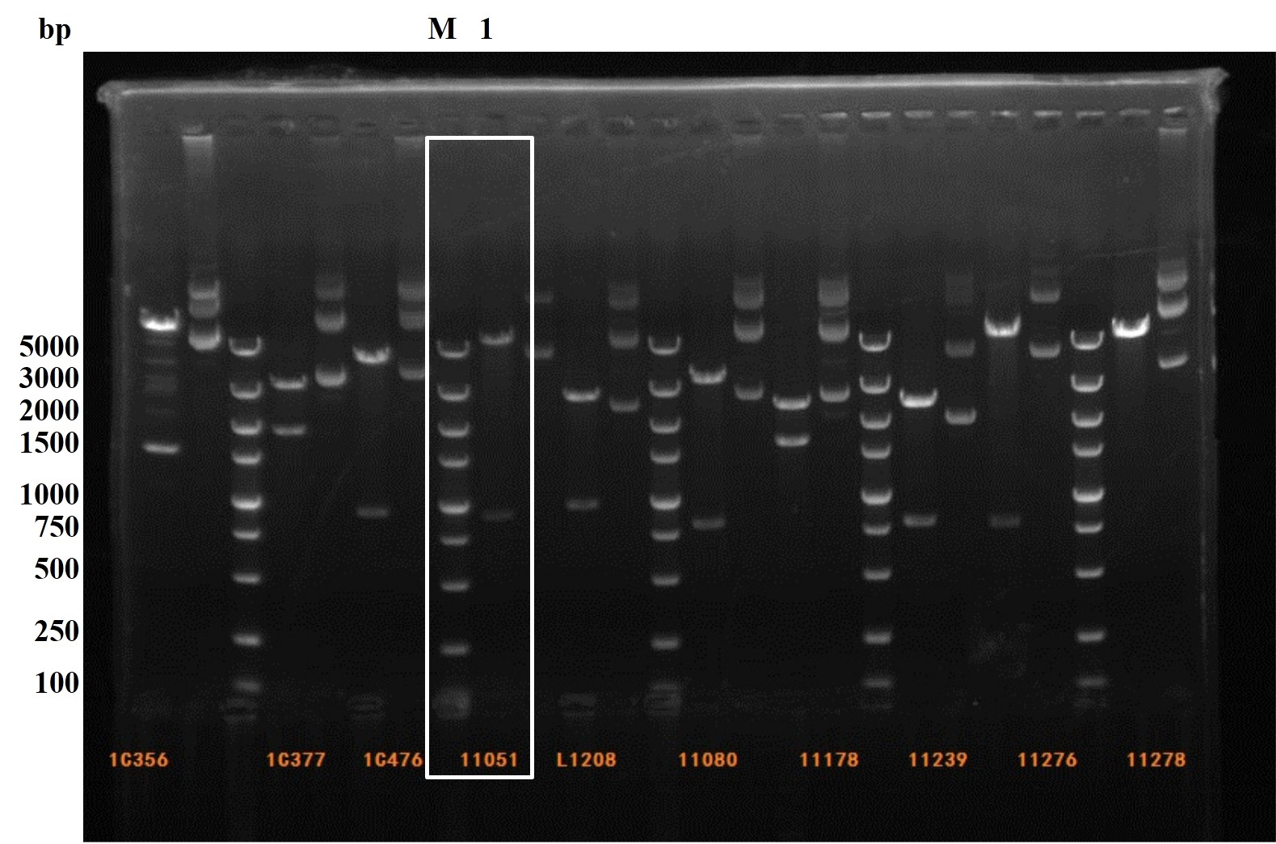
Fig. 2 Restriction digestion analysis. M, DL5000 DNA Marker; 1, Plasmid pET-28a-EtCRK2 digested by EcoR I and Hind III.

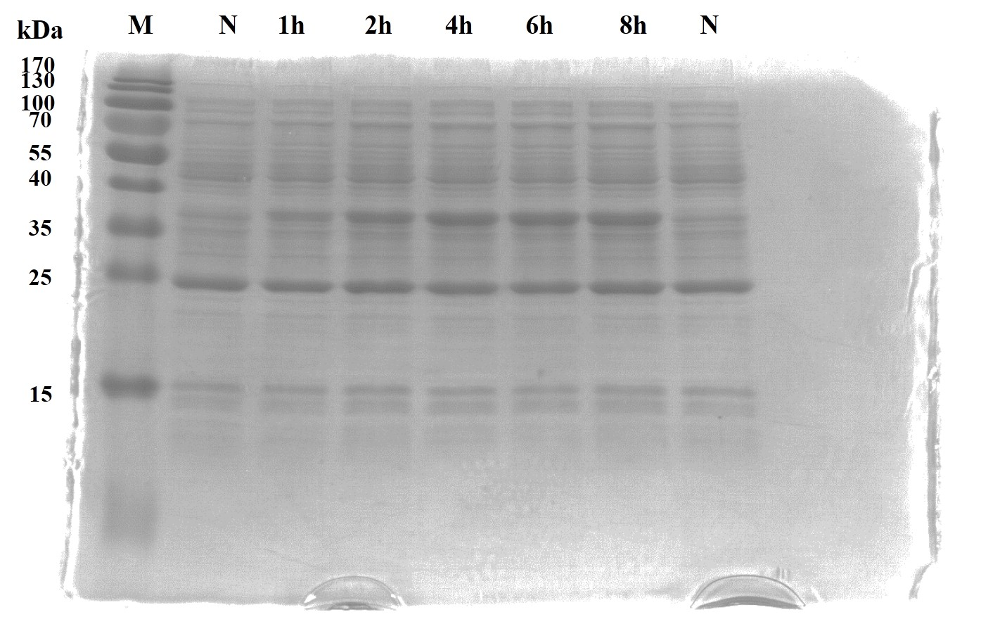
Fig. 3 Induced expression of EtCRK2 fusion protein. M, Protein molecular weight Marker; pET-28a-EtCRK2 were induced expression of 1 h, 2 h, 4 h, 6 h and 8 h, respectively; N, empty pET-28a were induced expression.

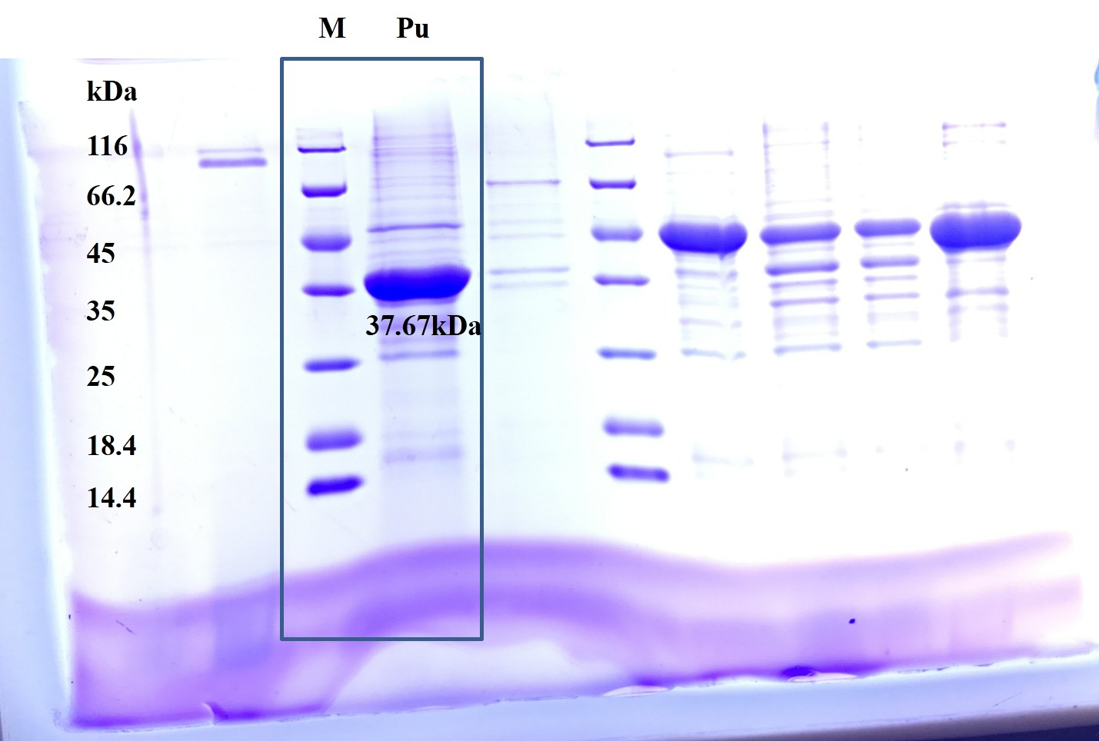
Fig. 4 Purification of rEtCRK2 protein. M, Protein molecular weight Marker; Pu, purified rEtCRK2 protein.

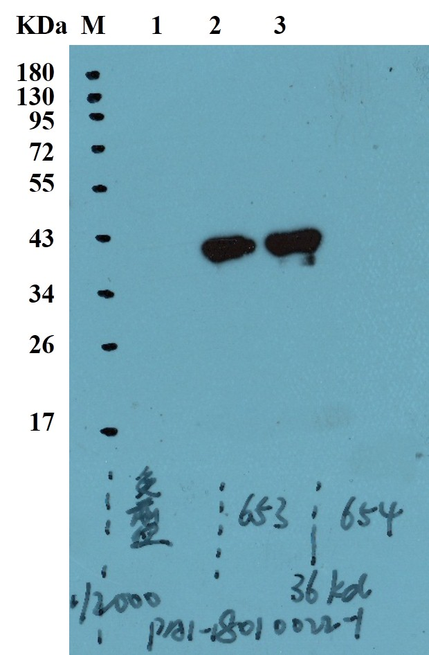
Fig. 5 Rabbit-anti-EtCRK2 serum specific binding analysis by Western blot. M, Protein molecular weight Marker; 1, Pre-immunization serum as the first antibody; 2 and 3, antiserum as the first antibody.

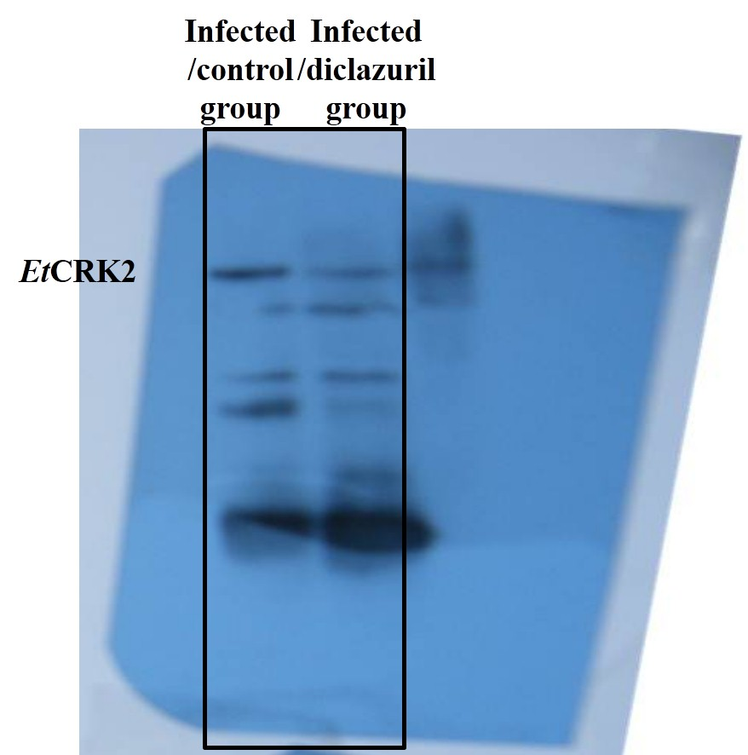
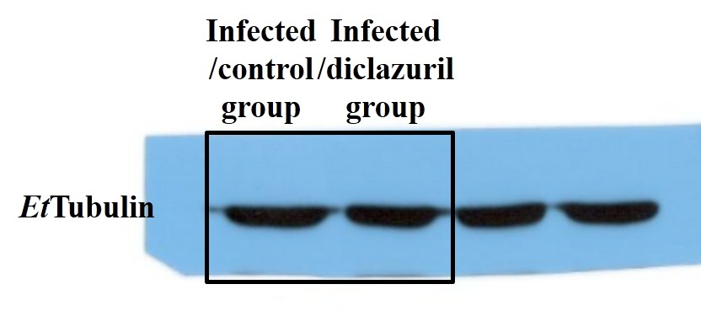
Fig. 8 Western blot analysis of EtCRK2 protein expression. A, Western blot electrophoretic pattern of EtCRK2 and EtTubulin.

