Supplementary materials
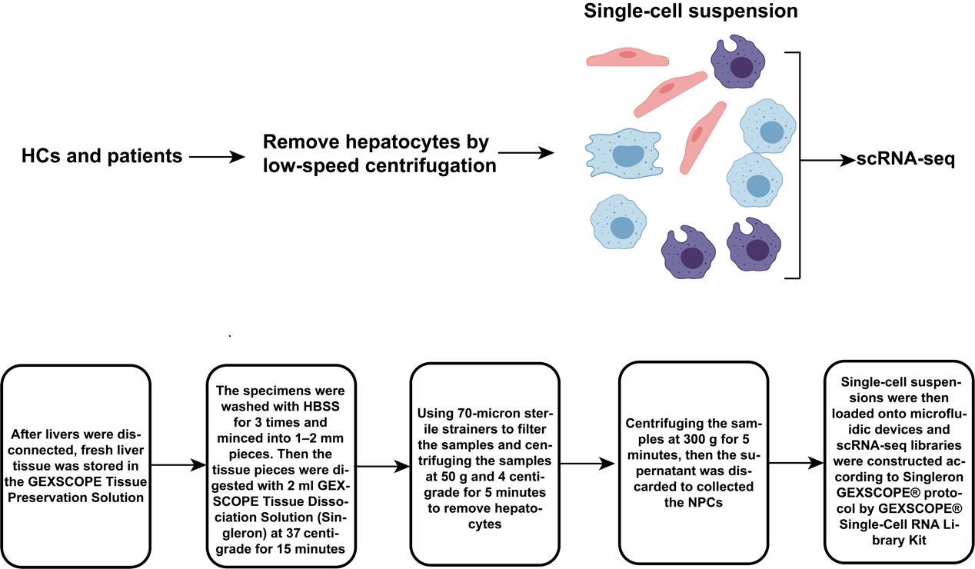
- Supplementary figures.

Supplementary figure 1 The flow diagram for the scRNA-seq of NPCs in the livers.

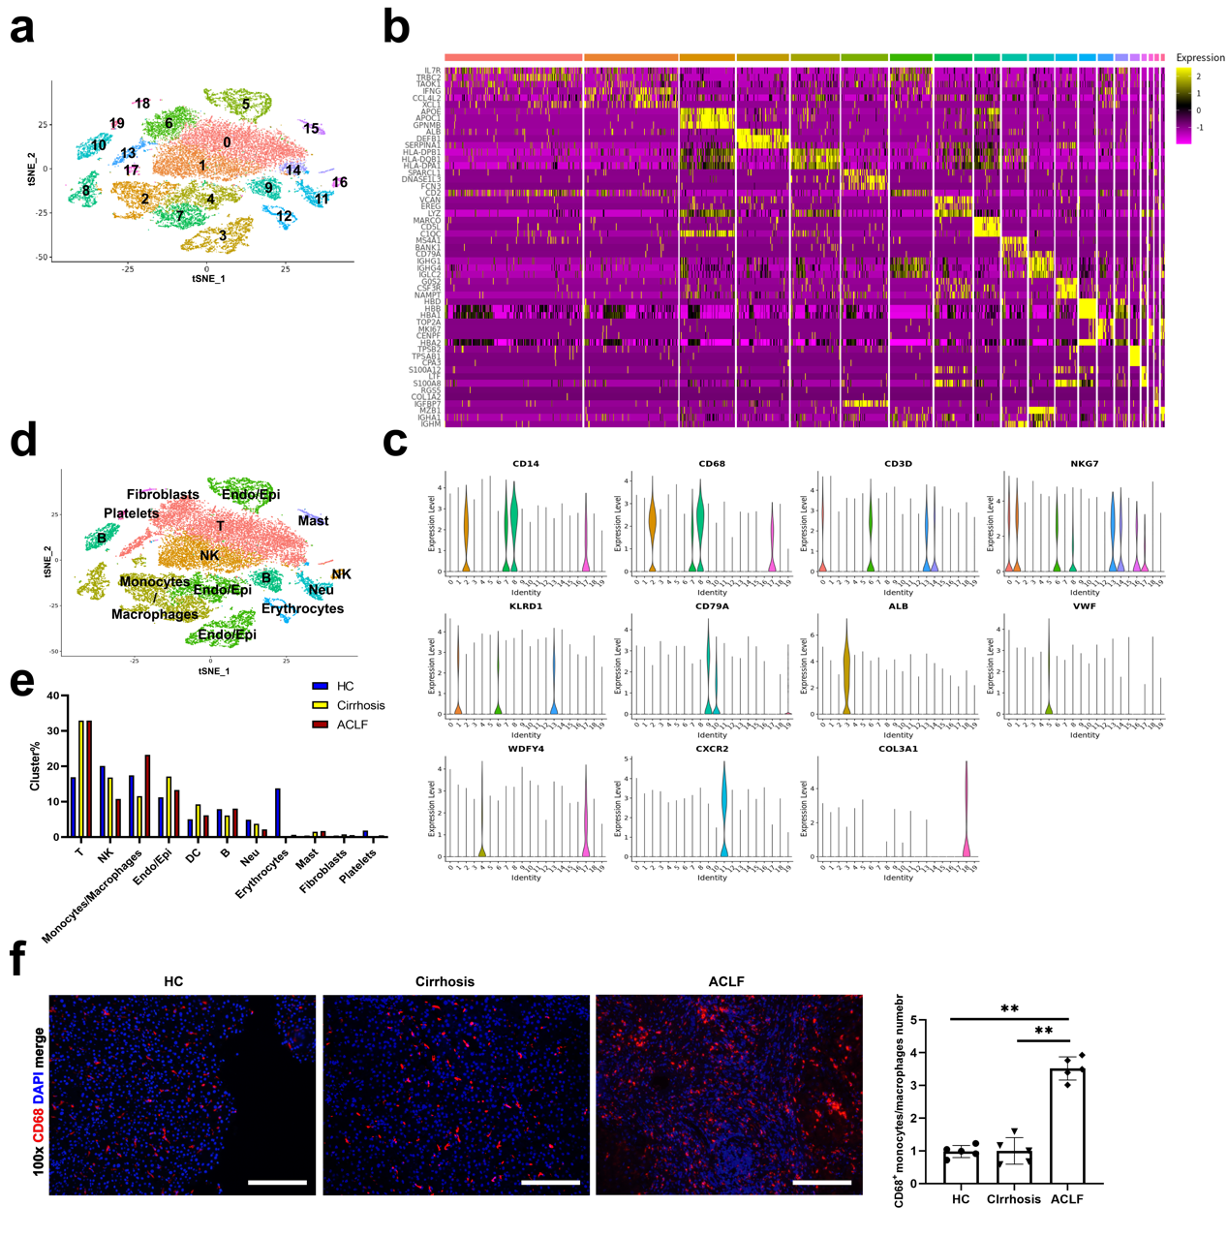
Supplementary figure 2 a 26,200 cells from HCs (n = 2), cirrhosis (n = 3) and ACLF (n = 5) human livers were clustered into 20 subpopulations (0 – 19). b The heat map of representative marker genes for the 20 subpopulations which were arranged in the order of 0 – 19. c The classical marker genes of each cluster. d The 20 subpopulations were re-annotated into 11 classical clusters according to their marker genes. e The proportions of 11 classical clusters among HCs, cirrhosis and ACLF patients. f Immunofluorescence staining for monocytes/macrophages (CD68) in the livers of HCs, cirrhosis and ACLF patients (100× field, ** p ＜ 0.01, bar = 200 μm). The scRNA-seq data and figures a – e were cited from our previous work (Ref 13, DOI: 10.3390/jcm11102910).
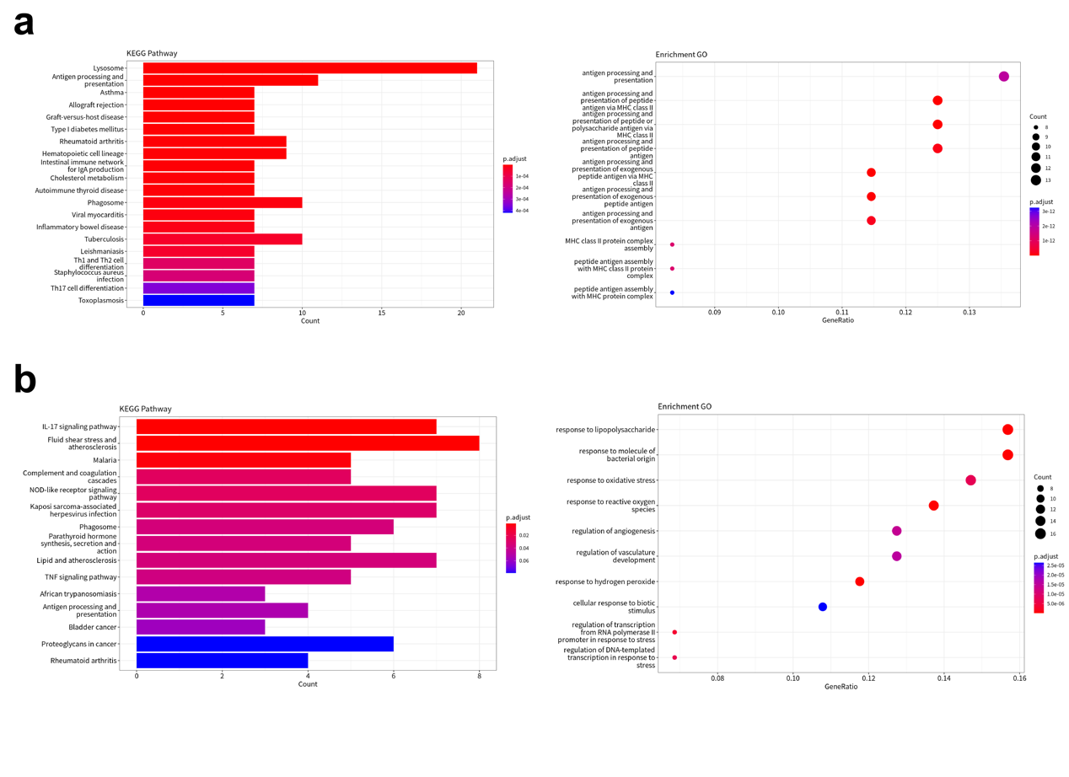
Supplementary figure 3 a The KEGG and GO analyses for cluster Mono1. b The KEGG and GO analyses for cluster Mono4.
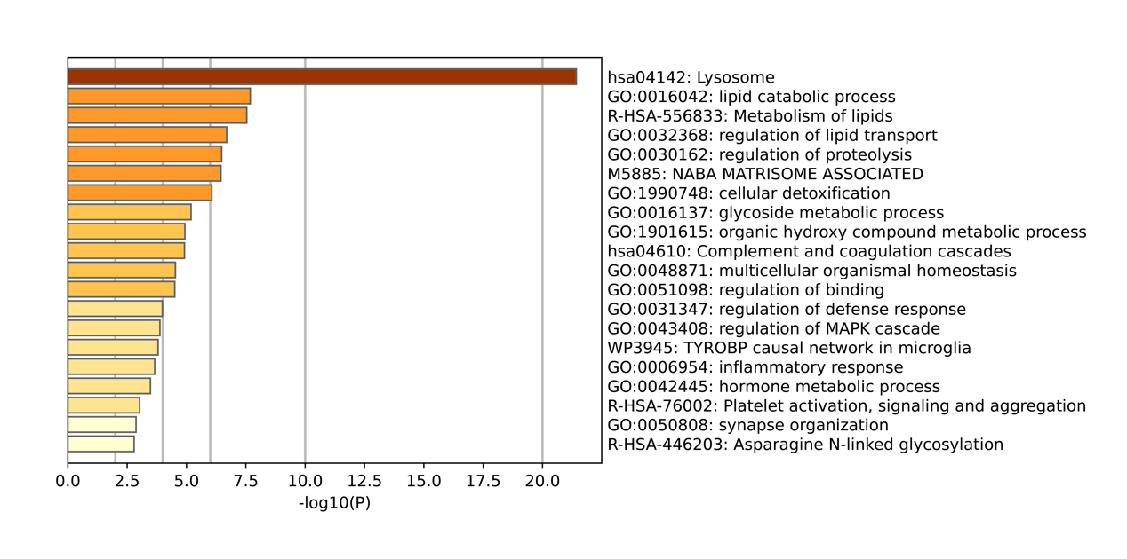
Supplementary figure 4 The gene enrichment analysis of the upregulated genes along the pseudotemporal trajectory from Mono2 to Mono1.

- Supplementary tables.
Supplementary Table 1. The clinical data of cirrhosis and ACLF patients
Number | Gender | Age (year) | Group | Na (mmol/L) | Liver |  |  |  | Kidney |  | Brain | Coagulation |  | Circulation | Respiration | ACLF score* | ACLF grade* | MELD-Na score
 |  |  |  |  | ALT (U/L) | AST (U/L) | Tbil  (umol/L) | Score | Creatinine (umol/L) | Score | Score | INR | Score | Score | Score | ACLF score* | ACLF grade* | MELD-Na score
1 | Male | 46 | Cirrhosis | 144 | 28 | 32 | 52.5 | 1 | 74 | 1 | 1 | 1.4 | 1 | 1 | 1 | 6 | Absence | 14
2 | Male | 37 | Cirrhosis | 132 | 59 | 59 | 41.7 | 1 | 39 | 1 | 1 | 1.4 | 1 | 1 | 1 | 6 | Absence | 18
3 | Male | 54 | Cirrhosis | 143 | 73 | 63 | 27.4 | 1 | 165 | 1 | 1 | 1.1 | 1 | 1 | 1 | 6 | Absence | 15
4 | Male | 45 | ACLF | 148 | 457 | 728 | 446.1 | 3 | 90 | 1 | 1 | 2.7 | 3 | 1 | 2 | 11 | ACLF-2 | 30
5 | Male | 37 | ACLF | 138 | 67 | 82 | 576.7 | 3 | 78 | 1 | 3 | 3.1 | 3 | 1 | 1 | 12 | ACLF-3 | 31
6 | Male | 52 | ACLF | 133 | 141 | 91 | 387.2 | 3 | 52 | 1 | 1 | 3.6 | 3 | 1 | 2 | 11 | ACLF-2 | 33
7 | Male | 48 | ACLF | 144 | 384 | 221 | 306.4 | 3 | 55 | 1 | 1 | 3.0 | 3 | 1 | 2 | 11 | ACLF-2 | 30
8 | Male | 57 | ACLF | 139 | 1704 | 2677 | 339.9 | 3 | 76 | 1 | 1 | 3.0 | 3 | 1 | 1 | 10 | ACLF-2 | 30
* The score and grade of ACLF are assessed according to the EASL-CLIF Consortium organ-failure scoring system.
ACLF, acute-on-chronic liver failure. ALT, alanine aminotransferase. AST, aspartate aminotransferase. Tbil, total bilirubin. INR, international normalized ratio. MELD, model for end-stage liver disease. EASL-CLIF, European Association for the Study of the Liver–Chronic Liver Failure.

Supplementary table 2. The markers of proinflammatory/anti-inflammatory macrophage genes
Pro-inflammation | Anti-inflammation
CD40 | TREM2
PTGS2 | CHIT1
IL12A | CHI3L1
IL12B | APOC1
ICAM1 | LIPA
IFIT2 | APOC2
VCAM1 | APOE
RSAD2 | GM2A
GPR84 | CTSD
NFKBIZ | IFI27
EHD1 | ACP5
TRAF1 | FABP5
CCND2 | GPNMB
SOCS3 | RNASE1
ADORA2A | GCHFR
SERPINE1 | CD9
SERPINB2 | LPL
CD38 | CTSZ
INHBA | C1QB
LCN2 | VAT1
MEFV | PLD3
NFKB2 | CYP27A1
IL15RA | MARCO
IRF7 | IFI6
ZBP1 | FTL
PILRA | MSR1
OAS3 | LGALS3
IFIH1 | A2M
SLCO3A1 | NUPR1
NFKBIA | CAPG
MET | CD81
ISG20 | CD59
STAT2 | CTSB
BATF2 | LGMN
TLR2 | GRN
CFLAR | SPARC
HDC | PLA2G7
NUPR1 | HEXB
GAS7 | DBI
MMP14 | ACE
DHX58 | PRDX1
AGRN | CTSL
VCAN | GSN
IFI35 | ANXA2
JAK2 | LGALS3BP
ARG2 | PSAP
GCH1 | SCD
PELI1 | C1QA
DDX60 | LY6E
VASP | CSTB
ZUFSP | LAMP1
EIF2AK2 | C1QC
SOD2 | BCAP31
CD274 | GALM
ELL2 | SERPING1
PTGES | CTSK
BATF | CD63
SLC25A37 | TIMP2
PSTPIP2 | ABHD12
ITGAL | TNS3
PARP9 | RARRES1
NOTCH1 | RMDN3
HCK | SRGN
SNX20
NFKBIB
CCRL2
SAMSN1
DUSP2
CD14
CXCL16
JDP2
TAPBPL
STAT1
RBPMS
RAB32
MAP3K5
IL1RN
FLNB
BIRC3
TAP2
MITD1
GGCT
TNIP1
CD86
IRF9
IL17RA
TRIM25
LMO4
ACSL1
EBI3
GRAMD1A
ITGA5
RNF114
AGTRAP
PSMB9
IFNAR2
ST3GAL3
SLC31A1
TNFRSF1B
MTDH
CPD
PSMB8
SKIL
PDPN
SNX10
SYK
DENR
GADD45B
SLC15A3

