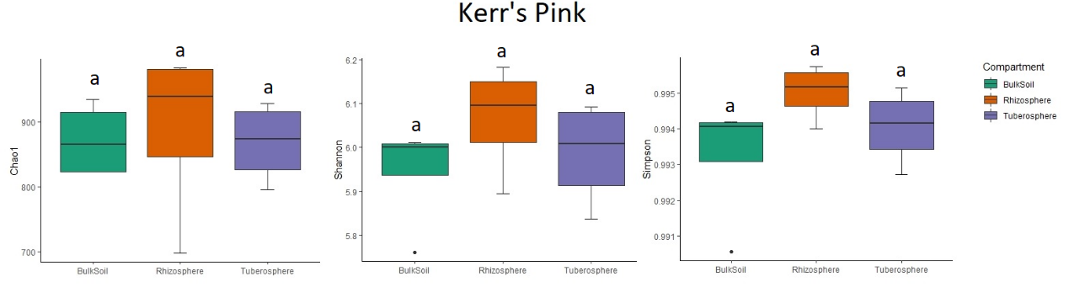
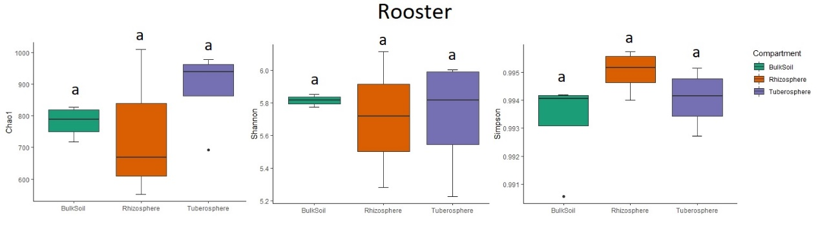

Figure S1 Alpha diversity analysis of Chao1, Shannon and Simpson across the three soil compartments of the varieties Kerr’s Pink and Rooster. Same letters indicate non-significant differences between the compartments (P>0.05).

