Supplementary materials

Supplementary Text S1: Motion coherence thresholds in young and old participants at 7°/s motion speed

The ANOVA showed a significant effect of the viewing condition (with or without an artificial scotoma), but no significant interaction between this variable and the pattern or the group. Therefore, even though the presence of a scotoma slightly increases motion coherence thresholds in all participants, the pattern of results obtained in the two viewing conditions when comparing the performances of the two groups are similar, as shown in Figure 1 and Figure S1. Older participants had higher motion coherence thresholds for the radial pattern and lower thresholds for the rotational pattern than the young participants, and this regardless of the viewing condition.

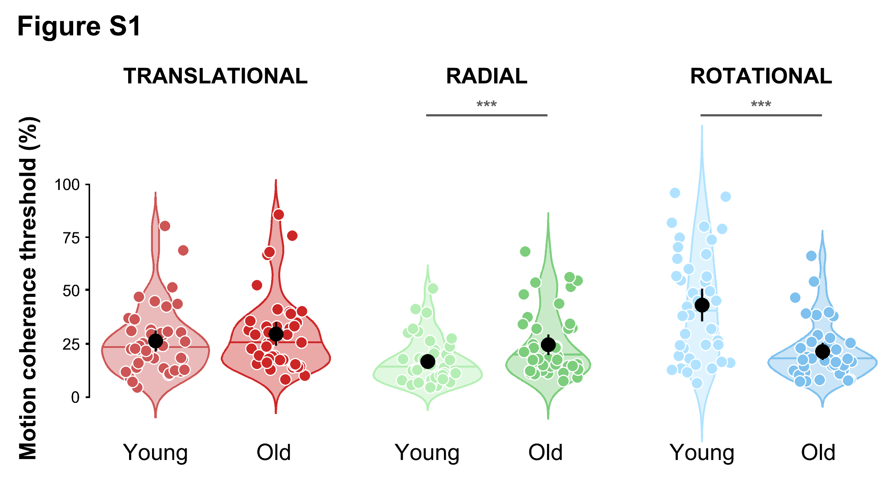
Distributions of the motion coherence thresholds estimated for translational (red), radial (green), and rotational (blue) optic flow patterns, for the young (age: 18-30, n = 42, light colors) and old (age: 70-90, n = 42, dark colors) adults groups. Black dots represent group-level means. Error bars represent the associated 95 percent confidence intervals. Horizontal colored lines represent group-level medians. Circles provide the individual data points of the distributions. Note that they were slightly offset horizontally to improve their visibility. Stars indicate significantly different distributions (***, p < 0.001).

Supplementary Text S2: Gender effects

In the aging literature, it has been reported that motion discrimination thresholds were higher in older women than in older men^{40,22}. More recent data^{21,41} showed that these gender differences can also be observed in younger participants and may therefore be present at all ages⁴. Our data are in line with these results. The interaction between gender and optic flow pattern was significant (p = 0.034). Post-hoc t-tests showed that women had higher thresholds than men for translational patterns, regardless of their group (p < 0.001). It is also true for elderly women compared to elderly men, or young women compared to young men (respectively p = 0.002 and p = 0.014, see Figure S2).

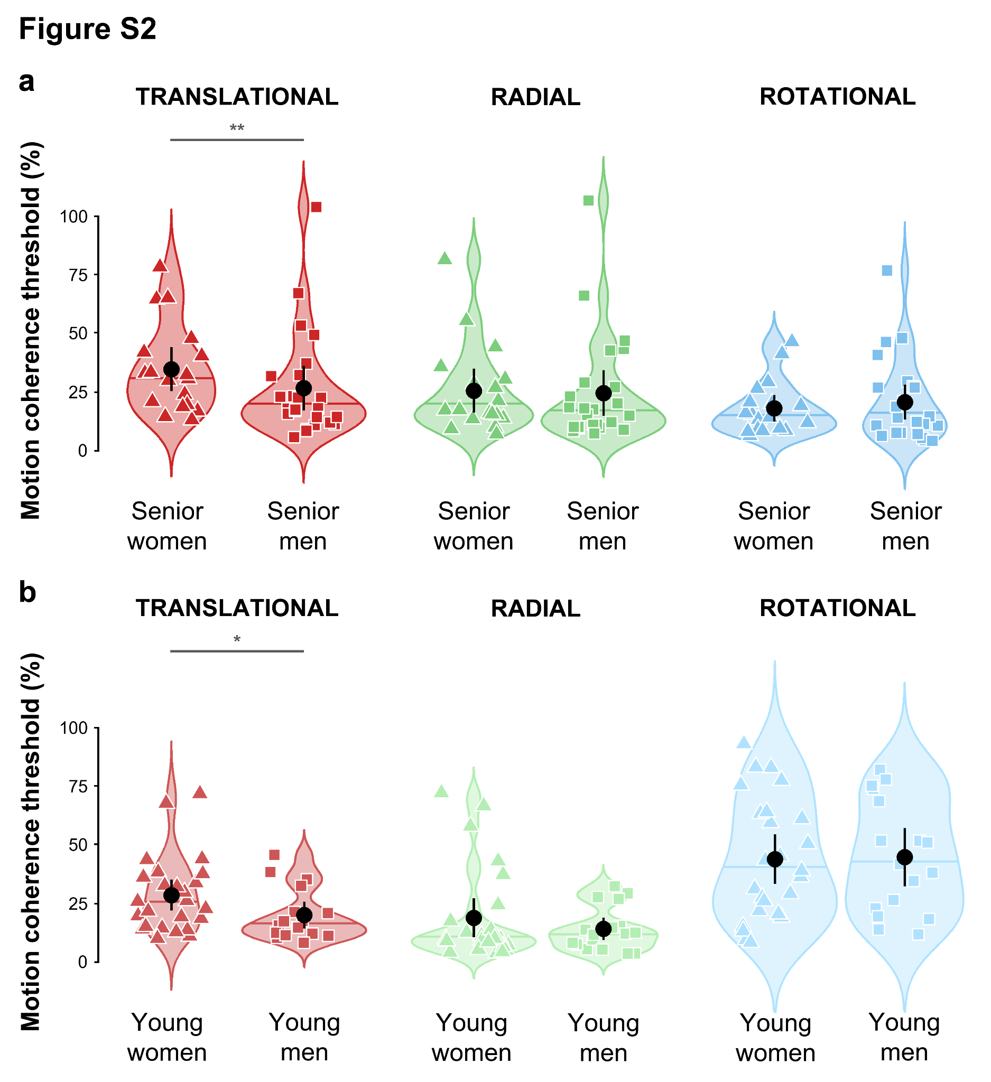
Distributions of the motion coherence thresholds estimated for translational (red), radial (green), and rotational (blue) optic flow patterns without a scotoma. Black dots represent group-level means of the (a) senior women (triangles) and senior men (squares) and (b) young women (triangles) and young men (squares). Error bars represent the associated 95 percent confidence intervals. Horizontal colored lines represent group-level medians. Circles provide the individual data points of the distributions. Note that they were slightly offset horizontally to improve their visibility. Stars indicate significantly different distributions (**, p < 0.01; *, p < 0.05).

Supplementary Text S3: Effect of speed on motion coherence thresholds in young and old participants

An ANOVA with the group (young or older participants) and the gender (women or men) as between factors and the optic flow pattern (translational, rotational or radial), the viewing condition (with or without a simulated scotoma) and the speed (7°/s our14°/s) as within factors was run. The effect of the viewing condition was significant, F(1,42) = 6.06, p = 0.018, with higher thresholds when the simulated scotoma was present (mean without scotoma = 23.5 ± 19.3 %, mean without scotoma = 24.7 ± 18.7 %). The results for the optic pattern and the interaction between group and pattern remained unchanged, respectively F(2,84) = 19.57, p < 0.001 and F(2,84) = 25.29, p < 0.001. Independently of the group, thresholds were lower radial than for rotational (mean radial = 17.9 ± 15.4 %, mean rotational = 29.7 ± 21.5 %, p = 0.001 and translational pattern (mean translational = 24.8 ± 17.7 %, p < 0.01). Coherence thresholds did not differ between rotational and translational patterns (p = 0.431). Similarly, older participant had higher thresholds for radial motion than the younger participants (mean young participant = 15.3 ± 13.7 %, mean old participants = 20.5 ± 16.5 %, p = 0.002), lower thresholds for rotational pattern (mean young = 41.0 ± 23.2 %, mean old = 18.4 ± 11.8 %, p < 0.001), and thresholds were equivalent in both groups for translational pattern (mean young = 23.7 ± 15.9 %, mean old = 25.8 ± 19.3 %, p = 0.697).

The interaction between the speed and the optic flow pattern was significant as well (F(2,84) = 3.69, p = 0.035). Post-hoc t-tests indicate that thresholds were lower at higher speed for the translational pattern (mean translational 7°/s = 26.0 ± 14.8 %, mean translational 14°/s = 23.6 ± 20.1 %, p = 0.023), but no difference at the different speeds were found for the rotational (mean rotational 7°/s = 29.8 ± 21.5 %, mean rotational 14°/s = 29.7 ± 21.7 %, p = 0.984) or radial (mean radial 7°/s = 19.1 ± 16.6 %, mean radial 14°/s = 16.6 ± 14.0 %, p = 0.199) patterns. Furthermore, at 7°/s and 14°/s, thresholds were lower for radial pattern than for rotational (p < 0.001) and translational pattern (p < 0.001), no difference was found between rotational and translational patterns (p = 1.0 at 7°/s and p = 0.059 at 14°/s).

With the 14°/s data, the ANOVA also led to a significant effect of the optic flow pattern and to an interaction between the group and the optic flow pattern (p < 0.001). However, post-hoc analysis showed that if the effect for the rotational pattern remained unchanged (higher thresholds in young participants, p < 0.001), the difference between young and older participants for the radial pattern was not observed anymore at a higher motion speed (p = 0.323). Figure S3 shows these results. Data in the viewing condition without a scotoma are shown in panel A and with a scotoma in panel B.
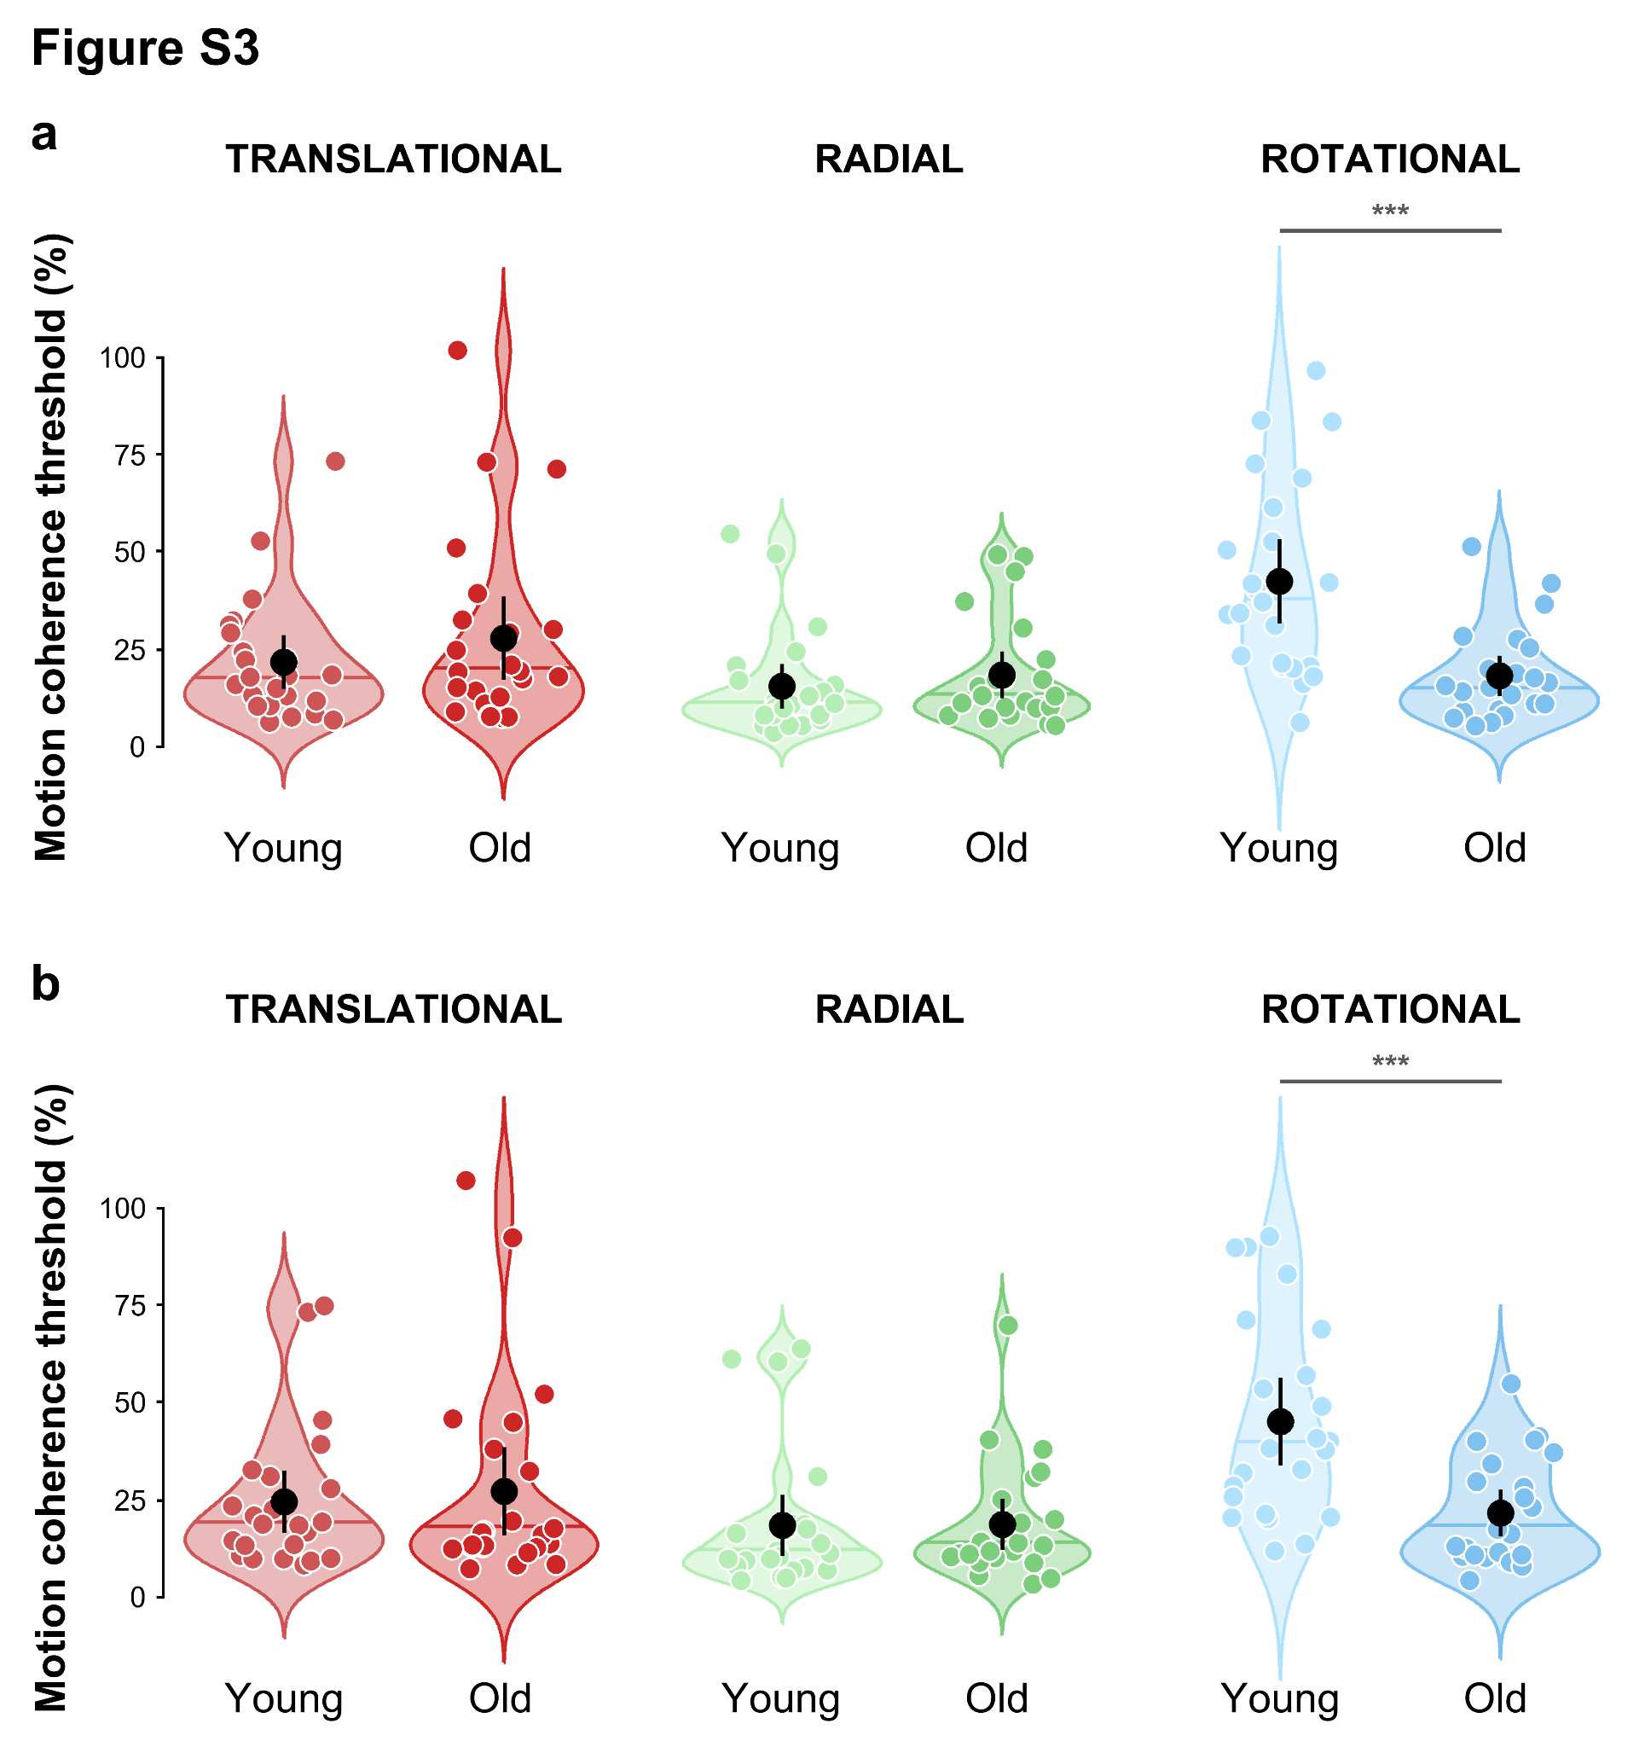
Distributions of the motion coherence thresholds estimated for translational (red), radial (green), and rotational (blue) optic flow patterns in a sub-group of participants at 14°/s motion speed, (a) without a scotoma and (b) with a scotoma. Black dots represent group-level means of the young (age: 18-30, n = 23) and old (age: 70-90, n = 23) adults groups. Error bars represent the associated 95 percent confidence intervals. Horizontal colored lines represent group-level medians. Circles provide the individual data points of the distributions. Note that they were slightly offset horizontally to improve their visibility. Stars indicate significantly different distributions (***, p < 0.001).

Supplementary Text S4: Reaction times

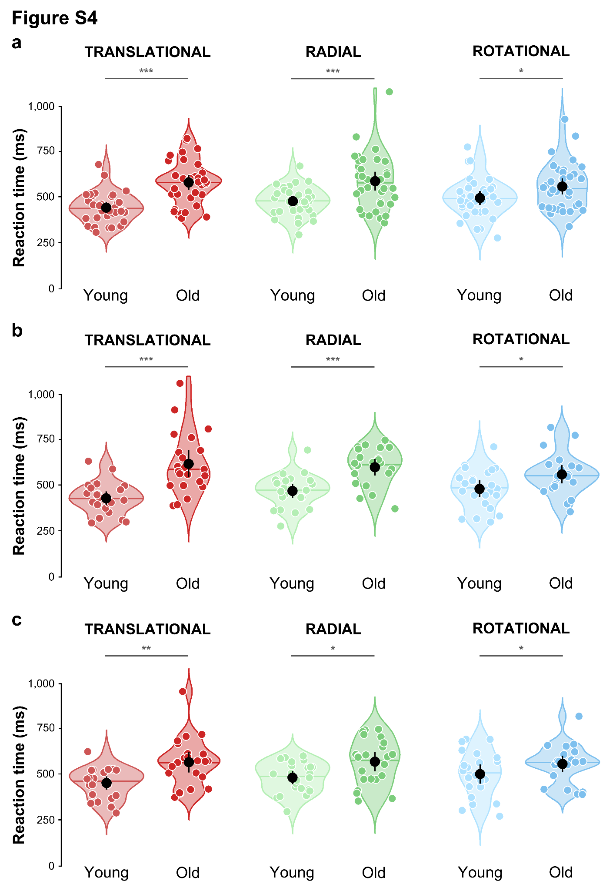
Reaction times estimated for translational (red), radial (green), and rotational (blue) optic flow patterns. Panel (a) shows data of young and old participants with a scotoma and at 7°/s motion speed. Panel (b) shows data of a subgroup of young and old participants without a scotoma and at 14°/s motion speed. Panel (c) shows data of a subgroup of young and old participants with a scotoma and at 14°/s motion speed. Black dots represent group-level means of the groups. Error bars represent the associated 95 percent confidence intervals. Horizontal colored lines represent group-level medians. Circles provide the individual data points of the distributions. Note that they were slightly offset horizontally to improve their visibility. Stars indicate significantly different distributions (***, p < 0.001; **, p < 0.01; * p < 0.05).
Finally, Figure S4 shows reaction times of young and old participants under all visual conditions. Panel A represents reaction times when the central part of the stimuli was masked by an artificial scotoma at 7°/s motion speed. Panel A shows reaction times when the stimuli were displayed full-field (without scotoma) at 14°/s motion speed. Panel C depicts reaction times when the central part of the stimuli was masked by an artificial scotoma at 14°/s motion speed.

Supplementary Figure S5: Bias analysis

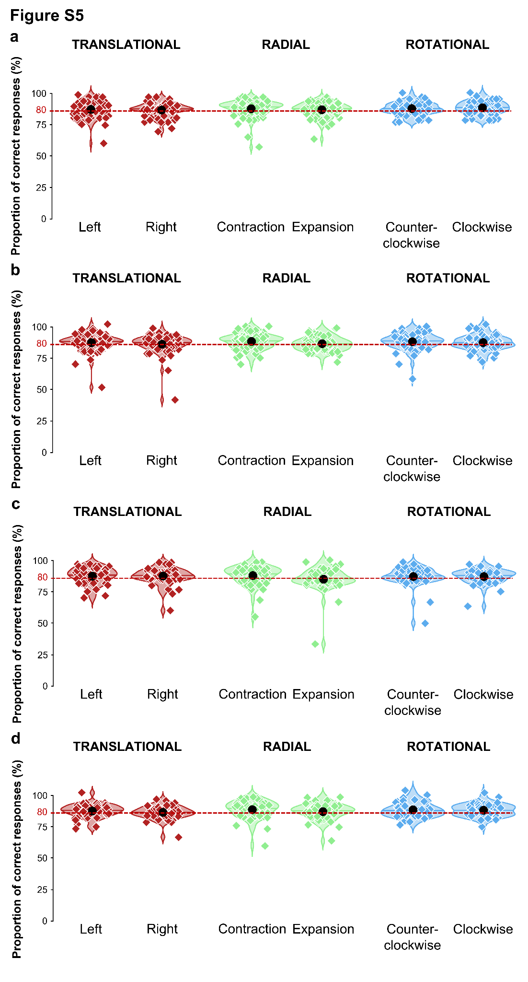
Proportion of correct responses for leftward and rightward motions (translational pattern), contraction and expansion (radial pattern), and counterclockwise and clockwise motions (rotational pattern). Red line corresponds to a performance level of 80%. Black dots represent means of proportion of correct responses for each direction of each optic flow pattern. Diamonds provide the individual data points of the distributions. Note that they were slightly offset horizontally to improve their visibility. Paired t-tests between the different data in controls and patients did not lead to any significant effects. Data represented are: (a) participants data without scotoma at 7°/s motion speed, (b) participants data with a scotoma at 7°/s motion speed, (c) participants data without scotoma at 14°/s motion speed and (d) participants data with a scotoma at 14°/s motion speed.

