Amorphous Ni-Mn-O Microspheres with High Energy Density and Ultralong-Term Stability up to 100, 000 Cycles for Aqueous Pseudo-Capacitors
Yingxv Gao #, Qian Ma #, Xiaohong Xia *, Hongbo Liu *
College of Material Science and Engineering, Hunan University, Changsha, Hunan 410082, China
*Corresponding author email: xxh@hnu.edu.cn (Xia X.); hndxlhb@163.com (Liu H.)
# Both the authors contributed equally to this work.

Supplementary equations

For the three-electrode system, C_{s} (C g⁻¹) was calculated from GCD measurements according to equations S1:
C_{s} = $\text{(i}\text{·}\text{Δt) / m}$ (S1)
where m (g) embodies the mass of the active materials on working electrodes, i (A) represents the discharge current and $\text{Δt}$ (s) depicts the discharge time.
For two-electrode systems, energy density E (Wh kg⁻¹ ) and power density P (W kg⁻¹ ) were calculated using equations S2 and S3 ^{[1, 2]}, respectively:
E = $\text{∫ }\text{i}\text{·}\text{V}\text{ d}\text{t} \text{/ (3.6 }\text{M}\text{)}$ (S2)
P = $E / (t / 3600)$ (S3)
where i (A) represents the discharge current, $\text{V}$ (V) conveys the potential, t (s) depicts the discharge time, M (g) embodies the total mass of active materials in both cathode and anode (M = m_{c} + m_{a}). Notably, M is 0.0040 g for SPC.
The formation mechanism of Ni(OH)₂ under hydrothermal conditions can be described by equation S4-S6 ^{[3]}:
Ni + nH₂O → [Ni(H₂O)_{n}]²⁺ + 2e⁻ (S4)
O₂ + 2H₂O + 4e⁻ → 4OH⁻ (S5)
[Ni(H₂O)_{n}]²⁺ + 2OH⁻ → Ni(OH)₂ + nH₂O (S6)
Under hydrothermal environment, hydration of Ni occurs at Ni foam surface so that [Ni(H₂O)_{n}]²⁺ and electrons form (equation S4). Then, dissolved O₂ adsorbed on the Ni foam surface acquires electrons and react with H₂O to form OH⁻ ions (equation S5). Finally, Ni(OH)₂ forms by the reaction between [Ni(H₂O)_{n}]²⁺ and OH⁻ ions (equation S6).
Supplementary figures
Fig. S1. SEM images of NF-24@MnO₂-C.
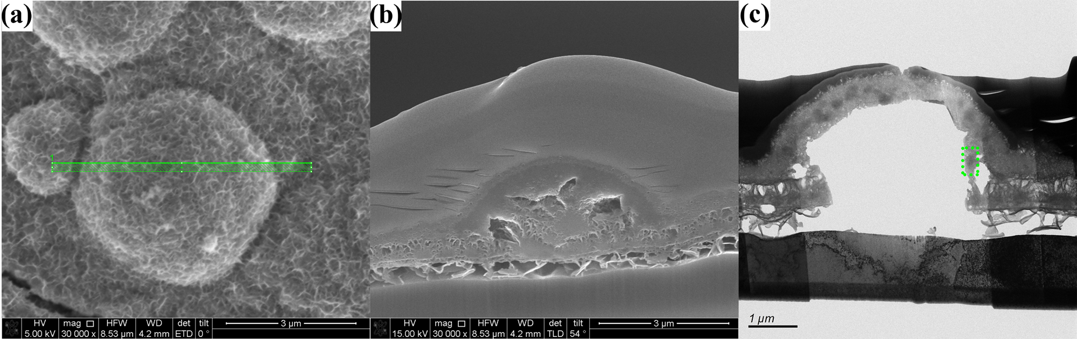
Fig. S2. The profile production of NF-24@MnO₂-C by FIB
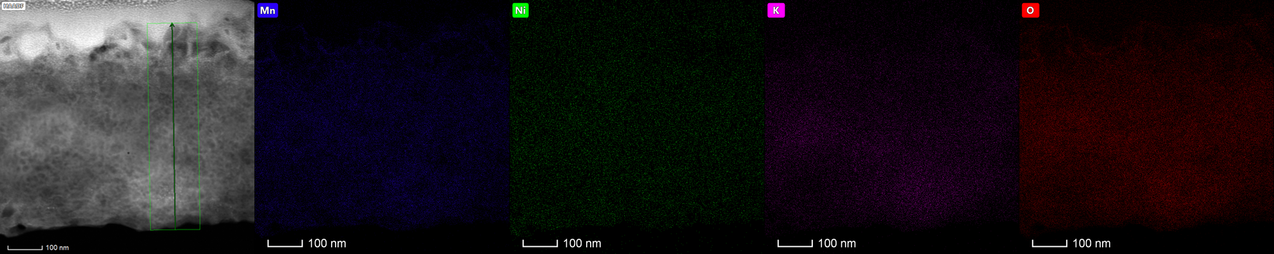
Fig. S3. STEM image of a part of shell in NF-24@MnO₂-C with EDX mappings.
Supplementary Tables
Table S1 Fitting parameters of corresponding equivalent circuit
Batteries | R_{el}/Ohm•cm² | R_{s}/Ohm• cm² | C_{s}/mF• cm⁻² | R_{ct}/Ohm•cm² | C_{dl}/mF•cm⁻² | Z_{w}/Ohm•cm²•s^{−0.5} | C_{int}/mF• cm⁻²
NF-24@MnO₂-A //NF-24@MnO₂-A | 0.49 | 1.00 | 0.06 | 2.96 | 0.06 | 5.05 | 1.14
NF-24@MnO₂-C //NF-24@MnO₂-C | 0.08 | 1.36 | 0.01 | 20.15 | 9.34  ×10⁻⁵ | 5.01 | 0.61
Table S2 The properties of NiMn_{1.57}O_{4.13} composite electrode were compared with those of similar composites reported in recent years.
Sample description | Synthesis | Electrolyte | Capacitance F g⁻¹ | Cycle performance | Ref
NF-24@MnO₂-A | electrochemical activation | Ni foam | 1390 F g⁻¹  (5 A g⁻¹) | 106.1 %  (100,000 cycles, 5 A g⁻¹) | This work
Ni(OH)₂-MnO₂@C | hydrothermal | Ni foam | 1608 F g⁻¹  (2 mA cm⁻²) | 93.9 %  (5000 cycles, 2 mA cm⁻²)) | [4]
Ni/MnO  nanosheet arrays | co-precipitation | Ni foam | 1235.6 F g⁻¹  (0.5 A g⁻¹) | 106 %  (15,000 cycles, 10 A g⁻¹) | [5]
PC-Ni/MnO₂ | calcination | carbon material | 267.34 F g⁻¹  (0.1 A g⁻¹) | 83.6 %  (5000 cycles, 1 A g⁻¹) | [6]
NiCo₂O₄ | pulsed laser ablation | Ni foam | 1650 F g⁻¹  (1 A g⁻¹) | 91.78 %  (12,000 cycles, 10 A g⁻¹) | [7]
NiMoO₄ | electrodeposition and hydrothermal | Ni foam | 2813 F g⁻¹  (3 A g⁻¹) | 94 %  (5000 cycles, 3 A g⁻¹) | [8]
MnO₂-CuO | hydrothermal | Ni foam | 279.2 F g⁻¹  (0.5 A g⁻¹) | 91.26 %  (10,000 cycles, 0.5 A g⁻¹) | [9]
3D-MnO₂/Ni | electrodeposition | Ni foam | 105 F g⁻¹  (0.5 A g⁻¹) | 97 %  (10,000 cycles, 7.5 A g⁻¹) | [10]
α- MnO₂ | hydrothermal | Ni foam | 294.5 F g⁻¹  (2 A g⁻¹) | 84.4 %  (5000 cycles, 1 A g⁻¹) | [11]
CuS/MnS@NF | solvothermal synthesis | Ni foam | 1517.07 F g⁻¹  (1 A g⁻¹) | 115.6 %  (3000 cycles, 10 A g⁻¹) | [12]
M-Fe₂O₃@MnO₂ | hydrothermal | Ni foam | 908.5 F g⁻¹  (1 A g⁻¹) | 78.7%  (8000 cycles, 1 A g⁻¹) | [13]
CoNi₂S₄-Ni(OH)₂NSAs | hydrothermal | Ni foam | 1570.2 F g⁻¹  (1 A g⁻¹) | 97.91%  (5000 cycles, 1 A g⁻¹) | [14]
NiO nanowires @NiO nanosheets @ NF | microwave-assisted hydrothermal synthesis | Ni foam | 1782 F g⁻¹  (1 A g⁻¹) | 70.33%  (5000 cycles, 1 A g⁻¹) | [15]
NiO@MnO₂ | hydrothermal route | Ni foam | 1227.2 F g⁻¹  (10 A g⁻¹) | 88.77%  (10,000 cycles, 10 A g⁻¹) | [16]

References

[1] B.S. Singu, S.E. Hong, K.R. Yoon, Chemical synthesis of sea-urchin shaped 3D-MnO₂ nano structures and their application in supercapacitors, Journal of Nanoscience and Nanotechnology 16(6) (2016) 6093-6101. https://doi.org/10.1166/jnn.2016.12114.
[2] Y. Ouyang, X.F. Xia, H.T. Ye, L. Wang, X.Y. Jiao, W. Lei, Q.L. Hao, Three-dimensional hierarchical structure ZnO@C@NiO on carbon cloth for asymmetric supercapacitor with enhanced cycle stability, Acs Applied Materials & Interfaces 10(4) (2018) 3549-3561. https://doi.org/10.1021/acsami.7b16021.
[3] K.D. Xia, C. Yang, Y.L. Chen, L.L. Tian, Y.Y. Su, J.B. Wang, L. Li, In situ fabrication of Ni(OH)₂ flakes on Ni foam through electrochemical corrosion as high sensitive and stable binder-free electrode for glucose sensing, Sensors and Actuators B-Chemical 240 (2017) 979-987. https://doi.org/10.1016/j.snb. 2016.09.077.
[4] J. Li, W. Cao, N. Zhou, F. Xu, N. Chen, Y. Liu, G. Du, Hierarchically nanostructured Ni(OH)₂-MnO₂@C ternary composites derived from Ni-MOFs grown on nickel foam as high-performance integrated electrodes for hybrid supercapacitors, Electrochimica Acta 343 (2020) 136139. https://doi.org/10.1016/ j.electacta. 2020.136139.
[5] M. Huang, Y. Lin, H. Huang, X. Fan, K. Shi, Z. Yang, W. Zhang, Nickel nanoparticles modified MnO nanosheet arrays for high-performance supercapacitor with long-lasting and sustainable capacitance increase, Electrochimica Acta 383 (2021) 138353. https://doi.org/10.1016/j.electact a.2021.138353.
[6] X. Ji, D. Sun, W. Zou, Z. Wang, D. Sun, Ni/MnO₂ doping pulping lignin-based porous carbon as supercapacitors electrode materials, Journal of Alloys and Compounds 876 (2021) 160112. https://doi. org/10.1016/j.jallcom.2021.160112.
[7] R. Bai, X. Luo, D. Zhen, C. Ci, J. Zhang, D. Wu, M. Cao, Y. Liu, Facile fabrication of comb-like porous NiCo₂O₄ nanoneedles on Ni foam as an advanced electrode for high-performance supercapacitor, International Journal of Hydrogen Energy 45(56) (2020) 32343-32354. https://doi.org/10.1016/j.ijhydene. 2020.08.156.
[8] S. Normohammadi, F. Bahmani, L. Fotouhi, M. Khoshfetrat, Electrodeposited nickel nanocone/ NiMoO₄ nanocomposite designed as superior electrode materials for high performance supercapacitor, International Journal of Hydrogen Energy 47(8) (2022) 5220-5229. https://doi.org/10.1016/ j.ijhydene.2021.11.161.
[9] K.M. Racik, A. Manikandan, M. Mahendiran, P. Prabakaran, J. Madhavan, M.V.A. Raj, Fabrication of manganese oxide decorated copper oxide (MnO₂/CuO) nanocomposite electrodes for energy storage supercapacitor devices, Physica E: Low-dimensional Systems and Nanostructures 119 (2020) 114033. https://doi.org/10.1016/j.physe.2020.114033.
[10] N. Swain, A. Mitra, B. Saravanakumar, S.K. Balasingam, S. Mohanty, S.K. Nayak, A. Ramadoss, construction of three-dimensional MnO₂/Ni network as an efficient electrode material for high performance supercapacitors, Electrochimica Acta 342 (2020) 136041. https://doi.org/10.1016/j.electact a.2020.136041.
[11] S. Jiang, B. Yang, Y. Lu, R. Xia, T. Yu, M. Gao, An aqueous symmetrical supercapacitor with high bulk pseudocapacitance induced by phase transformation of MnO₂, Journal of Alloys and Compounds 876 (2021) 160148. https://doi.org/10.1016/j.jallcom.2021.160148.
[12] M. Zhai, Y. Cheng, Y. Jin, J. Hu, Solvothermal synthesis of flower-like structure Cu-Mn bimetallic sulfide on Ni-foam for high-performance symmetric supercapacitors, International Journal of Hydrogen Energy 44(26) (2019) 13456-13465. https://doi.org/10.1016/j.ijhydene.2019.04.021.
[13] Y. Chen, C. Kang, L. Ma, L. Fu, G. Li, Q. Hu, Q. Liu, MOF-derived Fe₂O₃ decorated with MnO₂ nanosheet arrays as anode for high energy density hybrid supercapacitor, Chemical Engineering Journal 417 (2021) 129243. https://doi.org/10.1016/j.cej.2021.129243.
[14] A.K. Yedluri, D.K. Kulurumotlakatla, S. Sangaraju, I.M. Obaidat, H.-J. Kim, Facile synthesis of novel and highly efficient CoNi₂S₄-Ni(OH)₂ nanosheet arrays as pseudocapacitive-type electrode material for high-performance electrochemical supercapacitors, Journal of Energy Storage 31 (2020) 101623. https://doi.org/10.1016/j.est.2020.101623.
[15] A. Ali, M. Ammar, A. Mukhtar, T. Ahmed, M. Ali, M. Waqas, M.N. Amin, A. Rasheed, 3D NiO nanowires@NiO nanosheets core-shell structures grown on nickel foam for high performance supercapacitor electrode, Journal of Electroanalytical Chemistry 857 (2020) 113710. https://doi.org/ 10.1016/j.jelechem.2019.113710.
[16] T.-F. Yi, J. Mei, B. Guan, P. Cui, S. Luo, Y. Xie, Y. Liu, Construction of spherical NiO@MnO₂ with core-shell structure obtained by depositing MnO₂ nanoparticles on NiO nanosheets for high-performance supercapacitor, Ceramics International 46(1) (2020) 421-429. https://doi.org/10.1016/j.ceramint.20 19.08.278.

