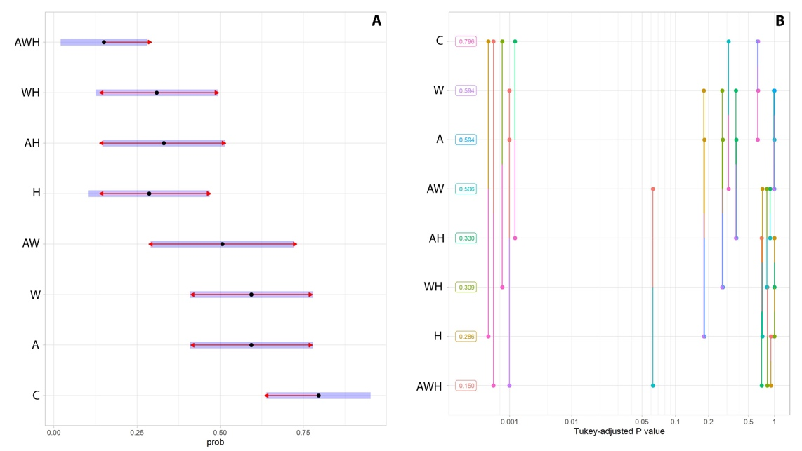
WAD
WD
AD
D
AW
W
A
C
WAD
WD
AD
D
AW
W
A
C

Figure S1. Multi-treatment post hoc comparative analysis of the effects of warming, acidification and deoxygenation treatments, in the hatching rates of early developmental stages of Sparus aurata (emmeans package). (A) shows 95% confidence intervals for each treatment estimate (black dots), as well as direction of significant differences (red arrows). Ordered by the same estimates, (B) shows the distribution of Tukey-adjusted p-values and pairwise comparisons between each experimental treatment (i.e. all connections left of p-value = 0.05 are significantly different). Legend description: C – control, W – warming, A – acidification, AW – acidification + warming, D – deoxygenation, WD – warming + deoxygenation, AD – acidification + deoxygenation, and AWD – acidification + warming + deoxygenation experimental treatment.

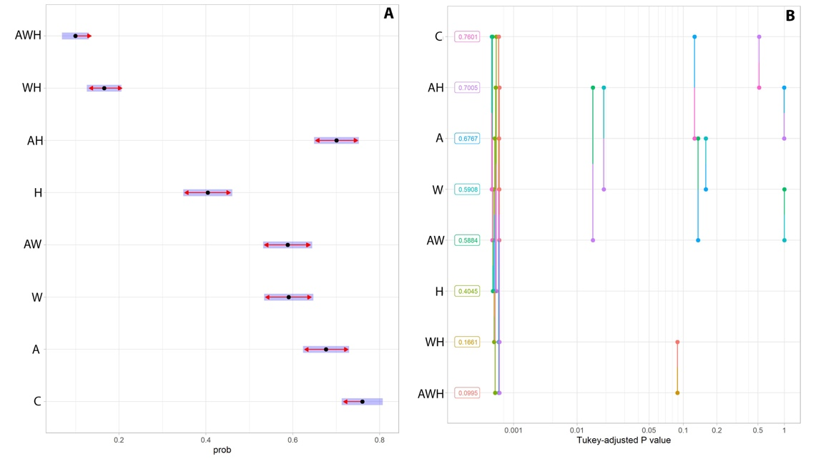
WAD
WD
AD
D
AW
W
A
C
WAD
WD
AD
D
AW
W
A
C
Figure S2. Multi-treatment post hoc comparative analysis of the effects of warming, acidification and deoxygenation treatments, in the survival rates of the early developmental stages of Sparus aurata (emmeans package). (A) shows 95% confidence intervals for each treatment estimate (black dots), as well as direction of significant differences (red arrows). Ordered by the same estimates, (B) shows the distribution of Tukey-adjusted p-values and pairwise comparisons between each experimental treatment (i.e. all connections left of p-value = 0.05 are significantly different). Legend description: C – control, W – warming, A – acidification, AW – acidification + warming, D – deoxygenation, WD – warming + deoxygenation, AD – acidification + deoxygenation, and AWD – acidification + warming + deoxygenation experimental treatment.

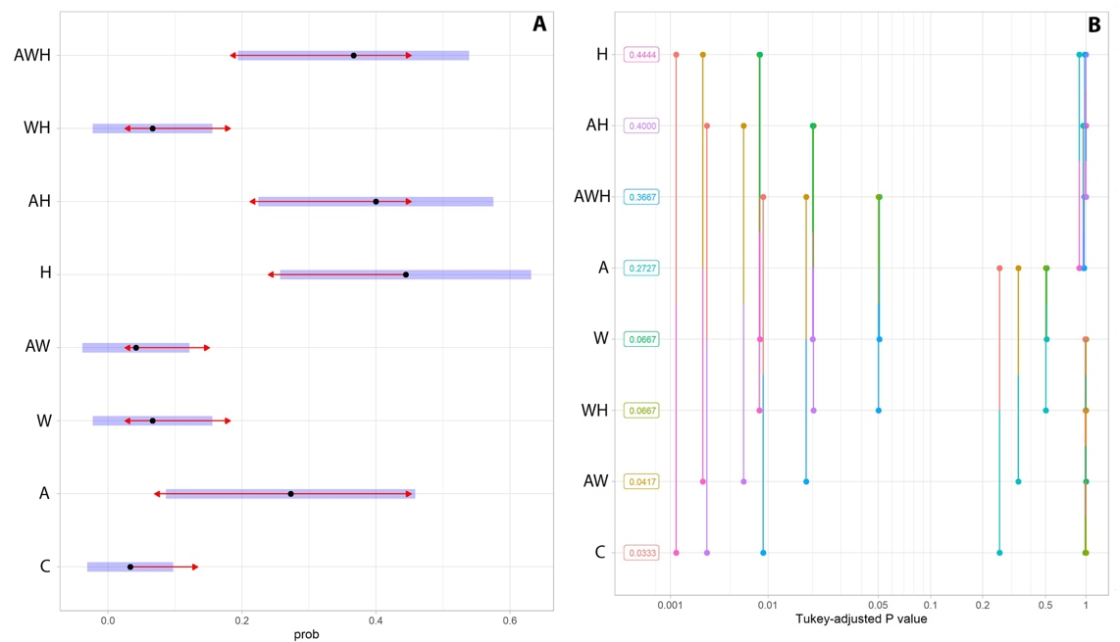
WAD
WD
AD
D
AW
W
A
C
WAD
WD
AD
D
AW
W
A
C
Figure S3. Multi-treatment post hoc comparative analysis of the effects of warming, acidification, and deoxygenation treatments, in deformities rates of the early developmental stages of Sparus aurata (emmeans package). (A) shows 95% confidence intervals for each treatment estimate (black dots), as well as direction of significant differences (red arrows). Ordered by the same estimates, (B) shows the distribution of Tukey-adjusted p-values and pairwise comparisons between each experimental treatment (i.e. all connections left of p-value = 0.05 are significantly different). Legend description: C – control, W – warming, A – acidification, AW – acidification + warming, D – deoxygenation, WD – warming + deoxygenation, AD – acidification + deoxygenation, and AWD – acidification + warming + deoxygenation experimental treatment.

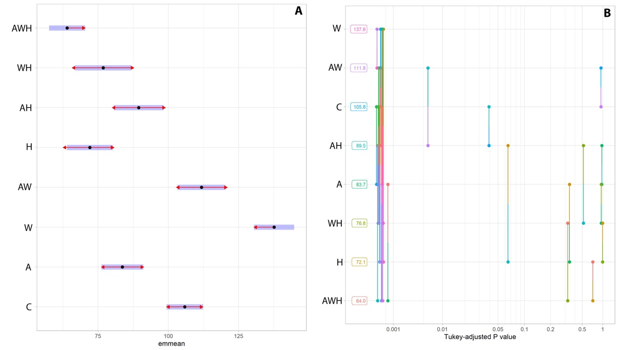
WAD
WD
AD
D
AW
W
A
C
WAD
WD
AD
D
AW
W
A
C
Figure S4. Multi-treatment post hoc comparative analysis of the effects of warming, acidification and deoxygenation treatments, in the heart rates of the early developmental stages of Sparus aurata (emmeans package). (A) shows 95% confidence intervals for each treatment estimate (black dots), as well as direction of significant differences (red arrows). Ordered by the same estimates, (B) shows the distribution of Tukey-adjusted p-values and pairwise comparisons between each experimental treatment (i.e. all connections left of p-value = 0.05 are significantly different). Legend description: C – control, W – warming, A – acidification, AW – acidification + warming, D – deoxygenation, WD – warming + deoxygenation, AD – acidification + deoxygenation, and AWD – acidification + warming + deoxygenation experimental treatment.

