Author biography

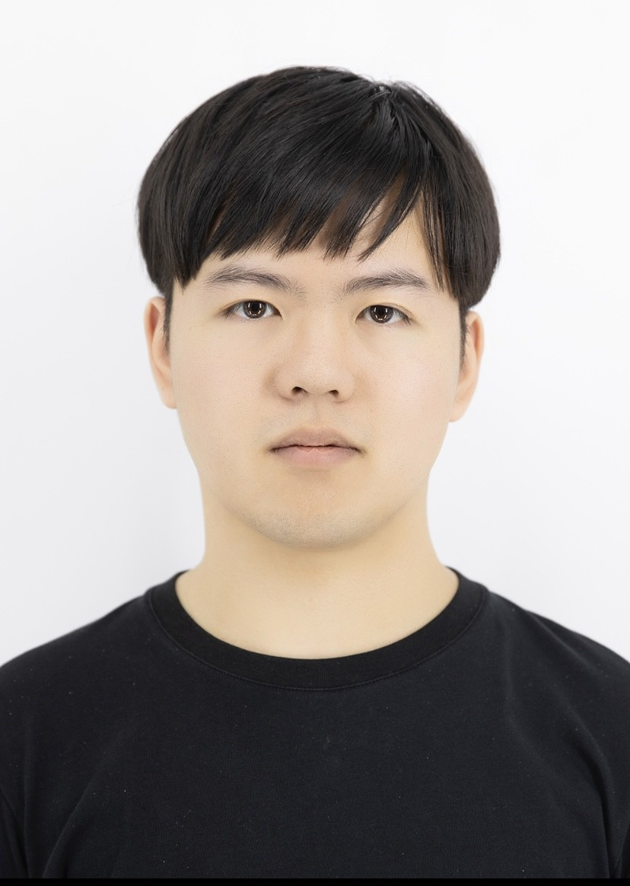
Jinzhen Han is a Ph.D. candidate at Sungkyunkwan Uni- versity. He specializes in automated data processing in mea- surement and holds a Bachelor’s degree from Beijing Uni- versity of Civil Engineering and Architecture and a Master’s degree from Sungkyunkwan University. His research aims to develop more accurate and efficient tools and procedures to assist in survey engineering.

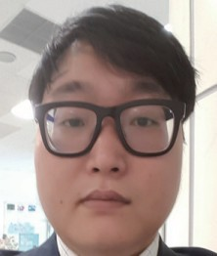
Seungjun Lee SeungJun Lee received his B.S. and M.S. Ph.D. degrees from Sungkyunkwan University, Korea, in 2003 and 2023, respectively. His research interests are in GNSS survey adjustment, GIS, geospatial data analysis and 3D GIS.

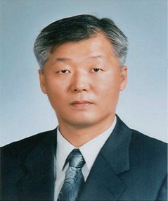
Hongsik Yun n received his B.S. and M.S. degrees from Sungkyunkwan University, Korea in 1984 and 1987, respec- tively. He received his Ph.D. degree from the Technical Uni- versity of Budapest, Hungary in 1995. Since 1999, he has been a professor at Sungkyunkwan University. His research interests are in satellite geodesy, GNSS positioning, and geoid modeling.

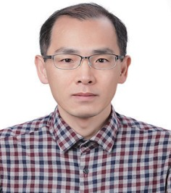
Kwangbae Kim received his B.S. and M.S. degrees from Sungkyunkwan University, Korea in 1993 and 1996, respec- tively. He also received his M.S.degree from Ohio State Uni- versity, USA in 2001 and Ph.D. degree from Kunsan Na- tional University, Korea in 2016, respectively. Since 2016, he has been a research professor at Sungkyunkwan Uni- versity. His research interests are in satellite geodesy and
bathymetry mapping.

PyRINEX: A New Multi-Purpose Python Package for GNSS RINEX Data 13
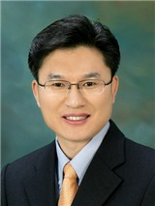
Sangwon Bae As a former civil engineering major at Dong-A University(B.S. degrees) and a graduate of Yon- sei University’s Disaster Prevention and Safety Engineer- ing program(M.S. degrees), he went on to become a section chief in the Ministry of Public Administration and Security. There, he were responsible for establishing disaster preven- tion plans and developing mitigation strategies.

