Supplementary figures
Fig. S1 The keystone OTUs identified in the Zi-Pi plots of each molecular ecological network
Fig. S2 The taxonomic assignment of the keystone OTUs
Fig. S3 The taxonomic differences between the two varieties based on metagenomic sequencing using Linear discriminant analysis Effect Size (LEfSe)
Fig. S4 The KOs differed in abundance in the epiphytic phyllosphere between the two varieties
Fig. S5 Polymorphism distribution patterns in all the bins assembled from the tobacco phyllosphere

Supplementary tables
Table S1 The taxonomic assignment of the keystone OTUs identified in the Zi-Pi plots
Table S2 Number of entries with higher abundance in each compartment of each variety

Fig. S1 The keystone OTUs identified in the Zi-Pi plots of each molecular ecological network
Fig.S2 The taxonomic assignment of the keystone OTUs
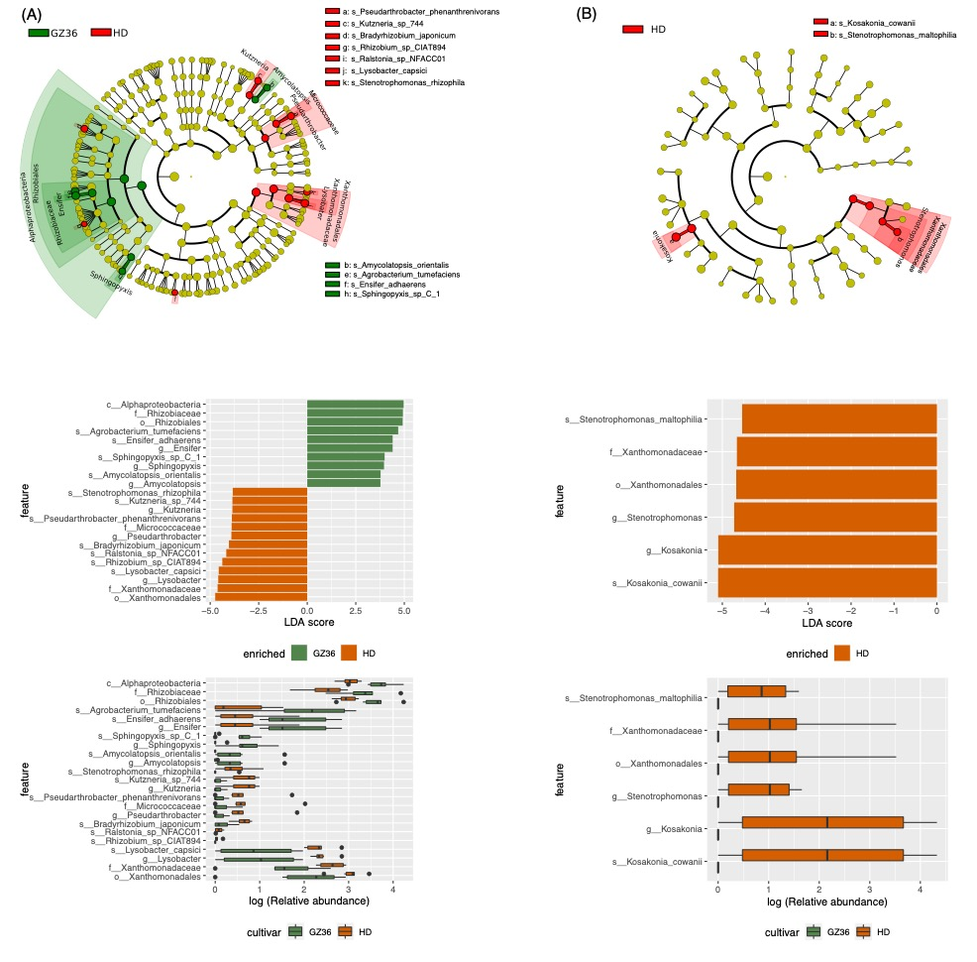
Fig. S3 The taxonomic differences between the two varieties based on metagenomic sequencing using Linear discriminant analysis Effect Size (LEfSe). (A) The rhizosphere and root endosphere were combined as root samples. (B) The epiphytic and endophytic leaf compartments were combined as phyllosphere.

Fig. S4 The KOs differed in abundance in the epiphytic phyllosphere between the two varieties.
Fig. S4. Polymorphism distribution patterns in all the bins assembled from the tobacco phyllosphere. Each dot represent a pN/pS for a protein.

Supplementary tables
Table S1 The taxonomic assignment of the keystone OTUs identified in the Zi-Pi plots
(a) The keystone OTUs in the root compartment of the variety GZ36
Nodes | Type | Taxonamy
Zotu1748 | Connectors | d:Bacteria
Zotu2992 | Connectors | d:Bacteria
Zotu304 | Connectors | d:Bacteria,p:Actinobacteria
Zotu910 | Connectors | d:Bacteria,p:Actinobacteria,c:Actinobacteria,o:Geodermatophilales,f:Geodermatophilaceae,g:Blastococcus
Zotu1533 | Connectors | d:Bacteria,p:Actinobacteria,c:Actinobacteria,o:Micrococcales,f:Promicromonosporaceae,g:Promicromonospora
Zotu447 | Connectors | d:Bacteria,p:Actinobacteria,c:Actinobacteria,o:Propionibacteriales,f:Nocardioidaceae,g:Marmoricola
Zotu536 | Connectors | d:Bacteria,p:Actinobacteria,c:Actinobacteria,o:Pseudonocardiales,f:Pseudonocardiaceae
Zotu982 | Connectors | d:Bacteria,p:Actinobacteria,c:Actinobacteria,o:Pseudonocardiales,f:Pseudonocardiaceae
Zotu912 | Connectors | d:Bacteria,p:Actinobacteria,c:Actinobacteria,o:Pseudonocardiales,f:Pseudonocardiaceae,g:Amycolatopsis
Zotu2715 | Connectors | d:Bacteria,p:Actinobacteria,c:Actinobacteria,o:Streptomycetales,f:Streptomycetaceae,g:Streptomyces
Zotu1046 | Connectors | d:Bacteria,p:Actinobacteria,c:Thermoleophilia,o:Solirubrobacterales
Zotu858 | Connectors | d:Bacteria,p:Actinobacteria,c:Thermoleophilia,o:Solirubrobacterales
Zotu545 | Connectors | d:Bacteria,p:Bacteroidetes,c:Chitinophagia,o:Chitinophagales,f:Chitinophagaceae,g:Chitinophaga
Zotu10882 | Connectors | d:Bacteria,p:Proteobacteria,c:Alphaproteobacteria,o:Rhizobiales
Zotu1223 | Connectors | d:Bacteria,p:Proteobacteria,c:Alphaproteobacteria,o:Rhizobiales
Zotu742 | Connectors | d:Bacteria,p:Proteobacteria,c:Alphaproteobacteria,o:Rhizobiales
Zotu8987 | Connectors | d:Bacteria,p:Proteobacteria,c:Alphaproteobacteria,o:Rhizobiales
Zotu916 | Connectors | d:Bacteria,p:Proteobacteria,c:Alphaproteobacteria,o:Rhizobiales
Zotu567 | Connectors | d:Bacteria,p:Proteobacteria,c:Alphaproteobacteria,o:Rhizobiales,f:Bradyrhizobiaceae
Zotu943 | Connectors | d:Bacteria,p:Proteobacteria,c:Alphaproteobacteria,o:Rhizobiales,f:Bradyrhizobiaceae
Zotu492 | Connectors | d:Bacteria,p:Proteobacteria,c:Alphaproteobacteria,o:Rhizobiales,f:Hyphomicrobiaceae,g:Hyphomicrobium
Zotu254 | Connectors | d:Bacteria,p:Proteobacteria,c:Alphaproteobacteria,o:Rhizobiales,f:Phyllobacteriaceae,g:Mesorhizobium
Zotu340 | Connectors | d:Bacteria,p:Proteobacteria,c:Alphaproteobacteria,o:Rhizobiales,f:Phyllobacteriaceae,g:Mesorhizobium
Zotu839 | Connectors | d:Bacteria,p:Proteobacteria,c:Alphaproteobacteria,o:Rhizobiales,f:Rhizobiaceae,g:Rhizobium
Zotu937 | Connectors | d:Bacteria,p:Proteobacteria,c:Alphaproteobacteria,o:Rhizobiales,f:Rhizobiaceae,g:Rhizobium
Zotu479 | Connectors | d:Bacteria,p:Proteobacteria,c:Alphaproteobacteria,o:Sphingomonadales,f:Erythrobacteraceae
Zotu3375 | Connectors | d:Bacteria,p:Proteobacteria,c:Alphaproteobacteria,o:Sphingomonadales,f:Sphingomonadaceae,g:Sphingomonas
Zotu183 | Connectors | d:Bacteria,p:Proteobacteria,c:Alphaproteobacteria,o:Sphingomonadales,f:Sphingomonadaceae,g:Sphingopyxis
Zotu1416 | Connectors | d:Bacteria,p:Proteobacteria,c:Betaproteobacteria
Zotu1317 | Connectors | d:Bacteria,p:Proteobacteria,c:Betaproteobacteria,o:Burkholderiales,f:Comamonadaceae,g:Variovorax

(b) The keystone OTUs in the root compartment of the variety HD
Nodes | Type | Taxonamy
Zotu1253 | Connectors | d:Bacteria
Zotu805 | Connectors | d:Bacteria
Zotu828 | Connectors | d:Bacteria
Zotu1036 | Connectors | d:Bacteria,p:Acidobacteria,c:Acidobacteria_Gp1,g:Gp1
Zotu467 | Connectors | d:Bacteria,p:Actinobacteria
Zotu490 | Connectors | d:Bacteria,p:Actinobacteria
Zotu597 | Connectors | d:Bacteria,p:Actinobacteria
Zotu747 | Connectors | d:Bacteria,p:Actinobacteria
Zotu658 | Connectors | d:Bacteria,p:Actinobacteria,c:Actinobacteria,o:Catenulisporales,f:Actinospicaceae
Zotu764 | Connectors | d:Bacteria,p:Actinobacteria,c:Actinobacteria,o:Catenulisporales,f:Catenulisporaceae,g:Catenulispora
Zotu767 | Connectors | d:Bacteria,p:Actinobacteria,c:Actinobacteria,o:Frankiales,f:Frankiaceae,g:Jatrophihabitans
Zotu379 | Connectors | d:Bacteria,p:Actinobacteria,c:Actinobacteria,o:Micrococcales,f:Intrasporangiaceae
Zotu395 | Connectors | d:Bacteria,p:Actinobacteria,c:Actinobacteria,o:Mycobacteriales,f:Mycobacteriaceae,g:Mycobacterium
Zotu189 | Connectors | d:Bacteria,p:Actinobacteria,c:Actinobacteria,o:Mycobacteriales,f:Nocardiaceae
Zotu538 | Connectors | d:Bacteria,p:Actinobacteria,c:Actinobacteria,o:Propionibacteriales
Zotu1058 | Connectors | d:Bacteria,p:Actinobacteria,c:Actinobacteria,o:Propionibacteriales,f:Nocardioidaceae,g:Nocardioides
Zotu1200 | Connectors | d:Bacteria,p:Actinobacteria,c:Actinobacteria,o:Propionibacteriales,f:Nocardioidaceae,g:Nocardioides
Zotu860 | Connectors | d:Bacteria,p:Actinobacteria,c:Actinobacteria,o:Streptomycetales,f:Streptomycetaceae,g:Kitasatospora
Zotu2715 | Connectors | d:Bacteria,p:Actinobacteria,c:Actinobacteria,o:Streptomycetales,f:Streptomycetaceae,g:Streptomyces
Zotu701 | Connectors | d:Bacteria,p:Actinobacteria,c:Thermoleophilia
Zotu570 | Connectors | d:Bacteria,p:Actinobacteria,c:Thermoleophilia,o:Solirubrobacterales
Zotu931 | Connectors | d:Bacteria,p:Candidatus_Saccharibacteria,g:Saccharibacteria_genera_incertae_sedis
Zotu566 | Connectors | d:Bacteria,p:Gemmatimonadetes,c:Gemmatimonadetes
Zotu1183 | Connectors | d:Bacteria,p:Proteobacteria,c:Alphaproteobacteria,o:Caulobacterales,f:Caulobacteraceae,g:Caulobacter
Zotu9541 | Connectors | d:Bacteria,p:Proteobacteria,c:Alphaproteobacteria,o:Rhizobiales
Zotu1270 | Connectors | d:Bacteria,p:Proteobacteria,c:Alphaproteobacteria,o:Rhizobiales,f:Bradyrhizobiaceae
Zotu78 | Connectors | d:Bacteria,p:Proteobacteria,c:Alphaproteobacteria,o:Rhizobiales,f:Bradyrhizobiaceae,g:Bradyrhizobium
Zotu522 | Connectors | d:Bacteria,p:Proteobacteria,c:Alphaproteobacteria,o:Rhizobiales,f:Phyllobacteriaceae,g:Mesorhizobium
Zotu669 | Connectors | d:Bacteria,p:Proteobacteria,c:Alphaproteobacteria,o:Rhizobiales,f:Phyllobacteriaceae,g:Mesorhizobium
Zotu459 | Connectors | d:Bacteria,p:Proteobacteria,c:Alphaproteobacteria,o:Rhodospirillales,f:Reyranellaceae,g:Reyranella
Zotu113 | Connectors | d:Bacteria,p:Proteobacteria,c:Alphaproteobacteria,o:Sphingomonadales,f:Sphingomonadaceae,g:Sphingomonas
Zotu451 | Connectors | d:Bacteria,p:Proteobacteria,c:Alphaproteobacteria,o:Sphingomonadales,f:Sphingomonadaceae,g:Sphingomonas
Zotu475 | Connectors | d:Bacteria,p:Proteobacteria,c:Alphaproteobacteria,o:Sphingomonadales,f:Sphingomonadaceae,g:Sphingomonas
Zotu430 | Connectors | d:Bacteria,p:Proteobacteria,c:Betaproteobacteria
Zotu565 | Connectors | d:Bacteria,p:Proteobacteria,c:Betaproteobacteria
Zotu1423 | Connectors | d:Bacteria,p:Proteobacteria,c:Betaproteobacteria,o:Burkholderiales,f:Burkholderiaceae
Zotu1559 | Connectors | d:Bacteria,p:Proteobacteria,c:Betaproteobacteria,o:Burkholderiales,f:Comamonadaceae
Zotu544 | Connectors | d:Bacteria,p:Proteobacteria,c:Betaproteobacteria,o:Burkholderiales,f:Oxalobacteraceae,g:Herbaspirillum
Zotu1515 | Connectors | d:Bacteria,p:Proteobacteria,c:Gammaproteobacteria
Zotu2412 | Connectors | d:Bacteria,p:Proteobacteria,c:Gammaproteobacteria
Zotu514 | Connectors | d:Bacteria,p:Proteobacteria,c:Gammaproteobacteria,o:Xanthomonadales

(c) The keystone OTUs in the leaf compartment of the variety GZ36
Nodes | Type | Taxonamy
Zotu10048 | Connectors | d:Bacteria
Zotu2919 | Connectors | d:Bacteria
Zotu5261 | Connectors | d:Bacteria
Zotu8255 | Connectors | d:Bacteria,p:Actinobacteria,c:Actinobacteria,o:Kineosporiales,f:Kineosporiaceae,g:Kineococcus
Zotu9881 | Connectors | d:Bacteria,p:Actinobacteria,c:Actinobacteria,o:Micrococcales,f:Brevibacteriaceae,g:Brevibacterium
Zotu10093 | Connectors | d:Bacteria,p:Bacteroidetes
Zotu11192 | Connectors | d:Bacteria,p:Bacteroidetes,c:Bacteroidia,o:Bacteroidales
Zotu4749 | Connectors | d:Bacteria,p:Bacteroidetes,c:Bacteroidia,o:Bacteroidales
Zotu5517 | Connectors | d:Bacteria,p:Bacteroidetes,c:Bacteroidia,o:Bacteroidales
Zotu8347 | Connectors | d:Bacteria,p:Bacteroidetes,c:Bacteroidia,o:Bacteroidales,f:Bacteroidaceae
Zotu9103 | Connectors | d:Bacteria,p:Bacteroidetes,c:Bacteroidia,o:Bacteroidales,f:Bacteroidaceae
Zotu1922 | Connectors | d:Bacteria,p:Bacteroidetes,c:Bacteroidia,o:Bacteroidales,f:Bacteroidaceae,g:Phocaeicola
Zotu4014 | Connectors | d:Bacteria,p:Bacteroidetes,c:Bacteroidia,o:Bacteroidales,f:Dysgonomonadaceae,g:Petrimonas
Zotu10565 | Connectors | d:Bacteria,p:Bacteroidetes,c:Bacteroidia,o:Bacteroidales,f:Porphyromonadaceae
Zotu10667 | Connectors | d:Bacteria,p:Bacteroidetes,c:Bacteroidia,o:Bacteroidales,f:Porphyromonadaceae
Zotu3641 | Connectors | d:Bacteria,p:Bacteroidetes,c:Bacteroidia,o:Bacteroidales,f:Porphyromonadaceae
Zotu7188 | Connectors | d:Bacteria,p:Bacteroidetes,c:Bacteroidia,o:Bacteroidales,f:Porphyromonadaceae
Zotu7521 | Connectors | d:Bacteria,p:Bacteroidetes,c:Bacteroidia,o:Bacteroidales,f:Porphyromonadaceae
Zotu3182 | Connectors | d:Bacteria,p:Bacteroidetes,c:Bacteroidia,o:Bacteroidales,f:Prevotellaceae,g:Prevotella
Zotu9331 | Connectors | d:Bacteria,p:Bacteroidetes,c:Bacteroidia,o:Bacteroidales,f:Prevotellaceae,g:Prevotella
Zotu5487 | Connectors | d:Bacteria,p:Firmicutes
Zotu2977 | Connectors | d:Bacteria,p:Firmicutes,c:Bacilli,o:Lactobacillales,f:Streptococcaceae,g:Lactococcus
Zotu4137 | Connectors | d:Bacteria,p:Proteobacteria,c:Alphaproteobacteria
Zotu6275 | Connectors | d:Bacteria,p:Proteobacteria,c:Alphaproteobacteria,o:Rhizobiales
Zotu9396 | Connectors | d:Bacteria,p:Proteobacteria,c:Alphaproteobacteria,o:Rhizobiales,f:Methylobacteriaceae,g:Methylobacterium
Zotu9651 | Connectors | d:Bacteria,p:Proteobacteria,c:Betaproteobacteria,o:Burkholderiales
Zotu8107 | Connectors | d:Bacteria,p:Proteobacteria,c:Gammaproteobacteria,o:Pseudomonadales,f:Pseudomonadaceae,g:Pseudomonas
Zotu10651 | Connectors | d:Bacteria,p:Proteobacteria,c:Gammaproteobacteria,o:Xanthomonadales,f:Xanthomonadaceae
Zotu3993 | Connectors | d:Bacteria,p:Spirochaetes,c:Spirochaetia,o:Spirochaetales,f:Sphaerochaetaceae,g:Sphaerochaeta

(d) The keystone OTUs in the leaf compartment of the variety HD
Nodes | Type | Taxonamy
Zotu5084 | Connectors | d:Bacteria
Zotu9313 | Module hubs | d:Bacteria
Zotu1568 | Connectors | d:Bacteria,p:Bacteroidetes,c:Bacteroidia,o:Bacteroidales,f:Porphyromonadaceae
Zotu6400 | Connectors | d:Bacteria,p:Bacteroidetes,c:Bacteroidia,o:Bacteroidales,f:Prevotellaceae
Zotu6361 | Connectors | d:Bacteria,p:Firmicutes
Zotu994 | Connectors | d:Bacteria,p:Firmicutes,c:Bacilli,o:Lactobacillales,f:Carnobacteriaceae,g:Trichococcus
Zotu9274 | Connectors | d:Bacteria,p:Proteobacteria,c:Betaproteobacteria,o:Burkholderiales,f:Burkholderiaceae,g:Cupriavidus
Zotu310 | Connectors | d:Bacteria,p:Proteobacteria,c:Gammaproteobacteria,o:Pseudomonadales,f:Moraxellaceae,g:Acinetobacter

