Carbon quantum dots fluorescence molecular imprinting sensor was fabricated using surface molecular imprinting technique to detect chloramphenicol in food
Hao Liu ¹, Jing Yang ¹, Xuyuan Sun¹, Yan Huang ¹, Li Li ^{1, *}, Yaping Ding ^{1, *}
¹ Department of Chemistry, College of Sciences, Shanghai University, Shanghai 200444, PR China
*Corresponding author Tel: +86−21−66134734;
E-mail address: lilidu@shu.edu.cn(L. Li), wdingyp@sina.com(Y.P. Ding)
CDs have been widely used in various aspects due to their unique advantages. Yang et al. synthesized carbon quantum dots by hydrothermal method, combined with silver nanoclusters to design a ratio fluorescence probe for detecting sulfur ions [1]; Zhang et al. synthesized blue-yellow luminescent carbon dots using hydrothermal method, combined with curcumin, for a sensor for fluorescence detection of fluoride ions [2]; Cui et al. prepared near infrared emission carbon quantum dots by hydrothermal method, combined with aptamers, for the detection of ofloxacin [3]. Hydrothermal synthesis of carbon quantum dots has attracted a lot of attention due to its simple operation and high quantum yield. In this paper, we used the hydrothermal method to prepare carbon quantum dots. Blue carbon quantum dots were prepared using citric acid as the carbon source and ethylenediamine as the nitrogen source.
APTES were used as functional monomers in molecular imprinted polymers. Orachorn et al. used APTES as functional monomers to prepare molecular imprinted adsorbent for extracting nonsteroidal anti-inflammatory drugs from milk [4]. Li et al. prepared molecularly imprinted polymer test strips for ferritin fluorescence detection based on the sol-gel method of APTES [5]. However, the addition of APTES will lead to a reduction of the template molecular response sites, which will affect the quenching efficiency of carbon quantum dots. Therefore, the CDs itself is used directly as a functional monomer in this paper.

- The fluorescence spectra of the CDs and MIP@CDs
- Nitrogen adsorption-desorption isotherms of MIP@CDs

- Fluorescence spectra at different pH
- Response of different masses MIP@CDs to chloramphenicol
- The reusability of MIP@CDs.
- The fluorescence stability of MIP@CDs
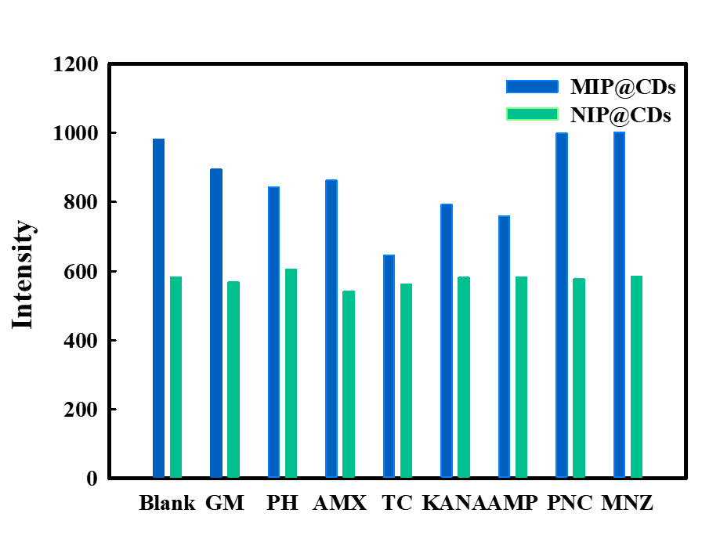
- Selective determination of 10×100 μg/L other potential interfering substances.

- Comparison with other reported methods for the detection of CLP
Materials | Linear range(μg/L) | LOD(μg/L) | Ref.
SPCE | 323.13-16156.5 | 32.31 | [6]
SERS-MIP | 100-50000 | 100 | [7]
N, P-CDs | 0.26-22.62 | 0.12 | [8]
Aptamer | 32.31-321.13 | 19.39 | [9]
Electrochemical sensor | 1615.65-29081.7 | 1066.33 | [10]
Dual-aptamer | 1-800 | 6.13 | [11]
MIP@CDs | 5-100 | 1 | This work

- Determination of different amounts of CIP in real samples
Sample | Added(μg·L⁻¹) | Found(μg·L⁻¹) | Recovery (%) | RSD (%)
Milk 1 | 5 | 4.96 | 99.20 | 0.66
2 | 10 | 10.88 | 108.80 | 0.66
3 | 15 | 14.85 | 99.01 | 0.66
4 | 25 | 24.93 | 99.72 | 0.66
5 | 35 | 35.23 | 100.66 | 0.66
References
- Yang, J., Huang, Y., Cui, H., Li, L., & Ding, Y. (2022). A FRET fluorescent sensor for ratiometric and visual detection of Sulfide based on Carbon Dots and Silver Nanoclusters. J Fluoresc 32(5): 1815-1823. https://doi.org/10.1007/s10895-022-02981-8
- Zhang, X., Tan, X., & Hu, Y. (2021). Blue/yellow emissive carbon dots coupled with curcumin: a hybrid sensor toward fluorescence turn-on detection of fluoride ion. J Hazard Mater 411:125184. https://doi.org/10.1016/j.jhazmat.2021.125184
- Cui, H., Yang, J., Lu, H., Li, L., Zhu, X., & Ding, Y. (2022). Near-infrared carbon dots for cell imaging and detecting ciprofloxacin by label-free fluorescence sensor based on aptamer. Microchim Acta 189(4):170. https://doi.org/10.1007/s00604-022-05273-x
- Orachorn, N., & Bunkoed, O. (2022). A composite adsorbent of graphene quantum dots, mesoporous carbon, and molecularly imprinted polymer to extract nonsteroidal anti-inflammatory drugs in milk. Microchim Acta 189(12):446. https://doi.org/10.1007/s00604-022-05550-9
- Li, T., Deng, Z., Bu, J., Liu, H., Yang, Y., & Zhong, S. (2022). Quantum dot based molecularly imprinted polymer test strips for fluorescence detection of ferritin. Sen Actuators B Chem 358：131548. https://doi.org/10.1016/j.snb.2022.131548
- Hue, N. T., Pham, T. N., Dinh, N. X., Van Tuan, H., Thuy, N. T. T., Nam, M. H., Lam, V. D., Le, A.-T., & Huy, T. Q. (2022). AuNPs-modified screen-printed electrodes (SPCE and SPPtE) for enhanced direct detection of chloramphenicol. J Electron Mater 51(4)：1669-1680. https://doi.org/10.1007/s11664-022-09434-9
- Xie, Y., Zhao, M., Hu, Q., Cheng, Y., Guo, Y., Qian, H., & Yao, W. (2017). Selective detection of chloramphenicol in milk based on a molecularly imprinted polymer–surface‐enhanced Raman spectroscopic nanosensor. J Raman Spectrosc 48(2):204-210. https://doi.org/10.1002/jrs.5034
- Zuo, P., Chen, Z., Yu, F., Zhang, J., Zuo, W., Gao, Y., & Liu, Q. (2020). An easy synthesis of nitrogen and phosphorus co-doped carbon dots as a probe for chloramphenicol. RSC Adv 10(54): 32919-32926. https://doi.org/10.1039/D0RA04228E
- Ma, P., Guo, H., Duan, N., Ma, X., Yue, L., Gu, Q., & Wang, Z. (2021). Label free structure-switching fluorescence polarization detection of chloramphenicol with truncated aptamer. Talanta 230:122349. https://doi.org/10.1016/j.talanta.2021.122349
- Banerjee, R., Ghosh, D., Bhaduri, S. N., Biswas, R., & Biswas, P. (2023). Electrochemical Detection of Chloramphenicol Using Metal Free Ordered Mesoporous Carbon. ChemistrySelect 8(1): e202202433. https://doi.org/10.1002/slct.202202433
- Gao, Z., Du, X., Ding, Y., & Li, H. (2021). Establishment of a dual-aptasensor for simultaneous detection of chloramphenicol and kanamycin. Food Addit Contam A 38(7):1148-1156. https://doi.org/10.1080/19440049.2021.1914871

