Supplemental of the manuscript:
“Distinct microbial taxa are associated with LDL-cholesterol reduction after 12 weeks of Lactobacillus plantarum intake in mild hypercholesterolemia”

Felix Kerlikowsky¹*, Mattea Müller¹*, Theresa Greupner¹, Lena Amend^{2,3}, Till Strowig^{2,3,4}, Andreas Hahn¹
¹Institute of Food Science and Human Nutrition, Leibniz University Hannover, Hannover, Germany
²Department of Microbial Immune Regulation, Helmholtz Center for Infection Research, Braunschweig, Germany
³Cluster of Excellence RESIST (EXC 2155), Hannover Medical School, Hannover, Germany;
⁴Center for Individualized Infection Medicine, Hannover, Germany
Correspondence: Felix Kerlikowsky
Leibniz University Hannover
Institute of Food Science and Human Nutrition
30167 Hannover, Germany
Email: kerlikowsky@nutrition.uni-hannover.de
Tel.: +49 511 762 5430
Fax: +49 511 762 5729
Supplemental Fig. 1 CONSORT flow diagram of the study

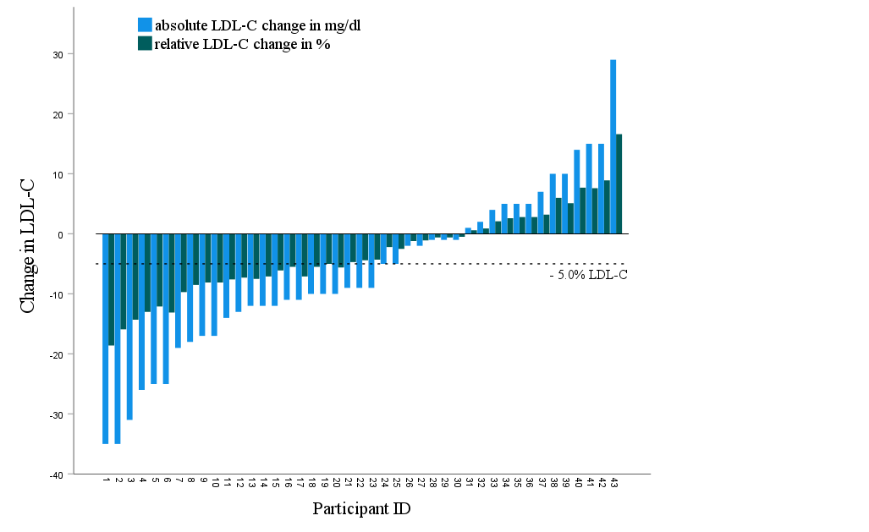
Supplemental Fig. 2 Absolute and relative changes of LDL-C concentrations (n= 43) after 12 weeks of Lactobacillus plantarum intake

Supplemental Table 1. Baseline characteristics of responder and non-responder within the Lacto group
Variables | Responder (n=20) | Non-responder (n=23) | P
Sex, male/female | 5/15 | 6/17 | 0.935 †
Age, y | 64.2 ± 6.6 | 64.7 ± 6.2 | 0.818
Weight, kg | 79.9 ± 11.7 | 71.6 ± 14.1 | 0.044
Body mass index, kg/m² | 28.1 ± 4.5 | 25.2 ± 3.9 | 0.029
Waist:hip ratio | 0.88 ± 0.1 | 0.85 ± 0.09 | 0.343
LDL cholesterol, mg/dl | 193.0 ± 18.1 | 188.5 ± 20.6 | 0.452
∆ LDL cholesterol , mg/dl | -18.1 ± 8.4 | 3.4 ± 9.2 | >0.001
Total cholesterol, mg/dl | 280 ± 30 | 327 ± 43 | 0.967
∆ Total cholesterol, mg/dl | -28.45 ± 19.2 | 5.3 ±15.7 | >0.001
Values are given as means ± SD. Group differences were assessed using independent Student’s t-test. †Group differences in sex were assessed using chi-squared test

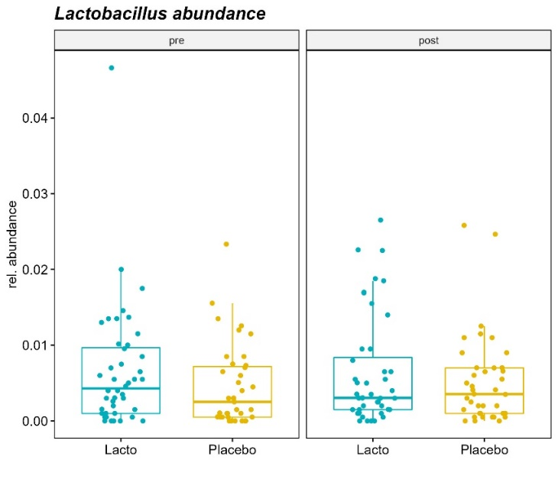
Supplemental Fig. 3 Relative fecal abundance of Lactobacillus in the Lacto (n=43) and placebo (n=43) group before and after the intervention

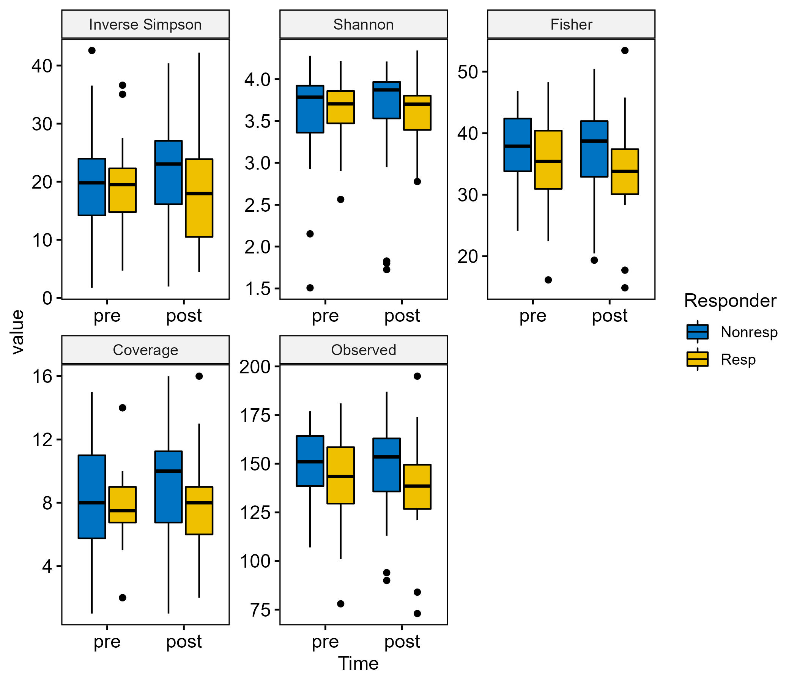
Supplemental Fig. 4 Alpha diversity indices of responder (n=20) and non-responder (n=23) before and after 12 weeks of Lactobacillus plantarum intake
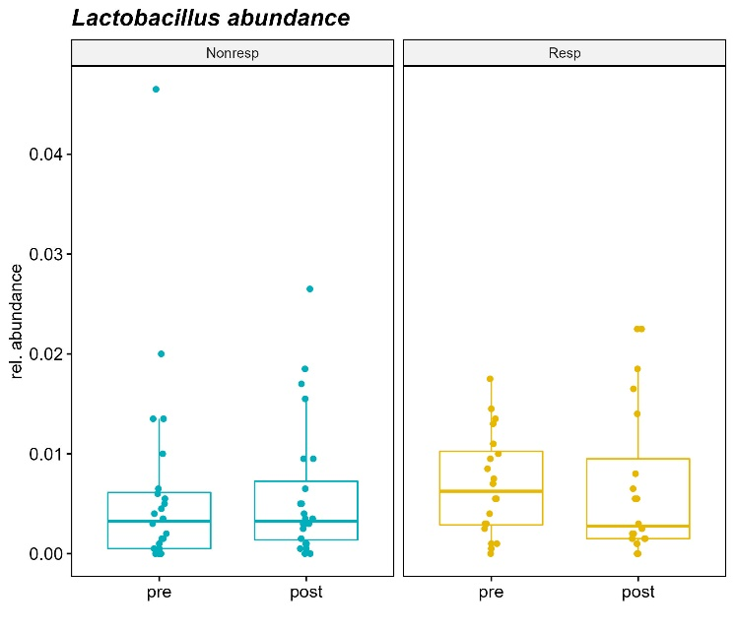
Supplemental Fig. 4 Relative fecal abundance of Lactobacillus in responder (n=20) and non-responder (n=23) before and after the intervention

Supplemental Table 3 Association between microbial taxa (genus level), responder status and clinical variables in the Lacto group (n=43).
Taxa (Genus level) | Value | coefficient | P-Value | Q-Value
Roseburia | Responder | 1.01 | >0.001 | 0.050
Oscillibacter | Responder | -1.36 | >0.001 | 0.050
Oscillibacter | ∆LDL-C | 0.66 | 0.001 | 0.057
Oscillibacter | ∆total cholesterol | 0.55 | 0.008 | 0.212
Roseburia | ∆total cholesterol | -0.38 | 0.016 | 0.237
Coef= model coefficient value for the OTU, q-value=FFR-corrected significance of the association based on the whole dataset, ∆ change between post –pre timepoints, LDL-C, low-density lipoprotein cholesterol

