Table S1: Chemical structural information of the training and test set compounds along with their IC₅₀.

COMP.NO. | R | MCF-7 IC₅₀ ((µM)) | pIC₅₀
1 | 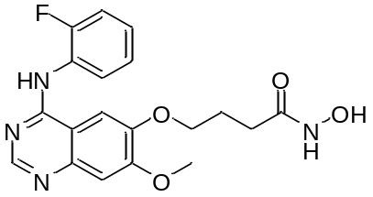 | 100 | 4.000
2 | 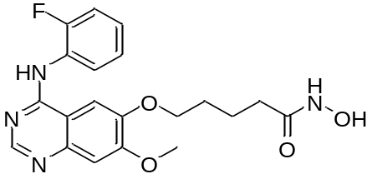 | 100 | 4.000
3 | 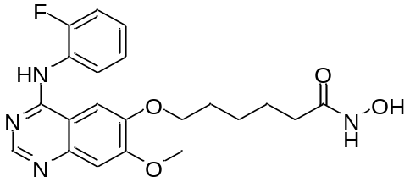 | 84 | 4.076
4 | 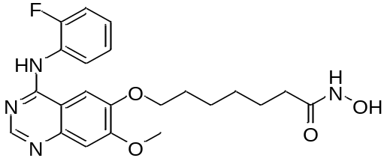 | 15 | 4.824
5 | 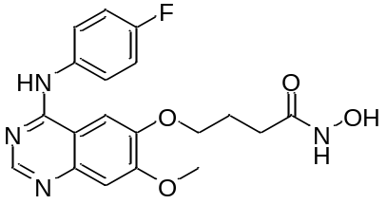 | 100 | 4.000
6 | 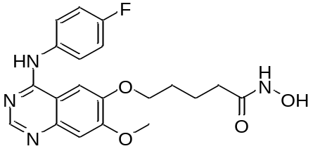 | 74 | 4.131
7 | 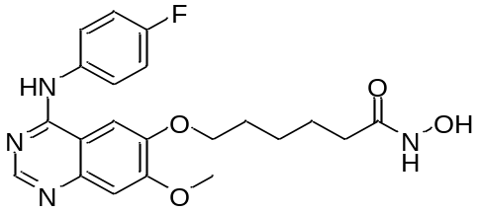 | 18 | 4.745
8 | 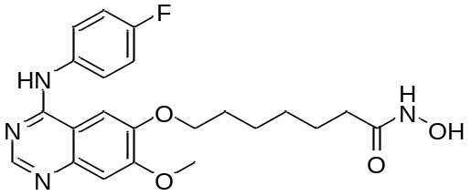 | 2.4 | 5.620
9 | 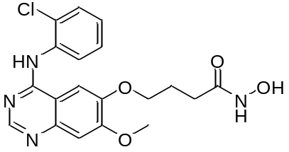 | 100 | 4.000
10 | 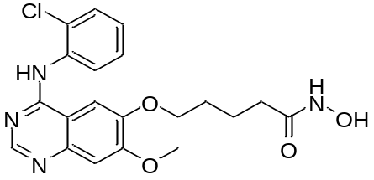 | 78 | 4.108
11 | 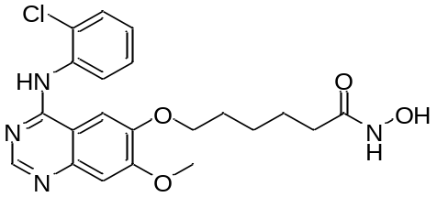 | 15 | 4.824
12 | 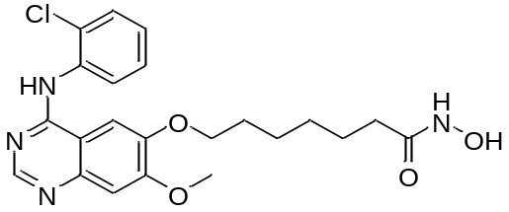 | 7.8 | 5.108
13 | 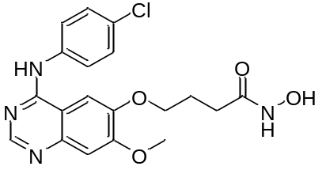 | 85 | 4.071
14 | 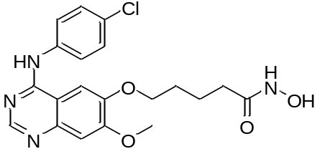 | 61 | 4.215
15 | 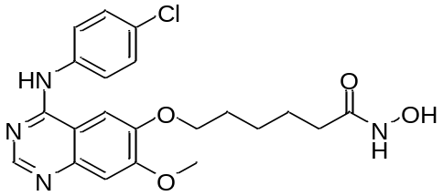 | 4 | 5.398
16 | 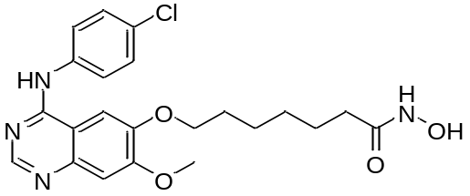 | 1.7 | 5.770
17 | 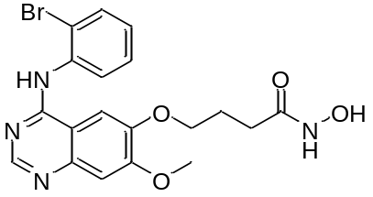 | 100 | 4.000
18 | 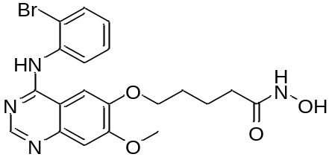 | 33 | 4.481
19 | 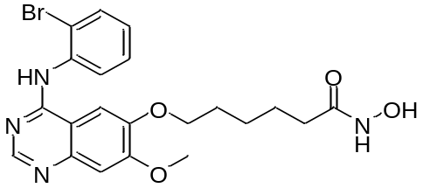 | 17 | 4.770
20 | 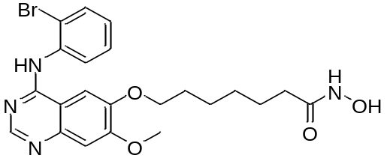 | 2.6 | 5.585
21 | 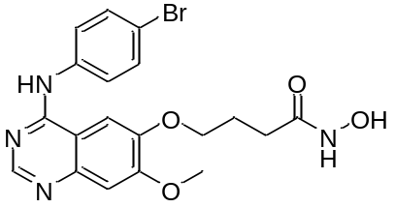 | 52 | 4.284
22 | 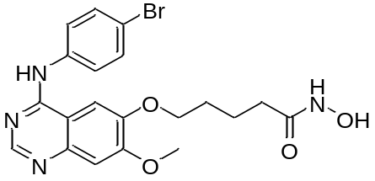 | 36 | 4.444
23 | 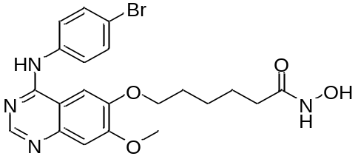 | 3.5 | 5.456
24 | 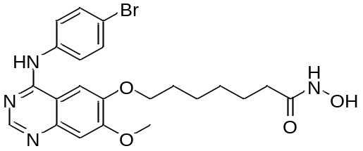 | 0.85 | 6.071
25 | 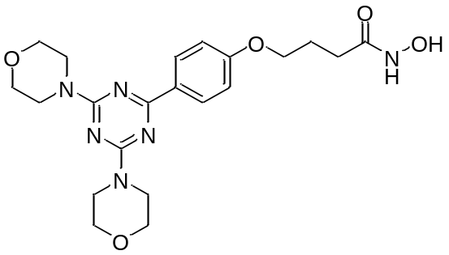 | 11.8 | 4.928
26 | 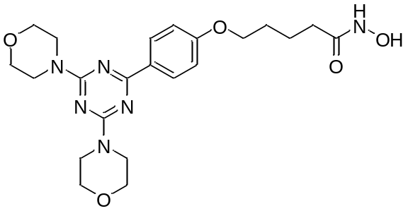 | 6.6 | 5.180
27 | 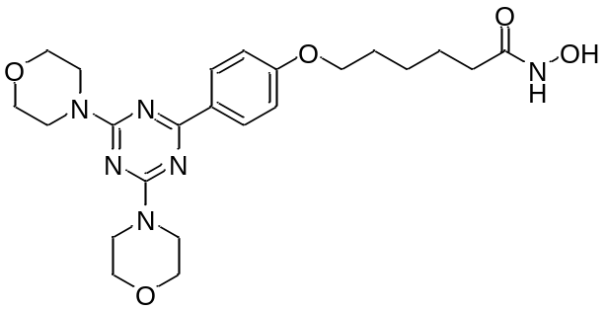 | 3.1 | 5.509
28 | 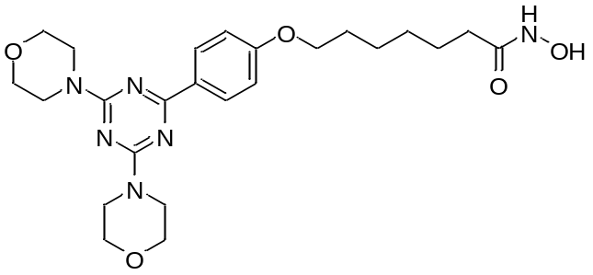 | 3.7 | 5.432
29 | 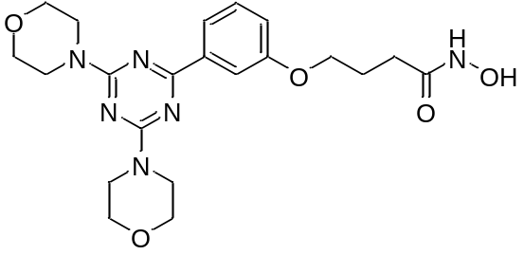 | 6.5 | 5.187
30 | 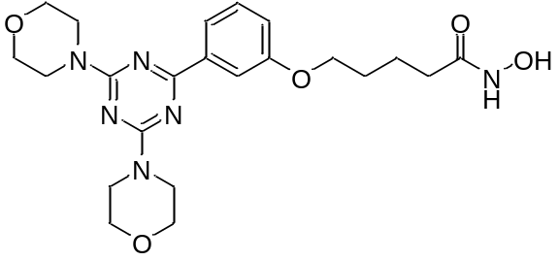 | 6.3 | 5.201
31 | 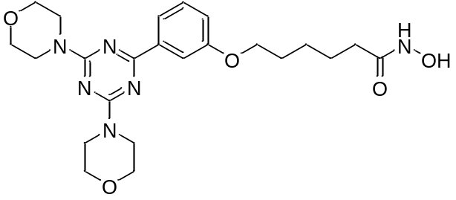 | 2.1 | 5.678
32 | 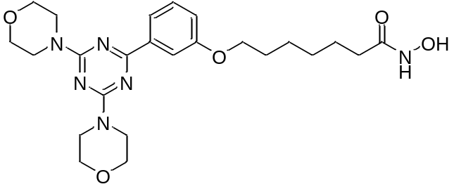 | 11.5 | 4.939
33 | 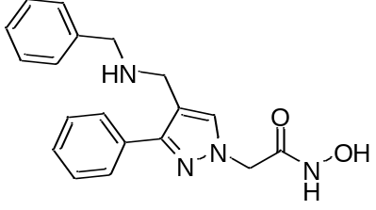 | 17.86 | 4.748
34 | 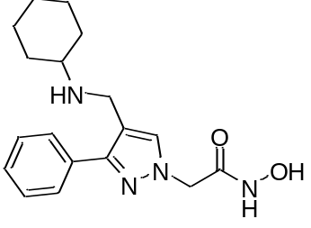 | 10.82 | 4.966
35 | 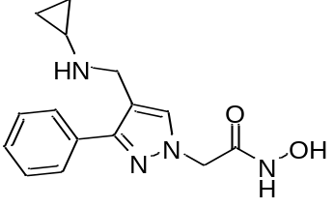 | 8.88 | 5.052
36 | 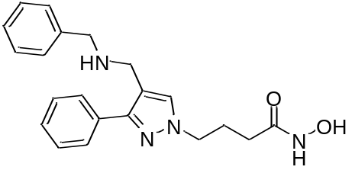 | 5.32 | 5.274
37 | 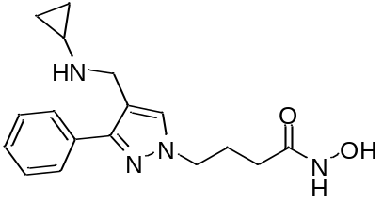 | 1.12 | 5.951
38 |  | 2.96 | 5.529
39 | 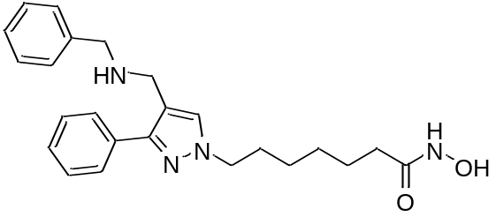 | 16.79 | 4.775
40 | 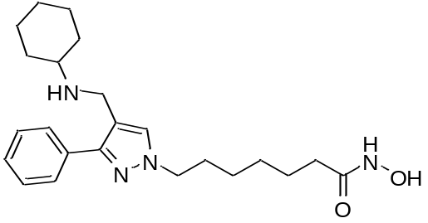 | 13.77 | 4.861
41 | 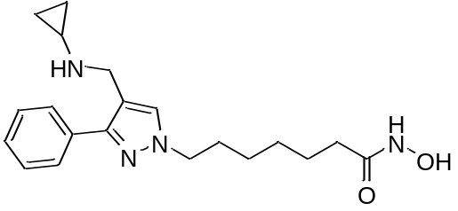 | 6.96 | 5.157

Table S2.
Name | Fit | Est | Act | Results
24 | 6.44 | 1.40E-05 | 8.50E-07 | Maximum Fit | 9.7785
37 | 6.74 | 7.00E-06 | 1.10E-06 | Total Cost | 111.7673
16 | 6.75 | 6.90E-06 | 1.70E-06 | RMS | 0.919189
31 | 7.62 | 9.30E-07 | 2.10E-06 | Correlation | 0.76517
8 | 6.53 | 1.10E-05 | 2.40E-06
20 | 6.32 | 1.80E-05 | 2.60E-06
38 | 6.82 | 5.80E-06 | 3.00E-06
27 | 6.85 | 5.50E-06 | 3.10E-06
23 | 6.53 | 1.10E-05 | 3.50E-06
28 | 6.52 | 1.10E-05 | 3.70E-06
15 | 6.44 | 1.40E-05 | 4.00E-06
36 | 6.71 | 7.60E-06 | 5.30E-06
30 | 6.69 | 7.90E-06 | 6.30E-06
29 | 6.81 | 6.00E-06 | 6.50E-06
26 | 7.05 | 3.50E-06 | 6.60E-06
41 | 6.31 | 1.90E-05 | 7.00E-06
12 | 6.36 | 1.70E-05 | 7.80E-06
35 | 6.89 | 4.90E-06 | 8.90E-06
34 | 6.89 | 5.00E-06 | 1.10E-05
32 | 6.89 | 4.90E-06 | 1.20E-05
25 | 6.43 | 1.40E-05 | 1.20E-05
40 | 6.41 | 1.50E-05 | 1.40E-05
4 | 6.61 | 9.40E-06 | 1.50E-05
11 | 6.27 | 2.10E-05 | 1.50E-05
39 | 6.44 | 1.40E-05 | 1.70E-05
19 | 6.31 | 1.90E-05 | 1.70E-05
33 | 6.88 | 5.00E-06 | 1.80E-05
7 | 6.46 | 1.30E-05 | 1.80E-05
18 | 6.26 | 2.10E-05 | 3.30E-05
22 | 6.26 | 2.10E-05 | 3.60E-05
21 | 6.2 | 2.40E-05 | 5.20E-05
14 | 6.05 | 3.40E-05 | 6.10E-05
6 | 6.05 | 3.40E-05 | 7.40E-05
10 | 6.04 | 3.50E-05 | 7.80E-05
3 | 6.04 | 3.50E-05 | 8.40E-05
13 | 5.99 | 4.00E-05 | 8.50E-05
1 | 6.04 | 3.50E-05 | 1.00E-04
9 | 6.17 | 2.60E-05 | 1.00E-04
2 | 6.03 | 3.60E-05 | 1.00E-04
5 | 6.12 | 3.00E-05 | 1.00E-04
17 | 6.11 | 3.00E-05 | 1.00E-04

