Optimization of vehicle joints based on adaptive stacking model and discrete marine predator optimization algorithm (Supplementary File)
C. L. Zhangª, Z. C. Heª, Eric Li^{b}, A. G. Cheng^{a,*}, J. Huang^{c}, D. F. Yang^{b}
ªState Key Laboratory of Advanced Design and Manufacturing for Vehicle Body, Hunan University, Changsha, 410082 P. R. China
^{b}School of Computing, Engineering & Digital Technologies , Teesside University, Middlesbrough, UK
^{c}School of Vehicle and Mobility, Tsinghua University, Beijing 100084, China

Benchmark functions
Table S1 shows the information of 34 benchmark functions.
Table S1 Benchmark functions.
Symbol | Variable dimension | Test function | Domain
TF1 | 2 | $$f(x)={\left(x_{2}-\frac{5.1x_{1}^{2}}{4π^{2}}+\frac{5x_{1}}{π}-6\right)}^{2}+10\left(1-\frac{1}{8π}\right)\cos\left(x_{1}\right)+10$$ | [-5,10]
TF2 | 2 | $$f(x)={\left(x_{1}-1\right)}^{2}+2{\left(2x_{2}^{2}-x_{1}\right)}^{2}$$ | [-10,10]
TF3 | 2 | $$\begin{matrix}f(x)=\left[1+{\left(x_{1}+x_{2}+1\right)}^{2}\left(19-14x_{1}+3x_{1}^{2}-14x_{2}+6x_{1}x_{2}+3x_{2}^{2}\right)\right] \\ ×\left[30+{\left(2x_{1}-3x_{2}\right)}^{2}\left(18-32x_{1}+12x_{1}^{2}+48x_{2}-6x_{1}x_{2}+27x_{2}^{2}\right)\right]\end{matrix}$$ | [-2,2]
TF4 | 2 | $$f(x)=x_{1}^{2}+x_{2}^{2}+200-{\left(x_{1}^{2}+x_{2}-11\right)}^{2}-{\left(x_{1}+x_{2}^{2}-7\right)}^{2}$$ | [-4,4]
TF5 | 2 | $$f(x)=4x_{1}^{2}-2.1x_{1}^{4}+x_{1}^{6}/3+x_{1}x_{2}-4x_{2}^{2}+4x_{2}^{4}$$ | [-5,5]
TF6 | 2 | $$f(x)=\cos\left(10x_{1}^{2}\right)+3.1\left|x_{1}-0.7\right|+2x_{1}^{2} \\ \left. +\sin\left.1/\left(∣x_{1}-0.7\right)∣+0.31\right)\right]+2x_{2}^{2}$$ | [0,1]
TF7 | 2 | $$f(x)=(C+1)/9.32,A=6x_{1}-2,B=6x_{2}-2, \\ C=\left(A^{2}+B^{2}+3\right)/2+\sin\left[\left(A^{2}+B^{2}+2\right)/2\right]$$ | [0,1]
TF8 | 2 | $$f(x)=e^{{\left(x_{1}-x_{2}\right)}^{2}}+e^{{\left(10-x_{1}\right)}^{2}}-x_{1}x_{2}$$ | [0,10]
TF9 | 2 | $$f(x)=\left|x_{1}\right|+x_{2}^{2}$$ | [-8,8]
TF10 | 2 | $$f(x)=\sin\left(πx_{1}/12\right)\cos\left(πx_{2}/16\right)$$ | [0,10]
TF11 | 2 | $$f(x)=\sin\left(x_{1}+x_{2}\right)+{\left(x_{1}-x_{2}\right)}^{2}-1.5x_{1}+2.5x_{2}+1$$ | [0,10]
TF12 | 2 | $$f(x)=\cos\left(\sqrt{x_{1}^{2}+x_{2}^{2}}\right)$$ | [-5,5]
TF13 | 2 | $$f(x)=\sum_{i=1}^{n}{\frac{x_{i}^{2}}{4000}}-\prod_{i=1}^{n∏\left(x_{i}/\sqrt{i}\right)}{cos}$$ | [-20,20]
TF14 | 2 | $$f(x)=20+x_{1}^{2}+x_{2}^{2}-10\left[\cos\left(2πx_{1}\right)+\cos\left(2πx_{2}\right)\right]$$ | [-1,1]
TF15 | 2 | $$f(x)=0.5+\sin\left\{\sqrt{x_{1}^{2}+x_{2}^{2}}/\left[1+0.1{\left(x_{1}^{2}+x_{2}^{2}\right)}^{2}\right]\right\}$$ | [-2,2]
TF16 | 2 | $$f(x)=\cos\left[6\left(x_{1}-0.5\right)\right]+3.1\left|x_{1}-7\right|+2{\left(x_{1}-0.5\right)}^{2} \\ +\sin\left[0.1/\left(\left|x_{1}-0.5\right|+0.31\right)\right]+0.5x_{2}$$ | [0,1]
TF17 | 2 | $$f(x)=2+0.01{\left(x_{2}-x_{1}^{2}\right)}^{2}+{\left(1-x_{1}\right)}^{2}+2\left(2-x_{2}\right) \\ +7\sin\left(0.5x_{1}\right)\sin\left(0.7x_{1}x_{2}\right)$$ | [0,5]
TF18 | 2 | $$f(x)=\sin\left(x_{1}\right)\cos\left(x_{2}\right)$$ | [-3,3]
TF19 | 2 | $$f(x)=\left(30+x_{1}{\sin{x}}_{1}\right)\left(4+e^{-x_{2}^{2}}\right)$$ | [0,10]
TF20 | 2 | $$f(x)=\cos\left(\sqrt{{\left(x_{1}-3\right)}^{2}+{\left(x_{2}-2\right)}^{2}}\right)$$ | [-5,5]
TF21 | 2 | $$f(x)={\left(x_{1}-0.2\right)}^{2}+{\left(x_{2}-11\right)}^{2}+{\left[x_{1}+{\left(x_{2}+0.3\right)}^{2}-7\right]}^{2}$$ | [-4,4]
TF22 | 4 | $$f(x)=100{\left(x_{1}^{2}-x_{2}\right)}^{2}+a_{1}^{2}+a_{3}^{2}+90\left(x_{3}^{2}-x_{4}\right) \\ +10.1\left(a_{2}^{2}+a_{4}^{2}\right)+19.8a_{2}a_{4},a_{i}=x_{i}-1$$ | [-10,10]
TF23 | 4 | $$f(x)={\left(x_{1}-1\right)}^{2}+\sum_{i=2}^{n}{i}{\left(2x_{i}^{2}-x_{i-1}\right)}^{2},n=4$$ | [-10,10]
TF24 | 4 | $$f(x)=\sum_{i=1}^{n}{\frac{x_{i}^{2}}{4000}}-\prod_{i=1}^{n∏\left(x_{i}/\sqrt{i}\right)}{cos}$$ | [-20,20]
TF25 | 4 | $$f(x)=10\sin\left[2\left(x_{1}-0.6π\right)\right]+x_{2}+x_{3}+x_{4}+x_{1}x_{2} \\ +x_{3}x_{4}+x_{1}^{3}+x_{4}^{3}$$ | [0,1]
TF26 | 4 | $$f(x)=1+e^{-2\left[{\left(x_{1}-1\right)}^{2}+x_{2}^{2}\right]-0.5\left(x_{3}^{2}+x_{4}^{2}\right)}+e^{-2\left[x_{1}^{2}+{\left(x_{2}-1\right)}^{2}\right]-0.5\left(x_{3}^{2}+x_{4}^{2}\right)}$$ | [0,1]
TF27 | 8 | $$f(x)=4\left(x_{1}-2+8x_{2}-8x_{2}^{2}\right)+{\left(3-4x_{2}^{2}\right)}^{2} \\ +16\sqrt{x_{3}+1}{\left(2x_{3}-1\right)}^{2}+\sum_{i=4}^{8}{i}\ln\left(1+\sum_{j=3}^{i}{x_{j}}\right)$$ | [0,1]
TF28 | 8 | $$f(x)={\left(x_{1}-1\right)}^{2}+\sum_{i=2}^{n}{i}{\left(2x_{i}^{2}-x_{i-1}\right)}^{2},n=8$$ | [-10,10]
TF29 | 8 | $$f(x)=\sum_{i=1}^{n}{\frac{x_{i}^{2}}{4000}}-\prod_{i=1}^{n∏\left(x_{i}/\sqrt{i}\right)}{cos}$$ | [-20,20]
TF30 | 10 | $$f(x)=\sum_{i=1}^{10}{x_{i}^{2}}+{\left(\sum_{i=1}^{10}{0}.5ix_{i}\right)}^{2}+{\left(\sum_{i=1}^{10}{0}.5ix_{i}\right)}^{4}$$ | [-5,10]
TF31 | 10 | $$f(x)=\sum_{i=1}^{10}{\left\{\frac{3}{10}+\sin\left(\frac{16}{15}x_{i}-1\right)+{\left[\sin\left(\frac{16}{15}x_{i}-1\right)\right]}^{2}\right\}}$$ | [-1,1]
TF32 | 12 | $$f(x)={\left(x_{1}-1\right)}^{2}+\sum_{i=2}^{n}{i}{\left(2x_{i}^{2}-x_{i-1}\right)}^{2},n=12$$ | [-10,10]
TF33 | 15 | $$f(x)={\left(x_{1}-1\right)}^{2}+\sum_{i=2}^{n}{i}{\left(2x_{i}^{2}-x_{i-1}\right)}^{2},n=15$$ | [-10,10]
TF34 | 15 | $$f(x)=\sum_{i=1}^{14}{\left[100{\left(x_{i+1}-x_{i}^{2}\right)}^{2}+{\left(x_{i}-1\right)}^{2}\right]}$$ | [-5,10]

Experimental comparison of OSM and BLs
Table S2 illustrates the experimental RMSE results of OSM and base learners on all benchmark functions.
Table S2 Experimental comparison of OSM and base learners on benchmark functions. The bolded values indicate the best results of RMSE.
Test  functions | BL1 | BL2 | BL3 | BL4 | BL5 | BL6 | BL7 | BL8 | BL9 | OSM
TF1 | 0.025 | 0.024 | 0.023 | 0.165 | 0.165 | 0.169 | 0.053 | 0.024 | 0.020 | 0.017
TF2 | 0.018 | 0.013 | 0.025 | 0.251 | 0.251 | 0.260 | 0.070 | 0.016 | 0.008 | 0.004
TF3 | 0.019 | 0.017 | 0.026 | 0.129 | 0.128 | 0.137 | 0.061 | 0.018 | 0.013 | 0.009
TF4 | 0.027 | 0.023 | 0.024 | 0.183 | 0.183 | 0.183 | 0.058 | 0.022 | 0.017 | 0.011
TF5 | 0.022 | 0.013 | 0.028 | 0.167 | 0.167 | 0.170 | 0.069 | 0.018 | 0.013 | 0.009
TF6 | 0.016 | 0.013 | 0.013 | 0.184 | 0.184 | 0.185 | 0.068 | 0.017 | 0.010 | 0.008
TF7 | 0.022 | 0.025 | 0.020 | 0.143 | 0.143 | 0.145 | 0.067 | 0.021 | 0.016 | 0.013
TF8 | 0.013 | 0.015 | 0.056 | 0.051 | 0.051 | 0.069 | 0.079 | 0.003 | 0.018 | 0.002
TF9 | 0.021 | 0.011 | 0.014 | 0.271 | 0.271 | 0.285 | 0.074 | 0.016 | 0.015 | 0.006
TF10 | 0.014 | 0.014 | 0.011 | 0.126 | 0.126 | 0.127 | 0.070 | 0.013 | 0.008 | 0.006
TF11 | 0.021 | 0.019 | 0.019 | 0.183 | 0.182 | 0.187 | 0.077 | 0.023 | 0.012 | 0.009
TF12 | 0.052 | 0.082 | 0.045 | 0.319 | 0.319 | 0.318 | 0.074 | 0.058 | 0.030 | 0.016
TF13 | 0.204 | 0.159 | 0.156 | 0.284 | 0.284 | 0.291 | 0.280 | 0.157 | 0.184 | 0.136
TF14 | 0.043 | 0.022 | 0.024 | 0.249 | 0.249 | 0.250 | 0.085 | 0.038 | 0.040 | 0.014
TF15 | 0.028 | 0.044 | 0.021 | 0.168 | 0.168 | 0.173 | 0.074 | 0.037 | 0.018 | 0.014
TF16 | 0.009 | 0.007 | 0.006 | 0.161 | 0.161 | 0.161 | 0.056 | 0.010 | 0.004 | 0.003
TF17 | 0.026 | 0.045 | 0.024 | 0.113 | 0.113 | 0.116 | 0.079 | 0.030 | 0.019 | 0.015
TF18 | 0.024 | 0.017 | 0.015 | 0.203 | 0.203 | 0.204 | 0.061 | 0.024 | 0.013 | 0.008
TF19 | 0.024 | 0.015 | 0.021 | 0.179 | 0.179 | 0.179 | 0.065 | 0.018 | 0.011 | 0.009
TF20 | 0.058 | 0.076 | 0.046 | 0.360 | 0.360 | 0.366 | 0.078 | 0.063 | 0.032 | 0.023
TF21 | 0.026 | 0.021 | 0.027 | 0.150 | 0.150 | 0.152 | 0.064 | 0.025 | 0.015 | 0.012
TF22 | 0.020 | 0.013 | 0.030 | 0.230 | 0.231 | 0.241 | 0.081 | 0.018 | 0.008 | 0.007
TF23 | 0.051 | 0.024 | 0.032 | 0.197 | 0.197 | 0.200 | 0.070 | 0.041 | 0.045 | 0.016
TF24 | 0.141 | 0.070 | 0.064 | 0.190 | 0.190 | 0.190 | 0.194 | 0.105 | 0.145 | 0.043
TF25 | 0.023 | 0.013 | 0.015 | 0.039 | 0.039 | 0.060 | 0.065 | 0.020 | 0.018 | 0.008
TF26 | 0.084 | 0.059 | 0.046 | 0.144 | 0.144 | 0.143 | 0.046 | 0.064 | 0.067 | 0.022
TF27 | 0.052 | 0.027 | 0.031 | 0.113 | 0.113 | 0.113 | 0.071 | 0.047 | 0.044 | 0.020
TF28 | 0.087 | 0.039 | 0.063 | 0.175 | 0.175 | 0.176 | 0.090 | 0.067 | 0.091 | 0.026
TF29 | 0.046 | 0.050 | 0.049 | 0.172 | 0.172 | 0.175 | 0.091 | 0.051 | 0.044 | 0.044
TF30 | 0.067 | 0.070 | 0.046 | 0.052 | 0.052 | 0.076 | 0.080 | 0.088 | 0.046 | 0.029
TF31 | 0.103 | 0.055 | 0.066 | 0.134 | 0.135 | 0.134 | 0.123 | 0.089 | 0.102 | 0.041
TF32 | 0.098 | 0.050 | 0.065 | 0.161 | 0.161 | 0.160 | 0.087 | 0.080 | 0.094 | 0.031
TF33 | 0.113 | 0.066 | 0.082 | 0.174 | 0.174 | 0.175 | 0.104 | 0.105 | 0.114 | 0.047
TF34 | 0.087 | 0.049 | 0.060 | 0.112 | 0.112 | 0.113 | 0.077 | 0.079 | 0.087 | 0.031
Table S3 illustrates the experimental MAE results of OSM and base learners on all benchmark functions.
Table S3 Experimental comparison of OSM and base learners on benchmark functions. The bolded values indicate the best results of MAE.
Test  functions | BL1 | BL2 | BL3 | BL4 | BL5 | BL6 | BL7 | BL8 | BL9 | OSM
TF1 | 0.013 | 0.015 | 0.011 | 0.119 | 0.119 | 0.119 | 0.041 | 0.013 | 0.008 | 0.006
TF2 | 0.010 | 0.008 | 0.013 | 0.203 | 0.203 | 0.178 | 0.063 | 0.009 | 0.004 | 0.002
TF3 | 0.007 | 0.008 | 0.011 | 0.077 | 0.078 | 0.093 | 0.051 | 0.008 | 0.004 | 0.004
TF4 | 0.018 | 0.016 | 0.015 | 0.148 | 0.148 | 0.148 | 0.049 | 0.015 | 0.010 | 0.008
TF5 | 0.011 | 0.007 | 0.014 | 0.138 | 0.138 | 0.128 | 0.063 | 0.009 | 0.005 | 0.005
TF6 | 0.011 | 0.009 | 0.009 | 0.159 | 0.159 | 0.158 | 0.060 | 0.012 | 0.006 | 0.005
TF7 | 0.011 | 0.016 | 0.011 | 0.120 | 0.120 | 0.120 | 0.061 | 0.011 | 0.008 | 0.007
TF8 | 0.001 | 0.001 | 0.011 | 0.011 | 0.011 | 0.050 | 0.063 | 0.000 | 0.002 | 0.001
TF9 | 0.015 | 0.008 | 0.010 | 0.233 | 0.233 | 0.232 | 0.070 | 0.012 | 0.010 | 0.005
TF10 | 0.011 | 0.010 | 0.009 | 0.098 | 0.098 | 0.097 | 0.063 | 0.010 | 0.006 | 0.004
TF11 | 0.013 | 0.013 | 0.013 | 0.146 | 0.146 | 0.138 | 0.073 | 0.016 | 0.005 | 0.004
TF12 | 0.039 | 0.063 | 0.033 | 0.279 | 0.279 | 0.277 | 0.067 | 0.044 | 0.024 | 0.012
TF13 | 0.147 | 0.126 | 0.122 | 0.247 | 0.247 | 0.226 | 0.214 | 0.118 | 0.134 | 0.109
TF14 | 0.034 | 0.017 | 0.018 | 0.206 | 0.206 | 0.207 | 0.070 | 0.029 | 0.031 | 0.011
TF15 | 0.020 | 0.030 | 0.016 | 0.136 | 0.136 | 0.132 | 0.068 | 0.025 | 0.012 | 0.009
TF16 | 0.006 | 0.005 | 0.005 | 0.144 | 0.144 | 0.144 | 0.048 | 0.007 | 0.002 | 0.002
TF17 | 0.018 | 0.030 | 0.016 | 0.091 | 0.091 | 0.094 | 0.069 | 0.020 | 0.013 | 0.009
TF18 | 0.018 | 0.012 | 0.012 | 0.174 | 0.174 | 0.174 | 0.055 | 0.017 | 0.009 | 0.006
TF19 | 0.009 | 0.007 | 0.010 | 0.149 | 0.149 | 0.150 | 0.057 | 0.008 | 0.006 | 0.006
TF20 | 0.042 | 0.055 | 0.032 | 0.323 | 0.323 | 0.324 | 0.069 | 0.042 | 0.023 | 0.015
TF21 | 0.014 | 0.014 | 0.014 | 0.103 | 0.104 | 0.106 | 0.056 | 0.015 | 0.006 | 0.005
TF22 | 0.012 | 0.008 | 0.016 | 0.182 | 0.182 | 0.172 | 0.069 | 0.011 | 0.005 | 0.005
TF23 | 0.034 | 0.016 | 0.022 | 0.164 | 0.164 | 0.161 | 0.056 | 0.025 | 0.030 | 0.011
TF24 | 0.117 | 0.058 | 0.052 | 0.157 | 0.157 | 0.157 | 0.159 | 0.085 | 0.121 | 0.034
TF25 | 0.018 | 0.011 | 0.011 | 0.031 | 0.031 | 0.052 | 0.057 | 0.016 | 0.014 | 0.006
TF26 | 0.064 | 0.045 | 0.033 | 0.112 | 0.113 | 0.112 | 0.036 | 0.049 | 0.051 | 0.017
TF27 | 0.039 | 0.021 | 0.024 | 0.094 | 0.094 | 0.095 | 0.057 | 0.037 | 0.034 | 0.015
TF28 | 0.063 | 0.027 | 0.044 | 0.138 | 0.138 | 0.139 | 0.069 | 0.046 | 0.066 | 0.018
TF29 | 0.026 | 0.030 | 0.032 | 0.144 | 0.144 | 0.143 | 0.071 | 0.030 | 0.024 | 0.023
TF30 | 0.031 | 0.028 | 0.025 | 0.034 | 0.034 | 0.067 | 0.074 | 0.030 | 0.024 | 0.017
TF31 | 0.083 | 0.044 | 0.051 | 0.107 | 0.108 | 0.107 | 0.097 | 0.071 | 0.083 | 0.032
TF32 | 0.075 | 0.039 | 0.046 | 0.129 | 0.129 | 0.129 | 0.070 | 0.062 | 0.073 | 0.023
TF33 | 0.089 | 0.051 | 0.061 | 0.137 | 0.137 | 0.137 | 0.081 | 0.080 | 0.089 | 0.036
TF34 | 0.066 | 0.037 | 0.043 | 0.088 | 0.088 | 0.088 | 0.060 | 0.058 | 0.066 | 0.023

Candidate modules of critical joints.
Fig. S1 presents the candidate modules of each critical joints of vehicle body.
(a) Candidate joint modules of UA | (b) Candidate joint modules of UB
(c) Candidate joint modules of LB | (d) Candidate joint modules of UC
(e) Candidate joint modules of MC | (f) Candidate joint modules of LC
Fig. S1. Schematic diagrams of candidate modules of (a) UA, (b) UB, (c) LB, (d) UC, (e) MC and (f) LC.

Finite element analysis (FEA) results.

Evaluation standard
The mesh evaluation standard used to generate the FEA model of base body and optimized body are listed in Table S4. The effectiveness of this mesh standard has been validated by an enterprise.
Table S4 Mesh size of finite element model.
Indicators | Value
Minimum size | 4 mm
Maximum size | 15 mm
Aspect ratio | $≤$5
Warpage angle | $≤$16°
Quadrilateral element interior angle | 45°~ 135°
Triangular element interior angle | 20°~ 120°
Skew | $≤$50°
Jacobian | $≥$0.6
Triangular element less than | $≤$8
We use the shell element to discretize each component, including first-order triangular element (CTRIA3) and first-order quadrilateral element (CQUAD4). The CTRIA3 is usually used in the corner place and its number is limited less than 5% of total elements. This method is validated effective and efficient by AISN company. Fig. S2 presents the model and coordinate system of shell element.
(a) Schematic of CTRIA3 element | (b) Schematic of CQUAD4 element
Fig. S2. Geometric model and coordinate system of (a) CTRIA3 and (b) CQUAD4.
From Fig. S2 (a), the CTRIA3 element consists three nodes and its coordinate origin is defined at node $G_{1}$. The element x-direction is assumed as the direction of line $G_{1}G_{2}$. The angle of element x-direction and material x-direction is assumed as $θ$. From Fig. S2 (b), the CQUAD4 element consists four nodes and its coordinate origin is defined at the intersection node P of line $G_{1}G_{3}$ and line $G_{2}G_{4}$. The element x-direction is assumed as the angular bisector of $∠G_{2}PG_{3}$. The origin of material x-direction is defined at the node $G_{1}$, and the angle of material x-direction and line $G_{1}G_{2}$ is assumed as $θ$. The mechanics feature of shell element is shown in Fig. S3. In Fig. S3, $M_{x}$ and $M_{y}$ are bending torque, $M_{xy}$ and $M_{yx}$ denote torsional torque, $Q_{x}$ and $Q_{y}$ indicate lateral force, $N_{x}$ and $N_{y}$ represent axial force, $N_{xy}$ and $N_{yx}$ denote shear force, and $σ_{x}$ and $σ_{y}$ are plane stress.
Fig. S3. Mechanics feature schematic of shell element.

First-order mode
The first-order torsional and bending mode are the intrinsic structural attributes. Figs. S4 (a) and (b) shows the first-order torsional mode of the base and optimized models. The values of base and optimized body are 22.17 Hz and 23.11 Hz, respectively. Figs. S5 (a) and (b) illustrates the first-order bending mode of the base and optimized models. The results of base and optimized body are 42.65 Hz and 42.80 Hz, respectively.
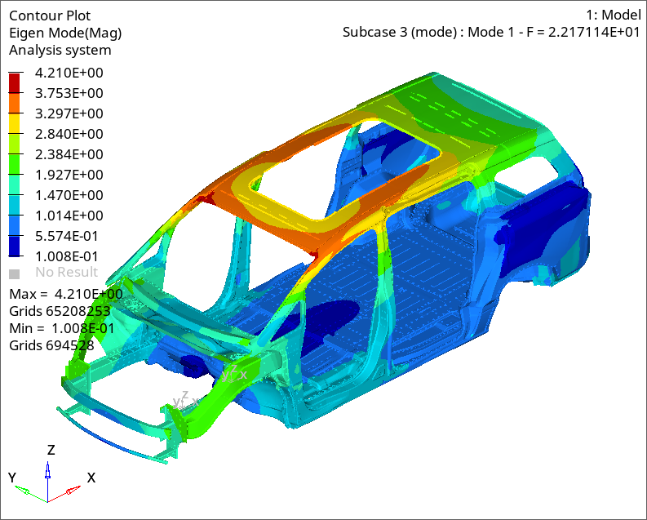 | 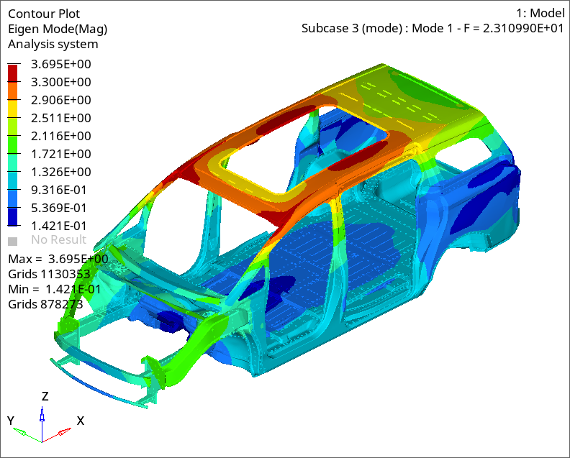
- Result of base model | - Result of optimized model
Fig. S4 First-order torsional mode of (a) base model and (b) optimized model.

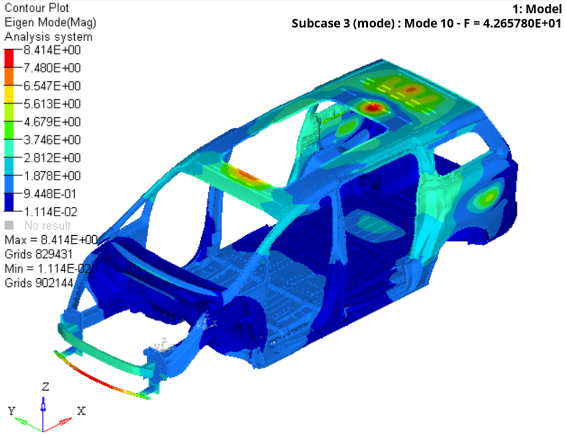 | 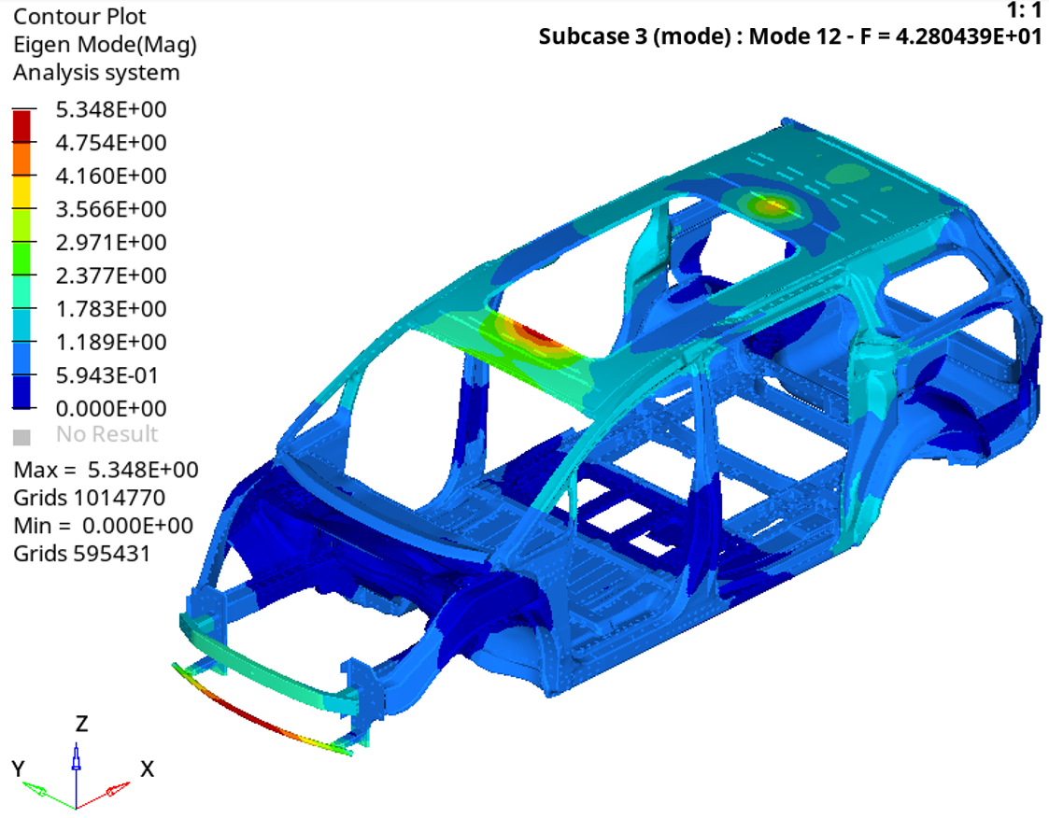
(a) Result of base model | (b) Result of optimized model
Fig. S5 First-order bending mode of (a) base model and (b) optimized model.

Torsional stiffness

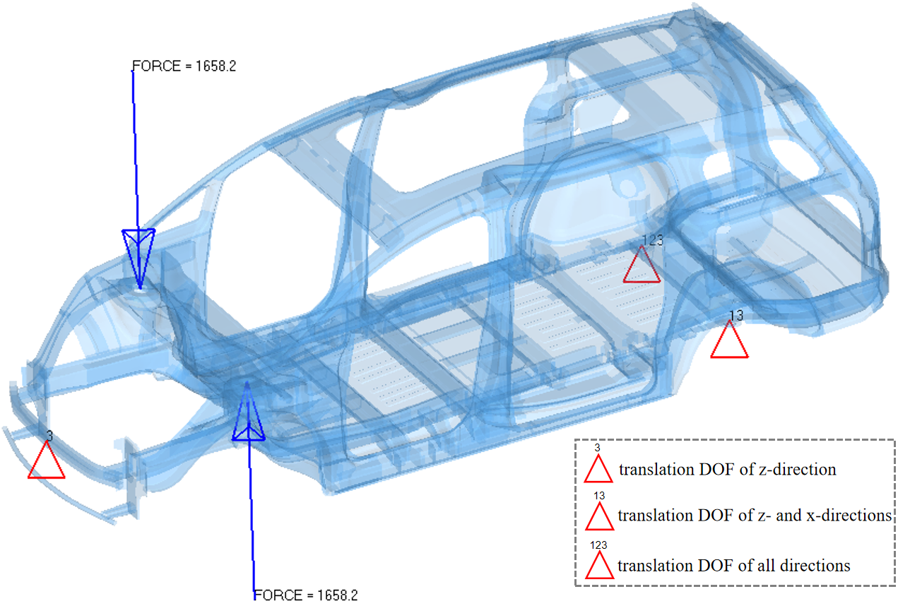
Fig. S6 Boundary condition of torsional stiffness.
As shown in Fig. S6, different constrains are set at the center of the front beam, the left rear suspension spring and the center of the right rear suspension spring. A couple of force with the same magnitude and opposite direction is applied at the left and right front suspensions to form a loading torque. When load case set, the simulation calculation is performed by the OPTISTRUCT solver.
As shown in Fig. S7, the post-processing steps are as follows: Extract the z-direction displacement values $V_{a1}$ and $V_{a2}$ of the beam monitoring points of the left and right front suspensions. Extract the z-direction displacement values $V_{b1}$ and $V_{b2}$ of the middle of the bottom surface of the left and right rear beams, which are corresponding to the center point of the rear suspension. Calculate the torsional angles $∅_{1}$ and $∅_{2}$ of front suspensions and rear suspensions by the following expressions:
$$∅_{1}=\frac{（\left|V_{a1}\right|+\left|V_{a2}\right|）}{L_{a}}$$ | （S1）
$$∅_{2}=\frac{（\left|V_{b1}\right|+\left|V_{b2}\right|）}{L_{b}}$$ | （S2）
where $L_{a}$ represents the y-direction distance of the center points of the front suspensions, $L_{b}$ denotes the distance of the center points of the front suspensions.
The torsional angle $∅$ of the vehicle can be expressed as:
$$∅=\left|∅_{1}-∅_{2}\right|$$ | （S3）
The torsional stiffness $K_{b}$ of vehicle body is calculated by the following equation:
$$K_{t}=\frac{M}{∅}=\frac{F*L}{∅}$$ | （S4）
where $M$ represents the applied torque, F indicates the applied force, $L$ denotes the y-direction distance of the center points of the front suspensions.

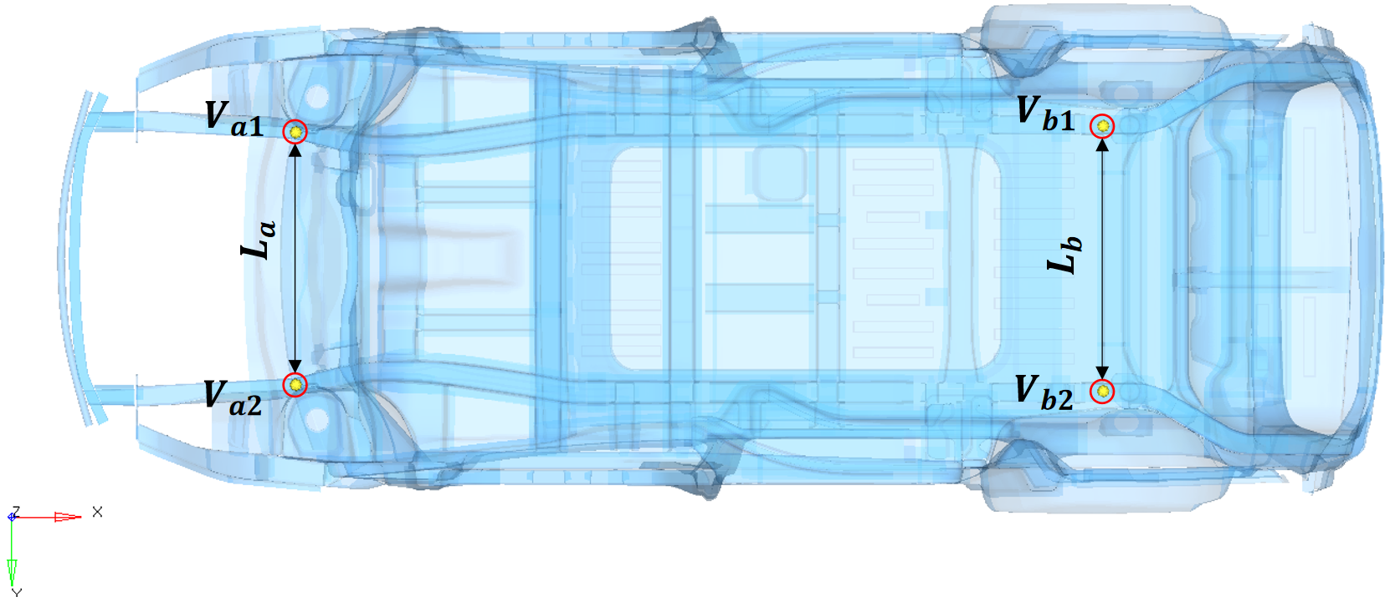
Fig. S7 Schematic of monitoring parameters under torsional working condition.
As introduced in section B.1, the values of F and $L$ are set as 1658.2 N and 1206 mm, respectively. These values are verified effectively by automobile enterprises. The deformation values of monitoring points are listed in Table S5.
Table S5 Deformation values of base and optimized models under torsional stiffness.
Parameters | Base model (mm) | Optimized model (mm)
$$V_{a1}$$ | 1.475 | 1.444
$$V_{a2}$$ | -1.479 | -1.443
$$V_{b1}$$ | 0.057 | 0.057
$$V_{b2}$$ | -0.062 | -0.057
$$L_{a}$$ | 909.93 | 909.93
$$L_{b}$$ | 1004.57 | 1004.57
Through Eqs. (S1) to (S4), the torsional stiffness of the base model is 11152.84 N$∙$m/$°$ and the torsional stiffness of the optimized model is 11403.13 N$∙$m/$°$.

Bending stiffness

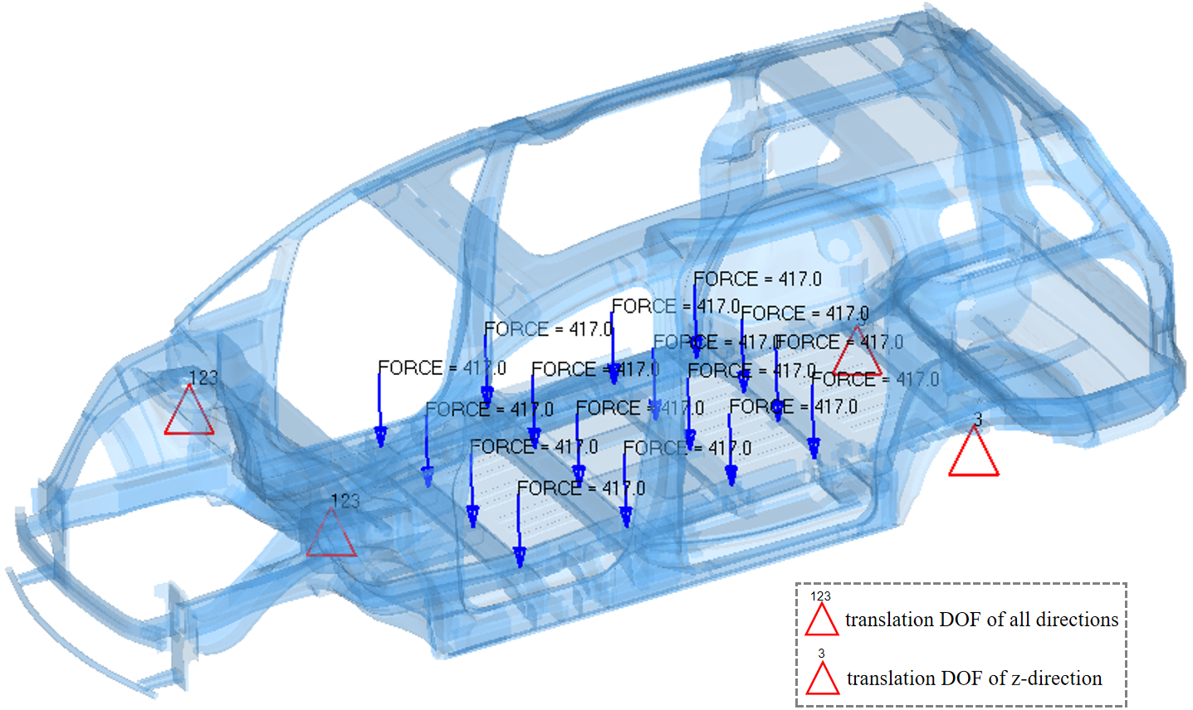
Fig. S8 Boundary condition of bending stiffness.
As shown in Fig. S8, four constraints need to be set for the bending stiffness. Firstly, the translation DOF at the center points of the front suspensions is constrained. Then, the constraints at the center points of spring seat of the rear suspensions are set. Subsequently, 16 forces are applied at the fixed points of the seats. The results are obtained through calculation of OPTISTRUCT solver.
As shown in Fig. S9, the post-processing steps are as follows: extract z-direction displacement value $V_{fl}$ at the bottom center of left beam corresponding to the front suspension center. Extract z-direction displacement value $V_{bl}$ at the bottom center of left beam corresponding to the rear suspension center. Extract the maximum z-direction displacement value $V_{lmax}$ at the bottom center of left beam corresponding to the load aera.
The bending parameter of left vehicle body can be calculated through:
$$V_{l}=V_{lmax}-\frac{V_{fl}{∙L}_{1}}{L}-\frac{V_{bl}{∙L}_{2}}{L}$$ | （S5）
where $L_{1}$ indicates the x-direction distance of maximum displacement point to rear suspension, $L_{2}$ presents the x-direction distance of maximum displacement point to front suspension, $L$ denotes the x-direction distance of front suspension to rear suspension. The bending stiffness $K_{bl}$ of left vehicle body can be calculated by:
$$K_{bl}=\frac{F}{V_{l}}$$ | （S6）

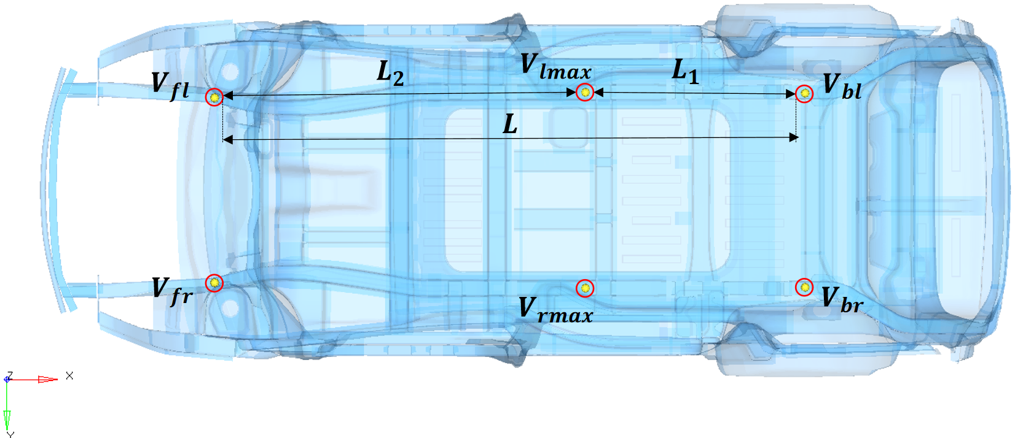
Fig. S9 Schematic of monitoring parameters under bending working condition.
The calculation process of bending stiffness $K_{br}$ of right vehicle body is similar as above. And then, the bending stiffness $K_{b}$ of whole vehicle is obtained by the following expression:
$$K_{b}=\frac{\left(K_{bl}+K_{br}\right)}{2}$$ | （S7）
Through simulation, the parametric data mentioned above is listed in Table S6.
Table S6 Bending stiffness simulation data of base model and optimized model.
Parameters | Base model (mm) | Optimized model (mm)
$$V_{fl}$$ | -0.055 | -0.031
$$V_{bl}$$ | -0.075 | -0.074
$$V_{lmax}$$ | -0.753 | -0.723
$$L_{1}$$ | 1118.85 | 1118.85
$$L_{2}$$ | 1888.61 | 1888.61
$$V_{fr}$$ | -0.056 | -0.030
$$V_{br}$$ | -0.080 | -0.074
$$V_{rmax}$$ | -0.76 | -0.723
In this work, each force applied is 417 N, and the joint force equals to 6672 N. Through Eqs. (S5) to (S7), the bending stiffness of base model is 9709.18 N/mm, and the bending stiffness of optimized model is 10030.32 N/mm.

Marine predator algorithm (MPA)
In MPA, it is supposed that predators always communicate and share the prey position with each other. The prey position indicates the candidate solution of each population after one iteration process, and its expression is denoted as:
$$P_{i}=\left[X_{n,m}\right]$$ | (S8)
where n presents the number of populations, m indicates the dimensions of searching space, and i denotes the number of iterations. The positions of predators represent the optimal solutions of each iteration, which is expressed as:
$$E_{i}=\left[X_{n,m}^{E}\right]$$ | (S9)
The initialization of each population is generated as:
$$X_{0}=X_{min}+rand∙\left(X_{max}-X_{min}\right)$$ | (S10)
where $X_{0}$ indicates the initial populations, $rand$ generates a random value among (0,1), $X_{min}$ and $X_{max}$ present the lower and upper limits, respectively. Two typical motions are adopted as the main iteration method of each population. For instance, L$\acute{e}$vy flight (denoted as $M_{L}$), which is a random motion pattern following L$\acute{e}$vy distribution trajectory firstly proposed by Mantegna, is used to help population explore in a large area. The expression of $M_{L}$ is presented as:
$$M_{L}=\frac{1}{π}\int_{0}^{∞}{exp(-γq^{α})cos(qx)dq}$$ | (S11)
where $γ$ is defined as adjustment coefficient and $α$ is defined as distribution coefficient. The other basic iteration motion defined in MPA is Brownian motion $(M_{B})$, which randomly generates motion trajectory based on probability distribution function:
$$M_{B}=\frac{1}{\sqrt{2π}}exp(-\frac{x^{2}}{2})$$ | (S12)
MPA divides the iteration process into three phases, namely high-speed ratio (HSR) phase, equal-speed ratio (ESR) phase and low-speed ratio phase (LSR) phase. HSR phase reflects that predators move faster than preys, and it happens before one third of the maximum iterations (denoted as $t≤\frac{1}{3}t_{max}$). The equation of HSR is defined as follows:
$${STEP}_{i}=M_{B}⊗(E_{i}-M_{B}⊗P_{i})$$ | (S13)
$$P_{i}=P_{i}+μ∙r⊗{STEP}_{i}$$ | (S14)
where ${STEP}_{i}$ represents the update vector of prey position in the i-th population. Symbol $⊗$ denotes the operation of vector product. $E_{i}$ and $P_{i}$ stand for the i-th population’s position of predators and preys, respectively. Symbol $μ$ is defined as the correction coefficient to control the scale of ${STEP}_{i}$, and $r$ indicates the update indicator randomizing from 0 to 1.
After HSR, MPA enters to the ESR phase (predator and prey move in similar velocity). This phase occurs in the middle phase of optimization ($\frac{1}{3}t_{max}<t≤\frac{2}{3}t_{max}$), and applies parallel calculation method to enhance the searching efficiency. Specifically, populations are divided into two parts. One part is denoted as the predator and adopts the following iteration strategy:
$${STEP}_{i}=M_{B}⊗(M_{B}⊗E_{i}-P_{i})$$ | (S15)
$$P_{i}=E_{i}+μ∙Ω⊗{STEP}_{i}$$ | (S16)
$$Ω={(1-\frac{t}{t_{max}})}^{(\frac{2t}{t_{max}})}$$ | (S17)
where $Ω$ is an adaptive correction indicator to control the iteration step size, $t$ is the current number of iterations, and $t_{max}$ is the maximum number of iterations. The remaining part is defined as the prey, and its iteration expression is defined as:
$${STEP}_{i}=M_{L}⊗(P_{i}-M_{L}⊗P_{i})$$ | (S18)
$$P_{i}=P_{i}+μ∙r⊗{STEP}_{i}$$ | (S19)
When iteration proceeds into the last LSR phase ($t>\frac{2}{3}t_{max}$), it is supposed prey moves faster than predator. The iteration strategy is expressed as:
$${STEP}_{i}=M_{L}⊗(M_{L}⊗E_{i}-P_{i})$$ | (S20)
$$P_{i}=E_{i}+μ∙Ω⊗{STEP}_{i}$$ | (S21)
To avoid falling into local minima, MPA defines a phenomenon called fish aggregating effect (FAE). FAE mimics the situation that predator spends most time in hunting around the prey vortex and use the rest time to take a longer jump in searching for the preys. FAE happens by possibility and its mathematical expression is denoted as:
$$P_{i}=\left\{\begin{aligned}P_{i}+Ω[X_{min}+r⊗(X_{max}-X_{min})]⊗U , if r≤ρ \\ P_{i}+[ρ(1-r)+r](P_{rand1}-P_{rand2}) , if r>ρ\end{aligned}\right.$$ | (S22)
where $X_{max}$ and $X_{min}$ represent the maximum and minimum dimensional vectors of each population, $U$ is a binary vector with values of 0 and 1, $ρ$ is defined as the trigger coefficient of FAE, $P_{rand1}$ and $P_{rand2}$ denote the random positions generated from the prey matrix.

