Identification of Biomarkers for Acute Myocardial Infarction based on Cell Senescence Genes and Machine Learning
The ROC validation results of the biomarkers in GSE62646 demonstrated the AUC of the 7 biomarkers as whole was 1, which was higher than any other single biomarker, illustrating the diagnostic accuracy of the model wasdecent.
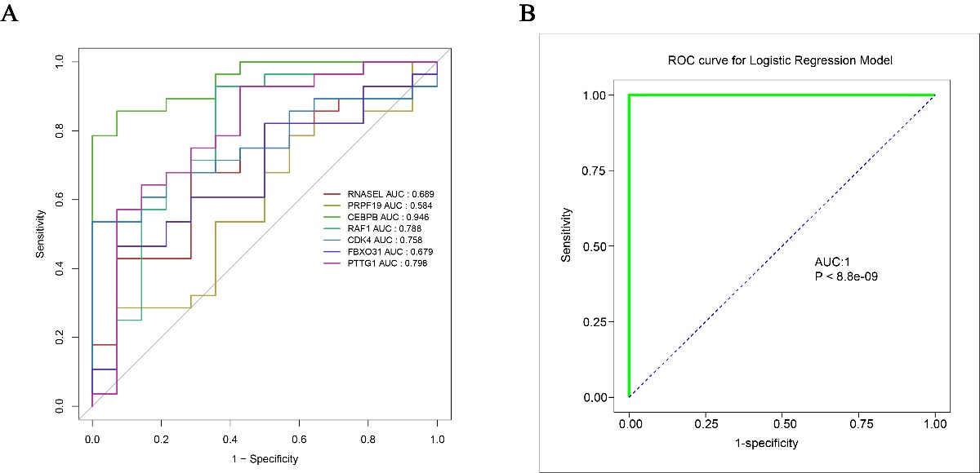
Supplementary Figure 1. The ROC curves of the 7 genes in GSE62646. (A) The single-gene ROC curve of 7 genes; (B) The ROC curve of the 7 genes as whole in a logistic regression model.

