Supplementary Material

Supplementary Figures and Tables

Supplementary Figures
Supplementary Figure 1. GO enrichment analysis of DEGs in Jingu cereal leaves after chromium exposure.
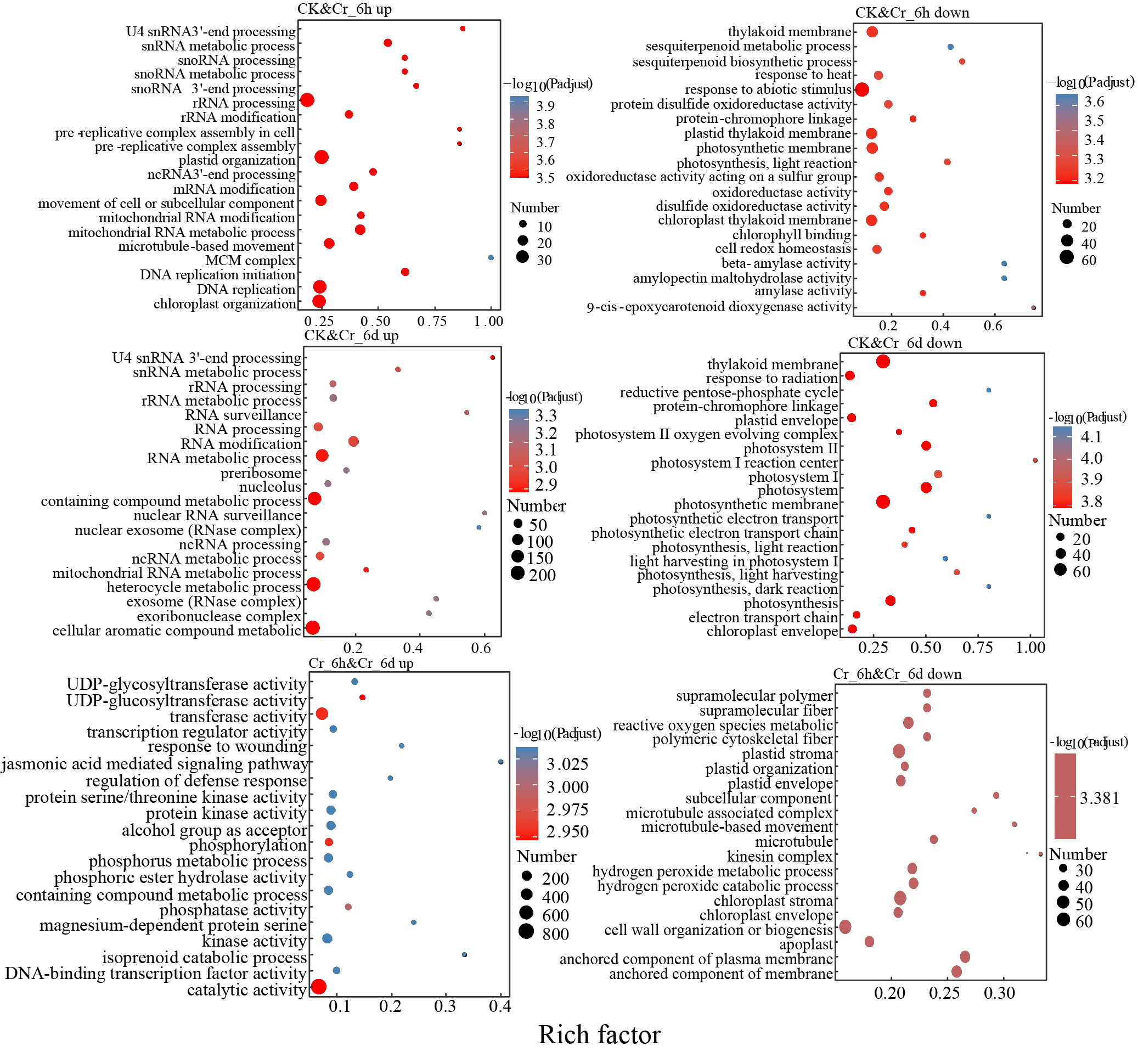

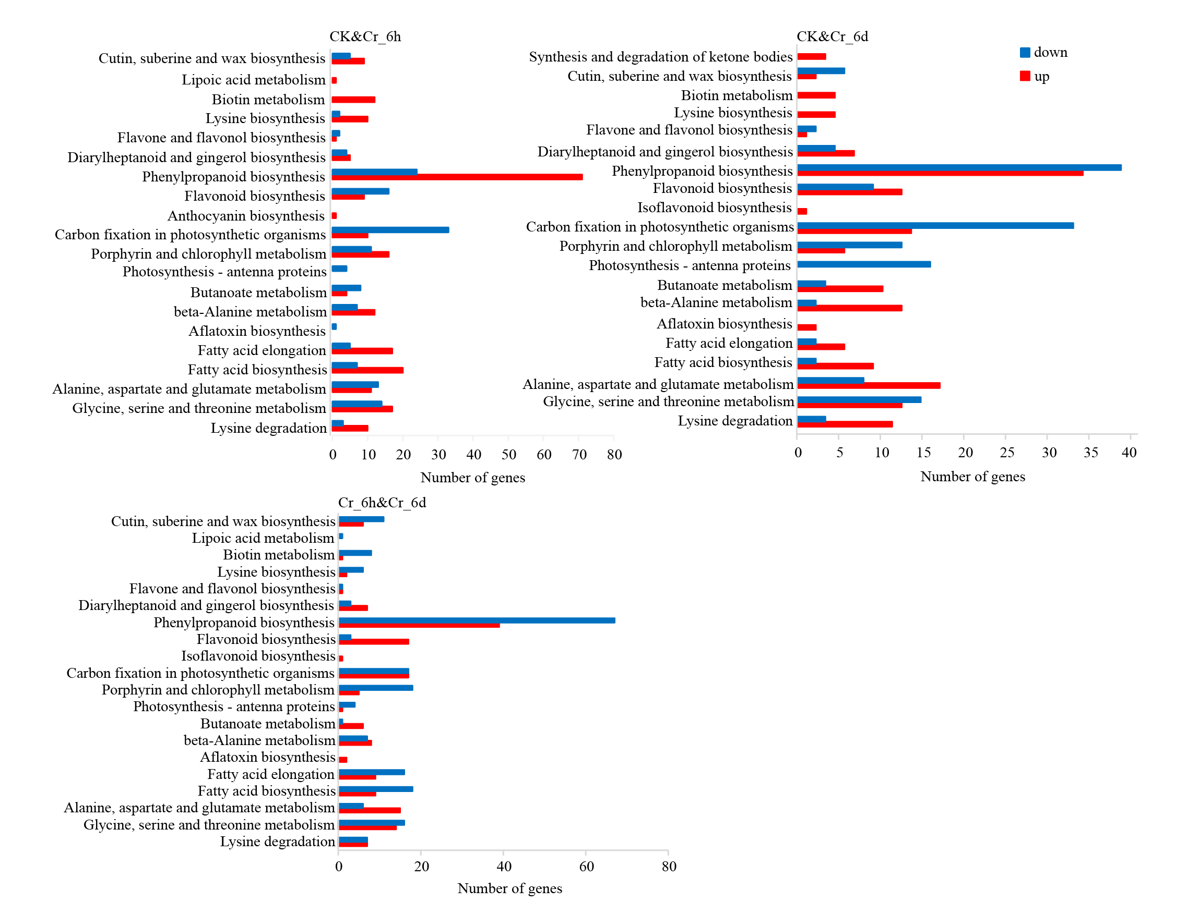
Supplementary Figure 2. KEGG annotation analysis of DEGs in Jingu cereal leaves after chromium exposure

Supplementary Tables
Supplementary Table 1. The primer sets for the amplification of functional genes involved in the nitrogen cycle
Target gene | Primer | Function
AOA-amoA | CrenamoA23F (ATGGTCTGGCTWAGACG)  CrenamoA 616R (GCCATCCATCTGTATGTCCA) | Nitrification
AOB-amoA | Bac-amoA-1F (GGGGTTTCTACTGGTGGT)  Bac-amoA- 2R (CCCCTCKGSAAAGCCTTCTTC) | Nitrification
narG | NifHF (TCGCCSATYCCGGCSATGTC)  NifHRb (GAGTTGTACCAGTCRGCSGAYT CSG) | Denitrification
nirK | nirK876 (ATYGGCGGVCAYGGCGA)  nirK1040(GCCTCGATCAGRTTRTGGTT) | Denitrification
nifH | nifH F (GGTGGTGTMGGATTCACACARTAYGCWACAGC)  nifH R (TTCATTGCRTAGTTWGGRTAGT T) | Ammonification
pmoA | A189F_ (GGNGACTGGGACTTCTGG)  mb661R (CCGGMGCAACGTCYTTACC) | Methane generation
mcrA | mcrA-F_ (GGTGGTGTMGGATTCACACARTAYGCWACAGC)  mcrA-R (TTCATTGCRTAGTTWGGRTAGTT) | Methane oxidation

Supplementary Table 2. Transcriptome sequencing quality assessment

Sample | Raw reads | Clean reads | Q20(%) | Q30(%) | GC content(%)
CK_1 | 43160218 | 42741044 | 98.41 | 95.11 | 54.99
CK_2 | 42282286 | 41694490 | 98.27 | 94.82 | 55.18
CK_3 | 42848634 | 42277974 | 98.26 | 94.78 | 55.19
Cr6h_1 | 44553716 | 43912092 | 98.39 | 95.08 | 54.35
Cr6h_2 | 40447840 | 39771594 | 98.22 | 94.7 | 54.57
Cr6h_3 | 44176666 | 43493968 | 98.42 | 95.2 | 53.83
Cr6d_1 | 43345554 | 42906542 | 98.28 | 94.83 | 54.46
Cr6d_2 | 47011994 | 46473272 | 98.43 | 95.2 | 54.34
Cr6d_3 | 45313342 | 44913500 | 98.43 | 95.22 | 54.79

Raw reads: total number of entries of original sequencing data; Clean reads: total number of items of sequencing data after quality control; Q20(%), Q30(%): refers to the percentage of bases with sequencing quality above 99% and 99.9% in the total bases, generally Q20 is above 85%, Q30 is above 80%; GC content(%) : percentage of the total G and C bases corresponding to the quality control data in the total bases.
Supplementary Table 3. Results of COG annotation of DEGs in Jingu leaves
Functional Categories | CK&Cr_6h |  | CK&Cr_6d |  | Cr_6h&Cr_6d
Functional Categories | up | down | up | down | up | down
Function unknown | 1569 | 874 | 711 | 603 | 1190 | 1658
Posttranslational modification, protein turnover, chaperones | 113 | 101 | 50 | 57 | 115 | 103
Transcription | 105 | 65 | 66 | 28 | 99 | 110
Carbohydrate transport and metabolism | 123 | 50 | 42 | 43 | 66 | 115
Signal transduction mechanisms | 83 | 48 | 61 | 25 | 94 | 64
Translation, ribosomal structure and biogenesis | 82 | 23 | 34 | 14 | 18 | 55
Amino acid transport and metabolism | 45 | 35 | 25 | 16 | 55 | 40
Secondary metabolites biosynthesis, transport and catabolism | 54 | 21 | 30 | 12 | 32 | 43
Intracellular trafficking, secretion, and vesicular transport | 47 | 27 | 18 | 18 | 34 | 38
Energy production and conversion | 26 | 29 | 15 | 37 | 29 | 16
Replication, recombination and repair | 48 | 13 | 20 | 9 | 19 | 24
Lipid transport and metabolism | 21 | 19 | 15 | 10 | 32 | 29
Cell wall/membrane/envelope biogenesis | 28 | 11 | 15 | 6 | 26 | 28
Inorganic ion transport and metabolism | 12 | 26 | 8 | 11 | 32 | 14
Coenzyme transport and metabolism | 19 | 8 | 10 | 7 | 11 | 23
Defense mechanisms | 17 | 11 | 9 | 4 | 15 | 13
Cell cycle control, cell division, chromosome partitioning | 20 | 8 | 12 | 6 | 7 | 15
Nucleotide transport and metabolism | 20 | 4 | 13 | 3 | 7 | 11
Chromatin structure and dynamics | 19 | 0 | 4 | 3 | 4 | 14
Cytoskeleton | 11 | 6 | 3 | 4 | 2 | 10
RNA processing and modification | 7 | 6 | 2 | 2 | 6 | 8
Supplementary Table 4. GO enrichment analysis in STEM
Profiles | GO term | Go descriptipn | No. of DEGs | p-value | p-adjust
10 | BP | intercellular transport | 12 | 2.84768E-07 | 0.000350975
10 | BP | plasmodesmata-mediated intercellular transport | 12 | 2.84768E-07 | 0.000350975
10 | BP | ribosomal large subunit assembly | 22 | 4.37788E-07 | 0.000350975
10 | BP | chloroplast fission | 15 | 4.46131E-07 | 0.000350975
10 | BP | plastid fission | 15 | 4.46131E-07 | 0.000350975
10 | BP | plastid transcription | 8 | 1.05163E-06 | 0.000350975
10 | BP | plant-type secondary cell wall biogenesis | 26 | 1.1561E-06 | 0.000350975
10 | BP | microtubule-based movement | 32 | 1.24068E-06 | 0.000350975
10 | BP | chloroplast organization | 60 | 1.28686E-06 | 0.000350975
10 | BP | establishment of protein localization to membrane | 36 | 1.3162E-06 | 0.000350975
10 | BP | movement of cell or subcellular component | 39 | 1.4446E-06 | 0.000350975
10 | BP | cytoskeleton organization | 51 | 1.79843E-06 | 0.000350975
10 | BP | protein targeting | 53 | 1.83324E-06 | 0.000350975
10 | BP | plastid organization | 68 | 1.83937E-06 | 0.000350975
10 | BP | microtubule-based process | 69 | 2.04833E-06 | 0.000350975
10 | BP | protein localization to chloroplast | 17 | 2.14261E-06 | 0.000350975
10 | BP | cytoplasmic translation | 19 | 2.30809E-06 | 0.000350975
10 | CC | chloroplast nucleoid | 15 | 2.90628E-07 | 0.000350975
10 | CC | endopeptidase Clp complex | 10 | 3.09723E-07 | 0.000350975
10 | CC | mitochondrial respiratory chain complex I | 23 | 4.27882E-07 | 0.000350975
14 | BP | rRNA pseudouridine synthesis | 7 | 4.71999E-08 | 9.0379E-05
14 | BP | snoRNA 3'-end processing | 9 | 6.49041E-08 | 9.0379E-05
14 | BP | nuclear RNA surveillance | 8 | 1.61372E-07 | 0.000140443
14 | BP | snoRNA metabolic process | 9 | 1.93967E-07 | 0.000140443
14 | BP | snoRNA processing | 9 | 1.93967E-07 | 0.000140443
14 | BP | maturation of SSU-rRNA from tricistronic rRNA transcript | 13 | 2.50158E-07 | 0.000140443
14 | BP | snRNA metabolic process | 14 | 2.63059E-07 | 0.000140443
14 | BP | pseudouridine synthesis | 14 | 3.43861E-07 | 0.000142201
14 | BP | regulation of helicase activity | 7 | 3.47963E-07 | 0.000142201
14 | BP | U4 snRNA 3'-end processing | 7 | 3.47963E-07 | 0.000142201
14 | BP | mitochondrial transport | 24 | 4.15098E-07 | 0.000142201
14 | CC | cytoplasmic exosome (RNase complex) | 8 | 3.50662E-08 | 9.0379E-05
14 | CC | box H/ACA RNP complex | 7 | 4.71999E-08 | 9.0379E-05
14 | CC | box H/ACA snoRNP complex | 7 | 4.71999E-08 | 9.0379E-05
14 | CC | small-subunit processome | 18 | 2.14469E-07 | 0.000140443
14 | CC | exosome (RNase complex) | 13 | 2.373E-07 | 0.000140443
14 | CC | U2 snRNP | 16 | 2.63059E-07 | 0.000140443
14 | CC | mitochondrial large ribosomal subunit | 20 | 2.68951E-07 | 0.000140443
14 | CC | organellar large ribosomal subunit | 20 | 2.68951E-07 | 0.000140443
11 | BP | ribonucleoprotein complex biogenesis | 15 | 3.32323E-07 | 0.000476491
11 | BP | tRNA modification | 18 | 3.66522E-07 | 0.000476491
11 | BP | rRNA processing | 29 | 3.93732E-07 | 0.000476491
11 | BP | macromolecule methylation | 23 | 4.23801E-07 | 0.000476491
11 | BP | RNA methylation | 15 | 4.51779E-07 | 0.000476491
11 | BP | tRNA processing | 24 | 4.97006E-07 | 0.000476491
11 | BP | tRNA methylation | 10 | 6.14679E-07 | 0.000476491
11 | BP | rRNA metabolic process | 30 | 7.60858E-07 | 0.000476491
11 | BP | peptidyl-amino acid modification | 34 | 8.40208E-07 | 0.000476491
11 | BP | tRNA metabolic process | 31 | 1.00641E-06 | 0.000476491
11 |  | nucleocytoplasmic transport | 18 | 1.0751E-06 | 0.000476491
11 |  | nuclear transport | 18 | 1.0751E-06 | 0.000476491
11 |  | intracellular protein transport | 52 | 1.10185E-06 | 0.000476491
11 |  | establishment of protein localization | 61 | 1.1652E-06 | 0.000476491
11 |  | ncRNA metabolic process | 63 | 1.22295E-06 | 0.000476491
11 |  | maturation of 5.8S rRNA | 7 | 1.33012E-06 | 0.000476491
11 |  | amide transport | 62 | 1.33041E-06 | 0.000476491
11 |  | establishment of localization in cell | 65 | 1.3916E-06 | 0.000476491
11 |  | intracellular transport | 63 | 1.40811E-06 | 0.000476491
11 |  | macromolecule localization | 64 | 1.49084E-06 | 0.000476491
15 | BP | RNA processing | 36 | 2.04432E-06 | 0.005323768
15 | BP | nucleobase-containing compound metabolic process | 91 | 2.83612E-06 | 0.005323768
15 | BP | RNA metabolic process | 55 | 3.07163E-06 | 0.005323768
15 | BP | heterocycle metabolic process | 93 | 3.45397E-06 | 0.005323768
15 | BP | cellular aromatic compound metabolic process | 94 | 3.83831E-06 | 0.005323768
15 | BP | cellular process | 304 | 3.88564E-06 | 0.005323768
15 | BP | nucleic acid metabolic process | 73 | 4.46037E-06 | 0.005323768
15 | BP | organic cyclic compound metabolic process | 96 | 5.72579E-06 | 0.005979876
15 | BP | carbohydrate derivative metabolic process | 27 | 1.77827E-05 | 0.015067893
15 | BP | cellular nitrogen compound metabolic process | 100 | 1.80346E-05 | 0.015067893
15 | BP | pentose-phosphate shunt | 5 | 2.41212E-05 | 0.016837713
15 | BP | NADP metabolic process | 6 | 2.41834E-05 | 0.016837713
15 | BP | NADPH regeneration | 5 | 3.16537E-05 | 0.020096014
15 | BP | intracellular transport | 29 | 3.67948E-05 | 0.020096014
15 | BP | biological_process | 378 | 3.8681E-05 | 0.020096014
15 | BP | glucose 6-phosphate metabolic process | 5 | 4.08896E-05 | 0.020096014
15 | BP | tRNA modification | 9 | 5.0302E-05 | 0.021313048
15 | MF | omega peptidase activity | 10 | 3.91642E-05 | 0.020096014
15 | CC | cytoplasmic vesicle | 15 | 4.85763E-05 | 0.021313048
15 | CC | intracellular vesicle | 15 | 5.10187E-05 | 0.021313048

