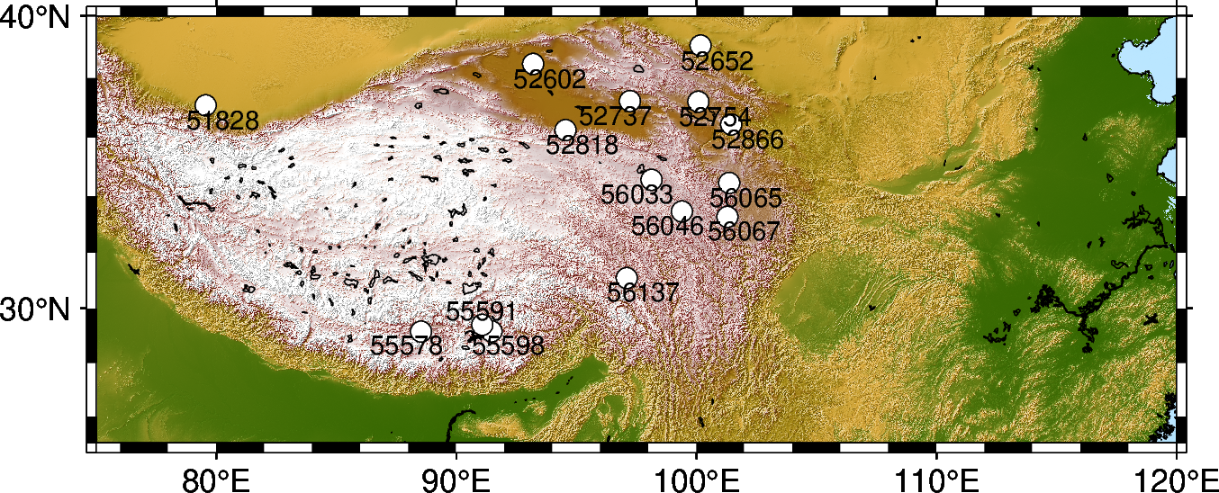

Figure S1. TP sites with soil temperature profiles.

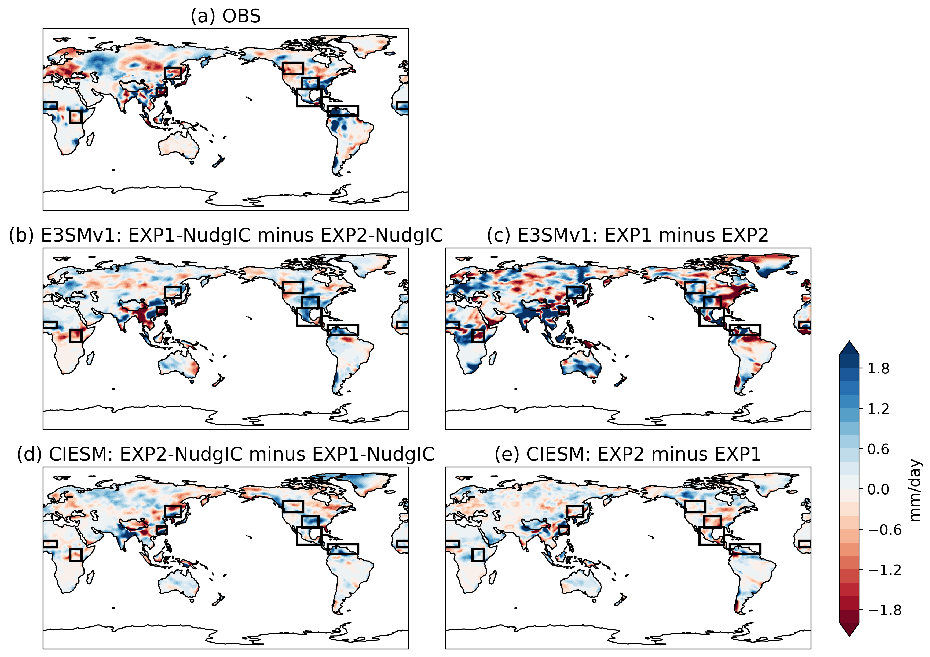

Figure S2. The June 2003 precipitation anomaly (mm/day) relative to the climatology from observation (a) and response with imposed land mask for E3SMv1 (b, c) and CIESM (d, e) with (b, d) and without (c, e) nudged ICs. The black boxes denote the eight hot spots.

Table S1. Observed/Simulated May 2003 T2m and June 2003 precipitation anomalies/differences due to LST/SUBT effects.

 | T2m (K) | Precipitation (mm/day)
 | TP above 4000 m | SYRB | NEast  Asia | East  Africa | Sahel | SGP | Central  America | NSouth  America | NW  US
OBS | -1.82 | -1.52 | -0.25 | -0.31 | 1.25 | 0.88 | 0.44 | 3.34 | -0.69
E3SMv1 with NudgIC | -0.78 | -2.51 | 0.17 | -0.87 | 0.28 | 1.01 | 0.34 | 0.83 | -0.20
E3SMv1 | -0.67 | -0.06 | 1.06 | -0.75 | 0.44 | 0.18 | 2.02 | -0.03 | 0.20
CIESM with NudgIC | -0.22 | 0.36 | 0.16 | -0.33 | 0.07 | 0.83 | 0.40 | 0.56 | 0.08
CIESM | -0.76 | -0.63 | -0.42 | 0.31 | 0.02 | -0.61 | -0.40 | -0.13 | -0.04

