SUPPLEMENTARY INFORMATION

Levels and composition of microplastics and microfibers in the South Saskatchewan River and stormwater retention ponds in the City of Saskatoon, Canada

Iyanu Kumayon¹, Saurabh Prajapati², Markus Brinkmann^{2,3,4}*, Tara F. Kahan^{1,4}

¹ Department of Chemistry, College of Arts and Science, University of Saskatchewan, Saskatoon, Saskatchewan, Canada
² School of Environment and Sustainability, University of Saskatchewan, Saskatoon, Saskatchewan, Canada
³ Toxicology Centre, University of Saskatchewan, Saskatoon, Saskatchewan, Canada
⁴ Global Institute for Water Security, University of Saskatchewan, Saskatoon, Saskatchewan, Canada

*Corresponding author:
Markus Brinkmann: markus.brinkmann@usask.ca
Sample Collection, Treatment, and Extraction

a.
b.
c.

Fig. S1: Schematic of the glass separator setup. (a) The cylindrical upper plate (left) with top and bottom ends open, and the lower plate (right) with the top end open and the bottom end sealed. (b) The lower plate and the upper plate stacked into a single unit to hold the solution. (c) The upper half of the device – which is expected to contain the microplastics and other less dense particles – separated from the lower half containing settled denser materials or sediments by sliding the upper plate over the lower plate such that the glass sheet extending from the top of the lower plate acted as a base for the liquid in the upper plate.
Validation of Method
The percent recovery of the instrument based on the density of the polymer samples was validated by extracting six virgin polymer samples (500 μm – 1000 μm) in 1.6 g.cm⁻³ sodium iodide using the glass separator device. All virgin polymer samples were obtained from the Thermo Fisher Chemical Company, USA, and were used without further purification. Polymers were categorized into two; polymers with densities less than or similar to the density of distilled water (1.00 g.cm⁻³) namely, nylon,6 (1.08 g.cm⁻³), polyethylene (PE, 0.925 g.cm⁻³) and polypropylene (PP, 0.900 g.cm⁻³). The other category includes those polymers whose densities are greater than the density of distilled water (> 1.00 g.cm⁻³) which include polyethylene terephthalate (PET, 1.68 g.cm⁻³), polysulfone (PSF, 1.24 g.cm⁻³) and polyvinyl chloride (PVC, 1.40 g.cm⁻³).
The results (Fig. S2) indicate that the glass separator unit shows 100% recovery for polymers with densities less than or close 1.00 g.cm⁻³, while the recovery of polymers with densities greater than 1.00 g.cm⁻³ ranges from 98.3% ± 0.6% to 100% ± 0.0% (Overall mean recovery 99.1% ± 0.8%). Analysis of their overall mean recovery rate using t-test, with P > α (p-value = 0.2248, α = 0.05) suggest that there is no significant difference between the overall mean recovery rate of less dense polymer samples and the dense polymer samples when extracted in a dense solution of sodium iodide (NaI) using the small glass density separator device, hence, the method is efficient for recovering both dense and less dense microplastics and anthropogenic fibers from water sample. This result further supports previous finding by Nakajima et al (2019) that there are no significant differences in the mean recovery rate of different polymer type in the same size classification, but the recovery rate increases with increasing polymer sizes (Nakajima et al, 2019).

Fig. S2: Percent recovery of the small glass separator unit. Blue bars indicate polymers with densities less than or similar to the density of distilled water, while green bars indicate polymers which have densities greater than the density of distilled water.

Normalized Intensity

Fig. S3: Reference Raman spectra of some selected polymers obtained for the in-house spectral library.
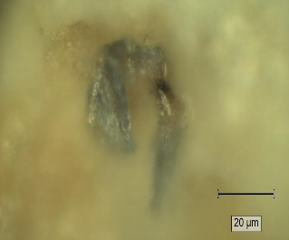
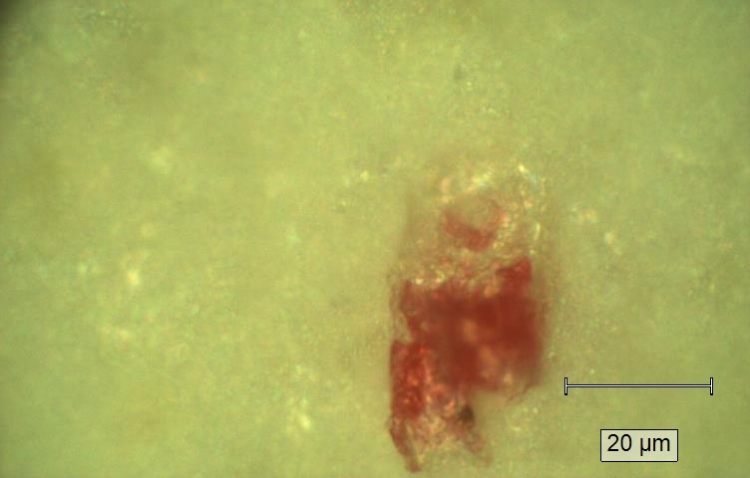
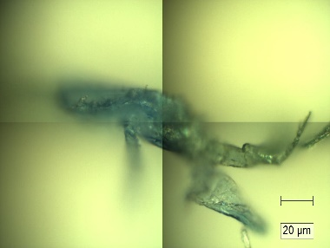
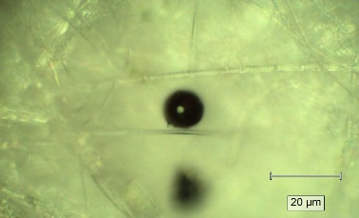
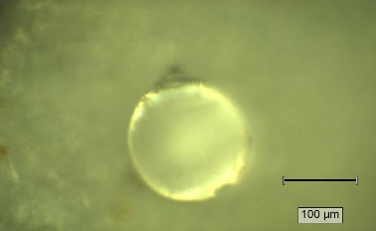
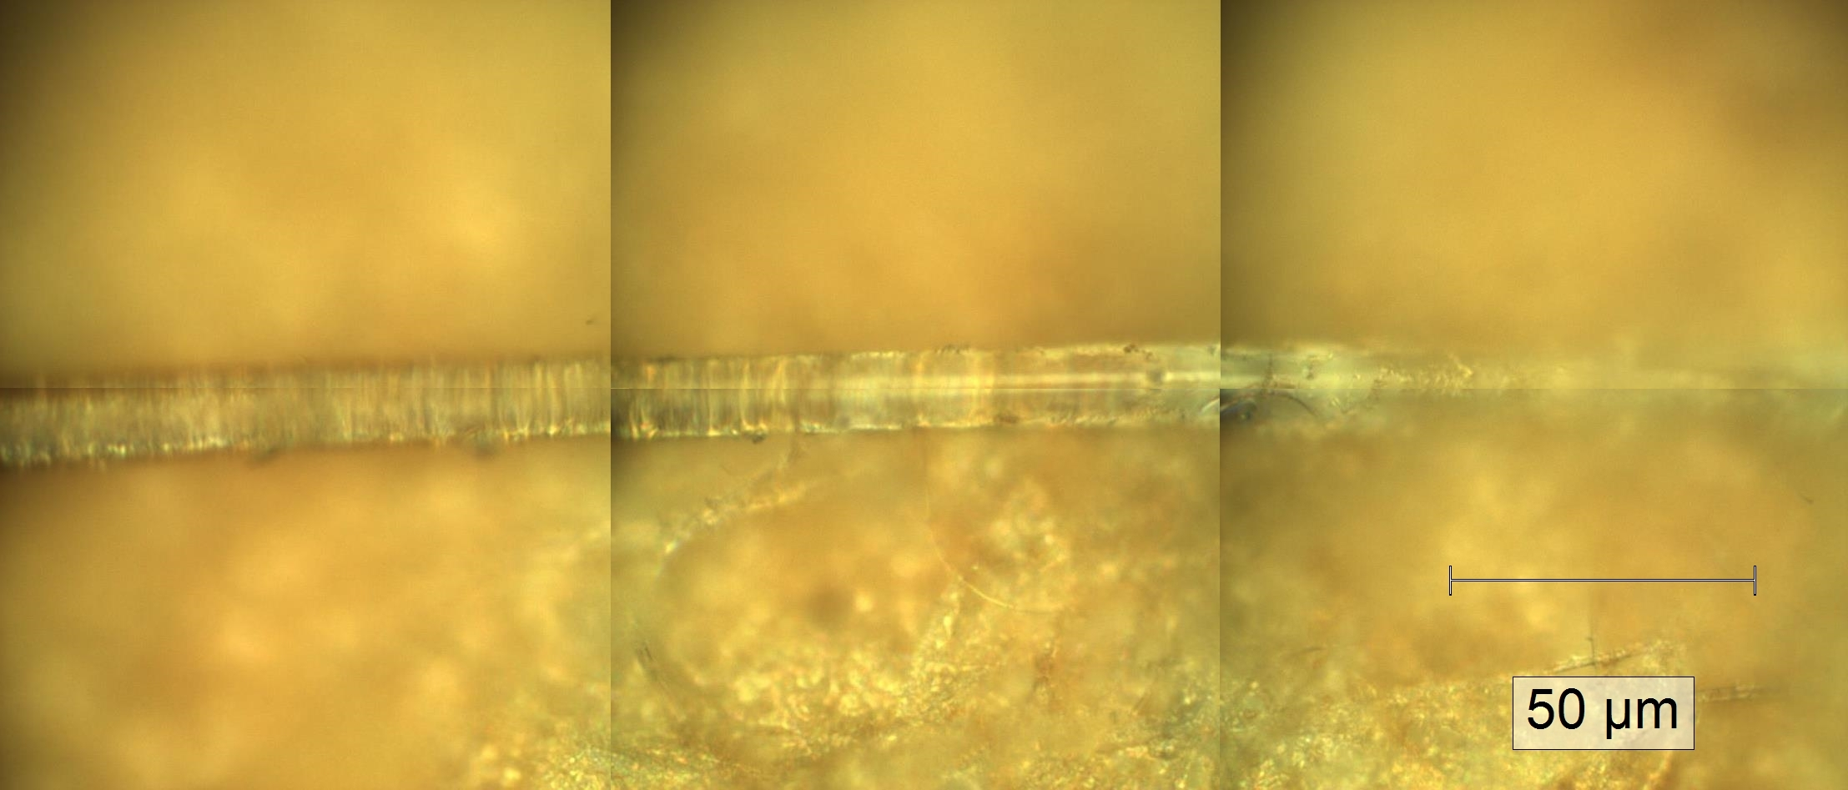
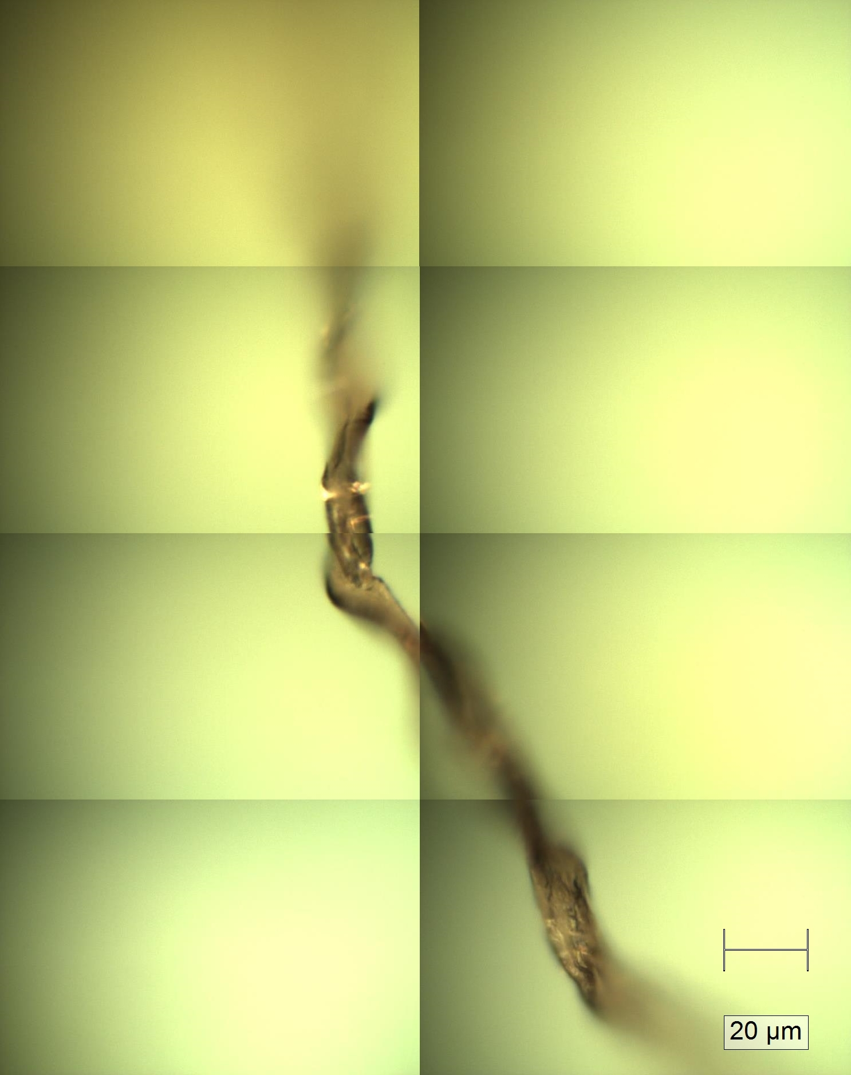
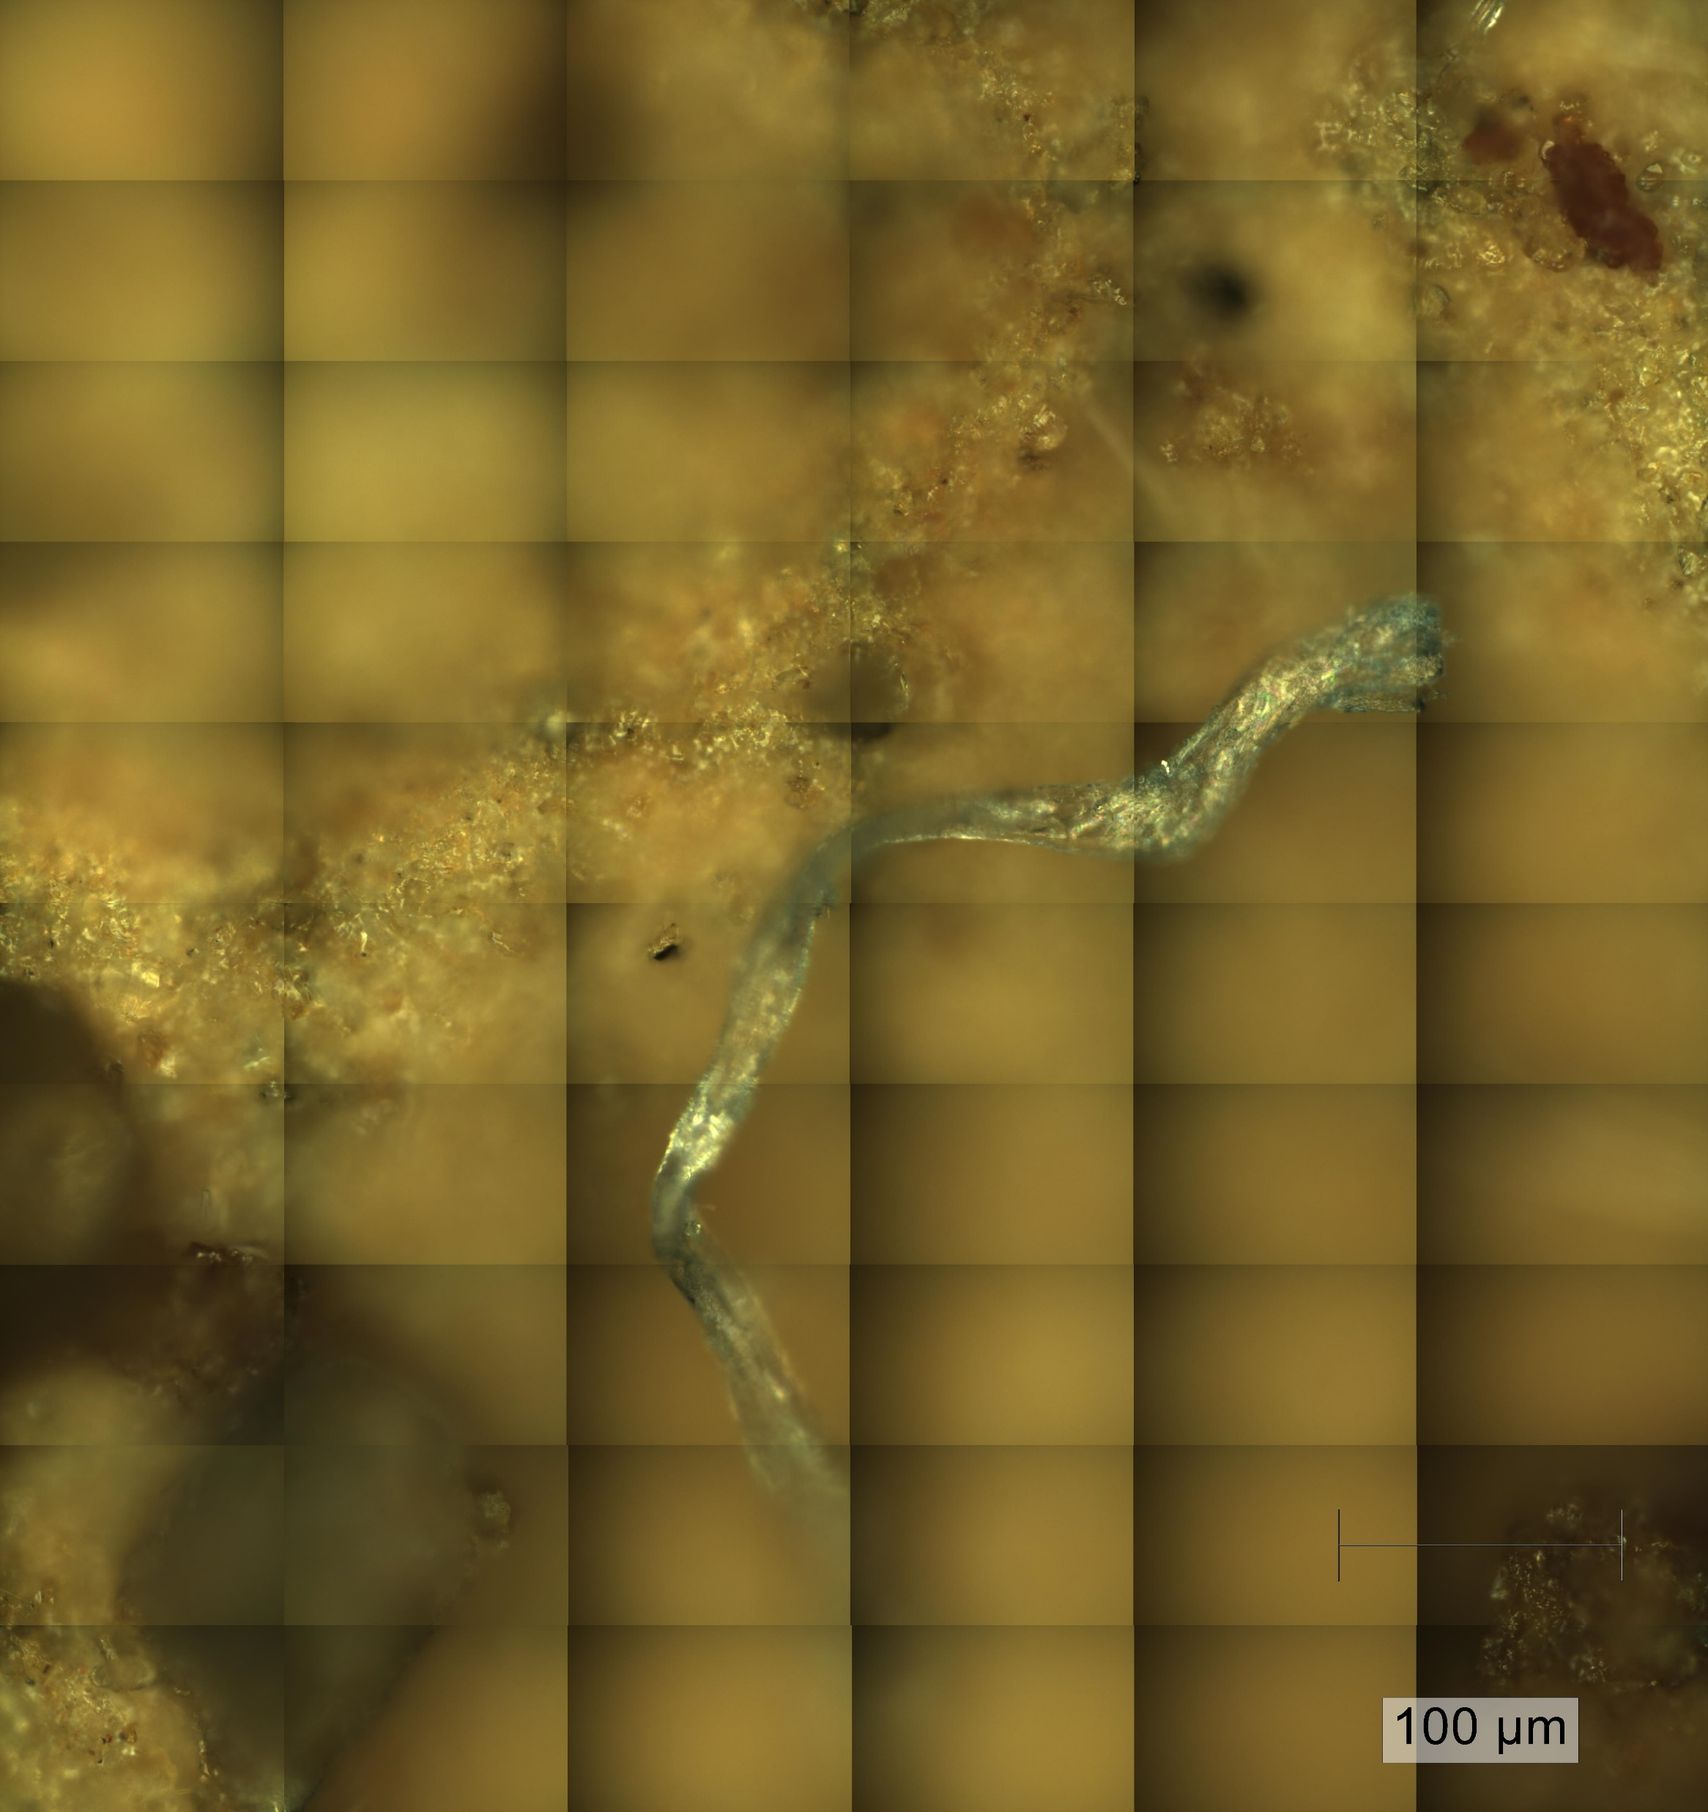
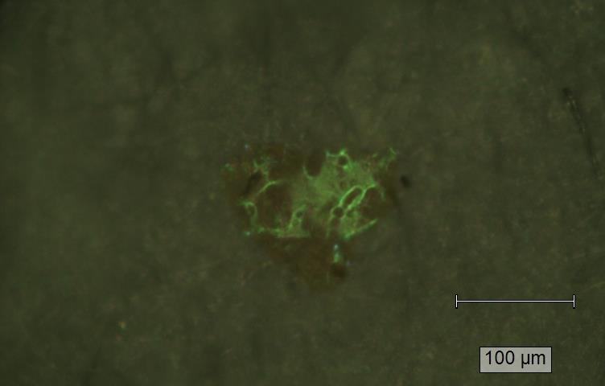
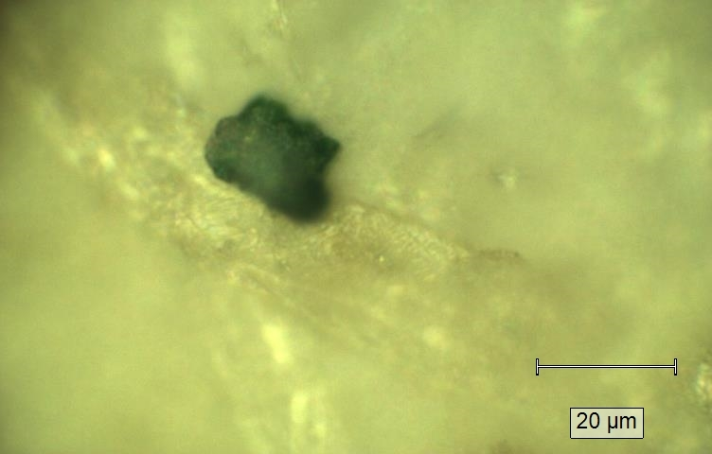
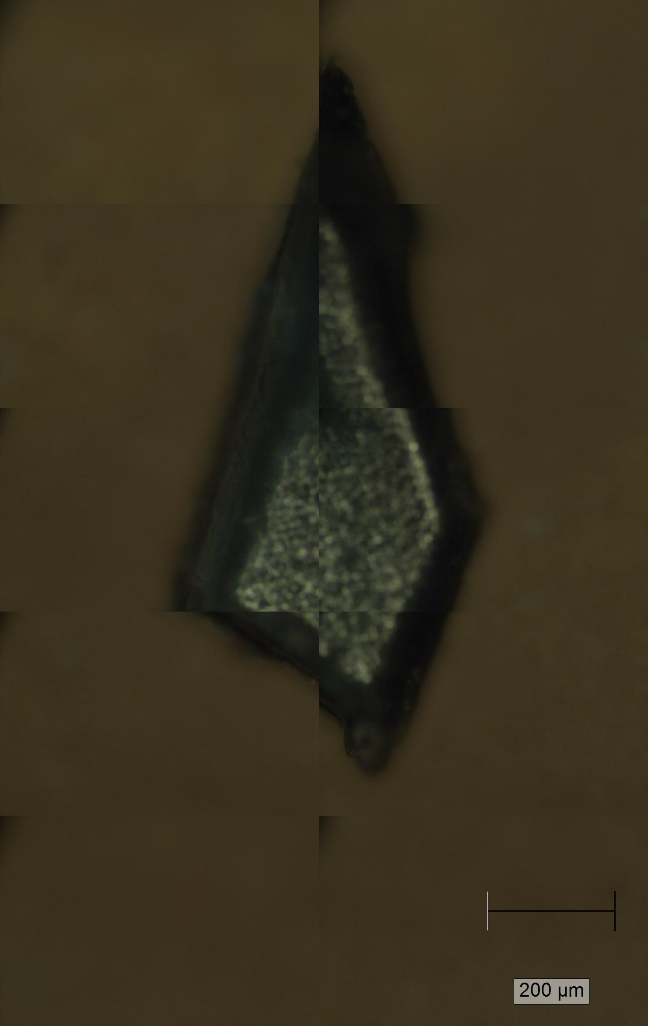
Films – 4%
Spheres – 3%
Synthetic fibers – 51%
Fragments – 42%

Fig. S4: Optical images of selected microplastics representing the four morphological categories.

1001
1031
1583
1602
1203
3110
2923

Fig. S5: Raman spectrum of polystyrene particle

Table S1: Raman band assignments for polystyrene
 | Identified peaks (cm⁻¹) | Literature value (cm⁻¹) | Band Assignment
1. | 975 | 975 | CH out-of-plane deformation
2. | 1001 | 1001 | Ring breathing mode
3. | 1031 | 1031 | C-H in-plane-deformation
3. | 1156 | 1155 | C-C stretch
4. | 1452 | 1450 | CH₂ scissoring
5. | 1583 | 1583 | C=C stretch
6. | 1602 | 1603 | Ring-skeletal stretch
7. | 2923 | 2923 | Methylene C-H backbone
8. | 3110 | 3110 | Aromatic C-H vibration.

1339
1458
2883
2831
1529
2950

Fig. S6: Raman spectrum of polypropylene particle

Table S2: Raman band assignments for polystyrene
 | Identified Peaks (cm⁻¹) | Literature value (cm⁻¹) | Band Assignment
1. | 808 | 808 | CH₂ rocking, C-CH₃ and C-C stretching
2. | 841 | 840 | CH₃ and CH₂ rocking
3. | 974 | 976 | CH₃ rocking and C-C stretching
4. | 1152 | 1152 | C-C and C-CH₃ stretching, CH bending, and CH₃ rocking
5. | 1167 | 1167 | C-C stretching
6. | 1339 | 1338 | CH₂ twisting
7. | 1458 | 1459 | CH₂ bending
8. | 2832 | 2831 | CH₂ sym. Stretching
9. | 2883 | 2444 | CH₃ sym. Stretching
10. | 2921 | 2920 | CH₂ asym. Stretching
11. | 2950 | 2952 | CH₃ asym. Stretching

706
859
1176
1095
2967
3083
1289
1411
1615
1725

Fig. S7: Raman spectrum of polyethylene terephthalate (PET) particle

Table S3. Raman band assignments for polyethylene terephthalate
 | Identified peaks (cm⁻¹) | Literature Values (cm⁻¹) | Band Assignment
1. | 706 | 706 | Ring -C-C- stretching
2. | 796 | 796 | Ring torsion and C=O stretching
3. | 859 | 857 | Ring mode of C-C and C(O)-O stretching
4. | 1095 | 1096 | Ethylene glycol C-O, C-C stretching, and C-O-C bending
5. | 1125 | 1126 | Ester C(O)-O and ethylene glycol C-C stretching
6. | 1176 | 1178 | Ring in plane C-H bond and C-C stretching
7. | 12 89 | 1290 | C(O)-C stretching
8. | 1308 | 1308 | Ring CH in plane bending
9. | 1411 | 1414 | C-CH bending and OCH bending
10. | 1452 | 1452 | CH₂ bending and OCH bending
11. | 1615 | 1615 | Ring mode 8a (in Wilson’s notation)
12. | 1725 | 1726 | C=O stretching
13. | 2895 | 2895 | C-H bond of methylene sequences
14. | 2963 | 2960 | Methylene groups adjacent to oxygen atoms
15. | 2967 | 2967 | C-H stretching
16. | 3080 | 3080 | C-H stretching of ring alkene

1613
1727
1570
1338
1283

Fig. S8: Raman spectrum of polycotton (blended cotton) fibers. The peak at 1338 cm⁻¹ is typical of cotton material while peaks at 1727, 1613, and at 1283 cm⁻¹ are typical of PET material.

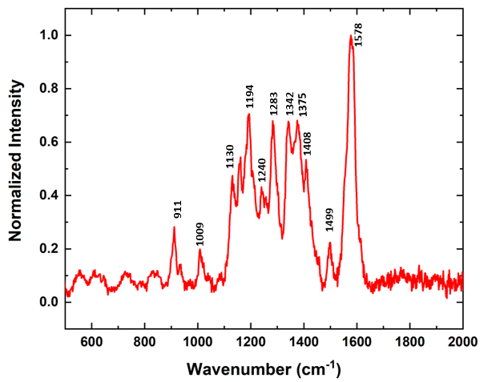
Fig. S9: Raman spectrum of Reactive Black 5 (RB 5) dye observed in some textile fiber samples.
1099
1228
1146
1249
1362
1460
1584
1608
1699
1296
1008

Fig. S10: Raman spectrum of Vat Indigo dye (Natural Blue 1) observed in some textile fiber samples.
1563
1608
1520
1451
1403
1351
1318
1264
1228

Fig. S11: Raman spectrum of Diarylide yellow (Pigment Yellow 83) observed in some textile fiber samples.
1521
1581
1483
1450
1362
1340
1141
947
748
678
591

Fig. S12: Raman spectrum of copper phthalocyanine dye (Pigment Blue 15:0).

