Supplemental Materials
Supplemental 1. Details for the acoustic telemetry stations included for calculating cumulative daily proportion of total run for each species.
Species | Station ID | Site | Number Receivers | Mean Latitude | Mean Longitude
Largemouth Bass & Common Carp | TOI-027 | TI 27 | 1 | 43.62138 | -79.38925
 | EMC-009 | Embayment C | 3 | 43.62862677 | -79.33389688
Northern Pike | EMC-010
 | EMC-036

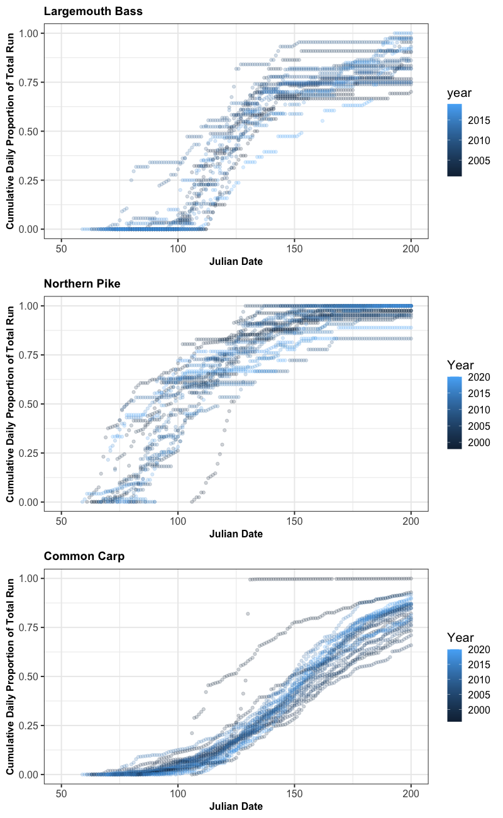
b)
a)
c)
Supplemental 2. Cumulative daily proportion of total run by sample year for each a) largemouth bass, b) northern pike, and c) common carp.
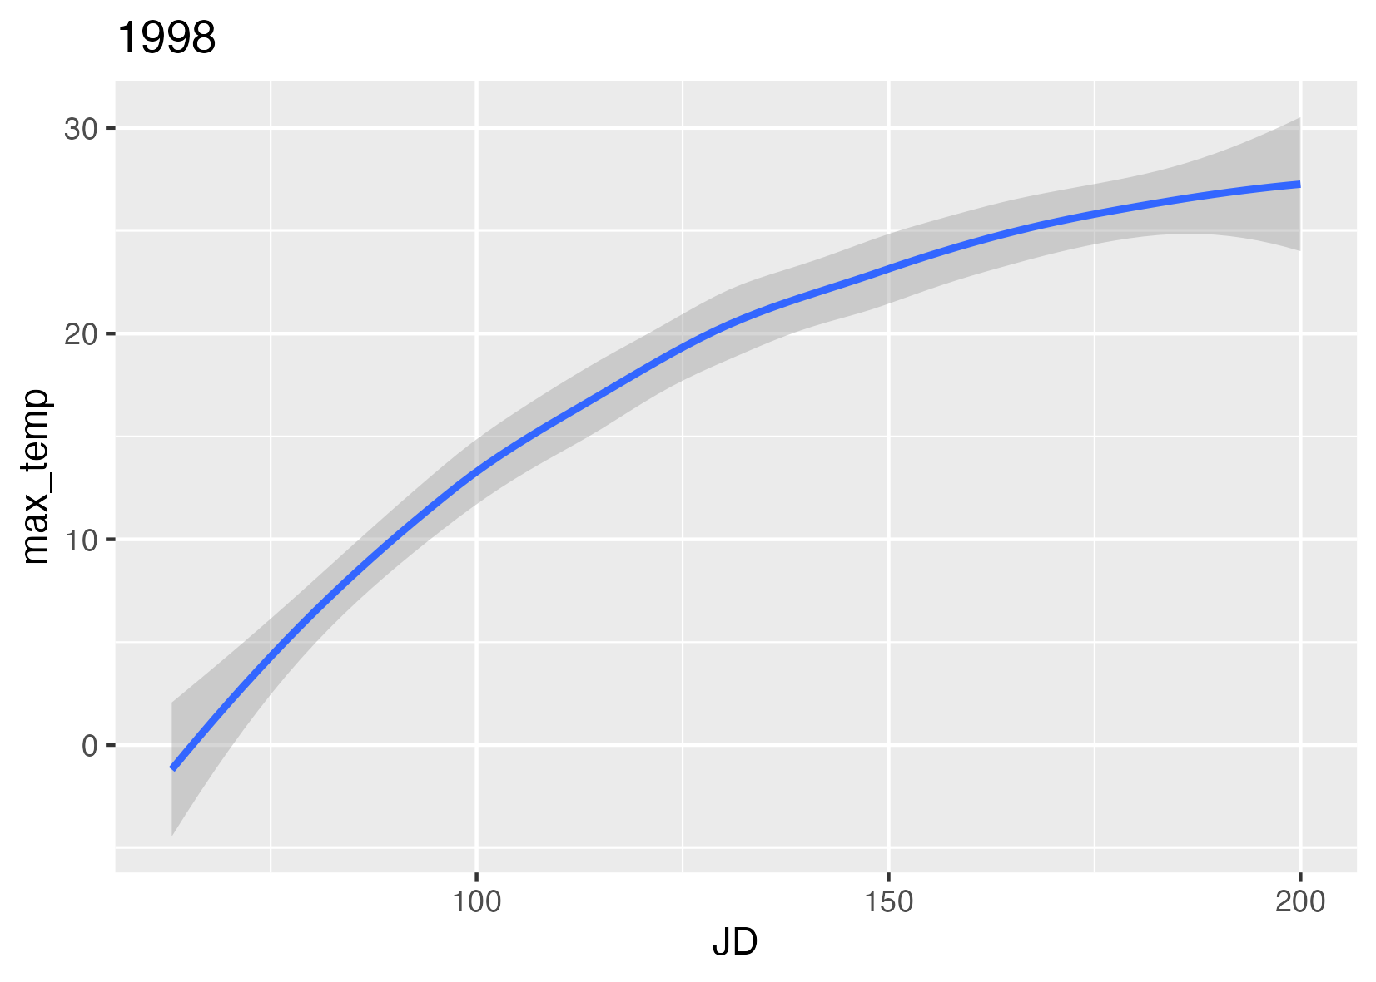
a)
b)
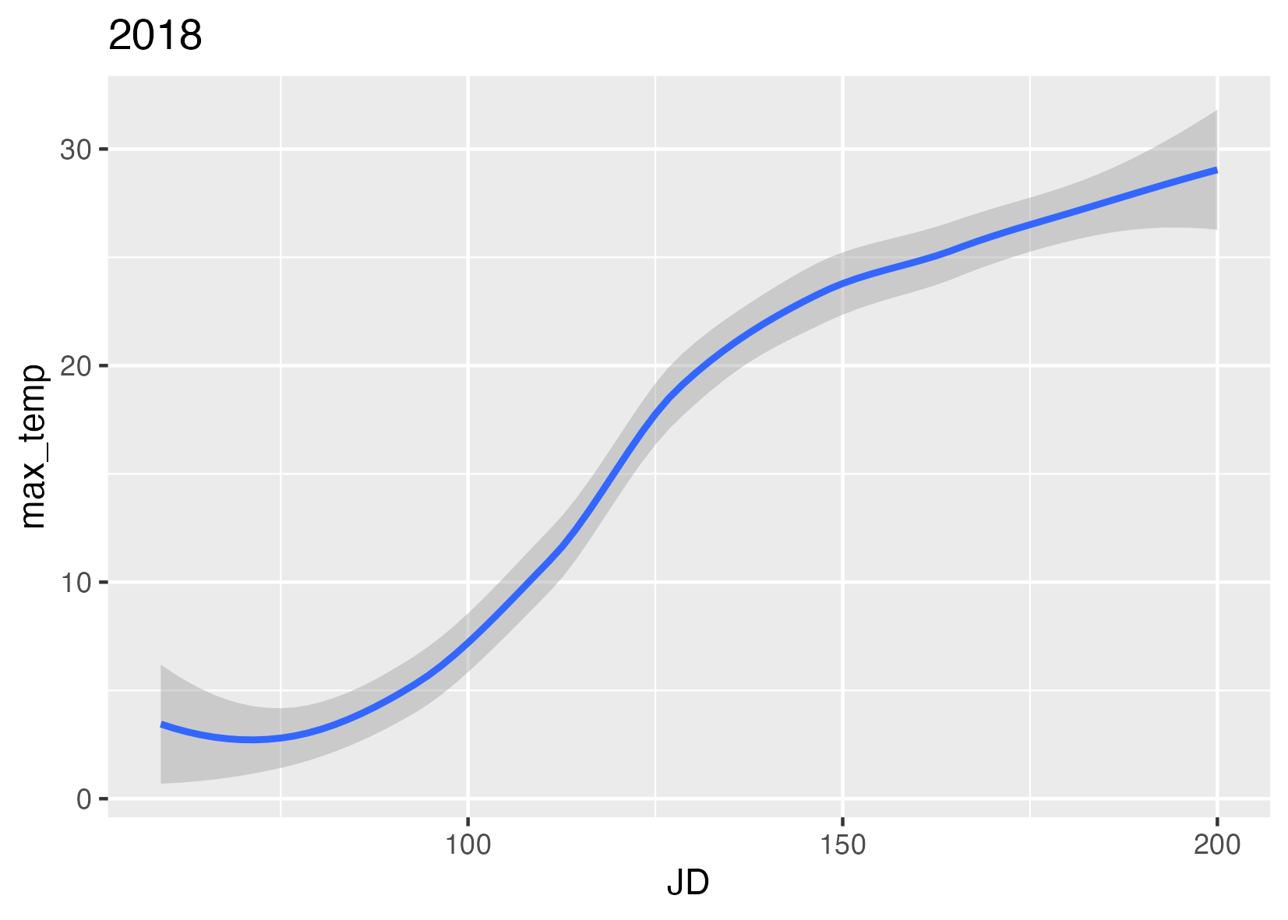
Supplemental 3. Daily maximum temperatures by Julian date in Hamilton Harbour with a) a warm year (1998) and b) and cold year (2018).
a)
b)
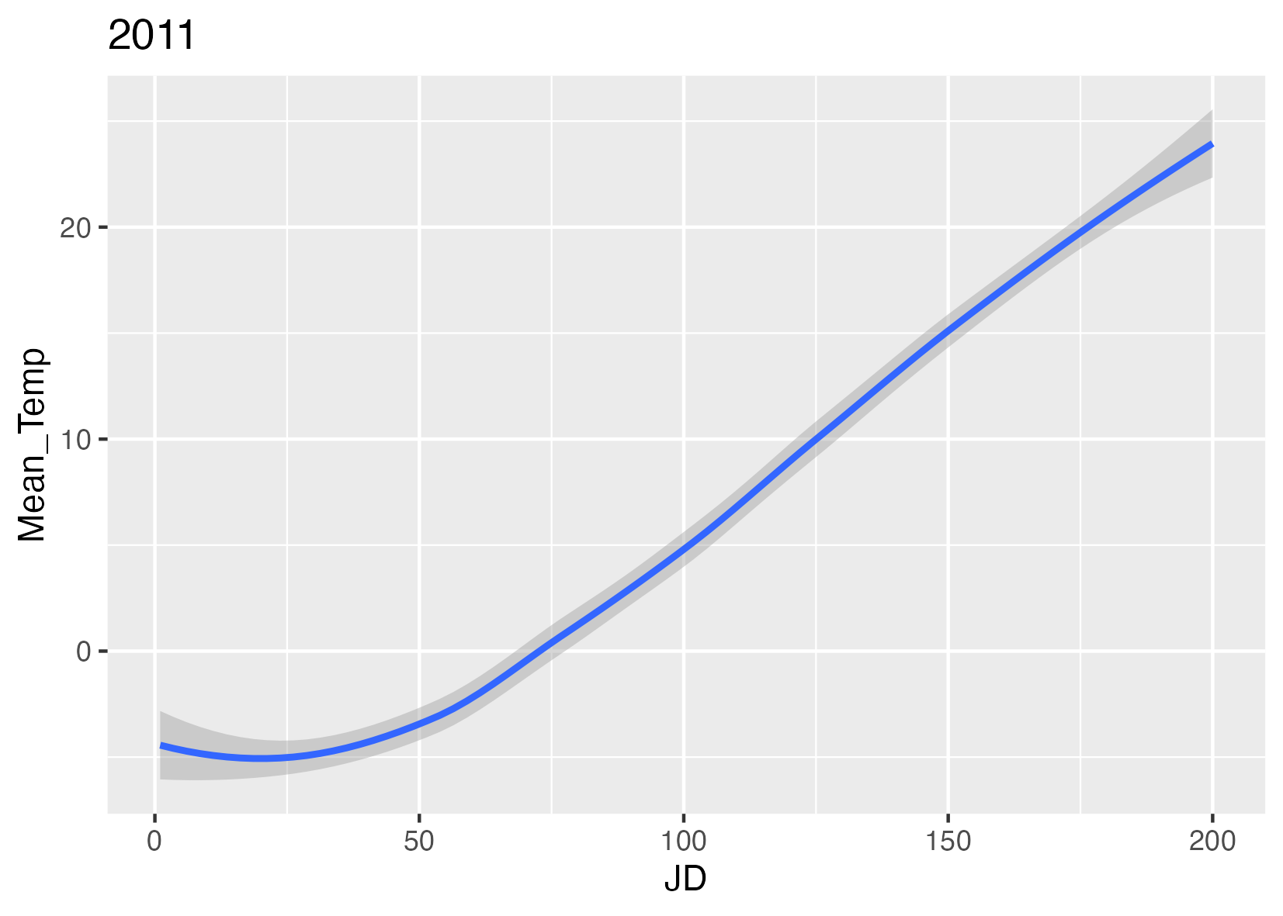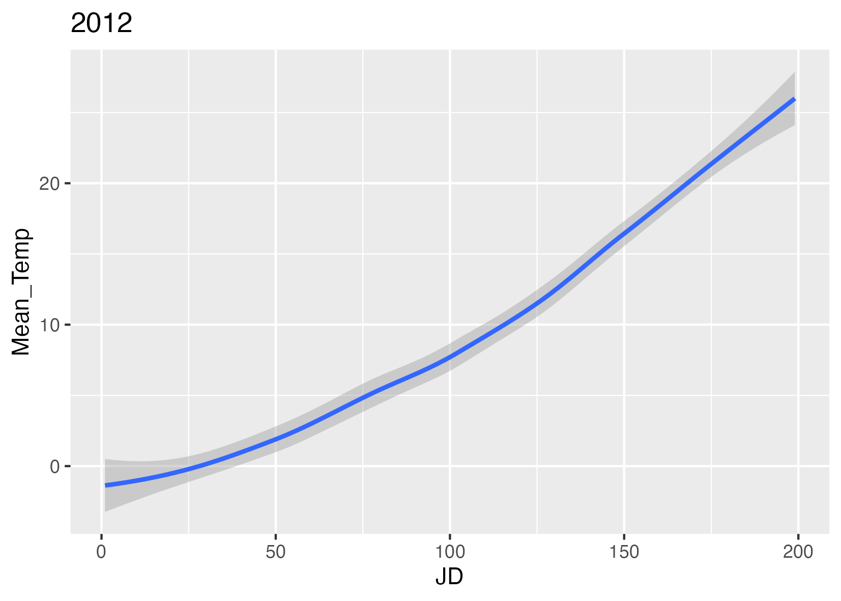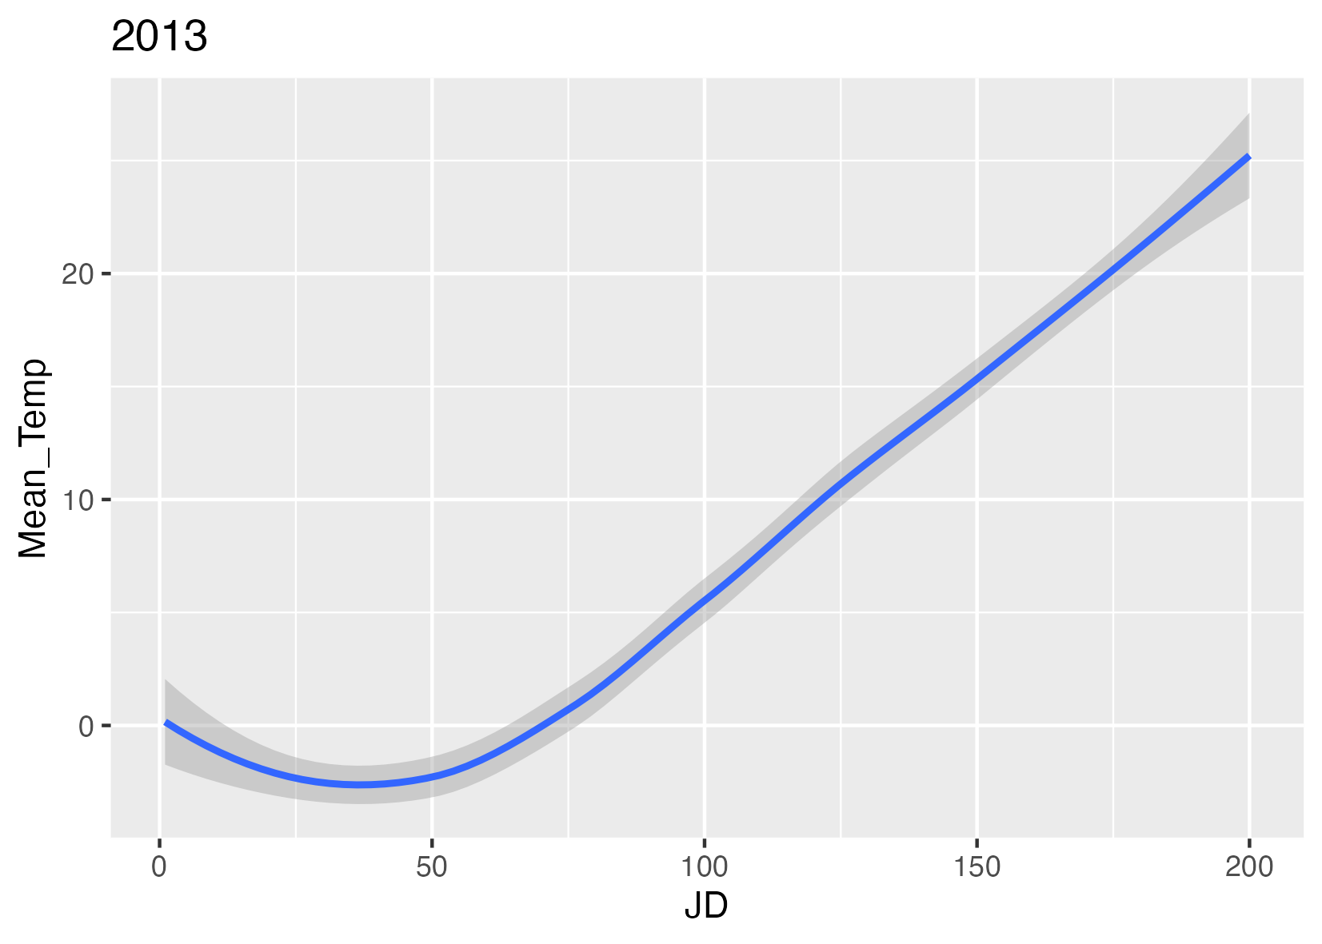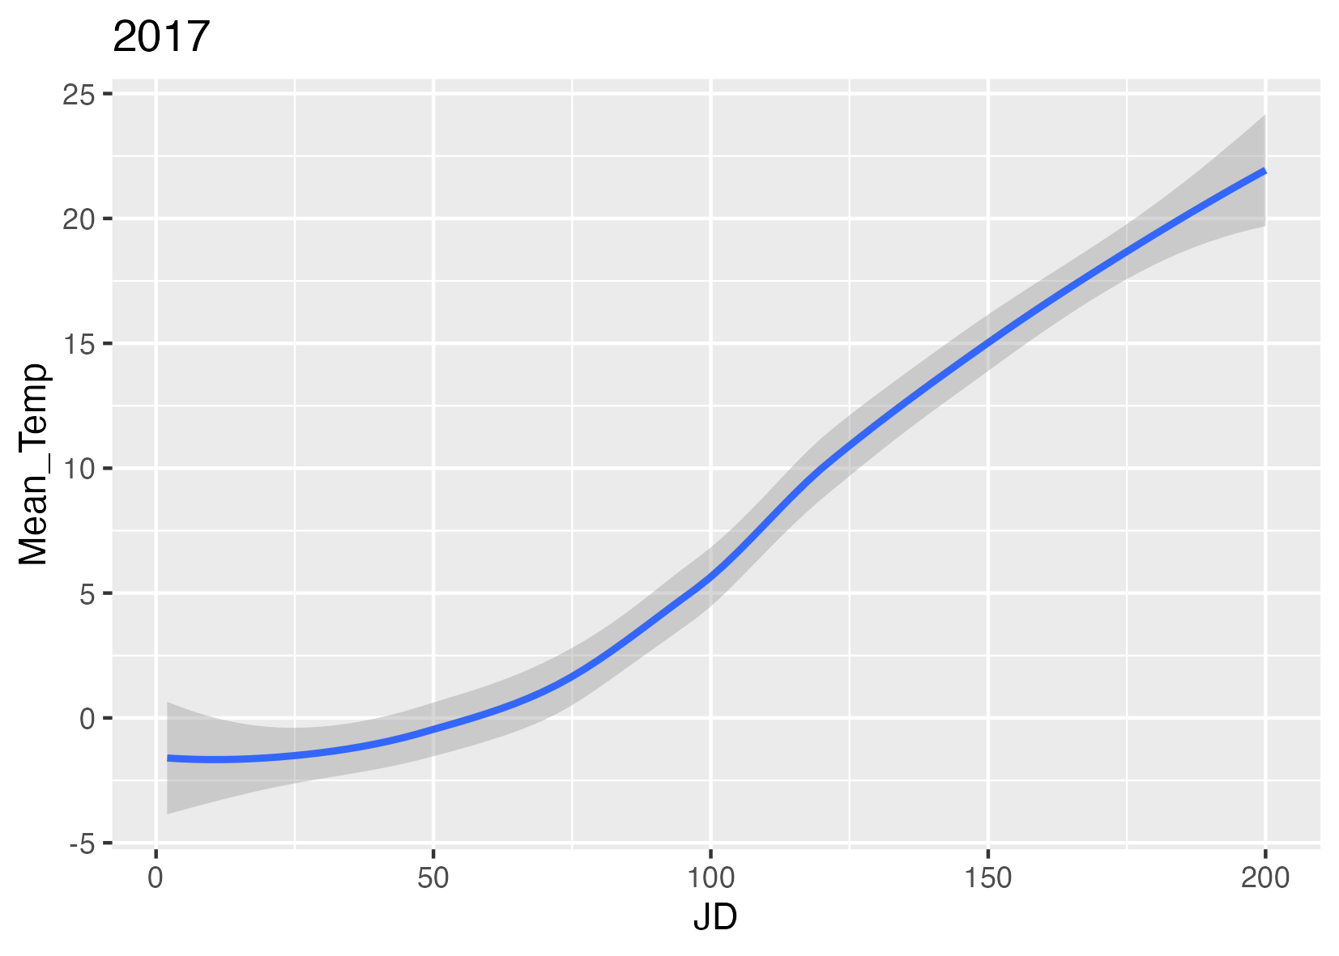
c)
d)
Supplemental 4. Daily mean temperatures for Toronto Harbour (from Billy Bishop Airport) for years used for calculating the cumulative growing degree day for acoustic telemetry data: a) 2011, b) 2012, c) 2013 and d) 2017.

