Immune cell population dynamics following neonatal BCG vaccination and aerosol BCG revaccination in rhesus macaques.

Laura Sibley¹, Charlotte Sarfas¹, Alexandra Morrison¹, Jessica Williams¹, Konstantinos Gkolfinos¹, Adam Mabbutt¹, William Eckworth¹, Steve Lawrence¹, Mike Dennis¹, Andrew White¹, Sally Sharpe¹.

¹UK Health Security Agency, Porton Down, Salisbury SP4 0JG

Supplementary data

Supplementary Figure 1. Treg numbers at week 12 post-BCG vaccination depending on which day after birth they were vaccinated on. Medians shown and dots indicate individuals.

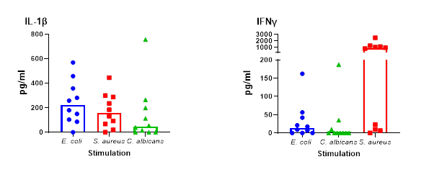

Supplementary Figure 2. Trained innate immunity cytokine production after stimulation with E. coli, S. aureus or C. albicans in naïve adult rhesus macaques. Medians shown and dots indicate individuals.

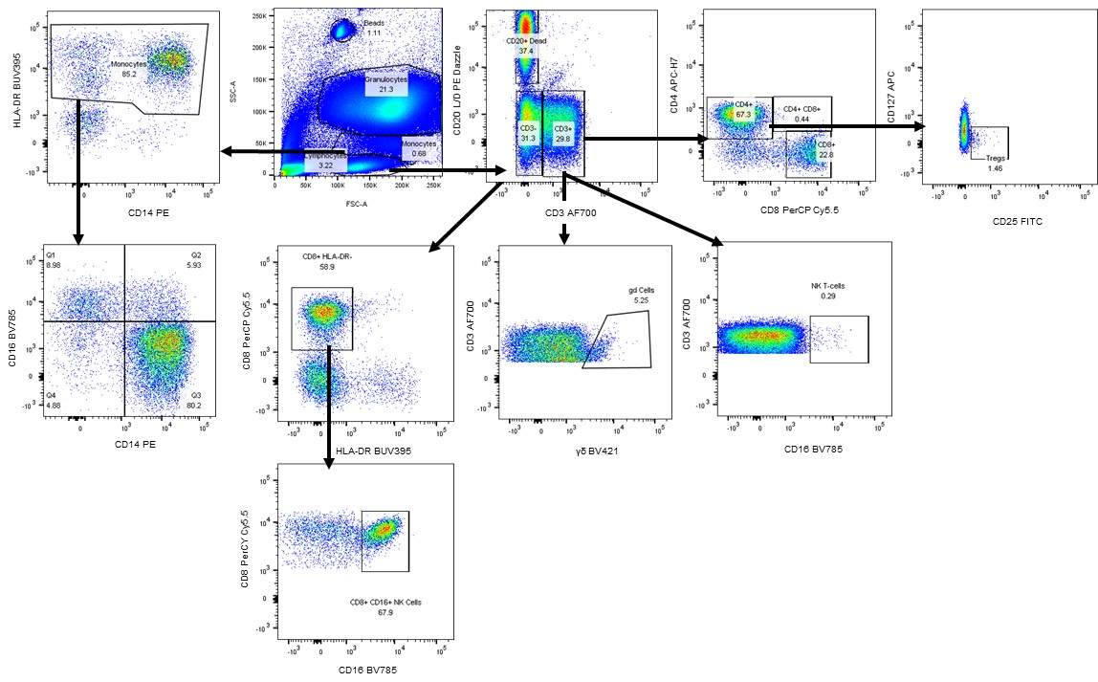
Supplementary Figure 3. Gating strategy for flow cytometry panel of whole blood, PBMC and BAL immunophenotyping.

