Additional file 1

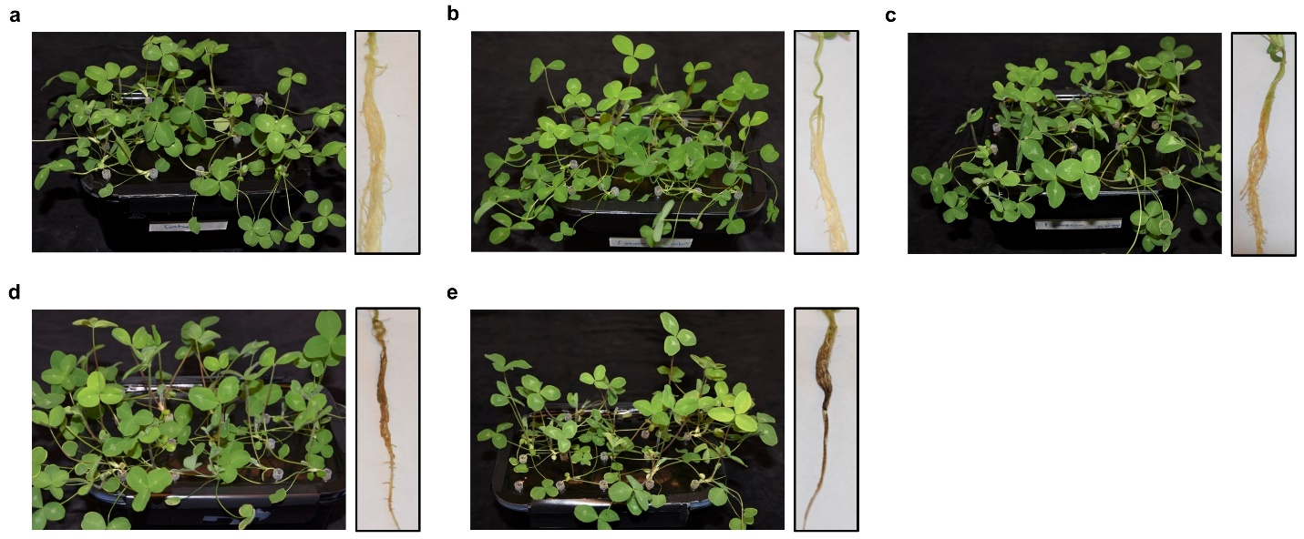
Figure S1 Phenotypic responses of red clover plants cv. Ares grown in hydroponic media after inoculation with 15, 000 spores/mL final concentration of F. avenaceum. (a) Non-inoculated plants, (b) wilting and root symptoms at 1 day post inoculation (dpi), (c) 3 dpi, (d) 5 dpi and, (e) 7 dpi.

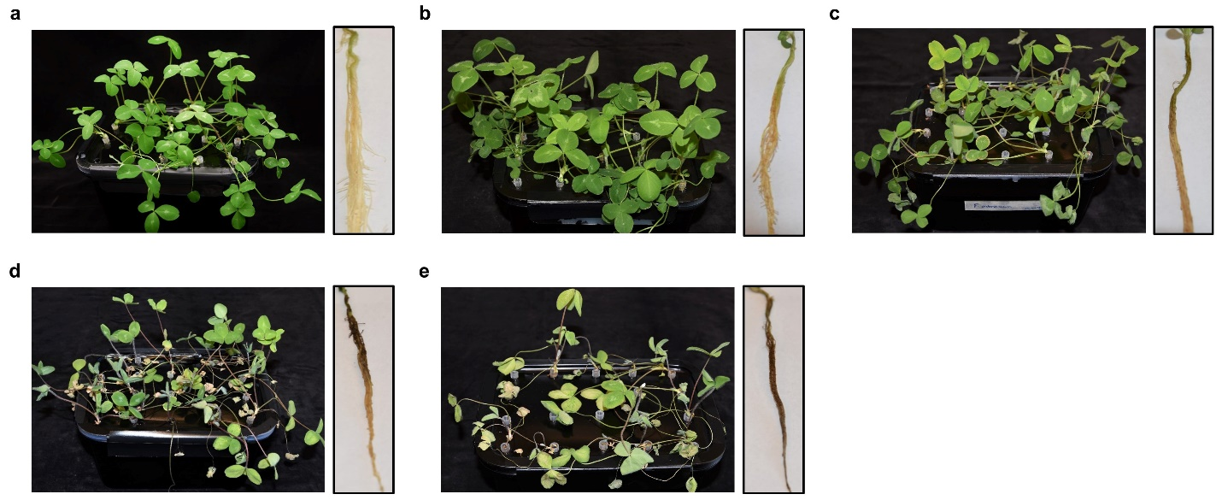
Figure S2. Phenotypic responses of red clover plants (cv. Ares) grown in hydroponic media after inoculation with 30,000 spores/mL final concentration of F. avenaceum. (a) Non-inoculated plants, (b) wilting and root symptoms at 1 day post inoculation (dpi), (c) 3 dpi, (d) 5 dpi and (e) 7 dpi.

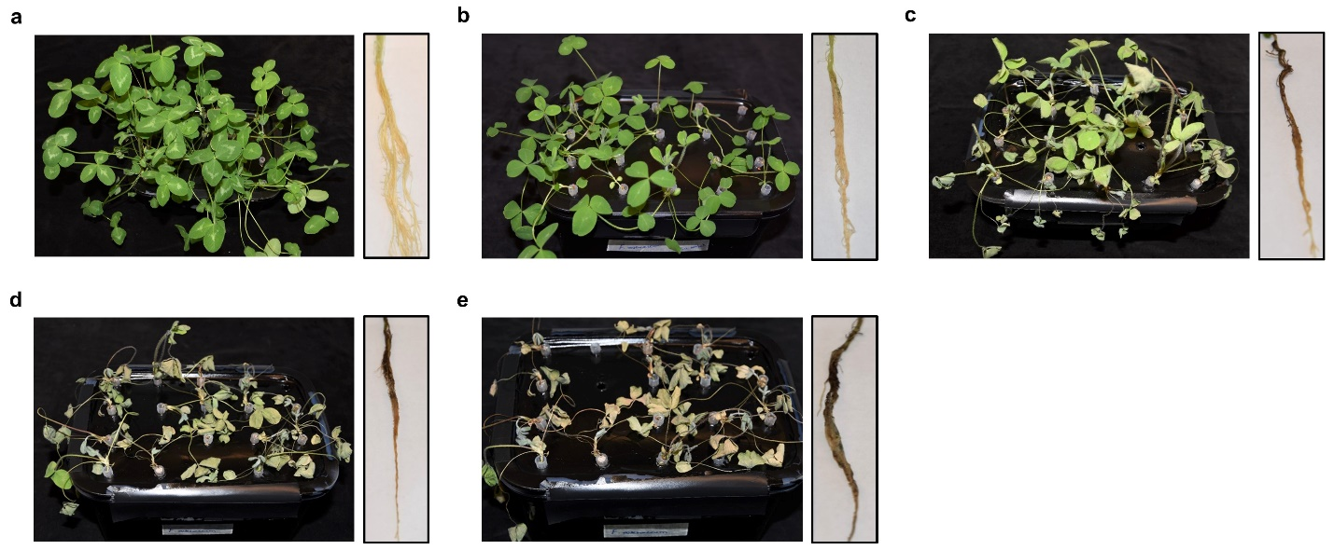
Figure S3. Phenotypic responses of red clover plants (cv. Ares) grown in hydroponics after inoculation with 60, 000 spores/mL final concentration of F. avenaceum. (a) Non-inoculated plants, (b) wilting and root symptoms at 1 day post inoculation (dpi), (c) 3 dpi, (d) 5 dpi and (e) 7 dpi.

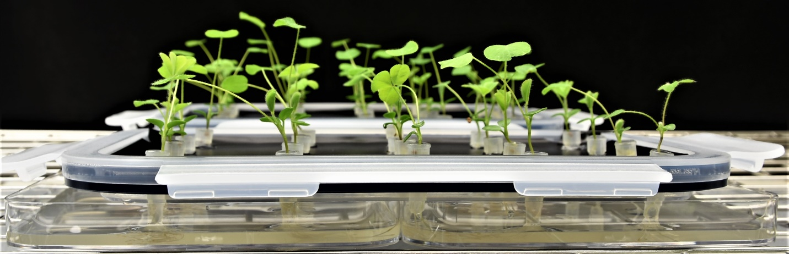
Figure S4. Red clover roots treated with R. leguminosarum bv. trifolii. Box lids with two-week old seedlings transferred to the square Petri dish containing 50 mL of rhizobial suspension (10³ cells/mL) and incubated for 2 h under darkness before return to the climate chamber and the hydroponics media with reduced nitrogen.

Supplementary tables

Table S1 Disease Index (DI) values 1, 3 and 7 days post inoculation of the red clover cv. Ares
Spore concentration/mL | 3 dpi | 5 dpi | 7 dpi
15,000 | 0.2 | 0.7 | 1.0
30,000 | 0.8 | 1.5 | 2.5
60,000 | 2.9 | 3.0 | 3.0

