Supporting information

Micro flower-like Hierarchical Mo₂C/Co@N-C (N-doped carbon) for efficient bifunctional electrocatalyst
Hee Soo Kim^{a,*}, Ahyoun Lim^{b}, Mino Wooª, Hae In Leeª, Yunjang Guª and Dong-Ha Lim^{a,*}

ªGreen Materials & Processes R&D Group, Korea Institute of Industrial Technology (KITECH), Ulsan, 44413 Republic of Korea

^{b}Hydrogen•Fuel Cell Research Center, Korea Institute of Science and Technology (KIST), Seoul 02792, Republic of Korea

* Corresponding Author
*E-Mail: catacylsm@kitech.re.kr (H.S. Kim)
*E-Mail: dongha4u@kitech.re.kr (L-H. Lim)

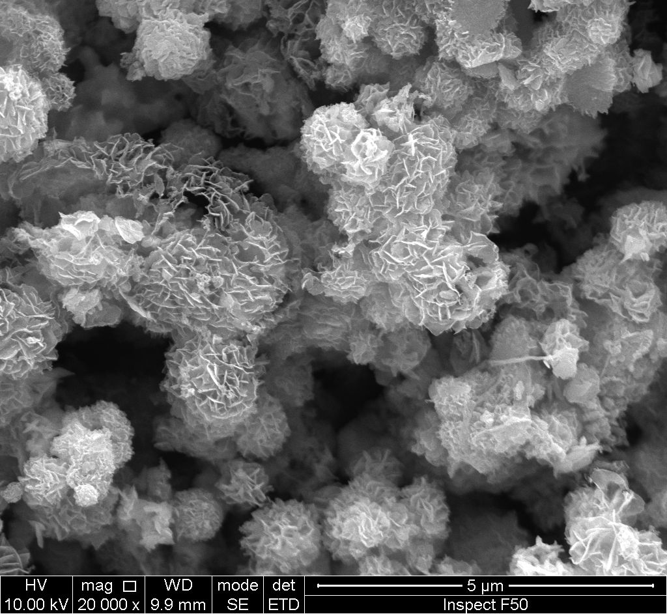
5um

Fig. S1. SEM image of Mo₂C/Co@dopamine polymer before carbonization

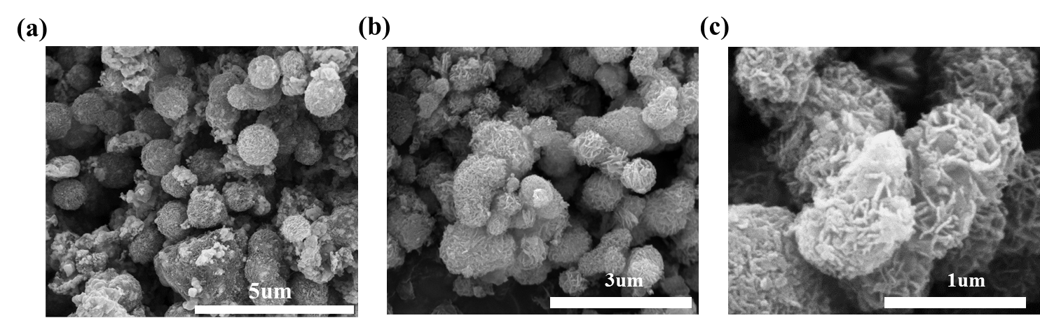
Fig. S2. SEM images of Mo₂C/Co@N-C (a) and Mo₂C@N-C (b and c)

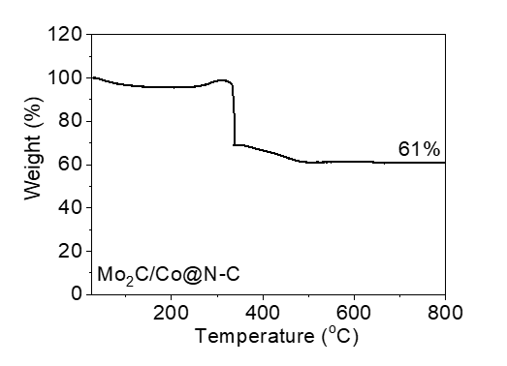

Fig. S3. TGA analysis result of Mo₂C/Co@N-C at air condition.

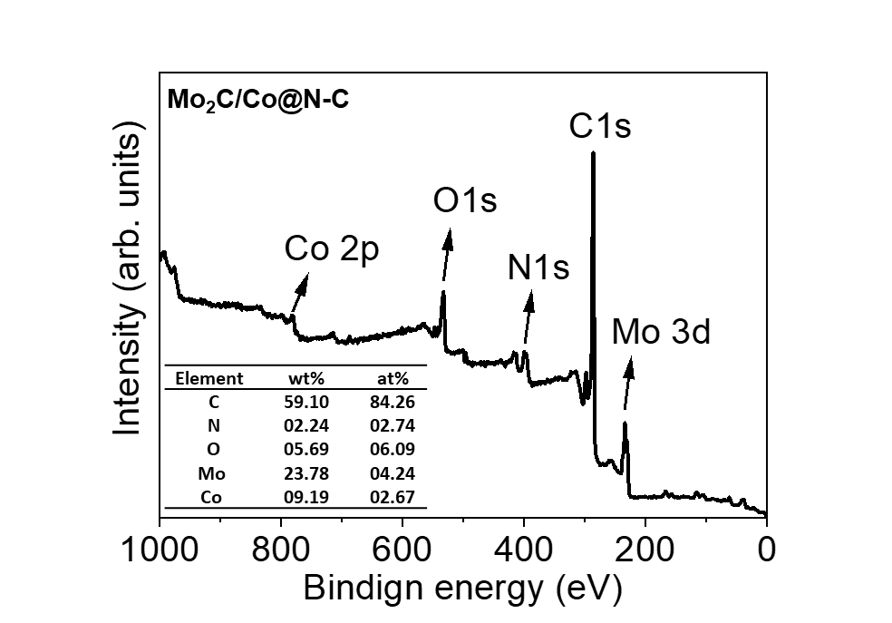

Fig. S4. The element ratio of the Mo₂C/Co@N-C catalyst from the XPS scan survey

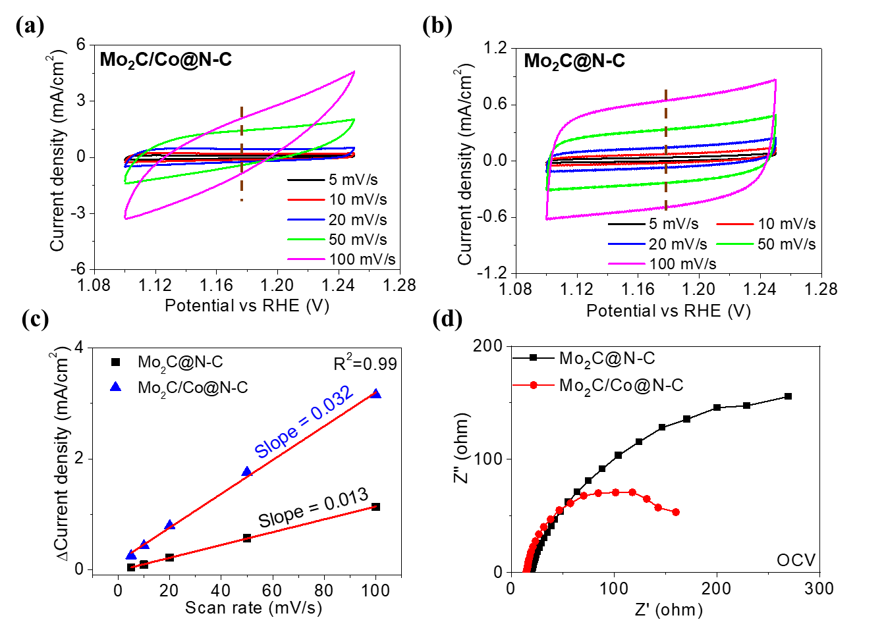

Fig. S5. CVs of the Mo₂C/CO@N-C (a) and Mo₂C@N-C (b) measured in a non-faradaic region at different scan rates from 5 to 100 mV/s. Linear plots of capacitive current against scan rate of various electrocatalyst (c). Nyquist plots of the Mo₂C@N-C and Mo₂C/Co@N-C catalyst at OCV (d)

