Supplementary Materials
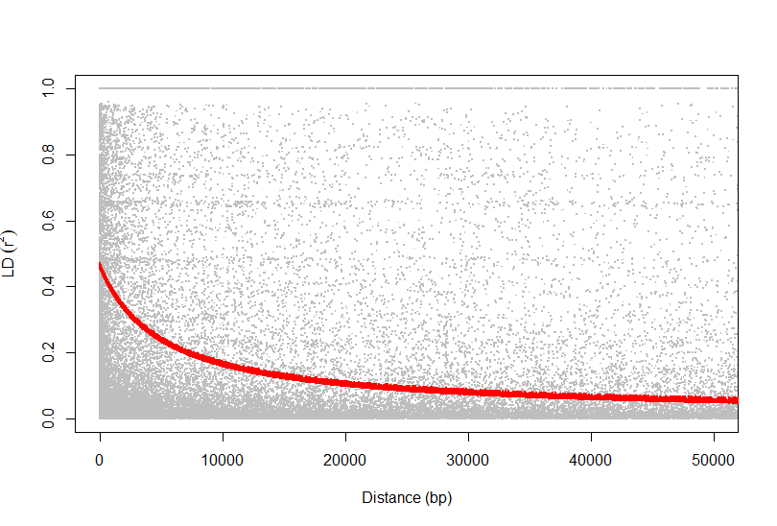
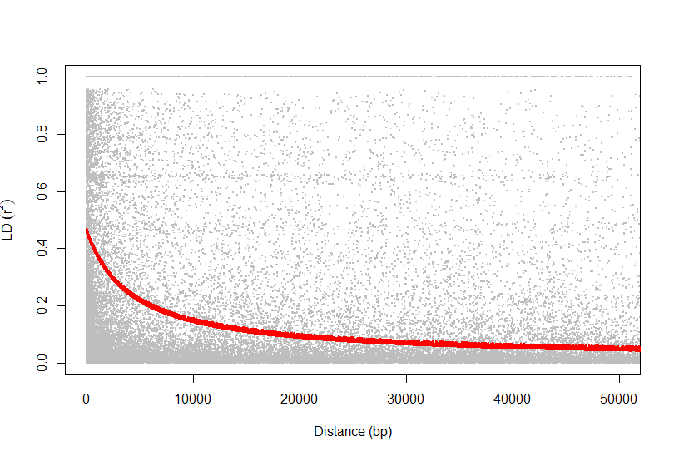
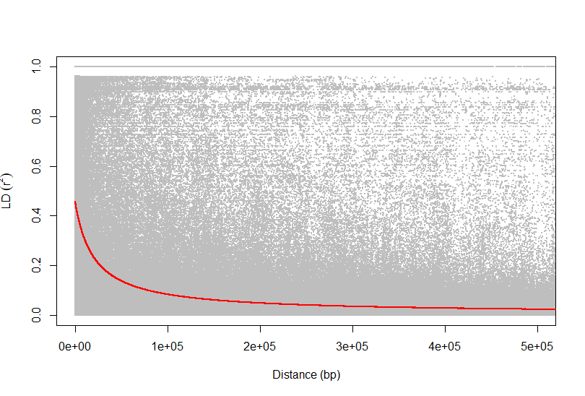
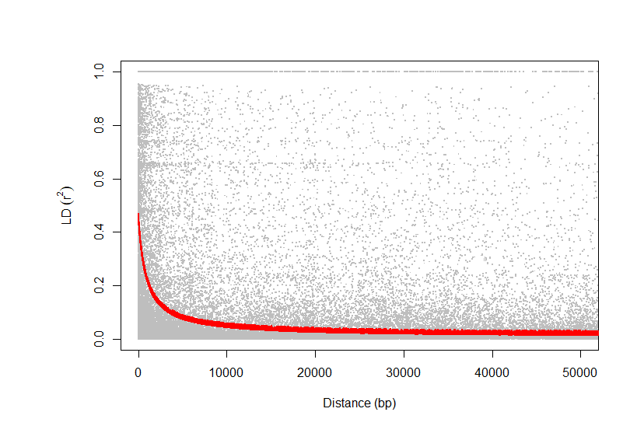
Chromosome 4
Chromosome 3
Chromosome 1
Chromosome 2

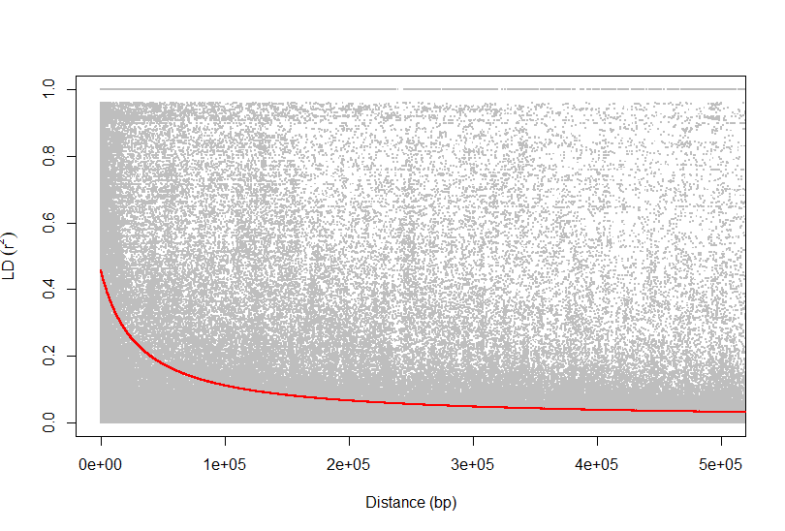
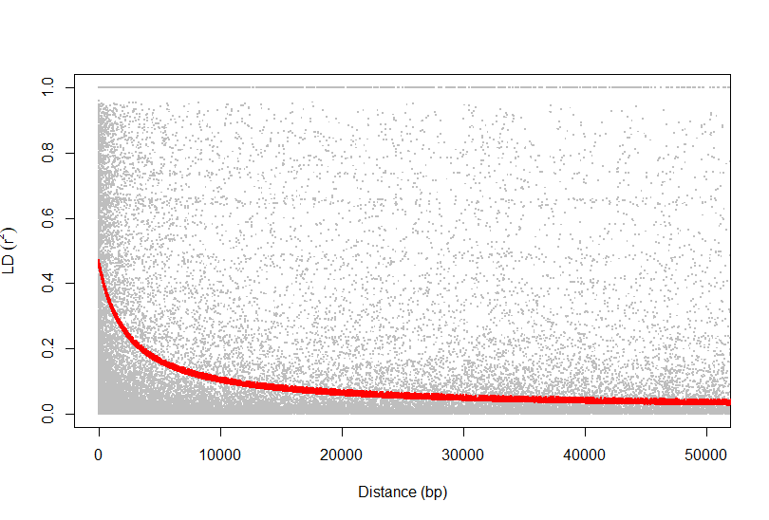
Chromosome 6
Chromosome 5

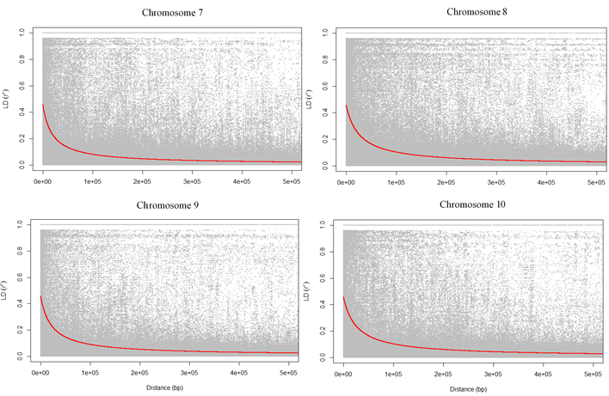

Figure S1. The linkage disequilibrium (LD) decay results for the 10 chromosomes of the maize dataset.

Table S1. The top 25 superior hybrid combinations of the pumpkin dataset identified by Wu et al. (2019) and our study. The colored ones are the common hybrids selected by both approaches.
Our study | Wu et al. (2019)
P026⨂P236 | P026⨂P236
P026⨂P234 | P026⨂P027
P026⨂P027 | P026⨂P235
P026⨂P235 | P026⨂P234
P026⨂P028 | P026⨂P237
P026⨂P237 | P026⨂P028
P234⨂P313 | P227⨂P236
P235⨂P313 | P227⨂P235
P236⨂P313 | P227⨂P234
P028⨂P313 | P026$⨂$P233
P227⨂P236 | P227$⨂$P237
P227⨂P235 | P028⨂P227
P027⨂P313 | P027⨂P227
P227⨂P234 | P026$⨂$P138
P028⨂P227 | P026⨂P253
P236⨂P252 | P026⨂P255
P027⨂P227 | P026⨂P254
P237⨂P313 | P026⨂P302
P007⨂P026 | P007⨂P026
P026⨂P302 | P008$⨂$P026
P227$⨂$P237 | P026⨂P252
P235⨂P252 | P026$⨂$P243
P028⨂P252 | P138$⨂$P241
P236⨂P257 | P026$⨂$P241
P234⨂P252 | P100⨂P236

Table S2. The top 10 superior parental lines of the pumpkin dataset identified by Wu et al. (2019) and our study. The colored ones are the common parental lines selected by both approaches.
Our study | Wu et al. (2019)
P236 | P026
P235 | P236
P027 | P235
P234 | P027
P028 | P234
P237 | P237
P026 | P241
P252 | P324
P007 | P028
P302 | P255

