Chart 1 Questionnaire summary graph -- Duration of receiving CBI education
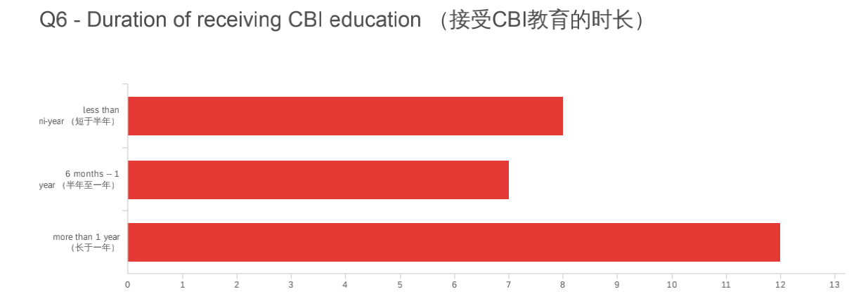

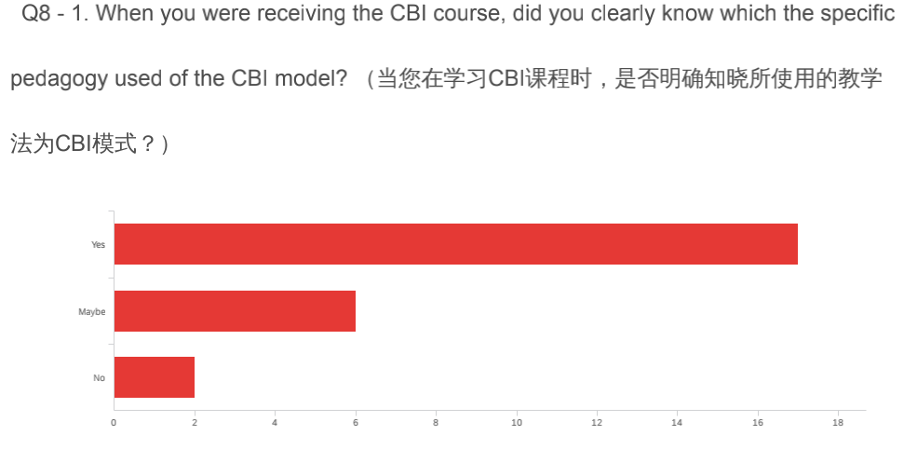
Chart 2 Questionnaire summary graph

Chart 3 Questionnaire summary graph
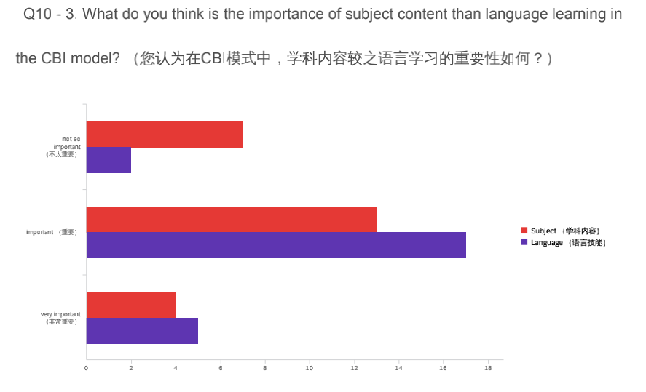

Chart 4 Questionnaire summary graph
