Primordial and ²⁴⁴Pu-derived xenon
missing from Earth's convecting mantle

Authors: D.V. Bekaert*^{1,2}, A. Caracausi³, G. Caro²,
M.W. Broadley², D. J. Byrne², P.H. Barry¹, B. Marty², A.M. Seltzer¹.

Supplementary Material

SM-1° "Mass balance Hadean.xlsx" is an excel file that presents the mass balance calculation of U partitioning during magma ocean crystallization and computes the ultimate amount of U within the hadean crust.

SM-2° "Kr-in-CC.xlsx" is an excel file that compiles available literature data for Kr isotopes in carbonaceous chondrites.
SM-3° "Mantle_Xe_evolution.py" is a python code used for modeling mantle Xe isotope evolution.

Supplementary Information

SI-1° Results, and comparison with previous methods
SI-2° Identification of a primordial Kr and Xe components
SI-3° Noble gas abundance ratio systematics
SI-4° Xe isotope correction for gravitational settling
SI-5° Monte Carlo deconvolution of Xe isotope signals
SI-6° Numerical model of mantle Xe evolution
SI-7° Results of the numerical model
SI-8° Magma ocean crystallization model

SI-1° Results and comparison with previous methods

One major difference between this study and previous work is the analytical technique that has been used for noble gas measurements (i.e., dynamic and static mass spectrometry, respectively). Because the DMS method does not require noble gas separation prior to analysis and allows for many comparable measurements of purified sample gas and standard gas of known isotopic composition over the course of an analysis⁸, it is ideally suited to provide accurate and unbiased isotopic ratio determinations. At present, the reason why noble gas analyses of popping rock 2∏D43 – considered to best represent the convecting mantle source composition – via static mass spectrometry have yielded inconsistent ¹³⁶Xe_{Pu}/¹³⁶Xe_{TF} estimates^{6,15} (Figure S1) remains unknown. The enhanced precision and accuracy of DMS measurements relative to static mass spectrometry (e.g., Figure 1) suggests that DMS data presented in this study may provide the most accurate description of the convecting mantle composition^{63,24,60}.

Figure S1 and S2 present a compilation of Xe isotope systematics for previously published (static mass spectrometry) mantle noble gas data and dynamic mass spectrometry data reported in this study for Mt. Etna and Eifel. Figure S1 presents a comparison of these data with the isotopic trends for ²³⁸U and ²⁴⁴Pu fission, thus highlighting the vast improvement in precision and accuracy compared to traditional static mass spectrometry techniques⁶. Figure S2 presents the classical δ¹²⁹Xe/¹³⁶Xe_{air} vs. δ¹³⁰Xe/¹³⁶Xe_{air} plot, which has been used to argue that small Xe isotopic differences between OIB and MORB mantle sources cannot be related solely through recycling atmospheric Xe or by adding fissiogenic ¹³⁶Xe to MORB Xe⁴. However, the recent finding that popping rock and Iceland plume data overlap in this isotopic space⁶ casts doubt on the interpretation that these small differences truly reflect primordial heterogeneities, and calls for a critical improvement in our analytical accuracy – as now enabled by DMS measurements (Figure S2).

(a) | Sample | ⁴⁰Ar/³⁶Ar | ±1σ | δ ⁸⁴Kr/³⁶Ar |  | δ ¹³²Xe/³⁶Ar
(a) | Mt. Etna 1 | 1880 | 21 | 876.7 | 2.9 | 2886.1 | 12.574
(a) | Mt. Etna 2 | 1910 | 21 | 875.2 | 2.9 | 2878.1 | 12.581
(a) | Mt. Etna 3 | 1920 | 21 | 868.9 | 2.9 | 2863.8 | 12.587
 | Eifel | 10,177 | 112 | 557.0 |  | 2433.8
(b) |  | δ⁸²Kr/⁸⁴Kr | ±1σ | δ⁸⁶Kr/⁸⁴Kr | ±1σ | δ⁸⁶Kr/⁸²Kr | ±1σ
(b) | Mt. Etna 1 | -0.182 | 0.088 | 0.406 | 0.075 | 0.589 | 0.106
(b) | Mt. Etna 2 | -0.302 | 0.090 | 0.420 | 0.076 | 0.723 | 0.108
(b) | Mt. Etna 3 | -0.206 | 0.091 | 0.453 | 0.077 | 0.659 | 0.109
 | Eifel | -0.193 |  | -0.136 |  | 0.057
(c) |  | δ¹²⁸Xe/¹³⁰Xe | ±1σ | δ¹²⁹Xe/¹³⁰Xe | ±1σ | δ¹³¹Xe/¹³⁰Xe | ±1σ
(c) | Mt. Etna 1 | 0.048 | 0.322 | 11.279 | 0.116 | 0.427 | 0.131
(c) | Mt. Etna 2 | -0.315 | 0.325 | 11.254 | 0.118 | 0.174 | 0.133
(c) | Mt. Etna 3 | 0.042 | 0.327 | 11.502 | 0.118 | 0.335 | 0.134
(c) | Eifel | 1.523 | 0.896 | 71.510 | 0.514 | 2.148 | 0.632
(c) |  | δ¹³²Xe/¹³⁰Xe | ±1σ | δ¹³⁴Xe/¹³⁰Xe | ±1σ | δ¹³⁶Xe/¹³⁰Xe | ±1σ
(c) | Mt. Etna 1 | 2.538 | 0.116 | 9.862 | 0.144 | 14.055 | 0.131
(c) | Mt. Etna 2 | 2.296 | 0.118 | 9.712 | 0.146 | 13.799 | 0.133
(c) | Mt. Etna 3 | 2.612 | 0.118 | 10.072 | 0.147 | 14.373 | 0.134
 | Eifel | 13.77791 | 0.514 | 49.76684 | 0.594 | 70.24757 | 0.608

Table S1: Mt. Etna and Eifel volcanic noble gas isotope data, measured by dynamic mass spectrometry, reported in delta notation relative to air¹⁰⁴.

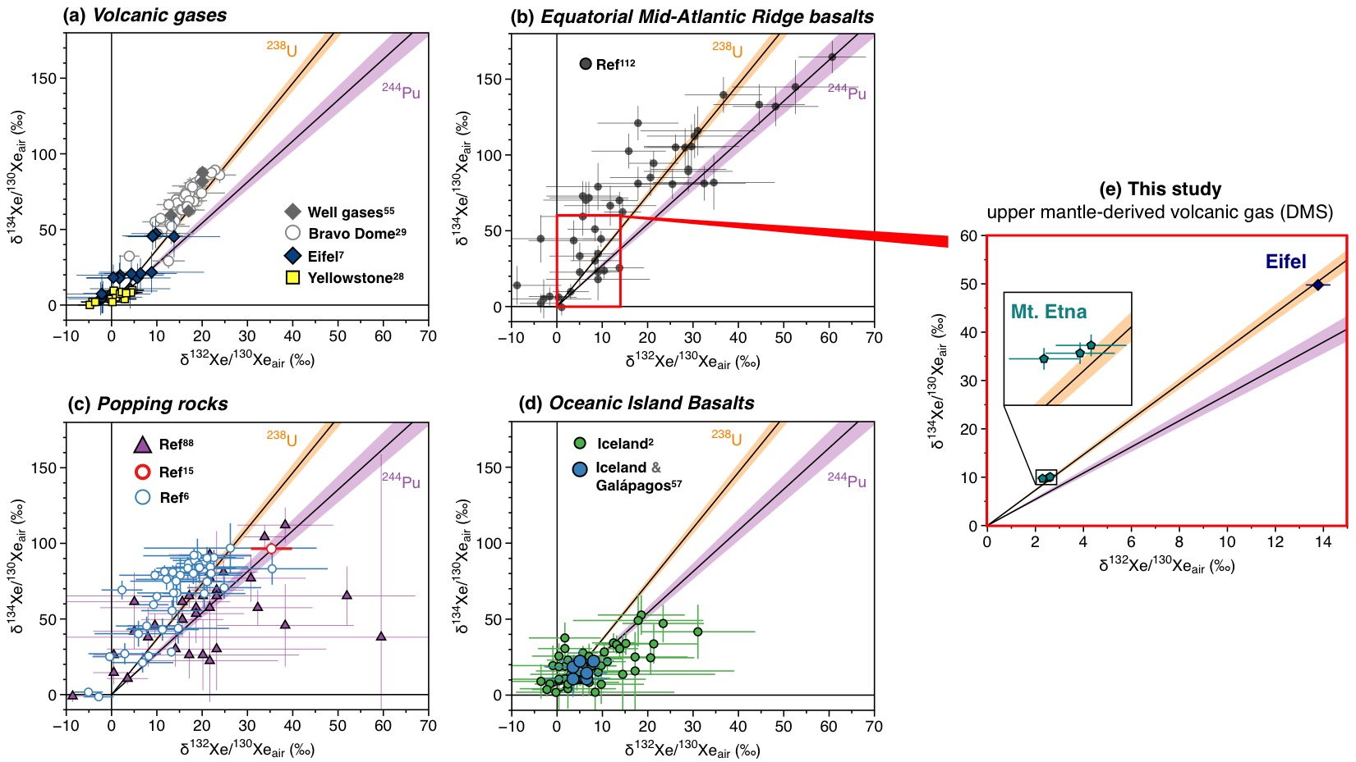
Figure S1. Compilation of δ¹³⁴Xe/¹³⁰Xe_{air} vs. δ¹³²Xe/¹³⁰Xe_{air} systematics for previously published (static mass spectrometry) mantle noble gas data and Mt. Etna (dynamic mass spectrometry, this study) data. Also shown is a comparison with the isotopic trends for ²³⁸U and ²⁴⁴Pu fission, which highlights the vast improvement in precision and accuracy compared to traditional static techniques⁶. Uncertainties are 1σ.

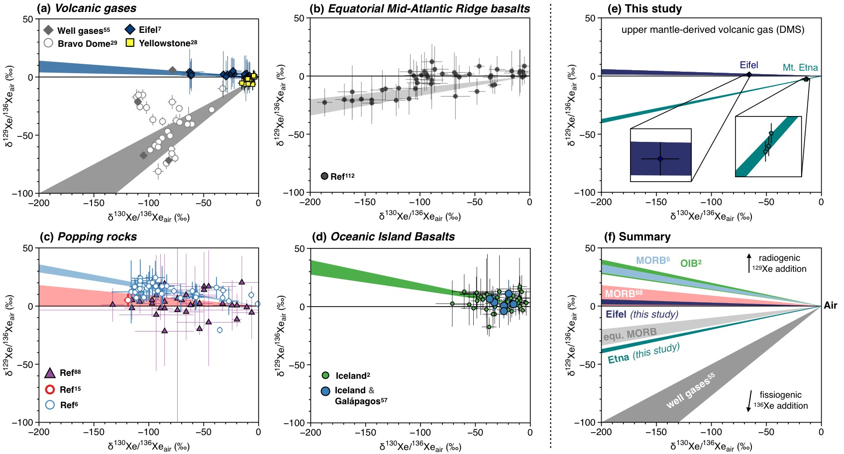
Figure S2. Compilation of δ¹²⁹Xe/¹³⁶Xe_{air} vs. δ¹³⁰Xe/¹³⁶Xe_{air} systematics for previously published mantle noble gas (static mass spectrometry) data and Mt. Etna (dynamic mass spectrometry, this study) data. This classical plot has been used to argue that small Xe isotopic differences between OIB and MORB mantle sources cannot be related solely through recycling atmospheric Xe or by adding fissiogenic ¹³⁶Xe to MORB Xe. However, the recent finding that popping rock and Iceland plume data overlap in this isotopic space⁶ casts doubt on the interpretation that these small differences truly reflect primordial heterogeneities, and calls for a critical improvement in our analytical accuracy – as now enabled by DMS measurements. Uncertainties are 1σ.

SI-2° Identification of primordial Kr and Xe components

New dynamic mass spectrometry data reported in this study revealed only a minor contribution from a primordial component in the Eifel and Mt. Etna mantle source, which contrasts with the previous detection of a meteorite-like component akin to average carbonaceous chondrites (AVCC) in mantle-derived samples analyzed by static mass spectrometry^{3,15,28}. Here, we carry out a correction for surficial and recycled atmospheric Xe contributions by extrapolating the measured δ¹²⁸Xe/¹³⁰Xe towards the mantle source δ¹²⁹Xe/¹³⁰Xe (Figure S3). Doing so, we find no resolvable ¹²⁸Xe excess potentially attributable to the occurrence of a chondritic Xe component in the Mt. Etna mantle source. When combined, Mt. Etna and Eifel Xe isotope data suggest that the fraction of primordial Xe within the upper mantle is below 3%, in stark contrast with previous suggestions of primordial Xe contributions ≥20%⁶ (Figure S3). This finding implies that the introduction of atmosphere-derived components within the mantle during subduction has more drastically overprinted the budget of mantle Xe than previously considered.

Dynamic mass spectrometry data obtained in this study for Etnaean gas reveal only slight heavy Kr isotope enrichments, compatible with minute contributions from AVCC-like Kr (Figure S4). For Eifel, where ≥25% of the measured gas is directly sourced from the convecting mantle⁷, the Kr isotope composition is found to be indistinguishable from air within uncertainty. This suggests that non-radiogenic Kr in the mantle almost entirely derives from the recycling of surface components via subduction, which is consistent with Xe isotope systematics (Figure S3) and with the proposal that the subduction has more drastically affected the budget of mantle heavy noble gases than previously thought. However, there are two very important points that one needs to make here:

1- Péron et al.⁵⁷ used the average and standard error of Kr isotope compositions from a subset of carbonaceous chondrites to define the AVCC composition used in this study. The authors proposed that small deviations from this composition should represent mantle Kr nucleosynthetic anomalies⁵⁷, which are not observed in this study. As shown on Figure S3, bulk carbonaceous chondrite Kr isotope data are highly variable, and so we would caution against overinterpreting Kr isotope deviations from this precisely defined AVCC end-member as necessarily reflecting mantle source Kr nucleosynthetic anomalies⁵⁷.

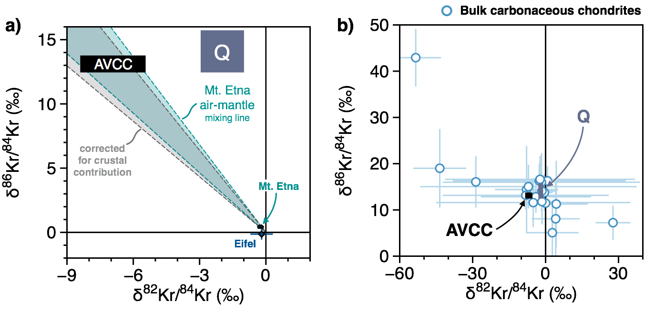

Figure S3. Comparison between AVCC⁵⁷, Q⁵⁸, and bulk carbonaceous chondrite data ("Kr-in-CC.xlsx")^{105,106,107,108,109,110}. This AVCC end-member was computed by Péron et al.⁵⁷, using the average and standard error of Kr isotope compositions from a subset of carbonaceous chondrites. Uncertainties are 1σ.

2- Bekaert et al. (2023)⁹ recently showed that subsurface isotope fractionation within hydrothermal systems is a globally pervasive process that can cause significant (per mil-level) non-radiogenic Ar-Kr-Xe isotope variations, including in Eifel gas samples. Notably, this process causes light noble gas isotope enrichments up to ~7 ‰, 2 ‰ and 1 ‰ per mass unit for Ar, Kr, and Xe isotopes, respectively⁹. Although the Eifel gas sample measured in this study exhibits a high mantle source contribution compared to previously measured samples (with a ⁴⁰Ar/³⁶Ar (~10,177) far greater than any value (≤ 1338) previously reported by Bekaert et al. (2023)⁹), we cannot exclude the possibility that the Eifel gas sample discussed here has also been affected by subsurface isotope fractionation. In this case, the proportion of atmosphere-derived Xe in the Eifel mantle source may only be seen as a minimum value. Because the Mt. Etna gas samples were collected from a ~60m deep well, it is likely that the process of subsurface isotope fractionation potentially affecting Eifel data does not apply to Mt. Etna samples. This possibility is notably supported by the observation that the δ¹²⁸Xe/¹³⁰Xe estimated for Eifel mantle source is slightly greater than that derived for Mt. Etna (Figure S3). In any case, the possibility for the Xe isotope composition of the Eifel gas sample analyzed in this study to have been affected by subsurface isotope fractionation strengthens our conclusion that the proportion of primordial Xe in the upper mantle is minor.

SI-3° Noble gas abundance ratio systematics

Noble gas elemental ratios in volcanic gases have been previously shown to broadly span the entire range between unfractionated air (i.e., δ⁸⁴Kr/³⁶Ar and δ¹³⁰Xe/³⁶Ar ~ 0‰) and Air-Equilibrated Water (AEW), with small, but significant, deviations from an air-AEW mixing line toward higher δ¹³²Xe/³⁶Ar values⁹. Our new data from Mt. Etna and Eifel fully support these previous observations, with both samples showing heavy noble gas compositions most compatible with Xe addition to an originally AEW-like end-member (Figure S4). Note that several samples (e.g., from the Chilean volcanic arc) had previously been shown to exhibit δ⁸⁴Kr/³⁶Ar and δ¹³⁰Xe/³⁶Ar values above the AEW range, attributed to contributions from Kr- and Xe-rich components possibly associated with subducted organic and sedimentary material⁹, which is not observed in the present study.

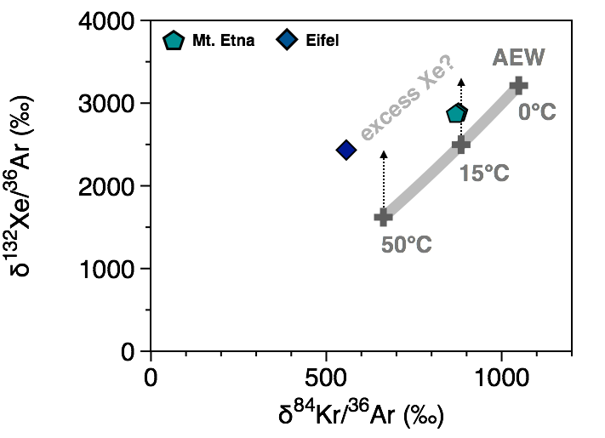

Figure S4. Heavy noble gas abundance ratios in Mt. Etna and Eifel volcanic gases, expressed in delta notation relative to the atmospheric composition. The Air-Equilibrated Water (AEW) component is shown at variable temperatures (in the range 0-50°C) for comparison¹¹¹. Uncertainties (1σ) are smaller than symbol sizes.

SI-4° Xe isotope correction for gravitational settling

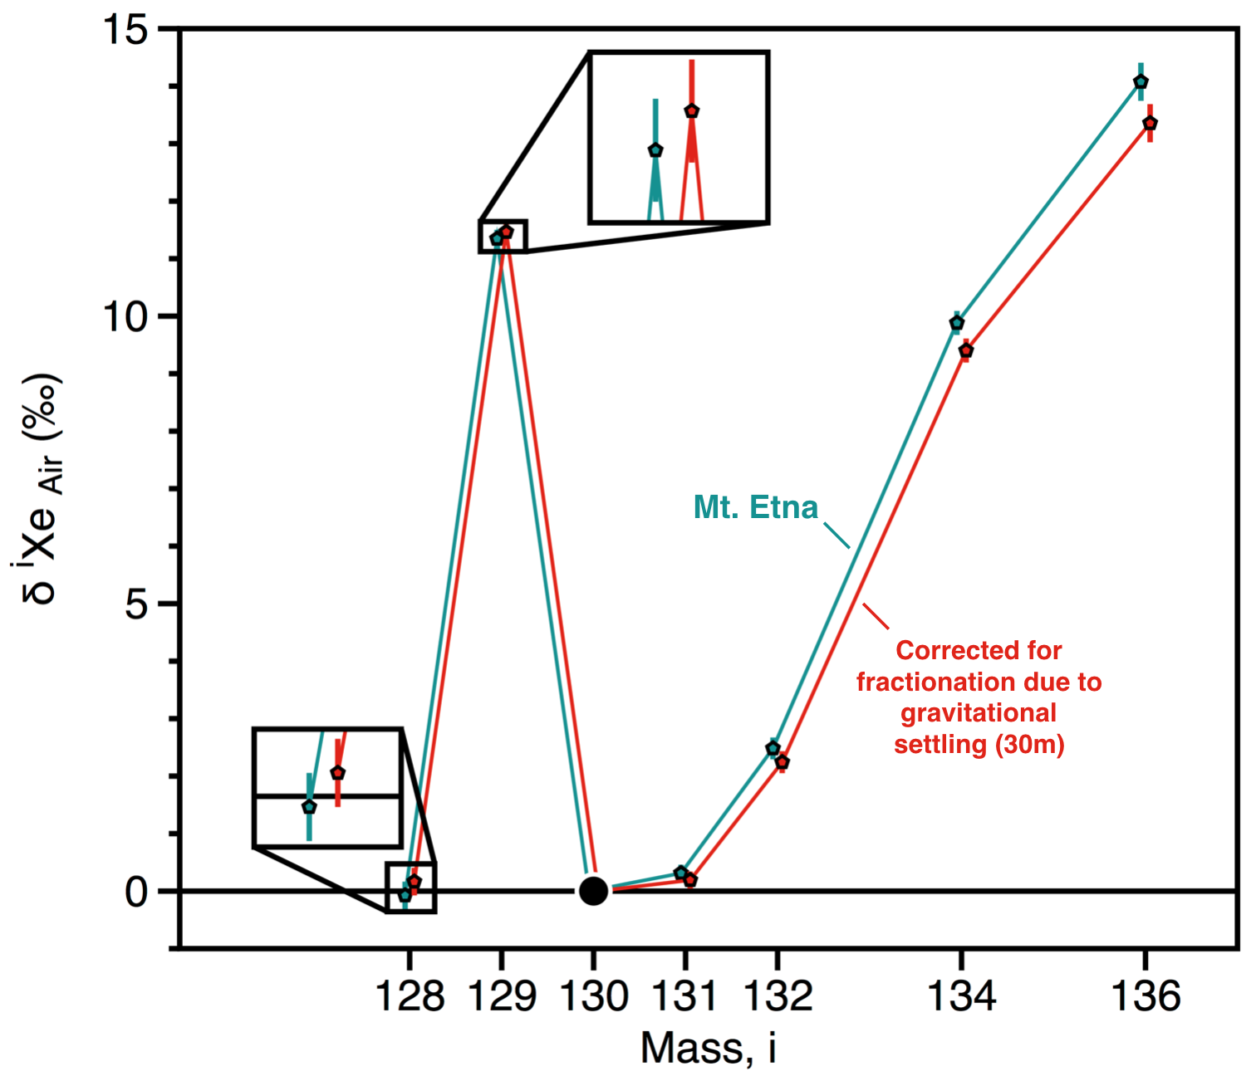

Figure S5. Correction of the Xe isotope composition of Mt. Etna volcanic gas for potential fractionation due to depth-proportional gravitational settling in soil air at the time of groundwater recharge²⁰ (considering a water table depth of 30 meters, as potentially suggested by Kr isotope systematics; Figure 2). Uncertainties are 1σ.
SI-5° Monte Carlo deconvolution of Xe isotope signals

It is clear from Figure S1 that our data are most compatible with fissiogenic Xe isotopes in the upper mantle being primarily (if not almost exclusively) derived from ²³⁸U fission, rather than ²⁴⁴Pu. In order to quantify the exact amount of Pu-Xe in the upper mantle from our new DMS data, we used a Monte Carlo linear least square code adapted from Parai and Mukhopadhyay (2015)²⁶ to compute the best-fit mixing of Xe from initial mantle (AVCC), modern atmosphere (recycled in to the mantle and acting as a contaminant during sampling), ²³⁸U-fission Xe and ²⁴⁴Pu-Xe (Figure S6, S7, and S8). The initial Xe mantle composition is considered to be chondritic and not solar, and is taken to be the average carbonaceous chondrite composition. Given that substantial full-scale recycling of atmospheric Xe into the deep Earth would have become significant only when the atmosphere had reached its present-day isotopic composition¹¹, the recycled atmosphere component is taken to have a modern-like isotopic composition. Also note that, since ¹²⁸Xe is the only isotope among ¹²⁸⁻¹³⁶Xe (except the normalizing isotope ¹³⁰Xe) that is not contributed by any radiogenic or fissiogenic production, we also ran best-fit mixing calculations excluding ¹²⁸Xe (Figure S6 and S7), following previous approach by Bekaert et al. (2019)²³. If the ¹²⁸Xe/¹³⁰Xe are not affected by any secondary effect of mass-dependent fractionation in the subsurface⁹ or during sample handling²³, simulations taking ¹²⁸Xe into account or not should give similar outcomes.

Figure S6: Histograms of ¹³⁶Xe_{Pu}/ ¹³⁶Xe_{TF} and ¹²⁹Xe_{I}/ ¹³⁶Xe_{Pu} best fit solutions from Monte Carlo linear least square deconvolutions²⁶ of Mt. Etna Xe isotope data. Output data excluding ¹²⁸Xe (for comparison with literature data) are summarized in Table S2.
Figure S7: Histograms of ¹³⁶Xe_{Pu}/ ¹³⁶Xe_{TF} and ¹²⁹Xe_{I}/ ¹³⁶Xe_{Pu} best-fit solutions from Monte Carlo linear least square deconvolutions²⁶ of Eifel Xe isotope data from static²³ (SMS) and dynamic (this study, DMS) mass spectrometry. Output data excluding ¹²⁸Xe (for comparison with literature data) are summarized in Table S2. Note that the histograms derived from DMS data exhibit clear Gaussian distributions that suggest the absence of artifacts. Conversely, histograms derived from SMS data show skewed, non-consistent distributions suggesting some secondary effects may have affected the data.

Sample | Reference | ¹³⁶Xe_{Pu}/¹³⁶Xe_{TF} (%) | ¹²⁹Xe_{I}/¹³⁶Xe_{Pu}
Eifel | ref⁷ | $${21}_{-14}^{+13}$$ | $${14}_{-5}^{+25}$$
MORB | ref⁶ | $${18}_{-11}^{+10}$$ | $${17}_{-6}^{+25}$$
SWIR-W | ref²⁶ | $${27}_{-21}^{+20}$$ | $${11}_{-5}^{+39}$$
SWIR-E | ref²⁶ | $${32}_{-20}^{+19}$$ | $$8_{-3}^{+15}$$
DMM | ref¹¹² | $${32}_{-16}^{+17}$$ | $$8_{-3}^{+8}$$
Bravo Dome | ref²⁹ | $${27}_{-16}^{+16}$$ | $$9_{-3}^{+14}$$
Well gas | ref⁵⁵ | $${28}_{-7}^{+7}$$ | $$8_{-2}^{+3}$$
Average |  | 26 ± 5 (±1σ) | 11 ± 3 (±1σ)
Lau | ref⁸⁹ | $${95}_{-23}^{+4}$$ | $${2.9}_{-0.2}^{+1.0}$$
DICE | ref⁴ | $${99}_{-19}^{+1}$$ | $${2.8}_{-0.1}^{+0.7}$$

Table S2a: Deconvolution of mantle-derived Xe isotope literature data (¹³⁶Xe_{Pu}/¹³⁶Xe_{TF} and ¹²⁹Xe_{I}/¹³⁶Xe_{Pu}) using numerical approach by Parai & Mukhopadhyay (2015)²⁶, excluding ¹²⁸Xe. Uncertainties represent the boundaries of the interquartile range²³, corresponding to the 25th and 75th percentiles of the output data.

Sample |  | ¹³⁶Xe_{Pu}/¹³⁶Xe_{TF} (%) | ±1σ | ¹²⁹Xe_{I}/¹³⁶Xe_{Pu} | ±1σ
Mt. Etna 1 | this study | 2.20 | 1.5x10⁻² | 53.29 | 0.56
Mt. Etna 2 | this study | 2.20 | 1.6x10⁻² | 57.28 | 0.57
Mt. Etna 3 | this study | 2.15 | 1.5x10⁻² | 54.18 | 0.57
Average |  | 2.18 | 0.03 | 54.9 2.1
Eifel | this study | 0.44 | 2.7x10⁻⁵ | 382.13 | 2.41

Table S2b: Deconvolution of mantle-derived Xe isotope data reported in this study (¹³⁶Xe_{Pu}/¹³⁶Xe_{TF} and ¹²⁹Xe_{I}/¹³⁶Xe_{Pu}) using numerical approach by Parai & Mukhopadhyay (2015)²⁶, excluding ¹²⁸Xe for consistency with previous studies. The Gaussian distribution of output data (Figure S6 and S7) allows for uncertainties to be given at 1σ.

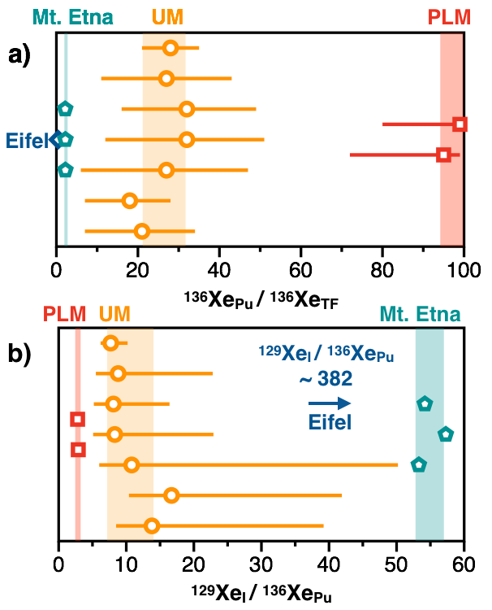

Figure S8. Deconvolution of radiogenic and fissiogenic Xe isotopes for Mt. Etna, Eifel, convecting "upper" mantle (UM), and primitive lower mantle (or plume mantle, PLM) samples (Table S2). (a) Variations of the ¹³⁶Xe_{Pu}/¹³⁶Xe_{TF} are considered to reflect the long-term degassing history of a mantle reservoir: a less-degassed reservoir would retain more of the Xe generated by ²⁴⁴Pu fission in the first ~500 Myr of Earth history. Plume sources are typically characterized by high ¹³⁶Xe_{Pu}/¹³⁶Xe_{TF}, indicating less long-term degassing than MORB mantle sources. (b) ¹²⁹Xe_{I}/¹³⁶Xe_{Pu} variations are considered to reflect (i) accretionary heterogeneities (i.e., later addition of volatile-rich, high I/Pu chondritic material to the upper mantle), (ii) sequestration of I from the lower mantle into the core¹⁶, and/or (iii) rapid degassing of mantle volatiles to the surface¹¹³. UM and PLM data are from Bekaert et al.⁷ and Parai & Mukhopadhyay⁶. Uncertainties are 1σ.
SI-6° Numerical model of mantle Xe evolution

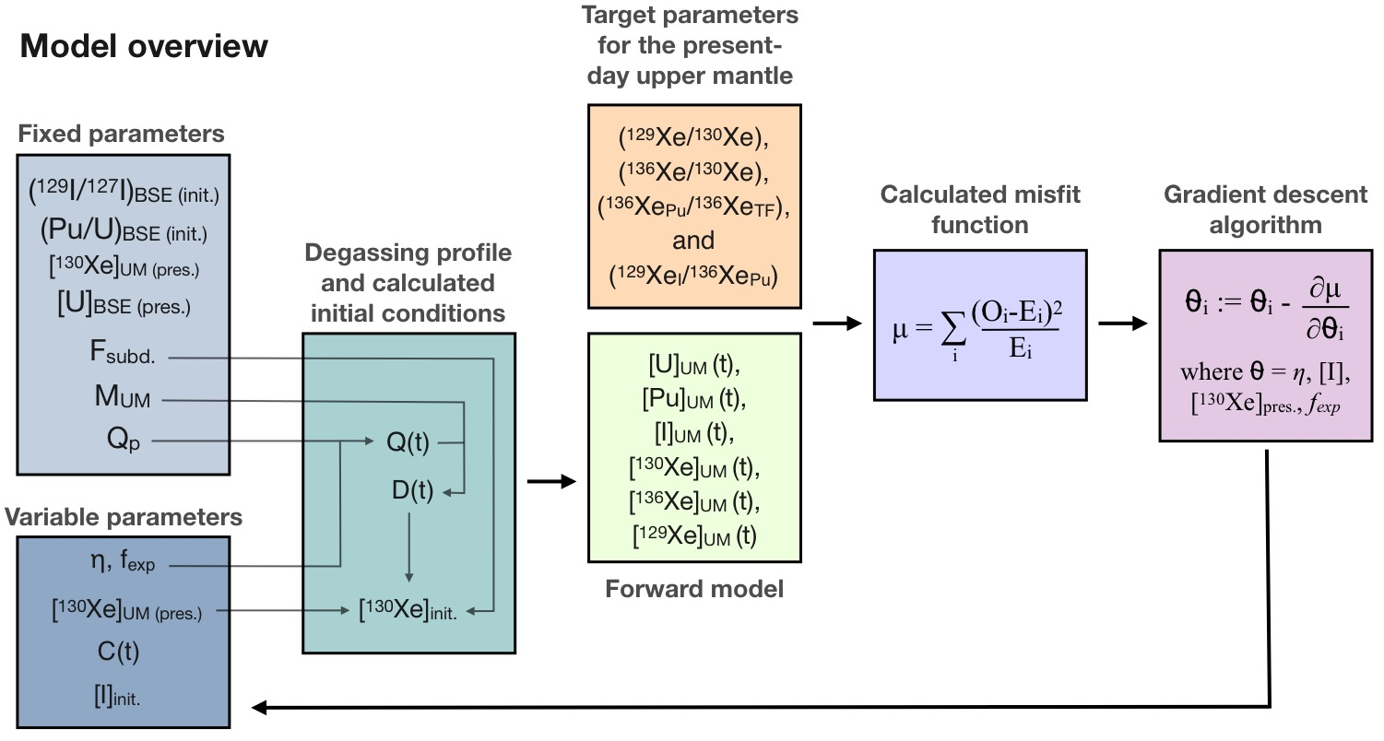
Figure S9. Schematic representation of the numerical model working principle.

init.: start of the solar system and time of onset of planetary formation, 4.567 Gyr ago.
pres.: present-day.
BSE: Bulk Silicate Earth.
UM: Convecting "Upper" Mantle.
F_{subd}: Fraction of present-day mantle non-radiogenic Xe originating from recycling via subduction.
M_{UM}: Mass of the convecting mantle.
Q_{p}: present-day mantle processing rate (6.1 x10¹⁷ g.yr⁻¹ ; ¹¹).
η: total amount of degassing, reflecting the rate at which mantle processing increases when moving back through time.
f_{exp}: fraction of the exponential component in the mantle processing curve.
C(t): continental crust growth curve relative to present.
Q(t): mantle processing rate through time.
TF: Total Fission (i.e., from both U and Pu)

A) Model parameterization

- Degassing model
One of the primary inputs of the model is the proposed mantle degassing history over time. This is linked to the rate at which oceanic crust is formed at mid-ocean ridges, referred to as the mantle processing rate. This rate was certainly higher early in Earth's history, but the exact form of this evolution, and the total magnitude of mantle processed is still poorly constrained¹¹⁴. Here, we can consider two simple end-member possibilities for mantle processing rate evolution, exponential and linear decay:
$Q_{exp}\left(t\right)= Q_{p} × e^{η\left(T_{E}-t\right)}$ (EQ. S1)
$Q_{lin}\left(t\right)= m × \left(T_{E}-t\right)+Q_{p}$ (EQ. S2)

where Q_{p} is the present-day mantle processing rate of 6.1 x10¹⁷ g.yr⁻¹ ¹¹, T_{E} is the age of the Earth and t is model time. The parameter η represents the rate at which mantle processing increases when moving back through time, and as such directly controls the total amount of degassing in the model. The equivalent parameter in the linear component is the gradient m. We can directly relate m to η such that over the model time they produce the same total amount of degassing.

$m=\frac{2{ × Q}_{p}}{T_{E}^{2}}\left(\frac{e^{ηT_{E}}-1 }{η}-T_{E}\right)$ (EQ. S3)

We can then combine the linear and exponential components to generate a mantle processing curve that can range from either purely exponential to purely linear or anywhere in between, for a given value of total degassing amount (controlled by η).

$Q\left(t\right)= f_{exp}{ × Q}_{exp}\left(t\right)+\left(1-f_{exp}\right)× Q_{lin}(t)$ (EQ. S4)

where f_{exp} is the fraction of the exponential component in the resulting mantle processing curve. The mantle processing curve can be converted into a degassing curve as follows:

$D\left(t\right)= \frac{Q(t)}{M_{CM}}$ (EQ. S5)

where M_{CM} is the mass of the convecting mantle (UM). D(t) represents the fractional degassing rate in units of Myr⁻¹. We can thus generate degassing curves using only two input parameters: η which controls the total amount of mantle degassing over Earth's history, and f_{exp} which controls the shape of the degassing curve (exponential versus linear). To generate a degassing curve we take a time array ranging from 0 to 4568 with a step size of 1 Myr, and calculate D(t) for each of these resulting in another array of length 4568. Example degassing curves are shown in Figure S10.

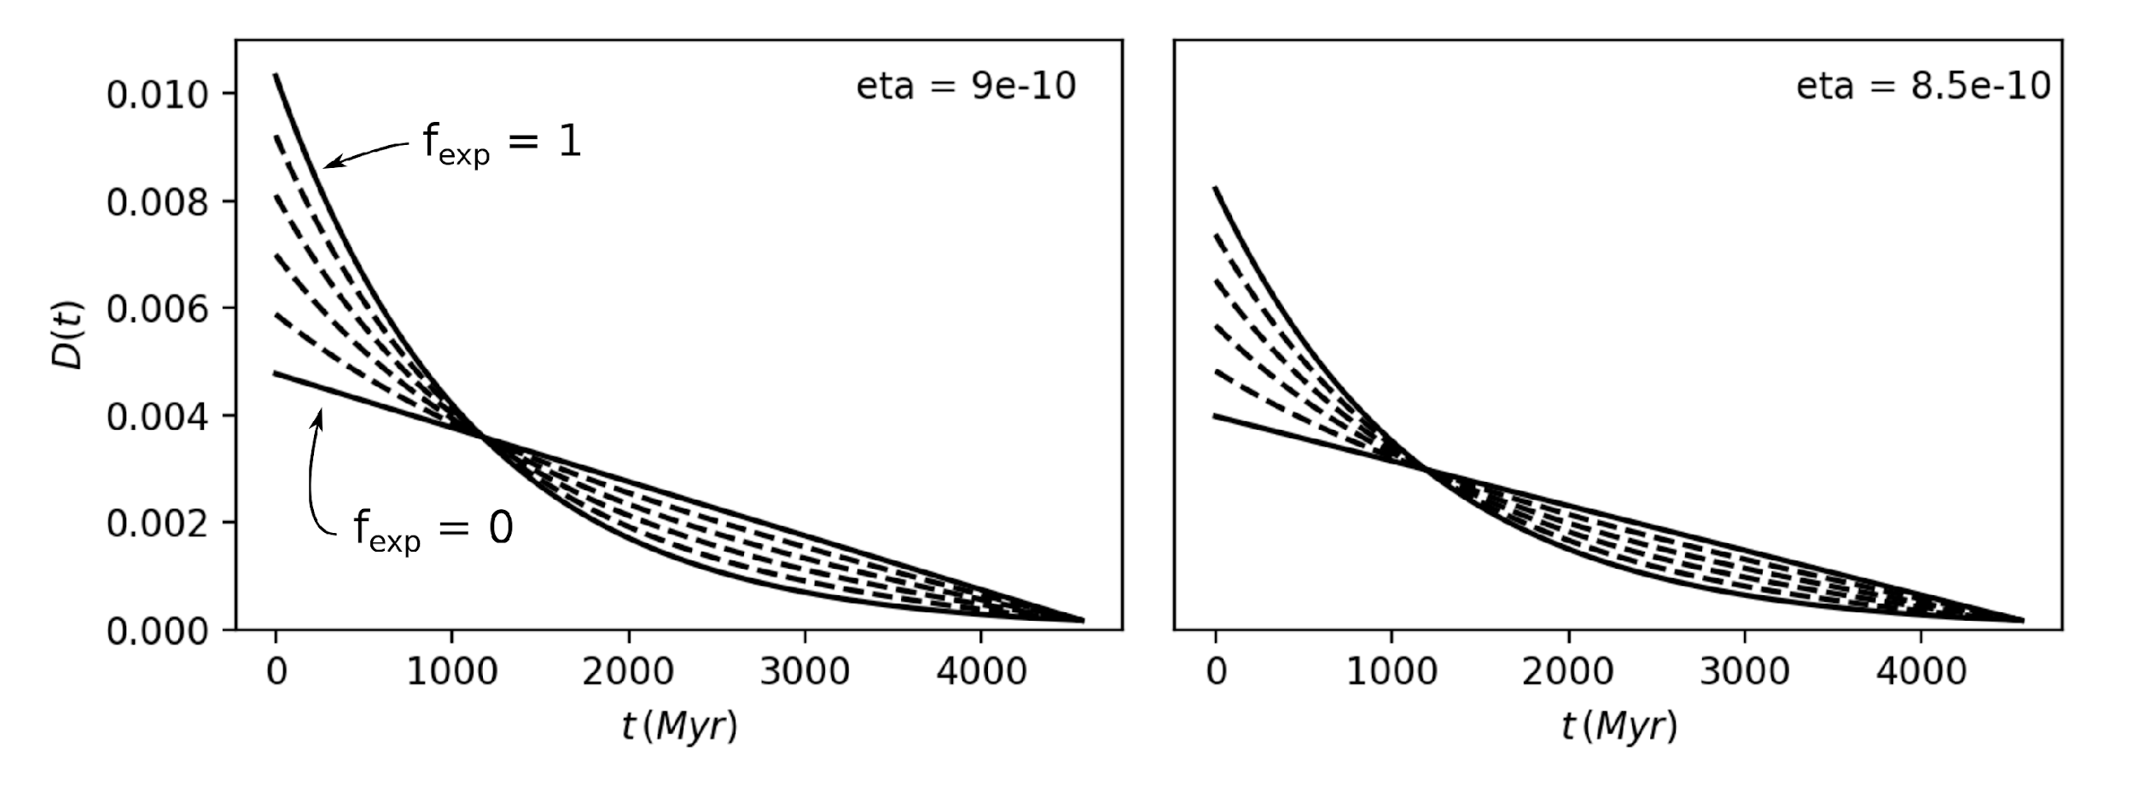
Figure S10. Example degassing curves for two selected values of η (eta), with variable f_{exp}. Degassing curves with f_{exp} equal to 1 and 0 are shown as solid lines and annotated respectively. Intermediate curves with f_{exp} of 0.2, 0.4, 0.6 and 0.8 are shown as dashed lines.

- Initial Xe abundance
A fundamental control on the Xe isotopic evolution of the mantle through time is the quantity of primordial Xe present in the convecting mantle (UM) at t = 0, before the start of degassing and radiogenic ingrowth. The most up-to-date estimate of modern ¹³⁰Xe abundance in the UM is (1.79±0.25) x10⁻¹⁸ mol/g¹⁴ and we will consider a range of possible values within a factor of 2 of this best estimate. The initial ¹³⁰Xe abundance in the mantle can be directly calculated from the supposed modern value and the chosen degassing profile:

${\left[ {}_{ }^{130}{Xe}\right]}_{init.}= \frac{{\left[ {}_{ }^{130}{Xe}\right]}_{pres. }× (1-F_{subd.})}{\prod_{t=0}^{T_{E}}{ (1-D\left(t\right))}}$ (EQ. S6)

where [¹³⁰Xe]_{pres.} is the present day UM ¹³⁰Xe abundance, and F_{subd.} is the fraction of mantle ¹³⁰Xe derived from recycling of surface-derived components (i.e., 80±2%¹¹).

- Continental crust growth
The generation of continental crust removes U (and other incompatible elements) from the mantle and therefore must be considered when calculating ingrowth of fissiogenic Xe isotopes. Crucially, previous models of terrestrial Xe evolution¹¹ have scaled the reduction in U and Pu concentrations in the UM over time to a growth curve of continental (felsic) crust over the Archean and Proterozoic eons. However, the shape of this curve remains highly debated, with a great variety of continental crust growth curves proposed in the literature (Figure S11). Models proposing a late crustal growth with a near absence of continental crust during the first 0.5–1 Gyr of Earth’s history appear highly incompatible with the conspicuous occurrence of a thick and stable Hadean crust⁴⁵. Yet, these are the models that are typically considered for modeling mantle Xe isotope evolutions^{3,5,11}.

Based on the occurrence of Hadean zircons (e.g., the 4.2 Ga zircons in 4.03 Ga Acasta gneisses^{115,116}, 4.4 Ga detrital zircons from Jack Hills in Western Australia^{117,118,119}, several models have suggested that crustal growth could have started as early as the Hadean, within the first 500 Myr of Earth’s history. Latest models of felsic continental growth based on argon degassing³⁶ and samarium-neodymium isotope³⁷ constraints even suggest that the net growth of continental crust was nearly complete by the end of the Hadean, which is broadly in line with early work from Armstrong (1981)¹²⁰. As detailed in the main text, the potential for most of the Pu and U to have been extracted from the mantle before Pu became extinct could have important implications for ¹³⁶Xe_{Pu}/¹³⁶Xe_{TF} systematics of mantle reservoirs. Overall, the rate of incompatible element depletion within the depleted mantle would mostly depend on the cumulated quantity of crustal extraction over the Hadean.

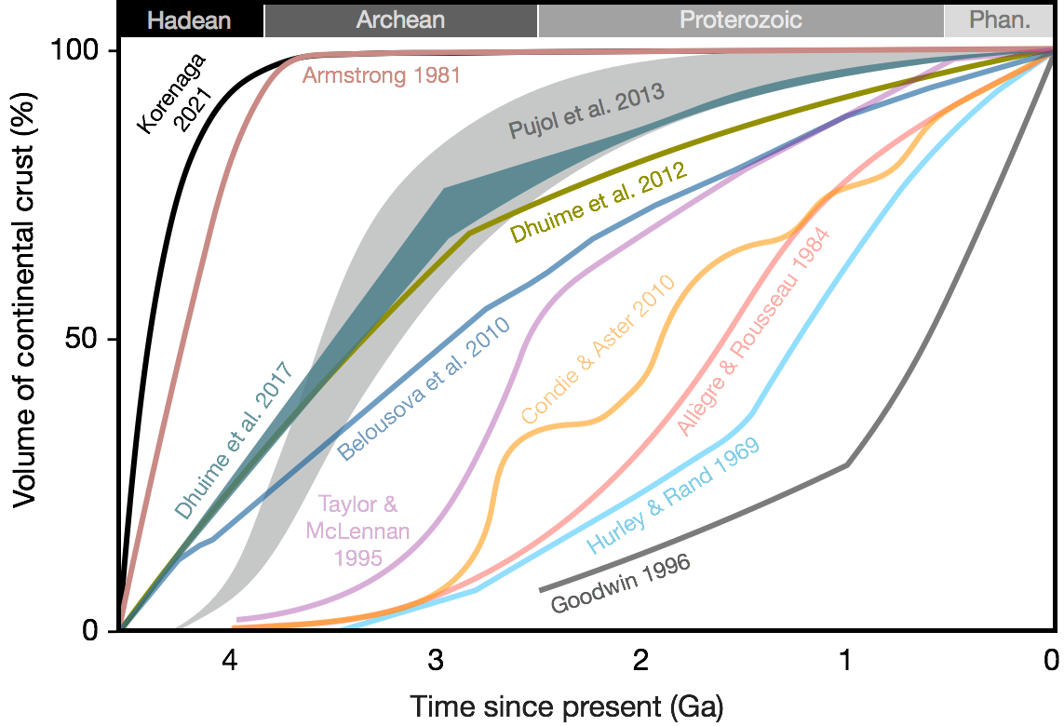
Figure S11. Selected crustal growth models, adapted from Hawkesworth et al. (2019)¹²¹, Korenaga (2021)¹²² and references therein. The curves seek to constrain the volumes of crust that were present at different times in Earth's history (from the Hadean to the Phanerozoic), even if they are no longer preserved in the present day.

Here, we consider a modified sigmoid function to model the growth of the continental crust:
$C\left(t\right)={\left(1+e^{\frac{-s\left(t-r\right)}{t^{k}}}\right)}^{-1}$ (EQ. S7)
where the parameters m, s, r and k are parameters that roughly control the sharpness, inflection point, and skew of the sigmoid function respectively. We generate a crustal growth curve from the same time array as for the degassing curve and normalize it so that our resultant C(t), representing the fraction of continental crust generated through time, reaches 1 (or 100%) at the present day. Our default crustal growth profile (blue curve (A) on Figure S12) corresponds to that from Pujol et al. (2013)¹²³, which was used in previous Xe modeling work¹¹. Curve B represents a scenario of early crustal growth, as proposed by Korenaga (2021)¹²².

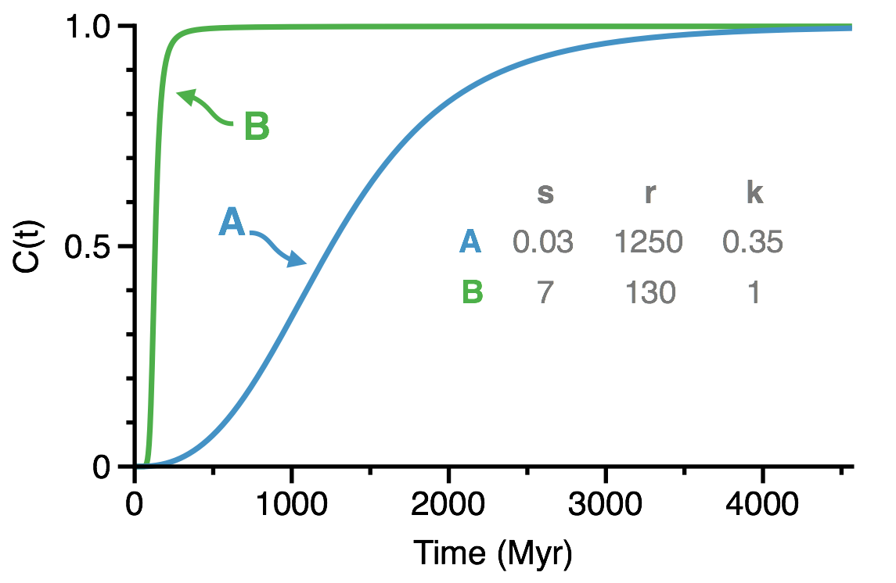
Figure S12. Selected crustal growth profiles generated using various values for s, r and k parameters in EQ. 9. A: "late" crustal growth during the Archean eon¹²³,¹¹. B: "early" crustal growth during the Hadean eon¹²².

- Uranium and plutonium evolution
The initial number of moles of ²³⁸U in the BSE is straightforward to calculate from the modern ²³⁸U inventory as:
$n_{{}_{ }^{238}U}=M_{BSE} [ {}_{ }^{238}U]_{pres. } × e^{λ_{238}T_{E}}$ (EQ. S8)

where [²³⁸U]_{pres.} is the present-day BSE concentration of ²³⁸U (21 ppb¹⁰³), and M_{BSE} is the mass of the bulk silicate Earth. Initial Pu is calculated using the chondritic (Pu/U)₀ of 0.0068³⁴. Given the importance of the assumed (Pu/U)₀ for mantle Xe isotope systematics and the strong case for revisiting the chondritic (Pu/U)₀ system (and improve our understanding of the internal and external variability of (Pu/U)₀¹⁰), we allow the (Pu/U)₀ to vary between ±50% of its assumed value (i.e., between 0.0034 and 0.0102).

The U content of the mantle is then computed as:

${\left[{}_{ }^{238}U\right]}_{UM}(t) =\frac{n_{{}_{ }^{238}U}{ × e}^{-λ_{238}t}\left(1-f_{U_{cont. cr.}} × C(t)\right)}{M_{UM}}$ (EQ. S9)

where f_{Ucr} is the observed fraction of U extracted into the crust in the modern Earth, and M_{UM} is the mass of the convecting mantle. [²⁴⁴Pu]_{UM} (t) is calculated in the same fashion, assuming that U and Pu are extracted to the crust at similar rates¹¹ (i.e., no fractionation of U/Pu during magmatic processes).

- Iodine evolution
Terrestrial iodine abundances are poorly constrained compared to U, with estimates of modern abundance of stable ¹²⁷I ranging from 3.5 ppb up to 13 ppb^{31,48,124,125,126}). The “time zero” of our model (4567 Myr ago) corresponds to the time when the ¹²⁹I/¹²⁷I_{init} ratio in meteorites was equal to the accepted value of (1.19±0.20)×10⁻⁴ (ref ¹²⁷). As this initial ¹²⁹I abundance is a sensitive parameter in our models we will consider a range of possible values encompassing the literature estimates. [¹²⁹I]_{m} is calculated similarly to [²³⁸U]_{m} in the above section, although with a f_{Icr} (the fraction of I extracted into the crust in the modern Earth) of 80%¹²⁶ reflecting the greater extent of I extraction from the mantle compared to U. Notably, crustal extraction is much less significant for ¹²⁹I evolution as its shorter half-life means that it has mostly decayed by the time that crustal growth has progressed significantly.

- Giant impact scenarios
The assumption that Earth's degassing history evolves in a secular fashion following a simple linear or exponential trajectory is likely an oversimplification. It is possible, and even likely, that larger, discrete degassing events punctuated a gradual decline in the background degassing rate of the mantle. These events may have been caused by giant impacts, magma ocean events, or changes in the rate of volcanism. We can simulate the effect of such an event within our model by artificially imposing a higher rate of degassing for a brief period. We consider a giant impact event the most likely candidate for such a discrete degassing event and as such we implement a range of possible scenarios in the model to approximate the effects of a giant impact-induced degassing event. For the sake of simplicity, we consider that enhanced degassing takes place for 10 Myr, which corresponds to the maximum time for whole magma ocean solidification (i.e., the time necessary for the solidification front to propagate from the core-mantle boundary to the surface¹²⁸). This value is representative of relatively long-lived magma oceans whose crystallization is slowed down by the blanketing effect of a growing H₂O-CO₂ atmosphere generated upon degassing of greenhouse volatiles^{129,130,131}. We then consider a range of start dates from 20 Myr up to 120 Myr (in 10 Myr increments), bracketing the reasonable time range for the moon-forming impact¹³², and a range of degassing intensities (D) from 2% Myr⁻¹ to 40% Myr⁻¹ (in increments of 2% Myr⁻¹). Because the timescale of giant impact-induced global degassing events is small (<10 Myr) compared to the timescale of radiogenic and fissiogenic Xe evolution, considering shorter durations of magma ocean degassing (e.g., 1 Myr) would require proportionally higher degassing intensities (e.g., 89% Myr⁻¹ for a 1 Myr-long magma ocean, instead of a 20% Myr⁻¹ degassing rate for a 10 Myr-long magma ocean) to give the same final mantle composition. This relationship can be written as:

$D_{n} = 1- {(1-D_{10})}^{10/n}$ (EQ. S10)

where n is the target duration of the magma ocean degassing episode (Myr), and $D_{n}$ and $D_{10}$ are the degassing intensities (% Myr⁻¹) for n Myr and 10 Myr of magma ocean duration, respectively.

B) Running the model

The model tracks the mantle abundance of primordial ^{129, 130, 136}Xe, as well as fissiogenic ¹³⁶Xe from both U and Pu decay, and radiogenic ¹²⁹Xe_{I} from ¹²⁹I decay. Initial ¹³⁰Xe abundance at t=0 (i.e., when ²⁹I/¹²⁷I = 1.19×10⁻⁴) is calculated as described above, and initial ^{129, 136}Xe are calculated assuming an initially chondritic composition⁵⁸:

${\left[ 130Xe\right]}_{(t+1)} ={\left[ 130Xe\right]}_{(t)} *\left(1-D\left(t\right)\right)$ (EQ. S11)
${\left[ 136Xe\right]}_{(t+1)}=\left({\left[{}_{ }^{136}{Xe}\right]}_{(t)} +{\left[ {}_{ }^{136}{Xe_{U}^{*}}\right]}_{(t)} {+\left[ {}_{ }^{136}{Xe_{Pu}^{*}}\right]}_{(t)}\right)* \left(1-D\left(t\right)\right)$ (EQ. S12)
${\left[ {}_{ }^{129}{Xe}\right]}_{(t+1)}=\left({\left[ {}_{ }^{129}{Xe}\right]}_{(t)}+{\left[ {}_{ }^{129}{Xe_{I}^{*}}\right]}_{(t)}\right)*\left(1-D\left(t\right)\right)$ (EQ. S13)

where [¹³⁶Xe_{U}](t) represents the amount of ¹³⁶Xe produced by fission of U at timestep t, calculated using [²³⁸U]_{m} (also at timestep t) as described in the previous section. The above iterations are performed repeatedly up to t = 4567 yr to calculate the modern-day isotopic composition of the mantle. The fractions of radiogenic and fissiogenic ¹²⁹Xe and ¹³⁶Xe generated from ¹²⁹I, ²³⁸U and ²⁴⁴Pu are tracked individually to allow for the calculation of the relevant ratios for straightforward comparison with measured modern mantle values.

- Misfit calculation
The goodness of fit of a given model is assessed by how close the predicted Xe isotopic composition of the mantle at t=T_{E} is compared to measured modern values. Specifically, we compare 4 variables: ¹³⁶Xe/¹³⁰Xe, ¹²⁹Xe/¹³⁰Xe, ¹³⁶Xe_{Pu}/(¹³⁶Xe_{Pu} + ¹³⁶Xe_{U})=¹³⁶Xe_{Pu}/¹³⁶Xe_{TF}, and ¹²⁹Xe_{I}/¹³⁶Xe_{Pu}. We use the sum of the χ² statistics of these outputs to calculate a total misfit value for the model:

$μ=\sum_{ }^{ }{\frac{{\left(O_{i}-E_{i}\right)}^{2}}{E_{i}}}$ (EQ. S14)
where O and E refer to the "observed" (model output) and "expected" (modern mantle composition) values for the 4 variables outlined above (Table S3). This provides an objective way to assess, for any given set of input parameters, how close the model predictions are to reality. We can now run a large number of models with various input parameters in order to find the physical conditions which (according to the assumptions built into the model) are most likely to have produced the modern mantle composition. We consider three sets of target parameters, representing our measured Mt. Etna and Eifel compositions (this study) and previous determinations of the MORB composition⁶, respectively.
 | MORB | Mt. Etna | Eifel
¹³⁶Xe/¹³⁰Xe | 3.49 | 3.49 | 3.49
¹²⁹Xe/¹³⁰Xe | 11.06 | 11.06 | 11.06
¹³⁶Xe_{Pu}/¹³⁶Xe_{TF} | 0.26 | 0.03 | 0.0044
¹²⁹Xe_{I}/¹³⁶Xe_{Pu} | 11 | 55 | 382

Table S3. Target parameters for MORB and Mt. Etna compositions. Convecting mantle ¹³⁶Xe/¹³⁰Xe and ¹²⁹Xe/¹³⁰Xe are corrected for the subduction of atmospheric Xe contributing 80% of the UM Xe inventory⁶.

- Free parameters
There are a number of input parameters to the model, with some well-constrained, and others less so. The primary unknown input parameters are: the magnitude of total degassing (η), the shape of the degassing curve (f_{exp}), the abundance of ¹³⁰Xe in the modern mantle, the initial BSE I abundance, and the shape of the crustal growth curve. In the following, we wish to find the values for the other 4 input parameters that provide the best fit to both our MORB and Mt. Etna target parameters, such that we can assess whether or not they constitute a plausible degassing history for Earth.

- Gradient descent algorithm
A brute force approach would simply be to try every possible reasonable combination of inputs for η, [I]_{init.}, [¹³⁰Xe]_{pres.} and f_{exp} and find the combination that produces the lowest misfit value μ. A more sophisticated approach is to pick a reasonable initial input parameter composition and then use a gradient descent algorithm to iteratively change the input parameters towards those that generate the lowest possible misfit. This can be mathematically represented by the following equation, which is repeated until convergence.
$θ_{i}≔ θ_{i}-α\frac{∂μ}{∂θ_{i}}$ (EQ. S15)
where θ_{i} represents an input parameter (in this case η, [I], [¹³⁰Xe]_{pres.} or f_{exp}), $\frac{∂μ}{∂θ_{i}}$ is the partial derivative of the misfit function μ with respect to θ_{i}, and α is the learning rate, which controls the magnitude of the changes to θ between iterations. It can be seen that as $\frac{∂μ}{∂θ_{i}}$ approaches zero the equation will converge, with the misfit μ having reached a minimum. This process can be performed simultaneously on our 4 input parameters, allowing us to quickly determine the values that most closely reproduce the target composition. A potential pitfall of the gradient descent technique is the presence of local minima in the misfit function topography, which will produce low $\frac{∂μ}{∂θ_{i}}$ and potentially prevent the algorithm from proceeding to the true minimum value. A coarse resolution look at the variation of the misfit function with respect to the 4 input parameters allows us to assess the likelihood of this issue arising.

SI-7° Results of the numerical model

No giant impact scenarios: A series of contour plots of the value of the misfit function for the conventional MORB target parameters is shown on Figure S13 for a large number of models run over the plausible range of the input parameters. Every simulation shows a single, well-defined minimum in the misfit function, suggesting that local minima are unlikely to be an issue. The same results are shown for Mt. Etna and Eifel data on Figure S14 and Figure S15, respectively. Note that, in each case, the learning rate for each input parameter must be tuned such that the gradient descent algorithm reliably and consistently finds these minima from a range of reasonable starting compositions. The best-fit input parameters generated using the gradient descent algorithm and the two continental crust growth functions presented in Figure S12 are shown in Table S4. The best-fit input parameters for crustal growth A (Figure S12) correspond to the misfit function minima observed in Figure S13, S14 and S15 for conventional MORB, Mt. Etna and Eifel target parameters, respectively.

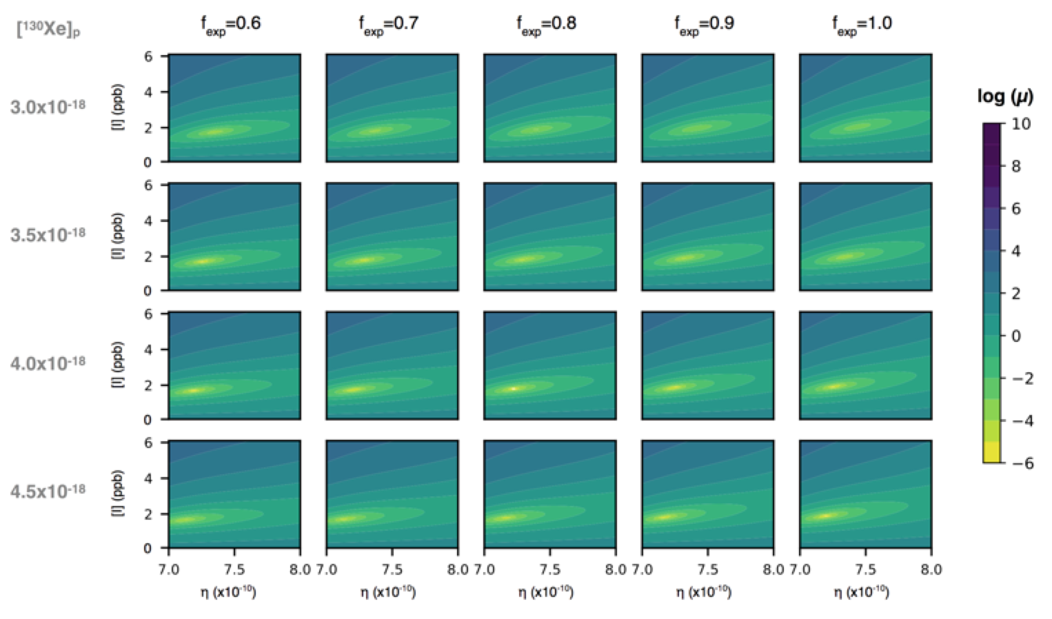
Figure S13. Misfit results for models run with MORB target parameters. Each panel represents a suite of models run with variable η from 7x10⁻¹⁰ to 8x10⁻¹⁰ at a step size of 0.01x10⁻¹⁰, and [I] ranging from 0.1 to 6 ppb with a step size of 0.1 ppb. Modern mantle [¹³⁰Xe]_{pres.} and f_{exp} are varied at a coarse resolution, and change with row and column respectively, as indicated by the row and column headers. The log of the resultant misfit for the model run at each point in the parameter space is shown using the color bar indicated.

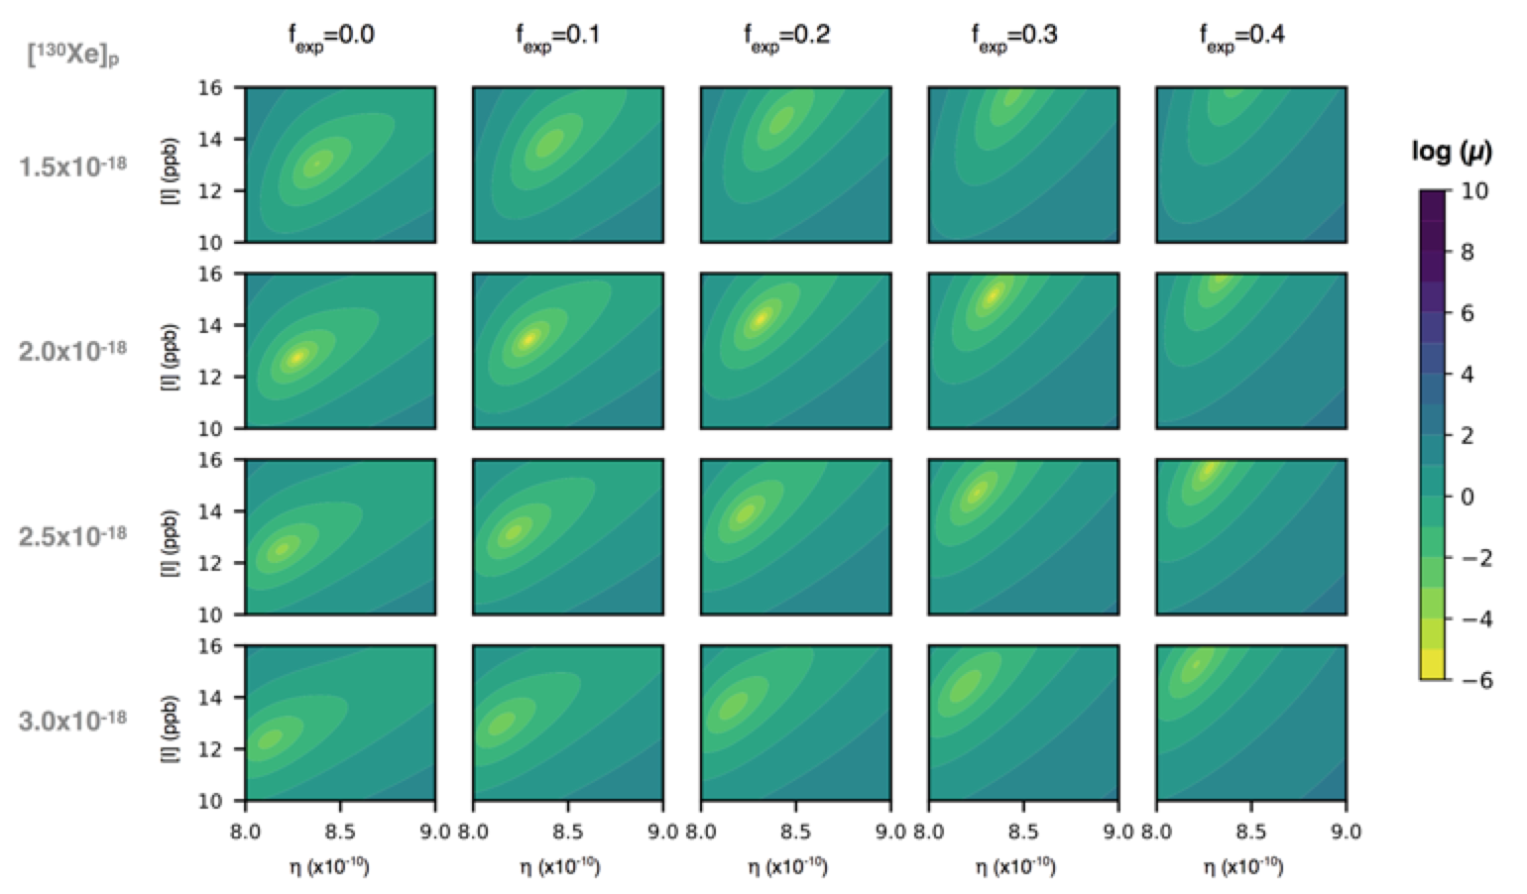
Figure S14. Selected misfit results for models run with Mt. Etna target parameters (same colorbar coding as Figure S13). Each panel represents a suite of models run with variable η from 8x10⁻¹⁰ to 9x10⁻¹⁰ at a step size of 0.01 x 10⁻¹⁰, and [I] ranging from 10 to 16 ppb with a step size of 0.1 ppb. Modern mantle [¹³⁰Xe]_{pres.} and f_{exp} are displayed for a different range to Figure S13 to account for the different locations of the lowest misfit values.

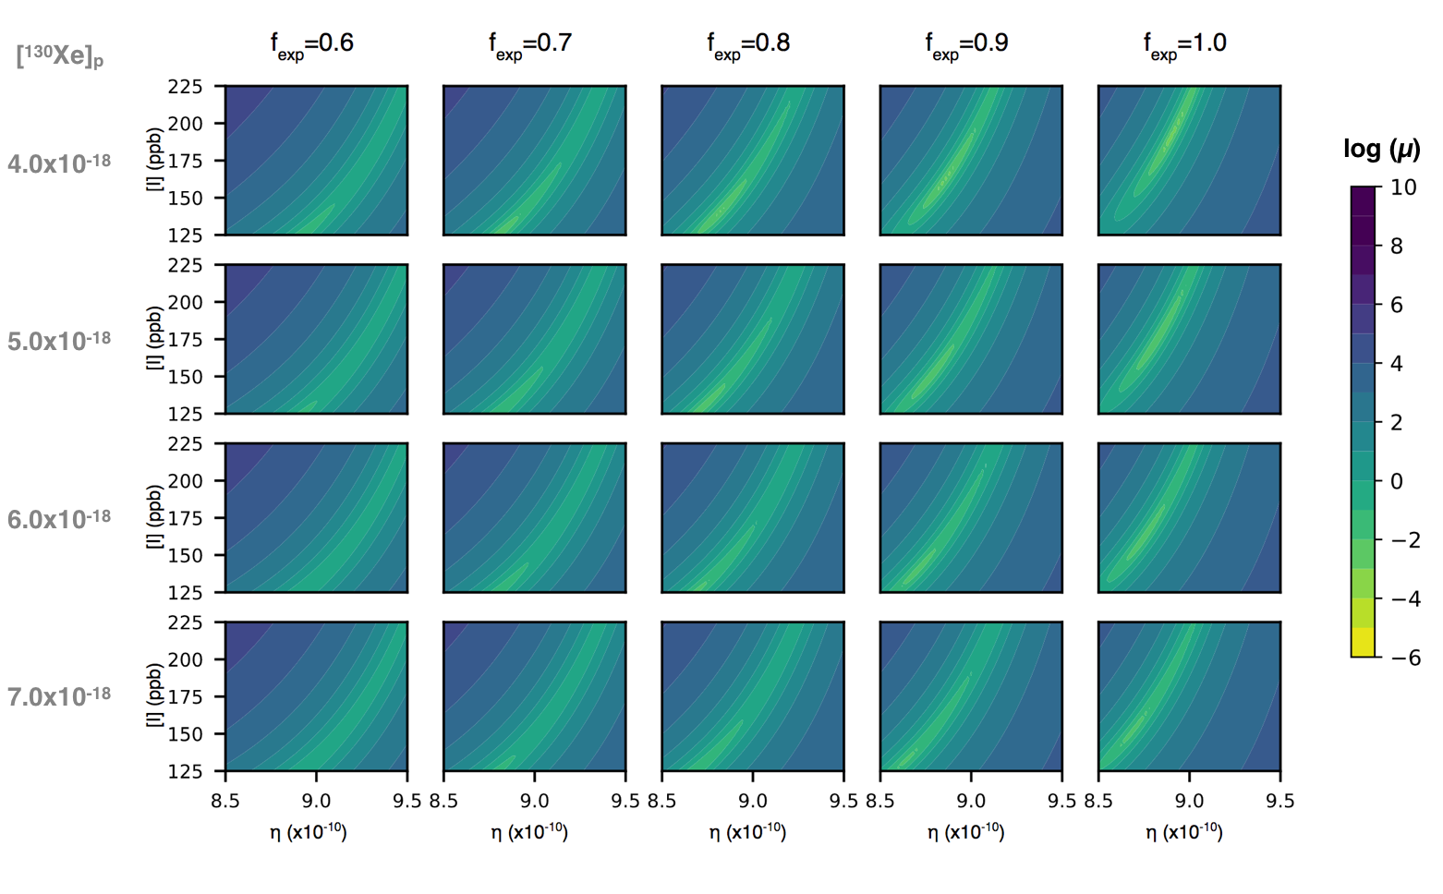
Figure S15. Selected misfit results for models run with Eifel target parameters (same colorbar coding as Figure S13 and S14). Each panel represents a suite of models run with variable η from 8.5x10⁻¹⁰ to 9.5x 10⁻¹⁰ at a step size of 0.01 x 10⁻¹⁰, and [I] ranging from 125 to 225 ppb with a step size of 1 ppb. Modern mantle [¹³⁰Xe]_{pres.} and f_{exp} are displayed for a different range to Figure S13 and S14 to account for the different locations of the lowest misfit values.
Reproducing the MORB mantle source values assuming a secular (linear or exponential) evolution of mantle degassing (i.e., no giant impact) requires ¹²⁷I_{init}(BSE) ~1.5 ppb, [¹³⁰Xe]_{pres.} (3.9x10⁻¹⁸ mol/g), and <0.4 wt.% equ.CC (Figure S8), markedly different from actual BSE estimates. In particular, the predicted [I]_{init.} value using conventional MORB parameters is lower (≤2 ppb) than the plausible range of 7-13 ppb^{30,31} (Figure S13). In line with previous studies³, we find that introducing one (or more) episode(s) of giant impact-induced degassing is required to reproduce the upper mantle Xe isotope composition derived from MORB analyses (Figure S16).

Giant impact scenarios: Episodes of early mantle degassing indeed require increasingly high [I]_{init.} to compensate for the early loss of ¹²⁹Xe_{I} (Figure S17). For each possible combination of giant impact start date and degassing intensity, we run the gradient descent algorithm to search for the best-fit input parameters when the relevant giant impact event is superimposed. The output is thus a set of the 4 input parameters corresponding to each combination of impact start date and degassing intensity. Variation of best-fit input parameters found using the gradient descent algorithm for a variety of impact-induced degassing scenarios are shown for conventional MORB and Mt. Etna target values on Figure S17 and S18, respectively. Doing so, we find that giant impact scenarios result in similar best final misfit values to the secular evolution models, suggesting that the imposition of a giant impact-induced degassing event does not prevent the model from finding solutions that satisfy target mantle parameters. However, the plausibility of these solutions must be assessed independently.
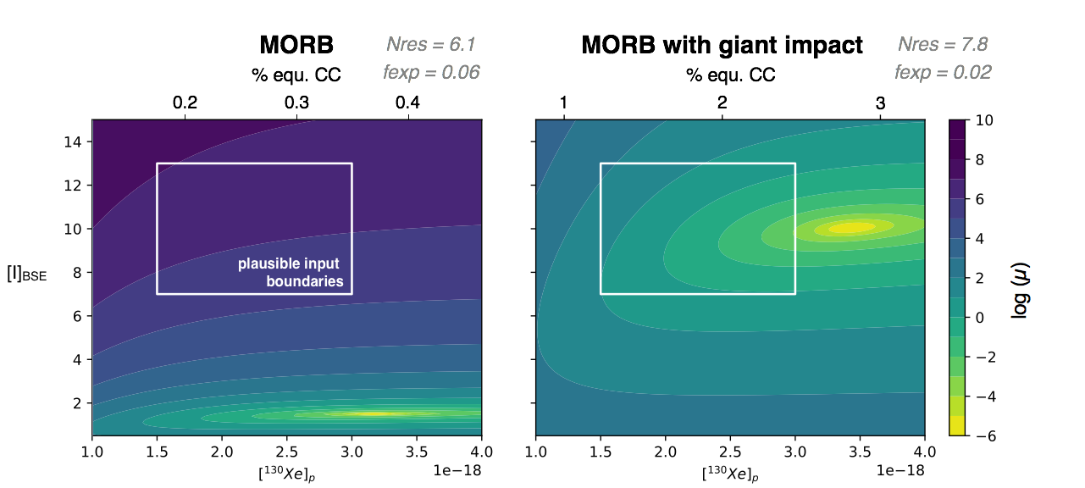

Figure S16. Heat maps of misfit between modeled and measured Xe isotope systematics for Mt. Etna and MORB (with and without giant impact degassing). Y- and x-axis represent bulk silicate Earth iodine content ([I]_{BSE}) and present-day mantle ¹³⁰Xe abundance [¹³⁰Xe]_{pres.}, respectively. [¹³⁰Xe]_{pres.} is directly related to % equ.CC (i.e., equivalent carbonaceous chondrites) by the amount of total degassing (controlled by η) and the fraction of the exponential component in the mantle processing curve (f_{exp}). The goodness of fit (sum of the χ²) of a given model is assessed by comparing the predicted, present-day Xe isotopic composition of the mantle (i.e., ¹³⁶Xe/¹³⁰Xe, ¹²⁹Xe/¹³⁰Xe, ¹³⁶Xe_{Pu}/(¹³⁶Xe_{Pu}+¹³⁶Xe_{U}) and ¹²⁹Xe_{I}/¹³⁶Xe_{Pu}) to measured modern values.

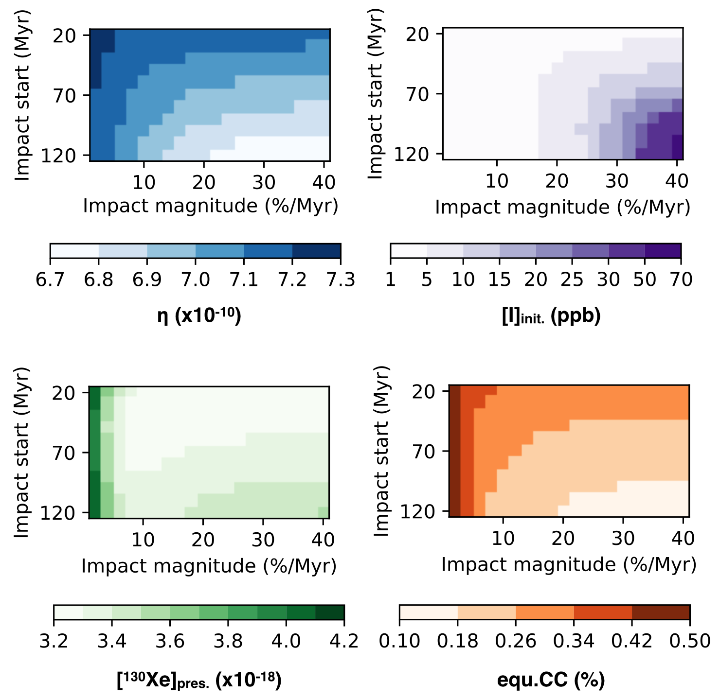
Figure S17. Variation of best-fit input parameters found using the gradient descent algorithm for a variety of impact induced degassing scenarios, using MORB target parameters. Each panel shows impact time on the y-axis in Myr and resultant degassing intensity in %Myr⁻¹ on the x-axis. Left-hand panels show color gradients indicating variations of η (top) and [¹³⁰Xe]_{pres.} (bottom, whilst right-hand panels show [I]_{init.} (top; plausible range between 7-13 ppb; Avice & Marty³⁰ and references therein) or equ.CC (bottom) variations.

Reproducing MORBs with reasonable ¹²⁷I_{init}(BSE) and [¹³⁰Xe]_{pres.} thus requires the depleted mantle to have undergone early and catastrophic degassing, which can be only achieved by introducing one (or more) discrete event(s) of intense mantle degassing, likely associated with giant impacts¹³³ (Figure S16). Conversely, Mt. Etna target values readily produce [I]_{init.} values that are at the upper limit of this range of plausible values (Figure S18), implying that additional loss of ¹²⁹Xe_{I} within the first 100 Myr of Earth's evolution will invariably require [I]_{init.} values that are greater than the range of previously considered values, therefore making these scenarios unlikely. In other words, the Mt. Etna Xe isotope composition is best explained by an absence of significant giant impact-induced degassing (i.e., ≤ 2% Myr⁻¹; Figure S18), with [I]_{init.} values becoming increasingly unreasonable for late giant impact scenarios and high degassing rates (Figure S19). For any giant impact scenario considered here, the total amount of degassing (η) is invariably higher for Mt. Etna (≥ 8.0x10⁻¹⁰) than for conventional MORB (≤ 7.3x10⁻¹⁰) target parameters. Likewise, [¹³⁰Xe]_{pres.} is invariably lower – and in better agreement with independent estimates of [¹³⁰Xe]_{pres.} at (1.79±0.25)x10⁻¹⁸ mol/g¹⁴ – for Mt. Etna (≤ 2.04x10⁻¹⁸ mol/g) than for conventional MORBs (≥ 3.2x10⁻¹⁸ mol/g).
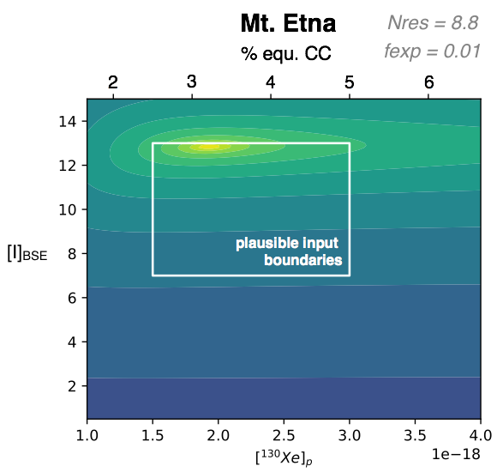
Figure S18. Heat maps of misfit between modeled and measured Xe isotope systematics for Mt. Etna, without giant impact degassing. Same color-coding and caption as Figure S16.

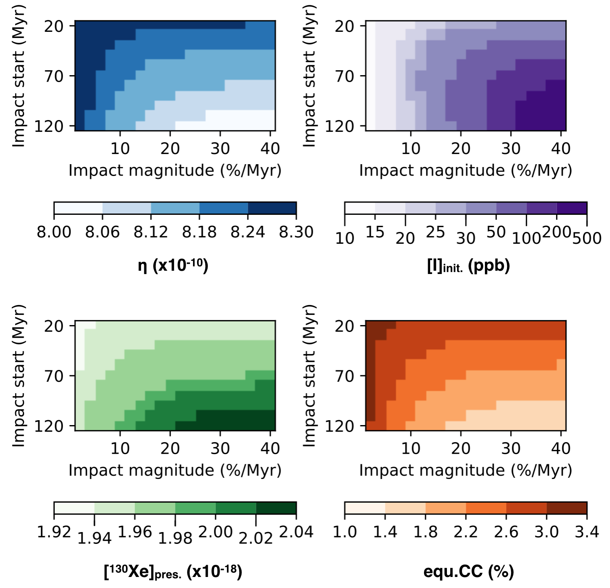
Figure S19. Variation of best-fit input parameters found using the gradient descent algorithm for a variety of impact-induced degassing scenarios, using Mt. Etna target parameters. Same color-coding and caption as Figure S17. Remarkably, we find that any episode of early giant impact-induced degassing (and thus ¹²⁹Xe_{I} loss) for the Mt. Etna mantle source would increase the required ¹²⁷I_{init}(BSE) beyond the range of plausible values, between 7 and 13 ppb^{30,31}.
Upper mantle reservoir(s): There is no overlap between the impact scenarios that can satisfactorily explain the MORB and Mt. Etna target parameters, indicating that the conventional MORB measurements and our new Mt. Etna measurements cannot be considered as representing a common upper mantle source. This suggests either a previously unrecognized heterogeneity in the convecting upper mantle, or a systematic disagreement between our novel DMS analytical technique and conventional static noble gas mass spectrometry. Considering Eifel mantle source data further strengthens the discrepancies between our findings and literature data. In essence, we find that any model attempting to reproduce the Eifel composition requires ¹²⁷I_{init}(BSE) ≥ 120 ppb, which is far beyond the range of plausible values. Because any episodes of early mantle degassing would require increasingly high [I]_{init.} to compensate for the early loss of ¹²⁹Xe_{I}, the unreasonably high [I]_{init.} derived from Eifel mantle source parameters cannot be accounted for by adjusting the mantle degassing history. As detailed in the main text, the difficulties in resolving the Xe_{Pu} component can generate spurious ¹²⁹Xe_{I}/¹³⁶Xe_{Pu} and low ¹³⁶Xe_{Pu}/¹³⁶Xe_{TF} estimates that may not be representative of the mantle source composition. Thus, the apparent discrepancy between mantle source Xe isotope composition estimates for Mt. Etna and Eifel may not be regarded as reflecting mantle source heterogeneities, but as consistently pointing towards a much greater ¹²⁹Xe_{I}/¹³⁶Xe_{Pu} (and lower ¹³⁶Xe_{Pu}/¹³⁶Xe_{TF}) for the convecting mantle than previously thought. Based on our modeling results, these fundamental observations cannot be simply explained in the classical framework of our understanding of mantle Xe isotope evolution. One possibility is therefore that one or several previously unrecognized processes have affected the Pu/U of the Earth's mantle, thereby causing the ultimate ¹²⁹Xe_{I}/¹³⁶Xe_{Pu} and ¹³⁶Xe_{Pu}/¹³⁶Xe_{TF} of this reservoir to be greater and lower, respectively, than previously recognized.

Revising Pu/U systematics on the early Earth: Initial Pu/U ratios (i.e., Pu/U corrected to the age of the solar system, hereafter (Pu/U)₀) in > 4 Ga terrestrial zircons span values both above (up to 0.0012) and below (down to zero) the widely accepted initial solar system value (at 0.0068³⁴). As noted by Turner et al. (2007)¹⁰, the widely used chondritic value (representative of average solar system) is arguably less certain than the quoted experimental error. The bulk (Pu/U)₀, inferred from two samples of the LL6 St Severin meteorite³⁴, was derived by combining temperature steps exhibiting a factor 4 variation in Pu/U, and then applying decay corrections based on whole-rock I– Xe ages¹⁰. Thus, there is a strong case for revisiting the chondritic (Pu/U)₀ system¹⁰ and improving our understanding of the internal and external variability of Pu/U in chondritic and planetary objects. Xe loss from zircons is an obvious potential cause for low apparent (Pu/U)₀: a total Xe loss from a zircon once Pu has become extinct would naturally produce (Pu/U)₀ ~ 0, and uranium-xenon ages equal to the time of Xe loss. The extent of apparent (Pu/U)₀ lowering thus depends on the timing of Xe loss: while a recent loss would preserve the (Pu/U)₀ information, ancient losses (within the first 500 Myr of terrestrial evolution) would lead to significant lowering of the apparent (Pu/U)₀¹³⁴. Overall, available (Pu/U)₀ data from Hadean zircons suggest that Pu/U fractionation during magmatic and/or aqueous processes between Earth's formation and crystallization of the zircons was relatively small (< factor 2)¹⁰. In studies of both meteorites^{135,136} and nuclear materials¹³⁷, Pu is commonly considered similar in chemistry to the light rare earth elements¹³⁸. However, our understanding of the geochemical behaviour of Pu in terrestrial settings, and the potential for significant fractionation of the Pu/U during aqueous and magmatic processes associated with the formation and evolution of the Hadean crust, is greatly hampered by the lack of extant natural Pu since about 4 Gyr. For example, in a scenario involving wet magma ocean(s) during the Earth’s differentiation (as proposed to account for the halogen budget of the mantle¹³⁹), the geochemical behaviours of U and Pu could have been mostly controlled by water behavior at the very early stages of Earth’s history. The difference in solubility between Pu⁴⁺ and the uranyl ion UO₂²⁺ under most crustal oxidation conditions could have permitted fractionation of U from Pu in aqueous systems¹⁴⁰. Notably, uranium displays different geochemical behavior from the other light actinides under even mildly oxidizing aqueous conditions: it oxidizes to form the water-soluble uranyl ion (UO₂²⁺)¹⁴¹ while Pu and Th remain in non-soluble tetravalent form^{140,142,}). Both Th and Pu indeed tend to occur in nature as water-insoluble tetravalent cations, in part because Pu⁴⁺ reacts quickly with solid surfaces to form essentially insoluble Pu³⁺ (ref¹⁴²). Because of this differing behavior, substantial Th/U and Pu/U fractionation may occur in aqueous systems, offering a possible mechanism for generating both super- and sub-chondritic Pu/U ratios. In summary, the strong case for revisiting the chondritic (Pu/U)₀ system¹⁰ and the possibility for some fractionation of the Pu/U to have occurred during aqueous and magmatic processes on the early Earth could both contribute to explaining the low abundance of Xe_{Pu} found in this study (Figure 20; Table S4), with far reaching implications for our understanding of mantle volatile evolution.

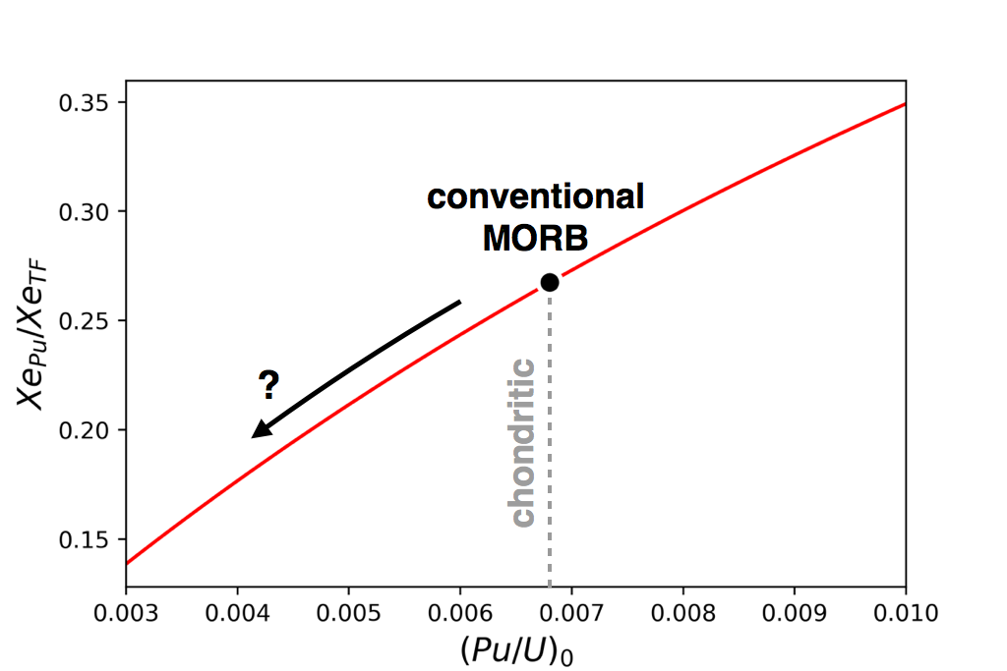

Figure S20. Effect of varying the (Pu/U)₀ on the ultimate Xe_{Pu}/Xe_{TF} of the upper mantle. For this exercise, the gradient descent technique was used to find the combination of input parameters that provides the best fit to the MORB⁶ target composition, using a (Pu/U)₀ of 0.0068³⁴. The (Pu/U)₀ was then varied (with all other input parameters kept constant) to explore the effect of uniquely varying the (Pu/U)₀ on the ultimate Xe_{Pu}/Xe_{TF} of the upper mantle.
 |  | (Pu/U)₀ = 0.0068 | (Pu/U)₀ = 0.0034
MORB  (no giant impact) | $$η$$ | 7.22 x10⁻¹⁰ | 6.74 x10⁻¹⁰
MORB  (no giant impact) | [I]_{init.} | 1.90 | 0.84
MORB  (no giant impact) | [¹³⁰Xe]_{pres.} | 4.30 x10⁻¹⁸ | 4.51 x10⁻¹⁸
MORB  (no giant impact) | f_{exp} | 1.00 | 1.00
Mt. Etna | $$η$$ | 8.29 x10⁻¹⁰ | 8.00 x10⁻¹⁰
Mt. Etna | [I]_{init.} | 12.8 | 6.13
Mt. Etna | [¹³⁰Xe]_{pres.} | 1.93 x10⁻¹⁸ | 2.06 x10⁻¹⁸
Mt. Etna | f_{exp} | 0.01 | 0.04

Table S4. Input parameter combinations that provide the best fit to Mt. Etna and MORB target compositions for different (Pu/U)₀, generated using the gradient descent technique.

SI-11° Magma ocean crystallization model

Our model of uranium partitionning during magma ocean crystallization builds upon previous models by Morino et al. (2018)³⁹ and Caracas et al. (2019)⁴⁰. According to this model, two main parameters can drastically affect the amount of mantle U ultimately extracted to the Hadean crust:

1- The first one is the amount of Ca-perovskite at pressures >22 GPa. Whereas bulk partition coefficients of U in the pressure range 22–0 GPa are consistently low, between 10⁻³ and 10⁻², the bulk partition coefficient of U at pressures >22 GPa can greatly increase due to the occurrence of Ca-perovskite, which is the only major mineralogical phase in Earth's mantle within which U is compatible (K_{d} = 7-15⁹⁶). However, the distribution of Ca-perovskite at pressures >22 GPa is highly uncertain, and a recent study demonstrated that all Ca may dissolve into bridgmanite in the deep lower mantle¹⁴³. Furthermore, the amount of Ca-rich bridgmanite in the mantle would have been much greater in the past than at present day, hence suggesting that the amount of Ca-perovskite would have proportionally increased as the mantle cooled with time¹⁴³. These considerations suggest that the amount of Ca-perovskite in the mantle at the time of magma ocean crystallization could have been limited, hence increasing the incompatibility of U at depth in the mantle, and favoring its extraction to the Hadean crust (and the BMO). Thus, we consider two end-member scenarios: one with no Ca-perovskite, and one with 1% Ca-perovskite in the mantle at the time of magma ocean crystallization, consistent with previous approach by Caracas et al. (2019)⁴⁰.

2- The second crucial parameter that may affect the amount of mantle U extracted to the Hadean crust is the fraction of entrapped melt in cumulates. The extent of chemical differentiation in a magma ocean indeed depends on how melt can segregate from the solid phase during crystallization. Rapid progression of the solidification front would likely cause the trapping of a substantial amount of residual liquid in cumulates, ultimately resulting in subdued chemical fractionation compared to that expected from a pure cumulate. To account for this effect, the model is allowed to include a "trapped liquid component", modeled as a mineral phase with a partition coefficient of 1 for all elements. In detail, solidification of the lower mantle is thought to have proceeded more rapidly (i.e., on the timescale of ~10²-10³ yr) than the upper mantle (on 10⁷–10⁸ yr timescales)^{93,144}. While rapid crystallization would likely hamper chemical differentiation (hence producing high fractions of entrapped melt in cumulates), the long crystallization timescale of the upper mantle would have allowed quantitative melt extraction. For the sake of simplicity, however, the fraction of trapped liquid is assumed to be the same in all mantle layers³⁹. In the scenario of Caracas et al. (2019)⁴⁰, efficient melt-solid segregation during the formation and evolution of the basal and shallow magma oceans should greatly limit the amount of entrapped melt. Thus, we consider two end-member scenarios: one with no entrapped melt (i.e., pure mantle cumulates), and one with 1% entrapped melt.

Assuming crystallization of pure cumulates (i.e., no melt entrapment) and insignificant amounts of Ca-perovskite at pressures >22 GPa, we find that a 40-km thick Hadean crust would contain ~1.5 ppm U, corresponding to a UM depletion factor of 92% (i.e., 1.25 ppb of U in the present-day UM; Figure S21). Assuming that cumulates consistently comprise ~1% of entrapped melt would reduce this UM depletion factor to ~85% (i.e., 2.30 ppb of U in the present-day UM; Figure S21). Note that these estimates are fairly insensitive to the thickness of the Hadean crust, as increasing the crystallization rate (i.e., diminishing the volume of residual melt at the end of magma ocean crystallization ) proportionally increases the U content of the Hadean crust (Figure S21), thus only marginally affecting the total amount of U extracted from the mantle. Alternatively, assuming crystallization of pure cumulates and ~1% of Ca-perovskite at pressures >22 GPa, we find that a 40 km thick Hadean crust would contain ~1.3 ppm U, which would lower the estimated UM depletion factor from 92% down to 73% (Figure S21), yielding a present-day UM U content of 4.57 ppb.

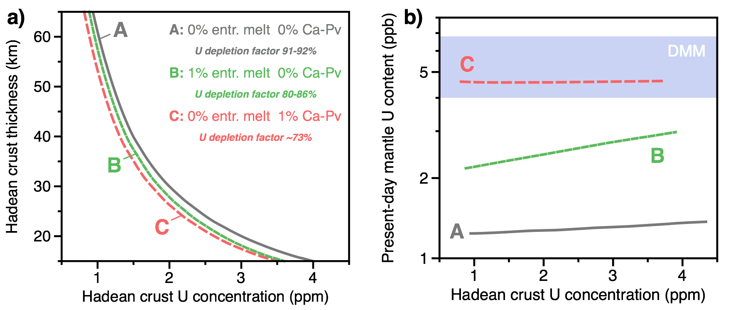

Figure S21. Magma ocean crystallization and box model outputs regarding the U budget of the Hadean crust and depletion factor of upper mantle uranium. These graphs were generated from the excel spreadsheet provided as Supplementary Material. Grey curves (A) correspond to an extreme scenario of no entrapped melt in magma ocean cumulates and no Ca-perovskite in cumulates formed at >22 GPa. Green curves (B) show the case of 1% entrapped melt and no Ca-perovskite. Red curves (C) show the case of no entrapped melt and 1% Ca-perovskite in cumulates formed at >22 GPa. Panels (a) and (b) show the Hadean crust thickness and modeled present-day upper mantle U content, respectively, as a function of Hadean cust U concentration, for each of the three scenarios. Modeled present-day upper mantle U contents are compared with the present-day U content of the depleted MORB mantle (DMM, 5.4±1.3ppb¹⁴⁵).

Overall, these results show that magma ocean crystallization has the potential to extract a substantial fraction of mantle U (and Pu) into Earth's primordial crust. In the simplified model presented above, the buffering effect of Ca-perovskite limits the UM depletion factor and more extreme degrees of mantle depletion can only be achieved by assuming a lower D_{U} than currently predicted based on experiments conducted at 23-25 GPa or a non-modal crystallization sequence dominated by bridgmanite. Combined with an overall low (≤1%) fraction of trapped melt, these scenarios minimize the buffering effect of Ca-perovskite and concentrate virtually all mantle U (and Pu) into the primordial crust. Comparing modeled and observed present-day U concentration in the UM (Figure S21b) further allows one to evaluate whether the average rate of U subduction would have been greater or lower than the rate of mantle U extraction at mid-ocean ridges over the past ~4.4 Gyr. Scenarios A and B, for instance, would require that the average rate of U subduction has been greater than that of mantle U extraction. For scenario C, the U content of the upper mantle predicted by the model is compatible with observations¹⁴⁵, suggesting only limited (if any) imbalance between the rates of mantle U input and output over the past ~4.4 Gyr.

As mentioned in the main text, the reintroduction of incompatible elements into the mantle via crustal recycling would have been inefficient on the early Earth. It is only from ~3 Gyr ago that oxidized uranium would have started being efficiently transported from the continents to the altered oceanic crust and ultimately, by subduction, back into the mantle⁴⁷. As of today, it is estimated that about 3.1x10⁷ mol of crustal U enters the mantle at subduction zones every year⁴⁷. Considering that about 20 km³ of oceanic crust with 50 ppb U is emitted at mid-ocean ridges every year, it follows that about 1.1x10⁷ mol of mantle U is emitted at Earth's surface every year. This first-order mass balance calculation suggests that the total amount of U in the convecting mantle may indeed increase through time, at a present-day rate of ~2 x10⁷ mol of U per year. Although the fraction of subducted U that ends up being sequestered within crustal levels of subduction zones, into the sub-continental lithospheric mantle, and the deep mantle should be considered, the possibility of combined (i) quantitative U (and Pu) extraction from the mantle during Hadean crust formation (Figure S21), and (ii) subsequent reintroduction of U into the mantle via subduction and convective mixing after Pu had gone extinct, represents one possible mechanism that could have fractionated the U/Pu of the upper mantle and contributed to producing the low ¹³⁶Xe_{Pu}/¹³⁶Xe_{TF} observed in this study (see summary cartoon Figure S22). The possibility that substantial incompatible element extraction to the crust occurred within the lifetime of ²⁴⁴Pu thus suggests that differences between the ¹³⁶Xe_{Pu}/¹³⁶Xe_{TF} and ¹²⁹Xe_{I}/¹³⁶Xe_{Pu} of deep and convecting mantle reservoirs may not solely reflect the outcomes of accretionary^{48,16} and long-term degassing processes, as yet conventionally assumed¹². Remarkably, considering a present-day influx of subducted U in oceanic crust of ~3.1x10⁰⁷ mol/yr⁴⁷ and computing the outflux of U emitted at mid ocean ridges (1.1x10⁰⁷ mol/yr, assuming 20 km³ of MORBs are emitted every year with 50 ppb U; see excel spreadsheet "Mass balance Hadean.xlsx") would indicate a net influx of U into the mantle of 2.0x10⁰⁷ mol/yr. Assuming this flux has remained constant over the 3 billion years of subduction would indicate that 5.9x10¹⁶ mol of U have been introduced into the mantle via subduction. When compared to the total mass of the convecting upper mantle (3.1x10²⁷ g), this amount of U (1.4x10¹⁹ g) would correspond to 4.5 ppb U., which is compatible with the actual U content of the depleted mantle (5.4±1.3ppb¹⁴⁵) (cf. "Mass balance Hadean.xlsx"). Also these considerations ignore the – largely underconstrained – fractions of subducting U potentially transferred to the lower crust or deep mantle⁴⁷, they suggest that the total amount of U introduced within the solid Earth of the last 3 billion years of subduction could have largely impacted the general U budget of the convecting mantle, as proposed in this study.
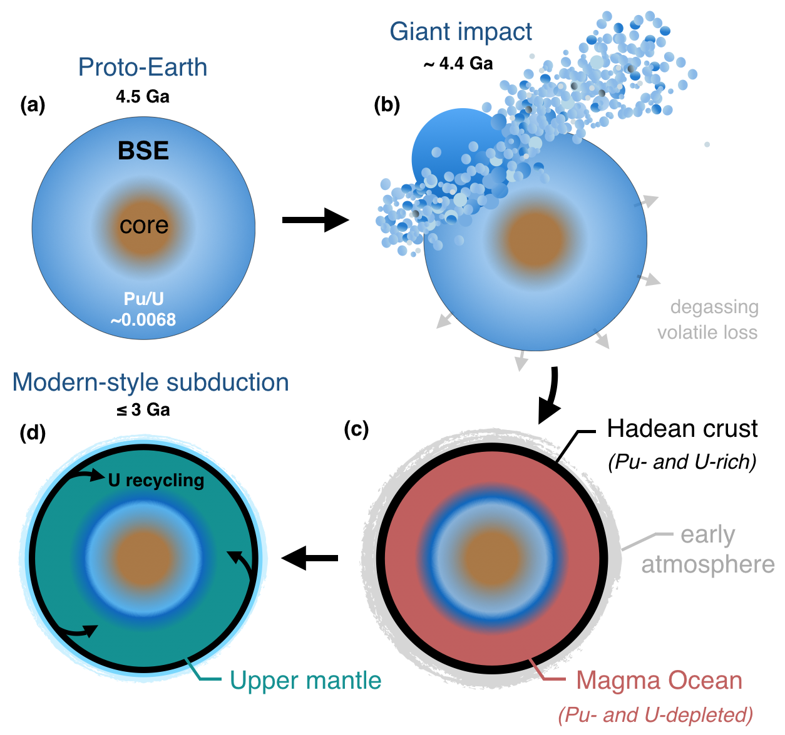

Figure S22. Cartoon of terrestrial formation, whereby a sizeable fraction of Pu decay on Earth occurred within shallow, crustal levels, rather than in the mantle. (a) At 4.5 Gyr ago, the proto-Earth would have formed and initiated its differentiation. (b) The Moon-forming giant impact would then have caused extensive mantle degassing and volatile loss. (c) Following the giant impact, an early (Hadean) crust would have formed rapidly (Figure S12, curve B), thereby concentrating most of the incompatible elements at Earth's surface. As dictated by Nd isotope systematics in Archean mantle and crust samples, this Hadean crust would have been preserved (although extensively reworked and recycled) on the timescale of up to ~1 Gyr. (d) The onset of efficient incompatible element recycling within the solid Earth would only have been made possible by the emergence of modern-style "cold" subduction, long after Pu had become extinct, around 3 Gyr ago¹⁴⁶. The protracted oxidation of Earth's surface then caused a significant change in the predominant surface oxidation state of U, which became soluble within oxidizing environments at the Earth's surface, thus facilitating its transport from continents to the altered oceanic crust and ultimately, by subduction, back into the mantle⁴⁷.

