Supplementary Materials
Suwonella silvatica gen. nov., sp. nov., a new genus of family Neisseriaceae isolated from forest soil in Suwon, South Korea by a soil substrate membrane system
Ngoc Hoang Trinh^{1,2} and Jaisoo Kim^{1*}
¹ Department of Life Science, College of Natural Sciences, Kyonggi University, Suwon, Gyeonggi-Do 16227, Republic of Korea
² Thai Nguyen University of Sciences, Thai Nguyen City, Thai Nguyen province 250000, Vietnam

Running title: Suwonella silvatica sp. nov.

Contents category: New Taxa; Subsection: Proteobacteria

*Corresponding author: Jaisoo Kim.
Tel: +82-31-249-9648; Fax: +82-31-249-9604
Email: jkimtamu@kgu.ac.kr

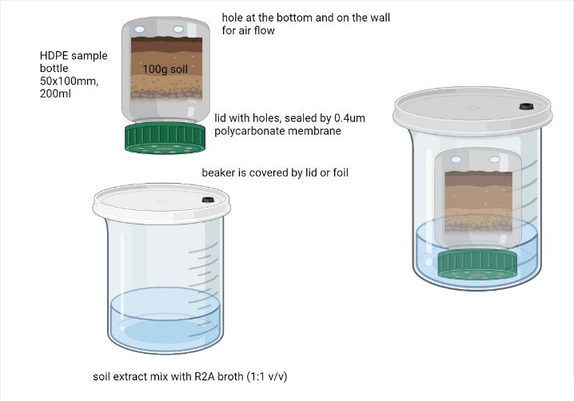
Fig. S1. Schematic overview of the soil substrate membrane system for isolation of Suwonella silvatica JH1-16^{T}
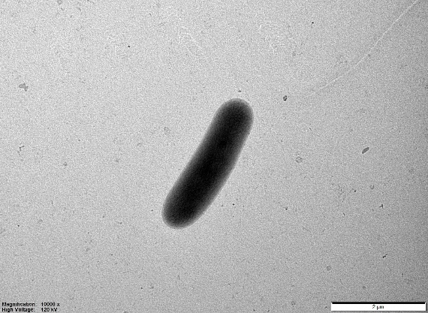
Fig. S2. TEM image indicated cell morphology of strain Suwonella silvatica JH1-16^{T}

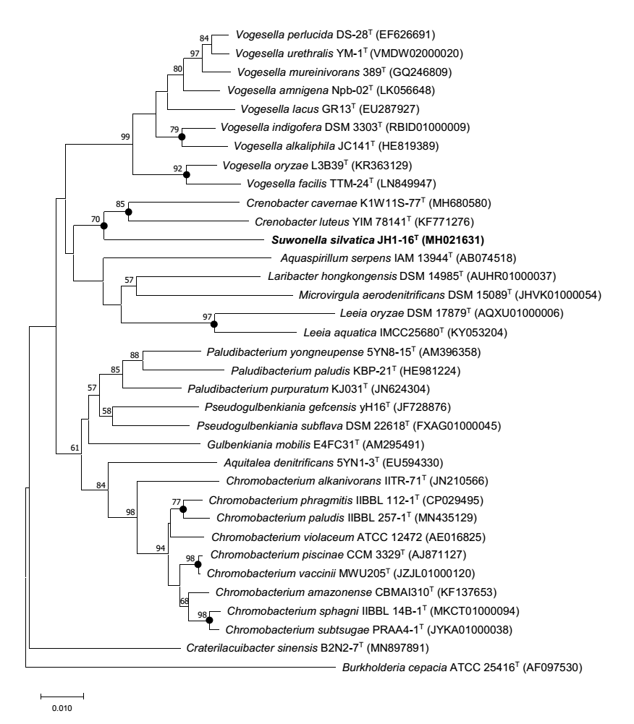
Fig. S3. Phylogenetic relationship of strain JH1-16^{T} with closed members of the family Chromobacteriaceae and family Neisseriaceae. The tree was constructed using the neighbour-joining method based on 16S rRNA gene sequences. Bootstrap values (expressed as percentages of 1000 replications) greater than 50 % are shown at branch points. Filled circles indicate that the corresponding nodes were also recovered in the tree generated with maximum-likelihood and maximum-parsimony algorithms. Bar 0.01 substitutions per nucleotide position.

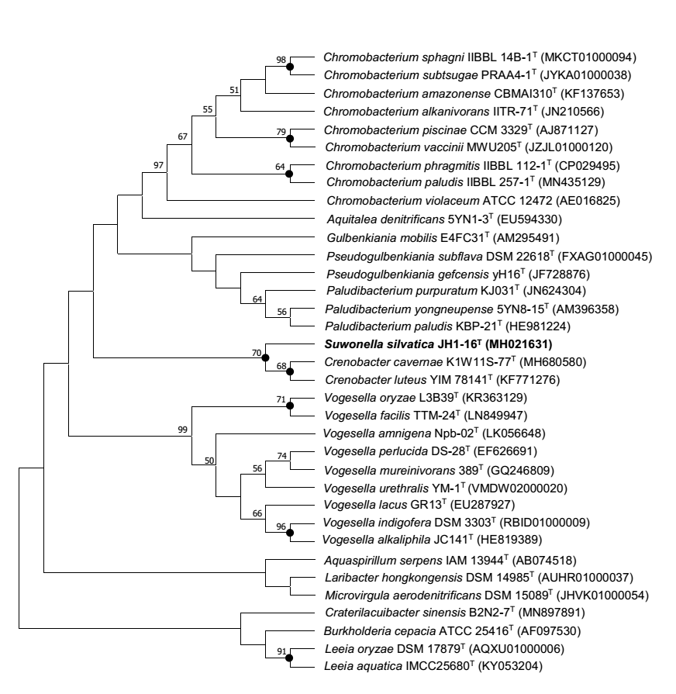
Fig. S4. Phylogenetic relationship of strain JH1-16^{T} with closed members of the family Chromobacteriaceae and family Neisseriaceae. The tree was constructed using the Maximum Parsimony method based on 16S rRNA gene sequences. Bootstrap values (expressed as percentages of 1000 replications) greater than 50 % are shown at branch points. Filled circles indicate that the corresponding nodes were also recovered in the tree generated with maximum-likelihood and maximum-parsimony algorithms.

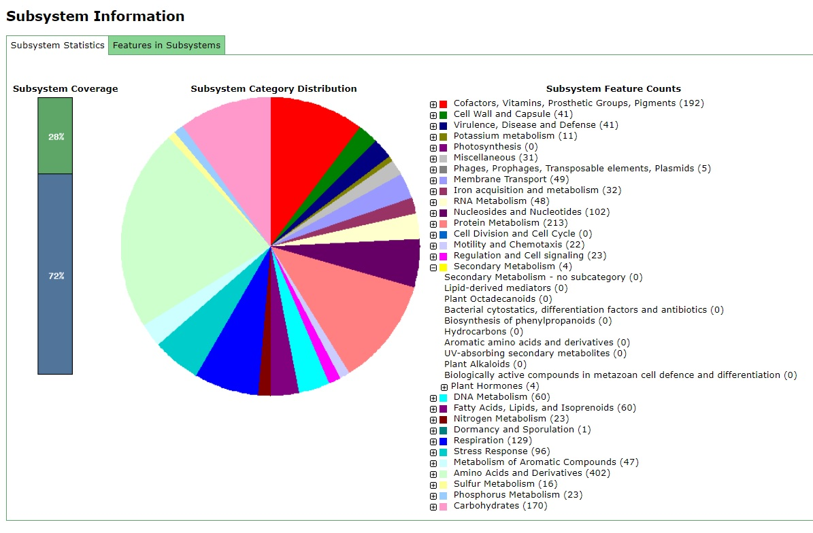
Fig. S5. Functional classes of protein-coding genes of Suwonella silvatica JH1-16^{T}

Table S1. The average nucleotide identity and digital DNA–DNA hybridization value values between strains JH1-16^{T} and related taxa.
Closed taxa | Suwonella silvatica JH1-16^{T}  (JAPDNP000000000)
Closed taxa | ANI value | dDDH
Crenobacter cavernae K1W11S-77^{T}  (CP031337) | 78.3 | 22.0
Crenobacter luteus YIM 78141^{T}  (SLXG00000000) | 78.7 | 21.8
Vogesella perlucida DS-28^{T}  (VOID00000000) | 75.1 | 20.4
Vogesella urethralis YM-1^{T}  (VMDW00000000) | 73.6 | 19.4
Vogesella oryzae Q2602  (CADEPL000000000) | 76.0 | 20.7

Table S2. General genome features of Suwonella silvatica JH1-16^{T}
Features | Values
Genome size (bp) | 4,602,739
G+C content (mol%) | 63.8
Genes (total) | 4,473
CDS | 4,382
Gene coding | 4,321
Protein coding (CDSs with protein) | 4,321
Number of rRNA gene (5S, 16S, 23S) | 9 (4, 3, 2)
tRNA genes | 69
Genome coverage | 21.69×

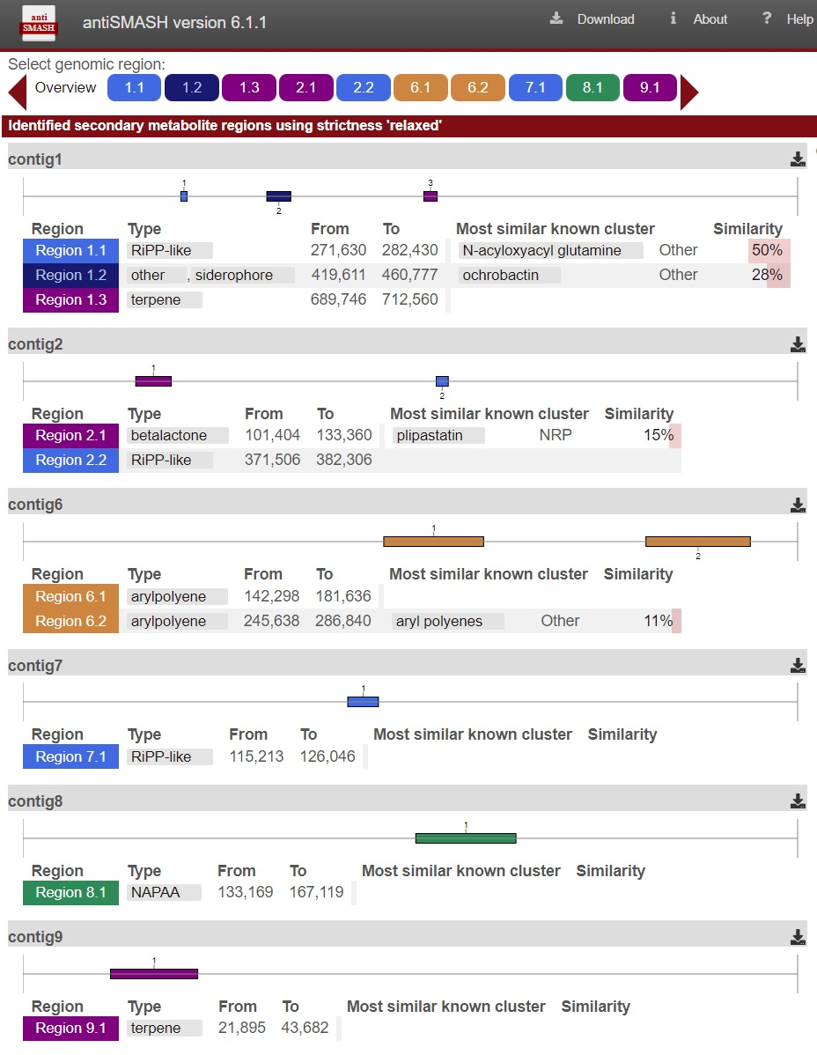
Fig. S.6. The Prediction Informatics for Secondary Metabolomes of strain JH1-16^{T}

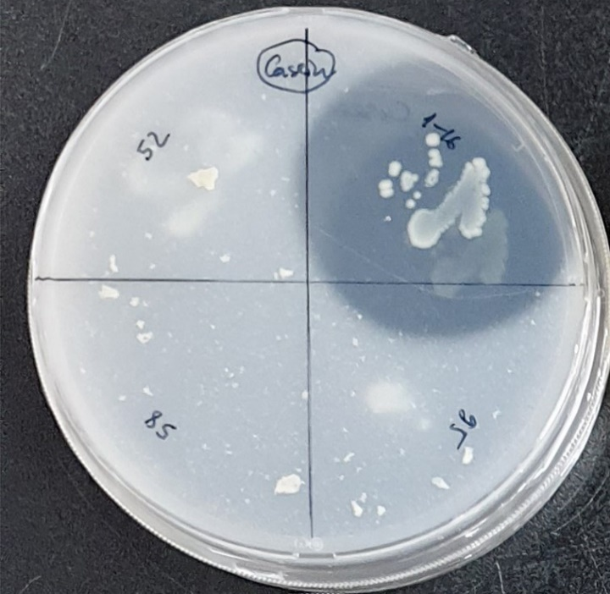
Fig. S7. Casein activity of Suwonella silvatica JH1-16^{T}

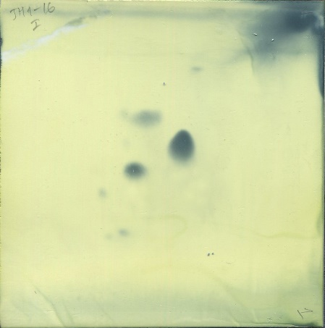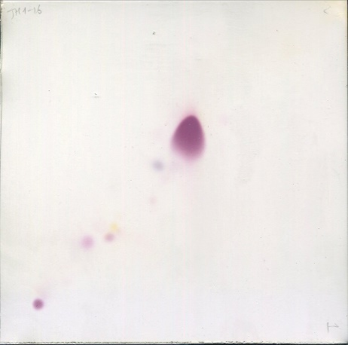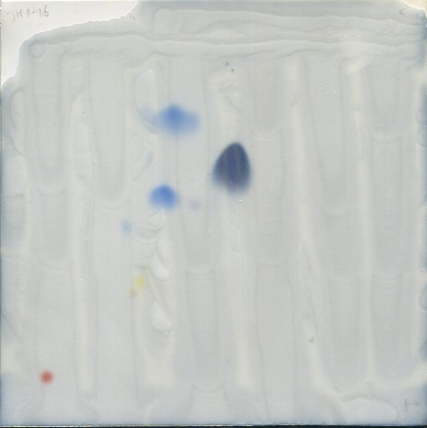
PE
AL1
AL2
PG
AL1
AL1
PL1
PG
PL1
DPG
DPG
PE
Fig. S8. Polar lipid profile of strain Suwonella silvatica JH1-16^{T}
PG - phosphatidylglycerol; DPG - diphosphatidylglycerol; PE - phosphatidylethanolamine; AL1, AL2 – unidentified aminolipid, PL1 - unidentified phospholipid.

