Supplementary information for:
The expression of cGAS-STING pathway is associated with high levels of genomic instability in breast cancer
Mengting Chen, Shibo Yu, Tineke van der Sluis, Mieke C. Zwager, Bert van der Vegt, Marcel A. T. M. van Vugt

Supplementary methods

SCNA score, Mutation-related score, HRD, and TMB
Somatic copy number alterations (SCNA) levels, including “SCNA Level” “Chrom SCNA Level”, “Arm SCNA Level”, “Chrom arm SCNA Level” and “SCNA Level normalized by size” in TCGA for BRCA were accessed from a previous study¹. Mutation-related scores, including non-silent and silent mutation rate, indel and single nucleotide variation (SNV) neoantigens, fraction altered, intratumor heterogeneity, and homologous recombination defects (HRD) in TCGA for BRCA were collected from Thorsson et al. in the TCGA cohort². HRD ≥ 42 was defined as high HRD according to a previous study³. Tumor mutation burden (TMB) data in the TCGA and METABRIC were collected from the cbioportal website (TMB (nonsynonymous)) (https://www.cbioportal.org/) and according to previously published papers, TMB ≥ 10 was defined as high TMB in this study⁴⁻⁷. The correlation between different genomic instability markers and cGAS-STING scores was calculated by using spearman’s correlation.

Functional enrichment analysis
To explore the potential role of the cGAS-STING score in the TCGA and METABRIC databases, we used the gene set enrichment analysis (GSEA) in these two cohorts by using the R package “clusterProfiler” according to the high and low cGAS-STING score⁸. The hallmarks gene sets (h.all.v7.5.1.symbols.gmt) from Molecular Signatures Database (MSigDB) were used to perform the enrichment analysis (https://www.gsea-msigdb.org/gsea/index.jsp). The pathways with a p.adjust value less than 0.05 are considered to be significant.

Copy number alteration (CNA) analysis
The gene-level CNA data for BRCA in the TCGA database were downloaded from cbioportal (https://www.cbioportal.org/). The CNA data were thresholded with the following cut-off: -2 = homozygous deletion; -1 = hemizygous deletion; 0 = neutral / no change; 1 = gain; 2 = high-level amplification. We defined gain and high-level amplification as CNA gain states for each oncogene in this study.

References
1. Davoli Teresa., Uno Hajime., Wooten Eric C., Elledge Stephen J. Tumor aneuploidy correlates with markers of immune evasion and with reduced response to immunotherapy. Science. 355, 6322 (2017).

2. Thorsson V., Gibbs DL., Brown SD., Wolf D., Bortone DS. et al. The immune landscape of cancer. Immunity, 51, 411–412 (2019).

3. Rempel E., Kluck K., Beck S., Ourailidis I., Kazdal D. et al. Pan-cancer analysis of genomic scar patterns caused by homologous repair deficiency (HRD). npj Preci Onc. 6, 36 (2022).

4. Barroso-Sousa R., Jain E., Cohen O., Kim D., Buendia-Buendia J. et al. Prevalence and mutational determinants of high tumor mutation burden in breast cancer. Ann. Oncol. 31, 387–394 (2020).

5. Winer E P., Lipatov O., Im S A., Goncalves A., Muñoz-Couselo E. et al. Association of tumor mutational burden (TMB) and clinical outcomes with pembrolizumab (pembro) versus chemotherapy (chemo) in patients with metastatic triple-negative breast cancer (mTNBC) from KEYNOTE-119. J. Clin. Oncol. 38, 1013–1013 (2020).

6. Chumsr S., Sokol E S., Soyano-Muller A E., Parrondo R D., Reynolds G A. et al. Durable complete response with immune checkpoint inhibitor in breast cancer with high tumor mutational burden and APOBEC signature. J. Natl Compr. Cancer Netw. JNCCN. 18, 517–521 (2020).

7. Alva A S., Mangat P K., Garrett-Mayer E., Halabi S., Alvarez R H. et al. Pembrolizumab (P) in patients (pts) with metastatic breast cancer (MBC) with high tumor mutational burden (HTMB): Results from the Targeted Agent and Profiling Utilization Registry (TAPUR) Study. J. Clin. Oncol. 37, 1014–1014 (2019).

8. Yu G., Wang L G., Han Y., He Q Y. clusterProfiler: An R package for comparing biological themes among gene clusters. OMICS. 16, 284–287 (2012).

Supplementary figures
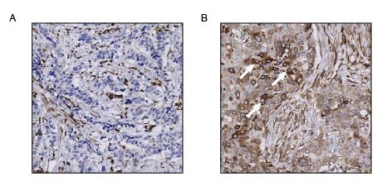
Fig. S1. Representative images of quantification of pnSTING tumor cells A The core with negative pnSTING expression B The core with positive pnSTING expression. White arrows represent pnSTING positive cells.

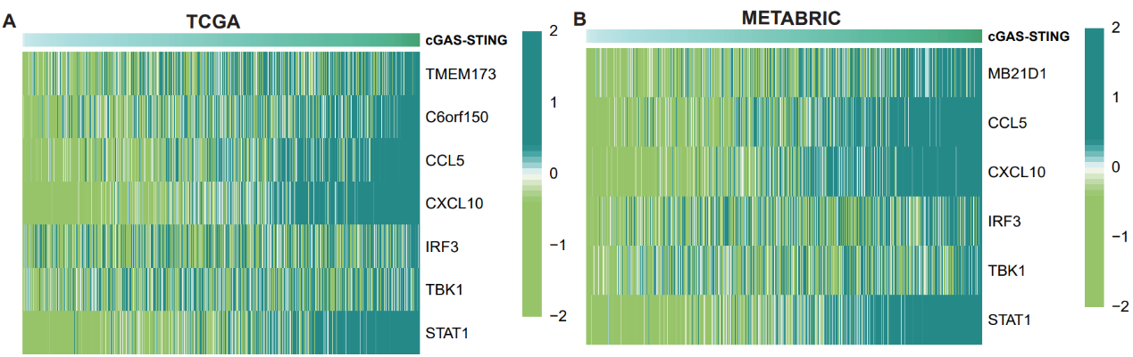
Fig. S2. Genes composed of the cGAS-STING score and the expression of cGAS-STING score in different BRCA subgroups.
A-B Heatmap of the expression of cGAS-STING related genes ranked from right to left by the cGAS-STING score in the TCGA (A) and METABRIC (B) database.

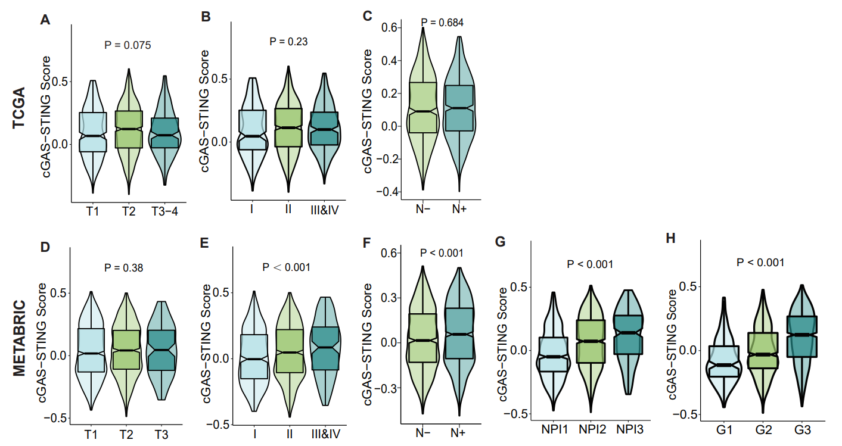
Fig. S3. cGAS-STING score in different breast cancer patient subgroups according to clinical characteristics A-C Comparison of cGAS-STING scores among patients with different tumor size (A), tumor stage (B) and lymph node status (C) in TCGA. The bottom and top of the boxes are the 25th and 75th percentiles; Statistical significance was tested by Wilcoxon rank-sum test or Kruskal–Wallis test. D-H Comparison of cGAS-STING scores among patients with different tumor size (D), tumor stage (E), lymph node status (F), Nottingham prognostic index (G), histologic Grade (H) in METABRIC. The bottom and top of the boxes are the 25th and 75th percentiles; Statistical significance was tested by Wilcoxon rank-sum test or Kruskal–Wallis test.

Fig. S4. Higher cGAS-STING score is associated with genomic instability in breast cancer.
A GSEA enrichment results with Normalized Enrichment Scores (NES) of all biological pathways in the METABRIC database, the dotted line is the threshold of NES >1.5 or <−1.5. B GSEA enrichment results with Normalized Enrichment Scores (NES) of all biological pathways in the TCGA database, the dotted line is the threshold of NES >1.5 or <−1.5. C Correlation between cGAS-STING score and Tumor Mutation Burden (TMB) score (log2 transformed) in the METABRIC database. D The difference of cGAS-STING score between TMB high and TMB low subgroups in the METABRIC database. The bottom and top of the boxes are the 25th and 75th percentiles; Statistical significance was tested by Wilcoxon rank-sum test. E Correlation between cGAS-STING score and different somatic copy number alterations (SCNA) levels in the TCGA database.

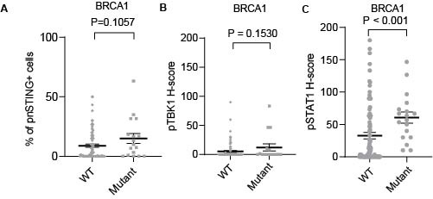
Fig. S5 The expression of inflammatory signaling based on BRCA1 status The percentage of pnSTING+ cells (A) and H-scores of pTBK1 (B) and pSTAT1 (C) in BRCA1 wildetype (WT, n=82) and mutant (n=18) breast cancer patients. Error bars represent mean ± SEM. Statistical significance was tested by Mann-Whitney U test.

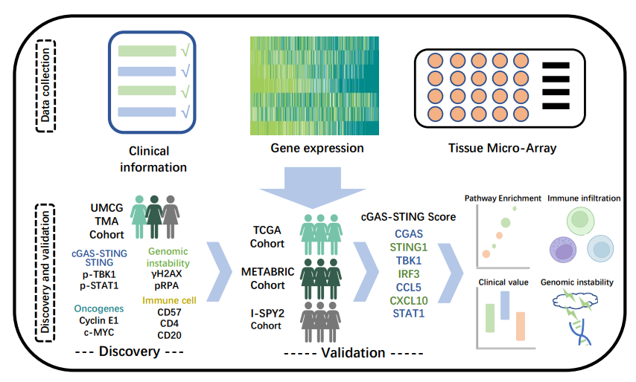
Fig. S6. Flowchart of this study. A Data collection of this study. B Evaluating the cGAS-STING Score in four independent cohorts (UMCG /TCGA/METABRIC/I-SPY2) and analyzing the characteristics of the cGAS-STING score in terms of pathway enrichment, immune infiltration, clinical value and genomic instability in breast cancer patients.

Supplementary Tables

Table S1. Spearman correlation among the inflammatory signaling proteins
 |  | STING | pnSTING | pTBK1 | pSTAT1
STING | correlation | - | 0.766 | 0.044 | 0.069
 | P value |  | <0.001 | 0.395 | 0.187
pnSTING | correlation |  | - | 0.086 | 0.123
 | P value |  |  | 0.099 | 0.017
pTBK1 | correlation |  |  | - | 0.301
 | P value |  |  |  | <0.001

Table S2. Names and Entrez ID of cGAS-STING related genes.

Gene symbol | Full name | Others gene symbol | Entrez ID
CGAS | Cyclic GMP-AMP Synthase | C6orf150/ MB21D1 | 115004
CCL5 | C-C Motif Chemokine Ligand 5 | TCP228 | 6352
CXCL10 | C-X-C Motif Chemokine Ligand 10 | IP-10/ GIP-10 | 3627
IRF3 | Interferon Regulatory Factor 3 | IIAE7/ IRF-3 | 3661
TBK1 | TANK Binding Kinase 1 | NAK | 29110
STING1 | Stimulator Of Interferon Response CGAMP Interactor 1 | STING/ TMEM17 | 340061
STAT1 | Signal Transducer And Activator Of Transcription 1 | STAT91/ ISGF-3 | 6772

Table S3. Relation between inflammatory signaling protein expression and patient clinicopathological characteristics

 |  | pSTAT1 |  |  | pTBK1 |  |  | STING
 |  | low | high | P | low | high | P | low | high | P
Menopausal status | Premenopausal | 32 | 61 | 0.002 | 73 | 21 | 0.749 | 52 | 41 | 0.260
 | Perimenopausal | 21 | 16 |  | 29 | 7 |  | 17 | 19
 | Postmenopausal | 88 | 81 |  | 139 | 29 |  | 77 | 92
 | Unknown | 33 | 17 |  | 39 | 11 |  | 29 | 21
Histological grade | I | 42 | 21 | 0.001 | 55 | 9 | 0.011 | 39 | 23 | 0.077
 | II | 67 | 53 |  | 104 | 15 |  | 60 | 60
 | III | 66 | 101 |  | 121 | 45 |  | 75 | 92
 | Unknown | 1 | 0 |  | 1 | 0 |  | 1 | 0
T | T1 | 98 | 118 | 0.012 | 171 | 44 | 0.783 | 106 | 109 | 0.886
 | T2 | 71 | 53 |  | 102 | 22 |  | 64 | 60
 | T3 | 6 | 1 |  | 5 | 2 |  | 3 | 4
 | T4 | 0 | 3 |  | 2 | 1 |  | 1 | 2
N | N0 | 122 | 116 | 0.259 | 187 | 50 | 0.860 | 111 | 127 | 0.082
 | N1 | 35 | 27 |  | 52 | 10 |  | 33 | 29
 | N2 | 12 | 18 |  | 24 | 6 |  | 21 | 9
 | N3 | 5 | 10 |  | 12 | 3 |  | 9 | 6

Table S4. Univariate COX regression analysis patient survival based on inflammatory signaling proteins
 | HR | 95% CI | P value
BCSS
STING
low | 0.860 | 0.414-1.789 | 0.688
high | Ref.
pnSTING
low | 0.984 | 0.475-2.038 | 0.965
high | Ref.
pTBK1
low | 1.113 | 0.453-2.736 | 0.815
high | Ref.
RFS
pSTAT1
low | 0.761 | 0.460-1.259 | 0.287
high | Ref.
STING
low | 0.802 | 0.481-1.336 | 0.397
high | Ref.
pnSTING
low | 0.882 | 0.534-1.457 | 0.624
high | Ref.
pTBK1
low | 0.914 | 0.476-1.756 | 0.787
high | Ref.
BCSS: breast cancer-specific survival; RFS: relapse-free survival

