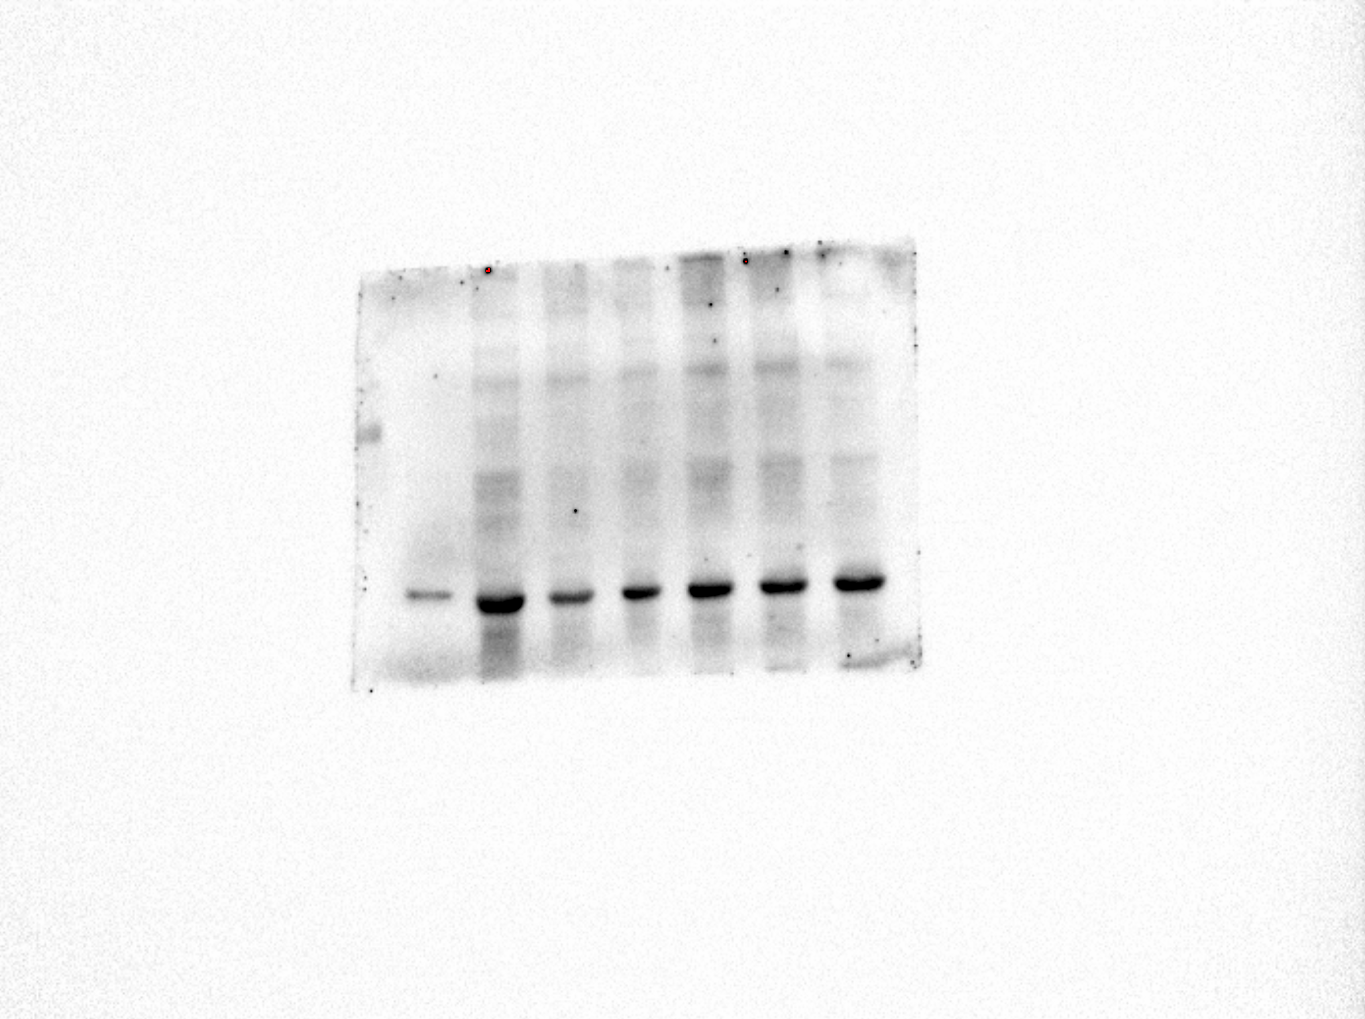
Protein Ladder (1-100 KDa)
CC SD SD+CPT
Actin (42 KDa)
Intentional loading of high quantity sample (50μg)

Protein Ladder (1-100 KDa)
CC SD SD+CPT
IL-6 (21KDa)

