Appendix
eFigure 1: Structure of end-to-end BERT models for the classification task. We use the [CLS] output token for classification along with added Linear and SoftMax layers.
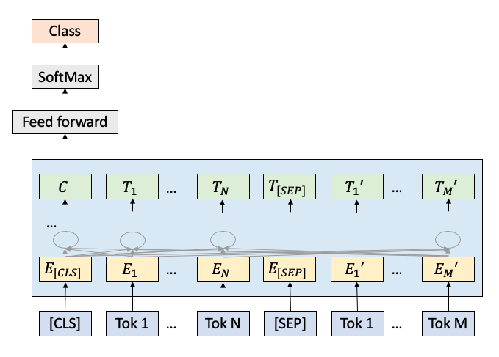
eFigure 2: Structure of concept-based LSTM models. Both bi-directional and uni-directional LSTM were tested. 128 hidden states in LSTM cells. Sigmoid function was used for classification.
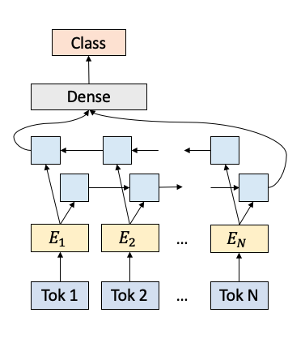
eFigure 3: PR-AUC of random forest model with random oversampling.
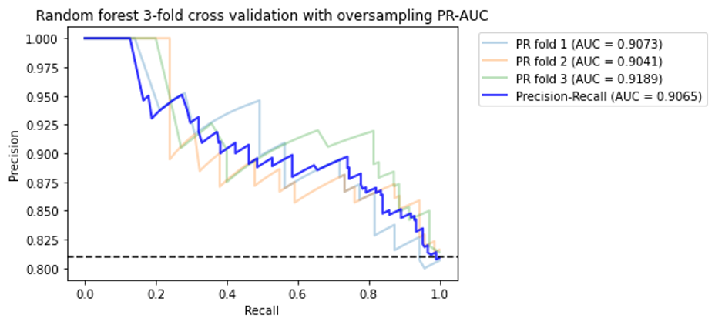

eFigure 4: ROC-AUC of random forest model with random oversampling
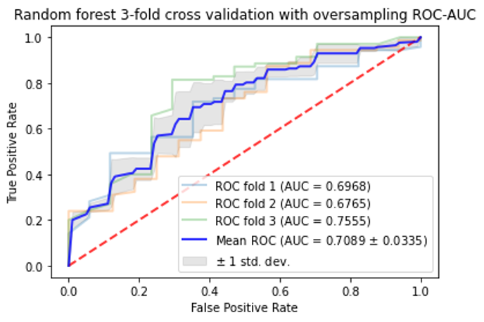
eFigure 5: PR-AUC from the concept-based Random Forest model.
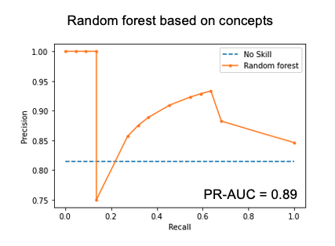

eTable 1: Tuned hyperparameters in machine learning models
Model | Tuned hyperparameters | Values
Random forest | n_estimators | [50, 100, 150]
Random forest | max_depth | [10, 20, 50]
Random forest | criterion | [“gini”, “entropy”]
XGBoost | learning_rate | 0.1, 0.05, 0.01
XGBoost | max_depth | range (2,10,1)
XGBoost | n_estimators | [50, 100,150]

