Supplementary Data
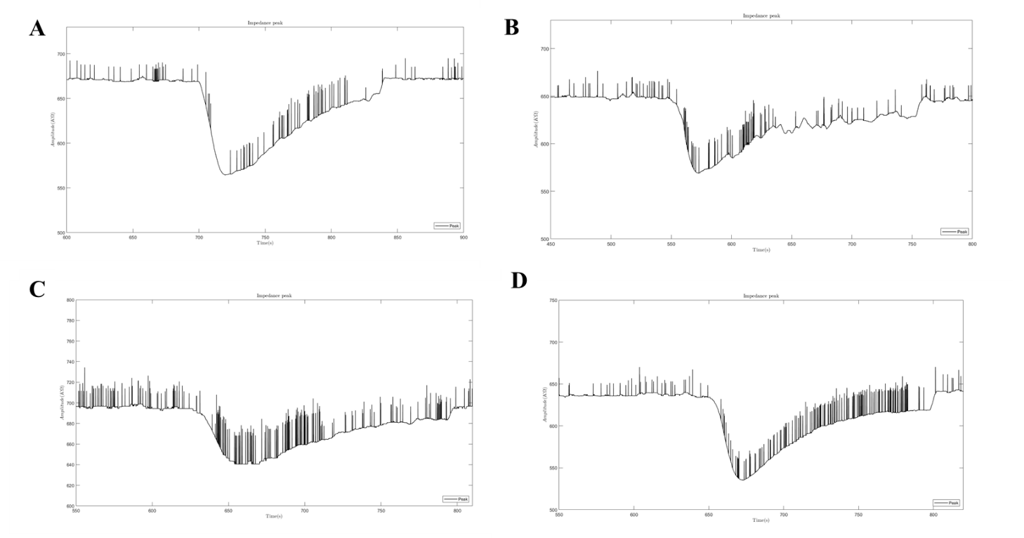
Fig. S1 – Timeline of impedance value as the liquid enters into the channel and leaves. A) Control sample, B) 35, C) 50 and D) 70 cells per µL.

