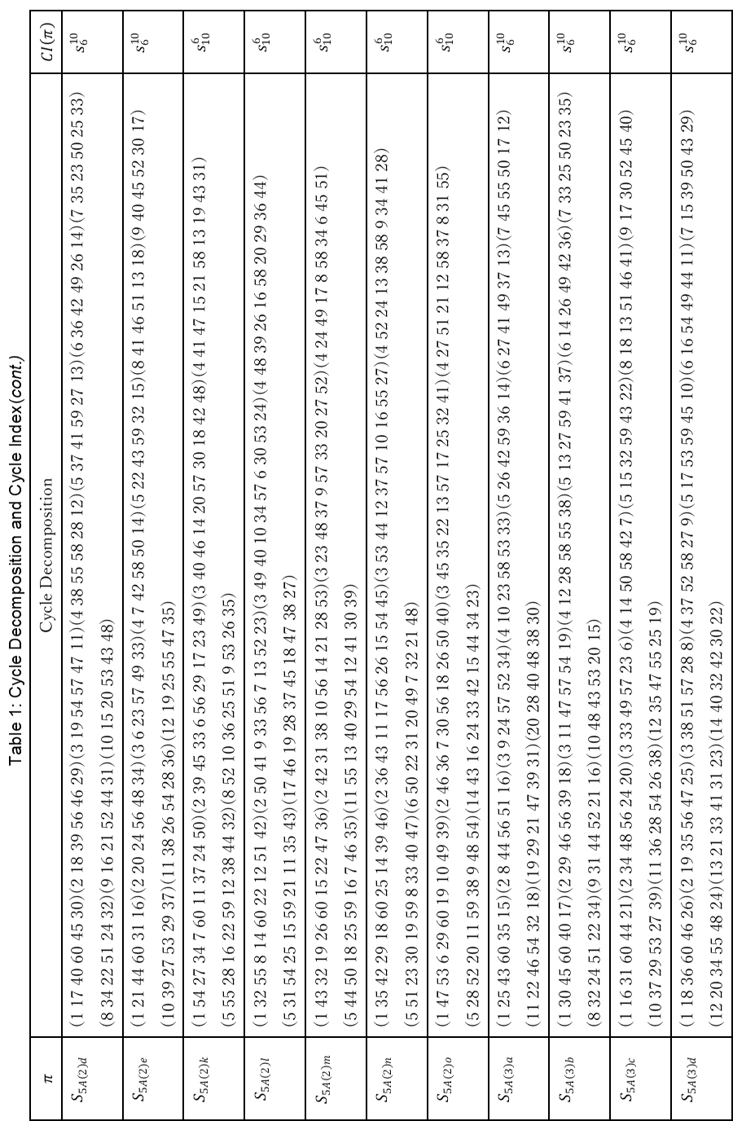
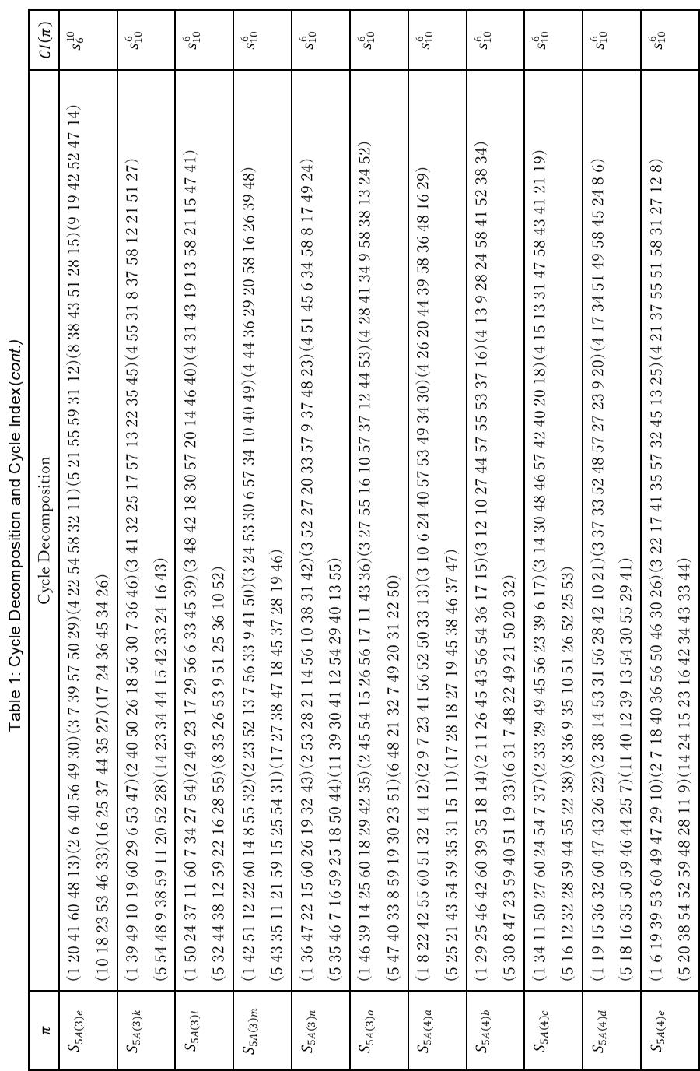
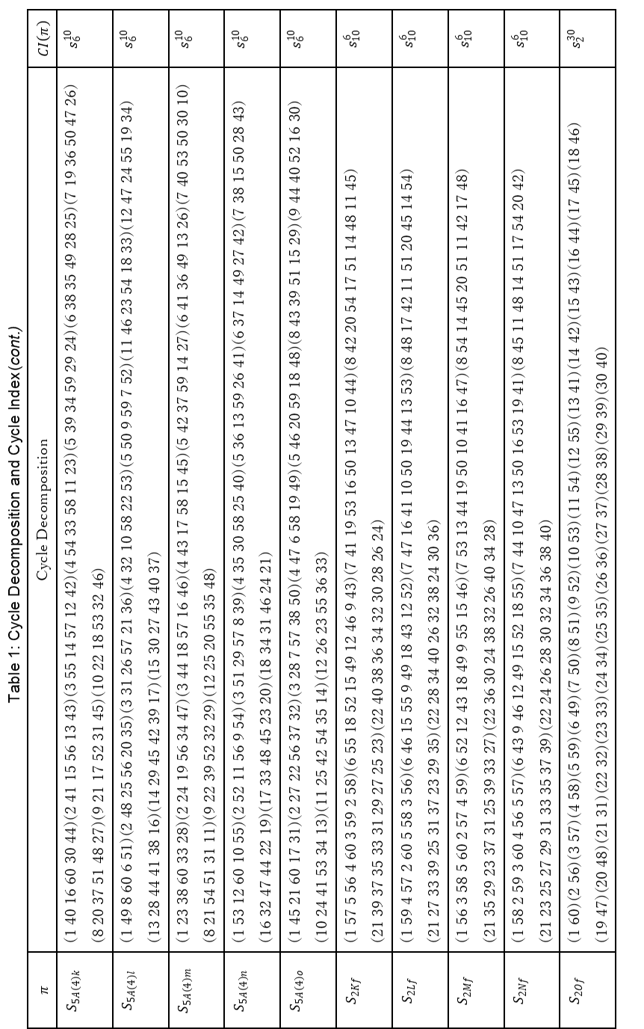
Table 2: The number of derivatives by modifying n carbons.
$$n$$ | Stereoisomers ($a_{n}$)  $θ_{n}$ of $GF\left(P_{60};x^{d}+1\right)$ | Structural isomers ($b_{n}$)  $θ_{n}$ of $GF\left(P_{120};x^{d}+1\right)$ | Chiral pairs ($c_{n}$)  $$a_{n}-b_{n}$$ | Achiral isomers ($d_{n}$)  $$b_{n}-c_{n}$$
0, 60 | 1 | 1 | 0 | 1
1, 59 | 1 | 1 | 0 | 1
2, 58 | 37 | 23 | 14 | 9
3, 57 | 577 | 303 | 274 | 29
4, 56 | 8,236 | 4,190 | 4,046 | 144
5, 55 | 91,030 | 45,718 | 45,312 | 406
6, 54 | 835,476 | 418,470 | 417,006 | 1,464
7, 53 | 6,436,782 | 3,220,218 | 3,216,564 | 3,654
8, 52 | 42,650,532 | 21,330,558 | 21,319,974 | 10,584
9, 51 | 246,386,091 | 123,204,921 | 123,181,170 | 23,751
10, 50 | 1,256,602,779 | 628,330,629 | 628,272,150 | 58,479
11, 49 | 5,711,668,755 | 2,855,893,755 | 2,855,775,000 | 118,755
12, 48 | 23,322,797,475 | 11,661,527,055 | 11,661,270,420 | 256,635
13, 47 | 86,114,390,460 | 43,057,432,740 | 43,056,957,720 | 475,020
14, 46 | 289,098,819,780 | 144,549,869,700 | 144,548,950,080 | 919,620
15, 45 | 886,568,158,468 | 443,284,859,624 | 443,283,298,844 | 1,560,780
16, 44 | 2,493,474,394,140 | 1,246,738,569,480 | 1,246,735,824,660 | 2,744,820
17, 43 | 6,453,694,644,705 | 3,226,849,468,425 | 3,226,845,176,280 | 4,292,145
18, 42 | 15,417,163,018,725 | 7,708,584,971,055 | 7,708,578,047,670 | 6,923,385
19, 41 | 34,080,036,632,565 | 17,040,023,323,785 | 17,040,013,308,780 | 10,015,005
20, 40 | 69,864,082,608,210 | 34,932,048,763,560 | 34,932,033,844,650 | 14,918,910
21, 39 | 133,074,428,781,570 | 66,537,224,405,790 | 66,537,204,375,780 | 20,030,010
22, 38 | 235,904,682,814,710 | 117,952,355,252,550 | 117,952,327,562,160 | 27,690,390
23, 37 | 389,755,540,347,810 | 194,877,787,472,550 | 194,877,752,875,260 | 34,597,290
24, 36 | 600,873,146,368,170 | 300,436,595,453,640 | 300,436,550,914,530 | 44,539,110
25, 35 | 865,257,299,572,455 | 432,628,675,734,195 | 432,628,623,838,260 | 51,895,935
26, 34 | 1,164,769,471,671,687 | 582,384,767,014,701 | 582,384,704,656,986 | 62,357,715
27, 33 | 1,466,746,704,458,899 | 733,373,386,161,407 | 733,373,318,297,492 | 67,863,915
28, 32 | 1,728,665,795,116,244 | 864,332,935,668,892 | 864,332,859,447,352 | 76,221,540
29, 31 | 1,907,493,251,046,152 | 953,746,664,302,456 | 953,746,586,743,696 | 77,558,760
30 | 1,971,076,398,255,692 | 985,538,239,868,528 | 985,538,158,387,164 | 81,481,364
total | 19,215,358,678,900,736 | 9,607,679,885,269,312 | 9,607,678,793,631,424 | 1,091,637,888

