Extended Data
Extended Data Table 1: The calculation of the global LPI and the LPI for each ecosystem adjusted (i) by increasing the number of records in individual populations included (time series with at least 3/5/10 records), (ii) by increasing the length of the population series included (time series at least 3/5/10 years long), (iii) by removing zeros and only marginal zeros from the population time series, (iv) by removing zeros from the population time series and including those with at least 3/5/10 records, (v) and by removing zeros from the population time series and including those at least 5 years long. (vi) The LPI without using the weights (compensating different species richness) for taxa and realms, (vii) and the unweighted LPI of the time series with at least 3/5/10 records, or (viii) at least 3/5/10 years long. (ix) The unweighted LPI without zeros in the population time series and without only marginal zeros, (x) and unweighted without zeros in the population time series included with at least 3/5/10 records or (xi) at least 5 years long. The values represent the final LPI values (the value of 1 was set for 1970). The green gradient shows the rate of decrease in the index decline (a positive difference between the adjusted and original value - the adjusted index declines less than the original). The red gradient shows the rate of increase in the index decline (a negative difference between the adjusted and original value - the adjusted index declines more than the original). Black colour refers to the rate of decrease in the index decline higher than 100%. * ts - time series

 | Original | ts >= 3 records | ts >= 5 records | ts >= 10 records | ts >= 3 years | ts >= 5 years | ts >= 10 years | no  zeros | no margin. zeros | no zeros ts >= 3 records | no zeros ts >= 5 records | no zeros ts >= 10 records | no zeros ts >= 5 years
Global | 0.327 | 0.470 | 0.474 | 0.591 | 0.358 | 0.310 | 0.368 | 0.519 | 0.540 | 0.564 | 0.639 | 0.687 | 0.552
Terrestrial | 0.368 | 0.381 | 0.423 | 0.773 | 0.392 | 0.377 | 0.397 | 0.706 | 0.669 | 0.719 | 0.965 | 0.974 | 0.704
Freshwater | 0.181 | 0.374 | 0.322 | 0.366 | 0.182 | 0.121 | 0.221 | 0.373 | 0.408 | 0.381 | 0.412 | 0.501 | 0.347
Marine | 0.526 | 0.730 | 0.782 | 0.730 | 0.642 | 0.650 | 0.569 | 0.532 | 0.577 | 0.655 | 0.657 | 0.662 | 0.689

 | no  weights | no weights  ts >= 3 records | no weights  ts >= 5 records | no weights  ts >= 10 records | no weights  ts >= 3 years | no weights  ts >= 5 years | no weights  ts >= 10 years | no weights no zeros | no weights  no margin. zeros | no weights no zeros  ts >= 3 records | no weights no zeros  ts >= 5 records | no weights no zeros  ts >= 10 records | no weights no zeros  ts >= 5 years
Global | 0.772 | 0.942 | 1.004 | 0.820 | 0.811 | 0.743 | 0.846 | 0.989 | 0.961 | 1.038 | 1.155 | 0.972 | 0.961
Terrestrial | 0.516 | 0.535 | 0.613 | 0.680 | 0.520 | 0.525 | 0.508 | 0.820 | 0.753 | 0.816 | 1.075 | 1.016 | 0.778
Freshwater | 0.654 | 0.963 | 0.891 | 0.624 | 0.672 | 0.514 | 0.970 | 0.910 | 0.950 | 0.885 | 0.975 | 0.688 | 0.864
Marine | 1.361 | 1.616 | 2.012 | 1.681 | 1.510 | 1.522 | 1.413 | 1.299 | 1.249 | 1.518 | 1.579 | 1.543 | 1.334

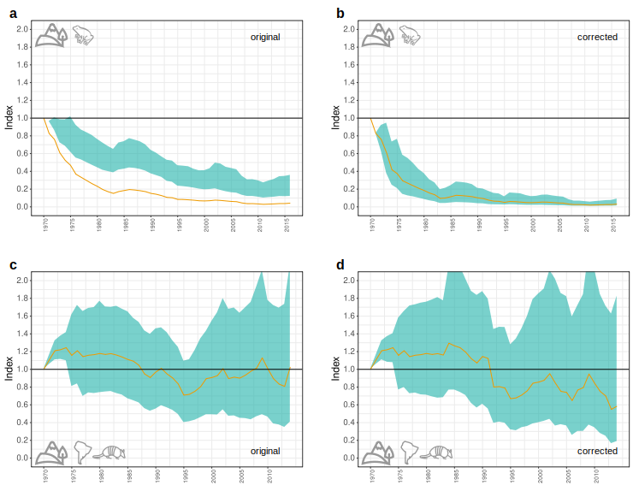
Extended Data Figure 1: Examples of the differences in the LPI due to the errors in the original code. The LPI calculated by the original code (a and c) and the corrected code (b and d) for terrestrial amphibians (a, b) and terrestrial Neotropical mammals (c, d). The green area shows the confidence intervals and the orange line shows the LPI values.
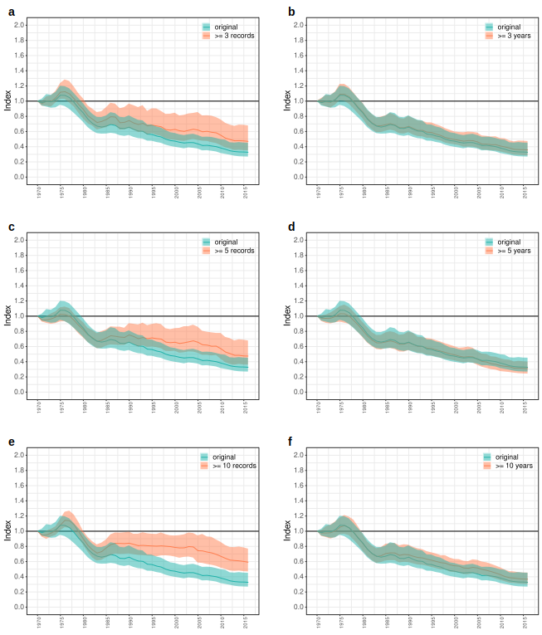
Extended Data Figure 2: The effect of the number of records in the time series and the length of the time series. The original global LPI is green and the adjusted LPI is coral, calculated with the population time series with at least 3 (a), 5 (c) and 10 (e) records and with the population time series at least 3 (b), 5 (d) and 10 (f) years long. The coloured area shows the confidence intervals and the lines show the LPI values.
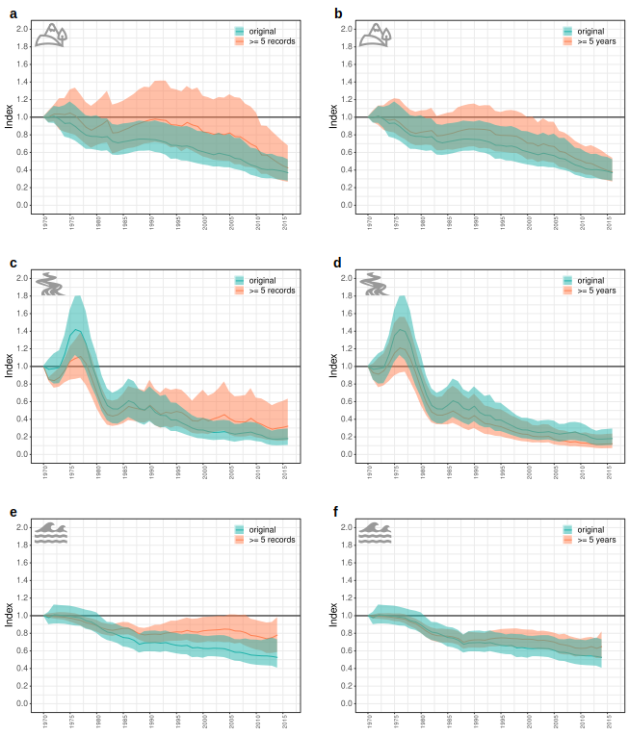
Extended Data Figure 3: The effect of the number of records in the time series and the length of the time series. The original LPI is green and the adjusted LPI is coral, calculated with the population time series with at least 5 records (a, c, e) and with the population time series at least 5 years long (b, d, f) separately for the terrestrial (a, b), freshwater (c, d) and marine (e, f) ecosystem. The coloured area shows the confidence intervals and the lines show the LPI values.
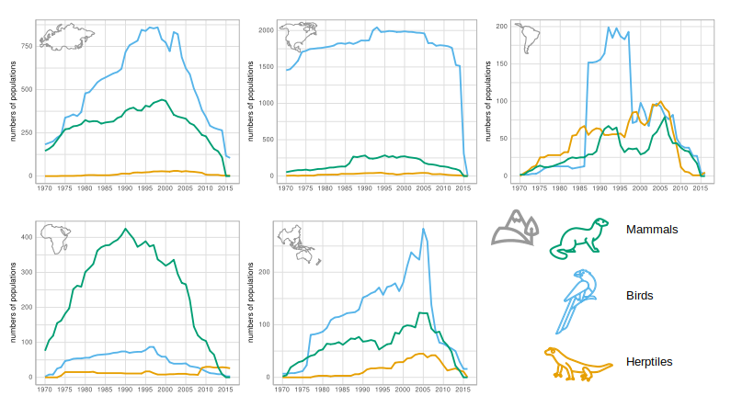
Extended Data Figure 4: Temporal distribution of population numbers in the study period for the terrestrial ecosystem. The number of populations for individual taxa (mammals, birds, herptiles) within individual biogeographical realms (Palearctic, Nearctic, Neotropical, Afrotropical, Indo-Pacific) are depicted. For the numbers of populations of individual taxa and realms for the freshwater and marine ecosystem, see Extended Data Fig. 5.
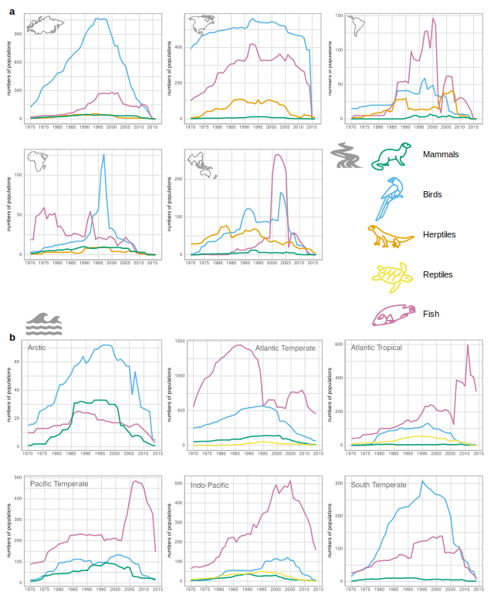
Extended Data Figure 5: Temporal distribution of population numbers in the study period. a, The number of populations for individual taxa (mammals, birds, herptiles, fish) within individual biogeographical realms (Palearctic, Nearctic, Neotropical, Afrotropical, Indo-Pacific) for the freshwater ecosystem. b, The number of populations for individual taxa (mammals, birds, reptiles, fish) within individual biogeographical realms (Arctic, Atlantic Temperate, Atlantic Tropical, Pacific Temperate, Inod-Pacific, South Temperate) for the marine ecosystem.
Extended Data Table 2: The number of zero values in population time series

 | num 0 beg | num 0 end | num 0 mid | beginning | end | middle | tot num ts
Terrestrial | 413 | 616 | 682 | 174 | 307 | 432 | 7920
Freshwater | 819 | 373 | 782 | 205 | 213 | 511 | 5585
Marine | 735 | 475 | 850 | 232 | 205 | 507 | 8670
total | 1967 | 1464 | 2314 | 611 | 725 | 1450 | 22175
* num 0 beg - the number of zeros at the beginning of time series
* num 0 end - the number of zeros at the end of time series
* num 0 mid - the number of zeros in the middle of time series
* beginning - the number of beginnings of time series with zero values
* end - the number of ends of time series with zero values
* middle - the number of middle zero values or middle sequences of zeros
* tot num ts - the total number of time series in the study
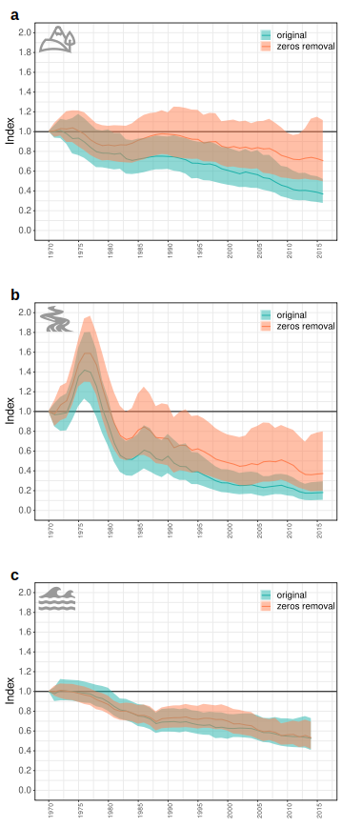
Extended Data Figure 6: The effect of removing zeros from population time series. The original LPI is green and the LPI calculated without zeros in the population time series is coral, separately for the terrestrial (a), freshwater (b) and marine (c) ecosystem. The coloured area shows the confidence intervals and the lines show the LPI values.

