Supplementary materials
Supplementary Figure 1. Follow-up figures in mothers and offspring.
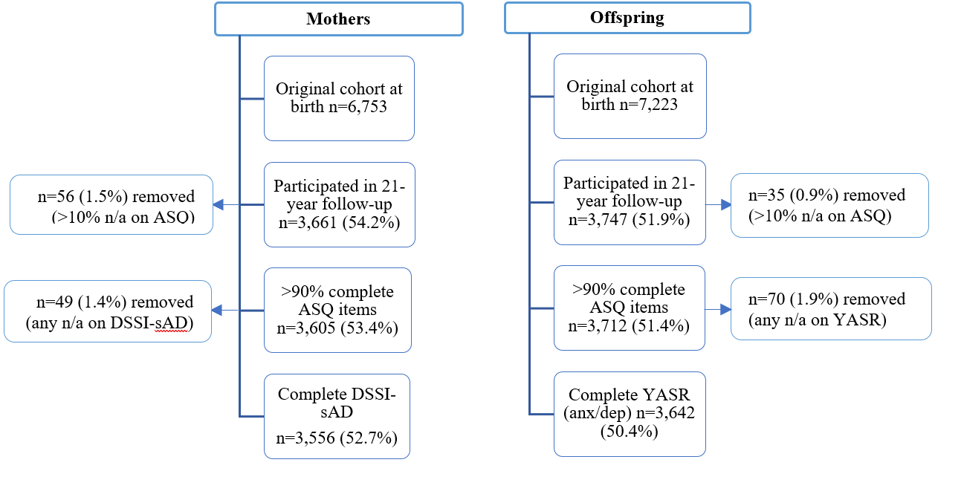

Supplementary Figure 2. CFA models of the 39-item ASQ in both mothers and offspring.
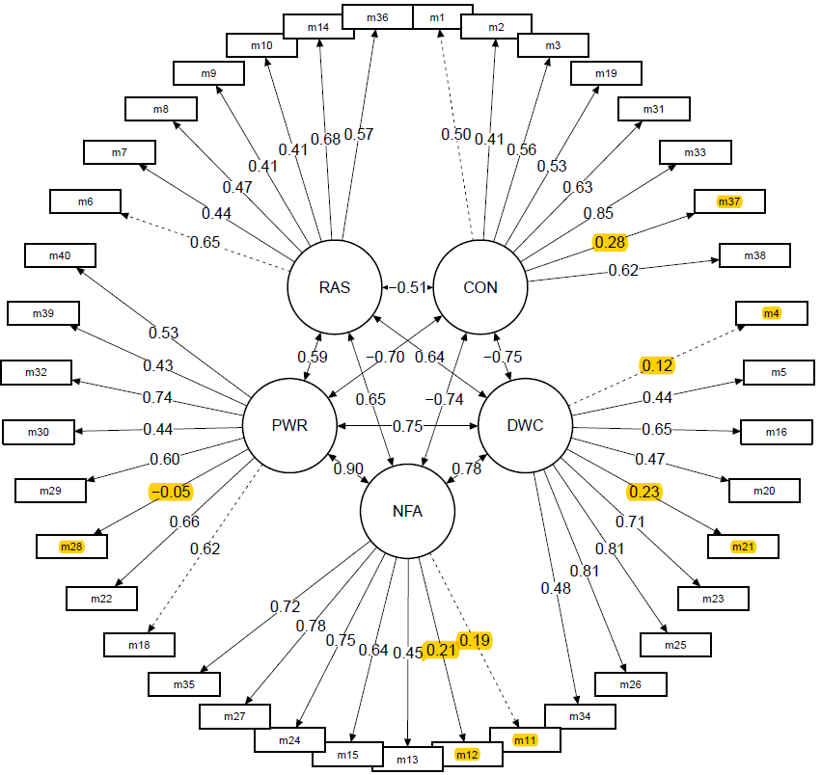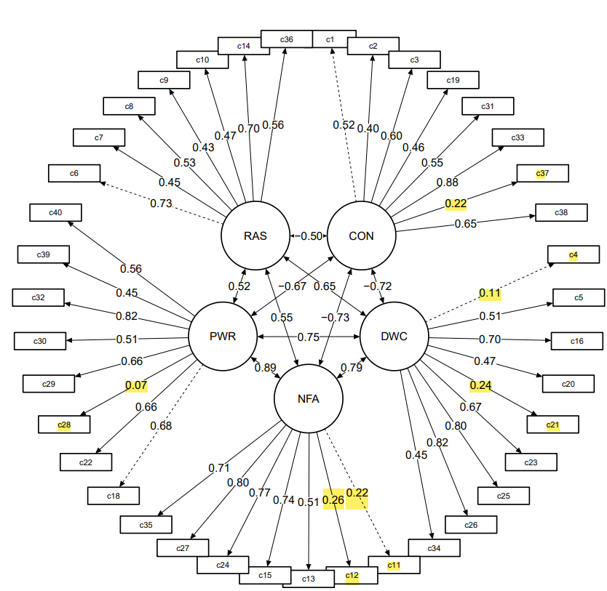
Mothers Offspring
Note. CON = Confidence, DWC = Discomfort with closeness, RAS = Relationships as secondary, NFA = Need for approval, PWR = Preoccupation with relationships. Highlighted items have a factor loading of <0.30 and were removed in the final 33-item ASQ.

Supplementary Figure 3. CFA models of the 33-item ASQ in both male (left) and female (right) offspring.
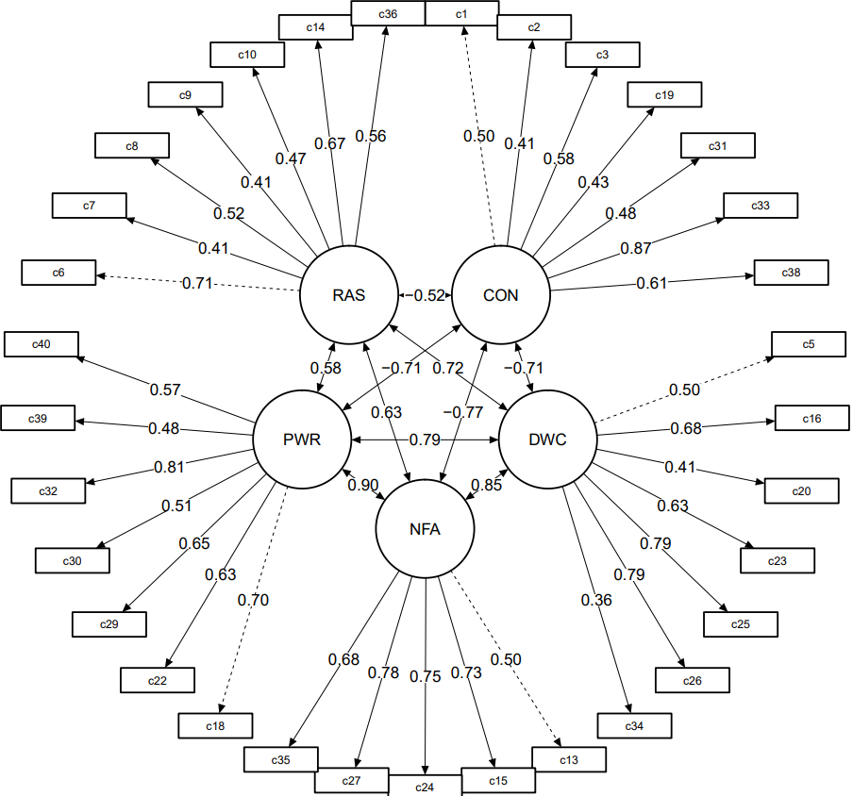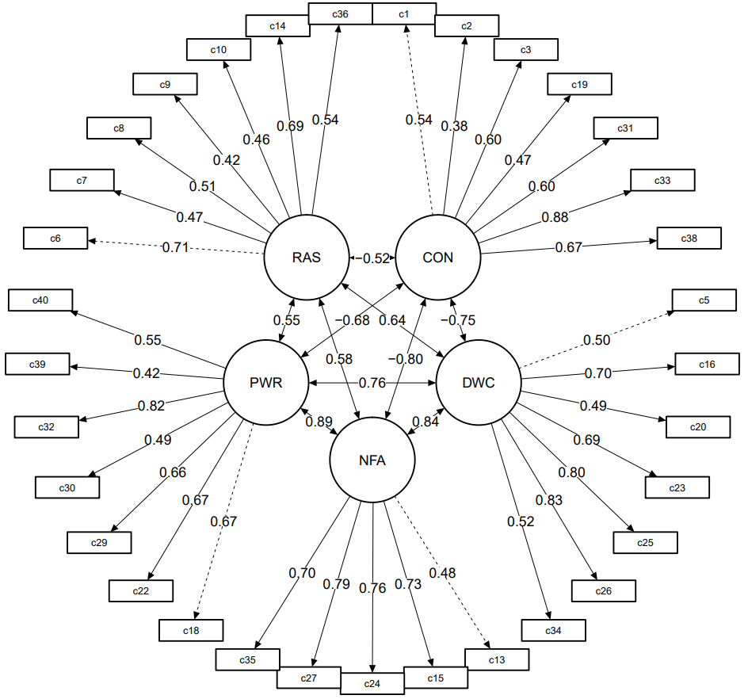
Note. CON = Confidence, DWC = Discomfort with closeness, RAS = Relationships as secondary, NFA = Need for approval, PWR = Preoccupation with relationships.
Supplementary Table 1. Descriptive statistics of mothers and offspring at the 21-year follow up presented as mean and standard deviation
 | Mothers n = 3,605 | Offspring n = 3,712
Age m (sd) range | 46.5 (5.0), 34.3 – 67.4 | 20.6 (0.9), 18.2 – 24.3
Sex (offspring)  Male  Female | 1,815 (50.3)  1,790 (49.7) | 1,740 (46.9)  1,972 (53.1)
Race (mother)  Caucasian  Asian  Indigenous | 3,386 (95.1)  85 (2.4)  89 (2.5) | 3,403 (94.8)  102 (2.8)  86 (2.4)
Education (mother) at FCV  Incomplete high-schoolª  Completed high-school  Post high-school  Other^{b} | 2,473 (70.1)  321 (9.1)  712 (20.2)  23 (0.7) | 2,576 (69.8)  352 (9.5)  739 (20.0)  21 (0.6)
Education (child)  Incomplete high-schoolª  Completed high-school  Post high-school  Other^{b} | 577 (19.0)  1,614 (53.1)  827 (27.2)  19 (0.6) | 747 (20.2)  1,958 (53.0)  969 (26.2)  20 (0.5)
Weekly household income (mother)  $0-$499  $500-$999  >$1000 | 1,038 (30.1)  1,311 (38.1)  1,095 (31.8) | 969 (29.8)  1,233 (37.9)  1,049 (32.3)
Weekly income (child)  $0-199  200-499  >$500 | 835 (42.7)  436 (22.3)  684 (35.0) | 1,029 (44.3)  489 (21.0)  806 (34.7)
Relationship status (mother)  Single-never married  Married / De facto  Separated/divorced  Widowed | 93 (2.6)  2,643 (75.0)  709 (20.1)  79 (2.2) | 85 (2.5)  2,528 (75.8)  649 (19.5)  72 (2.2)
Partners relationship to child (mother)  No relationship  Parent  Step parent  Other | 933 (26.4)  2,091 (59.2)  474 (13.4)  35 (1.0) | 835 (25.0)  2,056 (61.6)  415 (12.4)  32 (1.0)
Relationship status (child)^{c}  Single-never married  De facto/living together  Married  Separated/divorced | 2,394 (78.8)  527 (17.3)  101 (3.3)  18 (0.6) | 2,888 (78.1)  665 (18.0)  123 (3.3)  23 (0.6)
Living arrangements (mother)^{d}  Own accommodation (w/o mortgage)  Own accommodation (w/ mortgage)  Rent  Partners home | 1,039 (29.5)  1,569 (44.6)  858 (24.4)  54 (1.5) | 1,021 (30.7)  1,481 (44.6)  772 (23.2)  50 (1.5)
Living arrangements (child)  Live with parents  Own accommodation (w/ or w/o mortgage)  Rent  Live with relatives  Boarding  Other | 1,847 (60.8)  124 (4.1)  930 (30.6)  83 (2.7)  32 (1.1)  23 (0.8) | 2,209 (59.7)  149 (4.0)  1,159 (31.3)  108 (2.9)  40 (1.1)  34 (0.9)
Note. Category proportions between mothers and offspring differ as there was a greater number of offspring compared with mothers retained in the study (n=3,605 vs. n=3,712). In addition, mothers and offspring consented independently at the 21-year follow-up meaning some mothers remained in the study while their offspring did not and vice versa. FCV = first (antenatal) clinic visit. ª did not complete year 12. ^{b} special education, primary school education only or other. ^{c} One offspring reported being widowed (not presented in table). ^{d} Two mothers reported ‘other’(not presented in table).

Supplementary Table 2. Attachment Style Questionnaire (40 items)
Item | Variable label mother | Variable label offspring | Item | Scale
1 | m1 | c1 | Overall, I am a worthwhile person | Confidence
2 | m2 | c2 | I am easier to get to know than most people | Confidence
3 | m3 | c3 | I feel confident that other people will be there for me when I need them | Confidence
4 | m4 | c4 | I prefer to depend on myself rather than other people | Discomfort
5 | m5 | c5 | I prefer to keep to myself | Discomfort
6 | m6 | c6 | To ask for help is to admit that you’re a failure | Relationships
7 | m7 | c7 | People’s worth should be judged by what they achieve. | Relationships
8 | m8 | c8 | Achieving things is more important than building relationships | Relationships
9 | m9 | c9 | Doing your best is more important that getting on with others | Relationships
10 | m10 | c10 | If you’ve got a job to do, you should do it no matter who gets hurt | Relationships
11 | m11 | c11 | It’s important to me that others like me | Approval
12 | m12 | c12 | It’s important to me to avoid doing things that others won’t like | Approval
13 | m13 | c13 | I find it hard to make a decision unless I know what other people think | Approval
14 | m14 | c14 | My relationships with others are generally superficial | Relationships
15 | m15 | c15 | Sometimes I think I am no good at all | Approval
16 | m16 | c16 | I find it hard to trust other people | Discomfort
17 | - | - | I find it difficult to depend on others | Discomfort
18 | m18 | c18 | I find that others are reluctant to get as close as I would like | Preoccupation
19 | m19 | c19 | I find it relatively easy to get close to other people | Confidence
20* | m20 | c20 | I find easy to trust others | Discomfort
21* | m21 | c21 | I feel comfortable depending on other people | Discomfort
22 | m22 | c22 | I worry that others won’t care about me as much as I care about them | Preoccupation
23 | m23 | c23 | I worry about people getting to close | Discomfort
24 | m24 | c24 | I worry that I won’t measure up to other people | Approval
25 | m25 | c25 | I have mixed feelings about being close to others | Discomfort
26 | m26 | c26 | While I want to get close to others, I feel uneasy about it | Discomfort
27 | m27 | c27 | I wonder why people would want to be involved with me | Approval
28 | m28 | c28 | It’s very important to me to have a close relationship | Preoccupation
29 | m29 | c29 | I worry a lot about my relationships | Preoccupation
30 | m30 | c30 | I wonder how I would cope without someone to love me | Preoccupation
31 | m31 | c31 | I feel confident about relating to others. | Confidence
32 | m32 | c32 | I often feel left out or alone | Preoccupation
33* | m33 | c33 | I often worry that I do not really fit with other people | Confidence
34 | m34 | c34 | Other people have their own problems, so I don’t bother them with mine | Discomfort
35 | m35 | c35 | When I talk over my problems with others, I generally feel ashamed or foolish | Approval
36 | m36 | c36 | I am too busy with other activities to put much time into relationships | Relationships
37 | m37 | c37 | If something is bothering me, others are generally aware and concerned | Confidence
38 | m38 | c38 | I am confident that other people will like and respect me | Confidence
39 | m39 | c39 | I get frustrated when others are not available when I need them | Preoccupation
40 | m40 | c40 | Other people often disappoint me | Preoccupation
Note: Items in grey were removed in the 33-item ASQ. Item 17 was not administered to the MUSP cohort. Discomfort = discomfort with closeness, relationships = relationships as secondary, approval = need for approval, preoccupation = preoccupation with relationships. Responses were scored on 6-point Likert scale; 1 = totally disagree, 2 = strongly disagree, 3 = slightly disagree, 4 = slightly agree, 5 = strongly agree, 6 = totally agree. *Items 20, 21 and 33 require reverse coding.
Supplementary Table 3. Mean scores and internal consistency reliability coefficients (Cronbach’s α) of the ASQ subscales in offspring (n=3,712) at age 21-years and concurrently in their mothers (n=3,605).
 |  | CON |  | DWC * |  | RAS |  | NFA |  | PWR
 |  | m (SD) | α | m (SD) | α | m (SD) | α | m (SD) | α | m (SD) | α
 |  | 8-items |  | 9-items |  | 7-items |  | 7-items |  | 8-items
39 item ASQ | Mothers | 4.5 (0.7) | 0.79 | 3.4 (0.8) | 0.80 | 2.2 (0.8) | 0.72 | 2.9 (0.8) | 0.77 | 3.1 (0.8) | 0.76
39 item ASQ | Offspring | 4.4 (0.7) | 0.79 | 3.4 (0.8) | 0.80 | 2.5 (0.8) | 0.77 | 3.2 (0.9) | 0.80 | 3.3 (0.8) | 0.80
33 item ASQ |  | 7-items |  | 7-items |  | 7-items |  | 5-items |  | 7-items
33 item ASQ | Mothers | 4.6 (0.7) | 0.80 | 3.1 (0.9) | 0.81 | 2.2 (0.8) | 0.72 | 2.6 (1.0) | 0.79 | 2.9 (0.9) | 0.78
33 item ASQ | Offspring | 4.5 (0.7) | 0.80 | 3.2 (0.9) | 0.81 | 2.5 (0.8) | 0.77 | 2.9 (1.0) | 0.82 | 3.2 (0.9) | 0.82
Note. CON = confidence, DWC = discomfort with closeness, RAS = relationships as secondary, NFA = need for approval, PWR = preoccupation with relationships, 1 = totally disagree, 2 = strongly disagree, 3 = slightly disagree, 4 = slightly agree, 5 = strongly agree, 6 = totally agree. m = mean, SD = standard deviation. *One item from DWC scale not administered.

Supplementary Figure 4. Correlation plot using hierarchical clustering of 33-item ASQ in mothers and offspring
Mothers Offspring
