Association mapping of seed vigor in spring soybean (Glycine max (L.) Merr.) in northeast China

Authors
Caijin Wang^{1*}, Huiyan Zhao^{2*}, Yang Wang*

^{1*}College of Advanced Agriculture and Ecological Environment, Heilongjiang University, Harbin, Heilongjiang, China. Email: 1613115170@qq.com. ORCID: 0000-0001-5553-5457
^{2*}College of Advanced Agriculture and Ecological Environment, Heilongjiang University, Harbin, Heilongjiang, China. Email: 1628479338@qq.com

Correspondence
*Yang Wang, College of Advanced Agriculture and Ecological Environment, Heilongjiang University, Harbin, Heilongjiang, China. Email: 2004084@hlju.edu.cn

APPENDICES

Table S1. Information of 257 improved lines accessions
No. | Name | No. | Name | No. | Name
1 | 北豆5 (Beidou 5) | 87 | 绥农26 (Suinong 26) | 173 | 绥农31 (Suinong 31)
2 | 北豆14 (Beidou 14) | 88 | 绥杨1 (Suiyang 1) | 174 | 绥农35 (Suinong 35)
3 | 北疆2 (Beijiang 2) | 89 | 北豆10 (Beidou 10) | 175 | 绥农36 (Suinong 36)
4 | 北疆九1 (Beijiangjiu 1) | 90 | 北豆19 (Beidou 19) | 176 | 绥农38 (Suinong 38)
5 | 东升1 (Dongsheng 1) | 91 | 北豆21 (Beidou 21) | 177 | 绥农40 (Suinong 40)
6 | 东升3 (Dongsheng 3) | 92 | 北豆22 (Beidou 22) | 178 | 绥农41 (Suinong 41)
7 | 东升9 (Dongsheng 9) | 93 | 北豆34 (Beidou 34) | 179 | 宝农1 (Baonong 1)
8 | 合丰1 (Hefeng 1) | 94 | 北豆41 (Beidou 41) | 180 | 东农67 (Dongnong 67)
9 | 合丰14 (Hefeng 14) | 95 | 北豆42 (Beidou 42) | 181 | 哈05-5675 (Ha 05-5675)
10 | 合丰16 (Hefeng 16) | 96 | 北豆47 (Beidou 47) | 182 | 哈06-1939 (Ha 06-1939)
11 | 合丰23 (Hefeng 23) | 97 | 北豆49 (Beidou 49) | 183 | 哈北46-1 (Habei 46-1)
12 | 合丰24 (Hefeng 24) | 98 | 北丰11 (Beifeng 11) | 184 | 吉育95 (Jiyu 95)
13 | 合丰25 (Hefeng 25) | 99 | 北丰14 (Beifeng 14) | 185 | 垦豆25 (Kendou 25)
14 | 合丰26 (Hefeng 26) | 100 | 北疆1 (Beijiang 1) | 186 | 垦豆38 (Kendou 38)
15 | 合丰28 (Hefeng 28) | 101 | 东农24 (Dongnong 24) | 187 | 长密30 (Changmi 30)
16 | 合丰29 (Hefeng 29) | 102 | 东农36 (Dongnong 36) | 188 | 长农5 (Changnong 5)
17 | 合丰32 (Hefeng 32) | 103 | 东农38 (Dongnong 38) | 189 | 长农18 (Changnong 18)
18 | 合丰34 (Hefeng 34) | 104 | 东农42 (Dongnong 42) | 190 | 长农24 (Changnong 24)
19 | 合丰36 (Hefeng 36) | 105 | 东农43 (Dongnong 43) | 191 | 长农26 (Changnong 26)
20 | 合丰37 (Hefeng 37) | 106 | 东农47 (Dongnong 47) | 192 | 长农27 (Changnong 27)
21 | 合丰38 (Hefeng 38) | 107 | 东农48 (Dongnong 48) | 193 | 长农28 (Changnong 28)
22 | 合丰39 (Hefeng 39) | 108 | 东农49 (Dongnong 49) | 194 | 长农29 (Changnong 29)
23 | 合丰41 (Hefeng 41) | 109 | 东农50 (Dongnong 50) | 195 | 长农31 (Changnong 31)
24 | 合丰42 (Hefeng 42) | 110 | 东农51 (Dongnong 51) | 196 | 九农1 (Jiunong 1)
25 | 合丰43 (Hefeng 43) | 111 | 东农52 (Dongnong 52) | 197 | 九农2 (Jiunong 2)
26 | 合丰44 (Hefeng 44) | 112 | 东农53 (Dongnong 53) | 198 | 九农4 (Jiunong 4)
27 | 合丰46 (Hefeng 46) | 113 | 东农54 (Dongnong 54) | 199 | 九农5 (Jiunong 5)
28 | 合丰47 (Hefeng 47) | 114 | 东农55 (Dongnong 55) | 200 | 九农7 (Jiunong 7)
29 | 合丰48 (Hefeng 48) | 115 | 东农56 (Dongnong 56) | 201 | 九农9 (Jiunong 9)
30 | 合丰50 (Hefeng 50) | 116 | 东农57 (Dongnong 57) | 202 | 九农21 (Jiunong 21)
31 | 合丰51 (Hefeng 51) | 117 | 东农5 (Dongnong 5) | 203 | 吉林1 (Jilin 1)
32 | 合丰52 (Hefeng 52) | 118 | 东生7 (Donsheng 7) | 204 | 吉林2 (Jilin 2)
33 | 合丰53 (Hefeng 53) | 119 | 东生8 (Donsheng 8) | 205 | 吉林3 (Jilin 3)
34 | 合丰54 (Hefeng 53) | 120 | 丰收6 (Fengshou 6) | 206 | 吉林5 (Jilin 5)
35 | 合丰55 (Hefeng 55) | 121 | 丰收11 (Fengshou 11) | 207 | 吉林9 (Jilin 9)
36 | 合丰56 (Hefeng 56) | 122 | 丰收20 (Fengshou 20) | 208 | 吉林11 (Jilin 11)
37 | 合农59 (Henong 59) | 123 | 丰收24 (Fengshou 24) | 209 | 吉林12 (Jilin 12)
38 | 合农60 (Henong 60) | 124 | 丰收25 (Fengshou 25) | 210 | 吉林13 (Jilin 13)
39 | 合农61 (Henong 61) | 125 | 合丰5 (Hefeng 5) | 211 | 吉林14 (Jilin 14)
40 | 合农64 (Henong 64) | 126 | 合丰6 (Hefeng 6) | 212 | 吉林15 (Jilin 15)
41 | 合农65 (Henong 65) | 127 | 合丰22 (Hefeng 22) | 213 | 吉林17 (Jilin 17)
42 | 合农66 (Henong 66) | 128 | 合丰30 (Hefeng 30) | 214 | 吉林18 (Jilin 18)
43 | 合农68 (Henong 68) | 129 | 合丰35 (Hefeng 35) | 215 | 吉林19 (Jilin 19)
44 | 合农75 (Henong 75) | 130 | 合丰40 (Hefeng 40) | 216 | 吉林20 (Jilin 20)
45 | 合农76 (Henong 76) | 131 | 合丰45 (Hefeng 45) | 217 | 吉林21 (Jilin 21)
46 | 黑河35 (Heihe 35) | 132 | 合丰57 (Hefeng 57) | 218 | 吉林25 (Jilin 25)
47 | 黑农37 (Heinong 37) | 133 | 合丰58 (Hefeng 58) | 219 | 吉林28 (Jilin 28)
48 | 黑农40 (Heinong 40) | 134 | 合丰60 (Hefeng 60) | 220 | 吉林29 (Jilin 29)
49 | 黑农44 (Heinong 44) | 135 | 合丰61 (Hefeng 61) | 221 | 吉林30 (Jilin 30)
50 | 黑农48 (Heinong 48) | 136 | 合丰62 (Hefeng 62) | 222 | 吉林32 (Jilin 32)
51 | 黑农51 (Heinong 51) | 137 | 合农62 (Henong 62) | 223 | 通农4 (Tongnong 4)
52 | 黑农52 (Heinong 52) | 138 | 合农63 (Henong 63) | 224 | 通农5 (Tongnong 5)
53 | 黑农58 (Heinong 58) | 139 | 合农67 (Henong 67) | 225 | 通农8 (Tongnong 8)
54 | 黑农60 (Heinong 60) | 140 | 合农69 (Henong 69) | 226 | 通农9 (Tongnong 9)
55 | 黑农61 (Heinong 61) | 141 | 合农70 (Henong 70) | 227 | 吉青1 (Jiqing 1)
56 | 黑农62 (Heinong 62) | 142 | 黑河10 (Heihe 10) | 228 | 怀远1 (Huaiyuan 1)
57 | 黑农64 (Heinong 64) | 143 | 黑河11 (Heihe 11) | 229 | 公79 (Gong 79)
58 | 黑农65 (Heinong 65) | 144 | 黑河12 (Heihe 12) | 230 | 安丰1 (Anfeng 1)
59 | 黑农66 (Heinong 66) | 145 | 黑河14 (Heihe 14) | 231 | 金元2 (Jinyuan 2)
60 | 黑农68 (Heinong 68) | 146 | 黑河15 (Heihe 15) | 232 | 白农1 (Bainong 1)
61 | 黑农71 (Heinong 71) | 147 | 黑河16 (Heihe 16) | 233 | 延农2 (Yannong 2)
62 | 黑农83 (Heinong 83) | 148 | 黑河18 (Heihe 18) | 234 | 群选1 (Qunxuan 1)
63 | 华疆2 (Huajiang 2) | 149 | 黑河19 (Heihe 19) | 235 | 争光1 (Zhengguang 1)
64 | 华疆4 (Huajiang 4) | 150 | 黑河20 (Heihe 20) | 236 | 红丰3 (Hongfeng 3)
65 | 金源55 (Jinyuan 55) | 151 | 黑河21 (Heihe 21) | 237 | 北满41 (Beiman 41)
66 | 垦豆18 (Kendou 18) | 152 | 黑河22 (Heihe 22) | 238 | 丹豆1 (Dandou 1)
67 | 垦豆3 (Kendou 3) | 153 | 黑河23 (Heihe 23) | 239 | 丹豆2 (Dandou 2)
68 | 垦豆40 (Kendou 40) | 154 | 黑河24 (Heihe 24) | 240 | 辽豆3 (Liaodou 1)
69 | 垦豆41 (Kendou 41) | 155 | 黑河25 (Heihe 25) | 241 | 辽豆11 (Liaodou 11)
70 | 垦豆43 (Kendou 43) | 156 | 黑河26 (Heihe 26) | 242 | 铁丰5 (Tiefeng 5)
71 | 垦丰14 (Kenfeng 14) | 157 | 黑河33 (Heihe 33) | 243 | 铁丰9 (Tiefeng 9)
72 | 垦丰16 (Kenfeng 16) | 158 | 黑河39 (Heihe 39) | 244 | 铁丰16 (Tiefeng 16)
73 | 垦丰17 (Kenfeng 17) | 159 | 黑河43 (Heihe 43) | 245 | 铁丰18 (Tiefeng 18)
74 | 垦丰20 (Kenfeng 20) | 160 | 黑河44 (Heihe 44) | 246 | 铁丰22 (Tiefeng 22)
75 | 垦丰22 (Kenfeng 22) | 161 | 黑河46 (Heihe 46) | 247 | 铁丰25 (Tiefeng 25)
76 | 垦丰23 (Kenfeng 23) | 162 | 黑河49 (Heihe 49) | 248 | 集体1 (Jiti 1)
77 | 垦鉴27 (Kenjian 27) | 163 | 黑河50 (Heihe 50) | 249 | 开育8 (Kaiyu 8)
78 | 垦鉴豆43 (Kenjiandou 43) | 164 | 黑河51 (Heihe 51) | 250 | 紫花4 (Zihua 4)
79 | 垦农23 (Kennong 23) | 165 | 黑河52 (Heihe 52) | 251 | 育丰115 (Yufeng 115)
80 | 垦农26 (Kennong 26) | 166 | 黑河53 (Heihe 53) | 252 | 育丰20 (Yufeng 20)
81 | 垦农28 (Kennong 28) | 167 | 黑河56 (Heihe 56) | 253 | 登科1 (Dengke 1)
82 | 龙豆1 (Longdou 1) | 168 | 黑农69 (Heinong 69) | 254 | 登科5 (Dengke 5)
83 | 嫩奥1 (Nenao 1) | 169 | 黑农84 (Heinong 84) | 255 | 登科8 (Dengke 8)
84 | 嫩奥3 (Nenao 3) | 170 | 黑农85 (Heinong 85) | 256 | 赤豆1 (Chidou 1)
85 | 绥农22 (Suinong 22) | 171 | 绥农4 (Suinong 4) | 257 | 赤豆3 (Chidou 3)
86 | 绥农24 (Suinong 24) | 172 | 绥农25 (Suinong 25) | - | -

Table S2. Information of 104 landraces soybean
No. | Name | No. | Name
1 | 九台猪眼豆 (Jiutaizhuyandou) | 53 | 海龙丰地黄 ( Hailongfengdihuang)
2 | 白露豆 (Bailudou) | 54 | 扁大粒 (Biandali)
3 | 小金黄 (Xiaojinhuang) | 55 | 小猪腰 (Xiaozhuyao)
4 | 安达白眉 (Andabaimei) | 56 | 永丰豆 (Yongfengdou)
5 | 小白脐 (Xiaobaiqi) | 57 | 舒兰大叶黄金塔 (Shulandayehuangjinta)
6 | 伊通绿大豆 (Yitonglvdadou) | 58 | 小灰脐 (Xiaohuiqi)
7 | 通化平顶黄 (Tonghuapingdinghuang) | 59 | 崩皮 (Bengpi)
8 | 四粒黄 (Silihuang) | 60 | 小黑脐 (Xiaoheiqi)
9 | 汪清神仙豆 (Wangqingshengxiandou) | 61 | 小洋豆 (Xiaoyangdou)
10 | 黄豆 (Huangdou) | 62 | 黑滚豆 (Heigundou)
11 | 安图黑色大豆(Antuheisedadou) | 63 | 克旗小黑豆 (Keqixiaoheidou)
12 | 白铁荚青 (Baitiejiaqing) | 64 | 快豆 (Kuaidou)
13 | 白铁荚 (Baitiejia） | 65 | 苗圃 (Miaopu)
14 | 青磨石豆 (Qingmoshidou） | 66 | 茶色豆 (Chasedou)
15 | 海伦嘟噜豆 (Hailunduludou) | 67 | 缩尖豆 (Suijiandou)
16 | 青豆 (Qingdou) | 68 | 黑豆 (Heidou)
17 | 宁安小黑脐 (Ninganxiaoheiqi) | 69 | 牛毛黄 (Niumaohuang)
18 | 绥卫土丝子 (Suiweitusizi) | 70 | 铁荚青 (Tiejiaqing)
19 | 青皮豆 (Qingpidou) | 71 | 青扎豆 (Qingzadou)
20 | 关石锁大豆 (Guanshisuodadou) | 72 | 白秣食豆 (Baimoshidou)
21 | 蛟河紫花小白豆 (Jiaohezihuaxiaobaidou) | 73 | 保险豆 (Baoxiandou)
22 | 临江灰毛豆 (Linjianghuimaodou) | 74 | 黑脐大豆 (Heiqidadou)
23 | 满地金 (Mandijin) | 75 | 蓑衣领 (Suoyiling)
24 | 辉南白花铁荚 (Huinanbaihuatiejia) | 76 | 青皮四粒黄 (Qingpisilihuang)
25 | 玉石豆 (Yushidou) | 77 | 白皮子 (Baipizi)
26 | 牛毛青 (Niumaoqing) | 78 | 白花矬 (Baihuacuo)
27 | 一窝蜂 (Yiwofeng) | 79 | 黄壳 (Huangke)
28 | 大粒黄 (Dalihuang) | 80 | 白毛子 (Baimaozi)
29 | 爱辉本地种 (Aihuibendizhong) | 81 | 小白眉 (Xiaobaimei)
30 | 黄毛豆 (Huangmaodou） | 82 | 金黄豆 (Jinhuangdou)
31 | 九台无限白花 (Jiutaiwuxianbaihua) | 83 | 褐脐丰地黄 (Heqifengdihuang)
32 | 天鹅蛋 (Tianedan) | 84 | 嘟噜豆 (Duludou)
33 | 安图黑豆 (Antuheidou) | 85 | 抚松有限白花 (Fusongyouxianbaihua)
34 | 逊克小秧豆 (Xunkexiaoyangdou) | 86 | 安图白花绿大豆 (Antubaihualvdadou)
35 | 满仓金 (Mancangjin) | 87 | 方正白露豆 (Fangzhengbailudou)
36 | 辉南牛毛黄 (Huinanniumaohuang) | 88 | 双小金黄 (Shuangxiaojinhuang)
37 | 大金黄 (Dajinhuang) | 89 | 铁荚 (Tiejia)
38 | 辉南紫花黑豆 (Huinanzihuaheidou) | 90 | 长白小黄豆 (Changbaixiaohuangdou)
39 | 小黄壳 (Xiaohuangke) | 91 | 宝清小金黄 (Baoqingxiaojinhuang)
40 | 荆山扑 (Jingshanpu) | 92 | 宝清大白眉 (Baoqingdabaimei)
41 | 蛟河天鹅蛋 (Jiaohetianedan) | 93 | 蛟河小黑豆 (Jiaohexiaoheidou)
42 | 抚松花嘟噜豆 (Fusonghuaduludou) | 94 | 伊通满仓金 (Yitongmancangjin)
43 | 四粒黄(农16) (Silihuang (nong 16)) | 95 | 汤原秃荚子 (Tangyuantujiazi)
44 | 白脐小金黄 (Baiqixiaojinhuang) | 96 | 安图小黑豆 (Antuxiaoheidou)
45 | 元宝金 (Yuanbaojin) | 97 | 汤原猴顶奎 (Tangyuanhoudingkui)
46 | 一窝猴 (Yiwohou) | 98 | 黄金塔 (Huangjinta)
47 | 兔眼豆 (Tuyandou) | 99 | 辉南紫花小黑豆 (Huinanzihuaxiaoheidou)
48 | 平顶香 (Pingdingxiang) | 100 | 四粒黄(农27) (Silihuang (nong27))
49 | 和龙油太 (Helongyoutai) | 101 | 大白眉 (Dabaimei)
50 | 白露豆(小白花) (Bailudou（Xiaobaihua）) | 102 | 富锦四粒黄 (Fujinsilihuang)
51 | 前郭尖叶褐荚豆 (Qianguojianyehejiadou) | 103 | 克山大金黄 (Keshandajinhuang)
52 | 铁荚四粒黄 (Tiejiasilihuang) | 104 | 临江大黄豆 (Linjiangdahuangdou)

Table S3. Genetic diversity base to 175 SSR markers
SSR  marker | Chr. | Position  (cM)ª | Start position  (bp)ª | End position  (bp)ª | Alleles | Genetic diversity | PIC
Sat_160 | 1 | 104.27 | 53236862 | 53236911 | 4.0000 | 0.6215 | 0.5602
Sat_332 | 1 | 2.52 | 355735 | 355784 | 3.0000 | 0.4706 | 0.4096
Sat_414 | 1 | 85.48 | 51449361 | 51449420 | 6.0000 | 0.8165 | 0.7899
Satt147 | 1 | 108.88 | 53920024 | 53920068 | 9.0000 | 0.6059 | 0.5310
Satt267 | 1 | 57.34 | 42070368 | 42070415 | 5.0000 | 0.4517 | 0.3920
Satt436 | 1 | 70.69 | 48690007 | 48690072 | 5.0000 | 0.6679 | 0.6041
Satt531 | 1 | 40.86 | 3758404 | 3758445 | 3.0000 | 0.1965 | 0.1840
Sat_279 | 2 | 3.79 | 1974541 | 1974596 | 4.0000 | 0.5273 | 0.4738
Sat_289 | 2 | 131.91 | 50122113 | 50122158 | 7.0000 | 0.3870 | 0.3733
Sat_351 | 2 | 20.61 | 4844965 | 4845006 | 5.0000 | 0.6236 | 0.5692
Satt141 | 2 | 72.88 | 35083073 | 35083147 | 6.0000 | 0.6203 | 0.5814
Satt266 | 2 | 59.61 | 14090384 | 14090434 | 7.0000 | 0.5059 | 0.4713
Satt274 | 2 | 116.34 | 48345948 | 48346001 | 3.0000 | 0.3143 | 0.2844
Satt282 | 2 | 76.09 | 29515661 | 29515729 | 7.0000 | 0.3302 | 0.3156
Satt296 | 2 | 52.61 | 12975935 | 12975997 | 5.0000 | 0.4015 | 0.3373
Satt428 | 2 | 77.34 | 17474754 | 17474813 | 5.0000 | 0.6986 | 0.6432
Satt542 | 2 | 53.02 | 12956554 | 12956610 | 6.0000 | 0.3374 | 0.3207
Satt703 | 2 | 98.75 | 45655521 | 45655601 | 8.0000 | 0.5544 | 0.5269
Sat_186 | 3 | 30.11 | 3465436 | 3465507 | 5.0000 | 0.7452 | 0.7039
Sat_266 | 3 | 47.27 | 36046708 | 36046763 | 5.0000 | 0.7157 | 0.6683
Sat_280 | 3 | 43.45 | 34710412 | 34710471 | 5.0000 | 0.5936 | 0.5128
Sat_379 | 3 | 4.33 | 462846 | 462865 | 4.0000 | 0.4533 | 0.3710
Satt022 | 3 | 102.05 | 44682615 | 44682665 | 6.0000 | 0.7506 | 0.7093
Satt234 | 3 | 84.59 | 42180012 | 42180050 | 5.0000 | 0.5546 | 0.4596
Satt237 | 3 | 74.98 | 40119054 | 40119104 | 5.0000 | 0.2827 | 0.2712
Satt387 | 3 | 53.25 | 36576654 | 36576683 | 5.0000 | 0.4964 | 0.4498
Satt549 | 3 | 70.59 | 39360400 | 39360462 | 5.0000 | 0.5531 | 0.4585
Satt631 | 3 | 26.13 | 2916450 | 2916497 | 7.0000 | 0.7432 | 0.7066
Satt683 | 3 | 34.52 | 9058190 | 9058213 | 6.0000 | 0.6139 | 0.5763
AW277661 | 4 | 74.79 | 32803245 | 32803313 | 4.0000 | 0.5498 | 0.5000
Sat_207 | 4 | 87.3 | 42774033 | 42774058 | 4.0000 | 0.5412 | 0.4658
Sat_337 | 4 | 32.09 | 4172809 | 4172860 | 5.0000 | 0.6545 | 0.6017
Sat_367 | 4 | 28.04 | 3243827 | 3243876 | 7.0000 | 0.7329 | 0.6867
Satt396 | 4 | 24.11 | 2719766 | 2719792 | 3.0000 | 0.4932 | 0.3743
Satt524 | 4 | 120.12 | 47090323 | 47090364 | 3.0000 | 0.0487 | 0.0478
Satt565 | 4 | 0 | 511133 | 511189 | 5.0000 | 0.5885 | 0.5096
Satt578 | 4 | 65.08 | 7819442 | 7819474 | 4.0000 | 0.3434 | 0.2916
Satt661 | 4 | 74.36 | 10377538 | 10377573 | 4.0000 | 0.4908 | 0.4450
SOYGPATR | 4 | 10.34 | 525144 | 525164 | 5.0000 | 0.6344 | 0.5662
Sat_385 | 5 | 31.07 | 28385865 | 28385920 | 2.0000 | 0.1661 | 0.1523
Satt200 | 5 | 92.88 | 40716815 | 40716865 | 4.0000 | 0.4517 | 0.4093
Satt211 | 5 | 95.95 | 39925702 | 39925734 | 2.0000 | 0.4936 | 0.3718
Satt225 | 5 | 95.16 | 40076402 | 40076440 | 5.0000 | 0.6827 | 0.6268
Satt449 | 5 | 27.78 | 18415427 | 18415489 | 8.0000 | 0.7562 | 0.7253
Satt454 | 5 | 28.08 | 25287731 | 25287781 | 2.0000 | 0.3023 | 0.2566
Satt648 | 5 | 59.18 | 34158320 | 34158355 | 5.0000 | 0.5200 | 0.4709
Sat_213 | 6 | 90.93 | 14601388 | 14601421 | 8.0000 | 0.8166 | 0.7936
Sat_246 | 6 | 91.8 | 14444925 | 14444988 | 3.0000 | 0.2333 | 0.2179
Satt202 | 6 | 126.23 | 47820517 | 47820561 | 5.0000 | 0.6402 | 0.5918
Satt289 | 6 | 112.34 | 27545892 | 27545939 | 4.0000 | 0.5231 | 0.4101
Satt291 | 6 | 45.75 | 7320677 | 7320718 | 4.0000 | 0.4582 | 0.3675
Satt305 | 6 | 69.66 | 11310055 | 11310105 | 3.0000 | 0.3191 | 0.2732
Satt322 | 6 | 82.23 | 12310027 | 12310059 | 4.0000 | 0.2030 | 0.1930
Satt363 | 6 | 98.07 | 15756435 | 15756491 | 3.0000 | 0.0799 | 0.0771
Satt371 | 6 | 145.47 | 49159636 | 49159668 | 5.0000 | 0.5175 | 0.4748
Satt422 | 6 | 44.66 | 7227638 | 7227709 | 10.0000 | 0.7812 | 0.7481
Satt640 | 6 | 30.46 | 4677048 | 4677119 | 5.0000 | 0.6806 | 0.6195
Satt643 | 6 | 94.65 | 16057506 | 16057541 | 3.0000 | 0.1666 | 0.1536
Satt681 | 6 | 3.15 | 488842 | 488901 | 6.0000 | 0.7462 | 0.7054
Sat_256 | 7 | 74.52 | 17606889 | 17606932 | 9.0000 | 0.8493 | 0.8326
Sat_391 | 7 | 1.02 | 163240 | 163315 | 6.0000 | 0.5241 | 0.5030
Satt150 | 7 | 18.58 | 2414465 | 2414524 | 6.0000 | 0.5338 | 0.4397
Satt210 | 7 | 112.08 | 40968793 | 40968867 | 6.0000 | 0.7154 | 0.6619
Satt220 | 7 | 56.29 | 9862827 | 9862901 | 4.0000 | 0.4015 | 0.3371
Satt245 | 7 | 53.54 | 9320764 | 9320867 | 8.0000 | 0.7298 | 0.6806
Satt306 | 7 | 80.01 | 35032809 | 35032850 | 2.0000 | 0.1524 | 0.1408
Satt463 | 7 | 50.09 | 8243902 | 8244048 | 7.0000 | 0.6497 | 0.6015
Satt551 | 7 | 95.44 | 37174161 | 37174184 | 5.0000 | 0.6198 | 0.5428
Satt567 | 7 | 33.47 | 4510477 | 4510515 | 3.0000 | 0.6190 | 0.5389
Be820148 | 8 | 35.93 | 5164906 | 5164969 | 4.0000 | 0.6072 | 0.5263
Sat_378 | 8 | 116.62 | 23605177 | 23605222 | 6.0000 | 0.6079 | 0.5677
Satt233 | 8 | 100.08 | 17298012 | 17298059 | 5.0000 | 0.6746 | 0.6165
Satt329 | 8 | 110.94 | 21161155 | 21161226 | 7.0000 | 0.7606 | 0.7275
Satt390 | 8 | 9.14 | 1306479 | 1306529 | 5.0000 | 0.6651 | 0.6225
Satt480 | 8 | 28.44 | 4211778 | 4211819 | 3.0000 | 0.5266 | 0.4209
Satt632 | 8 | 51.5 | 8219301 | 8219351 | 4.0000 | 0.2915 | 0.2729
Sat_293 | 9 | 99.09 | 42848842 | 42848903 | 5.0000 | 0.6135 | 0.5737
Satt046 | 9 | 45.59 | 10894196 | 10894255 | 4.0000 | 0.5059 | 0.4161
Satt247 | 9 | 43.95 | 9265135 | 9265197 | 5.0000 | 0.7197 | 0.6742
Satt260 | 9 | 80.12 | 39730973 | 39731041 | 4.0000 | 0.5033 | 0.4565
Satt417 | 9 | 46.2 | 17539935 | 17539988 | 4.0000 | 0.4673 | 0.4258
Satt441 | 9 | 46.2 | 11271676 | 11271771 | 4.0000 | 0.4686 | 0.4212
Satt588 | 9 | 117.01 | 45420963 | 45421065 | 6.0000 | 0.6005 | 0.5695
Sct_190 | 9 | 77.37 | 39455480 | 39455503 | 2.0000 | 0.0110 | 0.0110
BF008905 | 10 | 28.95 | 3549058 | 3549081 | 3.0000 | 0.3961 | 0.3259
Satt262 | 10 | 57.02 | 35510863 | 35510922 | 4.0000 | 0.2921 | 0.2682
Satt347 | 10 | 42.29 | 5041002 | 5041034 | 3.0000 | 0.3335 | 0.2848
Satt358 | 10 | 5.44 | 1022833 | 1022889 | 5.0000 | 0.5283 | 0.4462
Satt420 | 10 | 49.7 | 9907940 | 9907987 | 4.0000 | 0.4758 | 0.3797
Satt477 | 10 | 82.08 | 39749472 | 39749504 | 4.0000 | 0.4042 | 0.3765
Satt478 | 10 | 71.09 | 38560136 | 38560189 | 3.0000 | 0.2255 | 0.2056
Satt492 | 10 | 17.25 | 1873507 | 1873551 | 3.0000 | 0.0799 | 0.0771
Satt592 | 10 | 100.37 | 42983859 | 42983897 | 5.0000 | 0.4994 | 0.4618
Sat_149 | 11 | 54 | 9972625 | 9972666 | 4.0000 | 0.6156 | 0.5665
Sat_270 | 11 | 21.99 | 4224502 | 4224559 | 5.0000 | 0.6116 | 0.5508
Sat_272 | 11 | 14.32 | 2710546 | 2710583 | 7.0000 | 0.6253 | 0.5708
Satt197 | 11 | 46.38 | 8879480 | 8879539 | 6.0000 | 0.5480 | 0.5067
Satt332 | 11 | 80.88 | 22137813 | 22137876 | 3.0000 | 0.0489 | 0.0482
Satt430 | 11 | 81.91 | 27078653 | 27078691 | 2.0000 | 0.0327 | 0.0322
Satt453 | 11 | 123.95 | 38360612 | 38360653 | 5.0000 | 0.6414 | 0.5866
Satt509 | 11 | 32.5 | 6206957 | 6207049 | 5.0000 | 0.2054 | 0.1991
Satt519 | 11 | 57.91 | 13984459 | 13984515 | 3.0000 | 0.2339 | 0.2122
Satt597 | 11 | 73.76 | 17065520 | 17065558 | 3.0000 | 0.1151 | 0.1096
Satt665 | 11 | 96.36 | 36229255 | 36229308 | 5.0000 | 0.5979 | 0.5324
Sat_214 | 12 | 2.85 | 14359 | 14368 | 4.0000 | 0.5862 | 0.5029
Sat_334 | 12 | 59 | 9096351 | 9096392 | 4.0000 | 0.3138 | 0.2950
Satt142 | 12 | 86.48 | 36043054 | 36043113 | 6.0000 | 0.5100 | 0.4728
Satt302 | 12 | 81.04 | 35108089 | 35108142 | 3.0000 | 0.3102 | 0.2638
Satt353 | 12 | 8.48 | 1682557 | 1682607 | 6.0000 | 0.5180 | 0.4821
Satt442 | 12 | 46.95 | 6361559 | 6361663 | 6.0000 | 0.5543 | 0.5131
Satt635 | 12 | 4.88 | 881836 | 881856 | 4.0000 | 0.4476 | 0.3873
Sat_390 | 13 | 1.79 | 10758204 | 10758294 | 6.0000 | 0.6846 | 0.6407
Satt269 | 13 | 11.37 | 6580533 | 6580565 | 5.0000 | 0.6230 | 0.5502
Satt309 | 13 | 4.53 | 1736305 | 1736343 | 4.0000 | 4.0000 | 0.4647
Satt334 | 13 | 78.05 | 28415974 | 28416021 | 4.0000 | 0.5704 | 0.5011
Satt510 | 13 | 71.41 | 30590369 | 30590395 | 6.0000 | 0.3206 | 0.3110
Satt522 | 13 | 119.19 | 38955478 | 38955525 | 5.0000 | 0.5031 | 0.4722
Satt649 | 13 | 5.36 | 12953321 | 12953374 | 3.0000 | 0.4905 | 0.3806
Satt656 | 13 | 135.11 | 41884999 | 41885028 | 4.0000 | 0.0963 | 0.0946
Satt659 | 13 | 26.7 | 1294383 | 1294443 | 6.0000 | 0.3401 | 0.3158
Sat_342 | 14 | 20.3 | 2954822 | 2954895 | 6.0000 | 0.7028 | 0.6668
Satt020 | 14 | 72.12 | 42022280 | 42022327 | 5.0000 | 0.3960 | 0.3591
Satt126 | 14 | 27.62 | 4935860 | 4935913 | 4.0000 | 0.2524 | 0.2374
Satt168 | 14 | 55.2 | 8210513 | 8210563 | 4.0000 | 0.4428 | 0.4021
Satt304 | 14 | 65.55 | 13284499 | 13284588 | 4.0000 | 0.3378 | 0.2997
Satt534 | 14 | 87.58 | 45763101 | 45763190 | 12.0000 | 0.7785 | 0.7493
satt577 | 14 | 6.05 | 668802 | 668837 | 5.0000 | 0.7397 | 0.6918
Satt687 | 14 | 113.61 | 49404136 | 49404162 | 8.0000 | 0.6563 | 0.5971
Sct_064 | 14 | 89.3 | 45520897 | 45520928 | 2.0000 | 0.1570 | 0.1447
Sat_381 | 15 | 64.18 | 50282249 | 50282298 | 3.0000 | 0.2452 | 0.2265
Satt045 | 15 | 46.65 | 24720209 | 24720262 | 11.0000 | 0.6089 | 0.5847
Satt117 | 15 | 45.77 | 39633943 | 39633978 | 5.0000 | 0.4992 | 0.4554
Satt212 | 15 | 32.27 | 5221921 | 5221947 | 5.0000 | 0.4925 | 0.3792
Satt411 | 15 | 12.92 | 2517299 | 2517331 | 6.0000 | 0.3009 | 0.2828
Satt606 | 15 | 39.77 | 14918728 | 14918821 | 4.0000 | 0.5160 | 0.4492
Satt685 | 15 | 56.7 | 48273606 | 48273647 | 3.0000 | 0.4827 | 0.3715
Satt720 | 15 | 20.79 | 4135853 | 4135903 | 3.0000 | 0.5314 | 0.4213
Sat_228 | 16 | 23.91 | 3049971 | 3050050 | 8.0000 | 0.7187 | 0.6830
Sat_366 | 16 | 52.84 | 30036787 | 30036827 | 3.0000 | 0.4560 | 0.3682
Sat_395 | 16 | 89.48 | 37084901 | 37084960 | 3.0000 | 0.3729 | 0.3420
Satt215 | 16 | 44.08 | 28589359 | 28589391 | 4.0000 | 0.4799 | 0.3725
Satt244 | 16 | 65.04 | 33327246 | 33327326 | 8.0000 | 0.7490 | 0.7142
Satt431 | 16 | 78.57 | 35718476 | 35718538 | 6.0000 | 0.6266 | 0.5667
Satt529 | 16 | 41.9 | 23096020 | 23096058 | 4.0000 | 0.6221 | 0.5477
Satt674 | 16 | 15.95 | 1543264 | 1543314 | 4.0000 | 0.6116 | 0.5296
Sat_354 | 17 | 93.7 | 38123489 | 38123544 | 6.0000 | 0.6625 | 0.6312
Satt186 | 17 | 105.44 | 39047273 | 39047329 | 6.0000 | 0.7246 | 0.6937
Satt256 | 17 | 124.3 | 40792640 | 40792669 | 4.0000 | 0.6649 | 0.5922
Satt311 | 17 | 84.62 | 18436187 | 18436225 | 8.0000 | 0.7465 | 0.7058
Satt413 | 17 | 113.61 | 40043052 | 40043061 | 7.0000 | 0.7283 | 0.6856
Satt514 | 17 | 85.69 | 18770846 | 18770926 | 5.0000 | 0.6714 | 0.6121
AF162283 | 18 | 87.94 | 57436765 | 57436786 | 3.0000 | 0.5902 | 0.5087
Sat_358 | 18 | 45.49 | 11619335 | 11619400 | 6.0000 | 0.7223 | 0.6815
Satt038 | 18 | 1.84 | 1343760 | 1343810 | 7.0000 | 0.6731 | 0.6394
Satt199 | 18 | 62.16 | 52465727 | 52465788 | 4.0000 | 0.5470 | 0.4880
Satt217 | 18 | 18.25 | 4692347 | 4692403 | 3.0000 | 0.0644 | 0.0627
Satt288 | 18 | 76.76 | 55407034 | 55407084 | 8.0000 | 0.5556 | 0.5347
Satt303 | 18 | 53.41 | 22150272 | 22150331 | 4.0000 | 0.6797 | 0.6146
Satt324 | 18 | 33.25 | 5890255 | 5890314 | 4.0000 | 0.5577 | 0.5078
Satt156 | 19 | 56.13 | 40444250 | 40444300 | 5.0000 | 0.6335 | 0.5691
Satt182 | 19 | 14.03 | 2014557 | 2014607 | 3.0000 | 0.4757 | 0.3652
Satt373 | 19 | 107.23 | 49191336 | 49191398 | 7.0000 | 0.6198 | 0.5604
Satt481 | 19 | 54.57 | 40127078 | 40127119 | 4.0000 | 0.3693 | 0.3107
Satt495 | 19 | 0 | 650674 | 650685 | 3.0000 | 0.5387 | 0.4318
Satt527 | 19 | 70.36 | 42835228 | 42835278 | 6.0000 | 0.4693 | 0.3786
Satt652 | 19 | 30.87 | 9202367 | 9202420 | 4.0000 | 0.6362 | 0.5815
Sat_174 | 20 | 36.59 | 24547862 | 24547903 | 4.0000 | 0.1851 | 0.1699
Sat_219 | 20 | 36.02 | 24528699 | 24528756 | 5.0000 | 0.6806 | 0.6313
Sat_299 | 20 | 99.83 | 42518131 | 42518174 | 4.0000 | 0.4439 | 0.4045
Satt239 | 20 | 36.93 | 24129710 | 24129775 | 6.0000 | 0.6349 | 0.5739
Satt496 | 20 | 36.4 | 26502997 | 26503035 | 3.0000 | 0.3388 | 0.3127
Satt571 | 20 | 18.5 | 1291809 | 1291850 | 2.0000 | 0.0897 | 0.0857
Satt587 | 20 | 31.49 | 3738340 | 3738384 | 3.0000 | 0.2521 | 0.2230
Sct_189 | 20 | 113.76 | 45550622 | 45550655 | 3.0000 | 0.6630 | 0.5891
Note: Chr., Chromosome; PIC, polymorphic information content. ª The estimated map position (cM) and physical position (bp) was inferred the Gremene (https://www.soybase.org/)

Table S4. Genetic diversity analysis of improved lines and landraces soybean accessions
populations | Number of variety | Number Of alleles | Gene diversity | PIC
Total accessions | 361 | 4.82 | 0.50 | 0.45
Improved lines | 257 | 4.15 | 0.45 | 0.40
Landraces soybean | 104 | 4.16 | 0.49 | 0.44
PIC, polymorphic information content.

Table S5. Simple sequence repeat (SSR) marker significantly associated with five traits (P <0.01)
Traits | SSR  marker | Chr. | Position  (cM)ª | Start position  (bp)ª | End position  (bp)ª | 2018 |  | 2019
 |  |  |  |  |  | P value | PVE(%) | P value | PVE(%)
Improved lines
FW | Sat_266 | 3 | 47.27 | 36046708 | 36046763 | 0.0085 | 5.95 | 0.0031 | 6.57
FW | Aw277661 | 3 | 74.49 | 32803245 | 32803313 | 0.0004 | 6.25 | 0.0005 | 6.37
FW | Sat_256 | 7 | 74.52 | 17606889 | 17606932 | 0.0001 | 12.08 | 0.0008 | 11.32
FW | Satt441 | 9 | 46.2 | 11271676 | 11271771 | 0.0001 | 8.59 | 0.0001 | 8.17
FW | Satt577 | 14 | 6.05 | 668802 | 668837 | 0.0001 | 9.07 | 0.0001 | 9.41
FW | Satt606 | 15 | 39.77 | 14918728 | 14918821 | 0.0001 | 8.34 | 0.0001 | 9.23
FW | Sat_228 | 16 | 23.91 | 3049971 | 3050050 | 0.0019 | 7.96 | 0.0011 | 8.32
FW | Satt202 | 6 | 126.23 | 47820517 | 47820561 | - | - | 0.0073 | 5.83
SL | Aw277661 | 4 | 74.49 | 32803245 | 32803313 | 0.0003 | 7.44 | 0.0016 | 6.35
SL | Satt441 | 9 | 46.2 | 11271676 | 11271771 | 0.0001 | 13.35 | 0.0001 | 13.35
SL | Satt422 | 6 | 44.66 | 7227638 | 7227709 | 0.0051 | 9.89 | - | -
SL | Sat_256 | 7 | 74.52 | 17606889 | 17606932 | - | - | 0.0065 | 11.13
SL | Satt269 | 13 | 11.37 | 6580533 | 6580565 | - | - | 0.0009 | 7.48
RL | Satt329 | 8 | 110.94 | 21161155 | 21161226 | 0.0001 | 12.11 | 0.0001 | 11.32
RL | Satt606 | 15 | 39.77 | 14918728 | 14918821 | 0.0005 | 7.09 | 0.0001 | 11.74
RL | Satt211 | 5 | 95.95 | 39925702 | 39925734 | - | - | 0.0007 | 5.64
RL | Satt649 | 13 | 5.36 | 12953321 | 12953374 | - | - | 0.0061 | 4.19
HL | Satt588 | 9 | 117.01 | 45420963 | 45421065 | 0.0059 | 8.58 | 0.0011 | 10.22
HL | Satt186 | 17 | 105.44 | 39047273 | 39047329 | - | - | 0.0003 | 10.35
HL | Satt652 | 19 | 30.87 | 9202367 | 9202420 | 0.0023 | 6.34 | - | -
GP | Satt606 | 15 | 39.77 | 14918728 | 14918821 | 0.0001 | 10.79 | 0.0005 | 6.98
GP | Satt413 | 17 | 113.61 | 40043052 | 40043061 | 0.0029 | 8.34 | 0.0031 | 7.84
GP | Satt640 | 6 | 30.46 | 4677048 | 4677119 | 0.0046 | 7.25 | - | -
GP | Satt588 | 9 | 117.01 | 45420963 | 45421065 | 0.0013 | 10.43 | - | -
GP | Satt510 | 13 | 71.41 | 30590369 | 30590395 | - | - | 0.0005 | 8.83
GP | Satt577 | 14 | 6.05 | 668802 | 668837 | 0.0001 | 10.07 | - | -
Landraces soybean
FW | Sat_378 | 8 | 116.62 | 23605177 | 23605222 | 0.0001 | 27.21 | 0.0003 | 23.11
FW | Satt262 | 10 | 57.02 | 35510863 | 35510922 | 0.0004 | 18.38 | 0.0005 | 18.44
FW | Satt509 | 11 | 32.5 | 6206957 | 6207049 | 0.0072 | 14.18 | 0.0040 | 14.96
FW | Satt558 | 2 | 43.91 | 10538026 | 10538073 | - | - | 0.0013 | 18.57
FW | Satt643 | 6 | 94.65 | 16057506 | 16057541 | 0.0080 | 11.43 | - | -
FW | Satt571 | 20 | 18.5 | 1291809 | 1291850 | 0.0029 | 12.08 | - | -
SL | Satt291 | 6 | 45.75 | 7320677 | 7320718 | 0.0061 | 12.74 | 0.0037 | 13.31
SL | Sat_378 | 8 | 116.62 | 23605177 | 23605222 | 0.0059 | 16.19 | 0.0093 | 16.47
SL | Satt304 | 14 | 65.55 | 13284499 | 13284588 | - | - | 0.0009 | 15.09
RL | Sat_337 | 4 | 32.09 | 4172809 | 4172860 | 0.0070 | 16.27 | 0.0031 | 18.2
RL | Satt571 | 20 | 18.5 | 1291809 | 1291850 | 0.0013 | 12.37 | 0.0011 | 12.74
RL | Sat_378 | 8 | 116.62 | 23605177 | 23605222 | - | - | 0.0097 | 17.59
HL | Satt304 | 14 | 65.55 | 13284499 | 13284588 | 0.0013 | 15.36 | 0.0049 | 12.6
GP | Sat_378 | 8 | 116.62 | 23605177 | 23605222 | 0.0009 | 21.08 | 0.0001 | 28.13
GP | Satt509 | 11 | 32.5 | 6206957 | 6207049 | 0.0022 | 15.07 | 0.0021 | 13.8
GP | Sat_272 | 11 | 14.32 | 2710546 | 2710583 | 0.0041 | 14.4 | - | -
Note: “-” show no association; Chr., chromosome; PVE, phenotypic variations explained; FW, seedling fresh weight; SL, seedling length; RL, main root length; HL, hypocotyl length; GP, germination percentage; RL lateral root length; ª The estimated map position (cM) and physical position (bp) was inferred the Gremene (https://www.soybase.org/)

Table S6. Phenotypic effect of marker alleles at SSR loci significantly associated with five traits were detected in two years
Traits | Locus-alleles |  |  |  | Carrier materials | Fre. (%)
Traits | Locus-alleles | 2018 | 2019 | Mean | Carrier materials | Fre. (%)
Improved lines
FW(g) | Sat_266-216 | +0.23 | +0.23 | +0.23 | 合丰48 (Hefeng 48) | 21.14
FW(g) | Sat_266-228 | +0.02 | +0.02 | +0.02 | 绥农26 (Suinong 26) | 37.80
FW(g) | Sat_266-233 | -0.08 | -0.09 | -0.09 | 东农50 (Dongnong 50) | 36.59
FW(g) | Sat_266-242 | -0.32 | -0.32 | -0.32 | 吉林17 (Jilin 17) | 4.47
FW(g) | Aw277661-246 | -0.32 | -0.32 | -0.32 | 东农50 (Dongnong 50) | 10.65
FW(g) | Aw277661-266 | +0.10 | +0.10 | +0.10 | 绥农26 (Suinong 26) | 76.05
FW(g) | Aw277661-268 | -0.31 | -0.30 | -0.31 | 吉林17 (Jilin 17) | 9.13
FW(g) | Sat_256-208 | +0.28 | +0.27 | +0.28 | 合丰55 (Hefeng 55) | 4.11
FW(g) | Sat_256-222 | -0.05 | -0.04 | -0.05 | 合丰53 (Hefeng 53) | 22.37
FW(g) | Sat_256-236 | +0.32 | +0.31 | +0.32 | 合丰48 (Hefeng 48) | 13.24
FW(g) | Sat_256-248 | +0.09 | +0.09 | +0.09 | 绥农26 (Suinong 26) | 42.92
FW(g) | Sat_256-255 | -0.44 | -0.44 | -0.44 | 吉林19 (Jilin 19) | 2.28
FW(g) | Sat_256-264 | -0.10 | -0.14 | -0.12 | 辽豆11 (Liaodou 11) | 2.28
FW(g) | Sat_256-270 | -0.30 | -0.30 | -0.30 | 吉林28 (Jilin 28) | 4.11
FW(g) | Sat_256-280 | -0.44 | -0.43 | -0.44 | 吉林17 (Jilin 17) | 8.68
FW(g) | Satt441-281 | +0.25 | +0.24 | +0.25 | 合丰48 (Hefeng 48) | 10.16
FW(g) | Satt441-287 | -0.19 | -0.19 | -0.19 | 吉林17 (Jilin 17) | 16.80
FW(g) | Satt441-294 | +0.01 | +0.01 | +0.01 | 绥农26 (Suinong 26) | 73.05
FW(g) | Satt577-100 | -0.01 | -0.01 | -0.01 | 东农53 (Dongnong 53) | 25.10
FW(g) | Satt577-112 | +0.20 | +0.20 | +0.20 | 绥农26 (Suinong 26) | 34.90
FW(g) | Satt577-119 | -0.19 | -0.19 | -0.19 | 吉林17 (Jilin 17) | 24.31
FW(g) | Satt577-122 | -0.11 | -0.11 | -0.11 | 延农2 (Yannong 2) | 15.69
FW(g) | Satt606-279 | -0.06 | -0.07 | -0.07 | 东农50 (Dongnong 50) | 27.06
FW(g) | Satt606-301 | +0.04 | +0.04 | +0.04 | 绥农26 (Suinong 26) | 60.78
FW(g) | Satt606-329 | -0.04 | -0.03 | -0.04 | 吉林17 (Jilin 17) | 12.16
FW(g) | Sat_228-205 | +0.15 | +0.13 | +0.14 | 黑农84 (Heinong 84) | 12.84
FW(g) | Sat_228-212 | -0.29 | -0.29 | -0.29 | 吉林13 (Jilin 13) | 5.84
FW(g) | Sat_228-224 | +0.10 | +0.11 | +0.11 | 绥农26 (Suinong 26) | 63.04
FW(g) | Sat_228-239 | -0.31 | -0.31 | -0.31 | 吉林17 (Jilin 17) | 4.28
FW(g) | Sat_228-249 | -0.34 | -0.34 | -0.34 | 东农50 (Dongnong 50) | 11.67
FW(g) | Sat_228-256 | -0.23 | -0.24 | -0.24 | 吉林9 (Jilin 9) | 2.33
SL (cm) | Aw277661-246 | -0.29 | -0.56 | -0.43 | 集体1 (Jiti 1) | 10.65
SL (cm) | Aw277661-266 | +0.25 | +0.27 | +0.26 | 黑农66 (Heinong 66) | 76.05
SL (cm) | Aw277661-268 | -1.42 | -1.25 | -1.34 | 吉林13 (Jilin 13) | 9.13
SL (cm) | Satt441-281 | +1.40 | +1.01 | +1.21 | 黑农66 (Heinong 66) | 10.16
SL (cm) | Satt441-287 | -1.16 | -1.16 | -1.16 | 集体1 (Jiti 1) | 16.80
SL (cm) | Satt441-294 | +0.07 | +0.12 | +0.10 | 黑农64 (Heinong 64) | 73.05
RL (cm) | Satt329-254 | +2.37 | +1.06 | +1.72 | 黑农37 (Heinong 37) | 4.31
RL (cm) | Satt329-262 | +3.83 | +3.32 | +3.58 | 黑农44 (Heinong 44) | 4.31
RL (cm) | Satt329-267 | -0.35 | -0.10 | -0.23 | 争光1 (Zhengguang 1) | 10.20
RL (cm) | Satt329-278 | -0.53 | -0.59 | -0.56 | 吉林13 (Jilin 13) | 17.25
RL (cm) | Satt329-281 | +0.58 | +1.15 | +0.87 | 东农50 (Dongnong 50) | 18.3
RL (cm) | Satt329-289 | -0.49 | -0.57 | -0.53 | 吉林12 (Jilin 12) | 45.49
RL (cm) | Satt606-279 | -0.70 | -0.07 | -0.39 | 赤豆3 (Chidou 3) | 27.06
RL (cm) | Satt606-301 | +0.65 | +0.80 | +0.73 | 黑农44 (Heinong 44) | 60.78
RL (cm) | Satt606-329 | -1.25 | -1.84 | -1.55 | 吉林17 (Jilin 17) | 12.16
HL (cm) | Satt588-128 | +0.46 | +1.52 | +0.99 | 九农1 (Jiunong 1) | 0.47
HL (cm) | Satt588-167 | +0.53 | +0.69 | +0.61 | 登科1 (Dengke 1) | 7.01
HL (cm) | Satt588-173 | -0.85 | -1.04 | -0.95 | 黑农84 (Heilong 84) | 11.68
HL (cm) | Satt588-185 | +0.15 | +0.17 | +0.16 | 安丰1 (Anfeng 1) | 74.30
HL (cm) | Satt588-190 | -0.45 | -0.54 | -0.50 | 垦豆25 (Kendou 25) | 6.54
GP (%) | Satt413-174 | +2.03 | +1.87 | +1.95 | 绥农31 (Suinong 31) | 35.00
GP (%) | Satt413-178 | -16.08 | -19.96 | -18.02 | 吉林20 (Jilin 20) | 2.27
GP (%) | Satt413-196 | +15.54 | +10.33 | +12.94 | 黑农44 (Heinong 44) | 12.73
GP (%) | Satt413-203 | -4.17 | -2.65 | -3.41 | 长农18 (Changnong 18) | 50.00
GP (%) | Satt606-279 | -6.97 | -4.43 | -5.70 | 吉林19 (Jilin 19) | 27.06
GP (%) | Satt606-301 | +5.01 | +2.42 | +3.72 | 合丰24 (Hefeng 24) | 60.78
GP (%) | Satt606-329 | -6.30 | -0.84 | -3.57 | 北豆47 (Beidou 47) | 12.16
Landraces soybean
FW (g) | Sat_378-156 | -0.14 | -0.16 | -0.15 | 克旗小黑豆 (Keqixiaoheidou) | 11.65
FW (g) | Sat_378-168 | +0.17 | +0.19 | +0.18 | 克山大金黄 (Keshandajinhuang) | 17.48
FW (g) | Sat_378-173 | -0.04 | -0.05 | -0.05 | 辉南紫花小黑豆 (Huinanzihuaxiaoheidou) | 17.48
FW (g) | Sat_378-178 | +0.04 | +0.03 | +0.04 | 大粒黄 (Dalihuang) | 49.51
FW (g) | Sat_378-301 | 0.21 | -0.54 | -0.17 | 安图黑豆 (Antuheidou) | 3.88
FW (g) | Satt262-249 | -0.31 | -0.31 | -0.31 | 黑豆 (Heidou) | 19.23
FW (g) | Satt262-256 | +0.07 | +0.07 | +0.07 | 大粒黄 (Dalihuang) | 76.92
FW (g) | Satt262-268 | -0.11 | -0.08 | -0.10 | 一窝猴 (Yiwohou) | 3.85
FW (g) | Satt509-181 | -0.41 | -0.40 | -0.41 | 克旗小黑豆 (Keqixiaoheidou) | 6.80
FW (g) | Satt509-189 | +0.05 | +0.05 | +0.05 | 大粒黄 (Dalihuang) | 81.55
FW (g) | Satt509-197 | -0.08 | -0.07 | -0.08 | 黑豆 (Heidou) | 11.65
SL (cm) | Satt291-217 | -0.04 | 0.04 | 0.00 | 宁安小黑脐 (Ninganxiaoheidou) | 25.96
SL (cm) | Satt291-223 | +0.19 | +0.15 | +0.17 | 伊通绿大豆 (Yitonglvdadou) | 70.19
SL (cm) | Satt291-239 | -2.91 | -2.74 | -2.83 | 蛟河小黑豆 (Jiaoheixiaoheidou) | 3.85
SL (cm) | Sat_378-156 | +0.65 | +0.59 | +0.62 | 铁荚四粒黄 (Tiejiasilihuang) | 11.65
SL (cm) | Sat_378-168 | -0.15 | -0.03 | -0.09 | 爱辉本地种 (Aihuibendizhong) | 17.48
SL (cm) | Sat_378-173 | +0.55 | +0.47 | +0.51 | 宁安小黑脐 (Ninganxiaoheidou) | 17.48
SL (cm) | Sat_378-178 | +0.02 | +0.01 | +0.02 | 小洋豆 (Xiaoyangdou) | 49.51
SL (cm) | Sat_378-301 | -0.69 | -3.04 | -1.87 | 安图小黑豆 (Antuxiaoheidou) | 3.88
RL (cm) | Sat_337-258 | +0.04 | -0.18 | -0.07 | 黑脐大豆 (Heiqidadou) | 3.06
RL (cm) | Sat_337-281 | +3.46 | +3.49 | +3.48 | 和龙油太 (Helongyoutai) | 17.35
RL (cm) | Sat_337-286 | -0.55 | -0.50 | -0.53 | 青皮四粒黄 (Qingpisilihuang) | 63.27
RL (cm) | Sat_337-292 | -1.30 | -1.48 | -1.39 | 蛟河小黑豆 (Jiaoheixiaoheidou) | 16.33
RL (cm) | Satt571-131 | -4.98 | -5.08 | -5.03 | 蛟河小黑豆 (Jiaoheixiaoheidou) | 5.77
RL (cm) | Satt571-135 | +0.35 | +0.35 | +0.35 | 和龙油太 (Helongyoutai) | 94.23
HL (cm) | Satt304-169 | +0.40 | +0.42 | +0.41 | 克山大金黄 (Keshandajinhuang) | 68.27
HL (cm) | Satt304-238 | -2.64 | -2.40 | -2.52 | 黄豆 (Huangdou) | 3.85
HL (cm) | Satt304-242 | -0.55 | -0.62 | -0.59 | 九台无限白花 (Jiutaiwuxianbaihua) | 27.86
GP (%) | Sat_378-156 | +7.75 | +8.16 | +7.96 | 方正白露豆 (Fangzhengbailudou) | 11.65
GP (%) | Sat_378-168 | -0.38 | +9.91 | +4.77 | 金黄豆 (Jinhuangdou) | 17.48
GP (%) | Sat_378-173 | +1.02 | -6.15 | -2.57 | 通化平顶黄 (Tonghuapingdinghuang) | 17.48
GP (%) | Sat_378-178 | +2.37 | -0.20 | +1.09 | 大白眉 (Dabaimei) | 49.51
GP (%) | Sat_378-301 | -1.40 | -27.59 | -14.50 | 安图黑豆 (Antuheidou) | 3.88
GP (%) | Satt509-181 | -33.56 | -22.66 | -28.11 | 克旗小黑豆 (Keqixiaoheidou) | 6.80
GP (%) | Satt509-189 | +1.96 | +1.60 | +1.78 | 克山大金黄 (Keshandajinhuang) | 81.55
GP (%) | Satt509-197 | +8.79 | +3.85 | +6.32 | 小黑脐 (Xiaoheiqi) | 11.65
Abbreviations: , phenotypic effect of the allele; Fre., Frequency

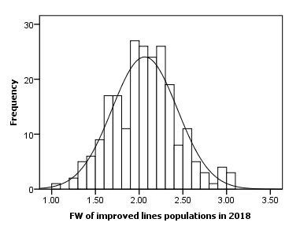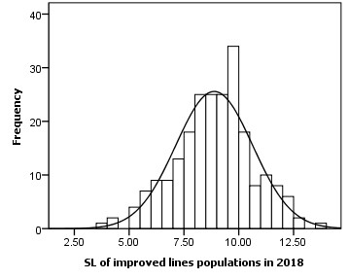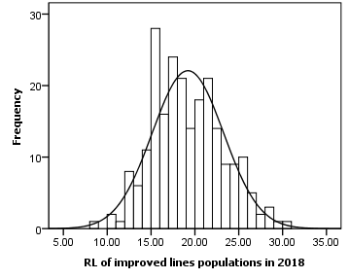
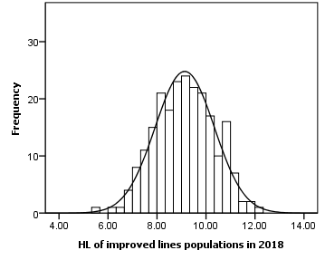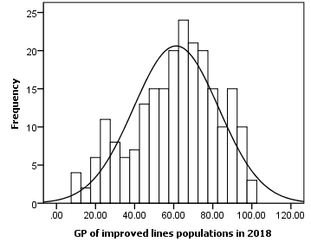
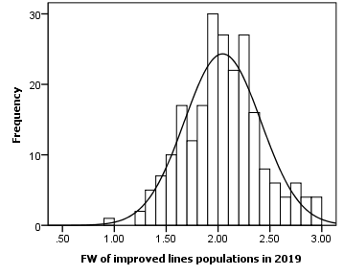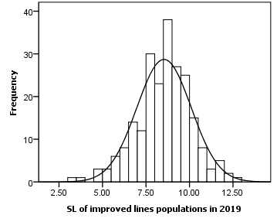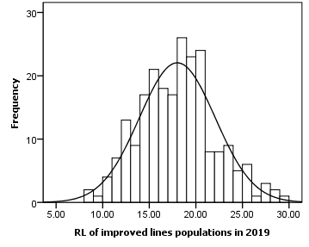
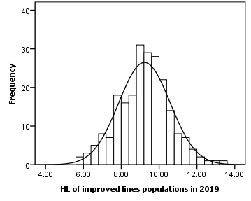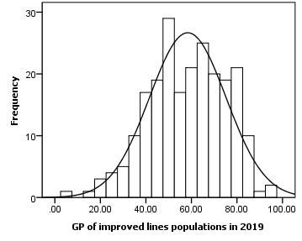
Figure S1. Frequency distribution of normal seedling fresh weight (FW), normal seedling length (SL), main root length (RL), hypocotyl length (HL), and germination percentage (GP) of improved lines populations in 2018 and 2019

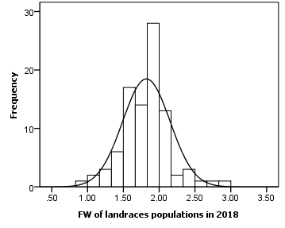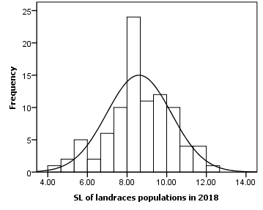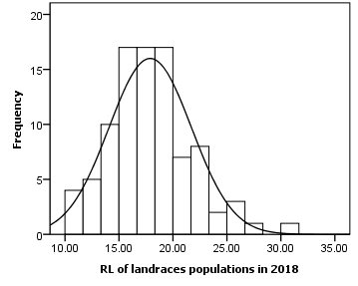
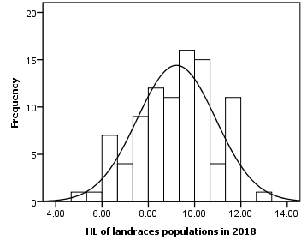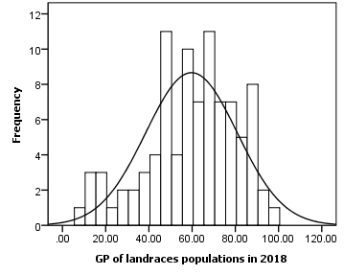
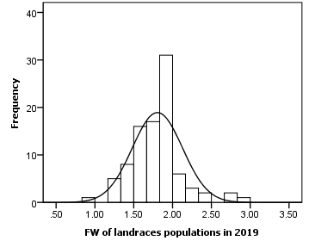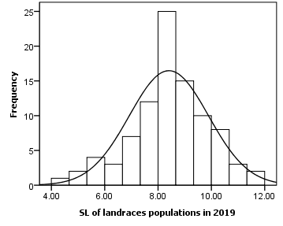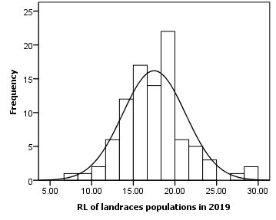
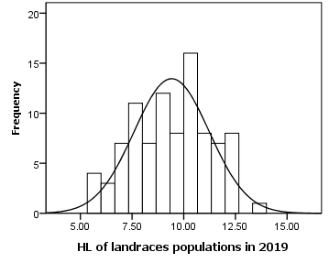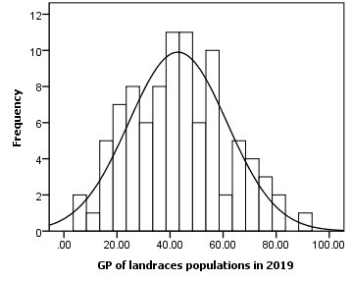
Figure S2. Frequency distribution of normal seedling fresh weight (FW), normal seedling length (SL), main root length (RL), hypocotyl length (HL), and germination percentage (GP) of landraces populations in 2018 and 2019

