Supporting Information. Veillard, D.¹, R. Tremblay, M. K. Sejr, L. Chauvaud, E. Cam, and F. Olivier. 2021. Recruitment dynamics of Hiatella arctica within a high Arctic site (Young Sound Fjord, NE Greenland). Polar Biology.

¹Institut Universitaire Européen de la Mer, Unité Mixte de Recherche ‘Laboratoire des sciences de l’environnement marin’ (LEMAR, UMR 6539), Centre National de la Recherche Scientifique, Institut de Recherche pour le Développement, Université de Bretagne Occidentale, Technopôle Brest-Iroise, rue Dumont d’Urville, 29280 Plouzané, France
Corresponding author email: delphine.veillard@uqar.ca
Appendix 1: Supplementary tables and figures
Table A1. Mean percentages (± SE) of different lipid classes found in young larval recruits collected over the sampling period from mid-August 2016 to mid-May 2017.
Sites | Sampling  period | n | %KET | %TAG | %FFA | %ALC | %ST | %AMPL | %PL
Pass Hytten | 9-months | 10 | 2.0 ± 0.7 | 1.1 ± 0.3 | 0.5 ± 0.3 | 1.9 ± 0.6 | 1.6 ± 0.5 | 4.8 ± 1.2 | 87.9 ± 2.7
Basalt Island | 9-months | 10 | 1.0 ± 0.4 | 1.1 ± 0.6 | 0.3 ± 0.2 | 1.4 ± 0.7 | 1.1 ± 0.5 | 3.3 ± 0.9 | 91.8 ± 2.5

Table A2. Results of multivariate statistics (Primer with n-MDS, PERMANOVA and Simper) realized on the percentage of the different lipid classes found in young larval recruits collected over the sampling period of 9-months.
Lipid classes
Source | df | Pseudo-F | P-perm
Sites | 1 | 2.1755E-09 | 1
Residus | 126

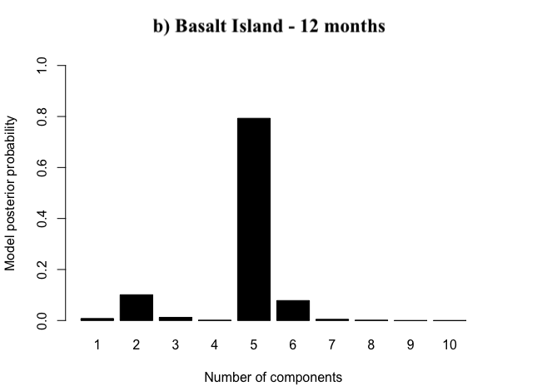
Figure A1. Size-class for recruits of H. arctica observed in samples collected in 5-weeks at Basalt Island (a) and in 12-months at Basalt Island (b) and Pass Hytten (c).
