Supplementary Information for
Prevention of ventilation-associated pneumonia applying a functionalized endotracheal tube and photodynamic therapy: a proof of principle with an artificial intubation model

Amanda Cristina Zangirolamiª, Leandro Serillo Pingueiroª, Fábio M. S. Rodrigues^{b}, Luis G. Arnaut^{b}, Mariette M. Pereira^{b} , Vanderlei Salvador Bagnato^{a,c}, Kate Cristina Blanco ^{a,c}

ªSão Carlos Institute of Physics, University of São Paulo, São Carlos - São Paulo 13566-590, Brazil.
^{b} Coimbra Chemistry Centre, Chemistry Department, University of Coimbra, 3004-535, Coimbra, Portugal
^{c} Texas A&M University, College Station, Texas, USA
* Correspondence author: Kate C Blanco, blancokate@gmail.com
Av. Trab. São-carlense Av., 400, 13566-590, São Carlos, São Paulo, Brazil.
Tel.: +55-16-3373-9810.

Contents:

S1 - Containers used in the immobilization of curcumin onto ET surface…………...…. | S2
S2 - Determination of the molar absorption coefficient of curcumin in THF…...…..…... | S2
S3 - Determination of curcumin distribution on ET-curc 5R surface……………….. | S3
S4 - Thermogravimetry of ETs (TG)………………………………………………...…... | S3
S5 - Statistical Analyses…………………………………………………………………. | S4

S1 - Containers used in the immobilization of curcumin on ET surface

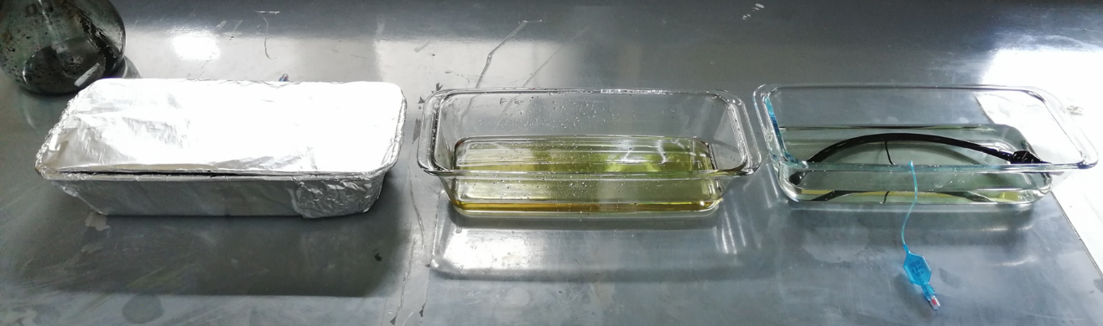
C
B
A
Figure S1: Containers used in the immobilization process of curcumin (A: curcumin basic solution, B: DMSO and C: EtOH)

S2 - Determination of the molar absorption coefficient of curcumin in THF
The molar absorption coefficient of curcumin was determined according to Beer-Lambert’s law, eight solutions were prepared in concentrations ranging from 4.6x10⁻⁷ to 1.7x10⁻⁵ M in THF corresponding to absorbance values between 0.03 and 1.1 relative to the maximum of absorption at 421 nm. The value was obtained in triplicate and the mean value of ε was used for further studies, ε₄₂₁(THF) = 59359 M⁻¹.cm⁻¹.
ε(421 nm)
M⁻¹.cm⁻¹
Exp1 | 58409
Exp2 | 60662
Exp3 | 59007

Mean | 59359
SD | 1167
RSD | 0,019661 |  | (<2%)

Figure S2: Data for the determination of the molar absorption coefficient of curcumin in THF.
S3 - Determination of curcumin distribution ET-curc 5R surface
To access the quantitative curcumin distribution over the outer and inner ET-curc 5R surfaces, samples from each surface were carefully prepared by cutting discs with 6 mm diameter (28.3 mm²) and ca 0.3 mm thickness from each area (A, B, C). Each sample was submitted to the UV-Vis quantification methodology and the results are presented in Figure S3. The amount of curcumin linked onto external surface areas of sections A, B and C ($\overline{x}=$ 3.40$×$10⁻⁴ mg/mm²) is quite homogenous. Through the surface and higher than the amounts observed on the inner surface of the tube. As expected, inside the material of the tube only vestigial amounts of curcumin were detected indicating once more that the immobilization of curcumin occurs essentially on the surface of the ET.
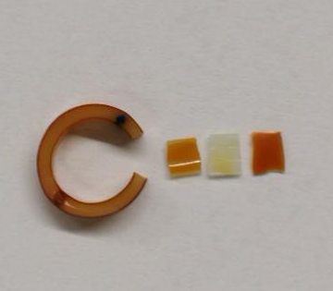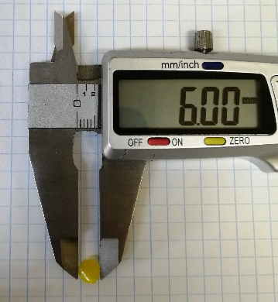
In.
Ext.
Tube Section | A |  | B |  | C
Section surface | Inner | External | Inner | External | Inner | External
[Curcumin]  mg/mm² | 3.35$×$10⁻⁴ | 3.47$×$10⁻⁴ | 2.20$×$10⁻⁴ | 3.55$×$10⁻⁴ | 1.59$×$10⁻⁴ | 3.20$×$10⁻⁴

Figure S3: Quantification of immobilized curcumin over the cross sections of the ET-curc 5R. Determined by UV-Vis quantification method using inner (In.) and external (Ext.) samples with 28.3 mm².

S4 - Thermogravimetry of ETs (TG)
Thermogravimetric analyses were made using a TG-DSC Parkin-Elmer STA6000 instrument with a heating rate of 10 °C min⁻¹ from 30 °C to 800 °C, under nitrogen flow (30 mL min⁻¹). The thermal stability of several samples from the ET-curc 5R (Zone A) was evaluated by Thermogravimetric - Differential Scanning Calorimetry (TG-DSC), Figure S4. The overlapped spectra of pristine ET, (black) ET-curc sample (blue) are presented in Figure S3. From the analysis of the figure, we observe that the mass loss occurred in three main events: I – Loss of adsorbed solvent (30-200 °C), resulting from the immobilization process, II – HCl elimination through thermal decomposition (201-350 °C) and III – Remaining organic matter decomposition (351-520 °C).[,] From the analysis of the TGA curves, we observe no significant differences in the degradation curves indicating that the functionalized ET-curc does not significantly affect the thermal proprieties of the polymeric material of the tube.
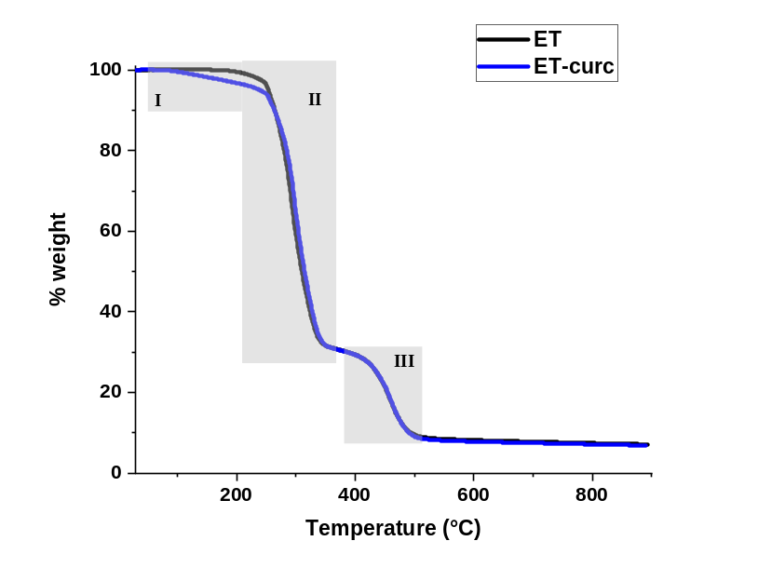
Figure S4: TGA curves for pristine ET (black) and ET-curc 5R (blue) samples.

S5 - Statistical Analyses
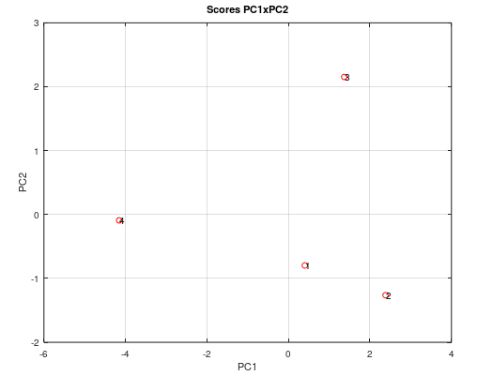
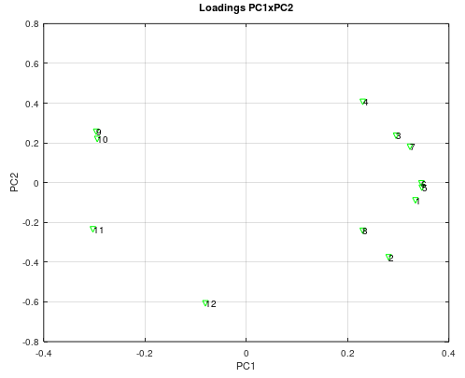
Figure S5: PCA designed in the four periods of time tested. A) loading graph with 2PCs representing the quantity of bacterial cells formed at the ETs; B) Score graph represented by four periods of time tested. * PCA performed by free software GNU Octave® version 5.2.0.
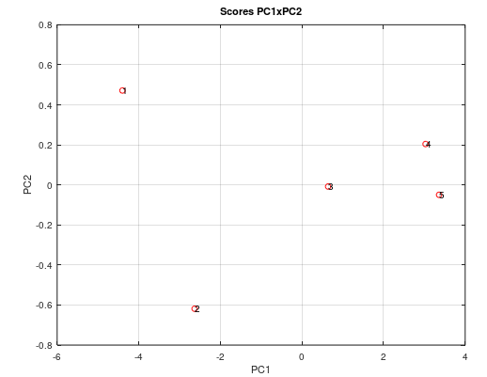
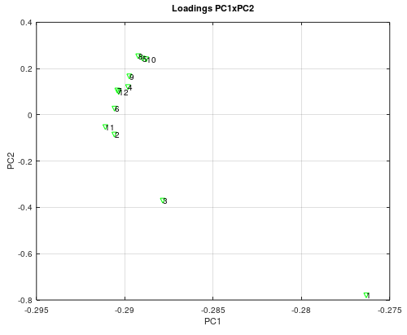
Figure S6: A) Score graph with PC1 and PC2 to analyses the four light doses tested on each tube; B) Loading graph of PC1 and PC2 showing the positions of the tubes.

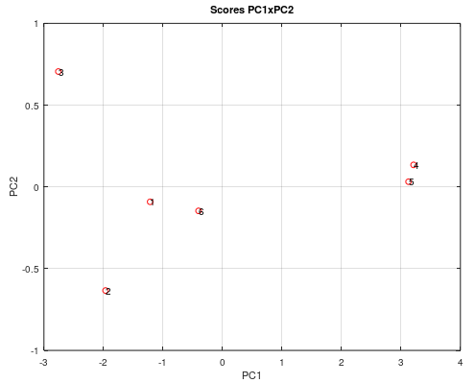
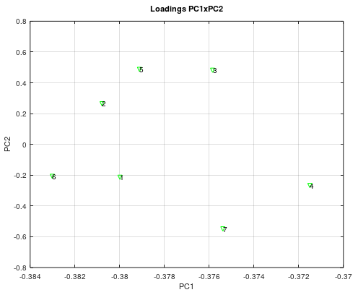
Figure S7: PCA for statistical comparison among the six groups described in Fig. 10. A) Score graph of the groups with 2PCs: 1-ET LL; 2-ET RL; 3-ET ORO; ETc LL; ETc RL and ETc ORO. B) Loading graph according to the 2PCs describing the results along 7-days of the Fig. 10.
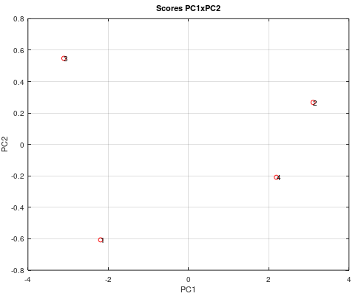
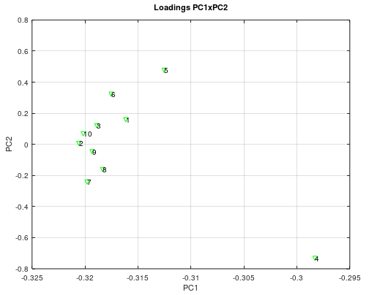
Figure S8: PCA of the groups control and PI tested with and without MV along 24 h. A) Score graph where describes four groups tested: 1-ET, 2-ETc, 3-ET MV and 4-ETc MV. B) Loading graph where shows the difference among the biofilm formed along the tubes.

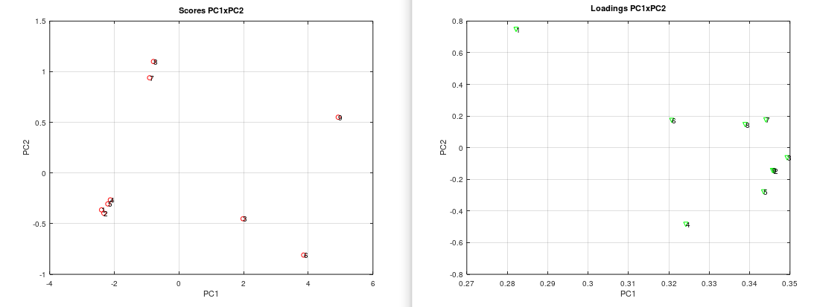
Figure S9: PCA of the groups control and PI tested with and without MV along 24 h and with MRSA. A) Score graph describing six groups analysed: 1-LL ETc SA, 2-LR SA; 3- Orobox SA; 4-LL MV SA, 5- LR MV SA; 6- Oro MV SA; 7- LL MRSA; 8- LR MRSA; 9- Oro MRSA.

References

Chen, J.; Wang, Y.; Huang, J.; Li, K.; Nie, X. Synthesis of Tung-Oil-Based Triglycidyl Ester Plasticizer and Its Effects on Poly(vinyl chloride) Soft Films. ACS Sustainable Chemistry & Engineering, V. 6, p. 642−651, 2018
Patil S.; Jena H. Performance assessment of polyvinyl chloride films plasticized with Citrullus lanatus seed oil based novel plasticizer. Polymer Testing, V. 101, p. 107271, 2021.

