Supporting information
Photocobilins integrate B12 and bilin photochemistry for enzyme control
Shaowei Zhang^{1, 2,} *, Harshwardhan Poddar¹, Yuqi Yu¹, Chuanyang Liu², Kaylee Patel¹, Laura N. Jeffreys¹, Lingyun Zhu², Cunyu Yan¹, Giorgio Schiro³, Martin Weik³, Michiyo Sakuma¹, Colin W. Levy¹, David Leys¹, Derren J. Heyes^{1,} *, Nigel S. Scrutton^{1,} *

Supporting figures:

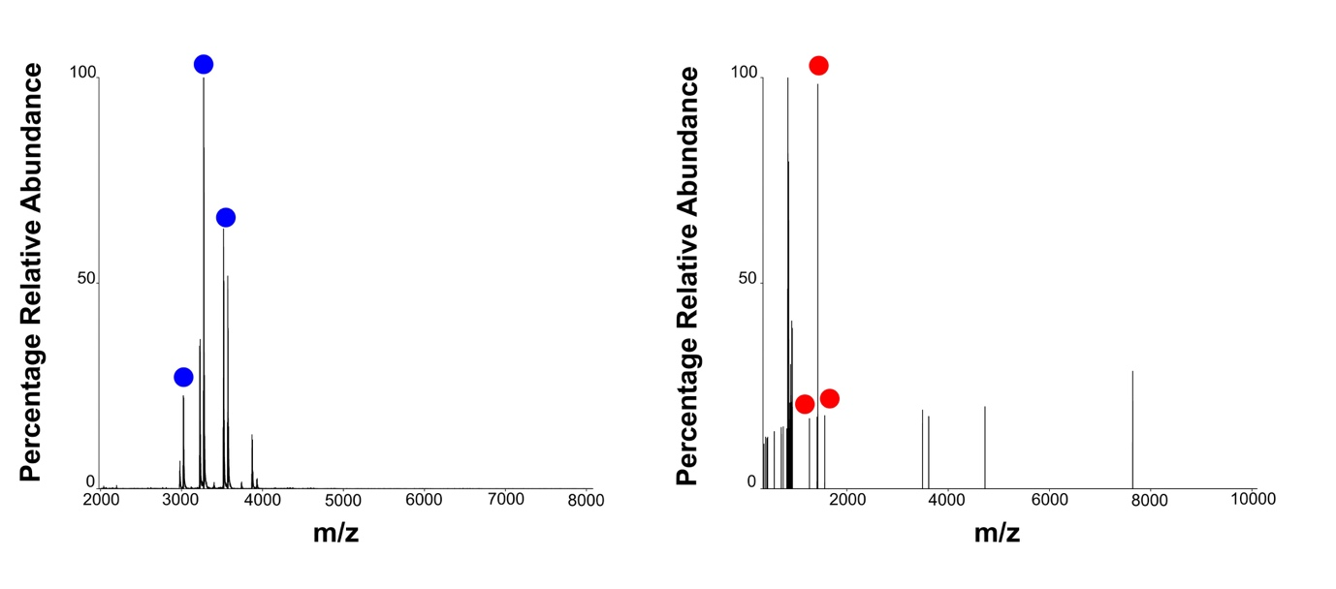
Figure S1. Native mass spectrometry measurements of SasPcob and AbDPcob. Native mass spectrometry was undertaken to determine the mass of SasPcob and AbDPcob under ambient light conditions. For both spectra multiple adduct states were observed. The species with the highest relative abundance for SasPcob corresponded to a mass of 39279 with a charge of +12 (shown with blue circles). The species with the highest relative abundance for AbDGC full length protein corresponded to a mass of 68451 Da with a charge of +48 (shown with red circles).

Figure S2. Analysis of AbPcob and AbDPcob structures after MD simulation. a, Root Mean Square Deviation (RMSD) of Cα atoms during the simulation time of AbPcob in light and dark state. b, Root Mean Square Fluctuations (RMSF) of Cα atoms during the simulation time of AbPcob in light and dark state. c, Root Mean Square Deviation (RMSD) of Cα atoms during the simulation time of AbDPcob in light and dark state. d, Root Mean Square Fluctuations (RMSF) of Cα atoms during the simulation time of AbDPcob in light and dark state. DGC region with conformational change was highlighted by a black circle. e, RMSF of residues superposed onto AbDPcob in light and dark states (f), with the most (least) variable regions depicted in red (blue).

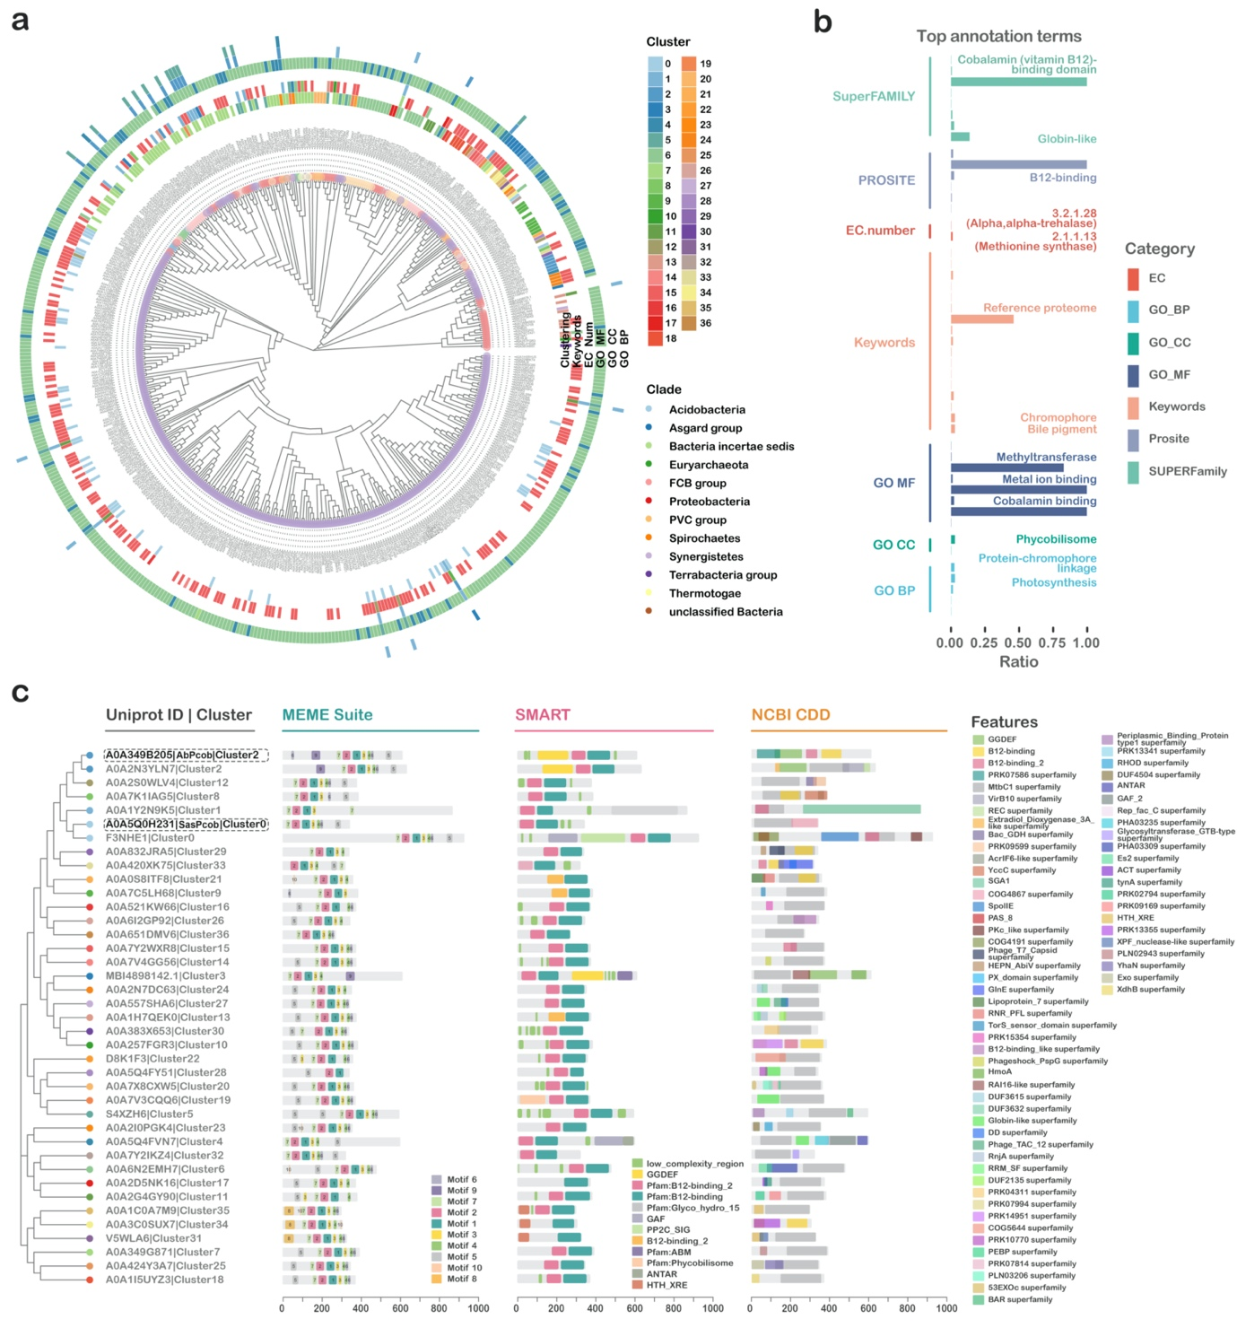
Figure S3. Phylogenetic analysis and feature annotation photocobilin-containing proteins. a, Phylogenetic analysis and functional annotation of 506 BG-containing proteins. 506 sequences were grouped into 37 clusters using three rounds of cd-hit software. b, Barplot showing the summary of functional annotations. c, Motif and domain prediction of representative protein sequence in 37 clusters. Motif predictions were performed using MEME Suite, Domain predictions were performed based on SMART and NCBI CDD tools.

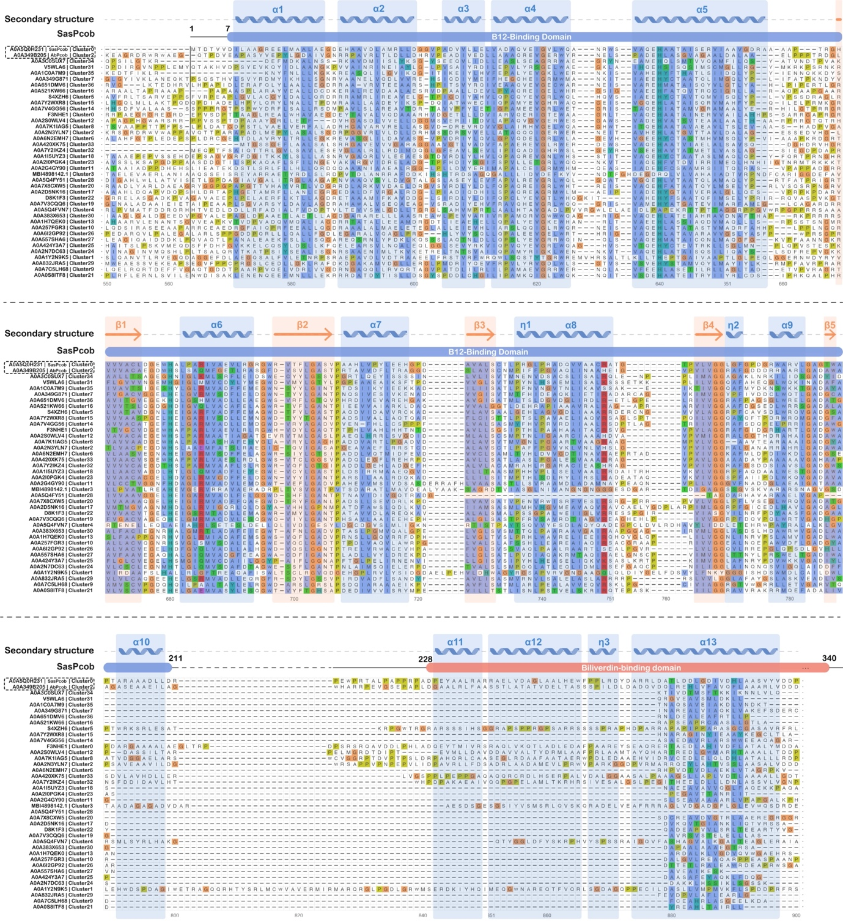
Figure S4. Multiple sequence alignment and structural annotation of the representative sequence of 37 clusters. The sequence of SasPcob and AbPcob are included in the analysis, which also shows secondary structure information and motif prediction.

Figure S5. Representative domains located at photocobilin-containing gene loci. a, Genome neighbourhood distribution of photocobilins used in this study. SasPcob and AbDPcob are shown as red box and other genes are named and coloured by their domains. b, Selected representative photocobilins and their gene loci. Each gene is represented as a box. The photocobilin is shown as the red box, while other boxes represent the Pfam families as indicated. The direction of the box shows the direction of the gene transcription. Apart from photocobilin, intensity of the colour shade represents the gene frequency of occurrence in the position.
Figure S6. Comparison of predicted photocobilin structures and sequences with SasPcob. Representative photocobilins were selected, grouped according to domain organisation and Alphafold2 models downloaded^{1,2}. a-d, Structure alignment of predicted Alphafold2 structures with SasPcob. Protein structures are shown as cartoon. B₁₂ and BV domain of SasPcob are coloured blue and orange respectively. Predicted structures and extra functional domains are shown as green and magenta cartoons. e, Multiple sequence alignment of selected photocobilins with SasPcob. The alignment result is coloured according to sequence identity by MView³.
Supporting Tables:
Table S1. Structures distribution after clustering of AbPcob and their maximum binding affinity to BV.
Cluster No. | Structures | Max binding affinity
1 | 1734 | >0
2 | 1262 | >0
3 | 779 | >0
4 | 232 | -5.5
5 | 228 | -0.8
6 | 159 | -7.9
7 | 132 | >0
8 | 84 | -6.1
9 | 78 | -6.4
10 | 72 | -6.4
11 | 47 | -2.7
12 | 29 | -9.7
13 | 26 | >0
14 | 19 | -1.6
15 | 15 | >0
16 | 13 | -4.9
17 | 13 | -2
18 | 12 | -2.1
19 | 11 | -8.4
20 | 7 | -6.7
21 | 7 | -0.9
22 | 7 | >0
23 | 4 | -6.2
24 | 4 | -4.2
25 | 4 | >0
26 | 3 | -6.9
27 | 3 | -4.9
28 | 3 | -4.8
29 | 2 | >0
30 | 2 | >0
31 | 2 | -5.1
32 | 2 | >0
33 | 1 | -5.2
34 | 1 | -3.2
35 | 1 | -7.6
36 | 1 | -3.1
37 | 1 | -1.7
38 | 1 | >0

Supplementary results

Analysis of AbPcob MD simulation and BV ensemble docking results
To explore the possible binding pose with BV, the conformations in MD trajectory of dark-state AbPcob were clustered to 38 clusters. Represented structures were collected and continued with BV docking analysis. Structure distributions for different clusters are displayed in Table S1. Maximum binding affinities of BV docking results reveal that around 80% of the conformations showed predicted binding affinity over 0, indicating non-favourable binding to BV (Figure S3). Only 4% of the AbPcob conformations could confidently bind BV with binding affinity lower that -7.0 kCal/mol. The binding of BV to the rest of the clustered structures are not sure. Among them, some could retain BV in the protein, but the interaction between BV and protein are not strong enough. Above all, after using MD simulation to rearrange the BV binding region, at certain conformation, BV could bind with AbPcob, but in the most of the case the His residue hinders the protein and ligand interaction.

Functional prediction of Pcob proteins
A total of 506 photocobilin photoreceptor proteins with a high similarity of overall sequence, structure, motifs and domain architecture were identified, either fused to other enzyme domains or as standalone proteins (Figure S3). To exlpore the possible biological function of photocobilin proteins we used bioinformatics approaches to explore their potential cellular roles. A multilevel bioinformatic analysis pipeline based on multidimensional information (features identification, genomic contextual information, and protein-protein interaction) of photocobilin containing proteins has been designed and utilised (Figure S3-S5). 506 Pcob proteins have been clustered into 37 groups based on their sequence and evolution relationship (Figure S3). The evolutionary trajectory of the fusion proteins suggests they have evolved over time, implying that the close proximity of the output domain is likely to be a more efficient mode of regulation. A number of common output domains are found to be fused to, and thus regulated by, photocobilin domains, including transcriptional regulators, DNA polymerase and serine/threonine phosphatase (Figure S5). Standalone photocobilin proteins are frequently associated with transcriptional regulators (e.g. TetR family), transporters (e.g. ABC transporter) and many domains of prokaryotic signal transduction systems (e.g., histidine kinase, histidine phosphotransferase, diguanylate cyclase, PAS/PAC sensor hybrid histidine kinase, SpoIIE and STAS domains).

Comparison of predicted Pcob structures with SasPcob
Pcob proteins have been clustered into 37 groups. Represented Pcob protein structures were downloaded from AlphaFold2 database¹. Comparison of structural alignment with SasPcob revealed that Pcobs have similar structure arrangement with either chromophore placed at N-terminal (Figure S6). Although different Pcobs have low sequence identity, their predicted 3D structure are looks like the same, RMSD value of C-alpha atoms ranging from 1.250 to 2.775. The linker region affects the relative position of two chromophores, which might be the key for investigating the function of Pcobs during the evolution.

Supplementary methods
Native mass spectrometry measurements of SasPcob and AbDPcob
On the day of analysis, protein was desalted by exchange into 50 mm ammonium acetate (SasPcob) or 200mM ammonium acetate (AbDPcob) both at pH 7.0 using Micro Bio-Spin Chromatography columns (Bio-Rad, Micro Bio-Spin 6 Columns), following the manufacturer's instructions. Native MS data were acquired using the Thermo Scientific™ Q Exactive™ Hybrid Quadrupole-Orbitrap™ mass spectrometer (Thermo Fisher Scientific, Cramlington, UK). NanoESI capillaries were prepared in house from thin-walled borosilicate capillaries (inner diameter 0.9 mm, outer diameter 1.2 mm) (World Precision Instruments, Stevenage, UK) using a Flaming/Brown P-97 micropipette puller (Sutter Instrument Company, Novato, CA). Around 10µL of 5µM protein was used per capillary tube. A positive voltage was applied to the solution through a platinum wire (Goodfellow Cambridge Ltd., Huntington, UK) inserted into the capillary. Data was acquired for 5 minutes per condition. For analysis all 5 minutes were averaged and processed in Thermo Xcalibur (Thermo Fisher Scientific, Cramlington, UK).

Protein function-oriented design of computational bioinformatic analysis
Due to the lack of functional annotations of most Pcob-containing proteins in known databases and literature, our study utilized an integrated analysis based on multiple bioinformatic analyses and multidimensional information of Pcob-containing proteins such as sequence information, structural and functional information, genomic contextual information, and protein-protein interaction networks, to enhance the performance of the computational analysis and identification of protein functions. Based on the function-oriented design of the computational analysis, we were capable of inferring the common functions of the submitted protein sequence, and collectively, we might synthesize the functionality of Pcob-containing proteins.

B₁₂-binding domain homologous sequence searches, functional annotation and sequence similarity-based clustering
We utilized the NCBI BLASTp algorithm (https://blast.ncbi.nlm.nih.gov/Blast.cgi) for the identification of B₁₂-containing homologous sequence using B₁₂-binding domain from CarH protein as the query sequence. 506 sequence was acquired and corresponding gene sequence information was collected for further analysis. Multiple sequence alignment (MSA) was performed based on all 506 Pcob-containing proteins using the MUSCLE algorithm. A phylogenetic tree using the neighborhood joining (NJ) method is constructed using Molecular Evolutionary Genetics Analysis software (version 10.2.6)⁴. All 506 BBD-containing proteins were mapped to Uniprot ID and submitted to the various database for preliminary annotation. The phylogenetic tree and related annotations are visualized by R using packages ggtree⁵ and ggtreeExtra⁶. The frequency of annotated terms was visualized by R package ggplot2, ggpubr, and Adobe Illustrator. To enhance the feature detection and reduce the statistical bias of downstream functional analysis, a multi-step sequence similarity-based clustering was performed using h-cd-hit⁷ (Threshold: 0.9, 0.6, 0.3). Representative sequences of clustering results (37 clusters) were used for further analysis.

Protein structure prediction, comparison, and analysis
Sequence alignment of 37 representative protein sequences was performed using ClustalW (https://www.genome.jp/tools-bin/clustalw). The three-dimensional protein structure was predicted by AlphaFold2⁸, an accurate computational approach to predict the three-dimensional structure of target proteins based on deep learning algorithms. Alignment results and The 3D structure of SasPcob were submitted to ESPript (Version 3.0, https://espript.ibcp.fr/ESPript/cgi-bin/ESPript.cgi) for structural annotation⁹. MSA alignment and structural annotation results were visualized by R package ggmsa¹⁰ and Adobe illustrator.
Motif prediction was performed based on MEME Suite¹¹, a well-known tool for the discovery of novel, ungapped motifs. Protein domain prediction was performed using the simple modular architecture research tool (SMART)¹² and NCBI Conserved Domain Database (CDD)¹³. The phylogenetic tree and architecture of predicted motifs and domains were collected and visualized by Adobe illustrator and TBtools¹⁴, a platform for integrative analyses and visualization of big biological data.

Supplementary reference

1 Varadi, M. et al. Alphafold protein structure database: Massively expanding the structural coverage of protein-sequence space with high-accuracy models. Nucleic Acids Res 50, D439-d444 (2022).
2 Jumper, J. et al. Highly accurate protein structure prediction with alphafold. Nature (2021).
3 Brown, N. P., Leroy, C. & Sander, C. Mview: A web-compatible database search or multiple alignment viewer. Bioinformatics 14, 380-381 (1998).
4 Kumar, S., Stecher, G., Li, M., Knyaz, C. & Tamura, K. Mega x: Molecular evolutionary genetics analysis across computing platforms. Molecular biology and evolution 35, 1547-1549 (2018).
5 Yu, G., Smith, D. K., Zhu, H., Guan, Y. & Lam, T. T.-Y. Ggtree: An r package for visualization and annotation of phylogenetic trees with their covariates and other associated data. 8, 28-36 (2017).
6 Xu, S. et al. Ggtreeextra: Compact visualization of richly annotated phylogenetic data. Molecular biology and evolution 38, 4039-4042 (2021).
7 Huang, Y., Niu, B., Gao, Y., Fu, L. & Li, W. Cd-hit suite: A web server for clustering and comparing biological sequences. Bioinformatics (Oxford, England) 26, 680-682 (2010).
8 Jumper, J. et al. Highly accurate protein structure prediction with alphafold. Nature 596, 583-589 (2021).
9 Robert, X. & Gouet, P. Deciphering key features in protein structures with the new endscript server. Nucleic acids research 42, W320-W324 (2014).
10 Zhou, L. et al. Ggmsa: A visual exploration tool for multiple sequence alignment and associated data. Briefings in bioinformatics (2022).
11 Bailey, T. L., Johnson, J., Grant, C. E. & Noble, W. S. The meme suite. Nucleic acids research 43, W39-49 (2015).
12 Letunic, I., Khedkar, S. & Bork, P. Smart: Recent updates, new developments and status in 2020. Nucleic acids research 49, D458-D460 (2020).
13 Lu, S. et al. Cdd/sparcle: The conserved domain database in 2020. Nucleic acids research 48, D265-d268 (2020).
14 Chen, C. et al. Tbtools: An integrative toolkit developed for interactive analyses of big biological data. Molecular plant 13, 1194-1202 (2020).

