Appendix A: A brief comparison between Φ-angle and alpha-delta ratio

The alpha/delta ratio is one of the main features used in the detection of ischemia in subrachnoid hemorrhage (2), showing promising results in prospective and retrospective studies. It is defined as
$ADR≡\frac{E_{α}}{E_{δ}}$ (A.1)

where $E_{α}$ and $E_{δ}$ are the energy of alpha and delta bands respectively defined as

$$EEG_{r}=\sum_{n=1}^{N}{{\left|EEG_{(w,r)}(n)\right|}^{2}}$$ | (A.2)

where r stands as one of the sub-bands and n refers to the n-th point of the w-th window where N is the windows length. A comparison with Φ-angle is presented in the following.

The temporal evolution of ADR in this experiment in relation to ICP and CPP was previously presented in another manuscript. There, it is shown that total power appeared to be better for both ICP and CPP tracking than ADR. However, the power and size characteristics of the test do not allow a reliable conclusion. In Table A.1 we reproduce the values of ICP and CPP correlation with slope together with the values of ADR correlation with the same signals. In Figure A.2 we can observe the superiority of the correlation when slope is taken into account instead of ADR for tracking the two signals. Given the difference between the medians of the two groups, the power of the Wilcoxon test for the difference between groups is 0.73 and 0.99, with a type I error of 0.05, for ICP and CPP respectively, so we could conclude that to follow the two signals the slope is more accurate than the ADR.

Appendix B: A brief explanation about power spectral density calculation

Welch method, based on the Fourier Transform, was applied to estimate the power spectral density (PSD) from the EEG signal. To calculate the PSD, the EEG was divided into L segments of M samples overlapping by D samples. The periodogram from each windowed segment $EEG_{i}$ was calculated by

$S_{i}\left(f\right)=\frac{1}{ME}{\left|\sum_{n=0}^{M-1}{{EEG}_{i}[n]w[n]e^{-2jπf}}\right|}^{2}$

Where $EEG_{i}\left[n\right]$ with $n=0,1,…,M-1$, $i=0,1,…,L-1$ and E is a normalization factor for the power or the window function used defined as,

$$E=\frac{1}{M}\sum_{n=0}^{M-1}{{\left|w[n]\right|}^{2}}$$

Then, the power spectrum density is estimated from the average of K periodograms

$$S\left(f\right)=\frac{1}{L}\sum_{i=0}^{L-1}{S_{i}\left(f\right)}$$

Choice of data windows

Welch method allows to reduce the variance in the estimation of the power spectrum density with respect to the periodogram technique. If we average over L segments, we obtain a reduction of the variance of approximately $1/L$ if it does not have overlapping segments. Therefore, if the length of the series N is sufficiently large, we can select $D=0$, i.e., there is no overlap between successive data segments.

If N is not sufficiently large, in order to obtain a minimum variance, overlapping segments can be taken. Normally, they overlap by one half their length, i.e., $D=M/2$ which is 50% overlap between successive data segments.

Given a compromise relationship between the computational cost and the reduction of the variance using this method, in the present work $L=8$ and $D=M/2$ which represented a 50% of overlap. M was established by L and D.

Figure A.1 Boxplot comparison for the SCC

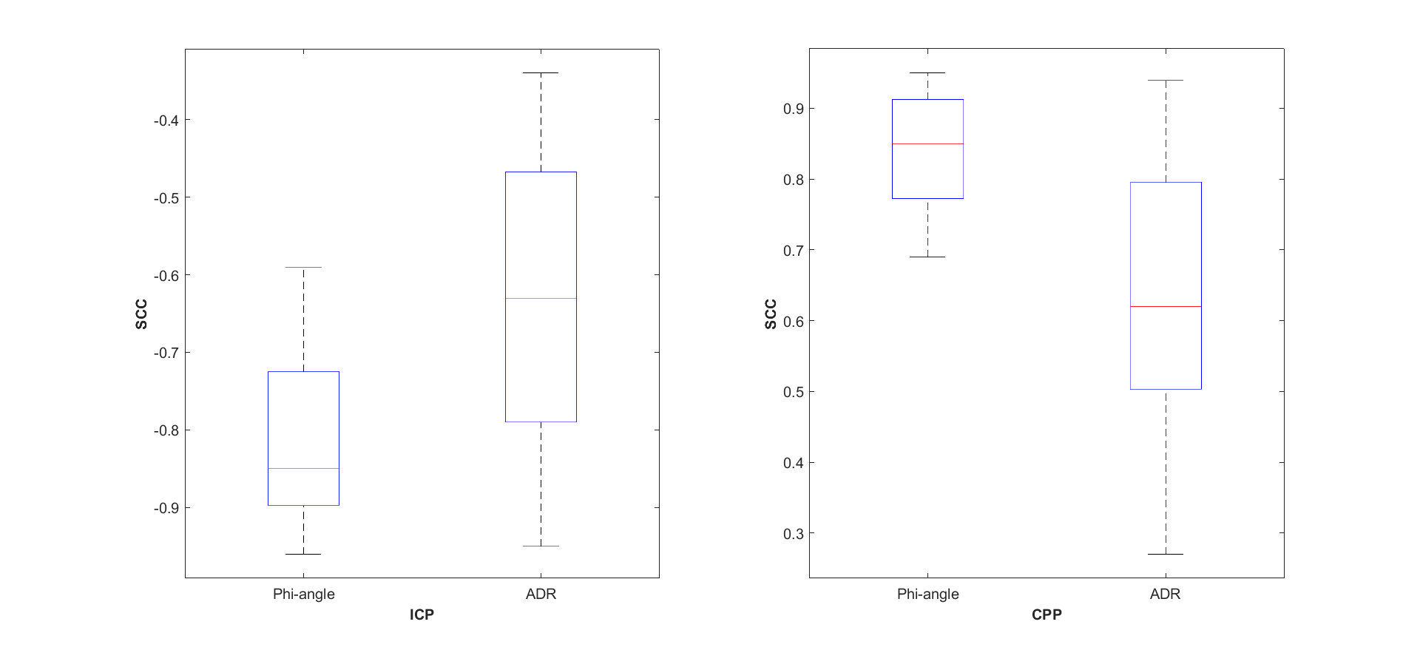

Table A.1: Comparison of the correlation between (Φ-angle,ICP) column 2, (ADR,ICP) column 3, (Φ-angle,CPP) column 4 and (ADR,CPP) column 5.

Episode | Correlation with ICP |  | Correlation with CPP
Episode | Φ-angle | ADR | Φ-angle | ADR
i | -0.96 | -0.46 | 0.95 | 0.49
ii | -0.74 | -0.95 | 0.78 | 0.94
iii | -0.85 | -0.58 | 0.8 | 0.54
iv | -0.63 | -0.45 | 0.77 | 0.45
v | -0.87 | -0.87 | 0.89 | 0.86
vi | -0.89 | -0.65 | 0.73 | 0.64
vii | -0.59 | -0.49 | 0.92 | 0.59
viii | -0.9 | -0.34 | 0.88 | 0.27
ix | -0.85 | -0.83 | 0.85 | 0.84
x | -0.72 | -0.63 | 0.69 | 0.62
xi | -0.96 | -0.41 | 0.95 | 0.51
xii | -0.98 | -0.67 | 0.96 | 0.66

