
General Surgery Resident Robotics Training Curriculum
(plan for academic year 2022-2023)

Aim:
All residents graduate with robotic equivalency certificate.

Purpose of this document:
In order to create a plan for stepwise development of competence with robotic surgical procedures, this curriculum outlines general, clinical and simulation goals for the rotations in which residents participate.

Paradigm:
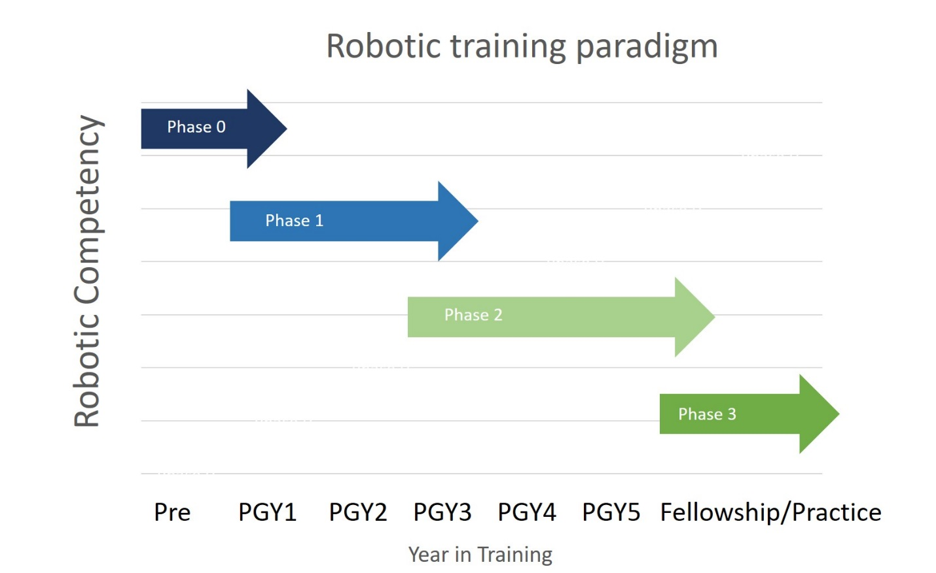

Table of contents
Phase 0 objectives ……………………………………………………………………………………………………………………..…. 3
Phase 1, 2 objectives …………………………………………………………………………………………………………………….. 4
Bariatric ………………………………………………………………………………………………………………………………..………… 4
Colorectal………………………………………………………………………………………………………………………..………………. 5
General Surgery……………………………………………………………………………………………………………….………………. 6
Thoracic ………………………………………………………………………………………………………………………………………….. 7
Proposed evaluation form……………………………………………………………………………………………………………… 8

Phase 0 Objectives
Phase 0 precedes any patient contact activity. Our goal will be to accomplish this training during Intern Boot camp with opportunity for refreshers or updates throughout the year. This will also take care of the non-clinical portion of the Equivalency Certificate. Please note that no simulation modules have been added to Phase 0 as there are specific modules we have linked to each rotation.

All residents to set up a learning profile through learning.intuitive.com (this will serve to track your progress on modules, simulation over time). You will need to complete the da Vinci Xi training modules (all platforms at VM are Xi), and online assessment (P8). Certificate will be proof of completion and that you are able to participate in robotic surgery.

General Objectives
- Understand pros/cons of robotics
- Understand system components
- Review patient safety issues and patient selection
- Register for e-learning platform (modules, simulation tracking, etc)
- Register for myintuitive app (universal login, case tracking/metrics)

Clinical Objectives
- Platform docking (in-service)
- Instrument exchange (in-service)

Simulation Objectives
- Complete online modules, assessment test
- Simulator (SimNow) account setup
- Simulator (SimNow) in-service

Rotation: Bariatric Surgery
Author: Mallipeddi
Phase 1
Simulation Objectives (>90% score)
- Competitive Needle PoseMatch 90
- Energy Pedals 1
- Ring Rollercoaster – Level 1,2
- Wrist Articulation – Level 1
General Objectives
- Understand port placement philosophy and strategy.
- Execute safe, effective docking of the robot with consideration to external interactions in obese patients. Includes clearance, spacing, instrument insertion, speed, etc.
- Become comfortable with basic instrument and camera manipulation, esp Vessel Sealer.
- Appreciate visual cues to assess tissue tension.
Clinical Objectives
- Resident should become proficient at bedside assistance through all steps of the case. This includes knowledge of the steps, setup/teardown, instrument transition, assisting/cueing surgeon as needed, and troubleshooting.
- Resident should be able to perform mobilization of greater curvature up to fundus during sleeve.
- Resident should be able to perform suture imbrication of proximal staple line during sleeve.
Phase 2
Simulation Objectives (>90% score)
- 4th Arm Cutting
- Combo Exercise
- Puzzle Piece Dissection
- SeaSpikes 2
General Objectives
- Become proficient in use of 3rd working arm.
- Safely dissect around the fundus and hiatus.
- Become comfortable with the robotic stapler.
Clinical Objectives
- Resident should be able to mobilize the entire stomach for a sleeve.
- Resident should be able to dissect the hiatus and repair a hiatal hernia.
- Resident should be able to create a straight, well positioned staple line for a sleeve.

Rotation: Colorectal Surgery
Author: Simianu
Phase 1
Simulation Objectives (>90% score)
- Right Hemicolectomy – Anatomy ID, Guided, Anastomosis
- Clutch
- Competitive Needle PoseMatch 60
- Energy Pedals 2
- Running Suture
- Wrist Articulation 2
General Objectives
- Ensure safe/fluid movement of arms; how robot interacts externally with patient
- Port placement philosophy and strategy
- Become comfortable with basic instrument manipulation
- Ability to use visual cues to assess tissue tensions
Clinical Objectives
- Become proficient at bedside assistance through all steps of the case. This includes knowledge of the steps, setup/teardown, instrument transition, needle/mesh insertion and retrieval, assisting/cueing surgeon as needed, and troubleshooting
- Portions of colonic attachments
- Portions of stapling
Phase 2
Simulation Objectives (>90% score)
- Closure Common Enterotomy – Guided, Top-down, bottom up, free
- 30-deg Scope Swap
- ATW Needle Driving
- Three Arm Relay 3
- Vessel Energy Dissection
General Objectives
- Proficient in use of 3rd arm
- Proficient in suturing
- Proficient in robotic stapler
- Proficient at mesenteric division
Clinical Objectives
- Majority of colon mobilization
- Portion of TME
- Majority of mesenteric division
- Portion of intracorporeal anastomosis
Rotation: General Surgery
Author: Biehl, Mallipeddi
Phase 1
Simulation Objectives (>90% score)
- Inguinal Hernia – Anatomy ID, Guided, Freehand, Mesh
- Camera 0
- Anterior Needle Driving Horizontal
- Anterior Needle Driving Vertical
- SeaSpikes 1
General Objectives
- Understand port placement philosophy and strategy.
- Execute safe, effective docking of the robot with consideration to external interactions. Includes clearance, spacing, instrument insertion, speed, etc.
- Become comfortable with basic instrument and camera manipulation.
- Appreciate visual cues to assess tissue tension.
Clinical Objectives
- Become proficient at bedside assistance through all steps of the case. This includes knowledge of the steps, setup/teardown, instrument transition, needle/mesh insertion and retrieval, assisting/cueing surgeon as needed, and troubleshooting
- Proficient in closing peritoneal flap

Phase 2
Simulation Objectives (>90% score)
- Acute Cholecystitis, Cholecystectomy
- Anterior Needle Driving ATW
- Posterior Needle Driving ATW
- Ring Tower Transfer
General Objectives
- Become proficient in use of 3rd arm.
Clinical Objectives
- Proficient in suturing mesh and intracorporeal knot tying
- Proficient in mesh placement
- Proficient in peritoneal flap dissection
- Proficient in hernia closure
- Proficient in hernia reduction and sac dissection

Rotation: Thoracic Surgery
Author: Hubka, Sternbach
Phase 1 Learner
Simulation Objectives (>90% score)
- Big Dipper Needle Driving
- Knot Tying
- Needle Pose Match
- Railroad track
- SeaSpikes Game
General Objectives
- Ensure safe/fluid movement of arms; how robot interacts externally with patient
- Safe port placement philosophy and strategy
- Become comfortable with basic instrument manipulation
- Ability to use visual cues to assess tissue tensions
Clinical Objectives
- Become proficient at bedside assistance through all steps of the case. This includes knowledge of the steps, setup/teardown, instrument transition, needle/mesh insertion and retrieval, assisting/cueing surgeon as needed, and troubleshooting
- Able to transition from single to two arm vessel division
- Proficient use of bipolar cautery and vessel sealer for dissection and hemostasis

Phase 2
Simulation Objectives (>90% score)
- Lobectomy – Freehand lobes (5)
- Three-arm Relay – 1, 2
- Ring Rollercoaster – 3, 4
General Objectives
- Proficient in use of 3rd arm, and camera repositioning
- Understanding on repositioning of 3rd arm and implication on tissue tension and exposure
- Proficient in suturing, and knot tying
Clinical Objectives
- Mobilization of EGJ and hernia sac, bipolar dissection
- Portion of crural repair
- Portion of fundoplication anastomosis

GEARS evaluation tool

