High Intrinsic Phase Stability of Ultrathin 1T’ WS₂
Xiangye Liu^{1, 2}, Pingting Zhang^{1, 2}, Shiyao Wang³, Yuqiang Fang^{4, 5}, Jipeng Chen^{1, 2}, Chendong Zhao⁴, Xian Zhang⁵, Wei Zhao⁴, Junjie Wang³, Fuqiang Huang⁴, Cao Guan^{1, 2}*
¹Institute of Flexible Electronics, Northwestern Polytechnical University, Xi’an 710072, China.
²Key laboratory of Flexible Electronics of Zhejiang Province, Ningbo Institute of Northwestern Polytechnical University, 218 Qingyi Road, Ningbo, 315103, China.
³State Key Laboratory of Solidification Processing, Northwestern Polytechnical University, Xi'an, Shaanxi 710072, China.
⁴State Key Laboratory of High-Performance Ceramics and Superfine Microstructure, Shanghai Institute of Ceramics, Chinese Academy of Sciences Shanghai 200050, China.
⁵Qian Xuesen Laboratory of Space Technology, China Academy of Space Technology, Beijing 100094, China.
⁶These authors contribute equally: Xiangye Liu, Pingting Zhang, Shiyao Wang and Yuqiang Fang.
Corresponding Author
*E-mail: iamcguan@nwpu.edu.cn (C. Guan)

Content
I. Fabrication of different layered 1T’ WS₂ 3
I.1 Synthesis of high purity 1T’ WS₂ single crystal 3
I.2 Mechanical exfoliation and transfer of 1T’ WS₂ 3
II. Temperature- and laser-power- dependent Raman and durability measurements 4
III. Computational method 4
IV. References 5
V. Supplementary figures 7

I. Fabrication of different layered 1T’ WS₂

I.1 Synthesis of high purity 1T’ WS₂ single crystal
As we previously reported¹, 1T’ WS₂ single crystals were prepared by deintercalation of interlayer potassium cations from K_{0.7}WS₂ crystals. For the synthesis of K_{0.7}WS₂, K₂S₂ (prepared via liquid ammonia), W (99.9%, Macklin) and S (99.99%, Macklin) were mixed by the stoichiometric ratios and ground in an argon-filled glovebox. The mixtures were pressed into a pellet and sealed in the evacuated quartz tube. The tube was heated at 850 °C for 2000 min and slowly cooled to 550 °C at a rate of 0.1 °C min⁻¹. The synthesized K_{0.7}WS₂ (0.1 g) was oxidized chemically by K₂Cr₂O₇ (0.01 mol L⁻¹) in aqueous H₂SO₄ (50 mL, 0.02 mol L⁻¹) at room temperature for 1 h. Finally, the 1T’ WS₂ crystals were obtained after washing in distilled water several times and drying in the vacuum oven at room temperature. The size of the obtained 1T’ WS₂ crystal is about 1 ~ 2 cm.

I.2 Mechanical exfoliation and transfer of 1T’ WS₂
Different layered WS₂ flakes were mechanically exfoliated from the synthesized bulk WS₂ onto a Si substrate covered with 300 nm SiO₂. In a typical run, pieces of bulk WS₂ were put on the sticky side of a piece of adhesive tape, followed by repeated folding and unfolding of the tape to produce thin flakes along the tape’s surface. The tape was then pressed onto a SiO₂/Si substrate. After heating at 50 ℃ for 5 minutes, the tape was removed from the substrate, leaving thin layered WS₂ flakes on the substrate.
To transfer the exfoliated WS₂ from SiO₂/Si to polydimethylsiloxane (PDMS), the SiO₂/Si substrate was spin-coated with PMMA film and annealed at 80 °C for 5 min. The PMMA precursor used in this experiment is 950 K A4, and the spin-coating was performed at 2000 rpm for 1 min. After etching with KOH solution, WS₂/PMMA film was floating on surface of the solution. A piece of PDMS film was used to pick up the WS₂/PMMA and it was further annealed at 80 °C for 5 min. Finally, the sample was soaked in acetone for an hour to remove the PMMA film.

II. Temperature- and laser-power- dependent Raman and durability measurements
Micro-Raman spectra were taken on the 1T’ WS₂ using a confocal microscope Raman system (WITec, Alpha300R) with optical microscope (Nikon). The measurements were performed with laser excitation wavelength of 532 nm and 100× objective lens. The maximum power of the laser was 23.4 mW. The Raman signals from the sample were introduced to an electron multiplying CCD detector (Andor) through a grating with 1800 grooves per millimiter. The CCD integration time was 10 s for all spectra. The Si peak at 520 cm⁻¹ was used as a reference for wavelength calibration.
For temperature-dependent Raman measurement, the exfoliated 1T’ WS₂ on a Si/SiO₂ or PDMS substrate was put on a hot plate and temperature was increased by 5 ℃ and held for 1 min or 15 min in each heating step. The heating treatment was carried out either in the air or in a glovebox with argon (Ar) atmosphere. After heating, the sample was transferred to the Raman instrument for Raman spectra acquisition.
For laser-power-dependent Raman measurement, the exfoliated 1T’ WS₂ on a Si/SiO₂ or PDMS substrate was measured by setting the laser at a certain output power.
For durability measurement, the exfoliated 1T’ WS₂ on Si/SiO₂ substrates were stored at room temperature either in the air or in a glovebox with Ar atmosphere. Samples were taken to measure Raman spectra every two days.

III. Computational method
All the calculations were performed by the employ of the Vienna ab initio simulation package (VASP)². The projector augmented wave pseudopotentials were used to describe the interactions between valence electrons and ionic cores³. A plane wave basis set with a cutoff of 520 eV was used to expand the wave functions. The Perdew-Burke-Ernzerhof form of the generalized gradient approximation (GGA) was employed to describe electronic exchange and correlation⁴. All the lattice constants and atom positions of different thicknessed WS₂ in 2H and 1T’ phases respectively were optimized by using the conjugate gradient algorithm until the maximum force on a single atom is less than 0.02 eV/Å. The thickness of the vacuum layer exceeded 15 Å to eliminate the fictitious interaction caused by periodic cells. The Brillouin-zone integrations were approximated by Г-centered k-point sampling of the Monkhorst-Pack scheme with a k-point mesh resolution of 2π × 0.03 Å⁻¹.⁵ The van der Waals interactions were depicted in terms of the D₃ method of Grimme⁶. To locate the transition state from 2H to 1T’, the climbing image nudged elastic band (CI-NEB) method was adopted⁷.

IV. References
1. Fang, Y. et al. Discovery of superconductivity in 2M WS₂ with possible topological surface states. Advanced Materials 31(2019).
2. Kresse, G. & Furthmuller, J. Efficient iterative schemes for ab initio total-energy calculations using a plane-wave basis set. Physical Review B 54, 11169-11186 (1996).
3. Kresse, G. & Joubert, D. From ultrasoft pseudopotentials to the projector augmented-wave method. Physical Review B 59, 1758-1775 (1999).
4. Perdew, J.P., Burke, K. & Ernzerhof, M. Generalized gradient approximation made simple. Physical Review Letters 77, 3865-3868 (1996).
5. Pack, J.D. & Monkhorst, H.J. Special points for Brillouin-zone integrations. Physical Review B 16, 1748-1749 (1977).
6. Grimme, S. Semiempirical GGA-type density functional constructed with a long-range dispersion correction. Journal of Computational Chemistry 27, 1787-1799 (2006).
7. Henkelman, G., Uberuaga, B.P. & Jonsson, H. A climbing image nudged elastic band method for finding saddle points and minimum energy paths. Journal of Chemical Physics 113, 9901-9904 (2000).

V. Supplementary figures
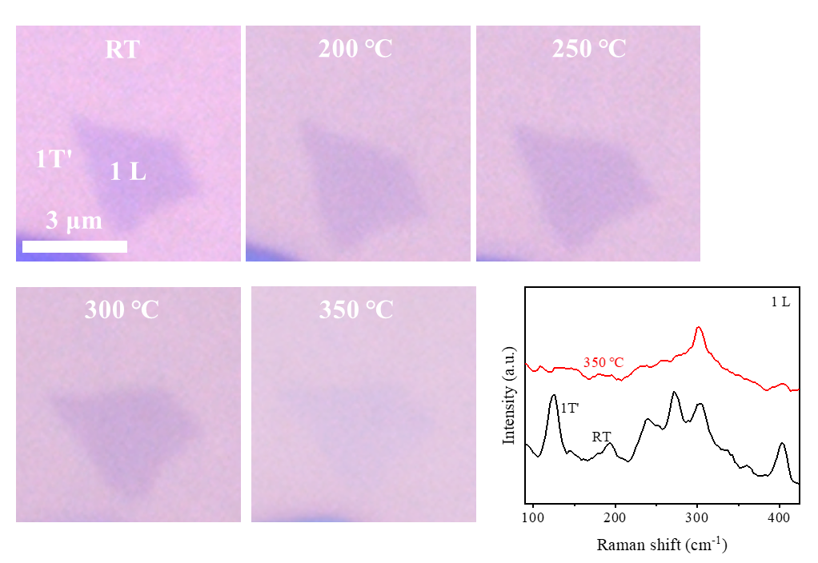

Supplementary Fig. 1. Optical images and Raman spectra of a piece of ML 1T’ WS₂ at different temperatures in the air. The flake can be hardly seen from the optical image when heated to 350 °C, and the corresponding Raman spectrogram does not show the WS₂ pattern at 350 °C, either. The disappearance of the tested ML 1T’ WS₂ at 350 °C is probably attributed to air oxidation.

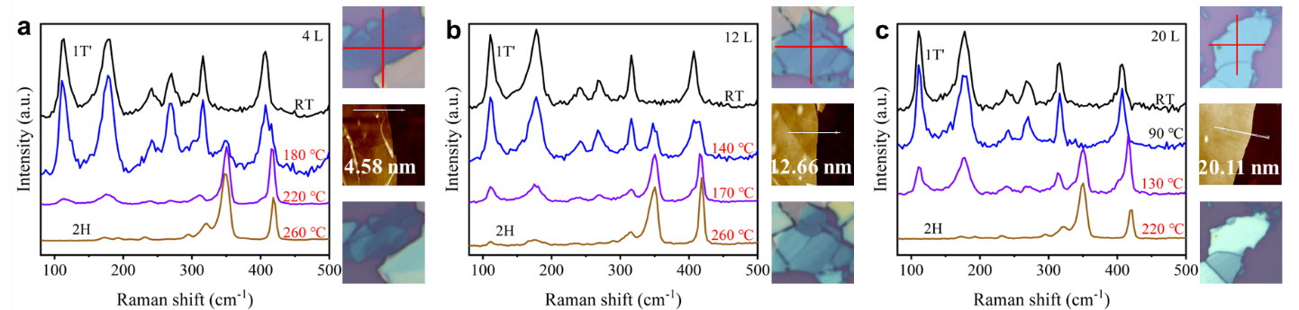

Supplementary Fig. 2. Optical and AFM images and Raman spectra of (a) 4 L, (b) 12 L and (c) 20 L 1T’ WS₂ flakes on Si/SiO₂ substrates at different temperatures in the air. 1T’ to 2H phase change can be identified when the Raman mode at 350.2 or 415.8 cm⁻¹ shows.

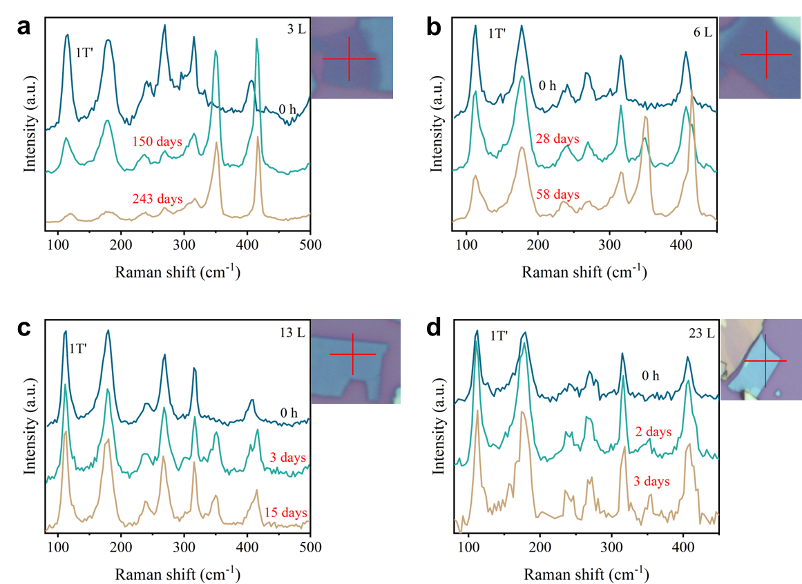

Supplementary Fig. 3. Optical images and Raman spectra of (a) 3 L, (b) 6 L, (c) 13 L and (d) 23 L 1T’ WS₂ flakes on Si/SiO₂ substrates storing in the air at room temperature. 1T’ to 2H phase change can be identified when the Raman mode at 350.2 or 415.8 cm⁻¹ shows.

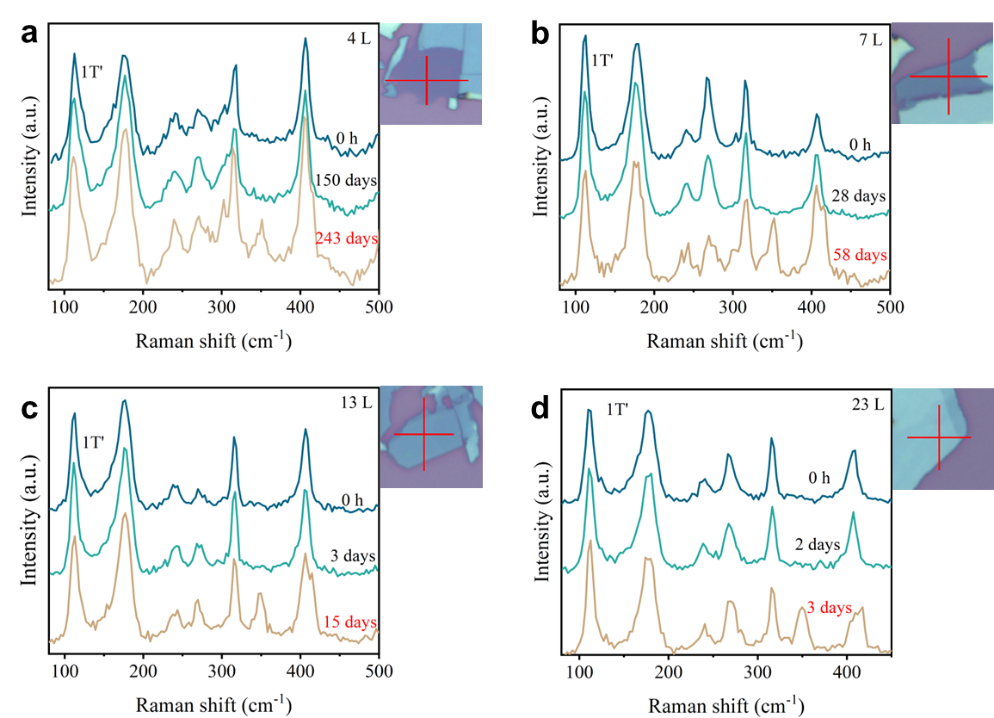

Supplementary Fig. 4. Optical images and Raman spectra of (a) 3 L, (b) 6 L, (c) 13 L and (d) 23 L 1T’ WS₂ flakes on Si/SiO₂ substrates storing in Ar atmosphere at room temperature. 1T’ to 2H phase change can be identified when the Raman mode at 350.2 or 415.8 cm⁻¹ shows.

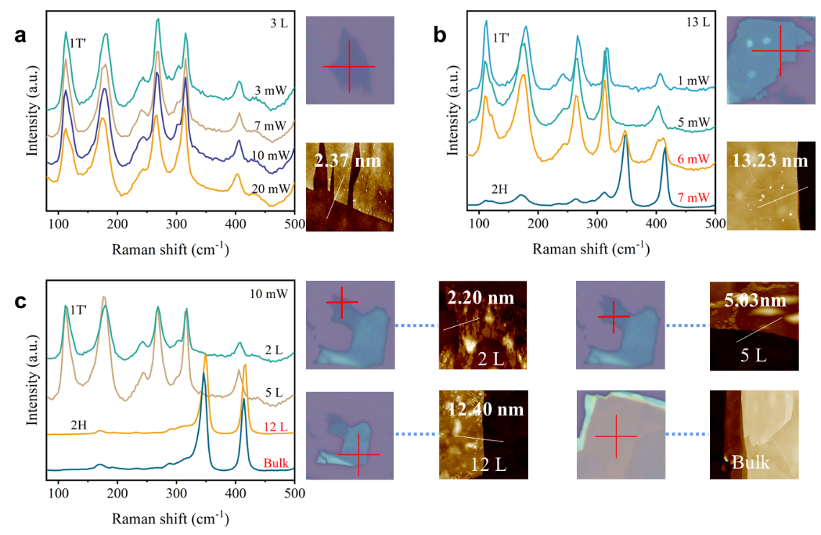

Supplementary Fig. 5. Optical and AFM images and Raman spectra of 1T’ WS₂ flakes with varied thickness on Si/SiO₂ substrates, measured at different layer power. 1T’ to 2H phase change can be identified when the Raman mode at 350.2 or 415.8 cm⁻¹ shows.

Supplementary Fig. 6. (a, c) Distorted octahedral coordinated W and S atoms and representative W‒S bond lengths and W‒S‒W angles and the average values in 1T’ WS₂. S1 atoms locate in C or A’ planes and S2 atoms locate in C’ or A planes as defined in Fig. 2a. (b, d) Trigonal prismatic coordinated W and S atoms and W‒S bond length and W‒S‒W angle in 2H WS₂. Color code: blue and orange spheres represent W and S, respectively.

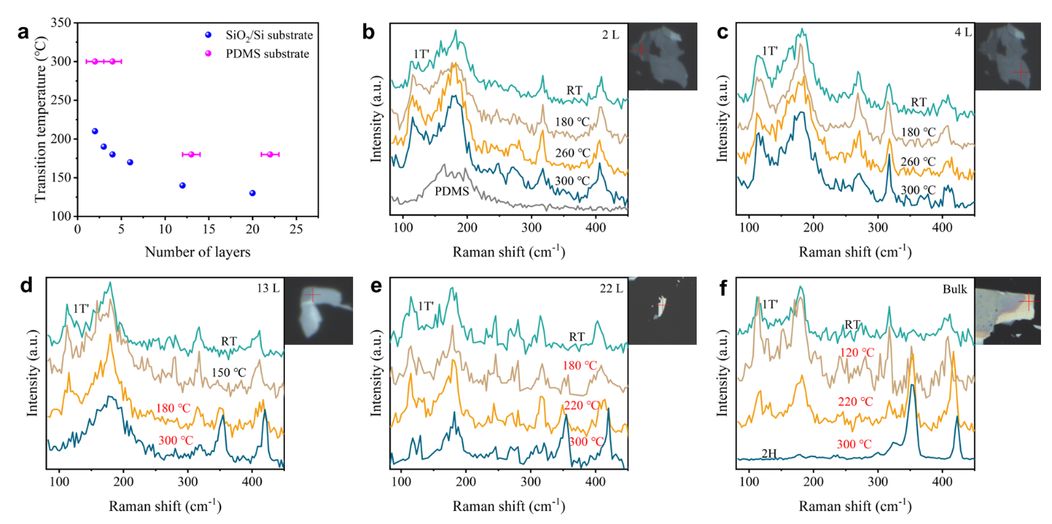

Supplementary Fig. 7. (a) 1T’ to 2H phase transition temperatures as a function of WS₂ layer thickness measured at PMDS and SiO₂/Si substrates in the air. In the heating program, temperature was elevated by 5 °C and held for 1 min in each step. RT is short of room temperature. (b-f) Optical images and Raman spectra of 1T’ WS₂ flakes with different thicknesses on PDMS substrates at different temperatures. 1T’ to 2H phase change can be identified when the Raman mode at 350.2 or 415.8 cm⁻¹ shows.

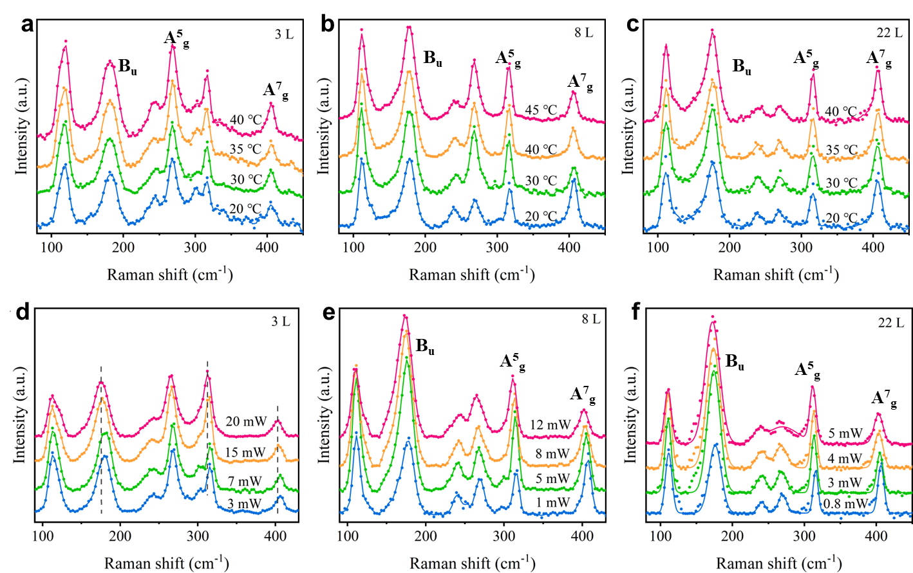

Supplementary Fig. 8. Raman spectra of a 3 L, an 8 L and a 22 L 1T’ WS₂ acquired (a-c) at different temperatures and (d-f) with different-power laser excitation.

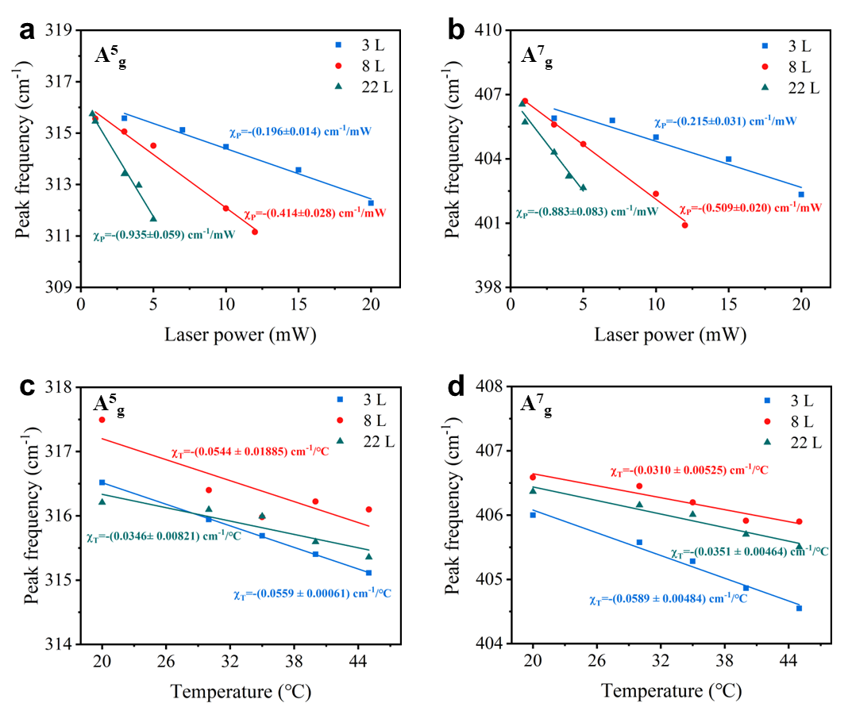

Supplementary Fig. 9. (a-b) Frequency of ${\text{A}}_{\text{g}}^{\text{5}}$ and ${\text{A}}_{\text{g}}^{\text{7}}$ Raman modes as functions of laser power and (c-d) frequency of ${\text{A}}_{\text{g}}^{\text{5}}$ and ${\text{A}}_{\text{g}}^{\text{7}}$ Raman modes as functions of temperature for 3 L, 8 L and 22 L 1T’ WS₂. Laser-power coefficient (${\text{χ}}_{\text{P}}$) and temperature coefficient (${\text{χ}}_{\text{T}}$) of Raman frequencies are extracted from the slopes of the corresponding plots.

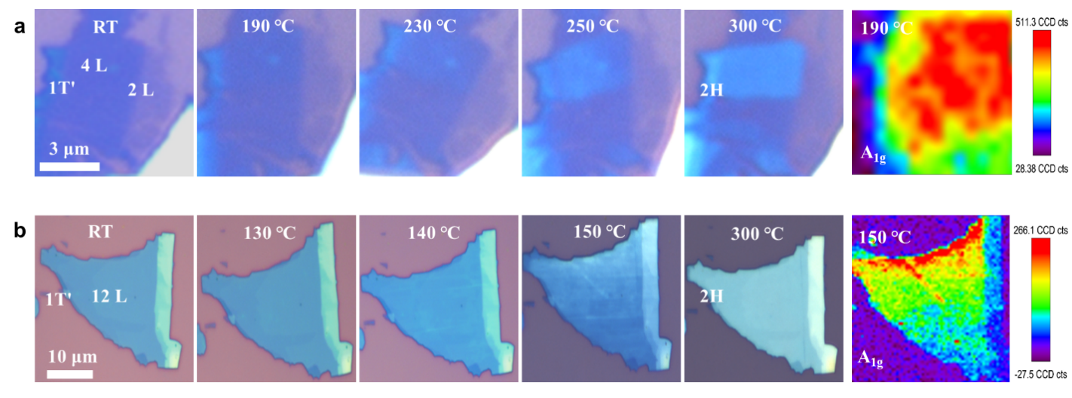

Supplementary Fig. 10. Optical images and E¹_{2g} Raman mode mappings of a piece of (a) 2 ~ 4 L and (b) 12 L 1T’ WS₂ at different temperatures in the air. In the heating program, temperature was elevated by 5 °C and held for 1 min in each step. RT is short of room temperature. The phase change area in the WS₂ flake turns opaque, since 2H WS₂ has a higher infraction index than 1T’ WS₂. 12 L WS₂ shows 1T’/2H stripes patterns during the heating program, but the 2 ~ 4 L WS₂ does not show this pattern.

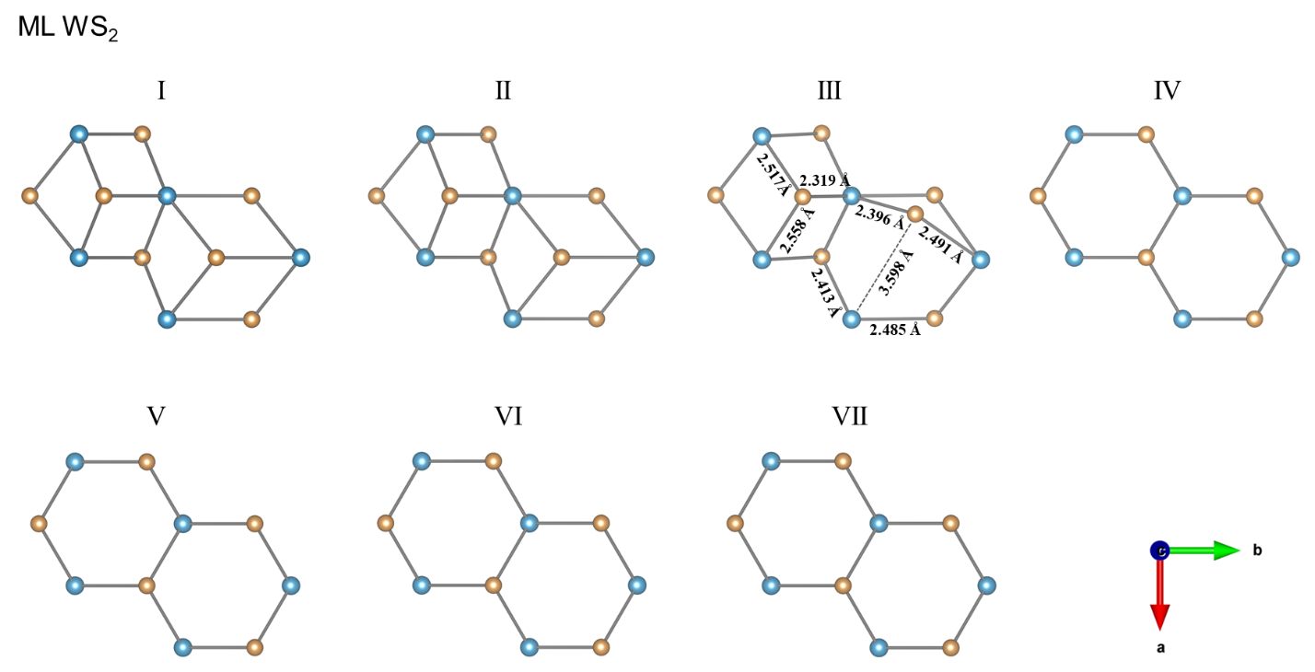

Supplementary Fig. 11. Snapshots of ML WS₂ molecular geometries at the initial 1T’ state (I), intermediate states (II to VI) and the final 2H state (VII), viewing from the c direction. Color code: blue and orange spheres represent W and S, respectively.

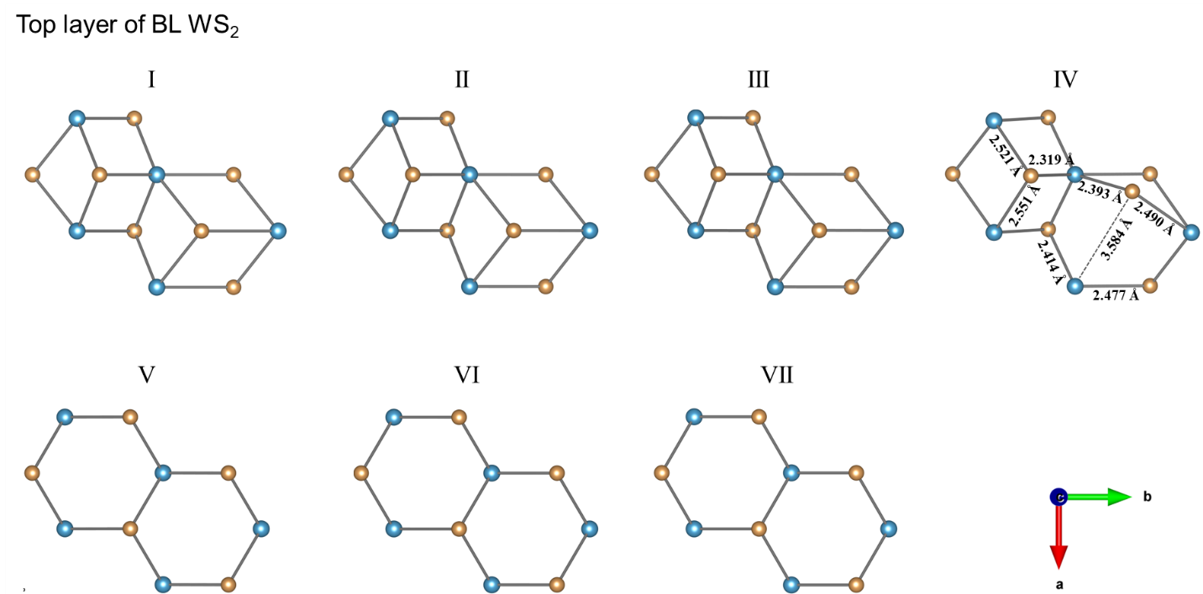

Supplementary Fig. 12. Snapshots of top layer of BL WS₂ molecular geometries at the initial 1T’ state (I), intermediate states (II to VI) and the final 2H state (VII), viewing from the c direction. Color code: blue and orange spheres represent W and S, respectively.

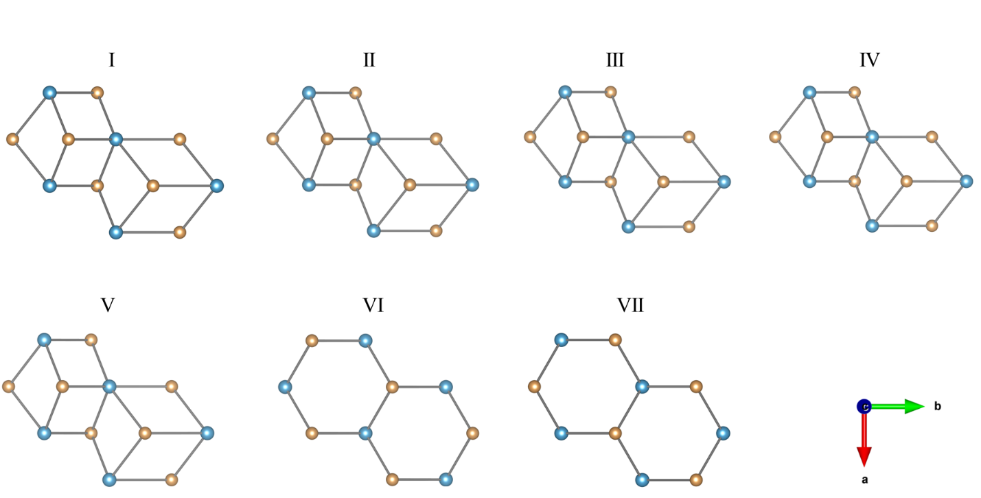

Supplementary Fig. 13. Snapshots of bottom layer of BL WS₂ molecular geometries at the initial 1T’ state (I), intermediate states (II to VI) and the final 2H state (VII), viewing from the c direction. Color code: blue and orange spheres represent W and S, respectively.

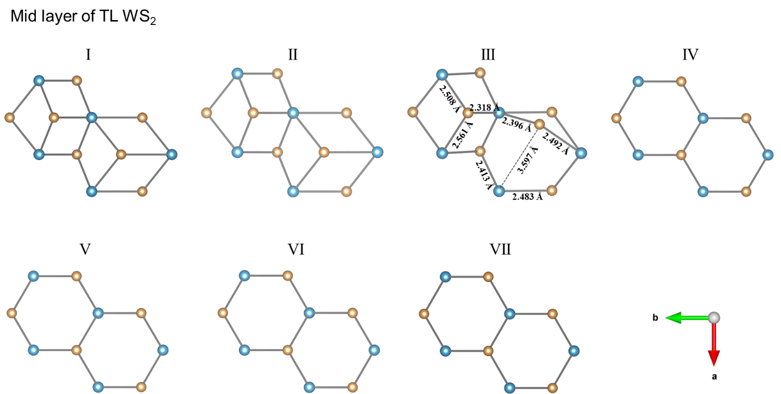

Supplementary Fig. 14. Snapshots of mid-layer layer of TL WS₂ molecular geometries at the initial 1T’ state (I), intermediate states (II to VI) and the final 2H state (VII), viewing from the c direction. Color code: blue and orange spheres represent W and S, respectively.

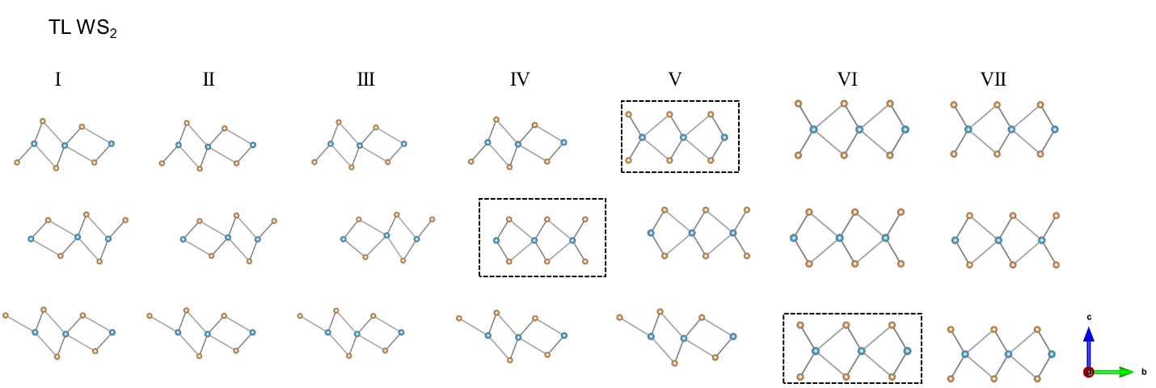

Supplementary Fig. 15. Snapshots of TL WS₂ molecular geometries at the initial 1T’ state (I), intermediate states (II to VI) and the final 2H state (VII), viewing from the a direction. Lattices marked by dotted squares turn from 1T’ to 2H types. Color code: blue and orange spheres represent W and S, respectively.

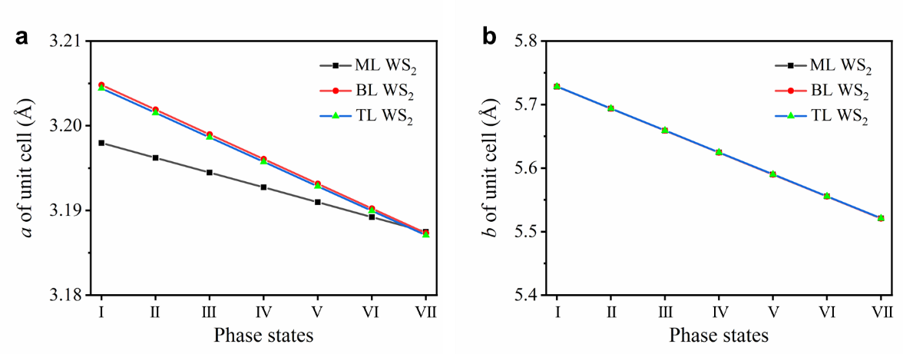

Supplementary Fig. 16. Variation of calculated WS₂ unit cell parameter of (a) a and (b) b in the initial 1T’ state (I), intermediate states (II to VI) and the final 2H state (VII), showing lattice shrinkages during 1T’ to 2H phase transitions.

