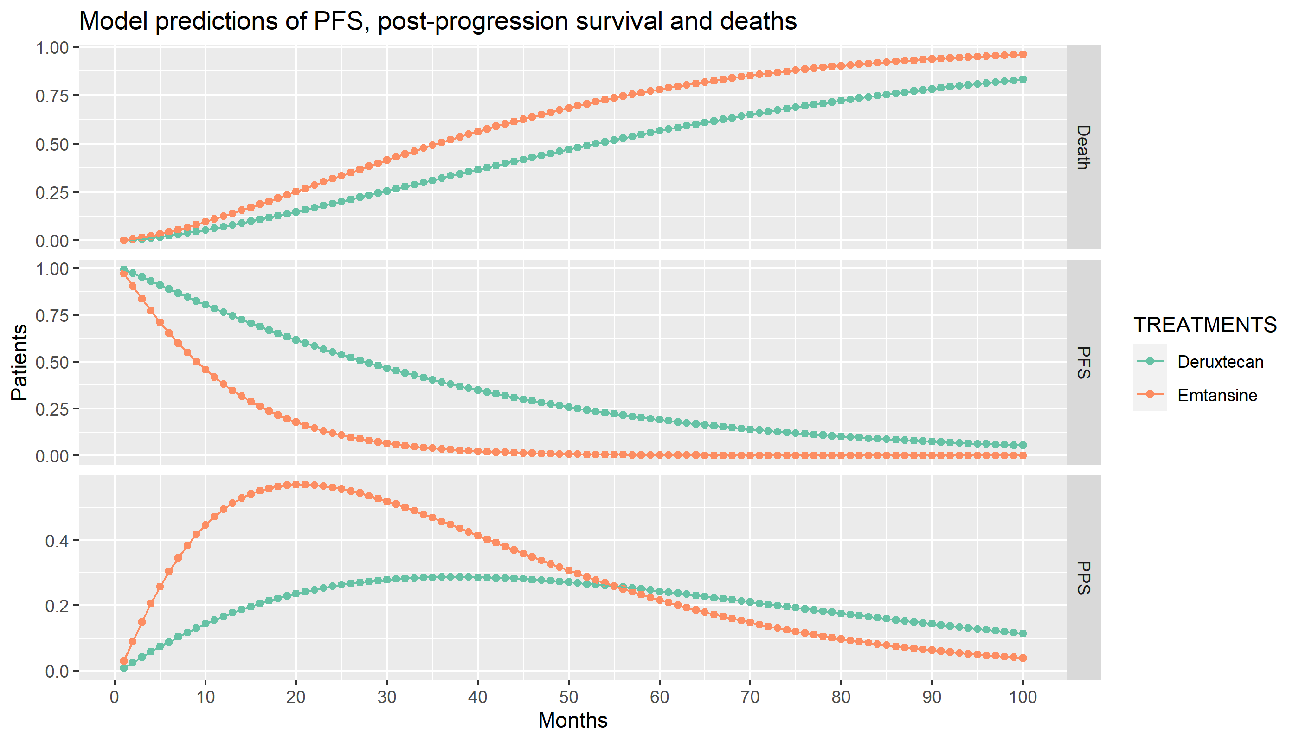
Supplementary Figure 3: Model predictions of PFS. Post-progression survival and deaths

