Supplementary information

Objective function equations

Minimize positive and negative deviation from current agricultural land
DeviationToProteinSupply=C​FG​PositiveDeviationToProteinSupplyC,FG+NegativeDeviationToProteinSupplyC,FG
where C is Country, FG is Food Group.

Minimize human nutrient gap
TotalHumanNutrientGap=C​N​HumanFoodNutrientGapC,N/MinimumNutrientRequirementN
where C is Country and N is human food macro and micronutrients used in the model.

Minimize Land use
TotalLand=C​Z​S​L​Crop​AgriculturalLandC,Z,S,L,Crop
where C is Country, Z is Climate Zones, S is Soil type, L is agricultural land type and Crop is the all the crops used in the model.

Minimize GHG emissions
TotalGHGEmissions=C​GHGEmissionsPerCountryC
where C is Country.

Supplementary figures

S1. Crop area per scenario and crop group
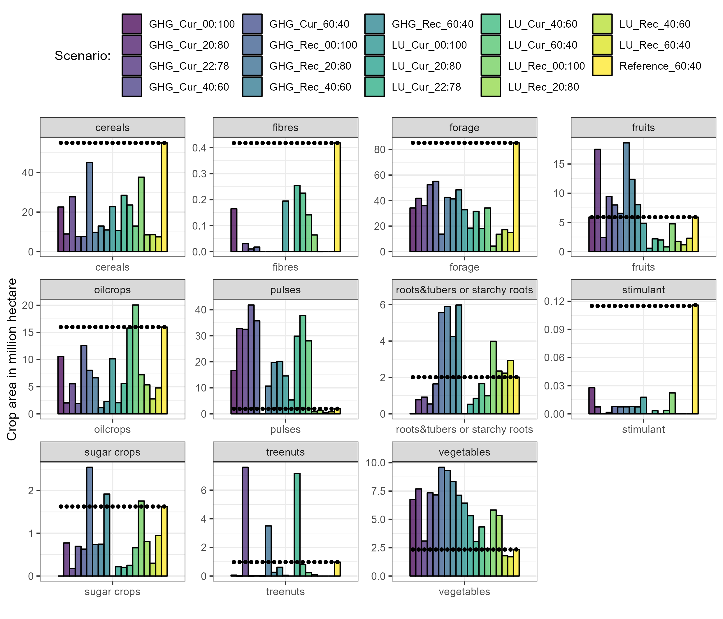 S1. Crop area per crop group on a EU28 level. Dots indicate the reference baseline.

S2. Relative deviation in life weight from reference scenario in percentage and per animal type
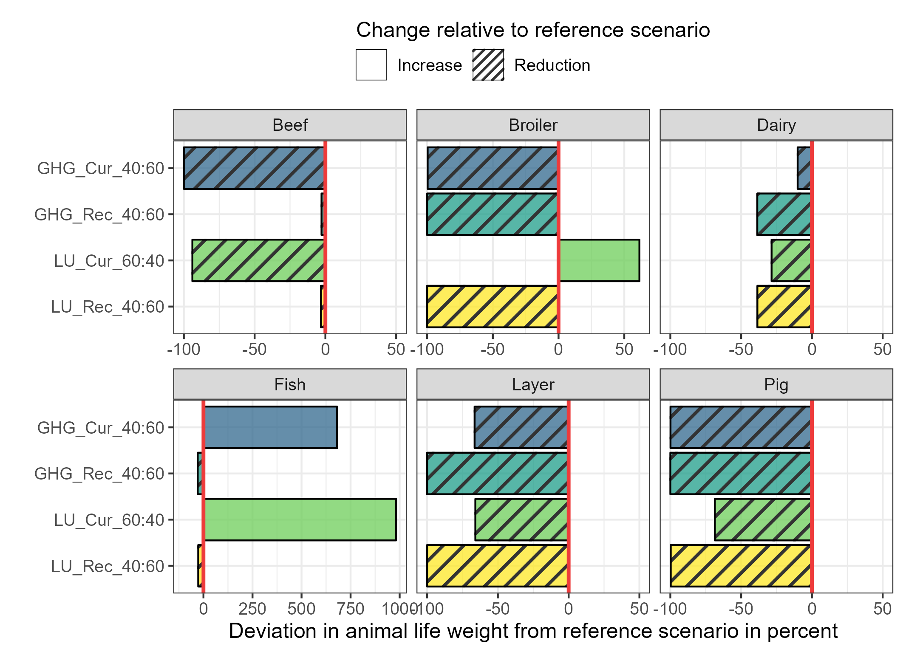
S2. Relative deviation in life weight from reference scenario in percentage and per animal type. The red line represents the reference (0% deviation). The stripes indicate a relative reduction of the animal type per scenario compared to the reference scenario.

S3. GHG emissions by scenario and source
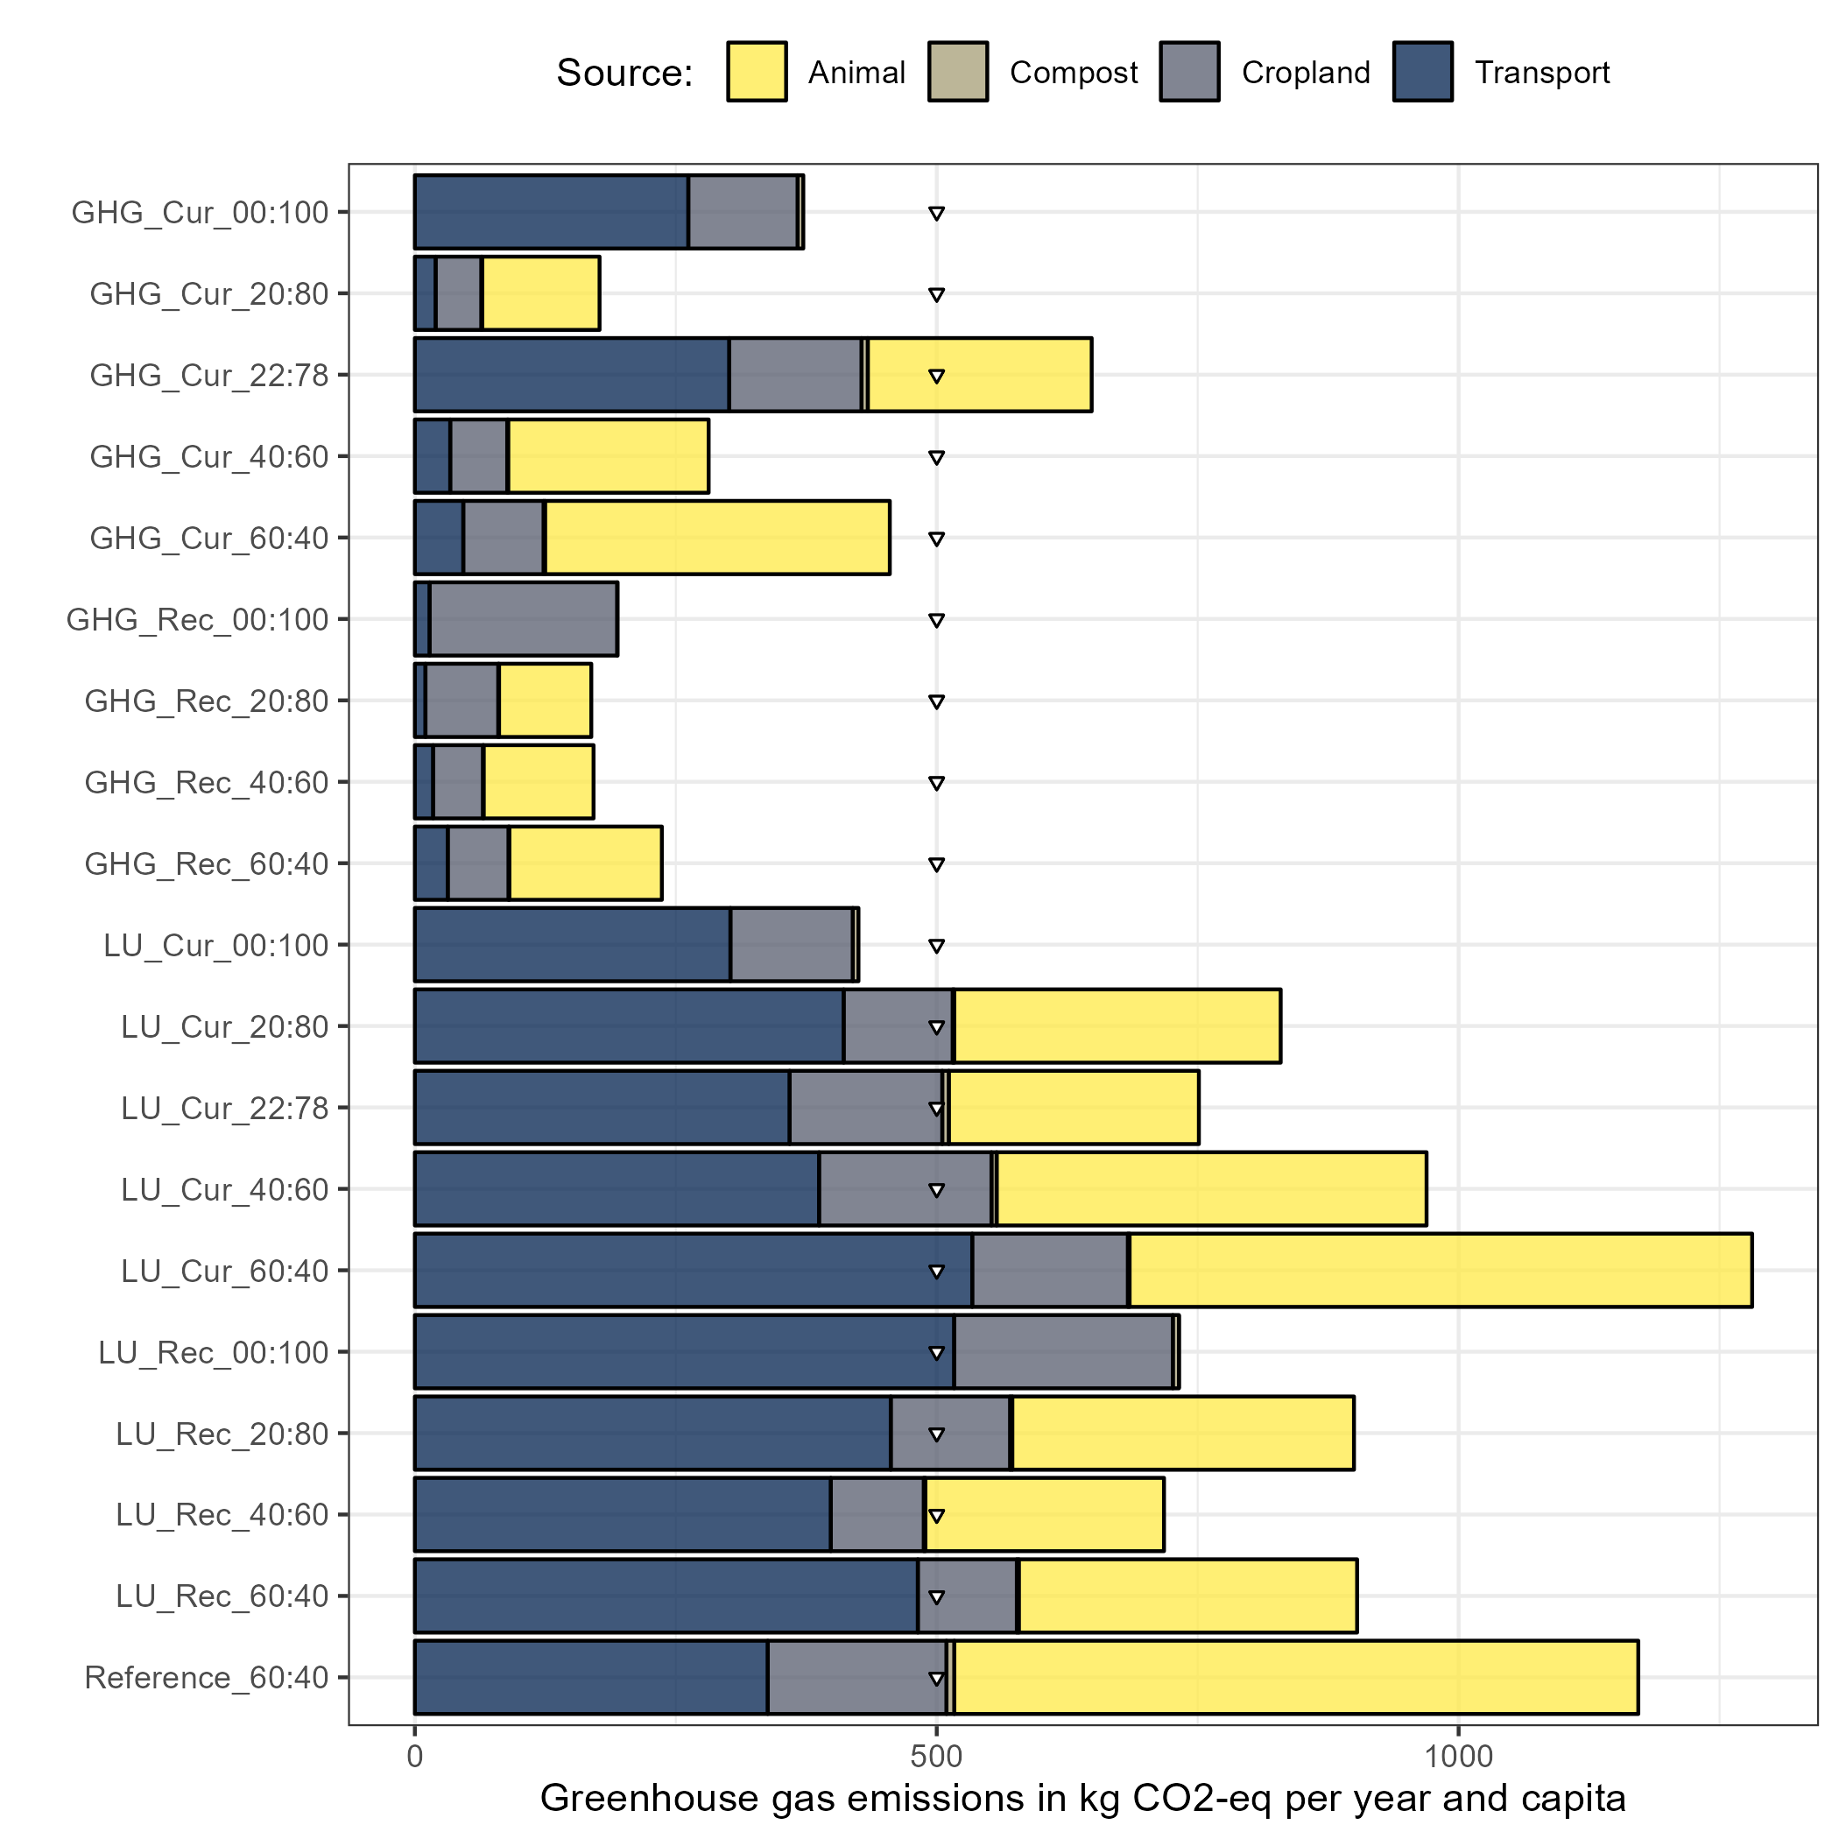
S3. Greenhouse gas emissions (GHG) by scenario and source. Dots indicated the sustainable amount of emissions from the food system per person and year (=500 kgCO2eq/capita/year).

