IMPAS analysis
I. S. Plank
24/06/2022

General information
This R Markdown document analyses pseudosynchrony of the videos used in the IMPAS study. It uses two approaches described by Moulder et al. (2018, Psychol Methods) to test the following hypotheses:
- data shuffling: “There is no time dependency at all between these two time series.”
- section sliding: “Synchrony does not exist between sections of size m in these two time series”
However, we will not apply dyad shuffling, as the authors only recommended it for larger samples than the one we have here. Additionally, since the conversations had the same prompt, there may be similarities due to a similar structure. Dyad shuffling checks the following hypothesis: “The amount of synchrony between participants engaged in conversation with one another is no different than participants not in conversation with one another”
To run this script, one would need two .RData files, one containing the synchrony values used for the power estimation “stm_data.RData” and one with the complete synchrony values “stm_data_complete.RData”. They are created by running “script_stim_ccf.R” and “script_stim_complete.R” respectively.
The following settings for the cross-correlation function were used (all in seconds): lag = 3 and both window size and increment = 10.

Data shuffling
Data shuffling is a kind of permutation test. From Moulder et al.: “For each pair of time series (X, Y) each data point, Xi, is randomly shuffled to create a new time series, Xs until no single data point existed at its original time point Xi!=Xjs.”. This new time series is then paired with an unchanged time series Y.
In this script, this is done in twice for each dyad, once so that the left partner is unchanged and once so that the right partner is unchanged. For each, 500 permutations are computed. Note that no check for uniqueness is performed. In the end, an average for this specific video is calculated from the 2*500 pseudosynchrony values.
dyad = c()
psync = c()
ls.ds = list()
filename = "shuffle_d.RData"
if (!file.exists(filename)) {
for (l in ls) {
for (m in 1:length(l)) {
d = strsplit(names(l)[m],"_")[[1]][2]
dyad = c(dyad, d)
val = c()
mea = l[[m]]
real = mea[["MEA"]]
for (i in 1:n) {
# shuffling left
mea[["MEA"]][,1] = sample(mea[["MEA"]][,1])
mea = MEAccf(mea, lagSec=lg, winSec=sz, incSec=sz)
val = c(val,mea[["ccfRes"]][["grandAver"]])
# shuffling right
mea[["MEA"]][,1] = real[,1]
mea[["MEA"]][,2] = sample(mea[["MEA"]][,2])
mea = MEAccf(mea, lagSec=lg, winSec=sz, incSec=sz)
val = c(val,mea[["ccfRes"]][["grandAver"]])
}
ls.ds = c(ls.ds,list(d,val))
psync = c(psync, mean(val,na.rm=T))
}
}
df.d_shuffle = data.frame(dyad,psync)
save(df.d_shuffle,ls.ds,file=filename)
} else {
load(filename)
}

Is there a time dependency between the time series?
df.d_shuffle = merge(df_sync[,c("dyad","all_lags_head","win_start")],df.d_shuffle,by="dyad",all.x=T)
td = ttestBF(x = df.d_shuffle$all_lags_head,
y = df.d_shuffle$psync,
paired=T)
td
## Bayes factor analysis
## --------------
## [1] Alt., r=0.707 : 97739616 ±0%
##
## Against denominator:
## Null, mu = 0
## ---
## Bayes factor type: BFoneSample, JZS
The paired t-test reveals extreme evidence in favour of a difference between the pseudosynchrony values obtained through data shuffling and the real synchrony values.
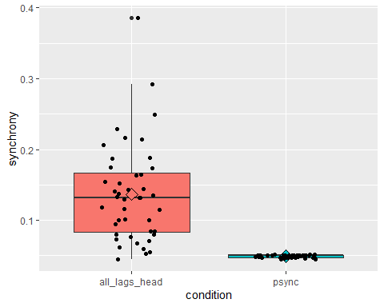
Figure 1: Difference between synchrony (all_lags_head) and pseudosynchrony (psync) obtained through data shuffling.

Segment shuffling
Segment shuffling, from Moulder et al., “requires researchers to cut a time series X into shorter sections of size m which are randomly appended to one another to create a new time series Xs until no section is in its original position”. This new time series is then paired with an unchanged time series Y.
In this script, this is done in twice for each dyad, once so that the left partner is unchanged and once so that the right partner is unchanged. For each, 500 permutations with 10-second segments are computed. Note that no check for uniqueness is performed. In the end, an average for this specific video is calculated from the 2*500 pseudosynchrony values.
dyad = c()
psync = c()
ls.ss = list()
filename = "shuffle_s.RData"
if (!file.exists(filename)) {
for (l in ls) {
for (m in 1:length(l)) {
d = strsplit(names(l)[m],"_")[[1]][2]
dyad = c(dyad, d)
val = c()
mea = l[[m]]
ch_L = split(mea[["MEA"]][,1], floor(seq_along(mea[["MEA"]][,1])/sz))
ch_R = split(mea[["MEA"]][,2], floor(seq_along(mea[["MEA"]][,2])/sz))
for (i in 1:n) {
# shuffling left
mea[["MEA"]][,2] = unlist(ch_R)
mea[["MEA"]][,1] = unlist(sample(ch_L))
mea = MEAccf(mea, lagSec=lg, winSec=sz, incSec=sz)
val = c(val,mea[["ccfRes"]][["grandAver"]])
# shuffling right
mea[["MEA"]][,1] = unlist(ch_L)
mea[["MEA"]][,2] = unlist(sample(ch_R))
mea = MEAccf(mea, lagSec=lg, winSec=sz, incSec=sz)
val = c(val,mea[["ccfRes"]][["grandAver"]])
}
ls.ss = c(ls.ss,list(d,val))
psync = c(psync, mean(val,na.rm=T))
}
}
df.s_shuffle = data.frame(dyad,psync)
save(df.s_shuffle,ls.ss,file=filename)
} else {
load(filename)
}

Is there synchrony between sections of size 10 seconds in these two time series?
df.s_shuffle = merge(df_sync[,c("dyad","all_lags_head","win_start")],df.s_shuffle,by="dyad",all.x=T)
ts = ttestBF(x = df.s_shuffle$all_lags_head,
y = df.s_shuffle$psync,
paired=T)
ts
## Bayes factor analysis
## --------------
## [1] Alt., r=0.707 : 10.83313 ±0%
##
## Against denominator:
## Null, mu = 0
## ---
## Bayes factor type: BFoneSample, JZS
The paired t-test reveals strong evidence in favour of a difference between the pseudosynchrony values obtained through segment shuffling and the real synchrony values.
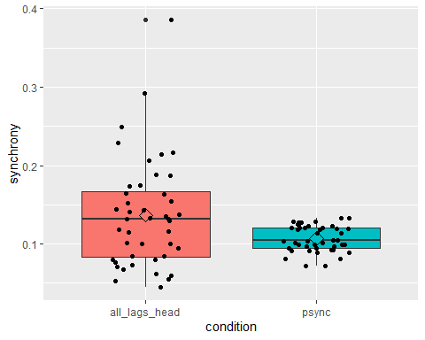
Figure 2: Difference between synchrony (all_lags_head) and pseudosynchrony (psync) obtained through segment shuffling.

Analysis

Software versions
R.Version()$version.string
## [1] "R version 4.2.2 (2022-10-31 ucrt)"
packageVersion('brms')
## [1] '2.18.0'
packageVersion('BayesFactor')
## [1] '0.9.12.4.4'
packageVersion('bayestestR')
## [1] '0.13.0'

Hypotheses
This study was preregistered after piloting 37 participants and before starting data collection. The goal was to analyse 195 datasets of people who have an AQ score below 6 and a WST score above 5.
We formulated the following hypotheses:
- Autistic interactants are judged differently compared to non-autistic interactants (non-directional, preregistered).
- Synchrony scores are associated with ratings (non-directional, preregistered).
- The effect of synchrony interacts with the diagnostic status of the interactant (non-directional, not preregistered)
- People fixate more often on autistic interactants due to idiosyncratic gestures associated with autism (directional, preregistered).
Additionally, we will investigate the interaction of leading and diagnostic status on ratings. We will use directional hypothesis testing in the direction of the estimate with an alpha of 2.5%, therefore, equivalent to a non-directional test with alpha set to 5% as preregistered.

Initialisation
First, let’s load all the data that we are going to need to investigate these hypotheses.
# load the relevant data in long format
df = read_csv("data/df_all.csv", show_col_types = F) %>%
mutate(sub_id = as.factor(sub_id)) %>%
mutate_if(is.character, as.factor) %>%
filter(WST >= 6) %>% # exclude people with IQ score that's too low
# exclude people that say themselves the data should not be used
filter(is.na(Seriousness_check) | Seriousness_check != "nein - meine Antworten sollten lieber nicht verwendet werden") %>%
mutate(aq_high = as.factor(AQ > 5), # add group: high or low aq
awk = 100 - awk) %>% # awkwardness rating needs to be reversed
rowwise() %>%
mutate(
imp = mean(c(int,lik,tru,awk,tlk,fri)),
diagnosis = recode_factor(as.factor(diagnosis),
"ASD" = "autistic",
"TD" = "non-autistic"
)
) %>%
rename("diagnostic status" = "diagnosis")
# have a closer look at the video specific values
df.sync = df %>% select(video, `diagnostic status`, sync,green_lead,white_lead,
mot_head,green_mot_head,white_mot_head) %>% distinct()
# first, let's check out our normal distributions of the predictors
# synchrony values are not normally distributed - but after log transforming they are
df.sync = df.sync %>%
mutate_at(vars(matches('sync|white_lead|green_lead')), log)
idx = grep("sync", colnames(df.sync))
lapply(df.sync[,idx:ncol(df.sync)], shapiro.test)
## $sync
##
## Shapiro-Wilk normality test
##
## data: X[[i]]
## W = 0.98897, p-value = 0.9453
##
##
## $green_lead
##
## Shapiro-Wilk normality test
##
## data: X[[i]]
## W = 0.98024, p-value = 0.6433
##
##
## $white_lead
##
## Shapiro-Wilk normality test
##
## data: X[[i]]
## W = 0.98358, p-value = 0.7761
##
##
## $mot_head
##
## Shapiro-Wilk normality test
##
## data: X[[i]]
## W = 0.96666, p-value = 0.2296
##
##
## $green_mot_head
##
## Shapiro-Wilk normality test
##
## data: X[[i]]
## W = 0.95324, p-value = 0.07266
##
##
## $white_mot_head
##
## Shapiro-Wilk normality test
##
## data: X[[i]]
## W = 0.95902, p-value = 0.1197
# now we can scale our predictors - Bodo Winter: "If in doubt, center"
df.sync[,idx:ncol(df.sync)] = scale(df.sync[,idx:ncol(df.sync)],scale=T)
# get rid of old values before merging data frames for analysis
df = df %>% select(-c(sync, green_lead, white_lead, mot_head, green_mot_head, white_mot_head))
df = merge(df,df.sync)
write_csv(df.sync, file = "data/df_sync-used.csv")
rm(list = c("df.sync"))
# setting contrasts (sum coding)
df$place = as.factor(df$place)
df$`diagnostic status` = as.factor(df$`diagnostic status`)
df$aq_high = as.factor(df$aq_high)
contrasts(df$aq_high) = contr.treatment(2, base = 2)
contrasts(df$`diagnostic status`) = contr.treatment(2, base = 2)
# turning sub and stm into simple numbers
df$sub = as.numeric(as.factor(df$sub_id))
df$stm = as.numeric(as.factor(df$video))
write_csv(df, "data/df_all_analysis.csv")

Sample description
df.sub = df %>% select(
sub_id, aq_high, AQ, WST, Alter, Bildung, Deutschsprachig, Erkrankung, Geschlecht,
Muttersprache, Sehhilfe, Kontakt_ASD) %>%
distinct()
kable(summary(df.sub[df.sub$aq_high == F,c(2:12)]))
 | aq_high | AQ | WST | Alter | Bildung | Deutschsprachig | Erkrankung | Geschlecht | Muttersprache | Sehhilfe | Kontakt_ASD
 | FALSE:196 | Min. :0.000 | Min. :15.00 | Min. :18.00 | Abitur/ Fachabitur :78 | 1-3 Jahre : 4 | nein:196 | männlich: 54 | ja :184 | Brille : 48 | Min. : 0.00
 | TRUE : 0 | 1st Qu.:1.000 | 1st Qu.:31.00 | 1st Qu.:23.00 | Bachelor :48 | 10+ Jahre :183 | NA | weiblich:142 | nein: 12 | keine benötigt:123 | 1st Qu.: 13.25
 | NA | Median :2.000 | Median :33.00 | Median :24.00 | Diplom/ Magister/ Master/ Staatsexamen :47 | 3-5 Jahre : 4 | NA | NA | NA | Kontaktlinsen : 25 | Median : 33.00
 | NA | Mean :2.388 | Mean :32.33 | Mean :26.56 | Abschluss einer anerkannten Berufsausbildung :11 | 5-10 Jahre : 2 | NA | NA | NA | NA | Mean : 36.77
 | NA | 3rd Qu.:3.000 | 3rd Qu.:35.00 | 3rd Qu.:28.00 | Meister-/Techniker- oder gleichwertiger Fachabschluss: 3 | mehr als ein Jahr: 1 | NA | NA | NA | NA | 3rd Qu.: 58.00
 | NA | Max. :5.000 | Max. :40.00 | Max. :59.00 | Promotion : 3 | Niemals : 2 | NA | NA | NA | NA | Max. :100.00
 | NA | NA | NA | NA | (Other) : 6 | NA | NA | NA | NA | NA | NA’s :18
kable(summary(df.sub[df.sub$aq_high == T,c(2:12)]))
Table 1: Demographic information describing the participants.
 | aq_high | AQ | WST | Alter | Bildung | Deutschsprachig | Erkrankung | Geschlecht | Muttersprache | Sehhilfe | Kontakt_ASD
 | FALSE: 0 | Min. : 6.000 | Min. :16.00 | Min. :19.00 | Abitur/ Fachabitur :21 | 1-3 Jahre : 3 | nein:49 | männlich:14 | ja :43 | Brille :12 | Min. : 0.00
 | TRUE :49 | 1st Qu.: 7.000 | 1st Qu.:32.00 | 1st Qu.:23.00 | Diplom/ Magister/ Master/ Staatsexamen :15 | 10+ Jahre :45 | NA | weiblich:35 | nein: 6 | keine benötigt:30 | 1st Qu.:11.00
 | NA | Median : 8.000 | Median :34.00 | Median :25.00 | Bachelor :12 | 3-5 Jahre : 1 | NA | NA | NA | Kontaktlinsen : 7 | Median :32.50
 | NA | Mean : 7.633 | Mean :32.69 | Mean :25.63 | Abschluss einer anerkannten Berufsausbildung : 1 | 5-10 Jahre : 0 | NA | NA | NA | NA | Mean :37.61
 | NA | 3rd Qu.: 9.000 | 3rd Qu.:35.00 | 3rd Qu.:27.00 | Haupt-/Volksschulabschluss : 0 | mehr als ein Jahr: 0 | NA | NA | NA | NA | 3rd Qu.:66.25
 | NA | Max. :10.000 | Max. :38.00 | Max. :44.00 | Meister-/Techniker- oder gleichwertiger Fachabschluss: 0 | Niemals : 0 | NA | NA | NA | NA | Max. :91.00
 | NA | NA | NA | NA | (Other) : 0 | NA | NA | NA | NA | NA | NA’s :5
We asked our participants to guess our research question. Let’s check how many guessed something with ASD:
df.rq = df %>% select(sub_id, `Was_untersucht?`) %>%
distinct()
mean(grepl("autis|Autis",df.rq$`Was_untersucht?`))
## [1] 0.04489796

H1, H2, H3: diagnostic status of the interactant and synchrony values
The first two hypotheses and the (not preregistered) interaction can all be tested with one model. According to our hypotheses, we are interested in the influence of diagnostic status and synchrony which are both within-subjects. Since the participants are supposed to rate one of the two interactants, we will break down synchrony into two scores: green_lead and white_lead. These factors are computed with lagged cross-correlations to estimate the influence of one interactant’s motion energy on the other interactant’s motion energy. We include both green_lead and white_lead as well as all interactions as fixed effects. Additionally, we include three factors for which variance we want to control, but we are not interested in their influence per se: green_mot_head, white_mot_head and place which are also within-subjects.

Choosing the model structure
Stimuli and subjects are our random effects: “A random factor is a factor whose levels are considered to represent a proper subset of all the levels in the population. Usually, you treat a factor as random when the levels you have in the data are the result of sampling, and you want to generalize beyond those levels. […] Rather than estimating the intercept and slope for each [level of the random effect] without considering the estimates for [the other levels], the model estimates values for the population, and pulls the estimates for individual [levels] toward those values, a statistical phenomenon known as shrinkage. […] The tradition in psychology when performing confirmatory analyses is to use the maximal random effects structure justified by the design of your study”. (Barr et al., 2021) Following Barr et al. (2021), we use the following guidelines to determine the nature of the random effects:
- If there are repeated measures on sampling units, you need a random intercept for that random factor: (1 | unit_id);
- If a factor x is between-unit, you do not need a random slope for that factor;
- Determine the highest order interaction of within-subject factors for the unit under consideration. If you have pseudoreplications within each cell defined by those combinations (i.e., multiple observations per cell), then for that unit you will need a slope for that interaction as well as for all lower order effects. If there are no pseudoreplications, then you do not need any random slopes.
According to (1), we need to add random intercepts to both stimuli and subjects: there are multiple stimuli per subject and multiple subjects per stimuli. The factors diagnostic status, green_lead, white_lead, green_mot_head, white_mot_head and place are all between-stimuli (one stimulus has one level), therefore, we don’t need any random slope for the random effect stimuli according to (2). However, they are all within-subjects (one subjects gets every level), so we need to have a look at their interactions and what is the highest order interaction that has pseudoreplications. The highest order interaction of these factors has only one measurement per subject associated with it, so there are no pseudoreplications. This is because each stimulus is only seen once per subject and each stimulus is associated with a unique green_lead, white_lead, green_mot_head and white_mot_head value. However, there are pseudoreplications of place and diagnostic status, so we add random slopes for these factors.

Unidimensionality analysis of the ratings
Instead of testing all six ratings separately, we will first investigate whether they might all measure the same concept, a composite impression score.
unidim(df[,c("awk","lik","tru","int","tlk","fri")])
##
## A measure of unidimensionality
## Call: unidim(x = df[, c("awk", "lik", "tru", "int", "tlk", "fri")])
##
## Unidimensionality index =
## u av.r fit fa.fit alpha av.r median.r Unidim.A
## 0.87 0.88 0.98 0.86 0.50 0.56 1.00
##
## unidim adjusted index reverses negatively scored items.
## alpha Based upon reverse scoring some items.
## average and median correlations are based upon reversed scored items
Reasonably high factor fit of 0.98 suggests that the variables might measure the same concept. Therefore, we will test our hypotheses with this composite score.

Investigate distribution of the outcome
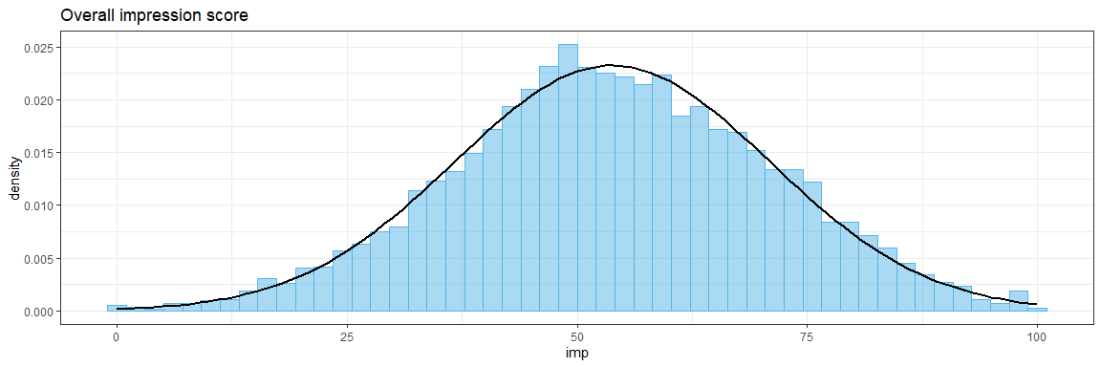
Figure 3: Distribution of the composite score integrating all ratings to an impression score.

Low AQ group: composite score

Model summary and assumptions check
# marginal R2 describes the proportion of variance explained by the fixed factor(s)
# conditional R2 describes the proportion of variance explained by both the fixed and random factors
if (file.exists("models/brm_imp.rds")) {
mimp = readRDS('models/brm_imp.rds')
} else {
mimp = brm(formula = imp ~
`diagnostic status`* green_lead * white_lead + # fixed effects
green_mot_head + white_mot_head + place + # regressors of no interest
(`diagnostic status`+ place|sub) + (1|stm), # random effects
data = df[df$aq_high == F,],
control = list(adapt_delta = 0.99,
max_treedepth = 13),
save_pars = save_pars(all = T),
chains = 4,
warmup = nw, iter = nw*2)
saveRDS(mimp, file = 'models/brm_imp.rds')
}
summary(mimp)
## Family: gaussian
## Links: mu = identity; sigma = identity
## Formula: imp ~ diagnosis * green_lead * white_lead + green_mot_head + white_mot_head + place + (diagnosis + place | sub) + (1 | stm)
## Data: df[df$aq_high == F, ] (Number of observations: 8624)
## Draws: 4 chains, each with iter = 10000; warmup = 5000; thin = 1;
## total post-warmup draws = 20000
##
## Group-Level Effects:
## ~stm (Number of levels: 44)
## Estimate Est.Error l-95% CI u-95% CI Rhat Bulk_ESS Tail_ESS
## sd(Intercept) 6.32 0.83 4.93 8.15 1.00 6755 11241
##
## ~sub (Number of levels: 196)
## Estimate Est.Error l-95% CI u-95% CI Rhat Bulk_ESS
## sd(Intercept) 7.71 0.46 6.85 8.65 1.00 6850
## sd(diagnosis1) 4.37 0.41 3.59 5.21 1.00 7434
## sd(placeMN) 4.04 0.40 3.27 4.84 1.00 8441
## cor(Intercept,diagnosis1) -0.17 0.10 -0.36 0.03 1.00 11205
## cor(Intercept,placeMN) -0.10 0.10 -0.30 0.11 1.00 11825
## cor(diagnosis1,placeMN) -0.28 0.13 -0.52 -0.02 1.00 5661
## Tail_ESS
## sd(Intercept) 10249
## sd(diagnosis1) 12807
## sd(placeMN) 13543
## cor(Intercept,diagnosis1) 13745
## cor(Intercept,placeMN) 14471
## cor(diagnosis1,placeMN) 9044
##
## Population-Level Effects:
## Estimate Est.Error l-95% CI u-95% CI Rhat
## Intercept 52.32 2.29 47.76 56.82 1.00
## diagnosis1 -4.93 2.57 -10.00 0.15 1.00
## green_lead 4.46 2.13 0.29 8.70 1.00
## white_lead -2.61 2.30 -7.22 1.90 1.00
## green_mot_head 2.77 1.28 0.29 5.32 1.00
## white_mot_head 3.09 1.44 0.25 5.96 1.00
## placeMN 5.80 2.35 1.26 10.43 1.00
## diagnosis1:green_lead -6.70 2.58 -11.87 -1.65 1.00
## diagnosis1:white_lead 2.36 2.61 -2.74 7.52 1.00
## green_lead:white_lead 0.20 1.71 -3.15 3.58 1.00
## diagnosis1:green_lead:white_lead -0.12 2.19 -4.42 4.15 1.00
## Bulk_ESS Tail_ESS
## Intercept 5580 8212
## diagnosis1 6206 10054
## green_lead 6398 9343
## white_lead 6230 9124
## green_mot_head 6653 9297
## white_mot_head 6157 9133
## placeMN 6533 9622
## diagnosis1:green_lead 6963 9505
## diagnosis1:white_lead 6771 10137
## green_lead:white_lead 7322 10777
## diagnosis1:green_lead:white_lead 7779 11230
##
## Family Specific Parameters:
## Estimate Est.Error l-95% CI u-95% CI Rhat Bulk_ESS Tail_ESS
## sigma 13.01 0.10 12.81 13.21 1.00 32015 14279
##
## Draws were sampled using sampling(NUTS). For each parameter, Bulk_ESS
## and Tail_ESS are effective sample size measures, and Rhat is the potential
## scale reduction factor on split chains (at convergence, Rhat = 1).
# check assumptions for this model
check_model(mimp, check=c("qq","linearity","homogeneity","reqq","vif","pp_check"))
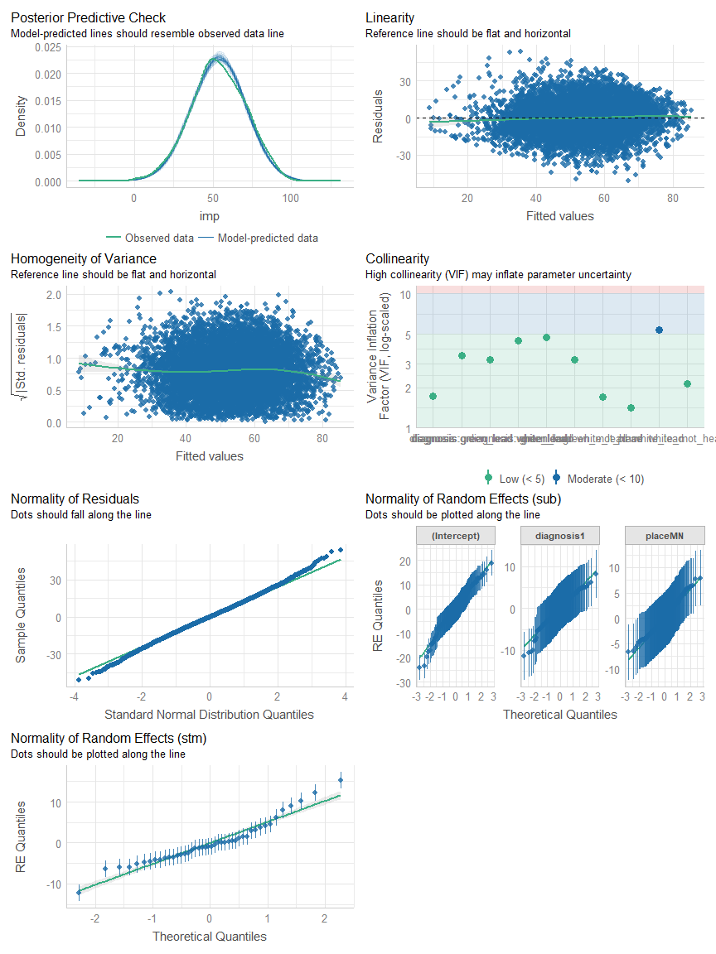
Figure 4: Checking the assumptions of the Bayesian linear mixed model investigating the predictors of the composite impression score.

Plot estimates and test hypotheses
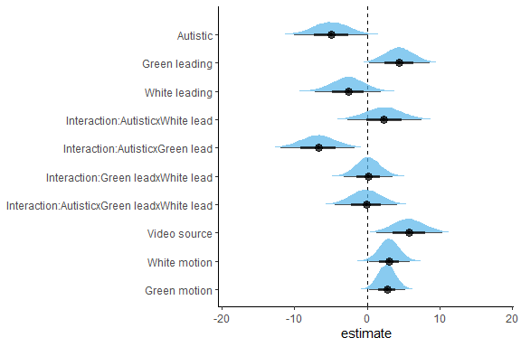
Figure 5: Plot the estimates of the predictors of the composite impression score.
# H1: effect of autism diagnosis
hypothesis(mimp, "diagnosis1 < 0", alpha = 0.025)
## Hypothesis Tests for class b:
## Hypothesis Estimate Est.Error CI.Lower CI.Upper Evid.Ratio Post.Prob
## 1 (diagnosis1) < 0 -4.93 2.57 -10 0.15 34.27 0.97
## Star
## 1
## ---
## 'CI': 95%-CI for one-sided and 97.5%-CI for two-sided hypotheses.
## '*': For one-sided hypotheses, the posterior probability exceeds 97.5%;
## for two-sided hypotheses, the value tested against lies outside the 97.5%-CI.
## Posterior probabilities of point hypotheses assume equal prior probabilities.
# H2: effect of synchrony
hypothesis(mimp, "green_lead > 0", alpha = 0.025) # for non-autistic
## Hypothesis Tests for class b:
## Hypothesis Estimate Est.Error CI.Lower CI.Upper Evid.Ratio Post.Prob
## 1 (green_lead) > 0 4.46 2.13 0.29 8.7 53.79 0.98
## Star
## 1 *
## ---
## 'CI': 95%-CI for one-sided and 97.5%-CI for two-sided hypotheses.
## '*': For one-sided hypotheses, the posterior probability exceeds 97.5%;
## for two-sided hypotheses, the value tested against lies outside the 97.5%-CI.
## Posterior probabilities of point hypotheses assume equal prior probabilities.
hypothesis(mimp, "white_lead < 0", alpha = 0.025) # for non-autistic
## Hypothesis Tests for class b:
## Hypothesis Estimate Est.Error CI.Lower CI.Upper Evid.Ratio Post.Prob
## 1 (white_lead) < 0 -2.61 2.3 -7.22 1.9 7.08 0.88
## Star
## 1
## ---
## 'CI': 95%-CI for one-sided and 97.5%-CI for two-sided hypotheses.
## '*': For one-sided hypotheses, the posterior probability exceeds 97.5%;
## for two-sided hypotheses, the value tested against lies outside the 97.5%-CI.
## Posterior probabilities of point hypotheses assume equal prior probabilities.
# H3
hypothesis(mimp, "diagnosis1:green_lead < 0", alpha = 0.025)
## Hypothesis Tests for class b:
## Hypothesis Estimate Est.Error CI.Lower CI.Upper Evid.Ratio
## 1 (diagnosis1:green... < 0 -6.7 2.58 -11.87 -1.65 185.92
## Post.Prob Star
## 1 0.99 *
## ---
## 'CI': 95%-CI for one-sided and 97.5%-CI for two-sided hypotheses.
## '*': For one-sided hypotheses, the posterior probability exceeds 97.5%;
## for two-sided hypotheses, the value tested against lies outside the 97.5%-CI.
## Posterior probabilities of point hypotheses assume equal prior probabilities.
hypothesis(mimp, "diagnosis1:white_lead > 0", alpha = 0.025)
## Hypothesis Tests for class b:
## Hypothesis Estimate Est.Error CI.Lower CI.Upper Evid.Ratio
## 1 (diagnosis1:white... > 0 2.36 2.61 -2.74 7.52 4.5
## Post.Prob Star
## 1 0.82
## ---
## 'CI': 95%-CI for one-sided and 97.5%-CI for two-sided hypotheses.
## '*': For one-sided hypotheses, the posterior probability exceeds 97.5%;
## for two-sided hypotheses, the value tested against lies outside the 97.5%-CI.
## Posterior probabilities of point hypotheses assume equal prior probabilities.
hypothesis(mimp, "diagnosis1:green_lead:white_lead < 0", alpha = 0.025)
## Hypothesis Tests for class b:
## Hypothesis Estimate Est.Error CI.Lower CI.Upper Evid.Ratio
## 1 (diagnosis1:green... < 0 -0.12 2.19 -4.42 4.15 1.1
## Post.Prob Star
## 1 0.52
## ---
## 'CI': 95%-CI for one-sided and 97.5%-CI for two-sided hypotheses.
## '*': For one-sided hypotheses, the posterior probability exceeds 97.5%;
## for two-sided hypotheses, the value tested against lies outside the 97.5%-CI.
## Posterior probabilities of point hypotheses assume equal prior probabilities.
As we can see, there is an interaction between diagnostic status and green_lead. We will compute correlations to investigate this interaction further. We also plot the data with a linear model line added to it.
## `summarise()` has grouped output by 'video'. You can override using the
## `.groups` argument.
##
## Pearson's product-moment correlation
##
## data: df.agg[df.agg$`diagnostic status` == "autistic", ]$imp and df.agg[df.agg$`diagnostic status` == "autistic", ]$green_lead
## t = -0.16349, df = 20, p-value = 0.8718
## alternative hypothesis: true correlation is not equal to 0
## 95 percent confidence interval:
## -0.4511928 0.3910985
## sample estimates:
## cor
## -0.03653411
##
## Pearson's product-moment correlation
##
## data: df.agg[df.agg$`diagnostic status` == "non-autistic", ]$imp and df.agg[df.agg$`diagnostic status` == "non-autistic", ]$green_lead
## t = 2.9775, df = 20, p-value = 0.007442
## alternative hypothesis: true correlation is not equal to 0
## 95 percent confidence interval:
## 0.1730182 0.7909895
## sample estimates:
## cor
## 0.5542
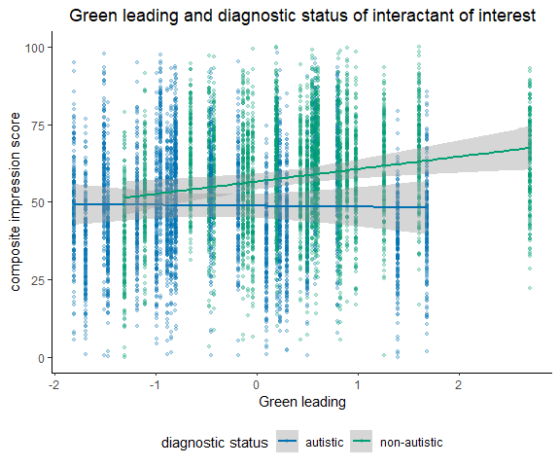
Figure 6: Association between impression and green interactant leading.

H4: fixations and diagnostic status of the interactant
Hypothesis 4 states that people fixate more often on interactants with autism due to idiosyncratic gestures associated with autism. We have the proportions of time that people looked at the left versus the right side of the screen. From this and the position of the interactants we can compute the percentage that people were watching the green autistic interactant and the green non-autistic interactant. We also need to exclude participants for whom the eye tracking did not work / worked badly. In the preprocessing of the eye tracking data, we have set a confidence threshold of 70% as well as a fixation threshold of 50ms. Only participants with at least 100 usable trials will be included in the analysis.
# first, we need to distinguish between the green (target) and the white (non-target) person's side
df$green_prop = NA
df[df$position_true == "Links",]$green_prop = df[df$position_true == "Links",]$L_prop
df[df$position_true == "Rechts",]$green_prop = df[df$position_true == "Rechts",]$R_prop
df$white_prop = NA
df[df$position_true == "Links",]$white_prop = df[df$position_true == "Links",]$R_prop
df[df$position_true == "Rechts",]$white_prop = df[df$position_true == "Rechts",]$L_prop
# then, we create a new data frame, filtering out trials with less than 400 samples,
# and proportions as well as switches that are outliers according to the IQR method.
# lastly, participants with less than 50% of the trials left are excluded.
df.et = df %>% mutate(
et = Trial_number >= 400
) %>%
replace_na(list(et = FALSE)) %>%
filter(aq_high == F, et == T) %>%
group_by(sub_id) %>%
mutate(
Vid_trials = n()
) %>% filter(Vid_trials >= 22)
# have a look at the remaining sample
df.et.sub = df.et %>% select(Alter, Geschlecht, Vid_trials) %>% distinct()
## Adding missing grouping variables: `sub_id`
summary(df.et.sub)
## sub_id Alter Geschlecht Vid_trials
## 5339563: 1 Min. :19.00 männlich:30 Min. :24.0
## 5416927: 1 1st Qu.:22.00 weiblich:61 1st Qu.:37.0
## 5419762: 1 Median :24.00 Median :43.0
## 5420374: 1 Mean :25.62 Mean :40.2
## 5428557: 1 3rd Qu.:27.00 3rd Qu.:44.0
## 5432166: 1 Max. :59.00 Max. :44.0
## (Other):85
# let's do a sanity check: did they look more often at the green person?
df.san = df.et %>%
select(sub, stm, white_prop, green_prop) %>%
pivot_longer(cols = c(green_prop, white_prop), names_to = "target", values_to = "proportion") %>%
separate(target, c("target", "lose")) %>%
select(-lose) %>% group_by(sub, target) %>%
summarise(
prop_agg = mean(proportion)
) %>% ungroup() %>%
mutate(
IQR = IQR(prop_agg),
upper = quantile(prop_agg, probs=c(0.75), na.rm = T) + 1.5*IQR,
lower = quantile(prop_agg, probs=c(0.25), na.rm = T) - 1.5*IQR
) %>%
filter(lower <= prop_agg & prop_agg <= upper)
## Adding missing grouping variables: `sub_id`
## `summarise()` has grouped output by 'sub'. You can override using the `.groups`
## argument.
mean(df.san[df.san$target == "green",]$prop_agg)
## [1] 0.6447416
mean(df.san[df.san$target == "white",]$prop_agg)
## [1] 0.3552584
# assumptions
var.test(df.san[df.san$target == "white",]$prop_agg, df.san[df.san$target == "green",]$prop_agg)
##
## F test to compare two variances
##
## data: df.san[df.san$target == "white", ]$prop_agg and df.san[df.san$target == "green", ]$prop_agg
## F = 1, num df = 90, denom df = 90, p-value = 1
## alternative hypothesis: true ratio of variances is not equal to 1
## 95 percent confidence interval:
## 0.6597954 1.5156213
## sample estimates:
## ratio of variances
## 1
shapiro.test(df.san[df.san$target == "white",]$prop_agg)
##
## Shapiro-Wilk normality test
##
## data: df.san[df.san$target == "white", ]$prop_agg
## W = 0.98326, p-value = 0.2941
shapiro.test(df.san[df.san$target == "green",]$prop_agg)
##
## Shapiro-Wilk normality test
##
## data: df.san[df.san$target == "green", ]$prop_agg
## W = 0.98326, p-value = 0.2941
# Bayesian t-test
ttestBF(x = df.san[df.san$target == "white",]$prop_agg,
y = df.san[df.san$target == "green",]$prop_agg,
paired = T)
## Bayes factor analysis
## --------------
## [1] Alt., r=0.707 : 1.185461e+21 ±0%
##
## Against denominator:
## Null, mu = 0
## ---
## Bayes factor type: BFoneSample, JZS
# plot the two
ggplot(df.san, aes(x = prop_agg, fill = target)) + geom_density(alpha=.3) +
scale_fill_manual(values = c(gr,db))
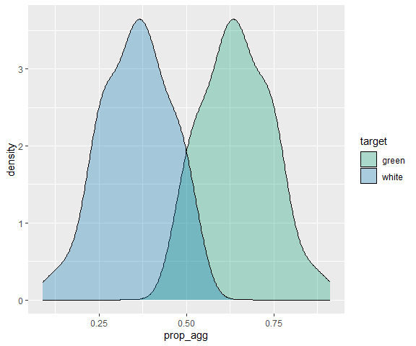
Figure 7: Proportion of the fixation time spent on the side of the green and the white person, showing that participants attending more strongly to the green interactant of interest.
Our sanity check works out nicely, showing that indeed the participants spent more time looking on the screen half that showed the green compared to the white person.
# let's check whether people looked more at the green person when it was an autistic person?
df.prop = df.et %>%
select(sub, stm, `diagnostic status`, green_prop) %>%
group_by(sub, `diagnostic status`) %>%
summarise(
prop_agg = mean(green_prop)
) %>% ungroup() %>%
mutate(
IQR = IQR(prop_agg),
upper = quantile(prop_agg, probs=c(0.75), na.rm = T) + 1.5*IQR,
lower = quantile(prop_agg, probs=c(0.25), na.rm = T) - 1.5*IQR
) %>%
filter(lower <= prop_agg & prop_agg <= upper) %>%
pivot_wider(names_from = `diagnostic status`, values_from = prop_agg) %>%
drop_na()
## Adding missing grouping variables: `sub_id`
## `summarise()` has grouped output by 'sub'. You can override using the `.groups`
## argument.
mean(df.prop$autistic)
## [1] 0.6500534
sd(df.prop$autistic)
## [1] 0.1042532
mean(df.prop$"non-autistic")
## [1] 0.6399938
sd(df.prop$"non-autistic")
## [1] 0.1049138
# assumptions
var.test(df.prop$autistic, df.prop$`non-autistic`)
##
## F test to compare two variances
##
## data: df.prop$autistic and df.prop$`non-autistic`
## F = 0.98745, num df = 90, denom df = 90, p-value = 0.9523
## alternative hypothesis: true ratio of variances is not equal to 1
## 95 percent confidence interval:
## 0.6515119 1.4965930
## sample estimates:
## ratio of variances
## 0.9874452
shapiro.test(df.prop$autistic)
##
## Shapiro-Wilk normality test
##
## data: df.prop$autistic
## W = 0.98451, p-value = 0.356
shapiro.test(df.prop$`non-autistic`)
##
## Shapiro-Wilk normality test
##
## data: df.prop$`non-autistic`
## W = 0.98284, p-value = 0.2755
# Bayesian t-test
ttestBF(x = df.prop$autistic,
y = df.prop$`non-autistic`,
paired = T)
## Bayes factor analysis
## --------------
## [1] Alt., r=0.707 : 0.2937007 ±0.06%
##
## Against denominator:
## Null, mu = 0
## ---
## Bayes factor type: BFoneSample, JZS
# plot the two
ggplot(df.prop %>% pivot_longer(cols = c(autistic, `non-autistic`), names_to = "diagnostic status"), aes(x = value, fill = `diagnostic status`)) + geom_density(alpha=.3) +
scale_fill_manual(values = c(gr,db))
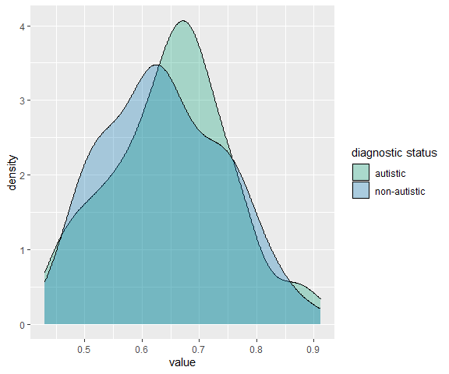
Figure 8: Proportion of time spent on autistic and non-autistic interactants of interest.
# let's check whether people performed more switches in the mixed condition?
df.switch = df.et %>%
select(sub, stm, `diagnostic status`, Switches, Trial_number) %>%
group_by(sub, `diagnostic status`) %>%
summarise(
switch_agg = (mean(Switches) * 100) / mean(Trial_number)
) %>% ungroup() %>%
mutate(
IQR = IQR(switch_agg),
upper = quantile(switch_agg, probs=c(0.75), na.rm = T) + 1.5*IQR,
lower = quantile(switch_agg, probs=c(0.25), na.rm = T) - 1.5*IQR
) %>%
filter(lower <= switch_agg & switch_agg <= upper) %>%
pivot_wider(names_from = `diagnostic status`, values_from = switch_agg) %>%
drop_na()
## Adding missing grouping variables: `sub_id`
## `summarise()` has grouped output by 'sub'. You can override using the `.groups`
## argument.
mean(df.switch$autistic)
## [1] 5.548391
sd(df.switch$autistic)
## [1] 1.730978
mean(df.switch$"non-autistic")
## [1] 5.486091
sd(df.switch$"non-autistic")
## [1] 1.714835
# assumptions
var.test(df.switch$autistic, df.switch$`non-autistic`)
##
## F test to compare two variances
##
## data: df.switch$autistic and df.switch$`non-autistic`
## F = 1.0189, num df = 85, denom df = 85, p-value = 0.9314
## alternative hypothesis: true ratio of variances is not equal to 1
## 95 percent confidence interval:
## 0.6641145 1.5632713
## sample estimates:
## ratio of variances
## 1.018917
shapiro.test(df.switch$autistic)
##
## Shapiro-Wilk normality test
##
## data: df.switch$autistic
## W = 0.98225, p-value = 0.2858
shapiro.test(df.switch$`non-autistic`)
##
## Shapiro-Wilk normality test
##
## data: df.switch$`non-autistic`
## W = 0.9739, p-value = 0.07877
# Bayesian t-test
ttestBF(x = df.switch$autistic,
y = df.switch$`non-autistic`,
paired = T)
## Bayes factor analysis
## --------------
## [1] Alt., r=0.707 : 0.1561716 ±0.1%
##
## Against denominator:
## Null, mu = 0
## ---
## Bayes factor type: BFoneSample, JZS
# plot the two
ggplot(df.switch %>% pivot_longer(cols = c(autistic, `non-autistic`), names_to = "diagnostic status"), aes(x = value, fill = `diagnostic status`)) + geom_density(alpha=.3)+
scale_fill_manual(values = c(gr,db))
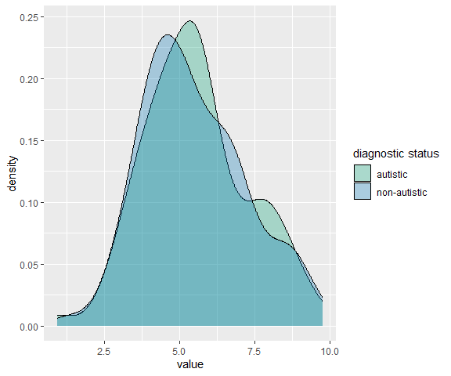
Figure 9: Distribution of switches per trial for videos with autistic and non-autistic interactants of interest.

Explorative analysis: people with high AQ values
Let’s take a look at what happens if we don’t exclude all people with an AQ score above 5, but rather compare them to the participants with lower AQ values. Will these two groups differ from each other?
if (file.exists("models/brm_imp-aq.rds")) {
mimpaq = readRDS('models/brm_imp-aq.rds')
} else {
mimpaq = brm(formula = imp ~
aq_high * `diagnostic status`* green_lead * white_lead + # fixed effects
green_mot_head + white_mot_head + place + # regressors of no interest
(`diagnostic status`+ place|sub) + (1|stm), # random effects
data = df,
control = list(adapt_delta = 0.99,
max_treedepth = 13),
save_pars = save_pars(all = T),
chains = 4,
warmup = nw, iter = nw*2)
saveRDS(mimpaq, file = 'models/brm_imp-aq.rds')
}
# check assumptions for this model
check_model(mimpaq, check=c("qq","linearity","homogeneity","reqq","vif","pp_check"))
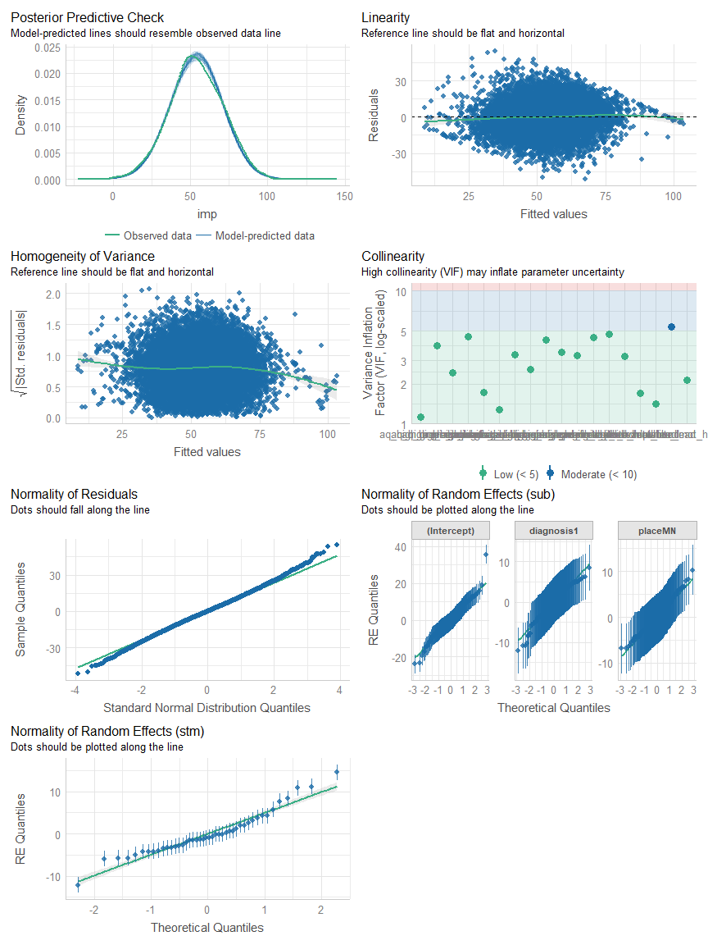
Figure 10: Model assumption check for the model including participants with high autism-like traits compared to participants with low-autistic participants.
# are there differences connected to the aq_high groups?
hypothesis(mimpaq, "aq_highTRUE > 0", alpha = 0.025)
## Hypothesis Tests for class b:
## Hypothesis Estimate Est.Error CI.Lower CI.Upper Evid.Ratio Post.Prob
## 1 (aq_highTRUE) > 0 0.83 1.32 -1.77 3.4 2.79 0.74
## Star
## 1
## ---
## 'CI': 95%-CI for one-sided and 97.5%-CI for two-sided hypotheses.
## '*': For one-sided hypotheses, the posterior probability exceeds 97.5%;
## for two-sided hypotheses, the value tested against lies outside the 97.5%-CI.
## Posterior probabilities of point hypotheses assume equal prior probabilities.
hypothesis(mimpaq, "diagnosis1:aq_highTRUE > 0", alpha = 0.025)
## Hypothesis Tests for class b:
## Hypothesis Estimate Est.Error CI.Lower CI.Upper Evid.Ratio
## 1 (diagnosis1:aq_hi... > 0 1.81 1.01 -0.14 3.79 27.94
## Post.Prob Star
## 1 0.97
## ---
## 'CI': 95%-CI for one-sided and 97.5%-CI for two-sided hypotheses.
## '*': For one-sided hypotheses, the posterior probability exceeds 97.5%;
## for two-sided hypotheses, the value tested against lies outside the 97.5%-CI.
## Posterior probabilities of point hypotheses assume equal prior probabilities.
# get statistics
kable(df %>% group_by(aq_high, `diagnostic status`) %>%
summarise(
imp_avg = mean(imp, na.rm = T),
imp_sd = sd(imp, na.rm = T)
))
## `summarise()` has grouped output by 'aq_high'. You can override using the
## `.groups` argument.
Table 2: Means in impression scores for participants with high and low autism-like traits for autistic and non-autistic interactants of interest.
aq_high | diagnostic status | imp_avg | imp_sd
FALSE | autistic | 48.86105 | 17.17859
FALSE | non-autistic | 58.10243 | 16.47337
TRUE | autistic | 51.18429 | 15.93985
TRUE | non-autistic | 58.96336 | 15.04769
There might be something connected to the interaction with the diagnostic status of the interactant. This could be worth checking out in a future study.

Explorative: separate ratings

Awkwardness
if (file.exists("models/brm_awk.rds")) {
mawk = readRDS('models/brm_awk.rds')
} else {
mawk = brm(formula = awk ~
`diagnostic status`* green_lead * white_lead + # fixed effects
green_mot_head + white_mot_head + place + # regressors of no interest
(`diagnostic status`+ place|sub) + (1|stm), # random effects
data = df[df$aq_high == F,],
control = list(adapt_delta = 0.99,
max_treedepth = 13),
save_pars = save_pars(all = T),
chains = 4,
warmup = nw, iter = nw*2)
saveRDS(mawk, file = 'models/brm_awk.rds')
}
# H1
hypothesis(mawk, "diagnosis1 < 0", alpha = 0.025)
## Hypothesis Tests for class b:
## Hypothesis Estimate Est.Error CI.Lower CI.Upper Evid.Ratio Post.Prob
## 1 (diagnosis1) < 0 -12.51 4.8 -22.05 -3 172.91 0.99
## Star
## 1 *
## ---
## 'CI': 95%-CI for one-sided and 97.5%-CI for two-sided hypotheses.
## '*': For one-sided hypotheses, the posterior probability exceeds 97.5%;
## for two-sided hypotheses, the value tested against lies outside the 97.5%-CI.
## Posterior probabilities of point hypotheses assume equal prior probabilities.
# H2
hypothesis(mawk, "green_lead > 0", alpha = 0.025)
## Hypothesis Tests for class b:
## Hypothesis Estimate Est.Error CI.Lower CI.Upper Evid.Ratio Post.Prob
## 1 (green_lead) > 0 2.07 3.99 -5.75 9.85 2.33 0.7
## Star
## 1
## ---
## 'CI': 95%-CI for one-sided and 97.5%-CI for two-sided hypotheses.
## '*': For one-sided hypotheses, the posterior probability exceeds 97.5%;
## for two-sided hypotheses, the value tested against lies outside the 97.5%-CI.
## Posterior probabilities of point hypotheses assume equal prior probabilities.
hypothesis(mawk, "white_lead > 0", alpha = 0.025)
## Hypothesis Tests for class b:
## Hypothesis Estimate Est.Error CI.Lower CI.Upper Evid.Ratio Post.Prob
## 1 (white_lead) > 0 0.82 4.28 -7.67 9.27 1.38 0.58
## Star
## 1
## ---
## 'CI': 95%-CI for one-sided and 97.5%-CI for two-sided hypotheses.
## '*': For one-sided hypotheses, the posterior probability exceeds 97.5%;
## for two-sided hypotheses, the value tested against lies outside the 97.5%-CI.
## Posterior probabilities of point hypotheses assume equal prior probabilities.
# H3
hypothesis(mawk, "diagnosis1:green_lead < 0", alpha = 0.025)
## Hypothesis Tests for class b:
## Hypothesis Estimate Est.Error CI.Lower CI.Upper Evid.Ratio
## 1 (diagnosis1:green... < 0 -8.14 4.72 -17.46 1.16 22.5
## Post.Prob Star
## 1 0.96
## ---
## 'CI': 95%-CI for one-sided and 97.5%-CI for two-sided hypotheses.
## '*': For one-sided hypotheses, the posterior probability exceeds 97.5%;
## for two-sided hypotheses, the value tested against lies outside the 97.5%-CI.
## Posterior probabilities of point hypotheses assume equal prior probabilities.
hypothesis(mawk, "diagnosis1:white_lead > 0", alpha = 0.025)
## Hypothesis Tests for class b:
## Hypothesis Estimate Est.Error CI.Lower CI.Upper Evid.Ratio
## 1 (diagnosis1:white... > 0 1.55 4.82 -7.88 11.17 1.68
## Post.Prob Star
## 1 0.63
## ---
## 'CI': 95%-CI for one-sided and 97.5%-CI for two-sided hypotheses.
## '*': For one-sided hypotheses, the posterior probability exceeds 97.5%;
## for two-sided hypotheses, the value tested against lies outside the 97.5%-CI.
## Posterior probabilities of point hypotheses assume equal prior probabilities.
hypothesis(mawk, "diagnosis1:green_lead:white_lead > 0", alpha = 0.025)
## Hypothesis Tests for class b:
## Hypothesis Estimate Est.Error CI.Lower CI.Upper Evid.Ratio
## 1 (diagnosis1:green... > 0 3.13 4.09 -4.92 11.18 3.63
## Post.Prob Star
## 1 0.78
## ---
## 'CI': 95%-CI for one-sided and 97.5%-CI for two-sided hypotheses.
## '*': For one-sided hypotheses, the posterior probability exceeds 97.5%;
## for two-sided hypotheses, the value tested against lies outside the 97.5%-CI.
## Posterior probabilities of point hypotheses assume equal prior probabilities.

Friends
if (file.exists("models/brm_fri.rds")) {
mfri = readRDS('models/brm_fri.rds')
} else {
mfri = brm(formula = fri ~
`diagnostic status`* green_lead * white_lead + # fixed effects
green_mot_head + white_mot_head + place + # regressors of no interest
(`diagnostic status`+ place|sub) + (1|stm), # random effects
data = df[df$aq_high == F,],
control = list(adapt_delta = 0.99,
max_treedepth = 13),
save_pars = save_pars(all = T),
chains = 4,
warmup = nw, iter = nw*2)
saveRDS(mfri, file = 'models/brm_fri.rds')
}
# H1
hypothesis(mfri, "diagnosis1 < 0", alpha = 0.025)
## Hypothesis Tests for class b:
## Hypothesis Estimate Est.Error CI.Lower CI.Upper Evid.Ratio Post.Prob
## 1 (diagnosis1) < 0 -7.51 3.66 -14.67 -0.22 43.94 0.98
## Star
## 1 *
## ---
## 'CI': 95%-CI for one-sided and 97.5%-CI for two-sided hypotheses.
## '*': For one-sided hypotheses, the posterior probability exceeds 97.5%;
## for two-sided hypotheses, the value tested against lies outside the 97.5%-CI.
## Posterior probabilities of point hypotheses assume equal prior probabilities.
# H2
hypothesis(mfri, "green_lead > 0", alpha = 0.025)
## Hypothesis Tests for class b:
## Hypothesis Estimate Est.Error CI.Lower CI.Upper Evid.Ratio Post.Prob
## 1 (green_lead) > 0 2.46 3.07 -3.67 8.51 3.88 0.8
## Star
## 1
## ---
## 'CI': 95%-CI for one-sided and 97.5%-CI for two-sided hypotheses.
## '*': For one-sided hypotheses, the posterior probability exceeds 97.5%;
## for two-sided hypotheses, the value tested against lies outside the 97.5%-CI.
## Posterior probabilities of point hypotheses assume equal prior probabilities.
hypothesis(mfri, "white_lead < 0", alpha = 0.025)
## Hypothesis Tests for class b:
## Hypothesis Estimate Est.Error CI.Lower CI.Upper Evid.Ratio Post.Prob
## 1 (white_lead) < 0 -0.56 3.31 -7.05 6.05 1.33 0.57
## Star
## 1
## ---
## 'CI': 95%-CI for one-sided and 97.5%-CI for two-sided hypotheses.
## '*': For one-sided hypotheses, the posterior probability exceeds 97.5%;
## for two-sided hypotheses, the value tested against lies outside the 97.5%-CI.
## Posterior probabilities of point hypotheses assume equal prior probabilities.
# H3
hypothesis(mfri, "diagnosis1:green_lead < 0", alpha = 0.025)
## Hypothesis Tests for class b:
## Hypothesis Estimate Est.Error CI.Lower CI.Upper Evid.Ratio
## 1 (diagnosis1:green... < 0 -5.92 3.67 -13.1 1.35 17.38
## Post.Prob Star
## 1 0.95
## ---
## 'CI': 95%-CI for one-sided and 97.5%-CI for two-sided hypotheses.
## '*': For one-sided hypotheses, the posterior probability exceeds 97.5%;
## for two-sided hypotheses, the value tested against lies outside the 97.5%-CI.
## Posterior probabilities of point hypotheses assume equal prior probabilities.
hypothesis(mfri, "diagnosis1:white_lead > 0", alpha = 0.025)
## Hypothesis Tests for class b:
## Hypothesis Estimate Est.Error CI.Lower CI.Upper Evid.Ratio
## 1 (diagnosis1:white... > 0 0.21 3.75 -7.21 7.59 1.1
## Post.Prob Star
## 1 0.52
## ---
## 'CI': 95%-CI for one-sided and 97.5%-CI for two-sided hypotheses.
## '*': For one-sided hypotheses, the posterior probability exceeds 97.5%;
## for two-sided hypotheses, the value tested against lies outside the 97.5%-CI.
## Posterior probabilities of point hypotheses assume equal prior probabilities.
hypothesis(mfri, "diagnosis1:green_lead:white_lead < 0", alpha = 0.025)
## Hypothesis Tests for class b:
## Hypothesis Estimate Est.Error CI.Lower CI.Upper Evid.Ratio
## 1 (diagnosis1:green... < 0 -1.44 3.12 -7.7 4.67 2.13
## Post.Prob Star
## 1 0.68
## ---
## 'CI': 95%-CI for one-sided and 97.5%-CI for two-sided hypotheses.
## '*': For one-sided hypotheses, the posterior probability exceeds 97.5%;
## for two-sided hypotheses, the value tested against lies outside the 97.5%-CI.
## Posterior probabilities of point hypotheses assume equal prior probabilities.

Intelligence
if (file.exists("models/brm_int.rds")) {
mint = readRDS('models/brm_int.rds')
} else {
mint = brm(formula = int ~
`diagnostic status`* green_lead * white_lead + # fixed effects
green_mot_head + white_mot_head + place + # regressors of no interest
(`diagnostic status`+ place|sub) + (1|stm), # random effects
data = df[df$aq_high == F,],
control = list(adapt_delta = 0.99,
max_treedepth = 13),
save_pars = save_pars(all = T),
chains = 4,
warmup = nw, iter = nw*2)
saveRDS(mint, file = 'models/brm_int.rds')
}
# H1
hypothesis(mint, "diagnosis1 < 0", alpha = 0.025)
## Hypothesis Tests for class b:
## Hypothesis Estimate Est.Error CI.Lower CI.Upper Evid.Ratio Post.Prob
## 1 (diagnosis1) < 0 -1.96 2.66 -7.18 3.28 3.39 0.77
## Star
## 1
## ---
## 'CI': 95%-CI for one-sided and 97.5%-CI for two-sided hypotheses.
## '*': For one-sided hypotheses, the posterior probability exceeds 97.5%;
## for two-sided hypotheses, the value tested against lies outside the 97.5%-CI.
## Posterior probabilities of point hypotheses assume equal prior probabilities.
# H2
hypothesis(mint, "green_lead > 0", alpha = 0.025)
## Hypothesis Tests for class b:
## Hypothesis Estimate Est.Error CI.Lower CI.Upper Evid.Ratio Post.Prob
## 1 (green_lead) > 0 6.03 2.21 1.71 10.39 226.27 1
## Star
## 1 *
## ---
## 'CI': 95%-CI for one-sided and 97.5%-CI for two-sided hypotheses.
## '*': For one-sided hypotheses, the posterior probability exceeds 97.5%;
## for two-sided hypotheses, the value tested against lies outside the 97.5%-CI.
## Posterior probabilities of point hypotheses assume equal prior probabilities.
hypothesis(mint, "white_lead < 0", alpha = 0.025)
## Hypothesis Tests for class b:
## Hypothesis Estimate Est.Error CI.Lower CI.Upper Evid.Ratio Post.Prob
## 1 (white_lead) < 0 -2.71 2.38 -7.38 2.01 7.05 0.88
## Star
## 1
## ---
## 'CI': 95%-CI for one-sided and 97.5%-CI for two-sided hypotheses.
## '*': For one-sided hypotheses, the posterior probability exceeds 97.5%;
## for two-sided hypotheses, the value tested against lies outside the 97.5%-CI.
## Posterior probabilities of point hypotheses assume equal prior probabilities.
# H3
hypothesis(mint, "diagnosis1:green_lead < 0", alpha = 0.025)
## Hypothesis Tests for class b:
## Hypothesis Estimate Est.Error CI.Lower CI.Upper Evid.Ratio
## 1 (diagnosis1:green... < 0 -7.94 2.68 -13.31 -2.66 688.66
## Post.Prob Star
## 1 1 *
## ---
## 'CI': 95%-CI for one-sided and 97.5%-CI for two-sided hypotheses.
## '*': For one-sided hypotheses, the posterior probability exceeds 97.5%;
## for two-sided hypotheses, the value tested against lies outside the 97.5%-CI.
## Posterior probabilities of point hypotheses assume equal prior probabilities.
hypothesis(mint, "diagnosis1:white_lead > 0", alpha = 0.025)
## Hypothesis Tests for class b:
## Hypothesis Estimate Est.Error CI.Lower CI.Upper Evid.Ratio
## 1 (diagnosis1:white... > 0 2.68 2.71 -2.65 8 5.42
## Post.Prob Star
## 1 0.84
## ---
## 'CI': 95%-CI for one-sided and 97.5%-CI for two-sided hypotheses.
## '*': For one-sided hypotheses, the posterior probability exceeds 97.5%;
## for two-sided hypotheses, the value tested against lies outside the 97.5%-CI.
## Posterior probabilities of point hypotheses assume equal prior probabilities.
hypothesis(mint, "diagnosis1:green_lead:white_lead > 0", alpha = 0.025)
## Hypothesis Tests for class b:
## Hypothesis Estimate Est.Error CI.Lower CI.Upper Evid.Ratio
## 1 (diagnosis1:green... > 0 0.96 2.3 -3.58 5.5 1.99
## Post.Prob Star
## 1 0.67
## ---
## 'CI': 95%-CI for one-sided and 97.5%-CI for two-sided hypotheses.
## '*': For one-sided hypotheses, the posterior probability exceeds 97.5%;
## for two-sided hypotheses, the value tested against lies outside the 97.5%-CI.
## Posterior probabilities of point hypotheses assume equal prior probabilities.

Likeability
if (file.exists("models/brm_lik.rds")) {
mlik = readRDS('models/brm_lik.rds')
} else {
mlik = brm(formula = lik ~
`diagnostic status`* green_lead * white_lead + # fixed effects
green_mot_head + white_mot_head + place + # regressors of no interest
(`diagnostic status`+ place|sub) + (1|stm), # random effects
data = df[df$aq_high == F,],
control = list(adapt_delta = 0.99,
max_treedepth = 13),
save_pars = save_pars(all = T),
chains = 4,
warmup = nw, iter = nw*2)
saveRDS(mlik, file = 'models/brm_lik.rds')
}
# H1
hypothesis(mlik, "diagnosis1 < 0", alpha = 0.025)
## Hypothesis Tests for class b:
## Hypothesis Estimate Est.Error CI.Lower CI.Upper Evid.Ratio Post.Prob
## 1 (diagnosis1) < 0 -2.33 2.55 -7.32 2.71 4.76 0.83
## Star
## 1
## ---
## 'CI': 95%-CI for one-sided and 97.5%-CI for two-sided hypotheses.
## '*': For one-sided hypotheses, the posterior probability exceeds 97.5%;
## for two-sided hypotheses, the value tested against lies outside the 97.5%-CI.
## Posterior probabilities of point hypotheses assume equal prior probabilities.
# H2
hypothesis(mlik, "green_lead > 0", alpha = 0.025)
## Hypothesis Tests for class b:
## Hypothesis Estimate Est.Error CI.Lower CI.Upper Evid.Ratio Post.Prob
## 1 (green_lead) > 0 5.08 2.09 0.96 9.18 115.96 0.99
## Star
## 1 *
## ---
## 'CI': 95%-CI for one-sided and 97.5%-CI for two-sided hypotheses.
## '*': For one-sided hypotheses, the posterior probability exceeds 97.5%;
## for two-sided hypotheses, the value tested against lies outside the 97.5%-CI.
## Posterior probabilities of point hypotheses assume equal prior probabilities.
hypothesis(mlik, "white_lead < 0", alpha = 0.025)
## Hypothesis Tests for class b:
## Hypothesis Estimate Est.Error CI.Lower CI.Upper Evid.Ratio Post.Prob
## 1 (white_lead) < 0 -4.34 2.24 -8.73 0.05 37.31 0.97
## Star
## 1
## ---
## 'CI': 95%-CI for one-sided and 97.5%-CI for two-sided hypotheses.
## '*': For one-sided hypotheses, the posterior probability exceeds 97.5%;
## for two-sided hypotheses, the value tested against lies outside the 97.5%-CI.
## Posterior probabilities of point hypotheses assume equal prior probabilities.
# H3
hypothesis(mlik, "diagnosis1:green_lead < 0", alpha = 0.025)
## Hypothesis Tests for class b:
## Hypothesis Estimate Est.Error CI.Lower CI.Upper Evid.Ratio
## 1 (diagnosis1:green... < 0 -5.53 2.5 -10.44 -0.55 63.94
## Post.Prob Star
## 1 0.98 *
## ---
## 'CI': 95%-CI for one-sided and 97.5%-CI for two-sided hypotheses.
## '*': For one-sided hypotheses, the posterior probability exceeds 97.5%;
## for two-sided hypotheses, the value tested against lies outside the 97.5%-CI.
## Posterior probabilities of point hypotheses assume equal prior probabilities.
hypothesis(mlik, "diagnosis1:white_lead > 0", alpha = 0.025)
## Hypothesis Tests for class b:
## Hypothesis Estimate Est.Error CI.Lower CI.Upper Evid.Ratio
## 1 (diagnosis1:white... > 0 2.85 2.57 -2.24 7.84 6.62
## Post.Prob Star
## 1 0.87
## ---
## 'CI': 95%-CI for one-sided and 97.5%-CI for two-sided hypotheses.
## '*': For one-sided hypotheses, the posterior probability exceeds 97.5%;
## for two-sided hypotheses, the value tested against lies outside the 97.5%-CI.
## Posterior probabilities of point hypotheses assume equal prior probabilities.
hypothesis(mlik, "diagnosis1:green_lead:white_lead < 0", alpha = 0.025)
## Hypothesis Tests for class b:
## Hypothesis Estimate Est.Error CI.Lower CI.Upper Evid.Ratio
## 1 (diagnosis1:green... < 0 -1.54 2.18 -5.82 2.69 3.19
## Post.Prob Star
## 1 0.76
## ---
## 'CI': 95%-CI for one-sided and 97.5%-CI for two-sided hypotheses.
## '*': For one-sided hypotheses, the posterior probability exceeds 97.5%;
## for two-sided hypotheses, the value tested against lies outside the 97.5%-CI.
## Posterior probabilities of point hypotheses assume equal prior probabilities.

Talk
if (file.exists("models/brm_tlk.rds")) {
mtlk = readRDS('models/brm_tlk.rds')
} else {
mtlk = brm(formula = tlk ~
`diagnostic status`* green_lead * white_lead + # fixed effects
green_mot_head + white_mot_head + place + # regressors of no interest
(`diagnostic status`+ place|sub) + (1|stm), # random effects
data = df[df$aq_high == F,],
control = list(adapt_delta = 0.99,
max_treedepth = 13),
save_pars = save_pars(all = T),
chains = 4,
warmup = nw, iter = nw*2)
saveRDS(mtlk, file = 'models/brm_tlk.rds')
}
# H1
hypothesis(mtlk, "diagnosis1 < 0", alpha = 0.025)
## Hypothesis Tests for class b:
## Hypothesis Estimate Est.Error CI.Lower CI.Upper Evid.Ratio Post.Prob
## 1 (diagnosis1) < 0 -3.4 2.67 -8.61 1.8 9.08 0.9
## Star
## 1
## ---
## 'CI': 95%-CI for one-sided and 97.5%-CI for two-sided hypotheses.
## '*': For one-sided hypotheses, the posterior probability exceeds 97.5%;
## for two-sided hypotheses, the value tested against lies outside the 97.5%-CI.
## Posterior probabilities of point hypotheses assume equal prior probabilities.
# H2
hypothesis(mtlk, "green_lead > 0", alpha = 0.025)
## Hypothesis Tests for class b:
## Hypothesis Estimate Est.Error CI.Lower CI.Upper Evid.Ratio Post.Prob
## 1 (green_lead) > 0 5.79 2.23 1.37 10.24 151.67 0.99
## Star
## 1 *
## ---
## 'CI': 95%-CI for one-sided and 97.5%-CI for two-sided hypotheses.
## '*': For one-sided hypotheses, the posterior probability exceeds 97.5%;
## for two-sided hypotheses, the value tested against lies outside the 97.5%-CI.
## Posterior probabilities of point hypotheses assume equal prior probabilities.
hypothesis(mtlk, "white_lead < 0", alpha = 0.025)
## Hypothesis Tests for class b:
## Hypothesis Estimate Est.Error CI.Lower CI.Upper Evid.Ratio Post.Prob
## 1 (white_lead) < 0 -4.07 2.42 -8.84 0.78 20.37 0.95
## Star
## 1
## ---
## 'CI': 95%-CI for one-sided and 97.5%-CI for two-sided hypotheses.
## '*': For one-sided hypotheses, the posterior probability exceeds 97.5%;
## for two-sided hypotheses, the value tested against lies outside the 97.5%-CI.
## Posterior probabilities of point hypotheses assume equal prior probabilities.
# H3
hypothesis(mtlk, "diagnosis1:green_lead < 0", alpha = 0.025)
## Hypothesis Tests for class b:
## Hypothesis Estimate Est.Error CI.Lower CI.Upper Evid.Ratio
## 1 (diagnosis1:green... < 0 -7.2 2.7 -12.47 -1.84 162.93
## Post.Prob Star
## 1 0.99 *
## ---
## 'CI': 95%-CI for one-sided and 97.5%-CI for two-sided hypotheses.
## '*': For one-sided hypotheses, the posterior probability exceeds 97.5%;
## for two-sided hypotheses, the value tested against lies outside the 97.5%-CI.
## Posterior probabilities of point hypotheses assume equal prior probabilities.
hypothesis(mtlk, "diagnosis1:white_lead > 0", alpha = 0.025)
## Hypothesis Tests for class b:
## Hypothesis Estimate Est.Error CI.Lower CI.Upper Evid.Ratio
## 1 (diagnosis1:white... > 0 2.94 2.75 -2.55 8.26 6.26
## Post.Prob Star
## 1 0.86
## ---
## 'CI': 95%-CI for one-sided and 97.5%-CI for two-sided hypotheses.
## '*': For one-sided hypotheses, the posterior probability exceeds 97.5%;
## for two-sided hypotheses, the value tested against lies outside the 97.5%-CI.
## Posterior probabilities of point hypotheses assume equal prior probabilities.
hypothesis(mtlk, "diagnosis1:green_lead:white_lead < 0", alpha = 0.025)
## Hypothesis Tests for class b:
## Hypothesis Estimate Est.Error CI.Lower CI.Upper Evid.Ratio
## 1 (diagnosis1:green... < 0 -0.91 2.29 -5.4 3.61 1.89
## Post.Prob Star
## 1 0.65
## ---
## 'CI': 95%-CI for one-sided and 97.5%-CI for two-sided hypotheses.
## '*': For one-sided hypotheses, the posterior probability exceeds 97.5%;
## for two-sided hypotheses, the value tested against lies outside the 97.5%-CI.
## Posterior probabilities of point hypotheses assume equal prior probabilities.

Trustworthiness
if (file.exists("models/brm_tru.rds")) {
mtru = readRDS('models/brm_tru.rds')
} else {
mtru = brm(formula = tru ~
`diagnostic status`* green_lead * white_lead + # fixed effects
green_mot_head + white_mot_head + place + # regressors of no interest
(`diagnostic status`+ place|sub) + (1|stm), # random effects
data = df[df$aq_high == F,],
control = list(adapt_delta = 0.99,
max_treedepth = 13),
save_pars = save_pars(all = T),
chains = 4,
warmup = nw, iter = nw*2)
saveRDS(mtru, file = 'models/brm_tru.rds')
}
# H1
hypothesis(mtru, "diagnosis1 < 0", alpha = 0.025)
## Hypothesis Tests for class b:
## Hypothesis Estimate Est.Error CI.Lower CI.Upper Evid.Ratio Post.Prob
## 1 (diagnosis1) < 0 -2.26 2.5 -7.13 2.73 4.61 0.82
## Star
## 1
## ---
## 'CI': 95%-CI for one-sided and 97.5%-CI for two-sided hypotheses.
## '*': For one-sided hypotheses, the posterior probability exceeds 97.5%;
## for two-sided hypotheses, the value tested against lies outside the 97.5%-CI.
## Posterior probabilities of point hypotheses assume equal prior probabilities.
# H2
hypothesis(mtru, "green_lead > 0", alpha = 0.025)
## Hypothesis Tests for class b:
## Hypothesis Estimate Est.Error CI.Lower CI.Upper Evid.Ratio Post.Prob
## 1 (green_lead) > 0 5.68 2.07 1.61 9.75 218.78 1
## Star
## 1 *
## ---
## 'CI': 95%-CI for one-sided and 97.5%-CI for two-sided hypotheses.
## '*': For one-sided hypotheses, the posterior probability exceeds 97.5%;
## for two-sided hypotheses, the value tested against lies outside the 97.5%-CI.
## Posterior probabilities of point hypotheses assume equal prior probabilities.
hypothesis(mtru, "white_lead < 0", alpha = 0.025)
## Hypothesis Tests for class b:
## Hypothesis Estimate Est.Error CI.Lower CI.Upper Evid.Ratio Post.Prob
## 1 (white_lead) < 0 -4.92 2.19 -9.26 -0.64 81.3 0.99
## Star
## 1 *
## ---
## 'CI': 95%-CI for one-sided and 97.5%-CI for two-sided hypotheses.
## '*': For one-sided hypotheses, the posterior probability exceeds 97.5%;
## for two-sided hypotheses, the value tested against lies outside the 97.5%-CI.
## Posterior probabilities of point hypotheses assume equal prior probabilities.
# H3
hypothesis(mtru, "diagnosis1:green_lead < 0", alpha = 0.025)
## Hypothesis Tests for class b:
## Hypothesis Estimate Est.Error CI.Lower CI.Upper Evid.Ratio
## 1 (diagnosis1:green... < 0 -5.92 2.49 -10.88 -0.98 105.95
## Post.Prob Star
## 1 0.99 *
## ---
## 'CI': 95%-CI for one-sided and 97.5%-CI for two-sided hypotheses.
## '*': For one-sided hypotheses, the posterior probability exceeds 97.5%;
## for two-sided hypotheses, the value tested against lies outside the 97.5%-CI.
## Posterior probabilities of point hypotheses assume equal prior probabilities.
hypothesis(mtru, "diagnosis1:white_lead > 0", alpha = 0.025)
## Hypothesis Tests for class b:
## Hypothesis Estimate Est.Error CI.Lower CI.Upper Evid.Ratio
## 1 (diagnosis1:white... > 0 4.21 2.51 -0.72 9.21 21.05
## Post.Prob Star
## 1 0.95
## ---
## 'CI': 95%-CI for one-sided and 97.5%-CI for two-sided hypotheses.
## '*': For one-sided hypotheses, the posterior probability exceeds 97.5%;
## for two-sided hypotheses, the value tested against lies outside the 97.5%-CI.
## Posterior probabilities of point hypotheses assume equal prior probabilities.
hypothesis(mtru, "diagnosis1:green_lead:white_lead < 0", alpha = 0.025)
## Hypothesis Tests for class b:
## Hypothesis Estimate Est.Error CI.Lower CI.Upper Evid.Ratio
## 1 (diagnosis1:green... < 0 -0.58 2.15 -4.78 3.68 1.58
## Post.Prob Star
## 1 0.61
## ---
## 'CI': 95%-CI for one-sided and 97.5%-CI for two-sided hypotheses.
## '*': For one-sided hypotheses, the posterior probability exceeds 97.5%;
## for two-sided hypotheses, the value tested against lies outside the 97.5%-CI.
## Posterior probabilities of point hypotheses assume equal prior probabilities.

