Supplemental materials: Label-free measurement of antimicrobial peptide interactions with lipid vesicles and nanodiscs using microscale thermophoresis
Philip Rainsford,ª Fredrik G. Rylandsholm, ª Martin Jakubec,ª Mitchell Silk,ª Eric Juskewitz,^{b} Johanna U. Ericson,^{b} John-Sigurd Svendsen,ª Richard A. Engh,ª Johan Isaksson^{*,a,c}
ª Department of Chemistry, Faculty of Science and Technology, UiT the Arctic University of Norway, 9019 Tromsø, Norway
^{b} Research Group for Host Microbe Interactions, Department of Medical Biology, Faculty of Health Sciences, UiT the Arctic University of Norway, 9019 Tromsø, Norway
^{c} Natural products and Medicinal Chemistry, Department of Pharmacy, Faculty of Health Sciences, UiT the Arctic University of Norway, 9037 Tromsø, Norway
*johan.isaksson@uit.no
Supp. 1
Cyclic Peptide Purification and characterization:
1; Cyclo(WWWRRR). Linear precursor: H₂N-Arg(Pbf)-Arg(Pbf)-Arg(Pbf)-Trp(Boc)-Trp(Boc)-Trp(Boc)-OH. Cyclic: cyclo(Trp-Trp-Trp-Arg-Arg-Arg). Purification gradient: 15-75% buffer B over 60 min, t_{R} = 18 min (33% buffer B). Yield: 46.7 mg (30.0% relative to linear precursor) as a white solid. ESI-FTMS [M + H]⁺ calculated: 1027.5419, found: 1027.5473, [M + 2H]²⁺ calculated: 514.2785, found: 514.2770, [M + 3H]³⁺ calculated: 343.1882, found: 343.1872.
2; Cyclo(WRWRWR). Linear precursor: H2N-Arg(Pbf)-Trp(Boc)-Arg(Pbf)-Trp(Boc)-Arg(Pbf)-Trp(Boc)-OH. Cyclic: cyclo(Trp-Arg-Trp-Arg-Trp-Arg). Purification gradient: 5-65% buffer B over 60 min, tR = 25 min (30% buffer B). Yield: 26.9 mg (22.6% relative to linear precursor) as a white solid. ESI-FTMS [M + 2H]2+ calculated: 514.2785, found: 514.2779, [M + 3H]3+ calculated: 343.1882, found: 343.1883.
3; Cyclo(WWWKKK). Linear precursor: H2N-Lys(Boc)-Lys(Boc)-Lys(Boc)-Trp(Boc)-Trp(Boc)-Trp(Boc)-OH. Cyclic: cyclo(Trp-Trp-Trp-Lys-Lys-Lys). Purification gradient: 10-70% buffer B over 60 min, tR = 22 min (32% buffer B). Yield: 49.5 mg (39.0% relative to linear precursor) as a white solid. ESI-FTMS [M + H]+ calculated: 943.5307, found: 943.5354, [M + Na]+ calculated: 965.5126, found: 965.5159, [M + 2H]2+ calculated: 472.2693, found: 472.2702.
4; Cyclo(WWWKKK). Linear precursor: H2N-Trp(Boc)-Lys(Boc)-Trp(Boc)-Lys(Boc)-Trp(Boc)-Lys(Boc)-OH. Cyclic: cyclo(Trp-Lys-Trp-Lys-Trp-Lys). Purification gradient: 5-65% buffer B over 60 min, tR = 21 min (26% buffer B). Yield: 40.7 mg (41.8% relative to linear precursor) as a white solid. ESI-FTMS [M + H]+ calculated: 943.5307, found: 943.5308, calculated: 472.2693, found: 472.2689.
5; Cyclo(LWwNKr). Linear precursor: H₂N-Trp(Boc)-D-Trp(Boc)-Asn(Trt)-Lys(Boc)-D-Arg(Pbf)-Leu-OH. Cyclic: cyclo(Leu-Trp-D-Trp-Asn-Lys-D-Arg). Purification gradient: 10-70% buffer B over 60 min, 6 mL/min, t_{R} = 23 min (33% buffer B). Yield: 35.1 mg (44.9% relative to linear precursor) as a white solid. ESI-FTMS [M + H]⁺ calculated: 884.4895, found: 884.4895, [M + 2H]²⁺ calculated: 442.7487, found: 442.7483.
Table S1: Table of lipid and peptide concentrations for MST
MST Sample | Final lipid concentration (nM) | Final AMP concentration (nM)
1 | 1500000 | 2500
2 | 1250000 | 2500
3 | 500000 | 2500
4 | 250000 | 2500
5 | 125000 | 2500
6 | 50000 | 2500
7 | 25000 | 2500
8 | 12500 | 2500
9 | 5000 | 2500
10 | 2500 | 2500
11 | 1250 | 2500
12 | 500 | 2500
13 | 250 | 2500
14 | 125 | 2500
15 | 50 | 2500
16 | 0 | 2500

Figure S1: MST traces of increasing DMPC/PG vesicle concentration with 1 (red) and with no peptide (green), demonstrating the typical differences of the MST traces when peptide is present. Notably a more irregular trace can only be observed in the absence of the fluorophore carrying peptides, with a smaller thermophoretic change.
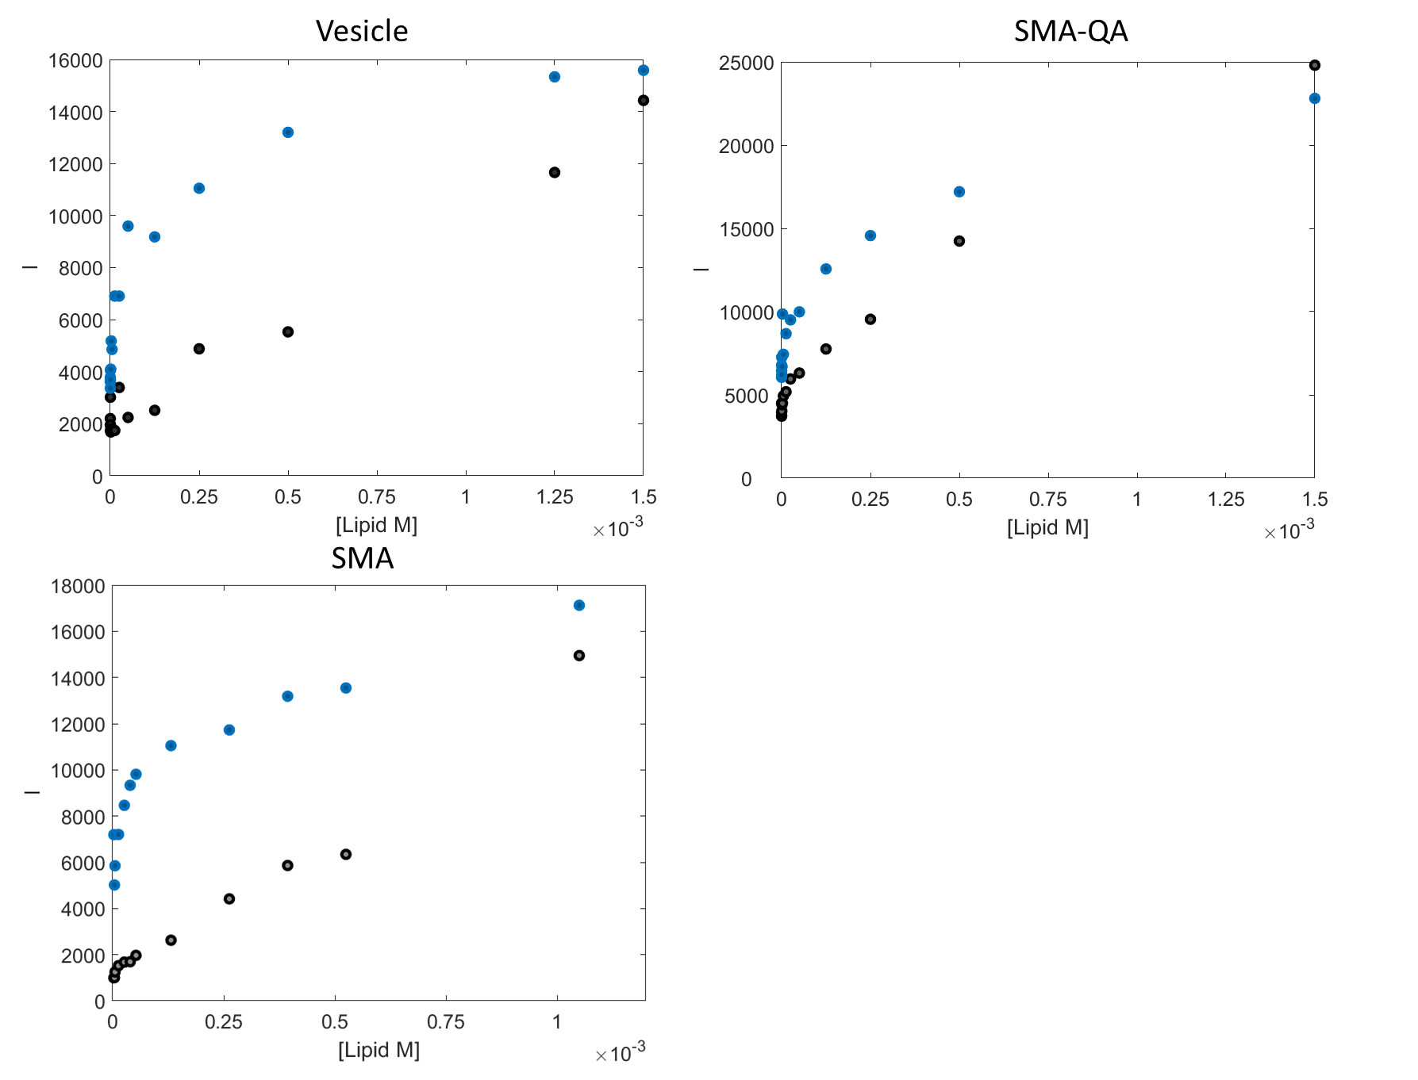
Figure S2: Fluorescent intensities of samples in the presence of 1 (blue) and without any peptide i.e. lipid only (grey). Both SMA and vesicle samples show markedly higher intensities when an AMP is present in the samples with a (generally) parabolic line shape. In SMA-QA the lipid only sample has a higher fluorescent intensity compared to SMA and vesicles, however the parabolic line shape is clearly differentiated when an AMP is present.
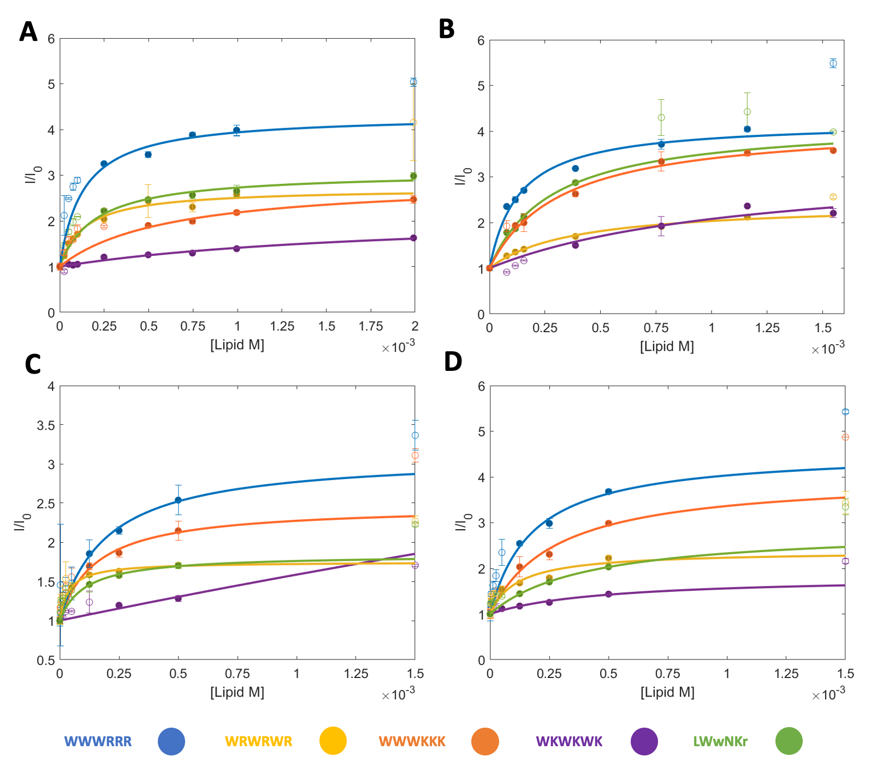
Figure S3: Initial fluorescence and K_{P} fits of 1-5 in different lipid compositions of nanodiscs. A: SMA 100% DMPC. B: SMA 95% DMPC with 5% DMPG. C: SMA-QA 100% DMPC. D: SMA-QA 95% DMPC with 5% DMPG. Lines and filled circles indicate the fit and the points used, unfilled circles are points not included. Error bars represent the standard deviation of the triplicates.

