Supplementary Information
Proportional inundation of four habitat types was used to estimate yearly access (and thus movement) of carp populations onto each habitat for spawning and subsequent early life history survival in both case studies. Inundation of the four different habitat types was calculated in each year as a function of the maximum flows within the year. Here, the maximum flow sustained over a 25-day period in each year between 1 September and 30 April was used as the ‘maximum flow’ value. This represents the time it takes for Carp to undergo the reproductive cycle within the spawning months, and so reflects spawning behaviours in each year (Koehn et al. 2000).
For Case Study 1, the maximum flow value for each year was then applied to flow specific habitat inundation tables from the lower Murray River specific to the area covered in this study to generate areas of inundation for each of the four habitat types for each operational scenario. Flow data used in this case study was modelled data that represents the Murray Darling Basin development, water use and water sharing arrangements as of June 2009 (Fig. S1: Department for Environment and Water 2021). The modelled flow data is similar to current conditions and includes environmental water already recovered for The Living Murray and Water for Rivers for the Snowy River. However, it does not include several other existing or proposed Australian Commonwealth Government environmental water recovery programs. The modelled time series represents usage and water delivery patterns over 114 years of climate and catchment inflows if June-2009 development and water sharing arrangements had been in place for the whole time period. Inundation areas of the four relevant habitats used in this study were calculated at a series of increasing flows at the South Australian state border with New South Wales and Victoria (0-100,000 ML day⁻¹ in 5,000 ML day⁻¹ increments). Natural floodplain inundation was calculated as the total area inundated from Lock 4 to the South Australian state border with Victoria and New South Wales at differing flows (adapted from Gibbs et al. 2012) minus areas of inundation of permanent river channel and permanent off-channel wetlands and creek habitats. Baseline inundation or the minimum area inundated in each year was assumed to be inundated areas at 5,000 ML day⁻¹.
Calculation of inundated area during operations considered both the operations of floodplain infrastructure and associated weir pool raising at the relevant sites (Fig. S2). Here, Scenario 1.4 in this study involved the operation of individual floodplains in sequence across years, and calculations of inundated areas at each site included areas in adjacent weir pools that were ‘overlapped’ by operations at individual sites.
Areas of inundation when operating each or all of the floodplains were assumed to be at maximum operational level for all flows, which for Pike operation was 16.4m AHD with Lock 5 at 16.8m AHD, with floodplain area inundated 2250 Ha (1740Ha managed floodplain and 510 Ha permanent off-channel wetland and creek habitat). For Katarapko operations this was 13.5m AHD with Lock 4 at 13.8m AHD, with floodplain area inundated 1050 Ha (990Ha managed floodplain and 60 Ha permanent off-channel wetland and creek habitat). For Chowilla operations the inundated area did vary with flow, where the Chowilla regulator was operated at constant 19.3 AHD and Lock 6 was at 19.87 AHD. Inundation tables are thus presented for Scenario 1.1 (Table S1), Scenario 1.2 and 1.3 (inundation is equivalent: Table S2) and Scenario 1.4 (Table S3).
Inundation area was calculated for Case Study 2 for the four habitat types in each year using the River Murray Floodplain Inundation Model (RiMFIM: Overton et al. 2006) with flow inputs generated by the Murray Source (hydrological) Model (Fig. S3 and see DPE 2022 for further description). Here, inundation area for each habitat was interpreted as the maximum area inundated for at least 25 days within each year in the Hume to Yarrawonga reach of the Murray River (Fig. S4).
Table S1 Sensitivity analysis of the characteristic polynomial (eqn 2) expressed as changes in the vital rates, the growth rate λ and percentage change in the growth rate from changes to the vital rates using parameterisation from Table 2 and habitat type H5: λ = 1.0562.
Parameter | -10% |  | +10%
 | λ | %change | λ | %change
S_{e} – S₂ | 1.0395 | -1.58 | 1.0722 | 1.51
All adult S | 1.0014 | -5.19 | 1.1146 | 5.53
All S | 0.9082 | -14.01 | 1.2176 | 15.28
All Fec | 1.0395 | -1.58 | 1.0722 | 1.51
All | 0.8958 | -15.19 | 1.2323 | 17.23

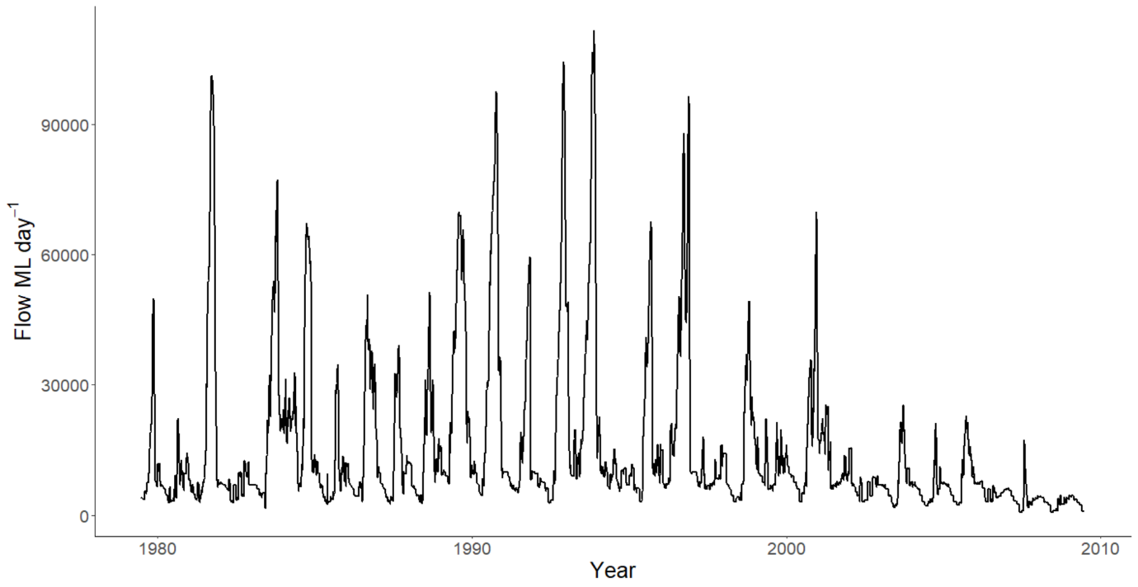
Fig. S1 Hydrograph for the hydro-geomorphic region of the lower Murray River downstream of the junction with Darling River (~825 km from the river mouth) which is made up of a series of predominantly lentic pools caused by the construction of 10 serial weirs in the 1920s.

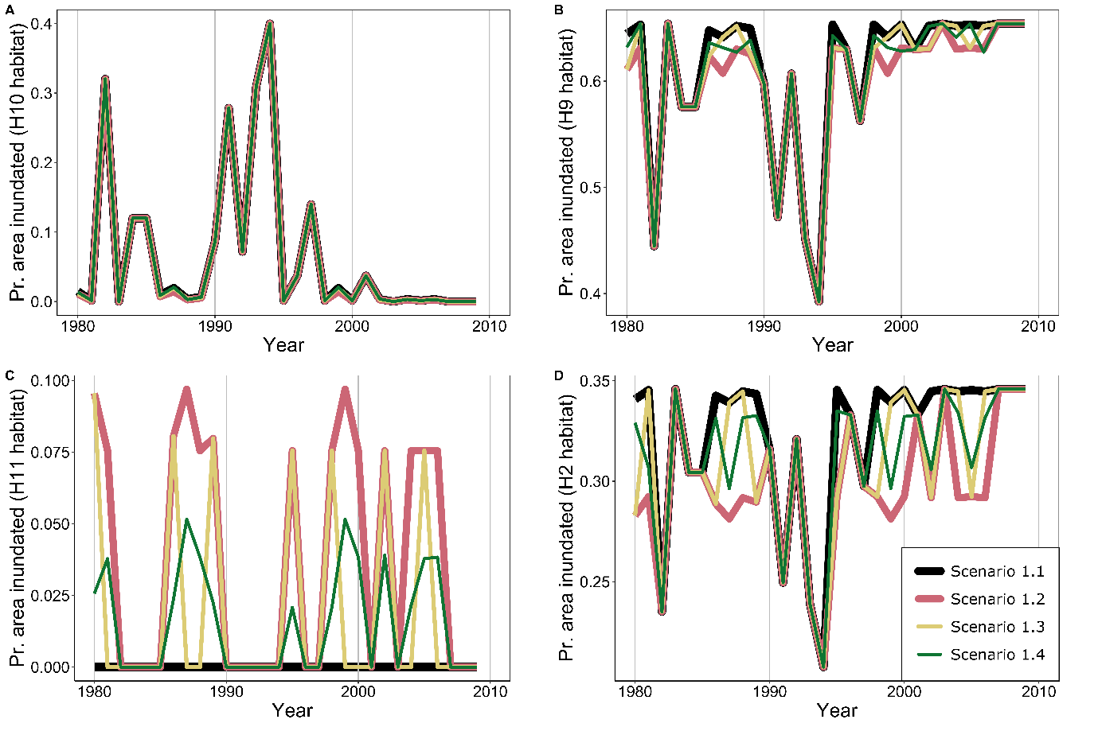
Fig. S2 Proportional 25-day inundation for all scenarios (scenario 1.1 or no artificial floodplain operations through to scenario 1.4) of the four habitat types through years in the Lower Murray River. Habitat inundation is shown in each panel: Panel A - H10 (natural floodplain habitat), Panel B - H9 (wetland permanently connected), Panel C - H11 (artificial floodplain habitat) and Panel D - H2 (river channel habitat). Proportional inundation was used to estimate yearly access (and thus movement) of carp populations onto each habitat for spawning and subsequent early life history survival (see Methods for further explanation).

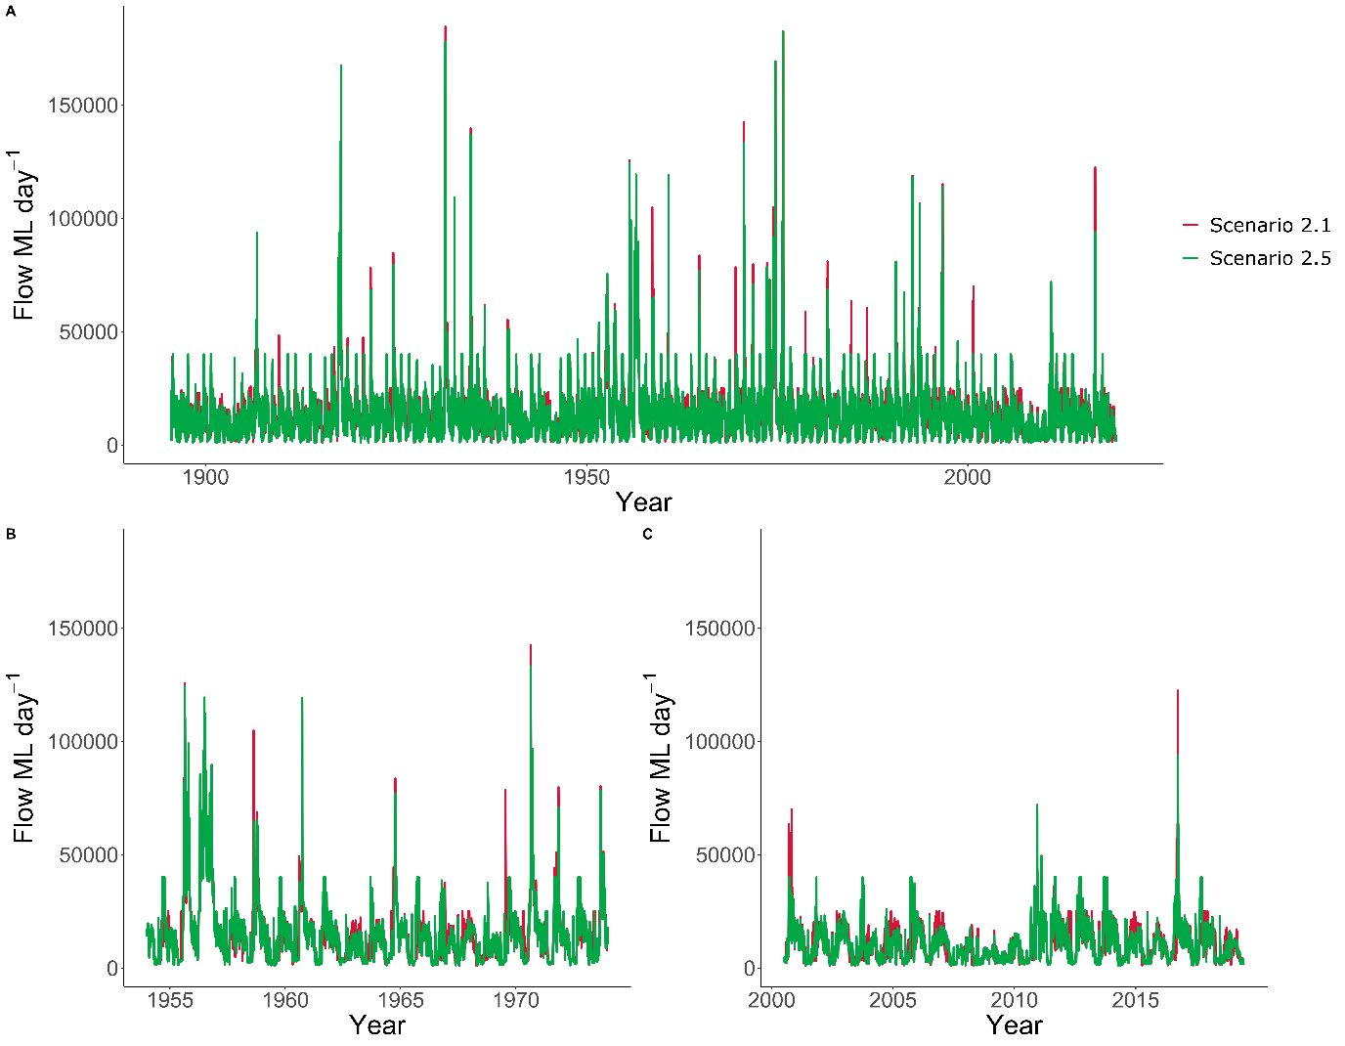Fig. S3 Hydrographs for the region of the upper Murray River from Hume Dam to Yarrawonga Weir which has retained its lotic nature, while remaining highly regulated. Panel A is the whole 124 year hydrograph with scenario 2.1 (15,000 ML day-1 flow limit) and scenario 2.5 (45,000 ML day-1 flow limit). Panel B and C are examples of different time periods within the 124 year hydrograph: B 1954 – 1964; and C 2000 – 2019. For clarity, we have only presented the lower and upper flow options considered in this case study.

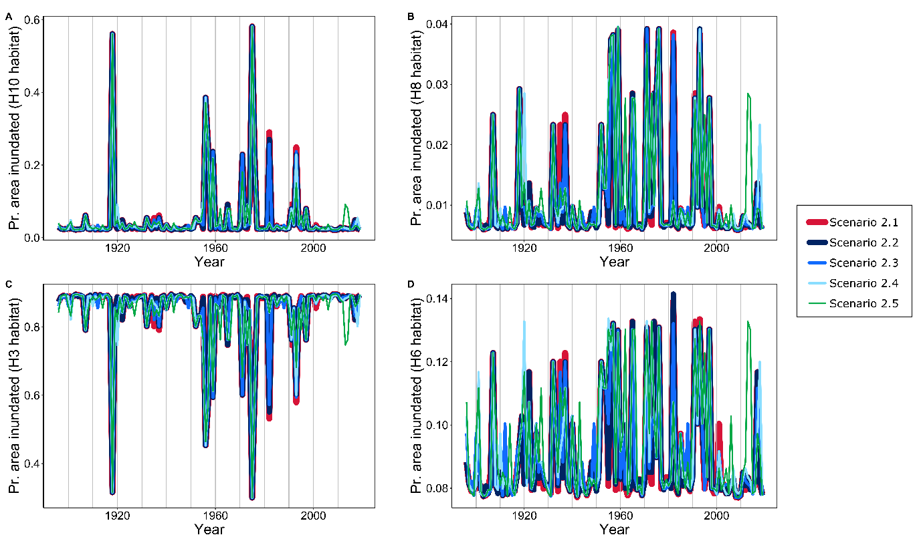
Fig. S4 Proportional 25-day inundation for all scenarios (scenario 2.1 or 15,000 ML day⁻¹ flow limit through to scenario 2.5 or 45,000 ML day⁻¹ flow limit) of the four habitat types through years in the Hume Weir to Yarrawonga Weir reach. Habitat inundation is shown in each panel: Panel A - H10 (natural floodplain habitat), Panel B - H8 (wetland ephemeral habitat), Panel C - H3 (river channel habitat) and Panel D - H6 (river wetland habitat). Proportional inundation was used to estimate yearly access (and thus movement) of carp populations onto each habitat for spawning and subsequent early life history survival (see Methods for further explanation). Inundation data was generated using the RiMFIM model (Overton et al. 2006).

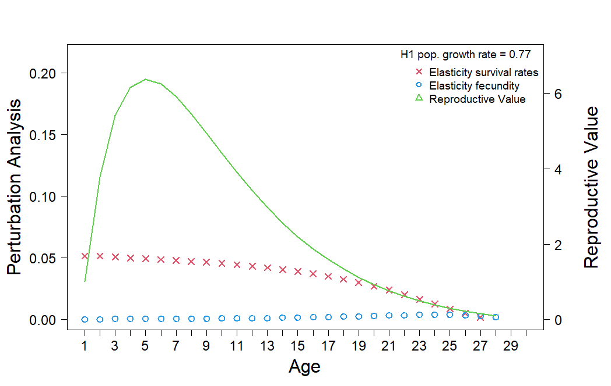
Fig. S5 Habitat 1 elasticity analysis (sensitivity of the growth rate to proportional change in the vital rates of survival and fecundity) and reproductive values for carp.
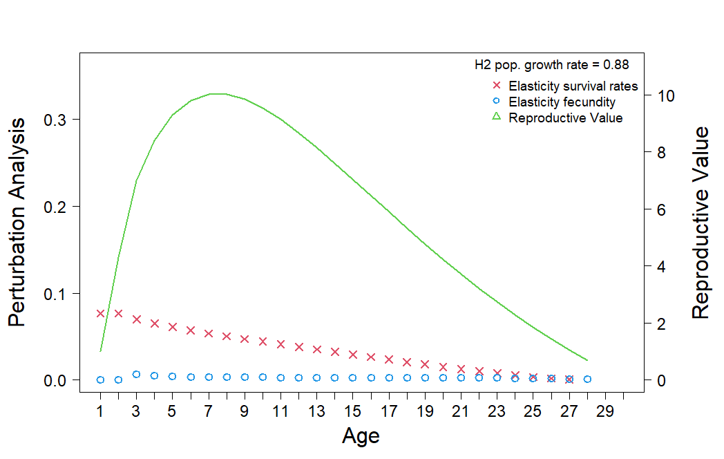
Fig. S6 Habitat 2 elasticity analysis and reproductive values for carp.
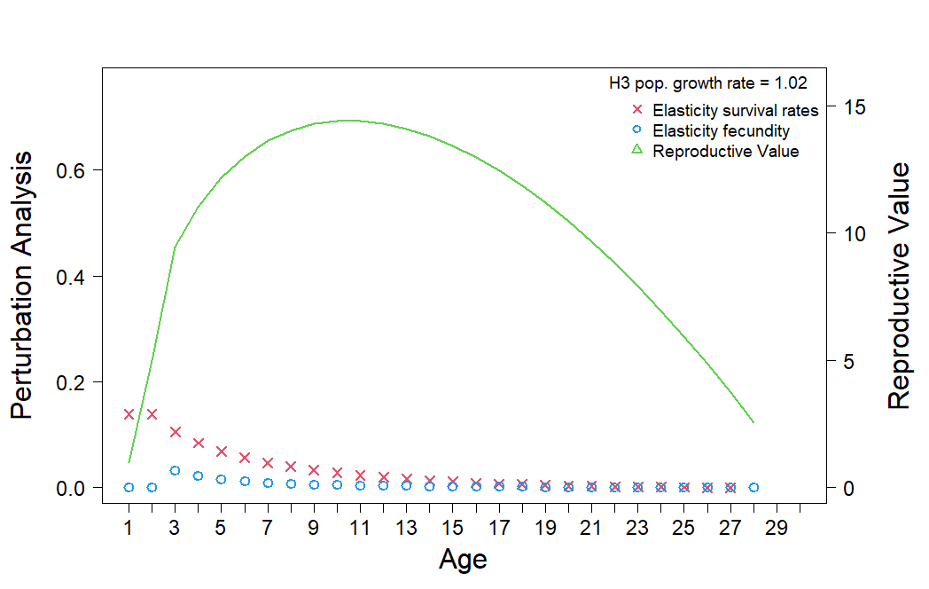
Fig. S7 Habitat 3 elasticity analysis and reproductive values for carp.
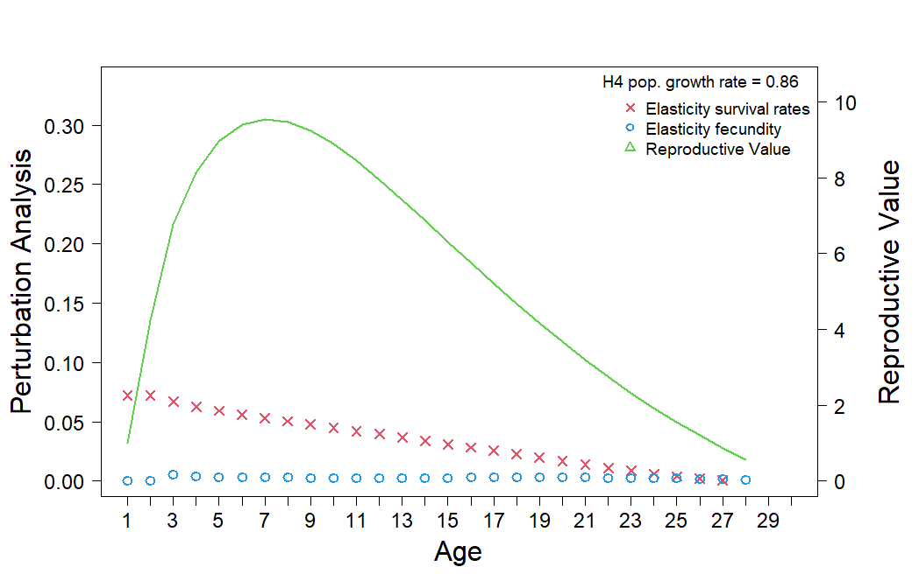
Fig. S8 Habitat 4 elasticity analysis and reproductive values for carp.
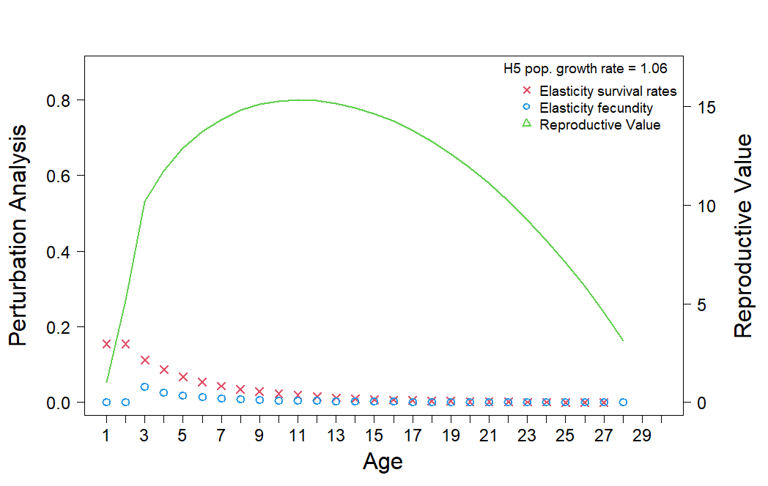
Fig. S9 Habitat 5 elasticity analysis and reproductive values for carp.
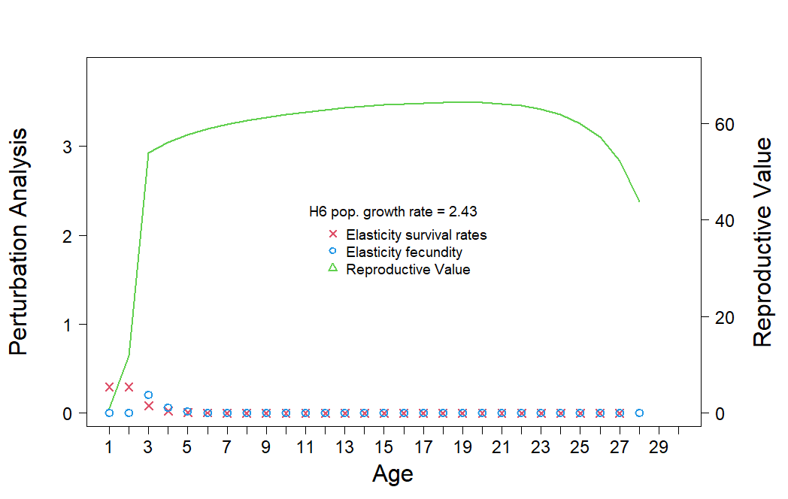
Fig. S10 Habitat 6 elasticity analysis and reproductive values for carp.
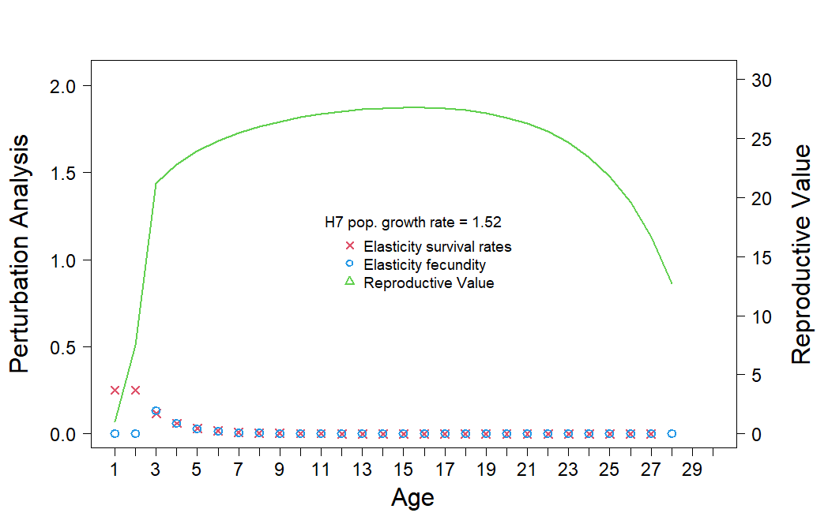
Fig. S11 Habitat 7 elasticity analysis and reproductive values for carp.
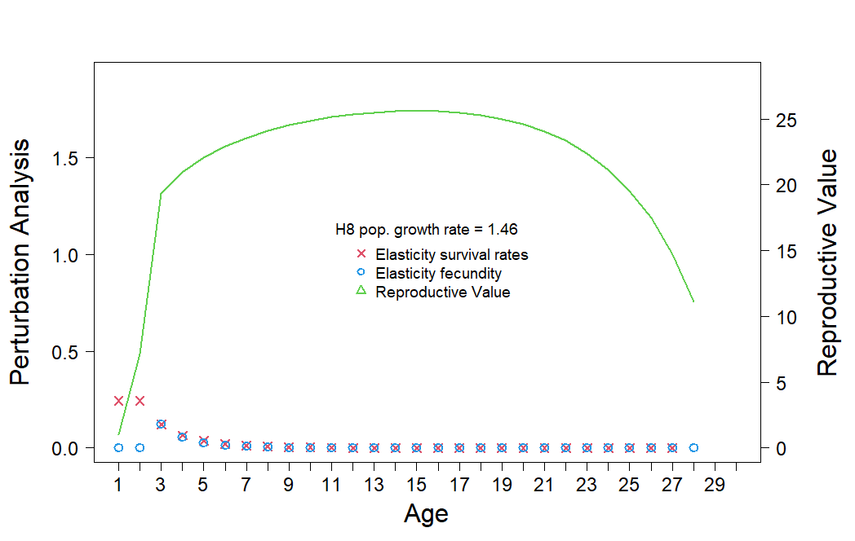
Fig. S12 Habitat 8 elasticity analysis and reproductive values for carp.
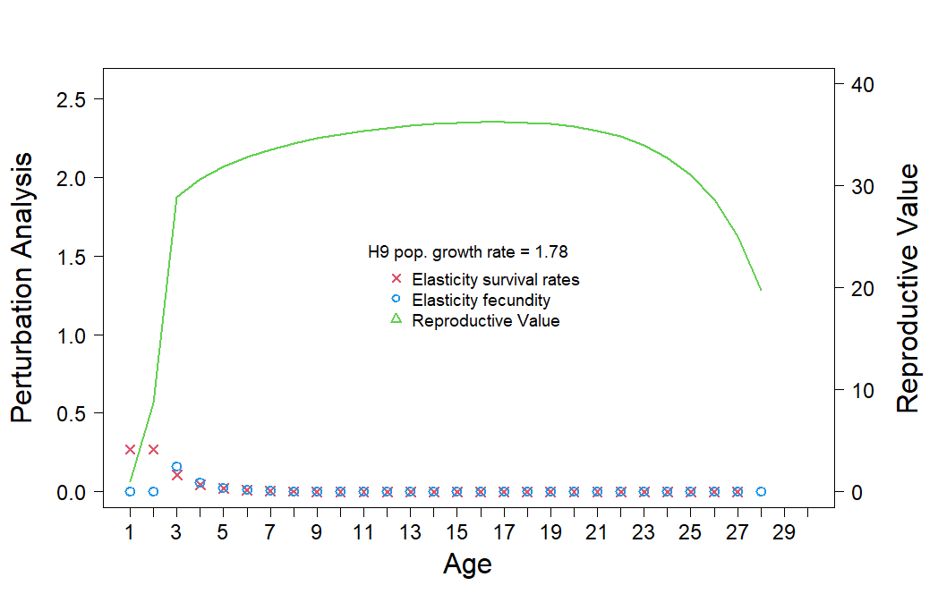
Fig. S13 Habitat 9 elasticity analysis and reproductive values for carp.
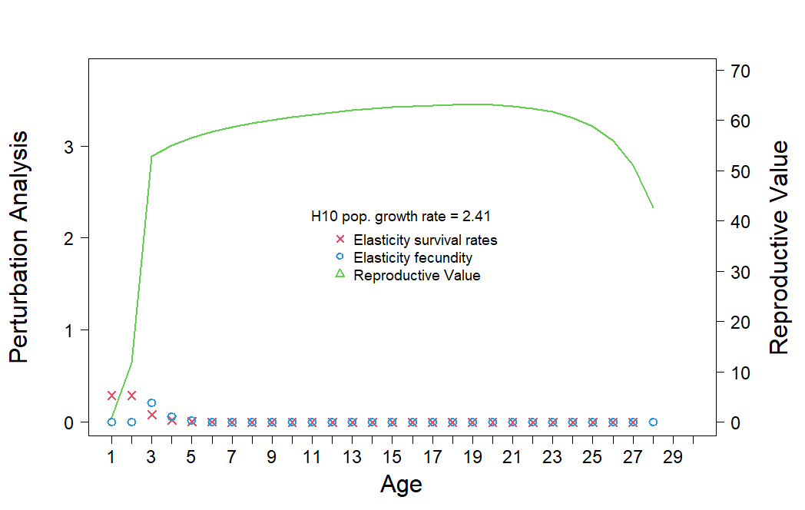
Fig. S14 Habitat 10 elasticity analysis and reproductive values for carp.
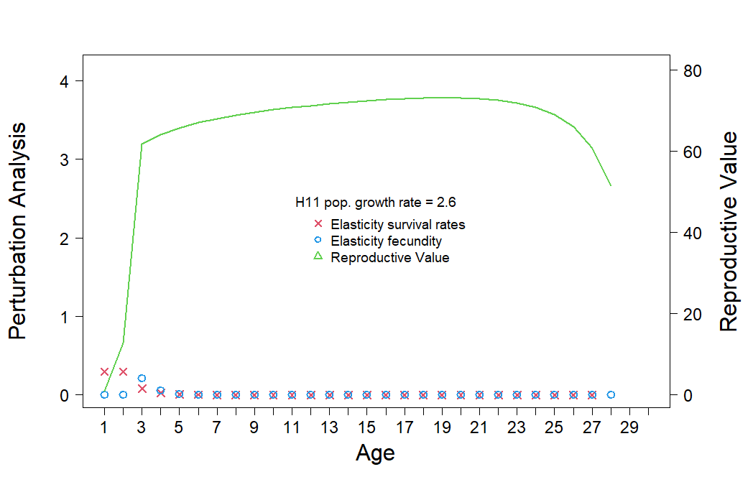
Fig. S15 Habitat 11 elasticity analysis and reproductive values for carp.
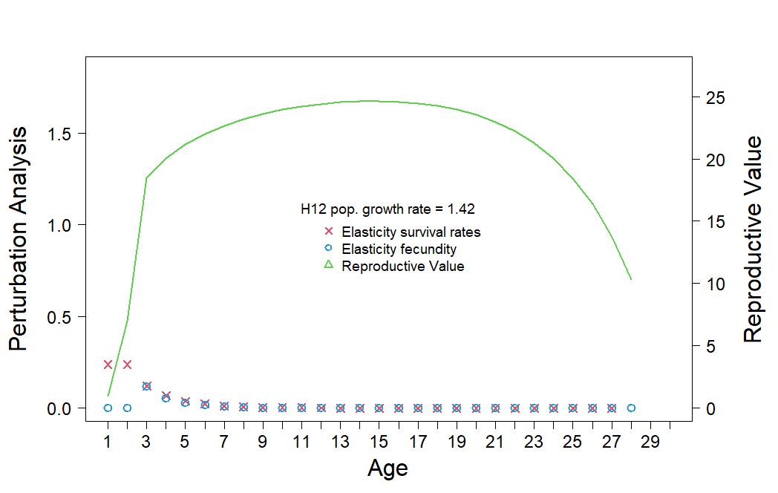
Fig. S16 Habitat 12 elasticity analysis and reproductive values for carp.
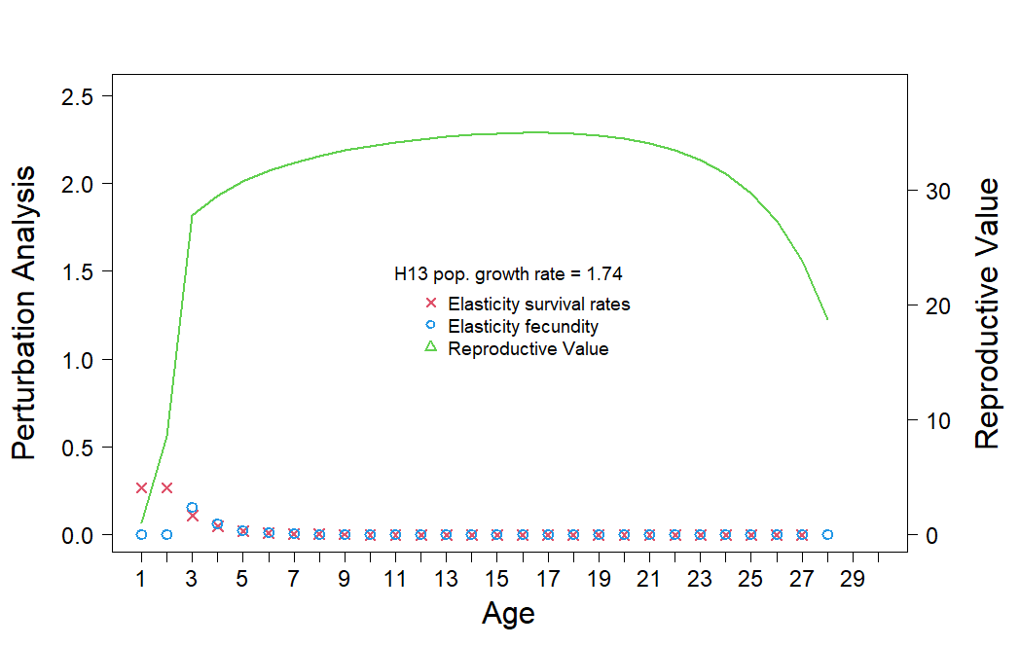
Fig. S17 Habitat 13 elasticity analysis and reproductive values for carp.
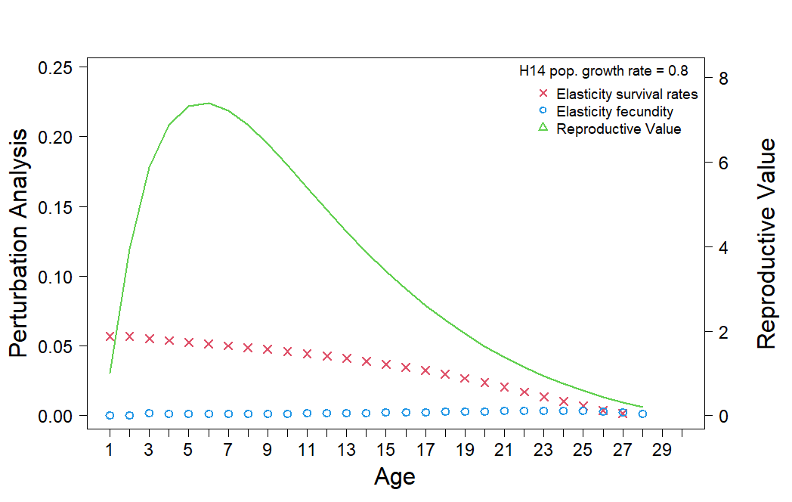
Fig. S18 Habitat 14 elasticity analysis and reproductive values for carp.

Reference
DPE (2022) Reconnecting River Country Program: Murray Environmental Benefits Analysis Synthesis Report. Report prepared by the Department of Planning and Environment, Sydney
Overton IC McEwan K Sherrah JR (2006) The River Murray Floodplain Inundation Model – Hume Dam to Lower Lakes. CSIRO Water for a Healthy Country Technical Report 2006. CSIRO, Canberra

